Expiration Date: XX/XXXX

**Find Local Help Contact Information Update Screens**

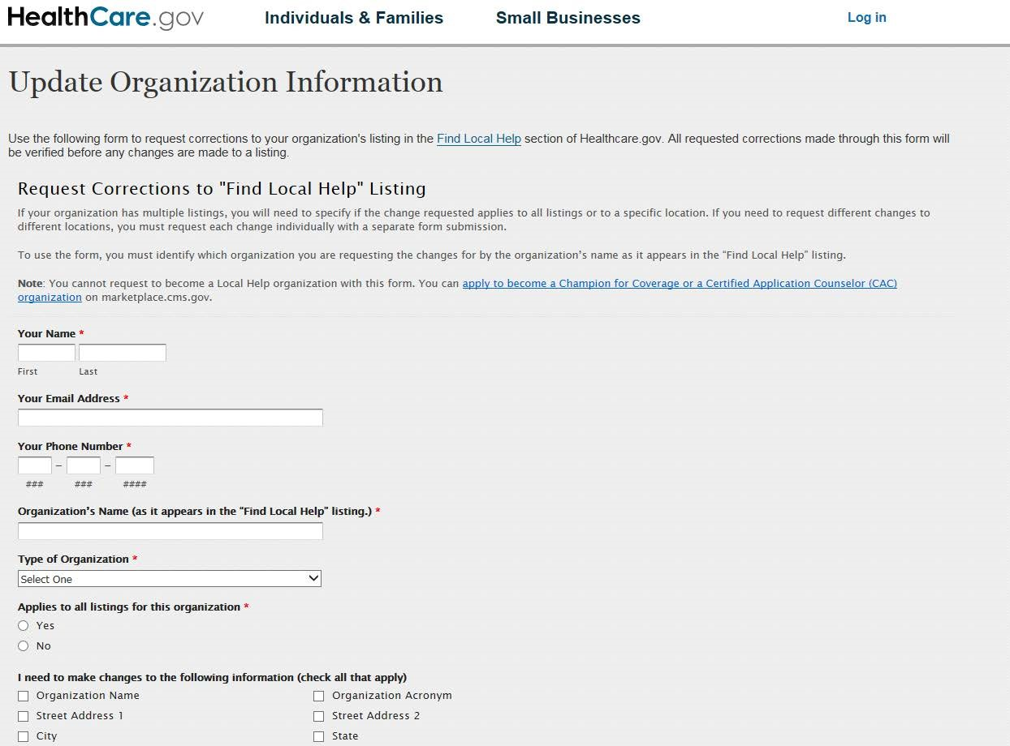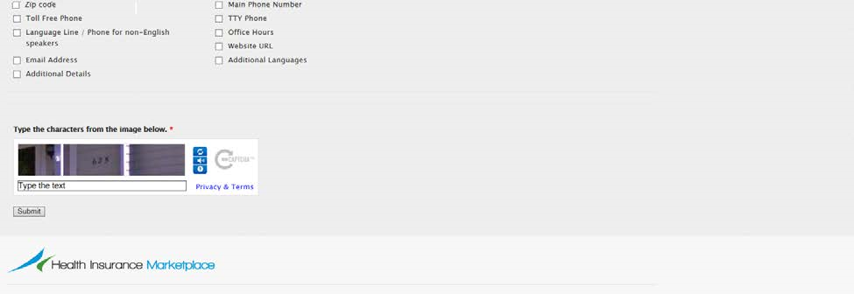

**Find Local Help Contact Information Update Screens**

Type of Organization Dropdown Menu

