HIS-Admission

OMB Control Number: 0938-1153
Expiration Date: XX/XXXX
Hospice Item Set - Admission
Section A | Administrative Information

A0050. Type of Record
Enter Code | - Add new record  - Modify existing record  - Inactivate existing record
A0100. Fac | ility Provider Numbers. Enter code in boxes provided.
- National Provider Identifier (NPI):

- CMS Certification Number (CCN):

A0205. Site | of Service at Admission
Enter Code | - Hospice in patient's home/residence  - Hospice in Assisted Living facility  - Hospice provided in Nursing Long Term Care (LTC) or Non-Skilled Nursing Facility  (NF)  - Hospice provided in a Skilled Nursing Facility (SNF)  - Hospice provided in Inpatient Hospital  - Hospice provided in Inpatient Hospice Facility  - Hospice provided in Long Term Care Hospital (LTCH)  - Hospice in Inpatient Psychiatric Facility  - Hospice provided in a place not otherwise specified (NOS)  - Hospice home care provided in a hospice facility
A0220. Ad | mission Date
 | Month Day Year
A0245. Dat | e Initial Nursing Assessment Initiated
 | Month Day Year
A0250. Rea | son for Record
Enter Code | 01. Admission  09. Discharge

Section A | Administrative Information

A0500. Legal Name of Patient
- First name:

- Middle initial:

- Last name:

- Suffix:

A0550. Pat | ient ZIP Code. Enter code in boxes provided.
Patient ZIP Code:
-

A0600. Soc | ial Security and Medicare Numbers
- Social Security Number:
 |  |  | - |  |  | -

- Medicare number (or comparable railroad insurance number):

A0700. Me | dicaid Number - Enter "+" if pending, "N" if not a Medicaid Recipient
A0800. Gen | der
Enter Code | - Male  - Female
A0900. Birt | h Date
 | Month Day Year

Section A | Administrative Information

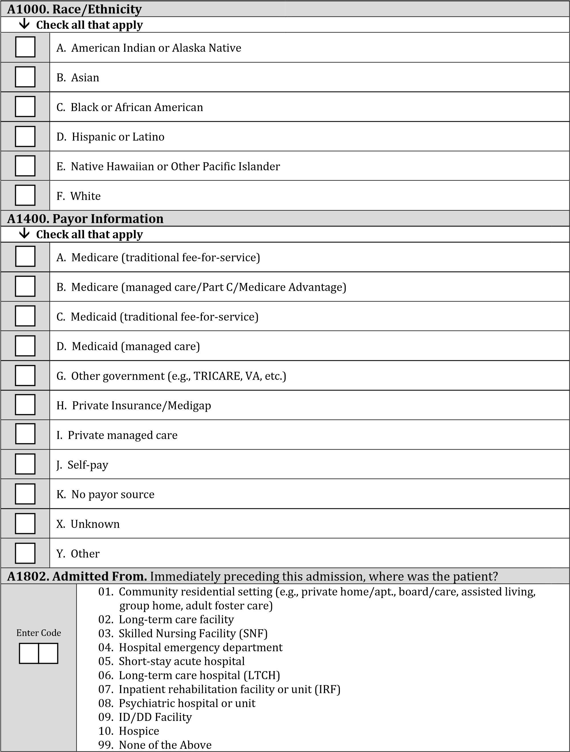

Section F | Preferences

F2000. CPR Preference

Enter Code | - Was the patient/responsible party asked about preference regarding the use of cardiopulmonary resuscitation (CPR)? - Select the most accurate response  - No → Skip to F2100, Other Life-Sustaining Treatment Preferences  - Yes, and discussion occurred  - Yes, but the patient/responsible party refused to discuss  - Date the patient/responsible party was first asked about preference regarding the use of CPR:  Month Day Year
F2100. Other Life-Sustaining Treatment Preferences

Enter Code | - Was the patient/responsible party asked about preferences regarding life-sustaining treatments other than CPR? - Select the most accurate response  - No → Skip to F2200, Hospitalization Preference  - Yes, and discussion occurred  - Yes, but the patient/responsible party refused to discuss  - Date the patient/responsible party was first asked about preferences regarding lifesustaining treatments other than CPR:  Month Day Year
F2200. Hospitalization Preference

Enter Code | - Was the patient/responsible party asked about preference regarding hospitalization? - Select the most accurate response 0. No → Skip to F3000, Spiritual/Existential Concerns  - Yes, and discussion occurred  - Yes, but the patient/responsible party refused to discuss  - Date the patient/responsible party was first asked about preference regarding hospitalization:  Month Day Year
F3000. Spiritual/Existential Concerns
Enter Code | - Was the patient and/or caregiver asked about spiritual/existential concerns? - Select the most accurate response  - No → Skip to I0010, Principal Diagnosis  - Yes, and discussion occurred  - Yes, but the patient and/or caregiver refused to discuss  - Date the patient and/or caregiver was first asked about spiritual/existential concerns:  Month Day Year

Section I | Active Diagnoses

I0010. Principal Diagnosis
Enter Code | - Cancer  - Dementia/Alzheimer’s  99. None of the above

Section J | Health Conditions

Pain
J0900. Pain Screening
Enter Code |  |  | - Was the patient screened for pain?  - No → Skip to J0905, Pain Active Problem  - Yes  - Date of first screening for pain:  Month Day Year
Enter Code |  |  | C. The patient’s pain severity was:  - None  - Mild  - Moderate  - Severe  9. Pain not rated
Enter Code |  |  | D. Type of standardized pain tool used:  - Numeric  - Verbal descriptor  - Patient visual  - Staff observation  9. No standardized tool used
J0905. Pain Active Problem
Enter Code |  |  | Is pain an active problem for the patient?  - No → Skip to J2030, Screening for Shortness of Breath  - Yes

Section J | Health Conditions

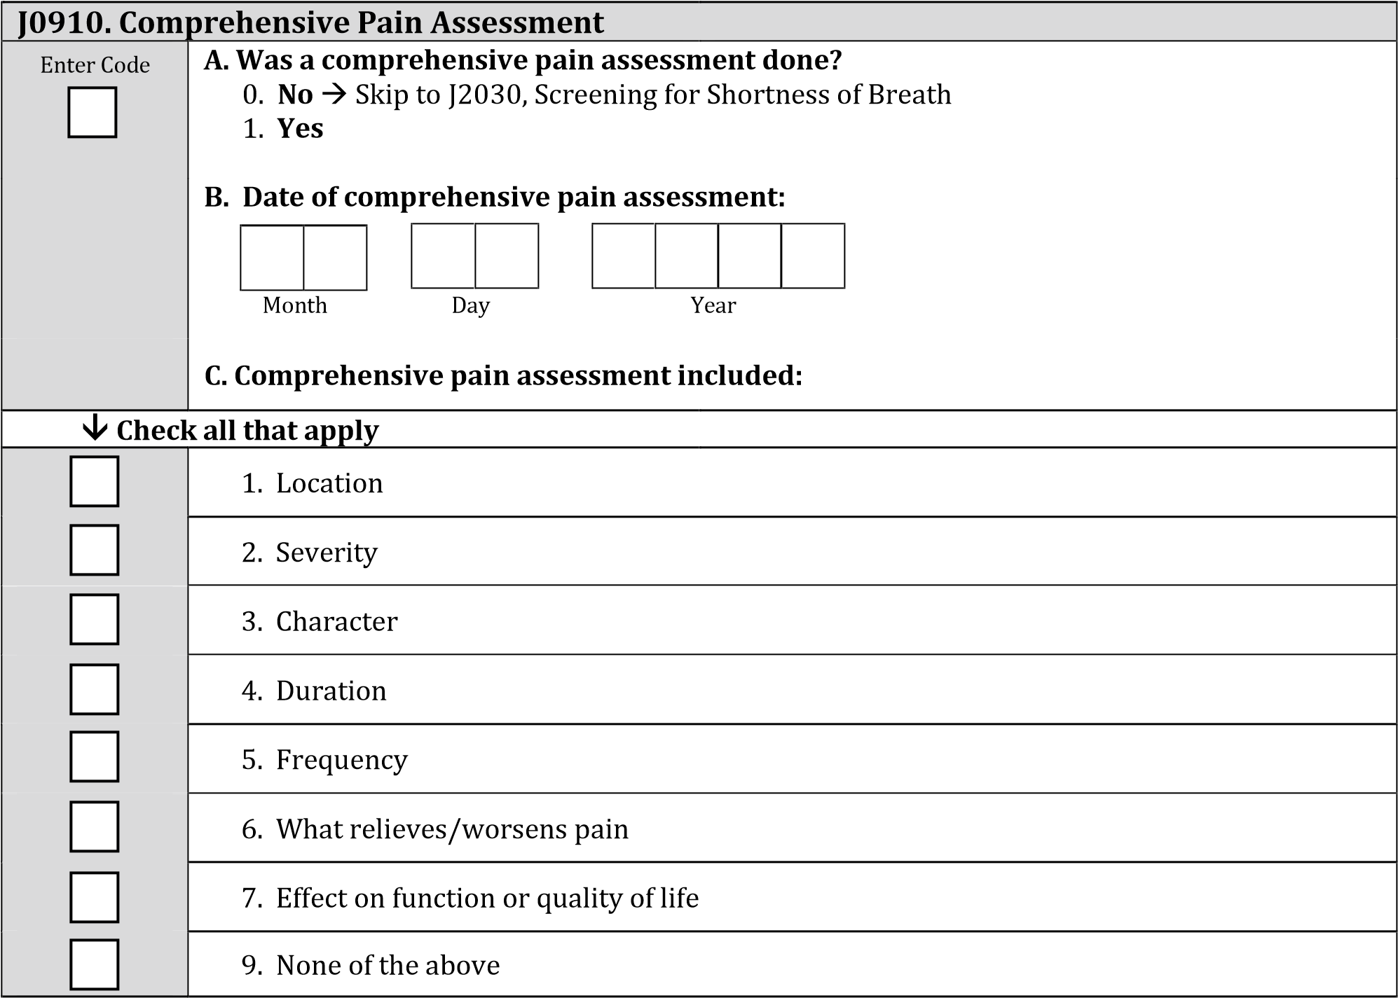

Section J | Health Conditions

Respiratory Status
J2030. Screening for Shortness of Breath
Enter Code |  |  | - Was the patient screened for shortness of breath?  - No → Skip to N0500, Scheduled Opioid  - Yes  - Date of first screening for shortness of breath:  Month Day Year
Enter Code |  |  | C. Did the screening indicate the patient had shortness of breath?  - No → Skip to N0500, Scheduled Opioid  - Yes
J2040. Treatment for Shortness of Breath
Enter Code |  |  | - Was treatment for shortness of breath initiated? - Select the most accurate response  - No → Skip to N0500, Scheduled Opioid  - No, patient declined treatment → Skip to N0500, Scheduled Opioid  - Yes  - Date treatment for shortness of breath initiated:  Month Day Year  - Type(s) of treatment for shortness of breath initiated:
↓ Check all that apply
 |  |  | 1. Opioids
 |  |  | 2. Other medication
 |  |  | 3. Oxygen
 |  |  | 4. Non-medication

Section N | Medications

N0500. Scheduled Opioid
Enter Code | - Was a scheduled opioid initiated or continued?  - No → Skip to N0510, PRN Opioid  - Yes  - Date scheduled opioid initiated or continued:  Month Day Year
N0510. PRN Opioid
Enter Code | - Was a PRN opioid initiated or continued?  - No → Skip to N0520, Bowel Regimen  - Yes  - Date PRN opioid initiated or continued:  Month Day Year
N0520. Bowel Regimen
Complete only if N0500A or N0510A = 1

Enter Code | - Was a bowel regimen initiated or continued? - Select the most accurate response  - No → Skip to Z0400, Signature(s) of Person(s) Completing the Record  - No, but there is documentation of why a bowel regimen was not initiated or continued → Skip to Z0400, Signature(s) of Person(s) Completing the Record  - Yes  - Date bowel regimen initiated or continued:  Month Day Year

Section Z | Record Administration

Z0400. Signature(s) of Person(s) Completing the Record
I certify that the accompanying information accurately reflects patient assessment
information for this patient and that I collected or coordinated collection of this information on the dates specified. To the best of my knowledge, this information was collected in accordance with applicable Medicare and Medicaid requirements. I understand that reporting this information is used as a basis for payment from federal funds. I further understand that failure to report such information may lead to a 2 percentage point reduction in the Fiscal Year payment determination. I also certify that I am authorized to submit this information by this provider on its behalf.
 | Signature | Title | Sections | Date Section  Completed
 | A.
 | B.
 | C.
 | D.
 | E.
 | F.
 | G.
 | H.
 | I.
 | J.
 | K.
 | L.
Z0500. Signature of Person Verifying Record Completion
A. Signature: B. Date:

_______________________________________________

Month Day Year

PRA Disclosure Statement

According to the Paperwork Reduction Act of 1995, no persons are required to respond to a collection of information unless it displays a valid OMB control number. The valid OMB control number for this information collection is 09381153. The time required to complete this information collection is estimated to average 19 minutes per response, including the time to review instructions, search existing data resources, gather the data needed, and complete and review the information collection. If you have comments concerning the accuracy of the time estimate(s) or suggestions for improving this form, please write to: CMS, 7500 Security Boulevard, Attn: PRA Reports Clearance Officer, Mail Stop C4-26-05, Baltimore, Maryland 21244-1850.

