

BBA 824 Intranet

Final Screen Package

May 18, 2017

Table of Contents

1. Initial Claim – No Qualified Claims on file 3

2. SSDI and SSI Qualified Claims on file - Authorization status Inactive 4

3. Active SSDI and Inactive SSI, Person available - No 5

4. Concurrent filing - Default 6

5. Concurrent filing– Yes, Authorized Both Claims 7

6. Concurrent filing – Yes, Refused Authorization for Both Claims 8

7. Concurrent filing - No 9

8. Current SSDI and SSI Authorization Inactive 10

9. SSDI and SSI Authorization Terminated at age 18 11

10. SSDI and SSI Authorization Active – Revoke not selected 12

11. SSDI and SSI Authorization Active– Revoke selected 13

12. SSDI Active and SSI Inactive - Revoke SSDI 14

13. SSDI Active and SSI Inactive – Authorize SSI 15

14. Single Claim only - SSDI Active – Revoke SSDI not selected 16

15. Single Claim only – SSDI Active – Revoke SSDI selected 17

16. Single Claim only –SSDI Inactive – Authorize SSDI 18

17. Authorization Details – More Info Light Box 19

18. Person Available – More Info Light Box 20

# Initial Claim – No Qualified Claims on file

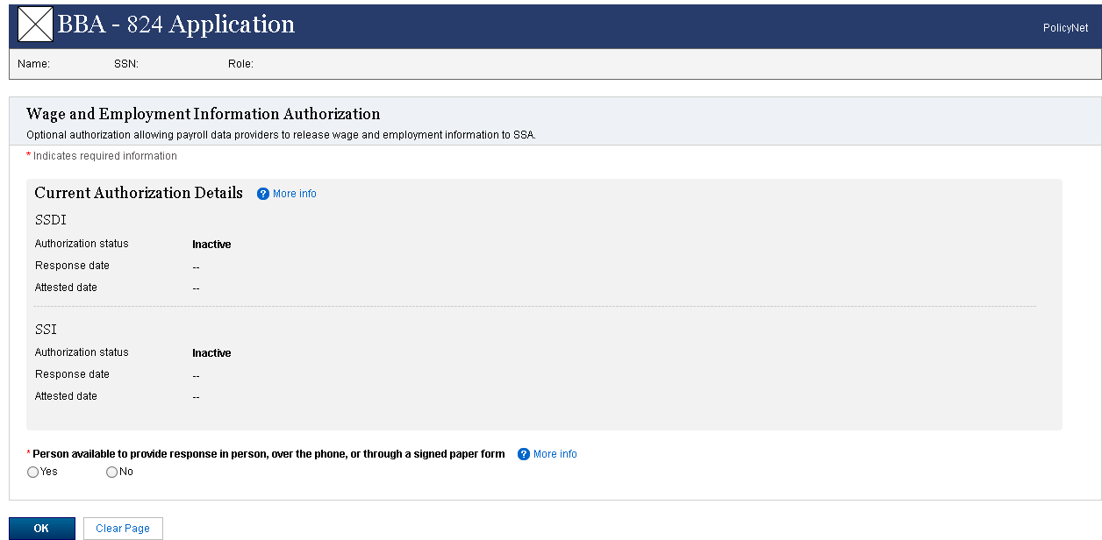

# SSDI and SSI Qualified Claims on file - Authorization status Inactive

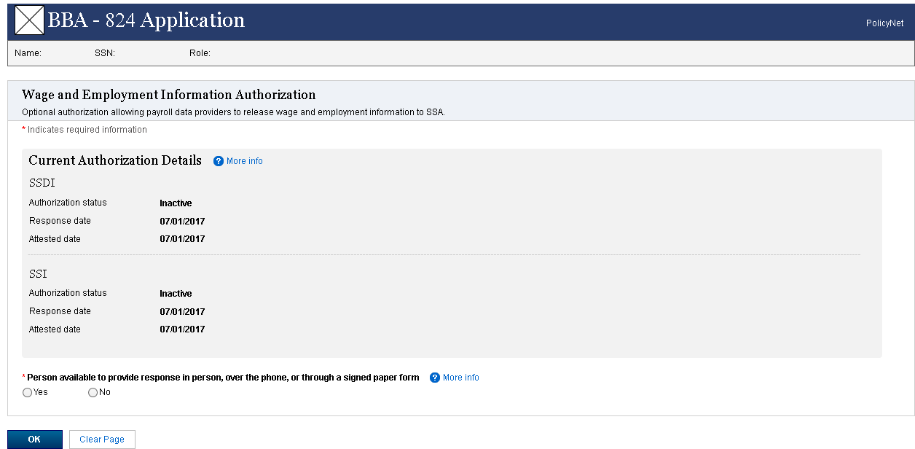

# Active SSDI and Inactive SSI, Person available - No

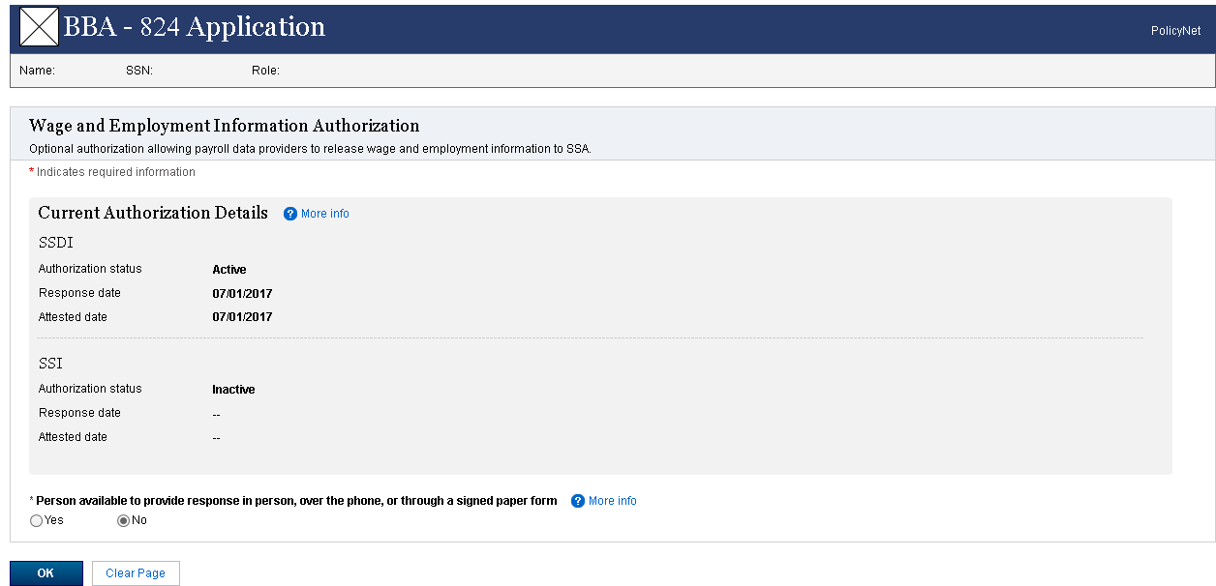

# Concurrent filing - Default

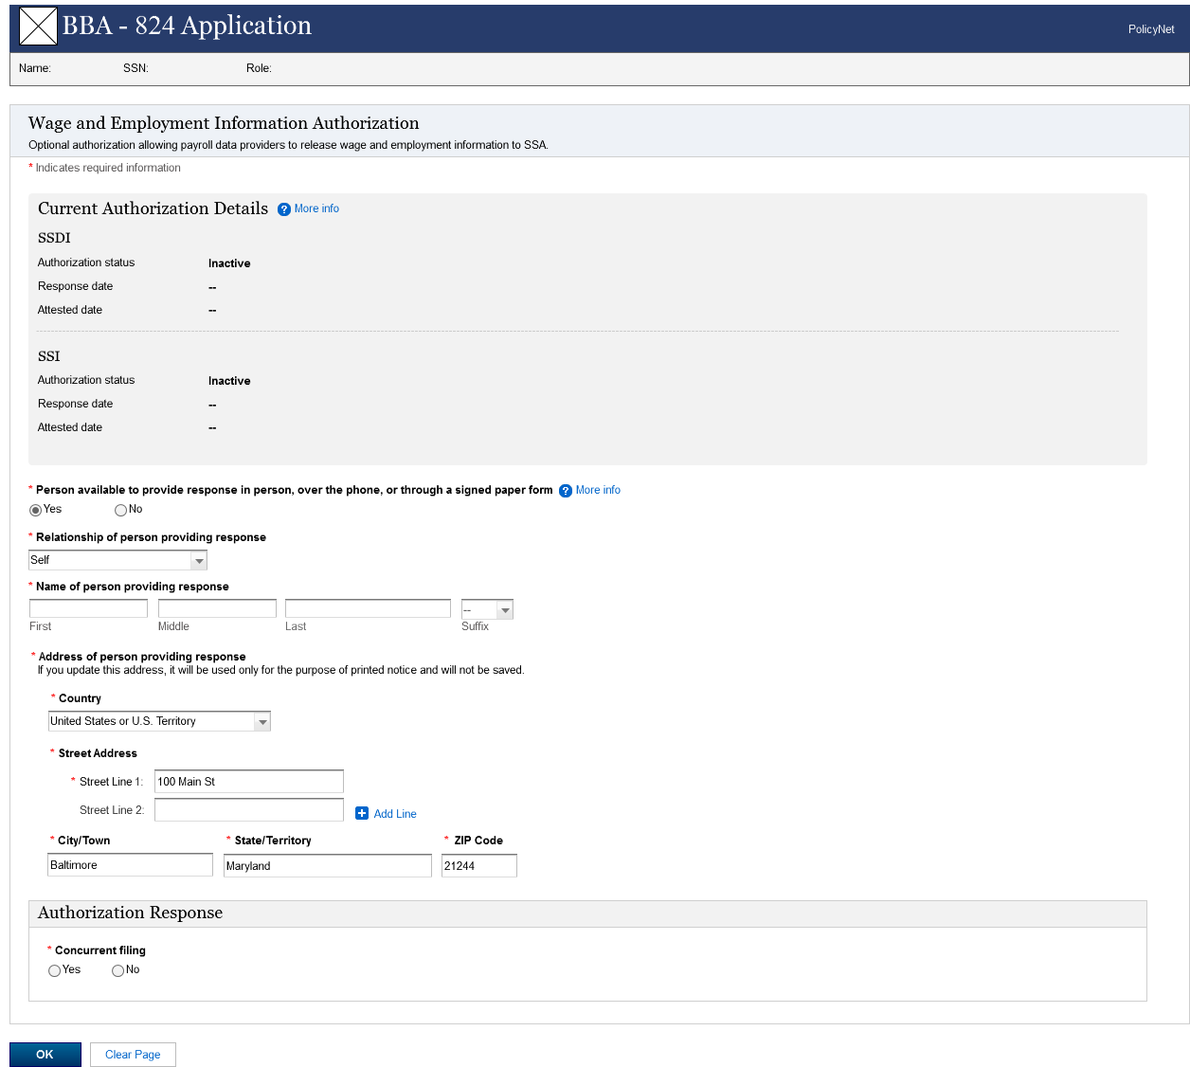

# Concurrent filing– Yes, Authorized Both Claims

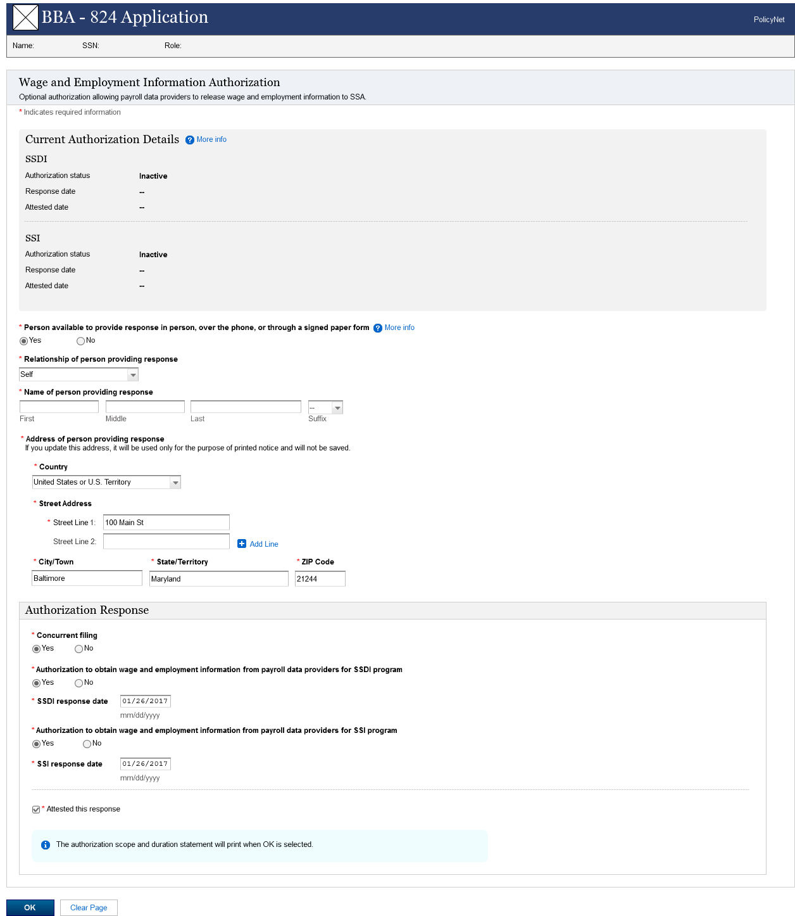

# Concurrent filing – Yes, Refused Authorization for Both Claims

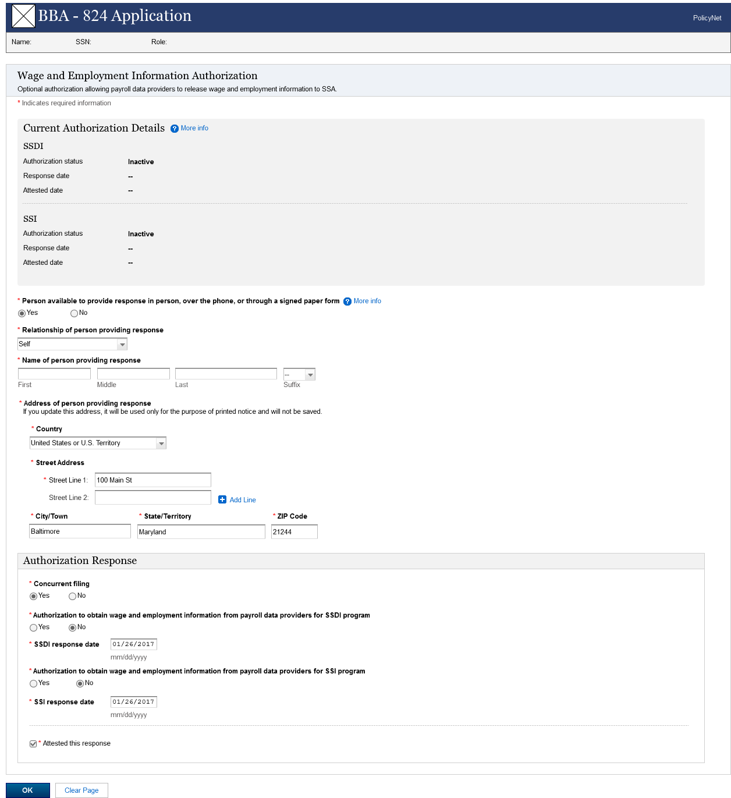

# Concurrent filing - No

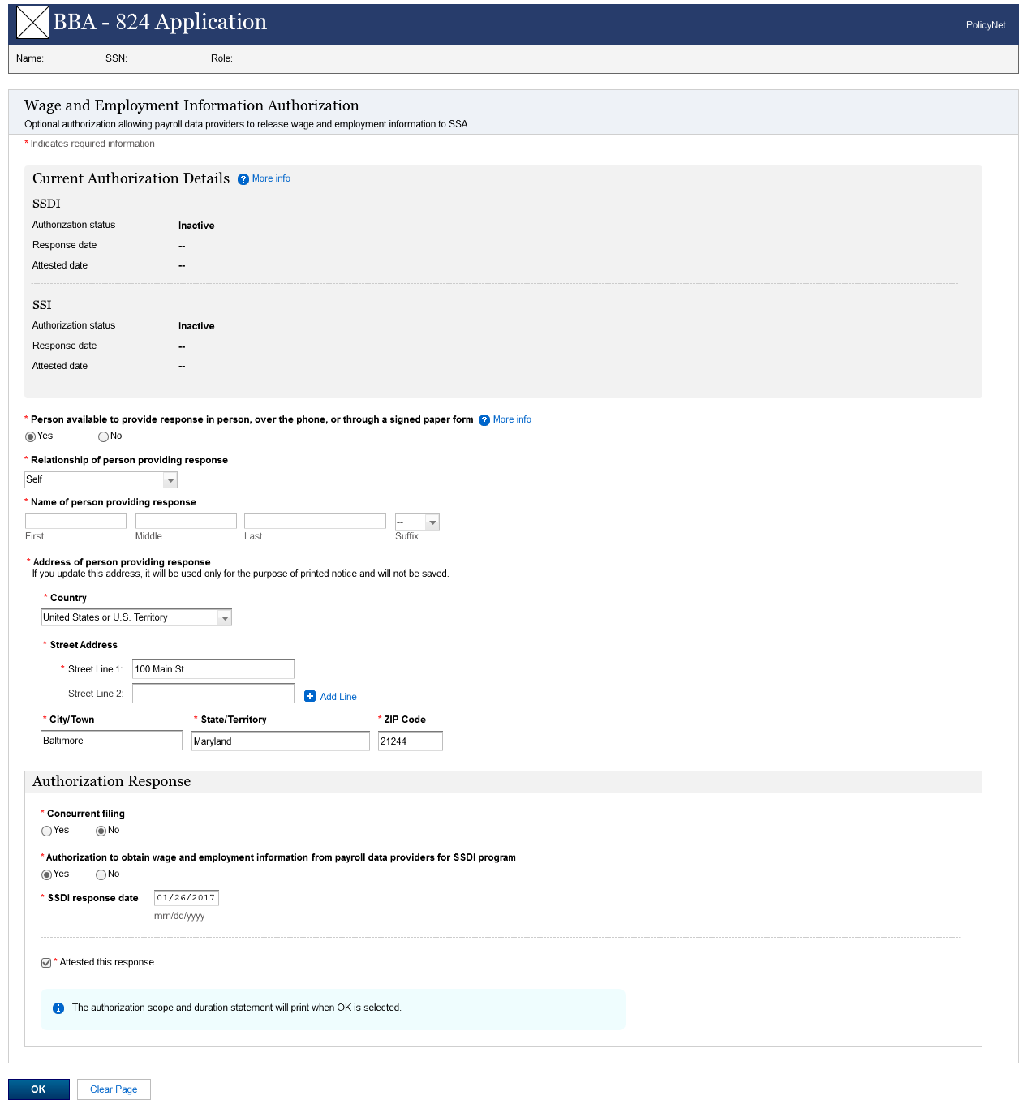

# Current SSDI and SSI Authorization Inactive

**Note:** This screen shows the authorization status as Inactive for both SSDI and SSI because the claimant previously refused to provide the authorization for both the claims.

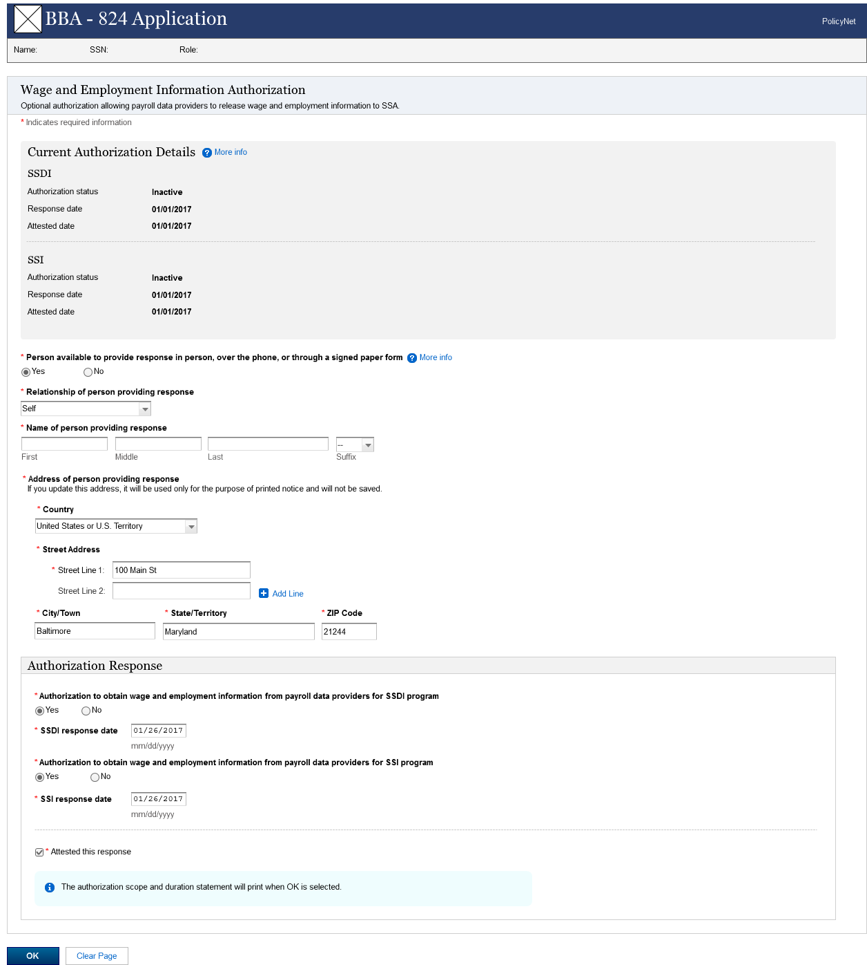

# SSDI and SSI Authorization Terminated at age 18

**Note:** This screen shows the authorization status as Inactive for both SSDI and SSI because system previously terminated the authorization due to age 18.

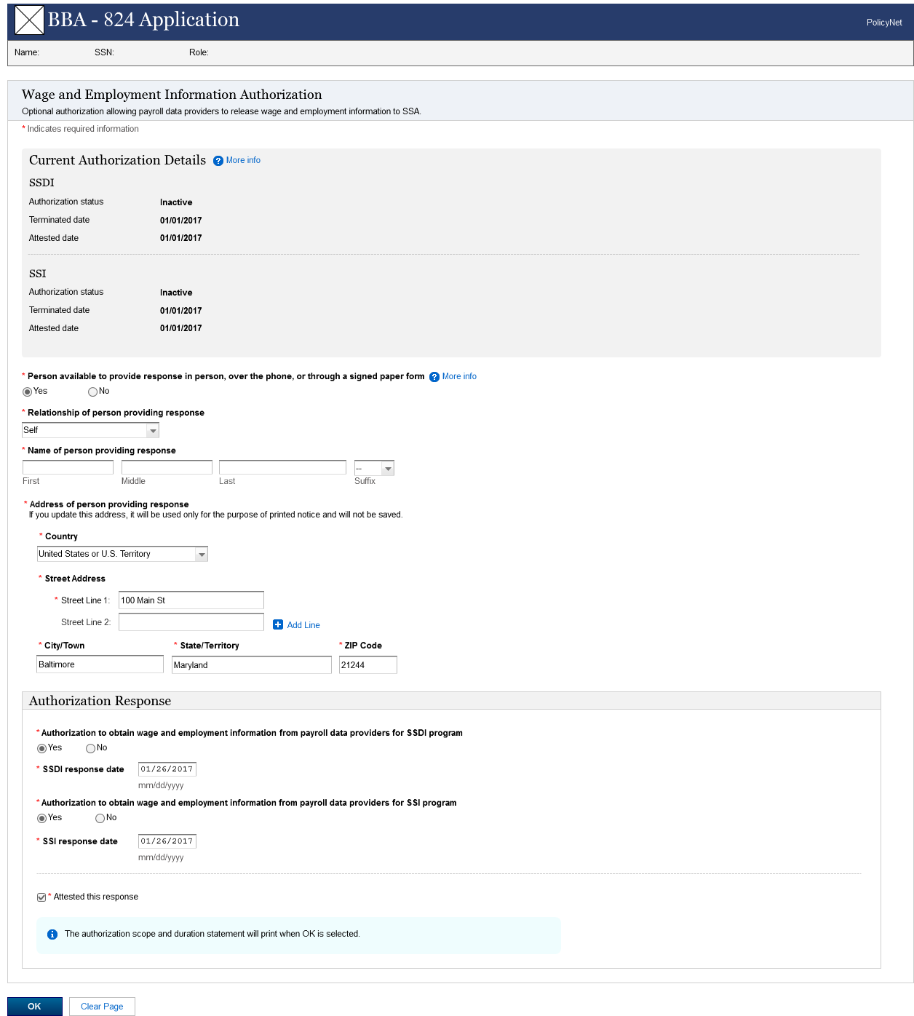

# SSDI and SSI Authorization Active – Revoke not selected

**Note**: The revocation question on this screen is optional because the current authorization status for both SSDI and SSI is active.

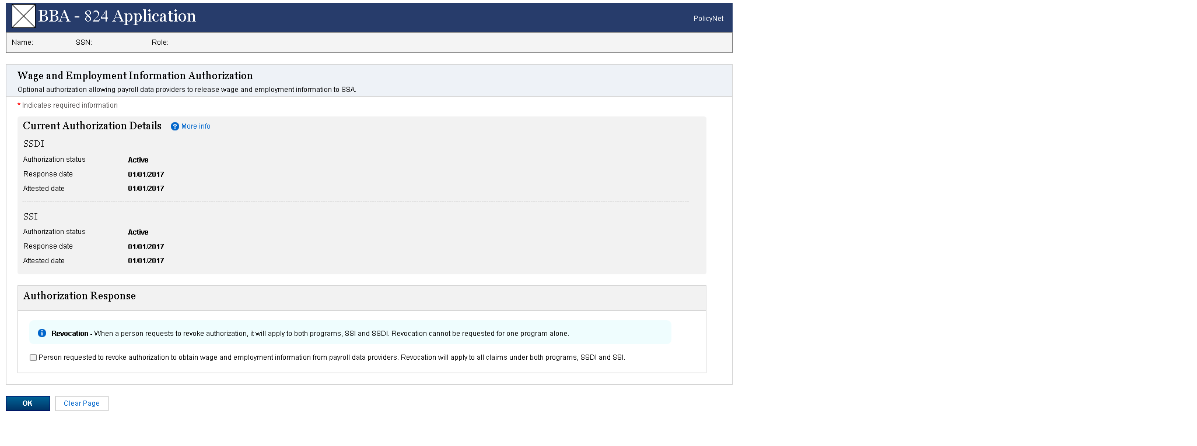

# SSDI and SSI Authorization Active– Revoke selected

**Note**: The revocation question on this screen is optional because the current authorization status for both SSDI and SSI is active.

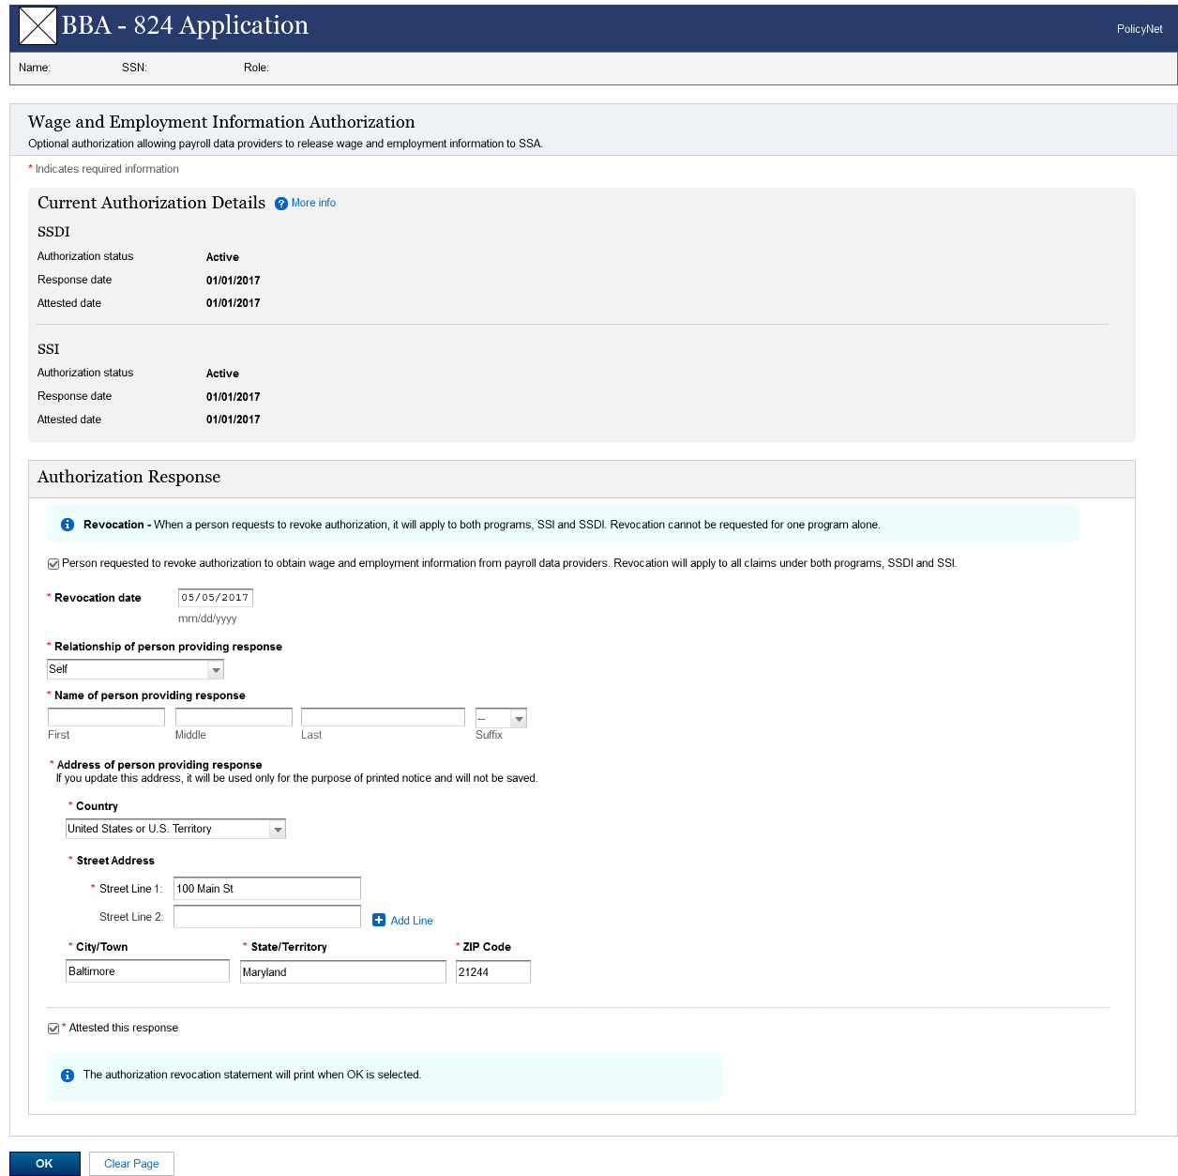

# SSDI Active and SSI Inactive - Revoke SSDI

**Note:** The following screen is displayed when the authorization status for SSDI is active andSSI is inactive. Similarly, this screen can be used to display when the authorization status for SSDI is inactive and SSI is active.

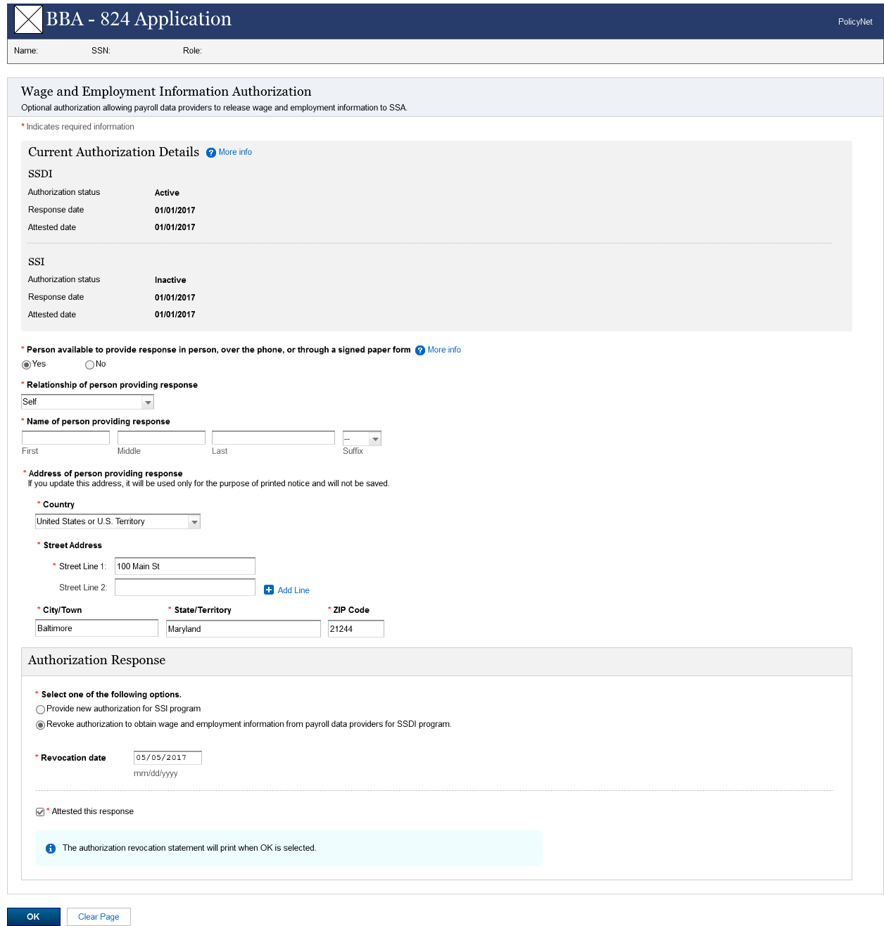

# SSDI Active and SSI Inactive – Authorize SSI

**Note:** The following screen is displayed when the authorization status for SSDI is active andSSI is inactive. Similarly, this screen can be used to display when the authorization status for SSDI is inactive and SSI is active.

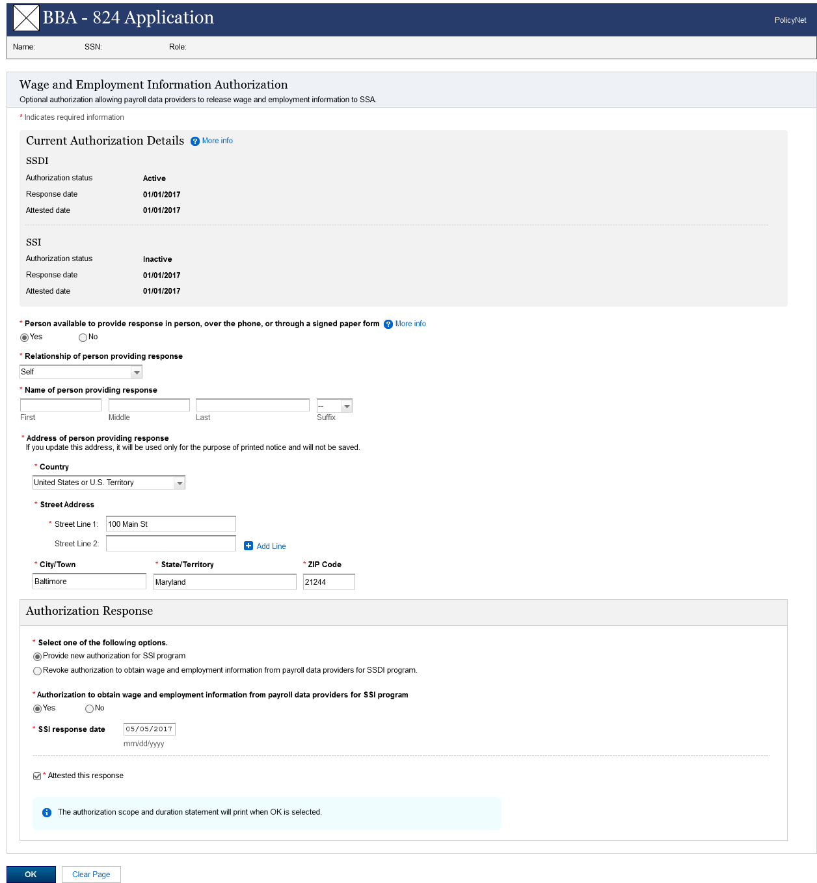

# Single Claim only - SSDI Active – Revoke SSDI not selected

**Note:** The following screen shows when theauthorization status for SSDI is active andSSI is inactivebecause there is no qualified SSI claim. Similarly, this screen can be displayed when the authorization status for SSDI is inactive because there is no qualified SSDI claim and SSI is active.

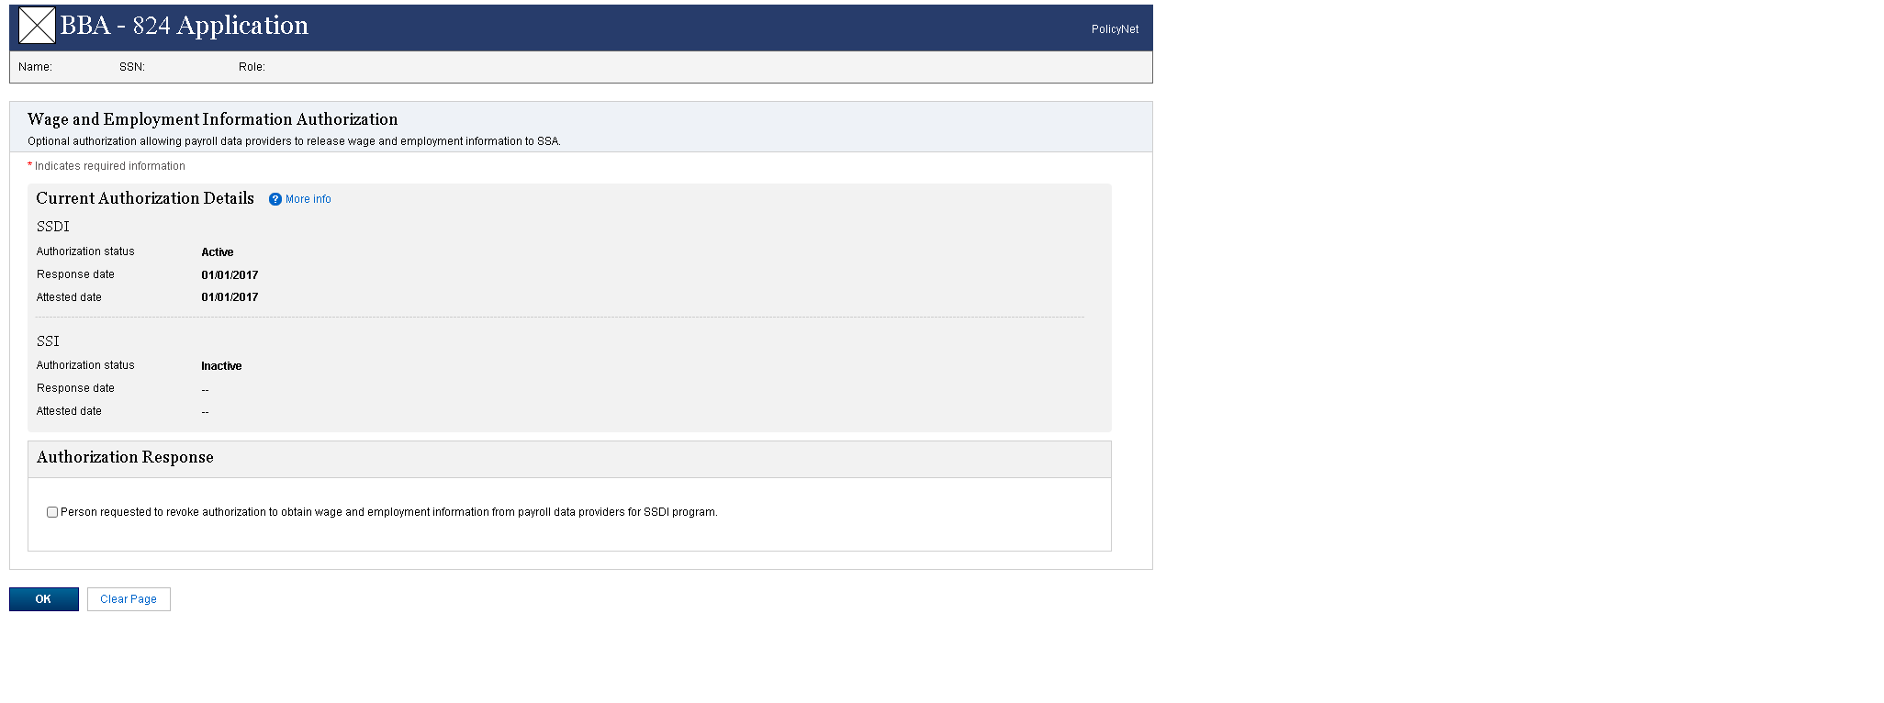

# Single Claim only – SSDI Active – Revoke SSDI selected

**Note:** The following screen shows when theauthorization status for SSDI is active andSSI is inactivebecause there is no qualified SSI claim. Similarly, this screen can be displayed when the authorization status for SSDI is inactive because there is no qualified SSDI claim and SSI is active.

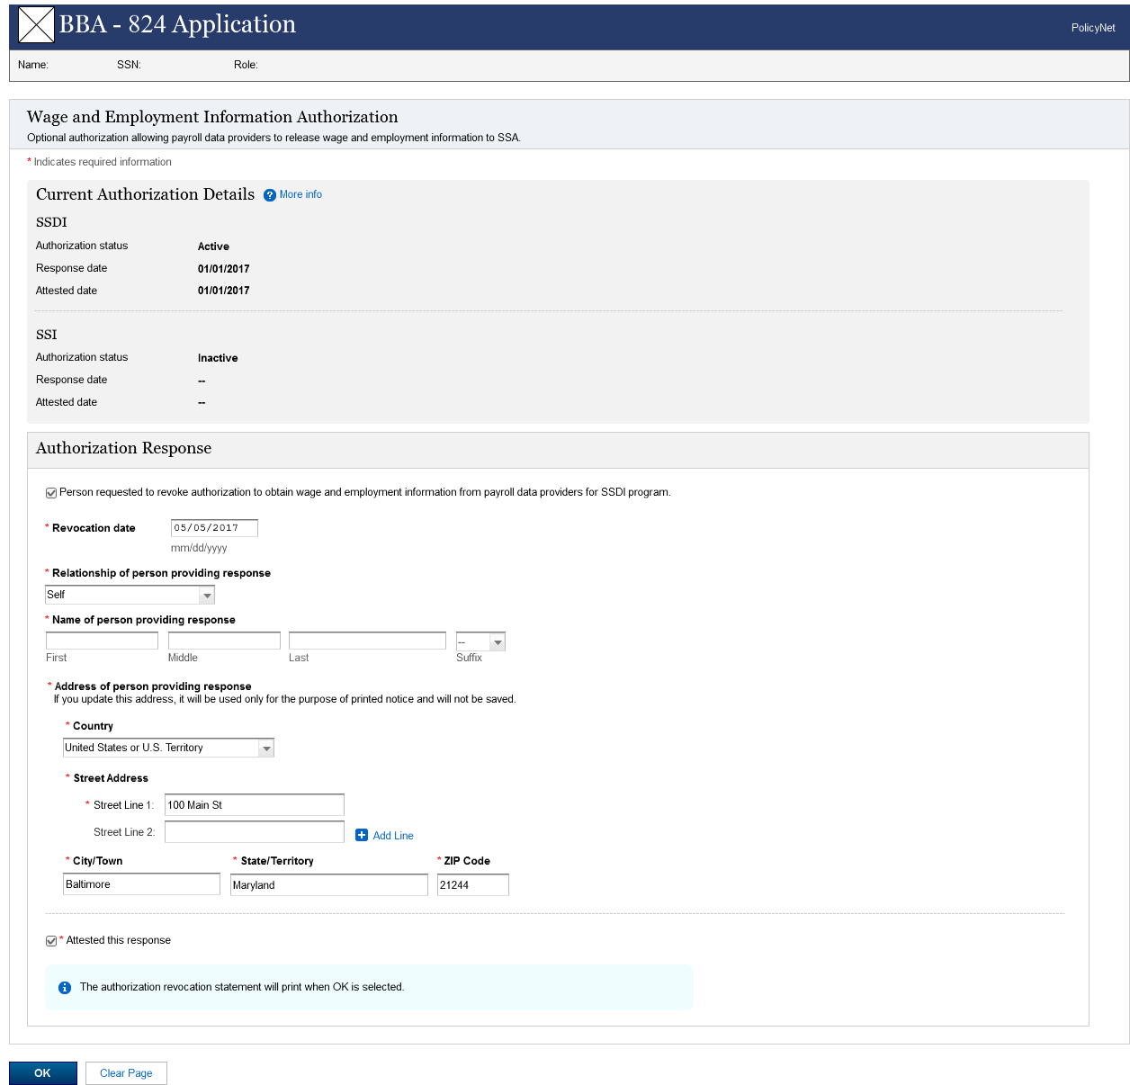

# Single Claim only –SSDI Inactive – Authorize SSDI

**Note:** The following screen shows when theauthorization status for SSDI is inactive andSSI is inactivebecause there is no qualified SSI claim. Similarly, this screen can be displayed when the authorization status for SSDI is inactive because there is not qualified SSDI claim and SSI is inactive.

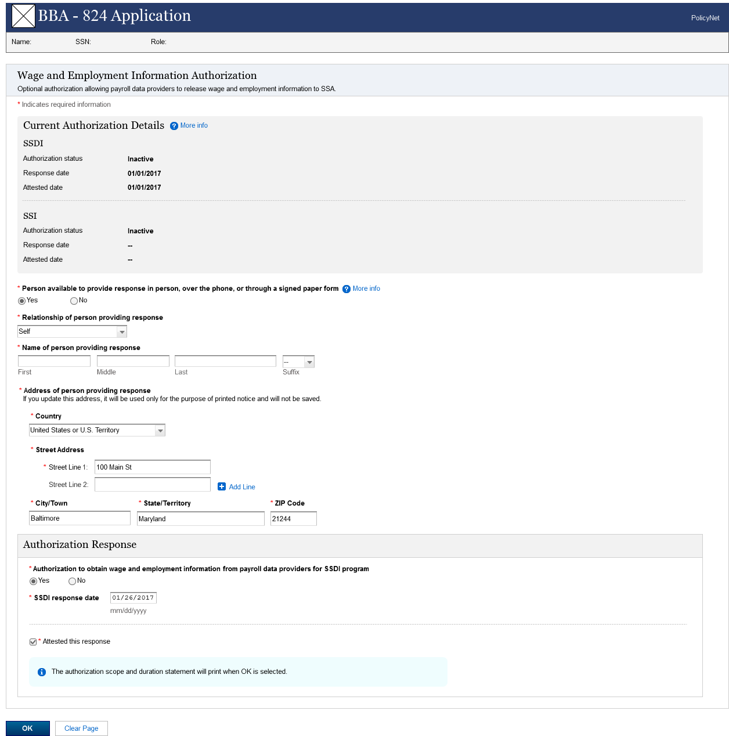

# Authorization Details – More Info Light Box

This light box is displayed when the user clicks on the more info link next to “Current Authorization Details”

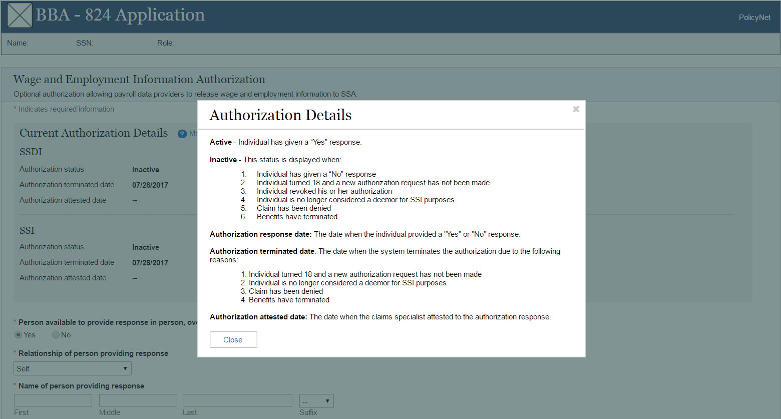

# Person Available – More Info Light Box

This light box is displayed when the user clicks on the more info link next to the “Person available to provide response …” question

