**Supporting Statement Part A For**

**Supported Employment Demonstration (SED) Project**

**OMB No. 0960-NEW**

1. **Justification**
2. **Introduction/Authoring Laws and Regulations**

The Social Security Disability Insurance (SSDI) program provides benefits to disabled workers and their families. In 2015, SSA paid more than $143 billion in SSDI benefits to almost 11 million people. The Supplemental Security Income (SSI) program guarantees a minimum level of income support to financially needy individuals who are aged, blind, or disabled. In 2015, SSA paid nearly $55 billion in Federal SSI benefits to more than 8 million people. SSA previously studied this population in the Mental Health Treatment Study (MHTS), which showed the provision of services had positive effects on employment, mental health, and lower hospital utilization. Currently we are interested in applying the intervention model earlier in the disablement process. Through the Supported Employment Demonstration (SED) project, SSA aims to study the impact of access to these services on outcomes such as benefit receipt; employment; medical recovery; and functioning among denied (SSDI or SSI) disability applicants. Given the large number of individuals who rely on the SSDI and SSI programs to make ends meet, and the interest in supporting employment efforts of those with disabilities, it is helpful for policymakers to have an evidentiary base from which to consider potential program improvements and innovations, which can strengthen the ability of individuals with disabilities to work. Part of SSA’s stewardship role involves finding ways to promote work and increase independence. Section *1110(a)* of the *Social Security Act (Act)* gives the Commissioner of Social Security the authority to help fund research or demonstration projects relating to the prevention and reduction of dependency. SSA contracted with Westat to implement and evaluate SED.

1. **Description of Collection**

The SED will offer the same MHTS services to individuals with mental illness for whom SSA denied Social Security disability benefits. SSA seeks to determine whether offering this evidence-based package of integrated vocational and mental health services to denied disability applicants fosters employment that leads to

self-sufficiency; improved mental health and quality of life; and reduced demand for disability benefits. The SED will use a randomized controlled trial to compare the outcomes of two treatment groups and a control group. Study participation spans 36 months beginning on the day following the date of randomization to one of the three study groups. The SED study population consists of individuals aged 18 to 50 who apply for disability benefits alleging a mental illness, and receive a denial of benefits as the initial decision within the past 60 days. The SED will enroll 1,000 participants in each of the three study arms for a total of 3,000 participants: 40 participants in each of three study arms for the 20 urban sites equaling an *n* of 2,400 urban site participants, and 20 participants in each of three arms for the 10 rural sites equaling an *n* of 600 rural site participants.

We randomly select and assign each enrolled participant to one of three study arms:

* Full-Service Treatment (n=1,000). The multi-component service model from the MHTS comprises the Full-Service Treatment. At its core, it includes an Individual Placement and Support (IPS) supported employment specialist and behavioral health specialist providing IPS supported employment services integrated with behavioral health care. Participants in the full‑service treatment group will also receive the services of a Nurse Care Coordinator who coordinates Systematic Medication Management services, as well assistance with: out-of-pocket expenses associated with prescription behavioral health medications; work-related expenses; and services and treatment not covered by the participant’s health insurance.
* *Basic-Service Treatment (n=1,000).* The Basic-Service Treatment model leaves intact IPS supported employment integrated with behavioral health services as the centerpiece of the intervention arm. The Basic-Service Treatment is essentially the Full-Service model without the services of the Nurse Care Coordinator; Systematic Medication Management; and the funds associated with out-of-pocket expenses for prescription behavioral health medications.
* *Usual Services (n=1,000).* This study arm represents a control group against which we can compare the two treatment groups. Participants assigned to this group seek services as they normally would (or would not) in their community. However, at the time of randomization, each Usual Service participant will receive a comprehensive manual describing mental health and vocational services in their locale, along with state and national resources.

This study will test the two treatment conditions against each other and against the control group on multiple outcomes of policy interest to SSA. The key outcomes of interest include: (1) employment; (2) earnings; (3) income; (4) mental status;

(5) quality of life; (6) health services utilization; and (7) SSA disability benefit receipt and amount. SSA is also interested in the study take up rate (participation); knowing who enrolls (and who does not); and fidelity to evidence-based treatments; among other aspects of implementation. Data collection for the evaluation of the SED will consist of the following activities: baseline in-person participant interviews; quarterly participant telephone interviews; receipt of SSA administrative record data; and collection of site-level program data. Evaluation team members will also conduct site visits involving: (1) pre-visit environmental scans to understand the local context in which we embed SED services; (2) independent fidelity assessments in conjunction with those carried out by state Mental Health or Vocational Rehabilitation staff; (3) key informant interviews with the IPS specialist, the nurse care coordinator, the case manager, and facility director; (4) focus groups with participants in the Full‑Service and Basic-Service Treatment groups; and

(5) ethnographic data collection consisting of observations in the natural environment, and person‑centered interviews with participants and non-participants. The respondents are study participants and non-participants; family members; IPS specialists; nurse care coordinators; case managers; and facility directors.

1. **Use of Information Technology to Collect the Information**

SSA’s contractor, Westat, will design, develop and maintain a high quality, secure, and cost-effective information technology (IT) solution to support the SED project. SSA designed, developed and maintained the Management Information System (MIS) used in the MHTS; however, the software applications that supported MHTS are nearly 10 years old and more sophisticated security threats render the underlying MHTS technology obsolete. Therefore, Westat aggressively retooled its underlying software components with technology solutions that meet the government’s exacting standards for efficiency and security. Westat will develop an integrated web-based MIS to maintain, track, and record all data we collect during the demonstration. The MIS will serve as the mission control center, and will include dashboards for the multiple sub-systems to monitor activities at all demonstration sites. SSA will use a web-based MIS to facilitate flexible tracking of demonstration activities, including recruitment and enrollment; provision of intervention services; and transition planning. Using a web-based MIS system allows us to enter, update, and store data in real-time so multiple users can access the system to view and enter information about participants to complete and monitor study activities. In addition, users can easily access the system from any computer with Internet access by simply typing in the url address and using their secure login credentials. The MIS will capture data on randomization results; insurance coverage; providers; and intervention services, and store these data in one secure, centralized database. We will program the MIS to implement automated edit checks to minimize errors and ensure data quality across study sites, and we will program built-in security measures to maintain confidentiality and privacy of participants. No Social Security Numbers will exist in the MIS.

Both the Implementation Team and the Evaluation Team will use data the MIS captures and maintains. However, we will design the system to maintain the firewall between implementation and evaluation. For example, although the MIS will track and report progress on the status of quarterly follow-up interviews, no users of the system will have access to the actual interview data. Furthermore, although the interviewers will have access to contact information stored within the MIS to administer the follow-up interviews, interviewers will not have access to randomization results or any other MIS subsystems, given they must remain blinded to the assigned group condition. The MIS will assign users specific access rights that will determine which subsystems, components, and data they can access. These limited, role-based user privileges will enforce the firewall between the implementation and evaluation components of the demonstration.

1. **Why We Cannot Use Duplicate Information**

The nature of the information we collect and the manner in which we collect it preclude duplication. SSA does not use another collection instrument to obtain similar data representative of all our SSDI beneficiaries and SSI recipients.

1. **Impact on Small Businesses or Other Small Entities**

This collection does not affect small businesses or other small entities.

1. **Consequences of Collecting the Information Less Frequently**

The data we collect will provide SSA with the scientific evidence it needs to assess the value of the intervention activities of the MHTS. In addition, SSA would not be able to accurately develop additional ways to improve services to current and future beneficiaries based on the outcomes of the MHTS, as well as other sources. Quarterly participant interviews cannot take place less frequently due to concerns about recall or specificity.

1. **Special Circumstances**

There are no special circumstances relating to the general requirements cited in

*5 CFR 1320.5.*

1. **Solicitation of Public Comment and Other Consultations with the Public**

The 60-day advance Federal Register Notice published on February 14, 2017, at

82 FR 10623, and we received no public comments. The 30-day FRN published on April 18, 2017 at 82 FR 18335. If we receive any comments in response to this Notice, we will forward them to OMB.

1. **Payment or Gift to Respondents**

Receipt of mental health services is a subject that people generally do not want to engage in because of the perceived stigma associated with mental health problems. Therefore, it is imperative that we use available resources and evidence-based practices to encourage participation and achieve the highest response rates possible. Research unequivocally demonstrates that incentives improve response rates. SSA will make payments to SED, respondents for participating in the following data collection activities:

* Potential participants will receive $45 for completing the screening process, which will take approximately 40 minutes.
* Participants will receive $50 for completing the baseline interview, which will take approximately 45 minutes.
* Participants will complete quarterly interviews during the three-year intervention period for a total of 12 interviews and receive payments for these interviews as follows:
* Participants will receive $25 for completing each quarterly interview lasting approximately 20 minutes (Quarters 1, 2, 3, 5, 6, 7, 9, 10, and 11) for a total of 9 quarterly interviews totaling a payment of $225.
* Participants will receive $40 for completing an annual interview lasting approximately 30 minutes (Quarters 4, 8, and 12) for a total of 3 annual interviews totaling a payment of $120.
* In the baseline and quarterly interviews, the interviewer asks the participant if he or she has plans to move, reiterates the toll-free participant number, and offers a $5 cash payment if the participant calls to report a new address.
* Participants will receive $40 for attending the focus group, which will last approximately 60 minutes.
* Participants and non-participants will receive $40 for completing the

person-centered interview, which will take approximately 60 minutes.

We will implement a tracking system within the MIS for managing payments to respondents. At the end of the baseline interview, participants will receive a reloadable MasterCard, similar to a debit card. The MIS will manage the incentive payments for the quarterly interviews and add the appropriate monetary amount to the debit cards once an interview is completed.

1. **Assurance of Confidentiality**

SSA assures the respondents that the proposed collection of information is voluntary and we will keep the information we collect. We communicate this to respondents in the Overview and FAQ document, and in the informed consent language regarding their participation in study activities. In addition, the United States Department of Health and Human Services (DHHS) will seek a Certificate of Confidentiality (COC). The COC will allow study staff to refuse to disclose identifying information on research participants in civil, criminal, administrative, legislative, or other proceedings, whether federal, state, or local. By protecting researchers and institutions from being compelled to disclose information that would identify research subjects, a COC minimizes risks to subjects by adding another level of protection for maintaining confidentiality of private information. Once DHHS obtains a COC, we will add a privacy statement to the Overview and FAQ document and will include all informed consent language that we communicated to respondents:

Westat has extensive experience conducting data collection in a secure environment. We will store all study materials Westat maintains in a secure project directory on the Westat network accessible only to project team members. For the SED project, SSA will provide data files to Westat via secure File Transfer Protocol (FTP). Westat will sanitize the SSA data files of Social Security Numbers (SSNs) and create random IDs for each potential demonstration participant. When we load contact information for each denied applicant into the MIS, we create another special ID. This ID provides an additional key that serves to tie the contact information ID with the subsequent enrollment decision, other study data, and the individual’s SSN. Westat will maintain a linking file that matches the sample file unique personal identifiers and the study IDs. Only the Westat IT security officer and his designee will hold the original files containing SSN, along with other personal information, and the linking file in an independent secure file location with access. With respect to activities conducted as part of the Supported Employment Demonstration, reviewers conducting the independent fidelity assessments will request the study site remove participant names from all records examined by fidelity reviews. We will not record any personally identifiable information (PII) on the fidelity assessments and we will only base fidelity ratings on aggregate data. We will examine all medical charts on the premises of the study site and we will not remove any charts or photocopies from the site. We will upload audio recordings from study-related interviews and focus groups to a secure Westat privacy secured website, as well as the Westat project directory accessible only to study staff, and erase them from the recording equipment. We will store transcripts from the audio recordings in Westat’s secure project directory that is accessible only to study staff. In addition, we will keep hard copy documents containing PII (e.g., scheduling notes) in a locked filing cabinet in a secure study file office only accessible to research staff. SSA staff will have access to redacted transcripts associated with the qualitative interviews, and we will not identify participants. We will destroy audio recordings, transcripts, notes, and any other identifying information associated with the data collection, once we finalize the study report and the client approves. Study-related reports, which Westat will submit to SSA, will not contain any PII. At the end of the project, Westat will deliver to SSA a final, de-identified report and a data package that includes a codebook, user’s guide, data dictionary, Public Use data files, and Restricted Use Files, along with a linking file that will allow SSA to re-identify participant data if they wish. Westat will conduct a disclosure analysis to protect respondent anonymity in the presentation of group statistics. The Public Use data files Westat will submit to SSA will not contain any PII, nor will they identify the study sites. Furthermore, we will also conduct disclosure risk analyses for the Public Use files, and will work with SSA’s Disclosure Review Board to employ statistical disclosure controls, such as variable suppression, recodes, top-codes, perturbation, and possible removal of especially high-risk variables, to reduce disclosure risk. This project has an estimated end date of 8/28/2022. After the study is completed, and after receiving approval from SSA, Westat will destroy all identifiable data and provide documentation of the destruction to SSA. We will also remove the Westat project directory from the Westat network server. We plan data destruction to occur no later than 1 year after the end of the contract or 8/28/2023.

1. **Justification for Sensitive Questions**

To estimate the prevalence of various mental impairments among the study population, we will invite enrolled participants to complete the World Health Organization (WHO), World Mental Health Composite International Diagnostic Interview (WMH-CIDI) in-person or by telephone within two weeks following randomization. The CIDI instrument contains sensitive questions on topics such as depression, anxiety, phobias, psychosis, mania, or post-traumatic stress disorder. Individuals who enroll in the Supported Employment Demonstration may also experience anxiety, fatigue, or frustration while completing other study-related interviews even though the other interviews do not contain sensitive questions as does the CIDI. To mitigate the risk of respondents becoming psychologically distressed during their participation in any study-related activities, all of the community mental health centers (CMHCs) selected as sites for the Supported Employment Demonstration will have existing crisis management services available. These services range from in-house services, to on-call service, to collaborations with local emergency rooms. Since all Full-Service and Basic Service participants in the SED will register at their local CMHC, they will be eligible for these existing crisis management services. Additionally, all staff conducting baseline and quarterly interviews; site visit interviews; and focus groups will receive training on how to recognize and handle a respondent who is experiencing psychological distress. Specifically, we will instruct staff to ask the respondents if they want to take a break, after which the respondents can decide whether they want to continue the interview. In some cases, it may be possible simply to skip the section that is causing distress and continue with the remainder of the interview or focus group protocol. Signs of severe psychological distress include respondents who are: (1) no longer making sense when speaking; (2) crying uncontrollably; or (3) stating plans or thoughts of harming themselves, or others. If respondents present a clear and immediate danger to themselves or others, Westat staff will end the session and follow established CMHC procedures, or call 911. In addition to the steps described above, immediately following the session Westat staff will notify the Westat Operations Director, who will in turn notify the Principal Investigators and the SSA Contracting Officer’s Representative or designee. The Westat Operations Director will also notify the Westat IRB in accordance with the appropriate reporting requirements.

1. **Estimates of Annualized Burden Hours and Costs**

|  |  |  |  |  |  |
| --- | --- | --- | --- | --- | --- |
| **Modality of Completion** | **Number of Respondents** | **Frequency of Response** | **Number of Responses** | **Average Burden per Response (minutes)** | **Total Annual Burden (hours)** |
| Competency and CIDI Screener | 3,000 | 1 | 3,000 | 40 | 2,000 |
| Baseline Interview | 3,000 | 1 | 3,000 | 45 | 2,250 |
| Quarterly Interview (Quarters 1, 2, 3, 5, 6, 7, 9, 10, and 11) | 3,000 | 9 | 27,000 | 20 | 9,000 |
| Annual Interview (Quarters 4, 8, and 11) | 3,000 | 3 | 9,000 | 30 | 4,500 |
| Fidelity Assessment Participant Interview | 180 | 4 | 720 | 60 | 720 |
| Fidelity Assessment Family Member Interview | 90 | 4 | 360 | 60 | 360 |
| Key Informant Interview | 120 | 4 | 480 | 60 | 480 |
| Participant Focus Groups | 600 | 2 | 1,200 | 60 | 1,200 |
| Person-Centered Interview | 180 | 4 | 720 | 60 | 720 |
| **TOTAL** | **13,170** |  | **45,480** |  | **21,230** |

The total burden for this ICR is 21,230 hours. This figure represents burden hours, and we did not calculate a separate cost burden.

1. **Annual Cost to the Respondents (Other)**

This collection does not impose a known cost burden on the respondents.

1. **Annual Cost To Federal Government**

The estimated cost of intervention implementation; evaluation data collection efforts associated with the burden described in item 12 (estimate of burden); and analysis and reporting activities is $63,918,323. The estimated annual cost is as follows:

|  |  |
| --- | --- |
| Year 1 | $5,336,884 |
| Year 2 | $13,632,576 |
| Year 3 | $15,960,479 |
| Year 4 | $15,847,528 |
| Year 5 | $10,583,870 |
| Year 6 | $2,556,986 |
| **Total** | **$63,918,323** |

1. **Explanation for Program Changes or Adjustments**

This is a new demonstration project that increases the public reporting burden. See #12 above for updated burden figures.

1. **Plans for Tabulation and Publication and Project Time Schedule**

As indicated in Figure 1 below, we will successfully complete a number of start-up activities in Year 1 so demonstration implementation can begin in Year 2. Assuming we receive OMB approval within nine months of submission of this information collection request, which will occur within three months of contract award, we will begin participant recruitment and enrollment activities in Year 2. We plan to recruit and enroll 1,000 participants in each arm within 12 months. Thus, intervention implementation will occur at the selected demonstration sites in Years 2 through 5. Finally, during Year 6, we will complete all planned analyses; submit the final evaluation reports; and deliver to SSA data files (including a public-use file) with accompanying documentation.

Figure 1. Overview of project schedule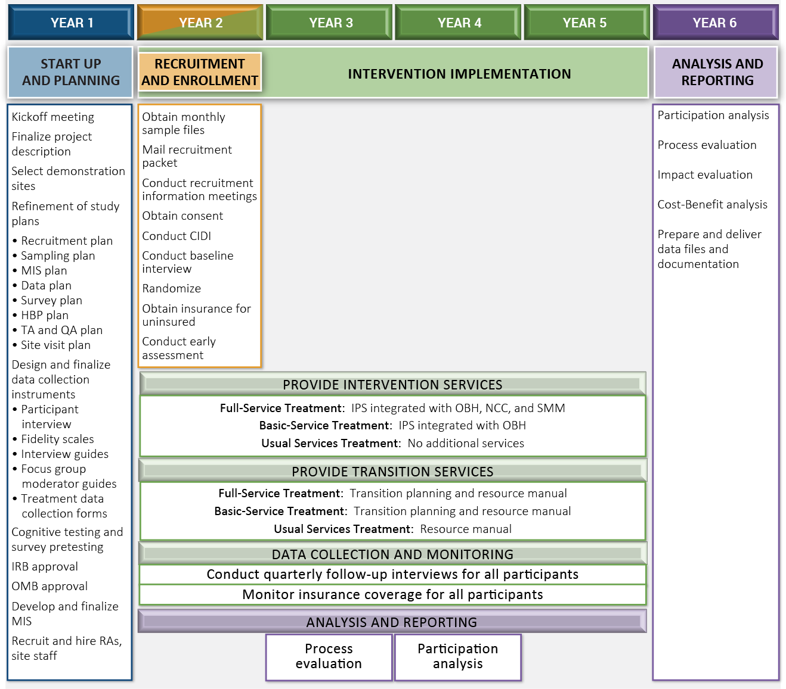

The demonstration will test the two treatment conditions against each other and the control group on multiple outcomes of policy interest to SSA. The primary outcome of interest is the receipt of SSA disability benefits. Additional outcomes of interest include the timing of benefits-related decisions; total award payments; employment; earnings; income; mental status; quality of life, and health services utilization. The evaluation will also assess participation (the take up rate of denied applicants); study implementation; mental health center and provider views of the study; and participant and non-participant views of their disability experience and association with the study. The ethnographic studies will add depth to our characterization of participants and non-participants and provide a deeper understanding of the complex interrelationship of social and economic contexts with individual experiences of mental illness and work among those applying for SSA disability benefits.

The evaluation will include five distinct components: early assessment analysis; participation analysis; process analysis; impact analysis; and a benefit-cost analysis.

1. **Early Assessment Analysis.** An early assessment of the study implementation (including recruitment and enrollment, service provision, etc.) will provide feedback on how the study is going. After approximately six months of experience with recruitment and enrollment, we will visit all sites and assess the implementation consistency within and across sites. The early assessment report will describe implementation across all sites. We will observe recruitment efforts; investigate the quality of random assignment; and identify any issues that arose with implementation technical assistance. We will describe the participant recruitment process and success, and fidelity to the treatment activities.
2. **Participation Analysis.** The participation analysis will assess the take-up rate for the study. The analysis will document the recruitment process as a series of discrete steps, within which we document the outcome or disposition of each step for each prospective participant until they disengage from the recruitment process or enroll in the study.
3. **Process Analysis.** The process analysis will describe implementation of the Supported Employment Demonstration across all sites. The analysis will provide a longitudinal account of demonstration activities to describe changes over time in response to contextual features of the implementation environments. For example, the process analysis will describe how early program operations matured, and explain how each component of the Supported Employment Demonstration evolved. The purpose of describing the implementation is to strengthen inferences of causality among program elements and outcomes. The goal of the process analysis is to provide a theory of how and why the Supported Employment Demonstration program works. Ultimately, the process analysis will integrate data from multiple sources to assess implementation fidelity; identify aspects of operations or implementation that required technical assistance; and assess the feasibility of expanding the demonstration or scaling up some or all of its features as future policy.
4. **Impact Analysis.** The impact analysis will assess the effectiveness of the interventions by comparing the three conditions: Full-Service, Basic-Service, and Usual Services (control). Analyses will include cross-sectional comparisons between the groups at key time points (e.g., univariate comparisons, multi-level model-based comparisons, assessment of the drivers of outcomes); longitudinal analyses (e.g., duration comparisons, multi-level model-based comparisons, assessment of the drivers of outcomes); and subgroup analyses (e.g., age and claim type). We will also assess the validity of random assignment by examining whether the treatment and control groups differ on baseline characteristics.

The goal of the Supported Employment Demonstration is to reduce demand for SSA disability benefits by intervening early in the disablement process and assisting denied applicants to obtain and maintain employment. Thus, the primary outcome for the impact evaluation is the receipt of SSA disability benefits. In looking at disability benefits received over the course of the study, we will examine the following variables: appeals/reapplications, length of time to award of benefits, and total award payments (over the life of the study). We will measure SSA disability benefit outcomes using data drawn from SSA program databases including the Master Beneficiary Record (MBR), the Supplemental Security Income Record (SSR), the Disability Control File (DCF), and the Structured Data Repository (SDR).

Other key outcomes include employment, earnings, clinical recovery, quality of life, and criminal justice involvement. We will measure employment outcomes using participant surveys. We will measure earnings using the SSA Master Earnings File (MEF). Clinical recovery outcomes will include measures of mental and physical health status, as well as healthcare service utilization (e.g., emergency room visits and overnight hospital stays). We will collect clinical recovery data from participant surveys and from service records maintained by the sites. Finally, we will draw quality of life measures from participant surveys.

The impact analysis will assess the effectiveness of the interventions by comparing outcomes across the Full-Service, Basic-Service, and Usual-Service (control) groups. Analyses will include cross-sectional comparisons between the groups at key time points (e.g., univariate comparisons, multi-level model-based comparisons, assessment of the drivers of outcomes); longitudinal analyses (e.g., duration comparisons, multi-level model-based comparisons, assessment of the drivers of outcomes); and subgroup analyses (e.g., age and claim type). We will also assess the validity of random assignment by examining whether the treatment and control groups differ on baseline characteristics, including demographics (drawn from participant surveys and the SSA program data) and baseline measures for each of the outcomes.

Relative to the Usual-Service (control) group, we expect Full-Service and Basic-Service recipients to have reduced or delayed participation in SSA disability benefits, greater employment and higher earnings, improved clinical recovery including reduced healthcare service utilization, and higher overall quality of life

1. **Benefit-Cost Analysis**

The cost-benefit analysis will use several sources of data to calculate the total costs of providing intervention services and the monetary value of benefits resulting from the interventions. These include:

* information reported by the sites on the costs of providing specific services and the number of clients served,
* SSA program data on earnings from the MEF and information on taxes paid (if available),
* data on employment, healthcare utilization, health status, arrests, and convictions from participants’ surveys, and
* Other extant data sources, e.g., the Agency for Healthcare Research and Quality (AHRQ) provides unit costs of health care services, and the Internal Revenue Service (IRS) has publicly available tax information.

We will include the costs of all resources associated with the production of intervention services, including volunteer labor, to develop a comprehensive measure of total costs. Primary benefits will include hypothesized increases in earnings, reductions in benefit amounts and healthcare costs, and improved health outcomes, which we will monetize using existing research. We will also consider reductions in criminal activity as far as we can attribute a monetary value to these activities. We will report the monetary value of each type of cost and benefit. We will examine benefit-cost ratios (BCRs), the ratio of the monetary value of total benefits to the monetary value of total costs, for each type of intervention to determine whether benefit outweigh costs. A BCR>1 indicates benefits exceed costs; a BCR<1 indicates they do not.

1. **Displaying the OMB Approval Expiration Date**

SSA is not requesting an exception to the requirement to display an expiration date .

1. **Exceptions to Certification for Paperwork Reduction Act Submissions**

SSA is not requesting an exception to the certification requirements at *5 CFR 1320.9* and related provisions at *5 CFR 1320.8(b)(3)***.**