C&S CADC SCREEN CAPTURES FOR OMB CLEARANCE 2014

The Outlet Messages tab

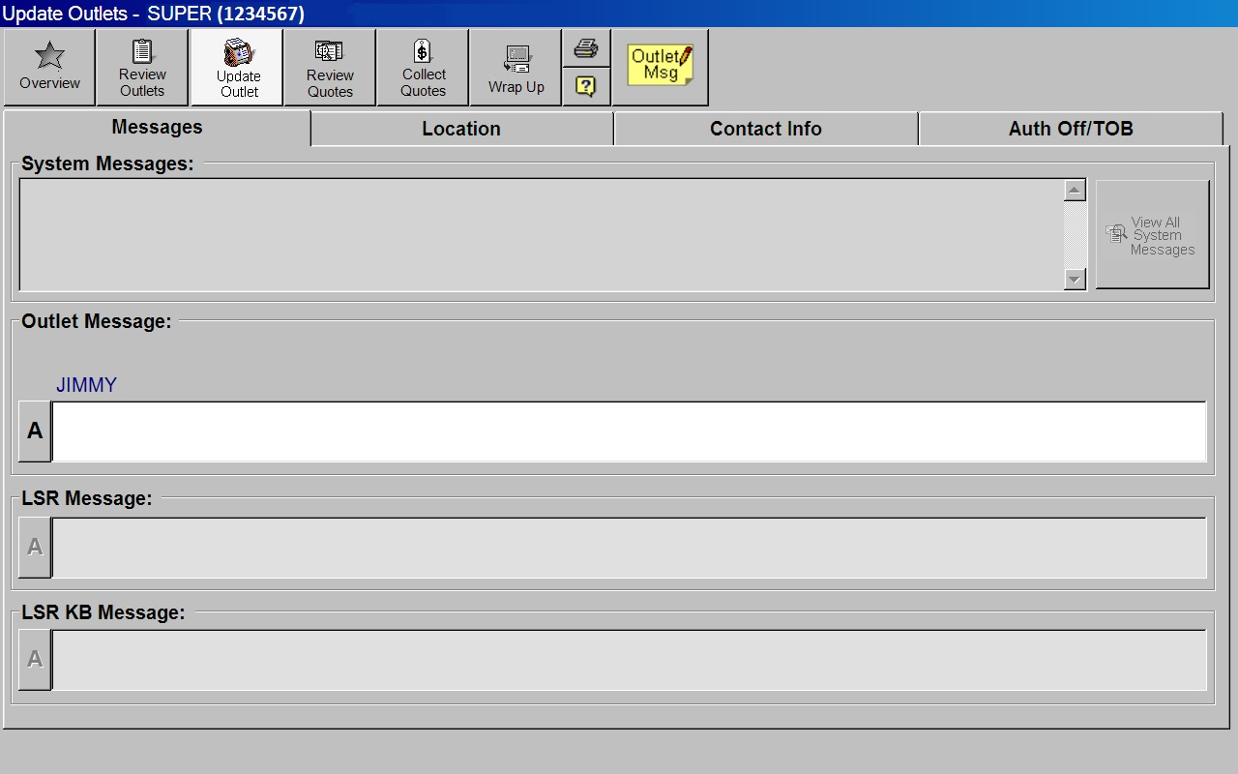
The Outlet Location tab

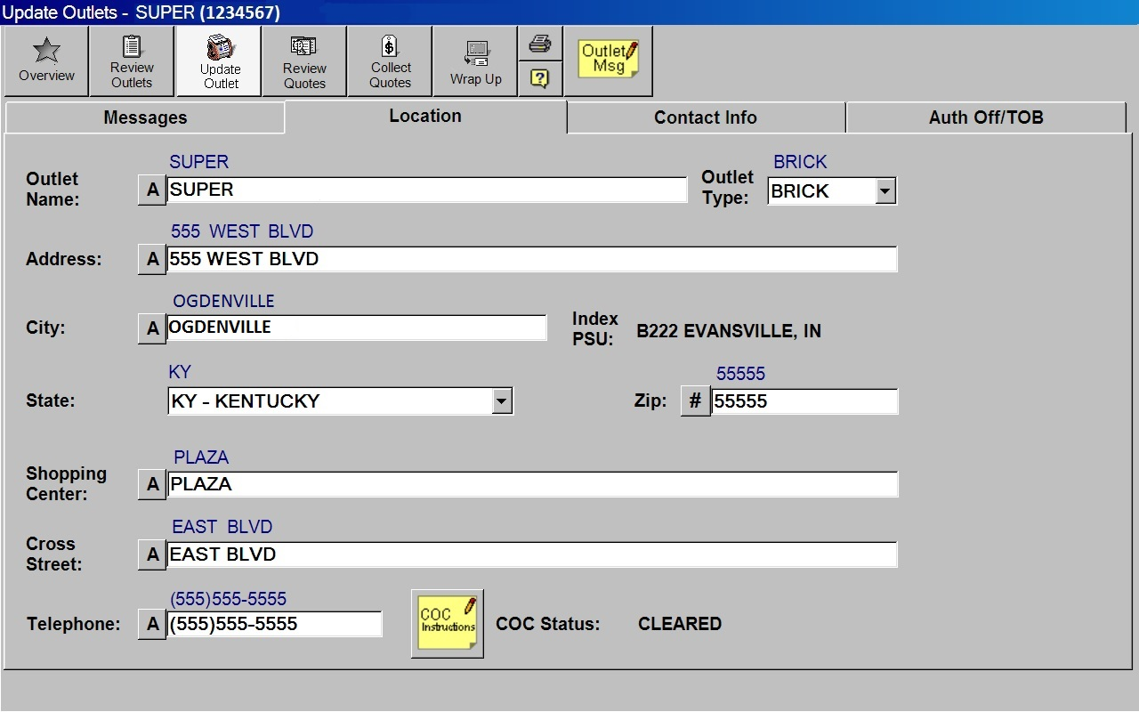
The Outlet Contact Info tab

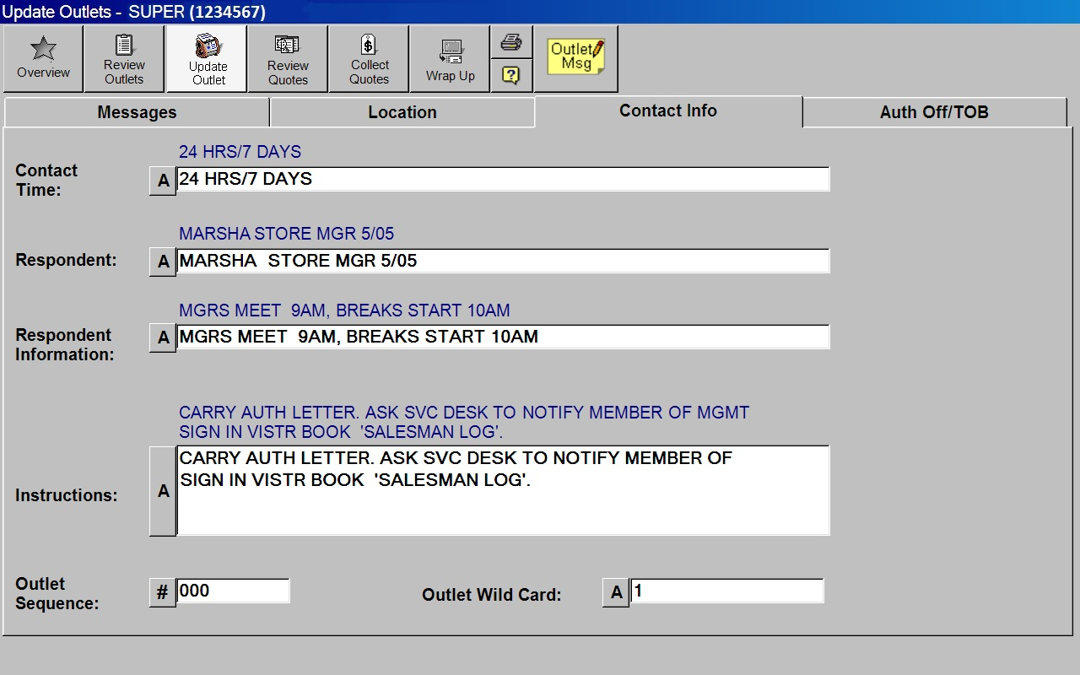
The Outlet Authorizing Official/Type of Business tab

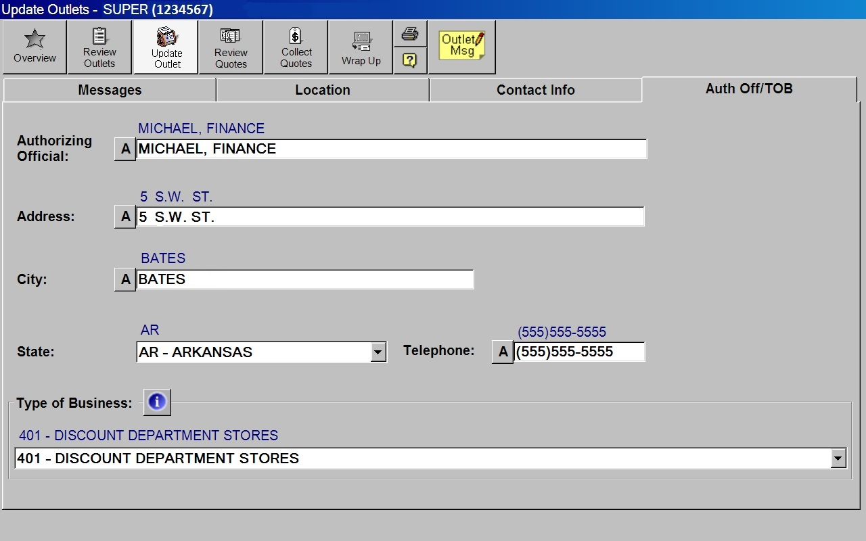
The Quote Messages tab

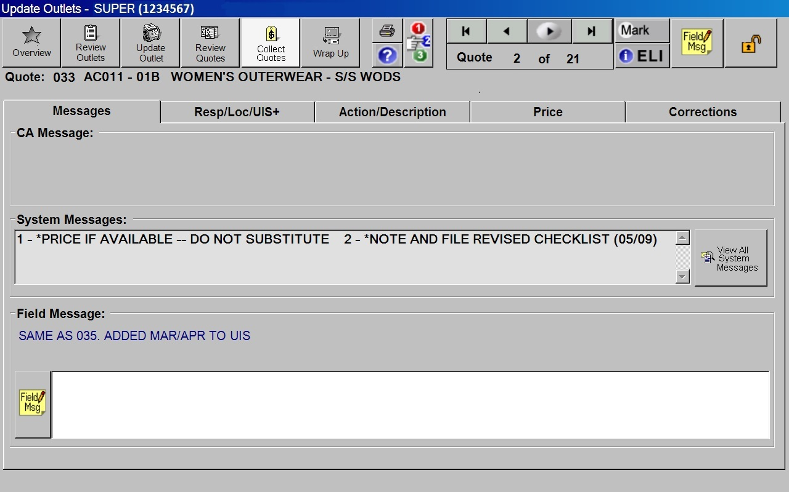
The Quote Respondent/Location/Seasonal information tab

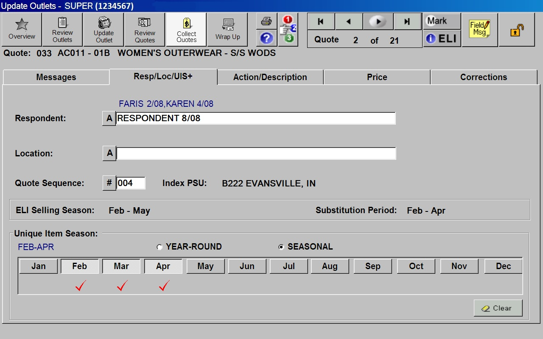
The Quote Action/Description tab

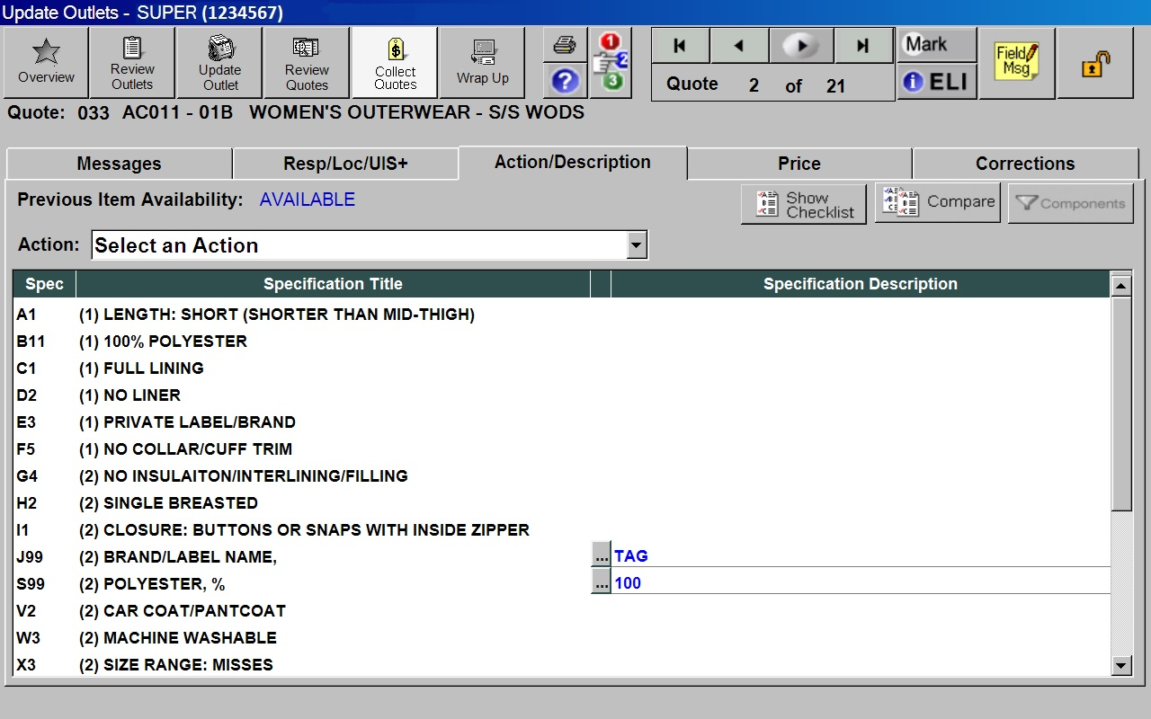
The Quote Price tab

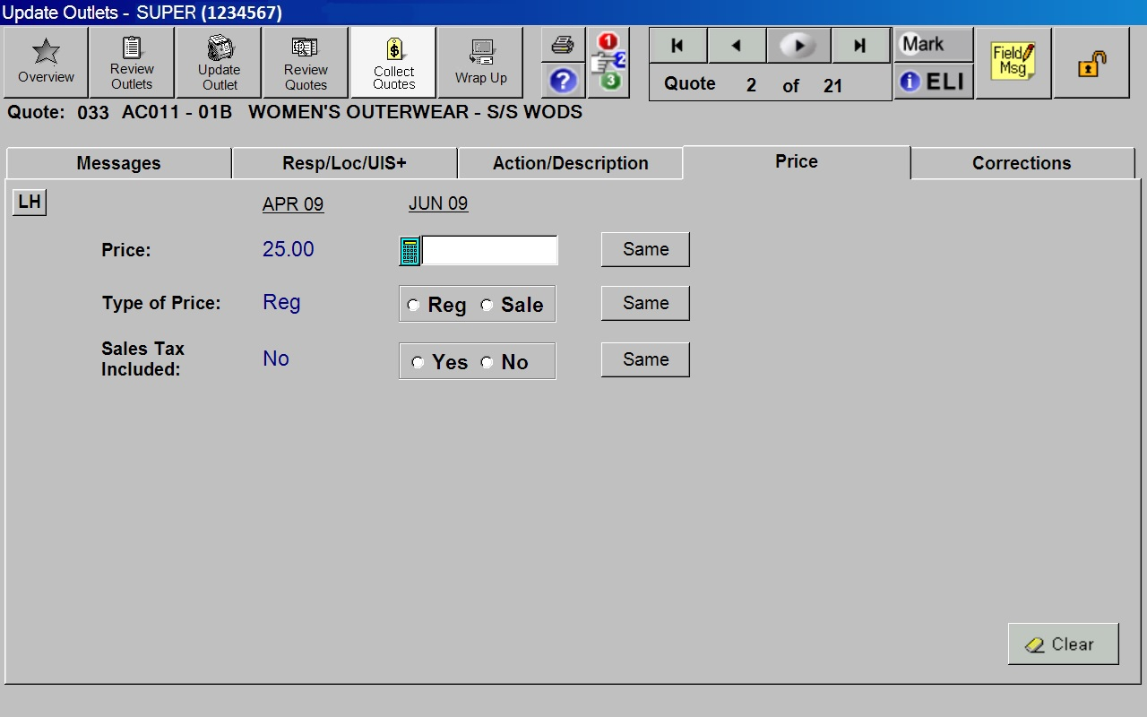
The Quote Corrections tab

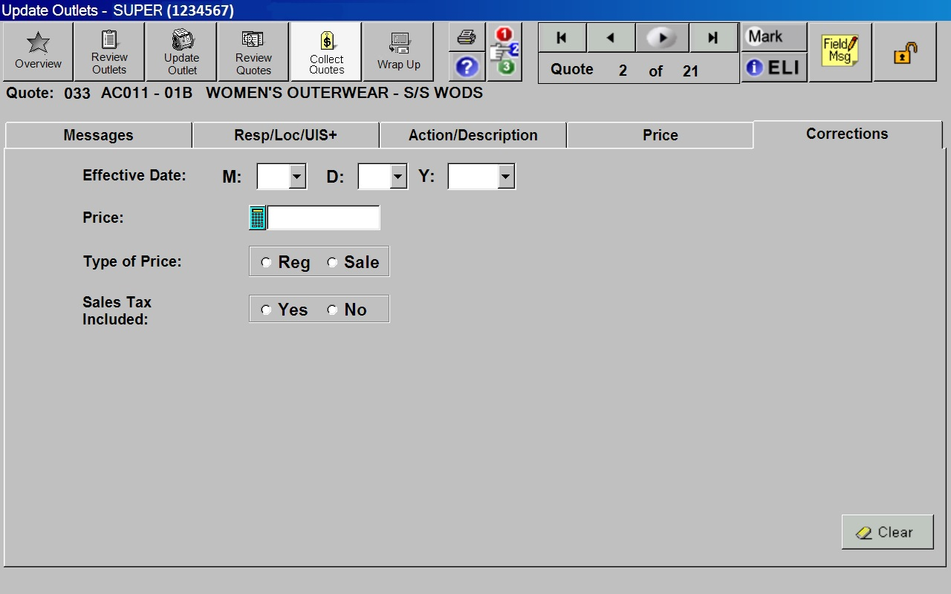
The ELI Checklist screen

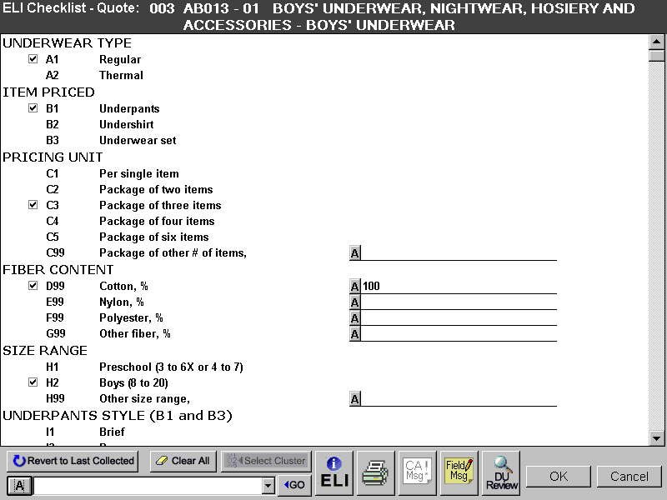
The ELI Info screen

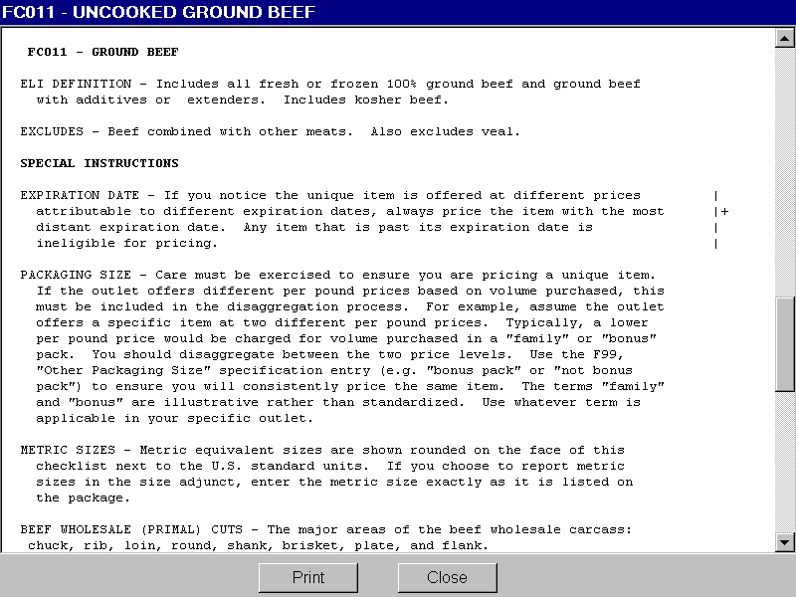
The Disaggregation Utility screen

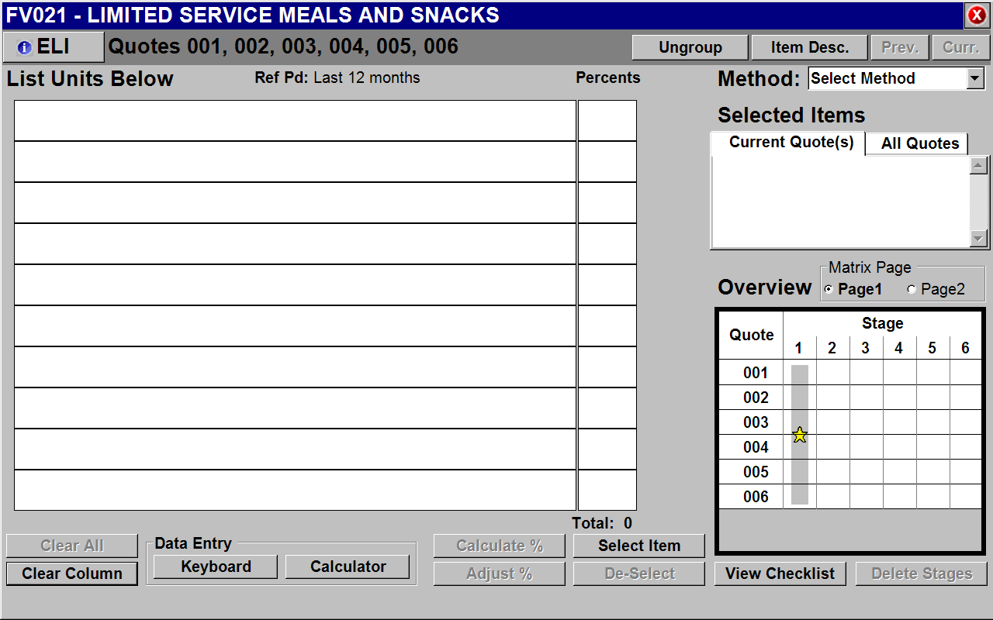

The Selling Season worksheet

