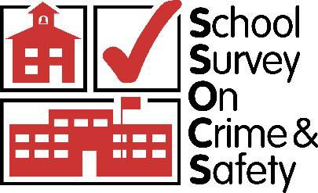

**School Survey on Crime and Safety (SSOCS) 2016**

#### OMB #1850-0761 v.8

Appendix A.1 – Communication Materials

National Center for Education Statistics

Institute of Education Sciences

U.S. Department of Education

September 17, 2015

###### Contents

**Special District Contact Call Script 3**

**District Administration Form 5**

**Special District Generic Cover Letter 6**

**Special District Generic Research Application 7**

**SSOCS Brochure 15**

**Letter to Superintendents 17**

**Letter to Chief State School Officers 18**

**Advance E-mail to Principals 19**

**Advance Letter to Principals 20**

**Advance Letter to Principals in Special Permission Districts 21**

**Postcard for Schools in Special Permission Districts 22**

**Cover Letter to Principals 23**

**Letter to Principals - Remail Request 24**

**Reminder Letter to Nonresponding Principals 25**

**Reminder E-mails to Respondents 26**

**Voice-mail Left by Interviewers. 32**

**Special District Approval Thank You Letter 33**

**Thank You Letter to Schools. 34**

Special District Contact Call Script

2015-16 School Survey on Crime and Safety (SSOCS)

|  |  |
| --- | --- |
| Label Information | |
| A. Special District Research Application - Contact Person’s Information | |
| Contact Name: | Contact Title: |
| Contact Phone Number: | Contact E-mail: |
| **Notes** | |

1. INTRODUCTION and CONTACT INFORMATION

A1. **Hello, this is from the U.S. Census Bureau. Have I reached (district name)?**

_ Yes → *GO TO item A2.*

_ Different district name → *Probe for district name if necessary and correct the district name in the address area above. If the difference is significant, record the change in the Notes section. Try to confirm the name*

*change (e.g., respondent says, “We used to be Jefferson District but are now Washington District.”). GO*

*TO item A2.*

_ No → *Verify that you dialed correctly.*

_ Correct number dialed → *Probe for the respondent’s name, location, and whether the person or organization reached is related to the district in any way. Record information in the Notes section.*

*Thank respondent and end call.*

_ Wrong number dialed → *Dial correct number. GO TO item A1 above.*

_ District closed → *Probe for the respondent’s name, former position, the closing date, and any other information to confirm that it is a closure rather than change in status. Record information in the Notes section. Thank respondent and end call.*

_ District merged → *Probe for the name of the merged districts, location and the date of the merge. Record information in the Notes section. GO TO item A2. Refer case to supervisor following the call.*

A2. **This call may be monitored to evaluate my performance and should only take a few minutes.**

**During this school year we will be conducting the School Survey on Crime and Safety (SSOCS) for the National Center for Education Statistics (or NCES) which is part of the U.S. Department of Education.**

**SSOCS is an important national study that collects information about crime and safety in public schools from school principals.**

**NCES is authorized to conduct this survey by the Education Sciences Reform Act of 2002 (ESRA; 20**

**U.S. Code §9543). The Office of Management and Budget approval number for this study is 1850-0761. The data provided by the school and staff may be used only for statistical purposes and may not be disclosed, or used, in identifiable form for any other purpose except as required by law (20 U.S.C.,**

**§9573).**

A3. **I would like to verify your mailing address for the purposes of delivering a research application. Is the following address correct?**

*Read address information from research. Make any necessary corrections if needed. Then GO TO item A4.*

A4. **Can you tell me the name of the person most appropriate to receive this request (for research approval)?**

_ Yes → *Record contact name and title in the appropriate spaces of the Contact Information section on the cover page. Probe for the contact person’s direct phone line and email address and record it in the Contact Information section. GO TO item A5.*

_ No → *Try to probe for a contact name, or ask for the department name that will review the package If no*

*information is given, suggest the Superintendent as the point of contact. GO TO item A5.*

A5. **Are there any other documents your district requires for the research application process that we should include in the package?**

_ Yes → *Record information in the Notes section. GO TO item A6.*

_ No → *GO TO item A6.*

A6. **Can you tell me about how long the district spends reviewing research applications?**

_ Yes → *Record information in the Notes section. Thank respondent and end call.*

_ No → *Thank respondent and end call.*

**2015-16 School Survey on Crime and Safety District Administration Form**

Please mark one of the boxes below to let us know your district’s decision to allow sampled school(s) to participate in this important national survey.

* + The U.S. Department of Education has permission to administer the 2015-16 School Survey on Crime and Safety to one or more schools in the <Enter District Name>.
  + The U.S. Department of Education does not have permission to administer the 2015-16 School Survey on Crime and Safety Survey to any school in the <Enter District Name>.

Printed

Name:

Date:

Signature:

Title:

Address:

Phone:

Email:

**Please return this form to Marie Zayas by email to** [**amanda.marie.zayas@census.gov,**](mailto:amanda.marie.zayas@census.gov) **or by mail to:**

**U.S. Census Bureau Marie Zayas, 6H030B**

**4600 Silver Hill Road, Stop 8400**

**Washington, DC 20233**

Last Revised: 9/10/15

*Special District Generic Cover Letter*

U.S. DEPARTMENT OF EDUCATION



INSTITUTE OF EDUCATION SCIENCES

NATIONAL CENTER FOR EDUCATION STATISTICS

*{DATE}*

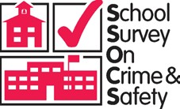

Dear *{DISTRICT CONTACT NAME},*

The National Center for Education Statistics (NCES) of the U.S. Department of Education is requesting approval for the administration of the 2015-16 School Survey on Crime and Safety (SSOCS) to # sampled schools within the *{DISTRICT NAME}* School District. SSOCS is administered to a sample of U.S. public schools on a recurring basis. The survey only entails the completion of a brief questionnaire that is estimated to take 52 minutes to complete. No student, faculty, or classroom time is involved.

SSOCS is one of the nation’s few sources of national information on school crime and safety, as reported by principals, in U.S. public schools. By participating, information from schools in your district allow for comparisons among different types of schools across the nation that are valuable to governing agencies, policy makers, educators and the general public. Further information about SSOCS is available on the NCES website

at [http://nces.ed.gov/surveys/ssocs/.](http://nces.ed.gov/surveys/ssocs/)

The Generic Research Application for SSOCS, a copy of the advance letter that will be sent to sampled school principals, and a copy of the questionnaire are enclosed.

We appreciate your review of our Generic Research Application for this important survey. If you have any questions, please contact Teresa Thomas, the SSOCS Communications Director at the U.S. Census Bureau, by e-mail at [addp.education.surveys@census.gov](mailto:addp.education.surveys@census.gov) or by telephone at 1-800-221-1204.

Sincerely,

Rachel Hansen Project Director

National Center for Education Statistics

WASHINGTON, DC 20208–5652

#### 2015–16 SSOCS Generic Research Application

###### Contact

Applicant: Rachel Hansen Title: Project Director

Affiliation: National Center for Education Statistics (NCES) Institute of Education Sciences (IES)

United States Department of Education Address: 1990 K Street NW, Suite #9034

Washington, DC 20006

E-mail: [school.crime@ed.gov](mailto:school.crime@ed.gov)

* 1. Census Bureau Contact:

Teresa Thomas, Communications Director 4600 Silver Hill Road, Stop ADDP-0080 Washington, DC 20233-8400

1-800-221-1204

[addp.education.surveys@census.gov](mailto:addp.education.surveys@census.gov)

###### Date: March 31, 2015

**Title of Study:** 2015–16 School Survey on Crime and Safety (SSOCS:2016)

**Anticipated Start Date:** February 2016

**Anticipated End Date:** June 2016

###### Purpose of Study:

The School Survey on Crime and Safety (SSOCS) is conducted by the National Center for Education Statistics (NCES), part of the Institute of Education Sciences (IES), within the United States Department of Education, in order to collect extensive data on issues of crime and safety in U.S. public primary, middle, high, and combined schools. The survey asks school principals about topics such as incidents of crime and violence; disciplinary actions; discipline problems; use of security measures; school policies and practices related to school crime and violence; violence prevention programs and activities; the presence and role of school security staff; parent and community involvement; staff training, availability of mental health services; as well as other school characteristics. NCES is authorized to conduct this survey by the Education Sciences Reform Act of 2002 (ESRA; 20 U.S. Code §9543).

SSOCS is one of the nation’s few sources of national information on school crime and safety, as reported by principals in U.S. public schools. SSOCS was first conducted during the 1999–2000 school year and was conducted again during the 2003–04, 2005–06, 2007–08, and 2009–10 school years. A questionnaire was developed for the 2011–12 school year, but due to funding issues was never fielded. Many topics in the prior administrations are repeated in the 2015–16 questionnaire to enable comparisons between the six survey periods. As data are collected on a recurring basis, we can assess whether our nation’s schools are becoming safer for students and

educators. By participating, information from schools in your district allow for comparisons among different types of schools across the nation that are valuable to governing agencies, policy makers, educators and the general public.

###### Hypotheses and Measurement:

The SSOCS questionnaire is divided into 10 broad research objectives, each with a series of measurement items addressing a specific research question. Each research objective is briefly stated below in terms of the crime and safety issues in need of measurement, as well as the research questions we are seeking to answer. These measurement items and corresponding research questions are presented below:

###### Frequency of Crime and Violence at School: frequency and nature of crime at public schools

* + - 1. What is the number of incidents, by type of crime?
      2. What are the characteristics of those incidents?
         1. How many incidents were reported to police?
      3. What is the number of hate-crime incidents?
         1. What biases motivated these incidents?
      4. How many arrests were made at school?
      5. How many schools report violent deaths?
      6. How many schools report school shootings?
      7. How many schools report disruptions for violent threats?

###### Number of Incidents: frequency and nature of discipline problems and disorder at public schools

* + - 1. What types of discipline problems and disorder occur at public schools?
      2. How serious are the problems?

###### Disciplinary Problems and Actions: disciplinary actions used by public schools

* + - 1. What types of disciplinary actions were available to principals?
      2. How many disciplinary actions were taken, by type of action and offense?

###### School Practices and Policies: practices to prevent/reduce crime and violence at public schools

* + - 1. How do schools monitor student behavior?
      2. How do schools control student behavior?
      3. How do schools monitor and secure the physical grounds?
      4. How do schools limit access to the school?
      5. How do schools plan and practice procedures for emergencies?

###### School Security Staff: involvement of law enforcement at public schools

* + - 1. Do schools have sworn law enforcement officers present on a regular basis?
         1. How often are they available and at what times?
         2. What activities do they participate in?
         3. How many are present at the school?
         4. How are sworn law enforcement officers armed?
      2. Is there written documentation outlining the roles and responsibilities of law enforcement in schools?
      3. Do schools have security guards or personnel other than law enforcement?

###### School Mental Health Services: availability and access to student mental health services at public schools

* + - 1. Are mental health services, such as diagnostic assessment and treatment, available to students?
         1. Where are those services available?
         2. Are services provided by school or district employees?
      2. What factors limit a school’s efforts to provide mental health services to students?

###### School Programs: formal programs designed to prevent/reduce crime and violence at public schools

* + - 1. Which programs target students, teachers, parents, and other community members?
      2. What are the characteristics of the programs?
      3. Do schools have threat assessment teams?
         1. How often do they formally meet?
      4. What student groups promote acceptance of student diversity?
      5. What training is provided to staff?

###### Parent and Community Involvement at School: efforts used by public schools to prevent/reduce crime and violence involving various stakeholders (e.g., law enforcement, parents, juvenile justice agencies, mental health agencies, social services, and the business community)

* + - 1. In what activities are stakeholders involved?
      2. How much are stakeholders involved?

###### Limitations on Crime Prevention: the problems principals encounter in preventing/reducing crime and violence in public schools

* + 1. **School Characteristics school characteristics which are related to the research questions above**
       1. What are the demographic characteristics of schools?
       2. What are the characteristics of the student population?
       3. What is the average student/teacher ratio?
       4. What are the general measures of school climate, such as truancy or student mobility?

###### Content Design:

In the 2015-16 administration, SSOCS will retain many of the topics covered in previous SSOCS administrations, maintaining the capability for trend analysis. At the same time, new items developed for SSOCS will collect information specifically on mental health services available for students.

###### Significance of the Study:

SSOCS is the only recurring federal survey that collects detailed information on the incidence, frequency, seriousness, and nature of violence affecting students and school personnel, as well as other indices of school safety from the schools’ perspective. As such, it fills an important gap in data collected by NCES and other agencies. With the help of survey participants, NCES is able to produce national estimates of school crime, discipline, disorder, programs, and policies. The ability of NCES to provide this beneficial service is contingent upon the voluntary participation of schools whose inclusion is dependent upon their districts’ approval. SSOCS provides respondents with the opportunity to participate in a unique national survey and thereby to contribute to data that are used by researchers interested in improving the education system in the United States.

The [District Name] benefits from being a sampled district by representing itself and other districts like it. Consequently, your district’s participation will improve the estimates, which will result in higher quality data. By choosing to participate, the policies, experiences, and characteristics of the [District Name] will be reflected in SSOCS:2016. The important information provided by your district’s schools will better inform and shape future education policies.

###### Questionnaire:

We have enclosed a copy of the 2015–16 SSOCS questionnaire.

###### Methodology and Sampling:

The U.S. Census Bureau is the collection agent for SSOCS data on behalf of NCES of the U.S. Department of Education. SSOCS is a self-administered survey that is mailed to sampled participants. Sampled principals, or the staff most knowledgeable about school crime and policies for a safe environment, are requested to record their answers either on the printed questionnaire and return the questionnaire as directed (by mail to the U.S. Census Bureau). School districts and state educational agencies are not involved in the data collection in any way. Depending on the school’s data collection system, some principals may seek input from other school staff, such as school resource officers or guidance counselors. The survey does not require the participation of either students or faculty.

SSOCS provides aggregate estimates for public schools across the nation. A stratified sample design was used to select approximately 3,230 U.S. public schools for SSOCS:2016. The sample is designed to provide national estimates of primary, middle, high, and combined schools taking into account the level of instruction, type of location, and size of the student enrollment.

The sampling frame for SSOCS was derived from the Common Core of Data (CCD), the universe of public schools supplied annually by state educational agencies to NCES. Only public schools in the 50 states and the District of Columbia were included in the SSOCS sampling frame. Certain types of schools are excluded, including special education schools, vocational schools, alternative schools (e.g., adult continuing education schools and remedial schools), newly closed schools, home schools, ungraded schools, schools with high grades of kindergarten or lower, schools sponsored by the Bureau of Indian Education. Regular schools, charter schools, and schools that have partial or total magnet programs are included in the frame. For sample allocation purposes, strata were defined by instructional level, type of locale, and enrollment size. Both percent minority enrollment and region were used as sorting variables in the sample selection process to induce implicit stratification.

###### Data Collection:

The 2015–16 SSOCS data collection will begin in February of 2016. The U.S. Census Bureau, acting as a contractor for NCES, will handle the data collection. Schools that have been selected for participation will receive a letter notifying them of the survey in February. Principals of selected schools will be mailed the SSOCS questionnaire on or around February 22, 2016 and will be asked to return the questionnaire within two weeks. If the surveys are not returned or items are left incomplete, the school may receive follow-up telephone calls and emails. All follow-up data collection activities will end in June 2016. Again, school districts and state education agencies are not involved in the data collection in any way, nor does the survey require the participation of students or faculty. Completed questionnaires are mailed back to the NCES contractor, directly.

###### SSOCS:2016 TIMETABLE

Questionnaires mailed to principals February 2016

Questionnaires due from principals March 2016 Phone and email follow-up with non-responders begins March 2016 All data collection efforts end June 2016

###### Response Burden:

SSOCS relies on the voluntary participation of schools. The quality of national estimates is limited by the level of respondent participation. The data provided by individual schools are combined with the information provided by others in statistical reports to present estimates of school crime, discipline, disorder, programs, and policies for schools nationwide. Every effort is made to create questionnaires that collect in-depth data without putting an undue burden on the respondent. The response burden for the survey is estimated to be 52 minutes per school. # schools from your district were chosen to participate in SSOCS.

SSOCS does not require the participation of either students or faculty. As is clearly stated on recruitment materials and in the questionnaires, SSOCS:2016 is a voluntary survey. The materials will also state that the data will only be reported in statistical summaries that preclude the identification of any individual principal or school participating in the survey.

SSOCS has achieved a high response rate in previous administrations. Weighted response rates for the 2007–08 and 2009–10 SSOCS administrations are presented in Table 2 below.

###### Table 1. Sample size and weighted response rate for 2007–08 and 2009–10 SSOCS administrations

|  |  |  |
| --- | --- | --- |
| **SSOCS administration** | **Sample size** | **Weighted response rate (%)** |
| 2007–08 | 3,484 | 77.2 |
| 2009–10 | 3,476 | 80.8 |

**Confidentiality:**

NCES, the American Institutes for Research (a contractor to NCES), and the Census Bureau have developed a plan for protecting individual data from disclosure. Under this plan, SSOCS:2016 will conform to all applicable federal legislation and guidelines—specifically, Section 183 of the Education Sciences Reform Act of 2002 (ESRA 2002) Public Law 107-279, Section 183, the Privacy Act of 1974 (5 U.S.C. 552a); the Privacy Act Regulations (34 CFR Part 5b); Sections 444 and 445 of the General Education Provisions Act (20 U.S.C. Sections 1232g and 1232h); the Federal Information Security Management Act of 2002; and the NCES *Statistical Standards* handbook.

From the initial contact with the participants in this survey through all of the follow-up efforts, potential survey respondents will be informed that the information they provide will be protected. The following language will be included recruitment materials, as appropriate, and on the survey instrument:

*Your answers may be used only for statistical purposes and may not be disclosed, or used, in identifiable form for any other purpose except as required by law [Education Sciences Reform Act of 2002 (ESRA 2002) 20 U.S.C., § 9573]. Reports of the findings from the survey will not identify participating districts, schools, or staff. Individual responses will be combined with those from other participants to produce summary statistics and reports.*

*According to the Paperwork Reduction Act of 1995, no persons are required to respond to a collection of information unless it displays a valid OMB control number. The valid OMB control number for this voluntary information collection is 1850-0761. The time required to complete this information collection is estimated to average 52 minutes per response, including the time to review instructions, search existing data resources, gather the data needed, and complete and review the information collection. If you have any comments concerning the accuracy of the time estimate, suggestions for improving this collection, or comments or concerns about the contents or the status of your individual submission of this questionnaire, please write directly to: School Survey on Crime and Safety (SSOCS), National Center for Education Statistics, 1990 K Street, N.W., #9034, Washington, DC 20006.*

A violation of the confidentiality restrictions is a felony, punishable by imprisonment of up to 5 years and/or a fine of up to $250,000.

All government or contracted staff working on the SSOCS project and having access to the data are required to sign the NCES Affidavit of Nondisclosure and have received public-trust security clearance.

###### Analysis and release of information:

The information collected in the 2015–16 SSOCS will be released in several ways. Many of the estimates will be included in statistical analysis reports published by NCES. In addition, the major findings will be included on the NCES website.

NCES allows researchers to access the data through restricted-use licensing for other analyses. Only users who have official clearance from NCES may have access to the restricted-use data files. The data will be made available to the public as soon as possible after data collection. A dataset will be made available to the public on the Department of Education web site, and on a CD-ROM. In compliance with NCES confidentiality procedures, the dataset will not contain any information that can be used to identify an individual school or the state or district in which the school is located.

###### Benefit to your school district:

The U.S. Department of Education recognizes that safe schools are essential for learning: without a safe and secure environment, teachers cannot teach and students cannot learn. Effective data collection and analysis provides educators with a powerful set of tools for achieving the goal of school safety. Schools in your district also benefit from being sampled by representing not only themselves but other schools with similar characteristics across the nation. Information from participating schools allows comparability across the United States that is valuable to governing agencies, policy makers, educators and the general public.

###### List of schools:

We would prefer not to share the names of schools sampled in your district, as principals may feel that they can respond more truthfully if they are given assurances that the district does not know they are in the sample. The methodology of this survey requires the principal to send the questionnaire directly to the U.S. Census Bureau. If your district’s approval process requires a list of sampled schools, please contact Teresa Thomas, the 2015–-16 SSOCS Communications Director, at 1-800-221-1204 or at [addp.education.surveys@census.gov.](mailto:addp.education.surveys@census.gov)

###### EXEMPTIONS

**IRB or Human Subjects Review:**

Title 34, Part 97, Subpart A, Section 97.101 of the U.S. Code of Federal Regulations (*Federal Policy for the Protection of Human Subjects)* states that, “Research involving the collection or study of existing data, documents, records, pathological specimens, or diagnostic specimens, if these sources are publicly available or if the information is recorded by the investigator in such a manner that subjects cannot be identified, directly or through identifiers linked to the subjects” is exempt from federal policy pertaining to human subjects. SSOCS is exempt from IRB review

because it utilizes survey procedures and is conducted in established or commonly accepted educational settings, involving normal educational practices. There is no potential for harm to human subjects.

(For more information, please see <http://www2.ed.gov/policy/fund/reg/humansub/part97-2.html.)>

###### Informed Consent:

The nature of this self-administered, cross-sectional survey is not considered intrusive and has been ruled to be exempt under the protection of human subjects’ provisions in federal research. There is no individual student data (such as test scores or Social Security numbers) associated with any of the data acquired in this data collection. Since no data is collected about individual students, it is not necessary to obtain active, informed consent from students’ parents/guardians.

Participation in SSOCS is completely voluntary, and individual survey items can be left blank, at the discretion of each respondent. Furthermore, only principals are asked to participate. Therefore, a principal gives implied consent through the act of completing the SSOCS questionnaire.

# Resources

Do individual school

# data remain confidential?

Your answers may be used only for statistical purposes and may not be disclosed or used in identifiable form for any other purpose except as required by law (20 U.S. Code, Section 9573). Your answers will be combined with those from others to produce summary statistics and reports. No individual data such as names or addresses will be reported. Any attempt on the part of a data user to

identify a school or a specific respondent is prohibited by law and punishable with a fine of up to $250,000 and/or a prison term up to 5 years.

Where can I find more information about the SSOCS?

To see reports, publications, and other information on the SSOCS, please visit the SSOCS website at

* **For helpful tips on emergency planning:** [**http://w w w2.ed.gov/about/offices/list/oese/**](http://www2.ed.gov/about/offices/list/oese/oshs/news.html)[**oshs/news.html**](http://www2.ed.gov/about/offices/list/oese/oshs/news.html)
* **For more information on the prevention of bullying:** [**http://w w w.stopbullying.gov**](http://www.stopbullying.gov/)
* **For important school safety resources:** [**http://nij.gov/topics/crime/school-crime**](http://nij.gov/topics/crime/school-crime)
* **More school safety resources:**

[**http://w w w.cdc.gov/features/safeschools**](http://www.cdc.gov/features/safeschools)

National Center for Education Statistics Institute of Education Sciences

1990 K Street NW Washington, DC 20006-5651

nces.ed.gov 202-502-7300

### The School Survey on Crime

Safety

and

( s s o c s )

[http://nces.ed.gov/surveys/SSOCS.](http://nces.ed.gov/surveys/SSOCS) [www.ed.gov](http://www.ed.gov/) ies.ed.gov

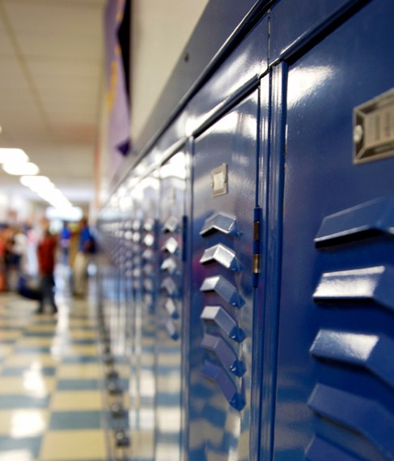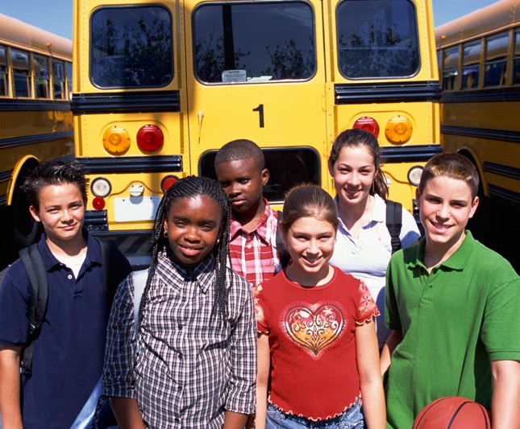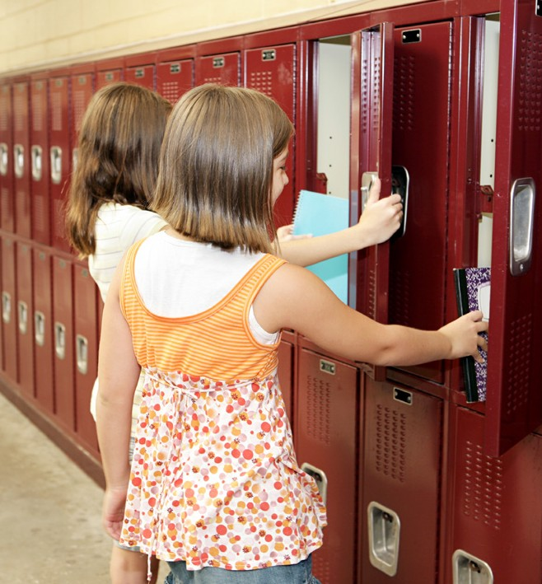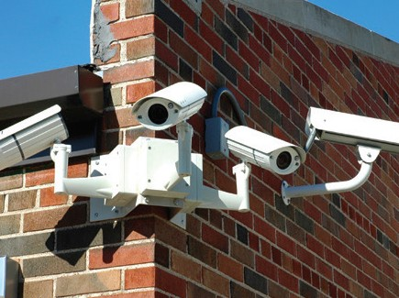

NCES 2015-045

15 U.S. DEPARTMENT OF EDUCATION

Why is the

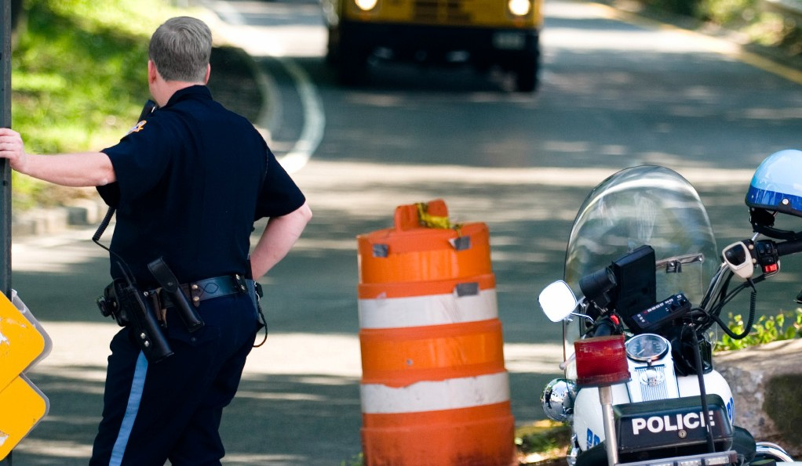

SSOCS

important?

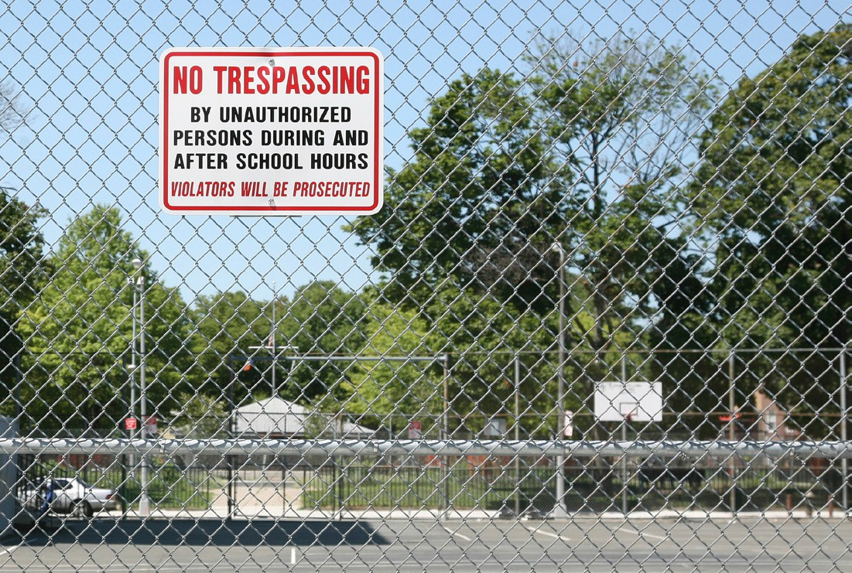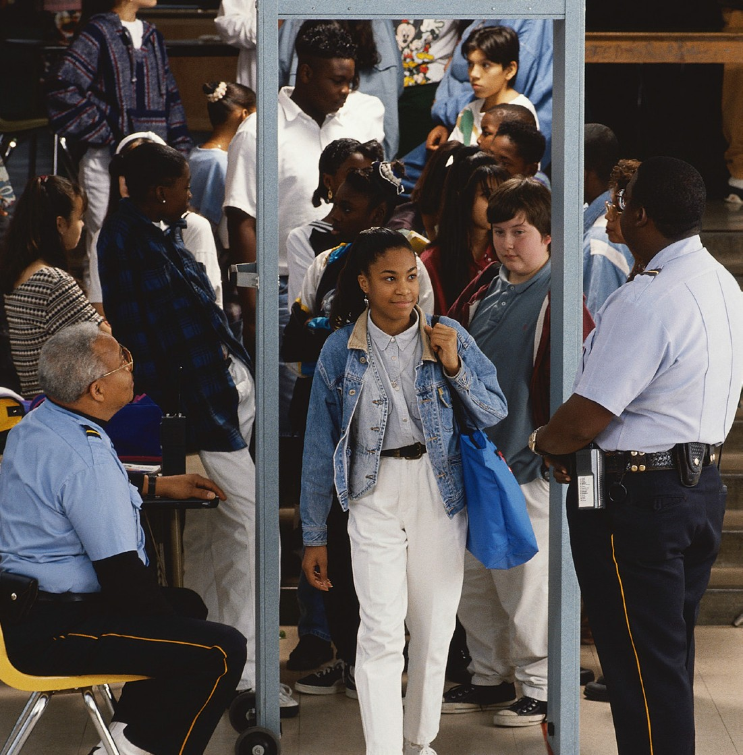

### What is

the School Survey on Crime and Safety?

The School Survey on Crime and Safety (SSOCS) is a national survey of elementary and secondary public school principals that collects information on school safety, including the frequency of school crime and violence, disciplinary actions, and school practices related to the prevention and reduction of crime. SSOCS is one of the nation’s primary sources of school-level data on crime and safety. Sponsored by the U.S. Department of Education, Institute of Education Sciences, National Center for Education

Statistics (NCES), it has been administered five times since 1999 to nationally representative samples of schools and will be conducted again in the spring of the 2015–16 school year. Your school has been selected to participate in this new wave of data collection.

To address school crime, parents, school staff, and policymakers must understand the extent and nature of the problem. SSOCS is designed to

provide measures of crime and safety in the nation’s public schools. Some findings from the most recent collection done in the 2009–10 school year:

* + During the 2009–10 school year, the rate of violent incidents per 1,000 students was

higher in middle schools (40 incidents) than in primary schools or high schools (21 incidents each).

* + Some 25 percent of schools reported at least one incident of the distribution, possession, or use of illegal drugs, a higher percentage than that of the distribution, possession, or use of alcohol (14 percent of schools) or prescription drugs (12 percent of schools).
  + A higher percentage of middle schools reported that student bullying occurred at school daily or at least once a week (39 percent) than did high schools or primary schools (20 percent each).

##### 16

What topics are covered in the questionnaire?

* + School policies and programs concerning crime and safety;
  + Student and teacher involvement in efforts to prevent or reduce school violence;
  + Frequency and types of disciplinary actions such as expulsions, transfers, and suspensions for selected offenses;
  + Frequency and types of crimes at school, including rape, sexual battery, physical attack, robbery, theft, and vandalism;
  + Student access to mental health services; and
  + Responsibilities of sworn law enforcement officers and SROs.

Why was my school selected?

There are more than 80,000 public schools in the United States and only a small proportion are surveyed at one time. Your school was selected to represent schools similar to yours from across the nation. Your participation is important so that the results represent the diversity of America’s public schools.

**D N**

**ME DU**

**RT C**

**A A**

**P TI**

**E O**

SSOCS is endorsed by:

* American Association of School Administrators
* American Federation of Teachers
* American School Counselors Association
* Association of American Educators
* Center for the Prevention of School Violence
* Council of Chief State School Officers
* Criminal Justice Institute,

Safe Schools Initiative Division

* National Association of Elementary School Principals
* National Association of School Resource Officers
* National Association of School Safety and Law Enforcement Officers
* National Association of Secondary School Principals
* National Association of State Boards of Education
* National Education Association
* National Middle School Association
* National PTA
* National School Boards Association
* National School Safety Center
* Northwest Regional Educational Laboratory
* Police Executive Research Forum
* School Safety Advocacy Council

**Data collected by:**

U.S. DEPARTMENT OF COMMERCE

Economics and Statistics Administration

U.S. CENSUS BUREAU

**Study conducted by:**

U.S. DEPARTMENT OF EDUCATION NATIONAL CENTER FOR EDUCATION STATISTICS

Dear Superintendent:

The U.S. Census Bureau is collecting data on behalf of the National Center for Education Statistics (NCES), of the U.S. Department of Education, for an important national study that collects information about crime and safety in public schools from school principals. The School Survey on Crime and Safety (SSOCS) was previously conducted in the 1999–2000, 2003–04, 2005–06, 2007–08, and 2009–10 school years.

**At least one school in your district has been selected to participate in SSOCS.** For your information, we are enclosing the materials that are being sent to the school(s), including the letter asking them to participate, the questionnaire, and a brochure describing the survey. Please do not provide this questionnaire to any school or complete it with district information. This questionnaire is only for your reference; you do not need

to take any action regarding this survey.

We recognize that some schools may not want to share information related to crime for fear of receiving negative attention. Please be assured that by federal mandate we are required to protect the identity of all schools included in our survey from public disclosure. NCES is authorized to conduct this survey by the Education Sciences Reform Act of 2002 (ESRA; 20 U.S.C.,

§ 9543). Information provided as part of this study may be used only for statistical purposes and may not be disclosed, or used, in identifiable form for any other purpose except as required by law (20 U.S.C., § 9573). Reports of the findings from the survey will not identify participating districts, schools, or staff. Individual responses will be combined with those from other participants to produce summary statistics and reports.

Though participation in the survey is voluntary, the success of any survey depends on the willingness of those selected to participate. The greater the level of participation, the better our survey data can provide a current picture of the full diversity of situations found across the nation’s schools. **We hope that you will encourage the selected schools in your district to participate.**

Thank you for your assistance. If you have any general questions about the study, please contact the U.S. Census Bureau at 1–800–221–1204. Someone will be available to take your call Monday through Friday, between 8:00 a.m. and 5:00 p.m. (Eastern Time). The U.S. Census Bureau is also available to answer your questions via e-mail at [addp.education.surveys@census.gov.](mailto:addp.education.surveys@census.gov)

Sincerely,

Peggy G. Carr

Acting Commissioner

National Center for Education Statistics

Enclosures

**D N**

**ME DU**

**RT C**

**A A**

**P TI**

**E O**

SSOCS is endorsed by:

* American Association of School Administrators
* American Federation of Teachers
* American School Counselors Association
* Association of American Educators
* Center for the Prevention of School Violence
* Council of Chief State School Officers
* Criminal Justice Institute,

Safe Schools Initiative Division

* National Association of Elementary School Principals
* National Association of School Resource Officers
* National Association of School Safety and Law Enforcement Officers
* National Association of Secondary School Principals
* National Association of State Boards of Education
* National Education Association
* National Middle School Association
* National PTA
* National School Boards Association
* National School Safety Center
* Northwest Regional Educational Laboratory
* Police Executive Research Forum
* School Safety Advocacy Council

**Data collected by:**

U.S. DEPARTMENT OF COMMERCE

Economics and Statistics Administration

U.S. CENSUS BUREAU

**Study conducted by:**

U.S. DEPARTMENT OF EDUCATION NATIONAL CENTER FOR EDUCATION STATISTICS

Dear [NAME]:

The U.S. Census Bureau is collecting data on behalf of the National Center for Education Statistics (NCES), of the U.S. Department of Education, for an important national study that collects information about crime and safety in public schools from school principals. The School Survey on Crime and Safety (SSOCS) was previously conducted in the 1999–2000, 2003–04, 2005–06, 2007–08, and 2009–

10 school years.

**At least one school in your state has been selected to participate in SSOCS.** For your information, we are enclosing the materials that are being sent to the school(s), including the letter asking them to participate, the questionnaire, and a brochure describing the survey. This questionnaire is only for your reference; you do not need to take any action regarding this survey.

We recognize that some schools may not want to share information related to crime for fear of receiving negative attention. Please be assured that by federal mandate we are required to protect the identity of all schools included in our survey from public disclosure. NCES is authorized to conduct this survey by the Education Sciences Reform Act of 2002

(ESRA; 20 U.S.C., § 9543). Information provided as part of this study may be used only for statistical purposes and may not be disclosed, or used, in identifiable form for any other purpose except as required by law (20 U.S.C.,

§ 9573). Reports of the findings from the survey will not identify participating districts, schools, or staff. Individual responses will be

combined with those from other participants to produce summary statistics

and reports.

Though participation in the survey is voluntary, the success of any survey depends on the willingness of those selected to participate. The greater the level of participation, the better our survey data can provide a current picture of the full diversity of situations found across the nation’s schools. **We hope that you will encourage the schools in your state to participate.**

Thank you for your assistance. If you have any general questions about the study, please contact the U.S. Census Bureau at 1–800–221–1204. Someone will be available to take your call Monday through Friday, between 8:00 a.m. and 5:00 p.m. (Eastern Time). The U.S. Census Bureau is also available to



answer your questions via e-mail at [addp.education.surveys@census.gov.](mailto:addp.education.surveys@census.gov)

Sincerely,

Peggy G. Carr

Acting Commissioner

National Center for Education Statistics

Enclosures

*Advance E-mail to Principal*

Advance email – February 2016

Subject line: The School Survey on Crime and Safety will arrive soon! Dear (name):

I am writing to invite you to participate in the 2016 School Survey on Crime and Safety (SSOCS) by providing information about your school in a brief questionnaire. Data collection for this survey is being carried out by the U.S. Census Bureau on behalf of the National Center for Education Statistics of the U.S. Department of Education. SSOCS is a recurring survey that focuses on the frequency of crime and violence in public schools and the programs and practices schools have developed to provide a safe school environment. It provides a unique opportunity to collect national data on crime and safety from the school’s perspective. **SSOCS is the only survey of its kind!**

**Please expect to receive the SSOCS questionnaire within the next week.** If you have any general questions about the study, please contact the U.S. Census Bureau at 1–888–595–1332. Staff will be available to take your call Monday through Friday, between 8:00 a.m. and 8:00 p.m. (Eastern Time). The U.S. Census Bureau is also available to answer your questions via e-mail at [addp.education.surveys@census.gov.](mailto:addp.education.surveys@census.gov)

Thank you in advance for your participation in this important survey!

Sincerely,

Rachel Hansen Project Director

National Center for Education Statistics

U.S. Department of Education 1990 K Street, NW, Room 9034

Washington, DC 20006 [Email: school.crime@ed.gov](mailto:school.crime@ed.gov)

##### 19

**SSOCS-12(L)**

**(12-2015)**

NATIONAL CENTER FOR EDUCATION STATISTICS

SSOCS is endorsed by:

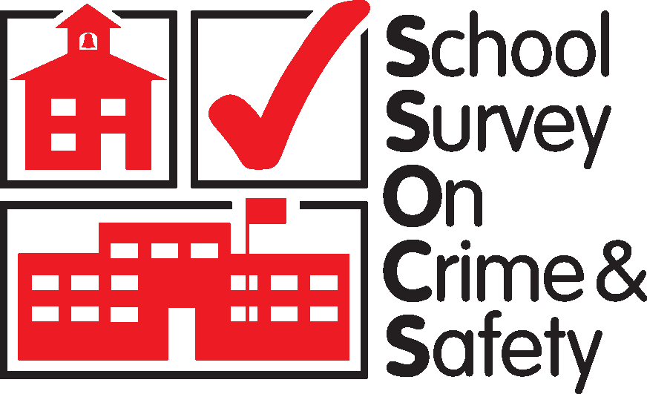

* American Association of School Administrators
* American Federation of Teachers
* American School Counselors Association
* Association of American Educators
* Center for the Prevention of School Violence
* Council of Chief State School Officers
* Criminal Justice Institute,

Safe Schools Initiative Division

* National Association of Elementary School Principals
* National Association of School Resource Officers
* National Association of School Safety and Law Enforcement Officers
* National Association of Secondary School Principals
* National Association of State Boards of Education
* National Education Association
* National Middle School Association
* National PTA
* National School Boards Association
* National School Safety Center
* Northwest Regional Educational Laboratory
* Police Executive Research Forum
* School Safety Advocacy Council

Dear [NAME]:

I am writing to invite you to participate in the 2016 School Survey on Crime and Safety (SSOCS). Data collection for this survey is being carried out by the U.S. Census Bureau on behalf of the National Center for Education Statistics of the U.S. Department of Education. SSOCS is a recurring survey that focuses on the frequency of crime and violence in public schools and the programs and practices schools have developed to provide a safe school environment. It provides a unique opportunity to collect national data on crime and safety from the school’s perspective. **SSOCS is the only survey of its kind.**

Your response is critical to the success of this study because your school is one of only a small number invited to participate in SSOCS. Your school represents hundreds of similar schools nationwide. Your involvement will only require the completion of a questionnaire. The person most knowledgeable about school crime and school policies to provide a safe environment should complete this survey.

NCES is authorized to conduct this survey by the Education Sciences Reform Act of 2002 (ESRA; 20 U.S.C., § 9543). Your answers may be used only for statistical purposes and may not be disclosed, or used, in identifiable form for any other purpose except as required by law (20

U.S.C., § 9573). Reports of the findings from the survey will not identify participating districts, schools, or staff. Individual responses will be

combined with those from other participants to produce summary statistics and reports.

**The U.S. Census Bureau will be sending the SSOCS questionnaire to your school next week.** If you have any general questions about the study, please contact the U.S. Census Bureau at 1–888– 595–1332. Someone will be available to take your call Monday through Friday, between 8:00 a.m. and 8:00 p.m. (Eastern Time). The U.S. Census Bureau is also available to answer your questions via e-mail at

[addp](mailto:addp.education.surveys@census.gov)[.education.surveys@census.gov.](mailto:.education.surveys@census.gov)

Thank you for giving this matter your attention. We look forward to your school’s participation in this important data collection effort.

Sincerely,



**Data collected by:**

U.S. DEPARTMENT OF COMMERCE

Economics and Statistics Administration

U.S. CENSUS BUREAU

**Study conducted by:**

U.S. DEPARTMENT OF EDUCATION NATIONAL CENTER FOR EDUCATION STATISTICS

Peggy G. Carr



Acting Commissioner

National Center for Education Statistics

Enclosures

**D N**

**ME DU**

**RT C**

**A A**

**P TI**

**E O**

WASHINGTON, DC 20006

**SSOCS-12(L)S (12-20**15**)**

NATIONAL CENTER FOR EDUCATION STATISTICS

**D N**

**ME DU**

**RT C**

**A A**

**P TI**

**E O**

SSOCS is endorsed by:

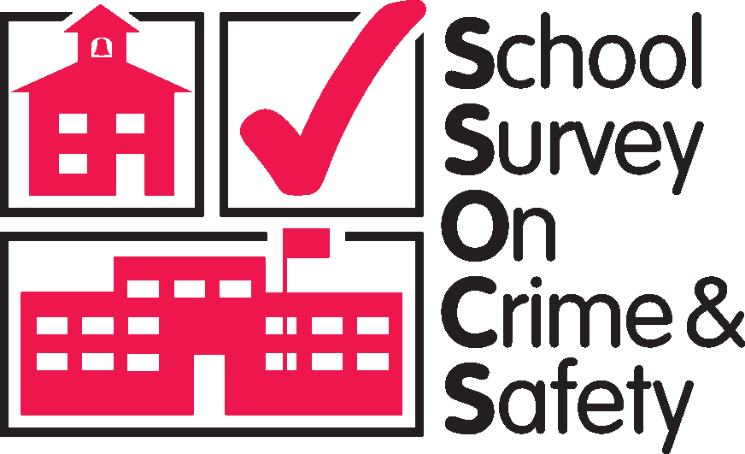

* American Association of School Administrators
* American Federation of Teachers
* American School Counselors Association
* Association of American Educators
* Center for the Prevention of School Violence
* Council of Chief State School Officers
* Criminal Justice Institute,

Safe Schools Initiative Division

* National Association of Elementary School Principals
* National Association of School Resource Officers
* National Association of School Safety and Law Enforcement Officers
* National Association of Secondary School Principals
* National Association of State Boards of Education
* National Education Association
* National Middle School Association
* National PTA
* National School Boards Association
* National School Safety Center
* Northwest Regional Educational Laboratory
* Police Executive Research Forum
* School Safety Advocacy Council

**Data collected by:**

U.S. DEPARTMENT OF COMMERCE

Economics and Statistics Administration

U.S. CENSUS BUREAU

**Study conducted by:**

U.S. DEPARTMENT OF EDUCATION NATIONAL CENTER FOR EDUCATION STATISTICS

Dear [NAME]:

I am writing to invite you to participate in the 2016 School Survey on Crime and Safety (SSOCS). Data collection for this survey is being carried out by the

U.S. Census Bureau on behalf of the National Center for Education Statistics

(NCES) of the U.S. Department of Education. SSOCS is a recurring survey that focuses on the frequency of crime and violence in public schools and the

programs and practices schools have developed to provide a safe school environment. It provides a unique opportunity to collect national data on crime

and safety from the school’s perspective. **SSOCS is the only survey of its kind.**

**Your response is critical to the success of this study** because your school is one of only a small number invited to participate in SSOCS. Your school represents hundreds of similar schools nationwide. Your involvement will only require the completion of a questionnaire. The person most

knowledgeable about school crime and school policies to provide a safe environment should complete this survey.

NCES is authorized to conduct this survey by the Education Sciences Reform Act of 2002 (ESRA; 20 U.S.C., § 9543).Your answers may be used only for statistical purposes and may not be disclosed, or used, in identifiable form for any other purpose except as required by law (20 U.S.C., § 9573). Reports of the findings from the survey will not identify participating districts, schools, or staff. Individual responses will be combined with those from other participants to produce summary statistics and reports.

We know that your school district requires researchers to obtain approval to conduct research in your district. **The NCES is in the process of obtaining permission to conduct SSOCS in your district.** If you have any questions about this process, please contact your district or the U.S. Census Bureau at 1-800-221-1204. Someone will be available to take your call Monday through Friday, between 8:00 a.m. and 5:00 p.m. (Eastern Time). You may also e-mail questions to [addp.education.surveys@census.gov.](mailto:addp.education.surveys@census.gov)

**The U.S. Census Bureau will be sending the SSOCS questionnaire to your school next week.** If you have any general questions about the survey, please contact the U.S. Census Bureau at the phone number or e-mail address provided above.

Thank you for giving this matter your attention. We look forward to your school’s participation in this important data collection effort.

Sincerely,



Peggy G. Carr

Acting Commissioner

National Center for Education Statistics

Enclosures

WASHINGTON, DC 20006

Data collected by:

*Postcard for Schools in Special Permission Districts*

##### Dear School Principal:

U.S. DEPARTMENT OF COMMERCE

Economics and Statistics Administration

U.S. CENSUS BUREAU

Study conducted by:

U.S. DEPARTMENT OF EDUCATION NATIONAL CENTER FOR EDUCATION STATISTICS

**YOUR DISTRICT HAS APPROVED SSOCS**



SSOCS-13(I) (12-2015)

##### We know that your school district requires researchers to obtain approval to conduct surveys in your district. The National Center for Education Statistics (NCES) of the U.S. Department of Education completed the application process and has received permission to conduct the School Survey on Crime and Safety (SSOCS) in your district. If you have any questions about this application process, please contact your district or the U.S. Census Bureau at 1–800–221–1204 or [addp](mailto:addp.education.surveys@census.gov)[.education.surveys@census.gov.](mailto:.education.surveys@census.gov)

I would like to thank you in advance for your help in completing this survey.

Sincerely,

Rachel Hansen

Project Director

National Center for Education Statistics

SSOCS-13(I) (12-2015)

##### 22

SSOCS is endorsed by:

* American Association of School Administrators
* American Federation of Teachers
* American School Counselors Association
* Association of American Educators
* Center for the Prevention of School Violence
* Council of Chief State School Officers
* Criminal Justice Institute,

Safe Schools Initiative Division

* National Association of Elementary School Principals
* National Association of School Resource Officers
* National Association of School Safety and Law Enforcement Officers
* National Association of Secondary School Principals
* National Association of State Boards of Education
* National Education Association
* National Middle School Association
* National PTA
* National School Boards Association
* National School Safety Center
* Northwest Regional Educational Laboratory
* Police Executive Research Forum
* School Safety Advocacy Council

**Data collected by:**

U.S. DEPARTMENT OF COMMERCE

Economics and Statistics Administration

U.S. CENSUS BUREAU

**Study conducted by:**

U.S. DEPARTMENT OF EDUCATION NATIONAL CENTER FOR EDUCATION STATISTICS

Last week, I wrote to request your participation in the School Survey on Crime

and Safety (SSOCS), an important national study that collects information about crime and safety in public schools. Data collection for this survey is being carried out by the U.S. Census Bureau on behalf of the National Center for Education Statistics (NCES) of the U.S. Department of Education.

As we mentioned in our previous letter, SSOCS provides a unique opportunity to collect national data on crime and safety from the school’s perspective. We are confident that, with your participation, we can provide data to state and federal agencies about various types of crime and discipline that exist in schools today. Although SSOCS may ask some questions that appear similar to those on other surveys, this survey is not connected to any other state or federal data collection system. **SSOCS is unique in that it provides national estimates of school crime and safety using common definitions across all states.**

NCES is authorized to conduct this survey by the Education Sciences Reform Act of 2002 (ESRA; 20 U.S.C., § 9543). We realize that data on school crime are highly sensitive, so we want to remind you that information provided as part of this study may be used only for statistical purposes and may not be disclosed, or used, in identifiable form for any other purpose except as required by law (20 U.S.C., § 9573). Reports of the findings from the survey will not identify participating districts, schools, or staff. Individual responses will be combined with those from other participants to produce summary statistics and reports.

While your participation in this survey is voluntary and your decision will not affect any benefits or funding you receive from the U.S. Department of

Education, we do hope that you will participate in this important national survey.

**We would appreciate the return of the questionnaire within two weeks.** A postage-paid return envelope has been enclosed for your convenience. If you have any general questions about the study, please contact the U.S. Census Bureau at 1–888–595–1332. Someone will be available to take your call Monday through Friday, between 8:00 a.m. and

8:00 p.m. (Eastern Time). The U.S. Census Bureau is also available to answer your questions via e-mail at [addp.education.surveys@census.gov.](mailto:addp.education.surveys@census.gov)



Sincerely,

Peggy G. Carr

Acting Commissioner

National Center for Education Statistics

Enclosures

**D N**

**ME DU**

**RT C**

**A A**

**P TI**

**E O**

WASHINGTON, DC 20006

**D N**

**ME DU**

**RT C**

**A A**

**P TI**

**E O**

SSOCS is endorsed by:

* American Association of School Administrators
* American Federation of Teachers
* American School Counselors Association
* Association of American Educators
* Center for the Prevention of School Violence
* Council of Chief State School Officers
* Criminal Justice Institute,

Safe Schools Initiative Division

* National Association of Elementary School Principals
* National Association of School Resource Officers
* National Association of School Safety and Law Enforcement Officers
* National Association of Secondary School Principals
* National Association of State Boards of Education
* National Education Association
* National Middle School Association
* National PTA
* National School Boards Association
* National School Safety Center
* Northwest Regional Educational Laboratory
* Police Executive Research Forum
* School Safety Advocacy Council

**Data collected by:**

U.S. DEPARTMENT OF COMMERCE

Economics and Statistics Administration

U.S. CENSUS BUREAU

**Study conducted by:**

U.S. DEPARTMENT OF EDUCATION NATIONAL CENTER FOR EDUCATION STATISTICS

Recently, someone from the U.S. Census Bureau spoke with you regarding the

School Survey on Crime and Safety (SSOCS), an important national study that

collects information about crime and safety in public schools. Data collection for this survey is being carried out by the U.S. Census Bureau on behalf of the National Center for Education Statistics (NCES) of the U.S. Department of

Education. **Enclosed is the replacement questionnaire that you requested.**

We realize that data on school crime are highly sensitive, so we want to remind you that information provided as part of this study may be used only for statistical purposes and may not be disclosed, or used, in identifiable form for any other purpose except as required by law (20 U.S.C., § 9573). Reports of the findings from the survey will not identify participating districts, schools, or staff. Individual responses will be combined with those from other participants to produce summary statistics and reports.

While your decision to participate is voluntary and will not affect any benefits or funding you receive from the U.S. Department of Education, we do hope that you will participate in this important national survey. The data you provide are combined with the information provided by others in statistical reports to present estimates of school crime, discipline, disorder, programs, and policies for schools nationwide.

We would appreciate the return of the questionnaire within two weeks. A postage-paid return envelope has been enclosed for your convenience. If you have any general questions about the survey, please contact the U.S. Census Bureau at 1–888–595–1332. Someone will be available to take your call Monday through Friday, between 8:00 a.m. and 8:00 p.m. (Eastern Time). The U.S. Census Bureau is also available to answer your questions via e-mail at

[addp](mailto:addp.education.surveys@census.gov)[.education.surveys@census.gov.](mailto:.education.surveys@census.gov)

Sincerely,



Peggy G. Carr

Acting Commissioner

National Center for Education Statistics

Enclosures

**Submission Deadline Extended**



**D N**

**ME DU**

**RT C**

**A A**

**P TI**

**E O**

SSOCS is endorsed by:

* American Association of School Administrators
* American Federation of Teachers
* American School Counselors Association
* Association of American Educators
* Center for the Prevention of School Violence
* Council of Chief State School Officers
* Criminal Justice Institute,

Safe Schools Initiative Division

* National Association of Elementary School Principals
* National Association of School Resource Officers
* National Association of School Safety and Law Enforcement Officers
* National Association of Secondary School Principals
* National Association of State Boards of Education
* National Education Association
* National Middle School Association
* National PTA
* National School Boards Association
* National School Safety Center
* Northwest Regional Educational Laboratory
* Police Executive Research Forum
* School Safety Advocacy Council

**Data collected by:**

U.S. DEPARTMENT OF COMMERCE

Economics and Statistics Administration

U.S. CENSUS BUREAU

**Study conducted by:**

U.S. DEPARTMENT OF EDUCATION

NATIONAL CENTER FOR EDUCATION

STATISTICS

Dear [NAME]:

As of today, we have not received your completed School Survey on Crime and Safety (SSOCS) questionnaire. If you have recently returned the questionnaire, thank you for your participation. If you have not yet completed the questionnaire, I encourage you to do so. **We have extended the deadline to [<DATE>]** SSOCS is an important national study that collects information about crime and safety in public schools. Data collection for this survey is being carried out by the U.S. Census Bureau on behalf of the National Center for Education Statistics (NCES) of the U.S. Department of Education.

We appreciate that you are very busy and that you receive many survey requests. However, we urge you to take the time to respond. Principals who participated in past iterations of SSOCS reported that they benefited from filling out our survey because it encouraged them to set aside time to focus on crime and safety issues at their schools.

Information provided as part of this study may be used only for statistical purposes and may not be disclosed, or used, in identifiable form for any other purpose except as required by law (20 U.S.C., § 9573). Reports of the findings from the survey will not identify participating districts, schools, or staff. Individual responses will be combined with those from other participants to produce summary statistics and reports.

While your decision to participate is voluntary and will not affect any benefits or funding you receive from the U.S. Department of Education, we do hope that you will participate in this important national survey. The data you provide are combined with the information provided by others in statistical reports to present estimates of school crime, discipline, disorder, programs, and policies for schools nationwide.

A postage-paid return envelope is enclosed for your convenience. If you have any questions about the study, please do not hesitate to contact the

U.S. Census Bureau at 1–888–595–1332. Someone will be available to take your call Monday through Friday, between 8:00 a.m. and 8:00 p.m. (Eastern Time). The U.S. Census Bureau is also available to answer your questions via

e-mail at [addp](mailto:addp.education.surveys@census.gov)[.education.surveys@census.gov.](mailto:.education.surveys@census.gov)

Sincerely,



Peggy G Carr

Acting Commissioner

National Center for Education Statistics

Enclosures

Follow-up email – March 2016

Subject line: Friendly Reminder – School Survey on Crime and Safety Dear (name):

Recently, we sent you the **2016 School Survey on Crime and Safety** (SSOCS) questionnaire. If you have already completed SSOCS, thank you!

If not, **please complete and return your questionnaire as soon as possible**. We will contact you shortly to determine the status of your questionnaire. If you have not received the questionnaire, please contact the U.S. Census Bureau to request a replacement copy by sending an e-mail to [addp.education.surveys@census.gov](mailto:addp.education.surveys@census.gov) or by calling 1–888–595–1332 between the hours of 8:00 a.m. and 8:00 p.m. (Eastern Time).

Your participation is critical to the success of our survey because your school was selected to represent hundreds of similar schools and cannot be replaced. Schools will not be identified by name in any reports. Please contact me if there is anything I can do to help you complete the questionnaire. We appreciate your participation in this valuable survey!

Sincerely,

Rachel Hansen Project Director

National Center for Education Statistics

U.S. Department of Education 1990 K Street, NW, Room 9034

Washington, DC 20006 [Email: school.crime@ed.gov](mailto:school.crime@ed.gov)

First email reminder – March 2016, approximately two weeks after follow-up email

Subject line: School Survey on Crime and Safety Dear (name):

Did you know that during the 2009-10 school year, the rate of violent incidents (rape, sexual battery other than rape, physical attack or fight with or without a weapon, threat of physical attack with or without a weapon, and robbery with or without a weapon) per 1,000 students was higher in middle schools than in primary schools or high schools?

We need your help to gather statistics on the frequency of both violent and nonviolent incidents that occur in schools today, along with the policies and practices educators have instituted to provide a safer environment for students.

The School Survey on Crime and Safety (SSOCS) collects these valuable data. If you have already completed and returned your questionnaire, thank you very much for your participation. If not, I encourage you to take the time to do so. Your participation is critical to the success of our survey because your school was selected to represent hundreds of similar schools. Please note that schools will not be identified by name in any reports.

Please contact me if there is anything I can do to help you complete the questionnaire. Sincerely,

Rachel Hansen Project Director

National Center for Education Statistics

U.S. Department of Education 1990 K Street, NW, Room 9034

Washington, DC 20006 [Email: school.crime@ed.gov](mailto:school.crime@ed.gov)

Second email reminder – April 2016, approximately two weeks after first reminder email

Subject line: School Survey on Crime and Safety – We Need Your Help! Dear (name):

We know that you are very busy, but we need your help!

The School Survey on Crime and Safety (SSOCS) collects valuable information on the frequency of crime and violence in public schools and the programs and practices schools have developed to provide a safe school environment.

The greater the level of participation, the better our survey data can provide a current picture of our nation’s schools. The data you provide are combined with the information provided by others in statistical reports to present estimates of school crime, discipline, disorder, programs, and policies for schools nationwide. Schools will not be identified by name in any reports.

If you have already completed and returned your questionnaire, thank you! If not, please complete and return your questionnaire as soon as possible.

If you have any general questions about the study, please contact the U.S. Census Bureau at 1–888–595–1332. Staff will be available to take your call Monday through Friday, between 8:00

a.m. and 8:00 p.m. (Eastern Time). The U.S. Census Bureau is also available to answer your questions via e-mail at [addp.education.surveys@census.gov.](mailto:addp.education.surveys@census.gov)

Sincerely,

Rachel Hansen Project Director

National Center for Education Statistics

* 1. Department of Education 1990 K Street, NW, Room 9034

Washington, DC 20006 [Email: school.crime@ed.gov](mailto:school.crime@ed.gov)

Third email reminder – April 2016, approximately two weeks after second reminder email

Subject line: Selected findings from the 2009-10 SSOCS! Dear (name):

The School Survey on Crime and Safety produces valuable data on crime and safety in public schools. Findings from the 2009-10 survey included:

* + - A greater percentage of schools reported at least one student threat of physical attack without a weapon than with a weapon.
    - A higher percentage of middle schools reported that student bullying occurred at school daily or at least once a week than did high schools or primary schools.
    - A higher percentage of suburban schools drilled students on a written plan describing procedures to be performed during a shooting than did city schools or rural schools.

Your completed questionnaire will help us to produce statistics for the 2015-16 school year. If you have already completed the survey, thank you for your assistance and please disregard this e- mail. If you haven’t had the opportunity to complete and return the survey yet, we encourage you to do so. You can also complete the survey over the phone by calling the U.S. Census Bureau at 1–888–595–1332 between the hours of 8:00 a.m. and 8:00 p.m. (Eastern Time). Please note that schools will not be identified by name in any reports.

Sincerely,

Rachel Hansen Project Director

National Center for Education Statistics

U.S. Department of Education 1990 K Street, NW, Room 9034

Washington, DC 20006 [Email: school.crime@ed.gov](mailto:school.crime@ed.gov)

Fourth email reminder – May 2016, approximately two weeks after third reminder email

Subject Line: Time is running out to participate in SSOCS! Dear (name):

Time is running out for your school to participate in the School Survey on Crime and Safety (SSOCS)!

If you have already completed and returned your questionnaire, thank you! If not, please complete and return it as soon as possible. You may also complete the survey over the phone by calling the U.S. Census Bureau at 1–888–595–1332. An interviewer will be available to assist you between the hours of 8:00 a.m. and 8:00 p.m. (Eastern Time). Please note that schools will not be identified by name in any reports.

Sincerely,

Rachel Hansen Project Director

National Center for Education Statistics

U.S. Department of Education 1990 K Street, NW, Room 9034

Washington, DC 20006 [Email: school.crime@ed.gov](mailto:school.crime@ed.gov)

Last Email reminder – June 2016, approximately two weeks after fourth reminder email

Subject line: Last chance to participate in SSOCS! Dear (name):

We need your help! Data collection for the School Survey on Crime and Safety (SSOCS) is coming to a close. Don’t miss your opportunity to contribute to data that are used for making and changing policies. If you have not already done so, please complete and return your SSOCS questionnaire. Schools will not be identified by name in any reports. We appreciate your help in this important data collection effort!

If you have any general questions about the study, please contact the U.S. Census Bureau at 1– 888–595–1332. Staff will be available to take your call Monday through Friday, between 8:00

a.m. and 8:00 p.m. (Eastern Time). The U.S. Census Bureau is also available to answer your questions via e-mail at [addp.education.surveys@census.gov.](mailto:addp.education.surveys@census.gov)

Sincerely,

Rachel Hansen Project Director

National Center for Education Statistics

U.S. Department of Education 1990 K Street, NW, Room 9034

Washington, DC 20006 [Email: school.crime@ed.gov](mailto:school.crime@ed.gov)

**Voice-mail Left by Interviewers**

This is the United States Census Bureau’s Jeffersonville Contact Center. Please return our call at: (toll-free number). Refer to case number: (case ID). Thank You.

The National Center for Education Statistics (NCES) of the U.S. Department of

Education and the U.S. Census Bureau would like to thank you for making the 2015–16 School Survey on Crime and Safety (SSOCS) a success.

SSOCS is endorsed by:

* American Association of School Administrators
* American Federation of Teachers
* American School Counselors Association
* Association of American Educators
* Center for the Prevention of School Violence
* Council of Chief State School Officers
* Criminal Justice Institute,

Safe Schools Initiative Division

* National Association of Elementary School Principals
* National Association of School Resource Officers
* National Association of School Safety and Law Enforcement Officers
* National Association of Secondary

School Principals

* National Association of State Boards of Education
* National Education Association
* National Middle School Association
* National PTA
* National School Boards Association
* National School Safety Center
* Northwest Regional Educational Laboratory
* Police Executive Research Forum
* School Safety Advocacy Council

**Data collected by:**

U.S. DEPARTMENT OF COMMERCE

Economics and Statistics Administration

U.S. CENSUS BUREAU

**Study conducted by:**

U.S. DEPARTMENT OF EDUCATION NATIONAL CENTER FOR EDUCATION STATISTICS

SSOCS is the only nationally representative survey that collects data on crime and safety from a principal’s perspective, so we appreciate your approval of our application to conduct research within your district. This school year, we were able to gather data from over [TOTAL] schools. Your approval was crucial in helping us achieve this success.

Please visit <http://nces.ed.gov/newsflash>and sign up to receive up-to-date alerts about a number of education topics, including crime and safety in schools. Tables based on data from the 2009-10 SSOCS and earlier SSOCS administrations are available on the NCES website. In addition to these data products, tables and reports based on the 2015-16 SSOCS will be posted to our website at <http://www.nces.ed.gov/surveys/ssocs>upon release.

Again, thank you for your approval. Sincerely,

Rachel Hansen

Project Director

National Center for Education Statistics

WASHINGTON, DC 20006

The National Center for Education Statistics of the U.S. Department of Education

and the U.S. Census Bureau would like to thank you for making the 2015–16 School Survey on Crime and Safety (SSOCS) a success.

SSOCS is endorsed by:

* American Association of School Administrators
* American Federation of Teachers
* American School Counselors Association
* Association of American Educators
* Center for the Prevention of School Violence
* Council of Chief State School Officers
* Criminal Justice Institute,

Safe Schools Initiative Division

* National Association of Elementary School Principals
* National Association of School Resource Officers
* National Association of School Safety and Law Enforcement Officers
* National Association of Secondary

School Principals

* National Association of State Boards of Education
* National Education Association
* National Middle School Association
* National PTA
* National School Boards Association
* National School Safety Center
* Northwest Regional Educational Laboratory
* Police Executive Research Forum
* School Safety Advocacy Council

**Data collected by:**

U.S. DEPARTMENT OF COMMERCE

Economics and Statistics Administration

U.S. CENSUS BUREAU

**Study conducted by:**

U.S. DEPARTMENT OF EDUCATION NATIONAL CENTER FOR EDUCATION STATISTICS

SSOCS is the only nationally representative survey that collects data on crime and safety from a principal’s perspective, so we appreciate you taking time out of your busy schedule to represent your school in this important effort. This school year, we were able to gather data from over [TOTAL] schools. Your participation was crucial in helping us achieve this success.

Please visit <http://nces.ed.gov/newsflash>and sign up to receive up-to-date

alerts about a number of education topics, including crime and safety in schools. Tables based on data from the 2009-10 SSOCS and earlier SSOCS administrations are available on the NCES website. In addition to these data products, tables and reports based on the 2015-16 SSOCS will be posted to our website at <http://www.nces.ed.gov/surveys/ssocs>upon release.

Again, thank you for your time and participation. Sincerely,

Rachel Hansen

Project Director

National Center for Education Statistics

WASHINGTON, DC 20006