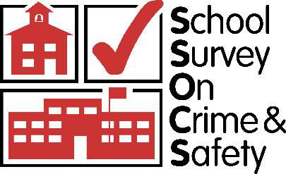

School Survey on Crime and Safety (SSOCS) 2018 & 2020

OMB #1850-0761 v.12

Appendix A – Communication Materials

National Center for Education Statistics
Institute of Education Sciences
U.S. Department of Education

March 2017
revised May 2017

Contents
District Research Application Cover Letter (Districts in SSOCS) - APPROVED 1
District Research Application Cover Letter (Districts in NTPS & SSOCS) - APPROVED 2
2017–18 SSOCS Generic Research Application - APPROVED 3
Special Contact District Approval Form (SSOCS) - APPROVED 9
Special Contact District Affidavit of Nondisclosure - APPROVED 10
2018 SSOCS Trifold Brochure 11
Example of Formatted SSOCS Communications Letter to Superintendents 13
Advance Letter to District Superintendent 14
Advance Letter to Chief State School Officer 15
Advance Letter to Principal 16
Advance Letter to Principal – Special District, Status Pending 17
Advance Letter to Principal – Special District, Status Approved 18
Postcard to Principal – Special District Approval 19
Initial Letter to Principal - Paper, No Incentive 20
Initial Letter to Principal - Paper, Incentive 21
Initial Letter to Principal - Web, No Incentive 22
Initial Letter to Principal - Web, Incentive 23
First Reminder Letter to Principal – Paper 24
First Reminder Letter to Principal – Internet 25
Second Reminder Letter to Principal – Paper 26
Second Reminder Letter to Principal - Internet (first paper questionnaire) 27
Third Reminder Letter to Principal 28
Letter to Principal – Replacement Questionnaire 29
Thank You Letter to District 30
Thank You Letter to School 31
Initial e-mail to principals - Paper, Incentive 32
Initial e-mail to principals - Paper, No incentive 33
Initial e-mail to principals - Web, Incentive 34
Initial e-mail to principals - Web, No incentive 35
First follow-up e-mail to principals – Paper 36
First follow-up e-mail to principals – Web 37
Second follow-up e-mail to principals – Paper 38
Second follow-up e-mail to principals – Web 39
Third follow-up e-mail reminder to nonresponding schools and thank you e-mail to responding schools – Paper 40
Third follow-up e-mail reminder to nonresponding schools and thank you e-mail to responding schools – Web 41
Fourth follow-up e-mail 42
Fifth follow-up e-mail 43
SSOCS Web Instrument Text 44
SSOCS Webpage Text 63

District Research Application Cover Letter (Districts in SSOCS) - APPROVED
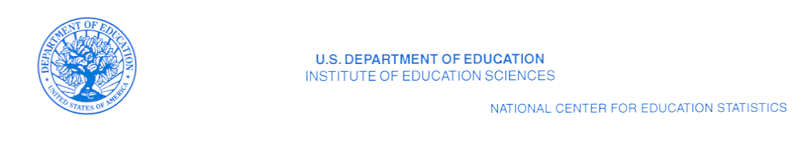

[Name] [date]
[Position, Department]
[School District]
[Street Address]
[City, State, Zip]

Dear [District Contact Name]

The National Center for Education Statistics (NCES) of the U.S. Department of Education is requesting approval to conduct the School Survey on Crime and Safety (SSOCS) 2018 in some of your district’s schools during the 2017-18 school year.

SSOCS is administered on a recurring basis by the U.S. Census Bureau on behalf of NCES. Its data are crucial in helping legislators and education leaders make informed decisions to provide a safe school environment. By participating in this survey, you will ensure that information about your district’s schools is included in those decisions.

[For districts where sample has been drawn, insert: “From your district, XX schools were sampled for SSOCS.”] No student, faculty, or classroom time is involved in this survey.

Thank you for your consideration of the research application for SSOCS 2018. The enclosed application and materials describe the purposes, survey topics, sample size, and respondent burden for SSOCS. The SSOCS 2016 questionnaire is also included for your reference. Only minor changes are proposed for the 2018 questionnaire. In addition, a District Approval Form is enclosed for you to indicate whether your district has approved participation in SSOCS. Please return the form as soon as possible to the contact listed on the form.

If you have any questions about SSOCS or the research application, please contact the study’s district research application team, by e-mail at [email]@westat.com or by telephone at 1-800-[phone]. You can find additional information about SSOCS and results from prior SSOCS administrations at http://www.nces.ed.gov/surveys/ssocs.

Sincerely,

Rachel Hansen
Project Director
School Survey on Crime and Safety
National Center for Education Statistics (NCES)
PCP, 550 12th St., SW, 4th floor, Room 4012
Washington, DC 20202

Enclosures

District Research Application Cover Letter (Districts in NTPS & SSOCS) - APPROVED

[Name] [date]
[Position, Department]
[School District]
[Street Address]
[City, State, Zip]

Dear [District Contact Name]

The National Center for Education Statistics (NCES) of the U.S. Department of Education is requesting approval to conduct the National Teacher and Principal Survey (NTPS) 2017-18 and the School Survey on Crime and Safety (SSOCS) 2018 in some of your district’s schools during the 2017-18 school year.

NTPS and SSOCS are administered by the U.S. Census Bureau on behalf of NCES on a recurring basis. The collected data are crucial in helping legislators and education leaders make informed decisions to improve education. By participating in these surveys, you will ensure that information about your district’s schools, principals, and teachers is included in those decisions. No student or classroom time is involved in either survey.

[For districts where sample has been drawn, insert: “From your district, XX of schools were sampled for NTPS and XX of schools were sampled for SSOCS.”] NCES recognizes the increased burden on schools asked to respond to multiple surveys. NTPS and SSOCS are working together to minimize as much as possible the number of schools asked to participate in both surveys.

We appreciate your consideration of the research applications for these important surveys. The enclosed applications and materials describe the purposes, survey topics, sample sizes, and respondent burden for NTPS and SSOCS. The applications and materials for each survey are provided separately. If you have any questions about the research applications, please contact the studies’ district research application team, by e-mail at [email]@westat.com or by telephone at 1-800-[phone].

Sincerely,

Amy Ho
Project Director
National Teacher and Principal Survey
National Center for Education Statistics (NCES)
PCP, 550 12th St., SW, 4th floor, Room 4014
Washington, DC 20202

Rachel Hansen
Project Director
School Survey on Crime and Safety
National Center for Education Statistics (NCES)
PCP, 550 12th St., SW, 4th floor, Room 4012
Washington, DC 20202
Enclosures

2017–18 SSOCS Generic Research Application - APPROVED

Contact
Applicant: Rachel Hansen
Title: Project Director
Affiliation: National Center for Education Statistics (NCES)
Institute of Education Sciences (IES)
United States Department of Education
Address: PCP, 550 12th Street, SW, 4th floor, Room 4012
Washington, DC 20202
Phone: (202) 245-7082
E-mail: school.crime@ed.gov

SSOCS Research Application Contact:
District Research Application Team
1-800-[phone]
[email]@westat.com

Title of Study: 2017–18 School Survey on Crime and Safety (SSOCS:2018)

Anticipated Start Date: February 2018
Anticipated End Date: June 2018

Purpose the Study:
The School Survey on Crime and Safety (SSOCS) is conducted by the National Center for Education Statistics (NCES), part of the Institute of Education Sciences (IES), within the United States Department of Education, in order to collect extensive data on issues of crime and safety in U.S. public primary, middle, high, and combined-grade schools. The survey asks school principals about topics such as incidents of crime and violence; disciplinary actions; discipline problems; use of security measures; school policies and practices related to school crime and violence; violence prevention programs and activities; the presence and role of school security staff; parent and community involvement; staff training; availability of mental health services; and other school characteristics. NCES is authorized to conduct SSOCS by the Education Sciences Reform Act of 2002 (ESRA 2002, 20 U.S.C. §9543).

SSOCS is one of the nation’s few sources of national information on school crime and safety, as reported by principals in U.S. public schools. SSOCS was first conducted during the 1999–2000 school year and was conducted again during the 2003–04, 2005–06, 2007–08, 2009–10, and 2015–16 school years. Many topics in the prior administrations are repeated in the 2017–18 questionnaire to enable comparisons between the seven survey periods. Because data are collected on a recurring basis, it is possible to assess whether our nation’s schools are becoming safer for students and educators. By participating, information from schools in your district allows for comparisons among different types of schools across the nation that are valuable to governing agencies, policy makers, educators and the general public.

Significance of the Study and Benefits of Participation:
SSOCS is the only recurring federal survey that collects detailed information on the incidence, frequency, seriousness, and nature of violence affecting students and school personnel, as well as other indices of school safety from the schools’ perspective. As such, it fills an important gap in data collected by NCES and other agencies. With the help of survey participants, NCES is able to produce national estimates of school crime and discipline, and of school policies and programs concerning crime and safety. These data are crucial in helping legislators and education leaders make informed decisions to provide a safe school environment. The ability of NCES to provide this important information is contingent upon the voluntary participation of sampled schools; participation of these schools is dependent upon their districts’ approval. Because your district and its schools represent themselves and many others like them, their participation is vital for producing high quality information. By participating in this survey, you will ensure that information about your districts’ schools is included in those important decisions.

Hypotheses and Measurement:
The SSOCS questionnaire is divided into 10 broad research objectives, each with a series of measurement items addressing a specific research question. Each research objective is briefly stated below in terms of the crime and safety issues in need of measurement, as well as the research questions we are seeking to answer. These measurement items and corresponding research questions are:

- Frequency of Crime and Violence at School: frequency and nature of crime at public schools
  - What is the number of incidents, by type of crime?
  - What are the characteristics of those incidents?
    - How many incidents were reported to police?
  - What is the number of hate-crime incidents?
    - What biases motivated these incidents?
  - How many arrests were made at school?
  - How many schools report violent deaths?
  - How many schools report school shootings?
  - How many schools report disruptions for violent threats?
- Number of Incidents: frequency and nature of discipline problems and disorder at public schools
  - What types of discipline problems and disorder occur at public schools?
  - How serious are the problems?
- Disciplinary Problems and Actions: disciplinary actions used by public schools
  - What types of disciplinary actions were available to principals?
  - How many disciplinary actions were taken, by type of action and offense?
- School Practices and Policies: practices to prevent/reduce crime and violence at public schools
  - How do schools monitor student behavior?
  - How do schools control student behavior?
  - How do schools monitor and secure the physical grounds?
  - How do schools limit access to the school?
  - How do schools plan and practice procedures for emergencies?
- School Security Staff: involvement of law enforcement at public schools
  - Do schools have sworn law enforcement officers present on a regular basis?
    - How often are they available and at what times?
    - What activities do they participate in?
    - How many are present at the school?
    - How are sworn law enforcement officers armed?
  - Is there written documentation outlining the roles and responsibilities of law enforcement in schools?
  - Do schools have security guards or personnel other than law enforcement?
- School Mental Health Services: availability and access to student mental health services at public schools
  - Are mental health services, such as diagnostic assessment and treatment, available to students?
    - Where are those services available?
  - What factors limit a school’s efforts to provide mental health services to students?
- School Programs: formal programs designed to prevent/reduce crime and violence at public schools
  - Which programs target students, teachers, parents, and other community members?
  - What are the characteristics of the programs?
  - Do schools have threat assessment teams?
    - How often do they formally meet?
  - What student groups promote acceptance of student diversity?
  - What training is provided to staff?
- Parent and Community Involvement at School: efforts used by public schools to prevent/reduce crime and violence involving various stakeholders (e.g., law enforcement, parents, juvenile justice agencies, mental health agencies, social services, and the business community)
  - In what activities are stakeholders involved?
  - How much are stakeholders involved?
- Limitations on Crime Prevention: the problems principals encounter in preventing/reducing crime and violence in public schools
- School Characteristics which are related to the research questions above
  - What are the demographic characteristics of schools?
  - What are the characteristics of the student population?
  - What is the average student/teacher ratio?
  - What are the general measures of school climate, such as truancy or student mobility?

Questionnaire:
A copy of the 2016 SSOCS questionnaire is enclosed for your reference. Only minor changes are proposed for the 2018 questionnaire. The sections in the 2018 questionnaire, outlined below, are the same as those in the 2016 questionnaire. Additional information about SSOCS and results from prior SSOCS administrations is available at http://nces.ed.goc/surveys/ssocs.
The SSOCS:2018 questionnaire consists of the following sections:
- School practices and programs;
- Parent and community involvement at school;
- School security staff;
- School mental health services;
- Staff training;
- Limitations on crime prevention;
- Frequency of crime and violence at school;
- Number of incidents;
- Disciplinary problems and actions; and
- School characteristics: 2017–18 school year.
Methodology and Sampling:
The U.S. Census Bureau collects the SSOCS data on behalf of NCES. SSOCS is a self-administered survey that is offered to respondents primarily through a mail questionnaire. As part of an effort to increase survey response rates, subject to approval, a random sample of respondents will be offered an online version of the survey in 2018 and a random sample of schools will receive a prepaid gift card in the initial survey package. Principals, or the school staff most knowledgeable about school crime and policies for a safe environment, complete the survey and return it directly to the U.S. Census Bureau. School districts and state educational agencies are not involved in the data collection in any way. Depending on the school’s data collection system, some principals may seek input from other school staff, such as school resource officers or guidance counselors. The survey does not require the participation of either students or faculty. No classroom time is involved in the completion of this survey.
SSOCS provides aggregate estimates for public schools across the nation. A stratified sample design is used to select approximately 4,500 U.S. public schools for SSOCS:2018. The sample is designed to provide national estimates of primary, middle, high, and combined-grade schools taking into account the level of instruction, type of locale (urbanicity), and size of the student enrollment.
The sampling frame for SSOCS is derived from the Common Core of Data (CCD), the universe of public schools supplied annually by state educational agencies to NCES. Only public schools in the 50 states and the District of Columbia are included in the SSOCS sampling frame. Certain types of schools are excluded, including special education schools, vocational schools, alternative schools (e.g., adult continuing education schools and remedial schools), newly closed schools, home schools, virtual schools, ungraded schools, schools with high grades of kindergarten or lower, and schools run by the Bureau of Indian Education. Regular public schools, charter schools, and schools that have partial or total magnet programs are included in the frame. For sample allocation purposes, strata are defined by instructional level, type of locale (urbanicity), and enrollment size. Both percent minority enrollment and region are used as sorting variables in the sample selection process to induce implicit stratification.
Data Collection:
The 2017–18 SSOCS data collection will begin in February of 2018. The U.S. Census Bureau, acting as a contractor for NCES, will handle the data collection. Sampled schools will receive a letter notifying them of the survey in February 2018. Within a week of receiving the advance letter notifying them of the survey, the principals of the sampled schools will be sent the SSOCS questionnaire, and will be asked to return the questionnaire within two weeks. If the surveys are not returned or items are left incomplete, the school may receive follow-up telephone calls and emails. All follow-up data collection activities will end in June 2018. School districts and state education agencies are not involved in the data collection in any way, nor does the survey require the participation of students or faculty. Completed questionnaires are sent directly back to the U.S. Census Bureau.
SSOCS:2018 timetable
Questionnaires mailed to principals | February 2018
Questionnaires due from principals | March 2018
Phone and email follow-up with non-responders begins | March 2018
All data collection efforts end | June 2018

Response Burden:
SSOCS relies on the voluntary participation of schools. The quality of national estimates is dependent on the level of respondent participation. The data provided by individual schools are combined with the information provided by other schools in statistical reports to present estimates of school crime and discipline, and of school policies and programs concerning crime and safety in schools nationwide. Every effort is made to create questionnaires that collect in-depth data without putting an undue burden on the respondent. The response burden for the survey is estimated to be 52 minutes per school.

SSOCS does not require the participation of either students or faculty. The recruitment materials and questionnaire clearly state that SSOCS:2018 is a voluntary survey. The materials also state that the data will only be reported in statistical summaries that preclude the identification of any individual principal or school participating in the survey.

Analysis and release of information:
The information collected in the 2017–18 SSOCS will be released in several ways. Many of the estimates will be included in statistical analysis reports published by NCES. In addition, the major findings will be included on the NCES website.

NCES allows researchers to access the data through restricted-use licensing for additional analyses. Only users who have official clearance from NCES may have access to the restricted-use data files. The data will be made available to the public as soon as possible after data collection. A public use dataset will be made available to the public on the Department of Education web site. In compliance with NCES confidentiality procedures, the public use dataset will not contain any information that can be used to identify an individual school or the state or district in which the school is located.

Benefit to your school district:
The U.S. Department of Education recognizes that safe schools are essential for learning: without a safe and secure environment, teachers cannot teach and students cannot learn. Effective data collection that encourages a high level of participation, and clear and timely analysis and presentation of the data, provide educators with a powerful set of tools for achieving the goal of school safety by providing accurate, up-to-date information about school crime and safety. This information is crucial in helping legislators and education leaders make informed decisions to provide a safe school environment. The ability of NCES to provide this important information is contingent upon the voluntary participation of sampled schools, and participation of these schools is dependent upon their districts’ approval. Because your district and its schools represent themselves and many others like them, their participation is vital for producing high quality information. By participating in this survey, you will ensure that information about your districts’ schools is included in those important decisions.

Confidentiality:
Data security and confidentiality protection procedures have been put in place for SSOCS:2018 to ensure that all NCES contractors and agents working on SSOCS:2018 comply with all privacy requirements including, as applicable: the Inter-agency agreement with NCES for this study; Privacy Act of 1974 (5 U.S.C. §552a); Privacy Act Regulations (34 CFR Part 5b); Computer Security Act of 1987; U.S.A. Patriot Act of 2001 (P.L. 107-56); Education Sciences Reform Act of 2002 (ESRA 2002, 20 U.S.C. §9573); Confidential Information Protect and Statistical efficiency Act of 2002; E-Government Act of 2002, Title V, Subtitle A; Cybersecurity Enhancement Act of 2015 (6 U.S.C. §151); the U.S. Department of Education General Handbook for Information Technology Security General Support Systems and Major Applications Inventory Procedures (March 2005); the U.S. Department of Education Incident Handling Procedures (February 2009); the U.S. Department of Education, ACS Directive OM: 5-101, Contractor Employee Personnel Security Screenings; NCES Statistical Standards; and all new legislation that impacts the data collected through the inter-agency agreement for this study.
The U.S. Census Bureau will collect data under an interagency agreement with NCES, and maintain the individually identifiable questionnaires per the security plan, including:
- Provisions for data collection in the field;
- Provisions to protect the data-coding phase required before machine processing;
- Provisions to safeguard completed survey documents;
- Authorization procedures to access or obtain files containing identifying information; and
- Provisions to remove printouts and other outputs that contain identification information from normal operation. Such materials will be maintained in secured storage areas and will be securely destroyed as soon as practical.
U.S. Census Bureau will comply with the Department of Education’s IT security policy requirements as set forth in the Handbook for Information Assurance Security Policy and related procedures and guidance, as well as IT security requirements in the Federal Information Security Management Act (FISMA), Federal Information Processing Standards (FIPS) publications, Office of Management and Budget (OMB) Circulars, and the National Institute of Standards and Technology (NIST) standards and guidance. All data products and publications will also adhere to: the revised NCES Statistical Standards, as described at the website: http://nces.ed.gov/statprog/2012/.
By law (20 U.S.C. §9573), a violation of the confidentiality restrictions is a felony, punishable by imprisonment of up to 5 years and/or a fine of up to $250,000. All government or contracted staff working on the SSOCS study and having access to the data are required to sign an NCES Affidavit of Nondisclosure and have received public-trust security clearance.
From the initial contact with the participants in this survey through all of the follow-up efforts, potential survey respondents will be informed that (a) the U.S. Census Bureau administers SSOCS on behalf of NCES; (b) NCES is authorized to conduct SSOCS by the Education Sciences Reform Act of 2002 (ESRA 2002, 20 U.S.C. §9543); (c) all of the information they provide may be used only for statistical purposes and may not be disclosed, or used, in identifiable form for any other purpose except as required by law (20 U.S.C. §9573 and 6 U.S.C. §151); and that their participation is voluntary.
The following language will be included in respondent contact materials and on data collection instruments:
All of the information you provide may be used only for statistical purposes and may not be disclosed, or used, in identifiable form for any other purpose except as required by law (20 U.S.C. §9573 and 6 U.S.C. §151).
According to the Paperwork Reduction Act of 1995, no persons are required to respond to a collection of information unless it displays a valid OMB control number. The valid OMB control number for this voluntary information collection is 1850-0761. The time required to complete this information collection is estimated to average 53 minutes per response, including the time to review instructions, search existing data resources, gather the data needed, and complete and review the information collection. If you have any comments concerning the accuracy of the time estimate, suggestions for improving this collection, or comments or concerns about the contents or the status of your individual submission of this questionnaire, please e-mail: ssocs@census.gov, or write directly to: School Survey on Crime and Safety (SSOCS), National Center for Education Statistics (NCES), PCP, 550 12th Street SW, #4012, Washington, DC 20202.
Institutional Review Board (IRB) or Human Subjects Review:
Under the federal policy for the protection of human subjects, SSOCS is exempt from IRB review because it utilizes survey procedures and is conducted in established or commonly accepted educational settings, involving normal educational practices. There is no potential for harm to human subjects.
The Department of Education has adopted a common set of regulations known as the Federal Policy for the Protection of Human Subjects or "Common Rule." The design of these regulations is based on established, internationally recognized ethical principles. The specific regulation is Title 34, Code of Federal Regulations, Part 97, Protection of Human Subjects, which includes Subpart A, Basic Policy, and Subpart D, Additional Protections for Children. These regulations classify as exempt certain categories of research. Research that is nonexempt is covered by the regulations. Research activities in which the only involvement of human subjects will be in one or more of the following categories are exempt [34 CFR 97.101(b)(2)]:
(2) Research involving the use of educational tests (cognitive, diagnostic, aptitude, achievement), survey procedures, interview procedures or observation of public behavior, unless the information identifies the subjects and disclosure could reasonably place the subjects at risk of criminal or civil liability or be damaging to the subjects' financial standing, employability, or reputation. Subpart D amends this exemption, in part: If the subjects are children, research involving interview or survey procedures and research involving observations of public behavior in which the researcher(s) participate in the activities being observed are not exempt. However, research involving the use of educational tests and research involving observations of public behavior in which the researcher(s) do not participate in the activities being observed are exempt.
For more information, please see http://www2.ed.gov/policy/fund/guid/humansub/overview.html.

Informed Consent:
The nature of this self-administered, cross-sectional survey is not considered intrusive and has been ruled to be exempt under the protection of human subjects’ provisions in federal research.
There are no individual student data (such as test scores or Social Security numbers) associated with any of the data acquired in this data collection. Since no data are collected about individual students, it is not necessary to obtain active, informed consent from students’ parents/guardians.

Participation in SSOCS is completely voluntary, and individual survey items can be left blank, at the discretion of each respondent. A statement on the questionnaire indicates that participation is voluntary. A respondent gives implied consent to participate by completing the SSOCS questionnaire.

Special Contact District Approval Form (SSOCS) - APPROVED

School Survey on Crime and Safety (SSOCS) 2018
District Approval Form

Please mark one of the boxes below to let us know your district’s decision to allow sampled school(s) to participate in the School Survey on Crime and Safety (SSOCS).

□ The U.S. Department of Education has permission to administer the School Survey on Crime and Safety (SSOCS) 2018 to one or more schools in the [District Name].

□ The U.S. Department of Education does not have permission to administer the School Survey on Crime and Safety (SSOCS) 2018 to any school in the [District Name].

Printed
Name: ___________________________ Date: ________________________

Signature: ___________________________ Title: ________________________

Address: ___________________________ Phone: _______________________

___________________________

Email: ___________________________

Please return this form to [contact info] by email to [email], or by mail to:

[address]

Special Contact District Affidavit of Nondisclosure - APPROVED

Affidavit of Nondisclosure for Districts that Require the List of Schools in the Study Sample

2018 School Survey on Crime and Safety (SSOCS)

____________________________________ __________________________________
(Job Title) (Organization Name)

2018 SSOCS List of Sampled Schools
____________________________________ __________________________________
(Name of NCES File with (Organization Address)
Individually Identifiable Information)

I, __________________________________________________________________________ ,
(Printed Full Name)

do solemnly swear (or affirm) that when given access to the subject NCES file, I will not

(i) use or reveal any individually identifiable information furnished, acquired, retrieved or assembled by me or others, under the provisions of the Education Sciences Reform Act of 2002 (20 U.S.C. §9573) and Title V, subtitle A of the E-Government Act of 2002 (P.L. 107-347) for any purpose other than statistical purposes specified in the NCES survey, project or agreement;

(ii) make any disclosure or publication whereby a sample unit or survey respondent (including principals, teachers, and schools) could be identified or the data furnished by or related to any particular person or school under these sections could be identified; or

(iii) permit anyone other than the individuals authorized by the Commissioner of the National Center for Education Statistics (NCES) who have signed an affidavit of nondisclosure to examine the list of participating districts, schools, and/or staff.

[The penalty for unlawful disclosure is a fine of not more than $250,000 (under 18 U.S.C. 3571) or imprisonment for not more than five years (under 18 U.S.C. 3559), or both. The word "swear" should be stricken out when a person elects to affirm the affidavit rather than to swear to it.]

___________________________________ _________________________
(Signature) (Date)

2018 SSOCS TRIFOLD BROCHURE

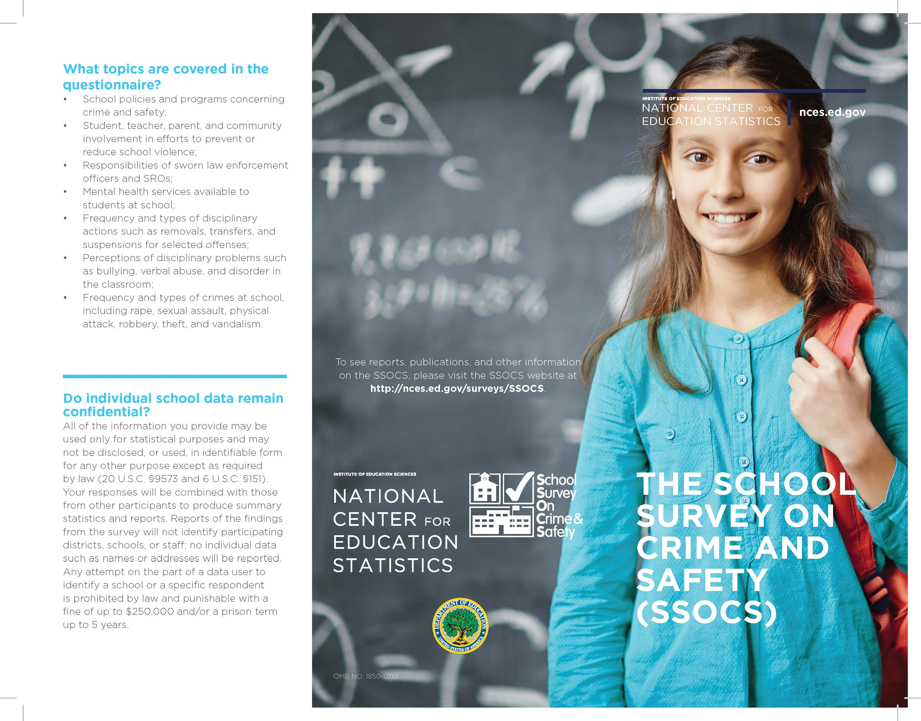
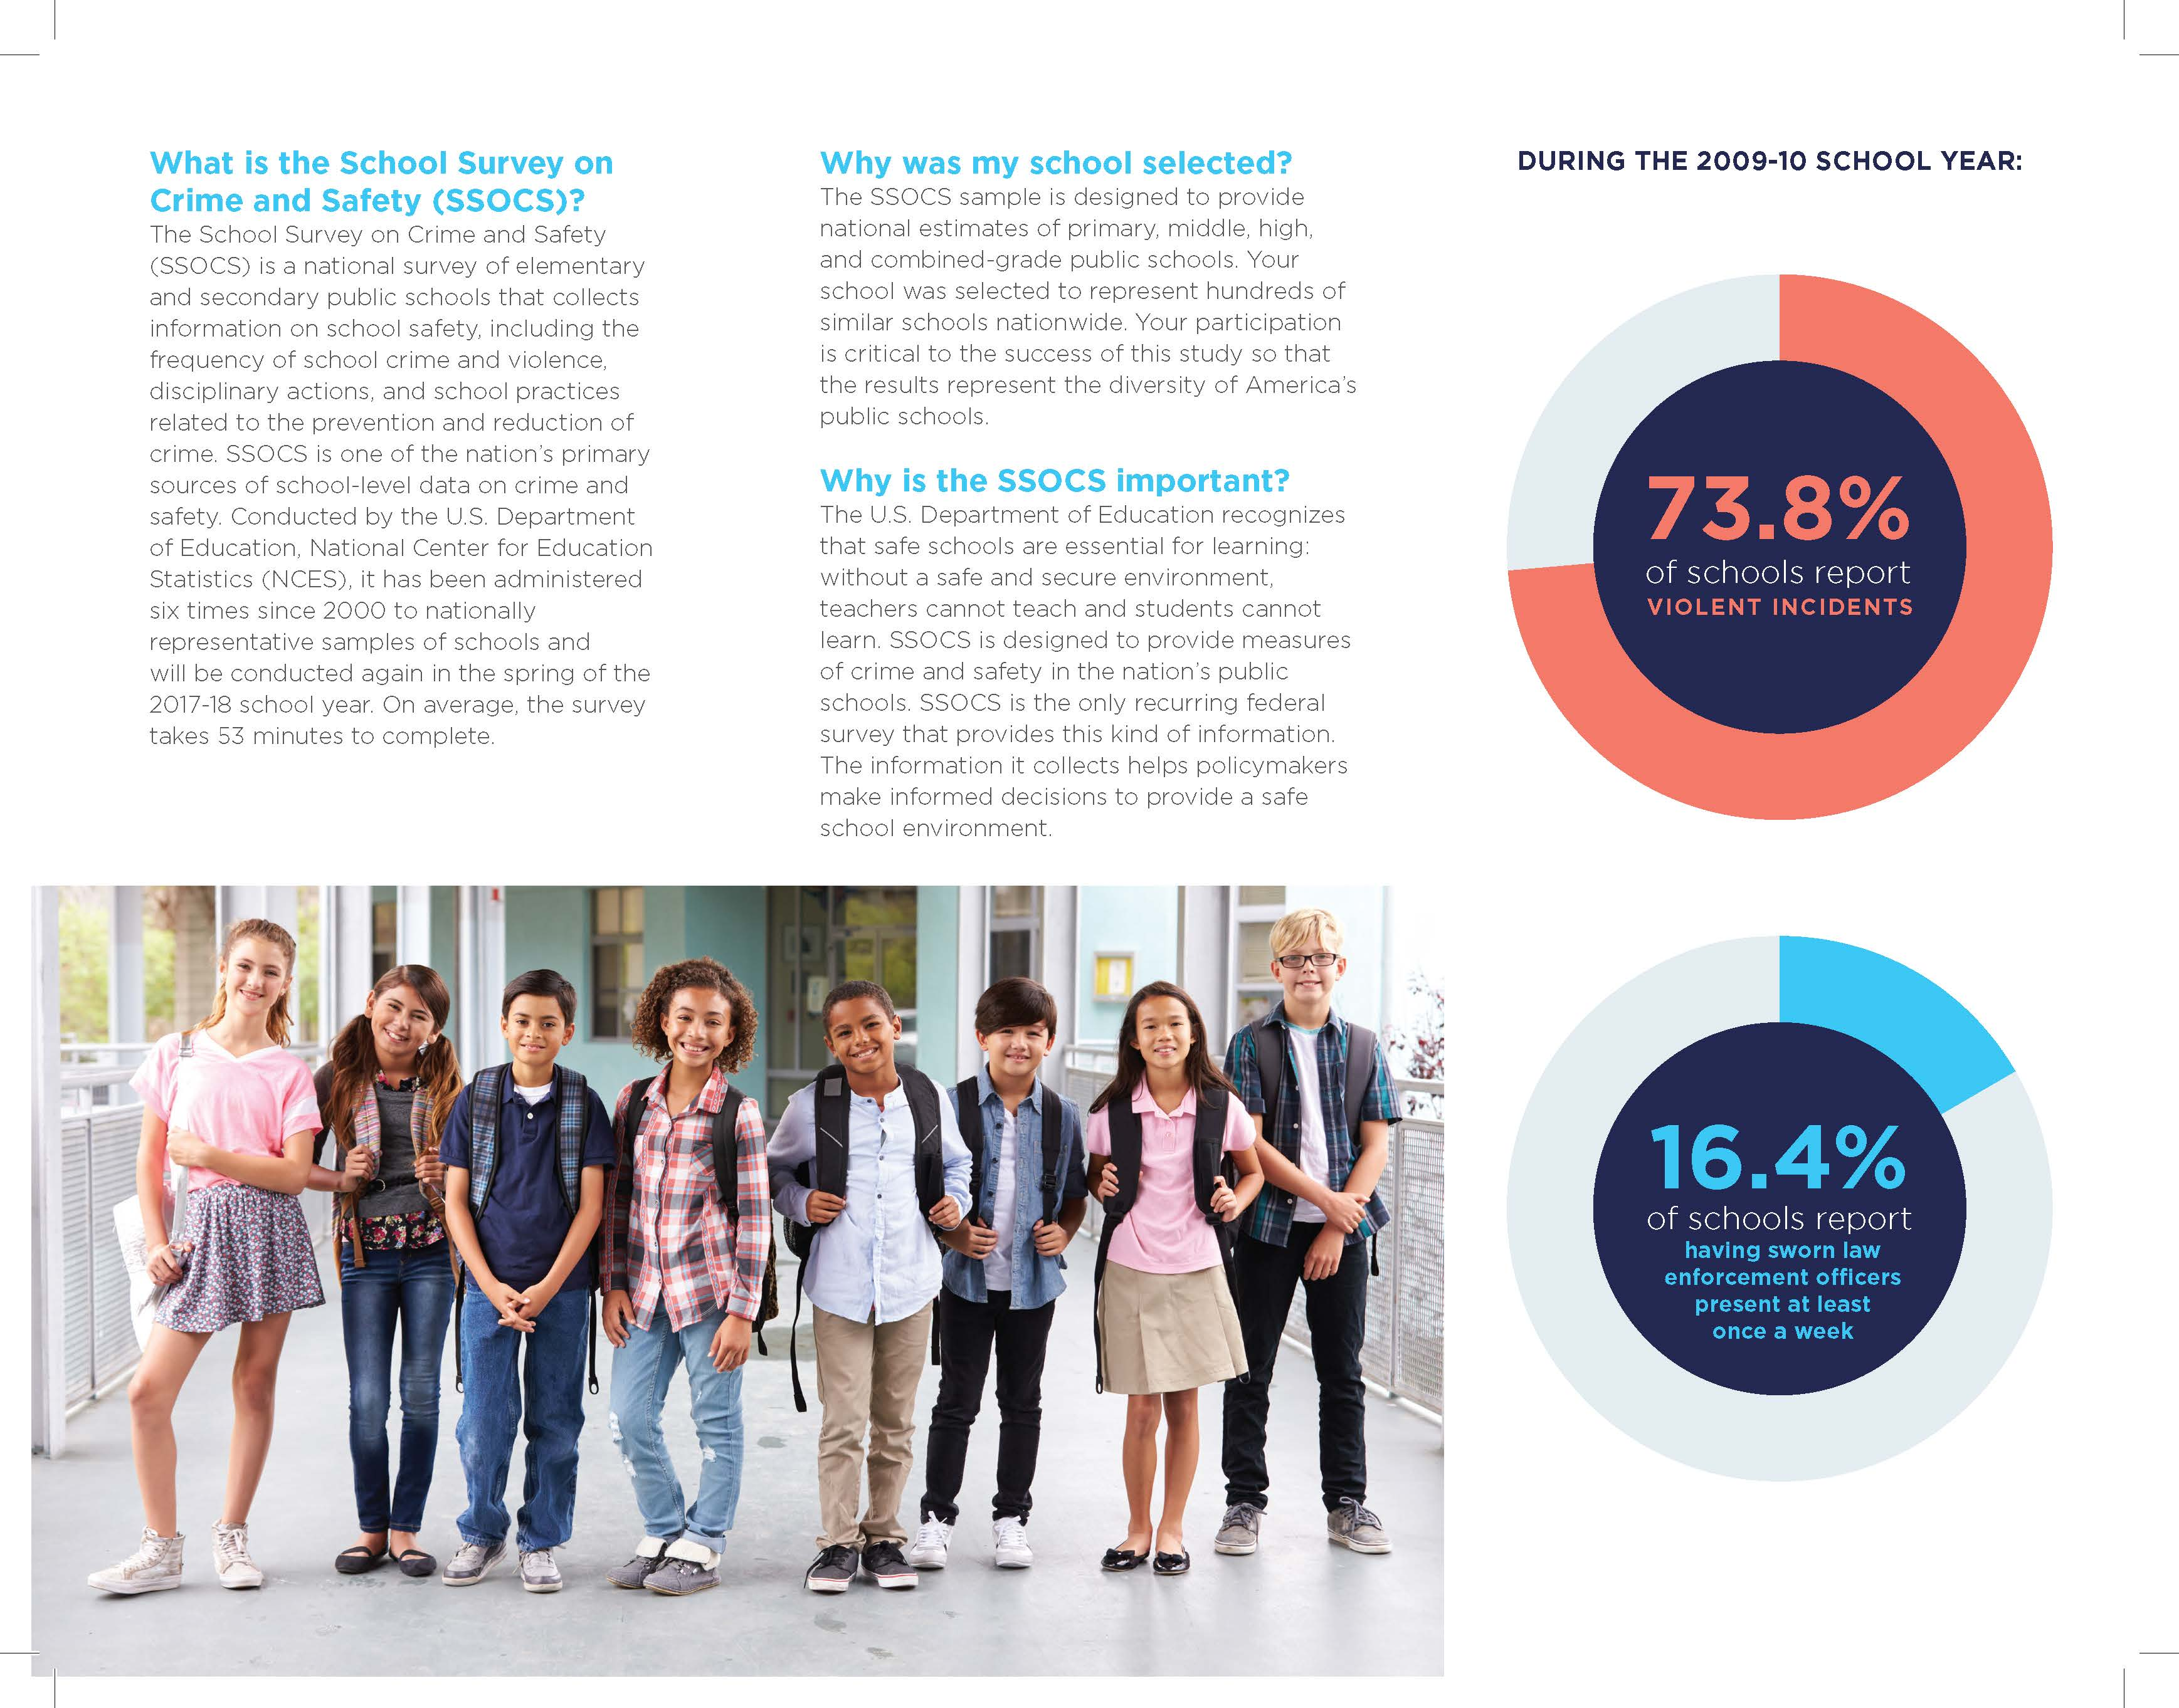

Example of Formatted SSOCS Communications Letter to Superintendents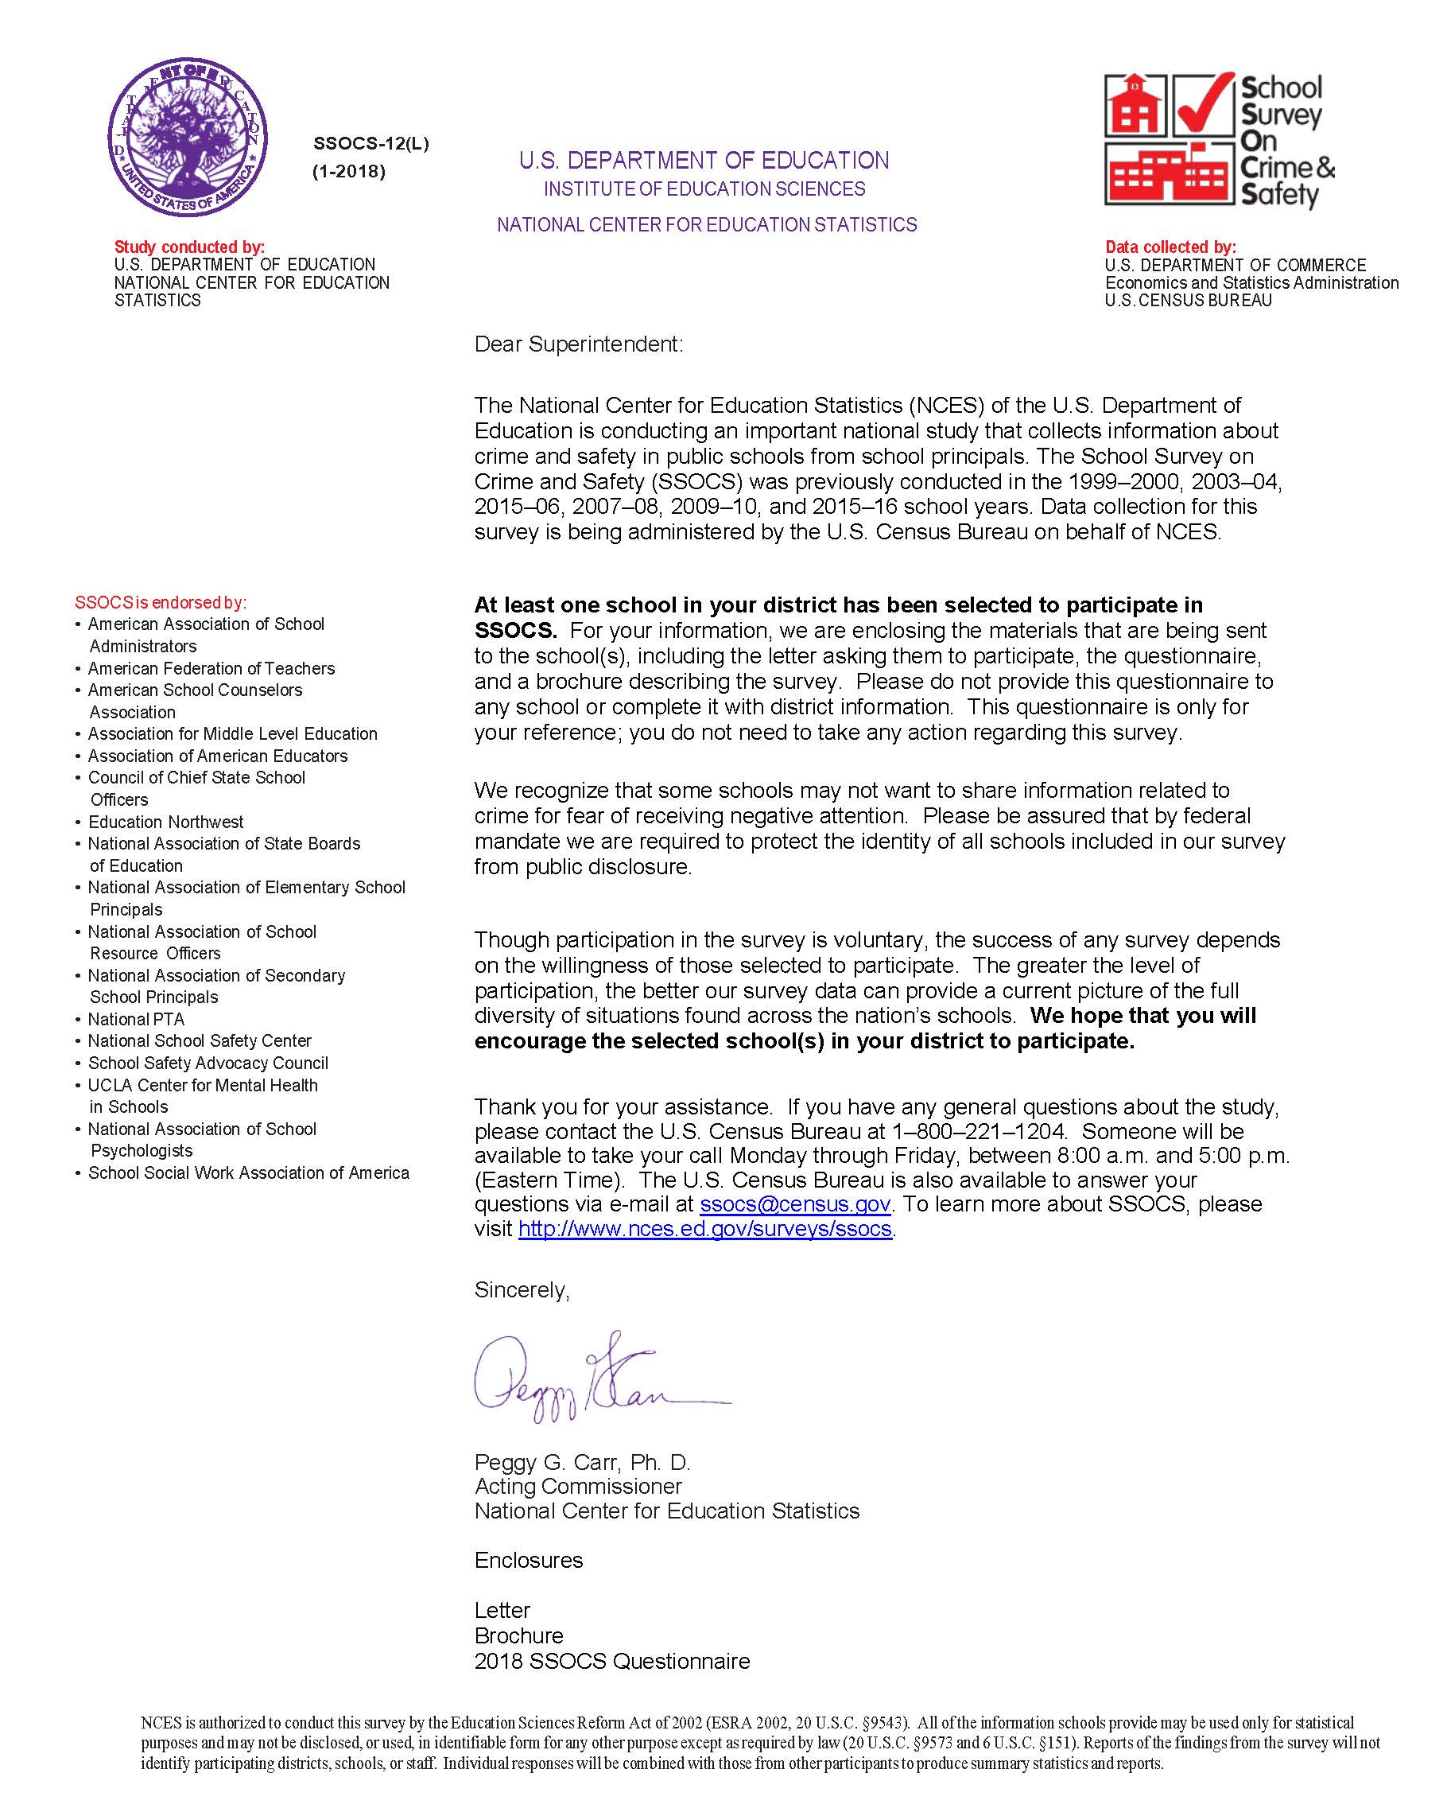

Advance Letter to District Superintendent
SSOCS-10L

Dear Superintendent:

The National Center for Education Statistics (NCES) of the U.S. Department of Education is conducting an important national study that collects information about crime and safety in public schools from school principals. The School Survey on Crime and Safety (SSOCS) was previously conducted in the 1999–2000, 2003–04, 2015–06, 2007–08, 2009–10, and 2015–16 school years. Data collection for this survey is being administered by the U.S. Census Bureau on behalf of NCES.

At least one school in your district has been selected to participate in SSOCS. For your information, we are enclosing the materials that are being sent to the school(s), including the letter asking them to participate, the questionnaire, and a brochure describing the survey. Please do not provide this questionnaire to any school or complete it with district information. This questionnaire is only for your reference; you do not need to take any action regarding this survey.

We recognize that some schools may not want to share information related to crime for fear of receiving negative attention. Please be assured that by federal mandate we are required to protect the identity of all schools included in our survey from public disclosure.

Though participation in the survey is voluntary, the success of any survey depends on the willingness of those selected to participate. The greater the level of participation, the better our survey data can provide a current picture of the full diversity of situations found across the nation’s schools. We hope that you will encourage the selected school(s) in your district to participate.

Thank you for your assistance. If you have any general questions about the study, please contact the U.S. Census Bureau at 1–800–221–1204. Someone will be available to take your call Monday through Friday, between 8:00 a.m. and 5:00 p.m. (Eastern Time). The U.S. Census Bureau is also available to answer your questions via e-mail at ssocs@census.gov. To learn more about SSOCS, please visit http://www.nces.ed.gov/surveys/ssocs.

Sincerely,

Peggy G. Carr, Ph. D.
Commissioner
National Center for Education Statistics (NCES)

Enclosures

Letter
Brochure
2018 SSOCS Questionnaire

NCES is authorized to conduct this survey by the Education Sciences Reform Act of 2002 (ESRA 2002, 20 U.S.C. §9543). All of the information schools provide may be used only for statistical purposes and may not be disclosed, or used, in identifiable form for any other purpose except as required by law (20 U.S.C. §9573 and 6 U.S.C. §151). Reports of the findings from the survey will not identify participating districts, schools, or staff. Individual responses will be combined with those from other participants to produce summary statistics and reports.

Advance Letter to Chief State School Officer
SSOCS-11L

Dear <insert name>:

The National Center for Education Statistics (NCES) of the U.S. Department of Education is conducting an important national study that collects information about crime and safety in public schools from school principals. The School Survey on Crime and Safety (SSOCS) was previously conducted in the 1999–2000, 2003–04, 2015–06, 2007–08, 2009–10, and 2015–16 school years. Data collection for this survey is being administered by the U.S. Census Bureau on behalf of NCES.

At least one school in your state has been selected to participate in SSOCS. For your information, we are enclosing the materials that are being sent to the school(s), including the letter asking them to participate, the questionnaire, and a brochure describing the survey. This questionnaire is only for your reference; you do not need to take any action regarding this survey.

We recognize that some schools may not want to share information related to crime for fear of receiving negative attention. Please be assured that by federal mandate we are required to protect the identity of all schools included in our survey from public disclosure.

Though participation in the survey is voluntary, the success of any survey depends on the willingness of those selected to participate. The greater the level of participation, the better our survey data can provide a current picture of the full diversity of situations found across the nation’s schools. We hope that you will encourage the school(s) in your state to participate.

Thank you for your assistance. If you have any general questions about the study, please contact the U.S. Census Bureau at 1–800–221–1204. Someone will be available to take your call Monday through Friday, between 8:00 a.m. and 5:00 p.m. (Eastern Time). The U.S. Census Bureau is also available to answer your questions via e-mail at ssocs@census.gov. To learn more about SSOCS, please visit http://www.nces.ed.gov/surveys/ssocs.

Sincerely,

Peggy G. Carr, Ph. D.
Commissioner
National Center for Education Statistics (NCES)

Enclosures

Letter
Brochure
2018 SSOCS Questionnaire

NCES is authorized to conduct this survey by the Education Sciences Reform Act of 2002 (ESRA 2002, 20 U.S.C. §9543). All of the information schools provide may be used only for statistical purposes and may not be disclosed, or used, in identifiable form for any other purpose except as required by law (20 U.S.C. §9573 and 6 U.S.C. §151). Reports of the findings from the survey will not identify participating districts, schools, or staff. Individual responses will be combined with those from other participants to produce summary statistics and reports.

Advance Letter to Principal
SSOCS-12L

Dear <insert name>:

Did you know that during the 2015–16 school year <insert finding from 2016 School Survey on Crime and Safety data collection>?

We at the National Center for Education Statistics (NCES) need your help collecting vital information about school crime and safety in schools like yours by completing the 2018 School Survey on Crime and Safety (SSOCS). Conducted by NCES within the U.S. Department of Education and collected by the U.S. Census Bureau, SSOCS is a recurring survey that focuses on the frequency of crime and violence in the nation’s public schools and the programs and practices schools have developed to provide a safe school environment.

Your response is critical to the success of this study because your school is one of only a small number invited to participate, and your school represents hundreds of similar schools nationwide. Additionally, your responses help the policy and program offices at U.S. Department of Education design grant programs intended to address school safety, violence prevention, and school climate.

The person most knowledgeable about school crime and school policies to provide a safe environment should complete this survey, which takes less than one hour on average.

The U.S. Census Bureau will be sending the SSOCS questionnaire to your school next week. If you have any general questions about the study, please contact the U.S. Census Bureau at 1–888–595–1332. Someone will be available to take your call Monday through Friday, between 8:00 a.m. and 8:00 p.m. (Eastern Time). The U.S. Census Bureau is also available to answer your questions via e-mail at ssocs@census.gov. To learn more about SSOCS, please visit http://www.nces.ed.gov/surveys/ssocs.

We look forward to your school’s participation in this important data collection effort.

Sincerely,

Peggy G. Carr, Ph. D.
Commissioner
National Center for Education Statistics (NCES)

Enclosures

Brochure
2018 SSOCS Questionnaire

NCES is authorized to conduct this survey by the Education Sciences Reform Act of 2002 (ESRA 2002, 20 U.S.C. §9543). All of the information you provide may be used only for statistical purposes and may not be disclosed, or used, in identifiable form for any other purpose except as required by law (20 U.S.C. §9573 and 6 U.S.C. §151). Reports of the findings from the survey will not identify participating districts, schools, or staff. Individual responses will be combined with those from other participants to produce summary statistics and reports.

Advance Letter to Principal – Special District, Status Pending
SSOCS-12L(s)

Dear <insert name>:

Did you know that during the 2015–16 school year <insert finding from 2016 School Survey on Crime and Safety data collection>?

We at the National Center for Education Statistics (NCES) need your help collecting vital information about school crime and safety in schools like yours by completing the 2018 School Survey on Crime and Safety (SSOCS). Conducted by NCES within the U.S. Department of Education and collected by the U.S. Census Bureau, SSOCS is a recurring survey that focuses on the frequency of crime and violence in the nation’s public schools and the programs and practices schools have developed to provide a safe school environment.

Your response is critical to the success of this study because your school is one of only a small number invited to participate, and your school represents hundreds of similar schools nationwide. Additionally, your responses help the policy and program offices at U.S. Department of Education design grant programs intended to address school safety, violence prevention, and school climate.

The person most knowledgeable about school crime and school policies to provide a safe environment should complete this survey, which takes less than one hour on average.

We know that your school district requires researchers to obtain approval to conduct research in your district. NCES is in the process of obtaining permission to conduct SSOCS in your district. If you have any questions about this process, please contact your district or the U.S. Census Bureau at 1–888–595–1332. Someone will be available to take your call Monday through Friday, between 8:00 a.m. and 5:00 p.m. (Eastern Time). You may also e-mail questions to ssocs@census.gov.

The U.S. Census Bureau will be sending the SSOCS questionnaire to your school next week. If you have any general questions about the survey, please contact the U.S. Census Bureau at the phone number or e-mail address provided above. To learn more about SSOCS, please visit http://www.nces.ed.gov/surveys/ssocs.

We look forward to your school’s participation in this important data collection effort.

Sincerely,

Peggy G. Carr, Ph. D.
Commissioner
National Center for Education Statistics (NCES)

Enclosures

Brochure
2018 SSOCS Questionnaire

NCES is authorized to conduct this survey by the Education Sciences Reform Act of 2002 (ESRA 2002, 20 U.S.C. §9543). All of the information you provide may be used only for statistical purposes and may not be disclosed, or used, in identifiable form for any other purpose except as required by law (20 U.S.C. §9573 and 6 U.S.C. §151). Reports of the findings from the survey will not identify participating districts, schools, or staff. Individual responses will be combined with those from other participants to produce summary statistics and reports.

Advance Letter to Principal – Special District, Status Approved
SSOCS-12L(S2)

Dear <insert name>:

Did you know that during the 2015–16 school year <insert finding from 2016 School Survey on Crime and Safety data collection>?

We at the National Center for Education Statistics (NCES) need your help collecting vital information about school crime and safety in schools like yours by completing the 2018 School Survey on Crime and Safety (SSOCS). Conducted by NCES within the U.S. Department of Education and collected by the U.S. Census Bureau, SSOCS is a recurring survey that focuses on the frequency of crime and violence in the nation’s public schools and the programs and practices schools have developed to provide a safe school environment.

Your response is critical to the success of this study because your school is one of only a small number invited to participate, and your school represents hundreds of similar schools nationwide. Additionally, your responses help the policy and program offices at U.S. Department of Education design grant programs intended to address school safety, violence prevention, and school climate.

The person most knowledgeable about school crime and school policies to provide a safe environment should complete this survey, which takes less than one hour on average.

We know that your school district requires researchers to obtain approval to conduct research in your district. NCES has obtained permission to conduct SSOCS in your district. If you have any questions about this process, please contact your district or the U.S. Census Bureau at 1–888–595–1332. Someone will be available to take your call Monday through Friday, between 8:00 a.m. and 5:00 p.m. (Eastern Time). You may also e-mail questions to ssocs@census.gov.

The U.S. Census Bureau will be sending the SSOCS questionnaire to your school next week. If you have any general questions about the survey, please contact the U.S. Census Bureau at the phone number or e-mail address provided above. To learn more about SSOCS, please visit http://www.nces.ed.gov/surveys/ssocs.

We look forward to your school’s participation in this important data collection effort.

Sincerely,

Peggy G. Carr, Ph. D.
Commissioner
National Center for Education Statistics (NCES)

Enclosures

Brochure
2018 SSOCS Questionnaire

NCES is authorized to conduct this survey by the Education Sciences Reform Act of 2002 (ESRA 2002, 20 U.S.C. §9543). All of the information you provide may be used only for statistical purposes and may not be disclosed, or used, in identifiable form for any other purpose except as required by law (20 U.S.C. §9573 and 6 U.S.C. §151). Reports of the findings from the survey will not identify participating districts, schools, or staff. Individual responses will be combined with those from other participants to produce summary statistics and reports.

Postcard to Principal – Special District Approval
SSOCS-13

Dear School Principal:

We know that your school district requires researchers to obtain approval to conduct surveys in your district. The National Center for Education Statistics (NCES) of the U.S. Department of Education completed the application process and has received permission to conduct the School Survey on Crime and Safety (SSOCS) in your district. If you have any questions about this application process, please contact your district or the U.S. Census Bureau at 1–800–221–1204 or ssocs@census.gov.

I would like to thank you in advance for your help in completing this survey.

Sincerely,

Rachel Hansen
Project Director
National Center for Education Statistics (NCES)

Initial Letter to Principal - Paper, No Incentive
SSOCS-13L

Dear <insert name>:

Last week, I wrote to request your participation in the School Survey on Crime and Safety (SSOCS), an important national study that collects information about crime and safety in public schools. The survey is conducted by the National Center for Education Statistics (NCES) of the U.S. Department of Education and data collection is being administered by the U.S. Census Bureau on behalf of NCES.

As we mentioned in our previous letter, SSOCS provides a unique opportunity to collect national data on crime and safety from the school’s perspective. Findings from the 2015–16 survey included:
- <insert finding from the 2016 SSOCS data collection>
- <insert finding from the 2016 SSOCS data collection>

We are confident that, with your participation, we can provide data to state and federal agencies about various types of crime and discipline that exist in schools today. Although SSOCS may ask some questions that appear similar to those on other surveys, this survey is not connected to any other state or federal data collection system. SSOCS is unique in that it provides national estimates of school crime and safety using common definitions across all states.

While your participation in this survey is voluntary and your decision will not affect any benefits or funding you receive from the U.S. Department of Education, we do hope that you will participate in this important national survey. We realize that data on school crime are highly sensitive, so we want to assure you that by federal mandate we are required to protect the identity of all schools included in our survey from public disclosure and that information provided as part of this study may be used only for statistical purposes.

We would appreciate the return of the questionnaire within two weeks. A postage-paid return envelope has been enclosed for your convenience.

If you have any general questions about the study, please contact the U.S. Census Bureau at 1–888–595–1332. Someone will be available to take your call Monday through Friday, between 8:00 a.m. and 8:00 p.m. (Eastern Time). The U.S. Census Bureau is also available to answer your questions via e-mail at ssocs@census.gov. To learn more about SSOCS, please visit http://www.nces.ed.gov/surveys/ssocs.

Sincerely,

Peggy G. Carr, Ph. D.
Commissioner
National Center for Education Statistics (NCES)

Enclosures

Brochure
2018 SSOCS Questionnaire

NCES is authorized to conduct this survey by the Education Sciences Reform Act of 2002 (ESRA 2002, 20 U.S.C. §9543). All of the information you provide may be used only for statistical purposes and may not be disclosed, or used, in identifiable form for any other purpose except as required by law (20 U.S.C. §9573 and 6 U.S.C. §151). Reports of the findings from the survey will not identify participating districts, schools, or staff. Individual responses will be combined with those from other participants to produce summary statistics and reports.

Initial Letter to Principal - Paper, Incentive
SSOCS-13L(I)

Dear <insert name>:

Last week, I wrote to request your participation in the School Survey on Crime and Safety (SSOCS), an important national study that collects information about crime and safety in public schools. The survey is conducted by the National Center for Education Statistics (NCES) of the U.S. Department of Education and data collection is being administered by the U.S. Census Bureau on behalf of NCES. Please accept the enclosed gift card as a token of our appreciation!

As we mentioned in our previous letter, SSOCS provides a unique opportunity to collect national data on crime and safety from the school’s perspective. Findings from the 2015–16 survey included:
- <insert finding from the 2016 SSOCS data collection>
- <insert finding from the 2016 SSOCS data collection>

We are confident that, with your participation, we can provide data to state and federal agencies about various types of crime and discipline that exist in schools today. Although SSOCS may ask some questions that appear similar to those on other surveys, this survey is not connected to any other state or federal data collection system. SSOCS is unique in that it provides national estimates of school crime and safety using common definitions across all states.

While your participation in this survey is voluntary and your decision will not affect any benefits or funding you receive from the U.S. Department of Education, we do hope that you will participate in this important national survey. We realize that data on school crime are highly sensitive, so we want to assure you that by federal mandate we are required to protect the identity of all schools included in our survey from public disclosure and that information provided as part of this study may be used only for statistical purposes.

We would appreciate the return of the questionnaire within two weeks. A postage-paid return envelope has been enclosed for your convenience.

If you have any general questions about the study, please contact the U.S. Census Bureau at 1–888–595–1332. Someone will be available to take your call Monday through Friday, between 8:00 a.m. and 8:00 p.m. (Eastern Time). The U.S. Census Bureau is also available to answer your questions via e-mail at ssocs@census.gov. To learn more about SSOCS, please visit http://www.nces.ed.gov/surveys/ssocs.

Sincerely,

Peggy G. Carr, Ph. D.
Commissioner
National Center for Education Statistics (NCES)

Enclosures

Brochure
Gift Card
2018 SSOCS Questionnaire

NCES is authorized to conduct this survey by the Education Sciences Reform Act of 2002 (ESRA 2002, 20 U.S.C. §9543). All of the information you provide may be used only for statistical purposes and may not be disclosed, or used, in identifiable form for any other purpose except as required by law (20 U.S.C. §9573 and 6 U.S.C. §151). Reports of the findings from the survey will not identify participating districts, schools, or staff. Individual responses will be combined with those from other participants to produce summary statistics and reports.

Initial Letter to Principal - Web, No Incentive
SSOCS-13L(W)

Dear <insert name>:

Last week, I wrote to request your participation in the School Survey on Crime and Safety (SSOCS), an important national study that collects information about crime and safety in public schools. The survey is conducted by the National Center for Education Statistics (NCES) of the U.S. Department of Education and data collection is being administered by the U.S. Census Bureau on behalf of NCES.

As we mentioned in our previous letter, SSOCS provides a unique opportunity to collect national data on crime and safety from the school’s perspective. Findings from the 2015–16 survey included:
- <insert finding from the 2016 SSOCS data collection>
- <insert finding from the 2016 SSOCS data collection>

We are confident that, with your participation, we can provide data to state and federal agencies about various types of crime and discipline that exist in schools today. Although SSOCS may ask some questions that appear similar to those on other surveys, this survey is not connected to any other state or federal data collection system. SSOCS is unique in that it provides national estimates of school crime and safety using common definitions across all states.

While your participation in this survey is voluntary and your decision will not affect any benefits or funding you receive from the U.S. Department of Education, we do hope that you will participate in this important national survey. We realize that data on school crime are highly sensitive, so we want to assure you that by federal mandate we are required to protect the identity of all schools included in our survey from public disclosure and that information provided as part of this study may be used only for statistical purposes.

Your survey responses will be collected on a secure website. Please complete the survey online within two weeks.

Respond now at https://respond.census.gov/ssocs
Log in using this User ID: <USERID>

If you have any general questions about the study, please contact the U.S. Census Bureau at 1–888–595–1332. Someone will be available to take your call Monday through Friday, between 8:00 a.m. and 8:00 p.m. (Eastern Time). The U.S. Census Bureau is also available to answer your questions via e-mail at ssocs@census.gov. To learn more about SSOCS, please visit http://www.nces.ed.gov/surveys/ssocs.

Sincerely,

Peggy G. Carr, Ph. D.
Commissioner
National Center for Education Statistics (NCES)

Enclosures

Brochure

NCES is authorized to conduct this survey by the Education Sciences Reform Act of 2002 (ESRA 2002, 20 U.S.C. §9543). All of the information you provide may be used only for statistical purposes and may not be disclosed, or used, in identifiable form for any other purpose except as required by law (20 U.S.C. §9573 and 6 U.S.C. §151). Reports of the findings from the survey will not identify participating districts, schools, or staff. Individual responses will be combined with those from other participants to produce summary statistics and reports.

Initial Letter to Principal - Web, Incentive
SSOCS-13L(WI)

Dear <insert name>:

Last week, I wrote to request your participation in the School Survey on Crime and Safety (SSOCS), an important national study that collects information about crime and safety in public schools. The survey is conducted by the National Center for Education Statistics (NCES) of the U.S. Department of Education and data collection is being administered by the U.S. Census Bureau on behalf of NCES. Please accept the enclosed gift card as a token of our appreciation!

As we mentioned in our previous letter, SSOCS provides a unique opportunity to collect national data on crime and safety from the school’s perspective. Findings from the 2015–16 survey included:
- <insert finding from the 2016 SSOCS data collection>
- <insert finding from the 2016 SSOCS data collection>

We are confident that, with your participation, we can provide data to state and federal agencies about various types of crime and discipline that exist in schools today. Although SSOCS may ask some questions that appear similar to those on other surveys, this survey is not connected to any other state or federal data collection system. SSOCS is unique in that it provides national estimates of school crime and safety using common definitions across all states.

While your participation in this survey is voluntary and your decision will not affect any benefits or funding you receive from the U.S. Department of Education, we do hope that you will participate in this important national survey. We realize that data on school crime are highly sensitive, so we want to assure you that by federal mandate we are required to protect the identity of all schools included in our survey from public disclosure and that information provided as part of this study may be used only for statistical purposes.

Your survey responses will be collected on a secure website. Please complete the survey online within two weeks.

Respond now at https://respond.census.gov/ssocs
Log in using this User ID: <USERID>

If you have any general questions about the study, please contact the U.S. Census Bureau at 1–888–595–1332. Someone will be available to take your call Monday through Friday, between 8:00 a.m. and 8:00 p.m. (Eastern Time). The U.S. Census Bureau is also available to answer your questions via e-mail at ssocs@census.gov. To learn more about SSOCS, please visit http://www.nces.ed.gov/surveys/ssocs.

Sincerely,

Peggy G. Carr, Ph. D.
Commissioner
National Center for Education Statistics (NCES)

Enclosures

Brochure
Gift Card

NCES is authorized to conduct this survey by the Education Sciences Reform Act of 2002 (ESRA 2002, 20 U.S.C. §9543). All of the information you provide may be used only for statistical purposes and may not be disclosed, or used, in identifiable form for any other purpose except as required by law (20 U.S.C. §9573 and 6 U.S.C. §151). Reports of the findings from the survey will not identify participating districts, schools, or staff. Individual responses will be combined with those from other participants to produce summary statistics and reports.

First Reminder Letter to Principal – Paper
SSOCS-14L

Submission Deadline Extended

Dear <insert name>:

As of today, we have not received your completed School Survey on Crime and Safety (SSOCS) questionnaire. If you have recently returned the questionnaire, thank you for your participation. If you have not yet completed the questionnaire, I encourage you to do so. We have extended the deadline to <insert date>.

SSOCS is an important national study that collects information about crime and safety in public schools. The survey is conducted by the National Center for Education Statistics (NCES) of the U.S. Department of Education and data collection is being administered by the U.S. Census Bureau on behalf of NCES.

We appreciate that you are very busy and that you receive many survey requests. However, we urge you to take the time to respond. Principals who participated in past iterations of SSOCS reported that they benefited from filling out our survey because it encouraged them to set aside time to focus on crime and safety issues at their schools.

While your decision to participate is voluntary and will not affect any benefits or funding you receive from the U.S. Department of Education, we do hope that you will participate in this important national survey. The data you provide are combined with the information provided by others in statistical reports to present estimates of school crime, discipline, disorder, programs, and policies for schools nationwide.

A postage-paid return envelope is enclosed for your convenience. If you have any questions about the study, please do not hesitate to contact the U.S. Census Bureau at 1–888–595–1332. Someone will be available to take your call Monday through Friday, between 8:00 a.m. and 8:00 p.m. (Eastern Time). The U.S. Census Bureau is also available to answer your questions via e-mail at ssocs@census.gov. To learn more about SSOCS, please visit http://www.nces.ed.gov/surveys/ssocs.

Sincerely,

Peggy G. Carr, Ph. D.
Commissioner
National Center for Education Statistics (NCES)

Enclosures

2018 SSOCS Questionnaire

NCES is authorized to conduct this survey by the Education Sciences Reform Act of 2002 (ESRA 2002, 20 U.S.C. §9543). All of the information you provide may be used only for statistical purposes and may not be disclosed, or used, in identifiable form for any other purpose except as required by law (20 U.S.C. §9573 and 6 U.S.C. §151). Reports of the findings from the survey will not identify participating districts, schools, or staff. Individual responses will be combined with those from other participants to produce summary statistics and reports.

First Reminder Letter to Principal – Internet
SSOCS-14L(W)

Submission Deadline Extended

Dear <insert name>:

As of today, we have not received your completed School Survey on Crime and Safety (SSOCS) questionnaire. If you have recently completed the online questionnaire, thank you for your participation. If you have not yet completed the questionnaire, I encourage you to do so. We have extended the deadline to <insert date>.

SSOCS is an important national study that collects information about crime and safety in public schools. The survey is conducted by the National Center for Education Statistics (NCES) of the U.S. Department of Education and data collection is being administered by the U.S. Census Bureau on behalf of NCES.

We appreciate that you are very busy and that you receive many survey requests. However, we urge you to take the time to respond. Principals who participated in past iterations of SSOCS reported that they benefited from filling out our survey because it encouraged them to set aside time to focus on crime and safety issues at their schools.

Your survey responses will be collected on a secure website.

Respond now at https://respond.census.gov/ssocs
Log in using this User ID: <USERID>

While your decision to participate is voluntary and will not affect any benefits or funding you receive from the U.S. Department of Education, we do hope that you will participate in this important national survey. The data you provide are combined with the information provided by others in statistical reports to present estimates of school crime, discipline, disorder, programs, and policies for schools nationwide.

If you have any questions about the study, please do not hesitate to contact the U.S. Census Bureau at 1–888–595–1332. Someone will be available to take your call Monday through Friday, between 8:00 a.m. and 8:00 p.m. (Eastern Time). The U.S. Census Bureau is also available to answer your questions via e-mail at ssocs@census.gov. To learn more about SSOCS, please visit http://www.nces.ed.gov/surveys/ssocs.

Sincerely,

Peggy G. Carr, Ph. D.
Commissioner
National Center for Education Statistics (NCES)

NCES is authorized to conduct this survey by the Education Sciences Reform Act of 2002 (ESRA 2002, 20 U.S.C. §9543). All of the information you provide may be used only for statistical purposes and may not be disclosed, or used, in identifiable form for any other purpose except as required by law (20 U.S.C. §9573 and 6 U.S.C. §151). Reports of the findings from the survey will not identify participating districts, schools, or staff. Individual responses will be combined with those from other participants to produce summary statistics and reports.

Second Reminder Letter to Principal – Paper
SSOCS-15L

Submission Deadline Extended

Dear <insert name>:

We recently mailed you a second package of materials for completing the School Survey on Crime and Safety (SSOCS), an important national study that collects information about crime and safety in public schools. The survey is conducted by the National Center for Education Statistics (NCES) of the U.S. Department of Education and data collection is being administered by the U.S. Census Bureau on behalf of NCES.

According to our records, you have not yet completed the SSOCS questionnaire. If you have recently returned the questionnaire, thank you for your participation, and please disregard this letter. If you have not yet had the opportunity to complete the questionnaire, I encourage you to do so. We have extended the deadline to <insert date>.

We appreciate that you are very busy and that you receive many survey requests. However, we urge you to take the time to respond. Principals who participated in past iterations of SSOCS reported that they benefited from filling out our survey because it encouraged them to set aside time to focus on crime and safety issues at their schools.

While your decision to participate is voluntary and will not affect any benefits or funding you receive from the U.S. Department of Education, we do hope that you will participate in this important national survey. The data you provide are combined with the information provided by others in statistical reports to present estimates of school crime, discipline, disorder, programs, and policies for schools nationwide.

A postage-paid return envelope is enclosed for your convenience. If you have any questions about the study, please do not hesitate to contact the U.S. Census Bureau at 1–888–595–1332. Someone will be available to take your call Monday through Friday, between 8:00 a.m. and 8:00 p.m. (Eastern Time). The U.S. Census Bureau is also available to answer your questions via e-mail at ssocs@census.gov. To learn more about SSOCS, please visit http://www.nces.ed.gov/surveys/ssocs.

Sincerely,

Peggy G. Carr, Ph. D.
Commissioner
National Center for Education Statistics (NCES)

Enclosures

2018 SSOCS Questionnaire

NCES is authorized to conduct this survey by the Education Sciences Reform Act of 2002 (ESRA 2002, 20 U.S.C. §9543). All of the information you provide may be used only for statistical purposes and may not be disclosed, or used, in identifiable form for any other purpose except as required by law (20 U.S.C. §9573 and 6 U.S.C. §151). Reports of the findings from the survey will not identify participating districts, schools, or staff. Individual responses will be combined with those from other participants to produce summary statistics and reports.

Second Reminder Letter to Principal - Internet (first paper questionnaire)
SSOCS-15L(W)

Submission Deadline Extended

Dear <insert name>:

We recently sent you a second invitation to complete the School Survey on Crime and Safety (SSOCS) online. SSOCS is an important national study that collects information about crime and safety in public schools. The survey is conducted by the National Center for Education Statistics (NCES) of the U.S. Department of Education and data collection is being administered by the U.S. Census Bureau on behalf of NCES.

According to our records, you have not yet completed the SSOCS questionnaire online. If you have recently completed the online questionnaire, thank you for your participation, and please disregard this letter. If you have not, I encourage you to complete the enclosed questionnaire. We have extended the deadline to <insert date>.

We appreciate that you are very busy and that you receive many survey requests. However, we urge you to take the time to respond. Principals who participated in past iterations of SSOCS reported that they benefited from filling out our survey because it encouraged them to set aside time to focus on crime and safety issues at their schools.

While your decision to participate is voluntary and will not affect any benefits or funding you receive from the U.S. Department of Education, we do hope that you will participate in this important national survey. The data you provide are combined with the information provided by others in statistical reports to present estimates of school crime, discipline, disorder, programs, and policies for schools nationwide.

A postage-paid return envelope is enclosed for your convenience. If you have any questions about the study, please do not hesitate to contact the U.S. Census Bureau at 1–888–595–1332. Someone will be available to take your call Monday through Friday, between 8:00 a.m. and 8:00 p.m. (Eastern Time). The U.S. Census Bureau is also available to answer your questions via e-mail at ssocs@census.gov. To learn more about SSOCS, please visit http://www.nces.ed.gov/surveys/ssocs.

Sincerely,

Peggy G. Carr, Ph. D.
Commissioner
National Center for Education Statistics (NCES)

Enclosures

2018 SSOCS Questionnaire

NCES is authorized to conduct this survey by the Education Sciences Reform Act of 2002 (ESRA 2002, 20 U.S.C. §9543). All of the information you provide may be used only for statistical purposes and may not be disclosed, or used, in identifiable form for any other purpose except as required by law (20 U.S.C. §9573 and 6 U.S.C. §151). Reports of the findings from the survey will not identify participating districts, schools, or staff. Individual responses will be combined with those from other participants to produce summary statistics and reports.

Third Reminder Letter to Principal
SSOCS-16L

Submission Deadline Extended

Dear <insert name>:

Over the past two months, we have contacted you to ask for your participation in the 2018 School Survey on Crime and Safety (SSOCS). SSOCS is an important national study that collects information about crime and safety in public schools. The survey is conducted by the National Center for Education Statistics (NCES) of the U.S. Department of Education and data collection is being administered by the U.S. Census Bureau on behalf of NCES.

If you have already returned the completed questionnaire, thank you for your participation, and please disregard this letter. If you have not yet had the opportunity to complete the questionnaire, I encourage you to complete the enclosed questionnaire as soon as possible.

We appreciate that you are very busy and that you receive many survey requests. However, we urge you to take the time to respond. Principals who participated in past iterations of SSOCS reported that they benefited from filling out our survey because it encouraged them to set aside time to focus on crime and safety issues at their schools.

While your decision to participate is voluntary and will not affect any benefits or funding you receive from the U.S. Department of Education, we do hope that you will participate in this important national survey. The data you provide are combined with the information provided by others in statistical reports to present estimates of school crime, discipline, disorder, programs, and policies for schools nationwide.

A postage-paid return envelope is enclosed for your convenience. If you have any questions about the study, please do not hesitate to contact the U.S. Census Bureau at 1–888–595–1332. Someone will be available to take your call Monday through Friday, between 8:00 a.m. and 8:00 p.m. (Eastern Time). The U.S. Census Bureau is also available to answer your questions via e-mail at ssocs@census.gov. To learn more about SSOCS, please visit http://www.nces.ed.gov/surveys/ssocs.

Sincerely,

Peggy G. Carr, Ph. D.
Commissioner
National Center for Education Statistics (NCES)

Enclosures

2018 SSOCS Questionnaire

NCES is authorized to conduct this survey by the Education Sciences Reform Act of 2002 (ESRA 2002, 20 U.S.C. §9543). All of the information you provide may be used only for statistical purposes and may not be disclosed, or used, in identifiable form for any other purpose except as required by law (20 U.S.C. §9573 and 6 U.S.C. §151). Reports of the findings from the survey will not identify participating districts, schools, or staff. Individual responses will be combined with those from other participants to produce summary statistics and reports.

Letter to Principal – Replacement Questionnaire
SSOCS-17L

Dear <insert name>:

Recently, someone from the U.S. Census Bureau spoke with you regarding the School Survey on Crime and Safety (SSOCS), an important national study that collects information about crime and safety in public schools. The survey is conducted by the National Center for Education Statistics (NCES) of the U.S. Department of Education and data collection is being administered by the U.S. Census Bureau on behalf of NCES. Enclosed is the replacement questionnaire that you requested.

We realize that data on school crime are highly sensitive, so we want to assure you that by federal mandate we are required to protect the identity of all schools included in our survey from public disclosure and that information provided as part of this study may be used only for statistical purposes.

While your decision to participate is voluntary and will not affect any benefits or funding you receive from the U.S. Department of Education, we do hope that you will participate in this important national survey. The data you provide are combined with the information provided by others in statistical reports to present estimates of school crime, discipline, disorder, programs, and policies for schools nationwide.

We would appreciate the return of the questionnaire within two weeks. A postage-paid return envelope is enclosed for your convenience. If you have any general questions about the survey, please contact the U.S. Census Bureau at 1–888–595–1332. Someone will be available to take your call Monday through Friday, between 8:00 a.m. and 8:00 p.m. (Eastern Time). The U.S. Census Bureau is also available to answer your questions via e-mail at ssocs@census.gov. To learn more about SSOCS, please visit http://www.nces.ed.gov/surveys/ssocs.

Sincerely,

Peggy G. Carr, Ph. D.
Commissioner
National Center for Education Statistics (NCES)

Enclosures

2018 SSOCS Questionnaire

NCES is authorized to conduct this survey by the Education Sciences Reform Act of 2002 (ESRA 2002, 20 U.S.C. §9543). All of the information you provide may be used only for statistical purposes and may not be disclosed, or used, in identifiable form for any other purpose except as required by law (20 U.S.C. §9573 and 6 U.S.C. §151). Reports of the findings from the survey will not identify participating districts, schools, or staff. Individual responses will be combined with those from other participants to produce summary statistics and reports.

Thank You Letter to District
SSOCS-18L(D)
Dear <insert name>:

The National Center for Education Statistics (NCES) of the U.S. Department of Education and the U.S. Census Bureau would like to thank you for making the 2017–18 School Survey on Crime and Safety (SSOCS) a success!

SSOCS is the only nationally representative survey that collects data on crime and safety from a principal’s perspective, so we appreciate your approval of our application to conduct research within your district. This school year, we were able to gather data from over <insert number> schools. Your approval was crucial in helping us achieve this success.

Please visit http://ies.ed.gov/newsflash/#nces and sign up to receive up-to-date alerts about a number of education topics, including crime and safety in schools. Tables based on data from the 2015–16 SSOCS and earlier SSOCS administrations are available on the NCES website. In addition to these data products, tables and reports based on the 2017–18 SSOCS will be posted to our website at http://www.nces.ed.gov/surveys/ssocs upon release.

Again, thank you for your approval.

Sincerely,

Rachel Hansen
Project Director
National Center for Education Statistics (NCES)

Thank You Letter to School
SSOCS-18L

Dear <insert name>:

The National Center for Education Statistics (NCES) of the U.S. Department of Education and the U.S. Census Bureau would like to thank you for making the 2017–18 School Survey on Crime and Safety (SSOCS) a success!

SSOCS is the only nationally representative survey that collects data on crime and safety from a principal’s perspective, so we appreciate you taking time out of your busy schedule to represent your school in this important effort. This school year, we were able to gather data from over <insert number> schools. Your participation was crucial in helping us achieve this success.

Please visit http://ies.ed.gov/newsflash/#nces and sign up to receive up-to-date alerts about a number of education topics, including crime and safety in schools. Tables based on data from the 2015–16 SSOCS and earlier SSOCS administrations are available on the NCES website. In addition to these data products, tables and reports based on the 2017–18 SSOCS will be posted to our website at http://www.nces.ed.gov/surveys/ssocs upon release.

Again, thank you for your time and participation.

Sincerely,

Rachel Hansen
Project Director
National Center for Education Statistics (NCES)

Initial e-mail to principals - Paper, Incentive

Subject line: U.S. Department of Education Survey will arrive soon!

Dear (name):

I am writing to invite you to participate in the 2018 School Survey on Crime and Safety (SSOCS) by providing information about your school in a brief questionnaire. When you receive the survey, you will find a prepaid gift card in the envelope as a token of our appreciation for your assistance with the 2017–18 SSOCS.

SSOCS is conducted by the National Center for Education Statistics (NCES) of the U.S. Department of Education and is collected by the U.S. Census Bureau. SSOCS is a recurring survey that focuses on the frequency of crime and violence in public schools and the programs and practices schools have developed to provide a safe school environment. It provides a unique opportunity to collect national data on crime and safety from the school’s perspective. SSOCS is the only survey of its kind!

Please expect to receive the SSOCS questionnaire within the next week. If you have any general questions about the study, please contact the U.S. Census Bureau at 1–888–595–1332. Staff will be available to take your call Monday through Friday, between 8:00 a.m. and 8:00 p.m. (Eastern Time). The U.S. Census Bureau is also available to answer your questions via e-mail at ssocs@census.gov.

Thank you in advance for your participation in this important survey!

Sincerely,

Rachel Hansen
Project Director
National Center for Education Statistics (NCES)
U.S. Department of Education
550 12th Street, SW, Room 4012
Washington, DC 20202
Email: school.crime@ed.gov
Website: http://www.nces.ed.gov/surveys/ssocs

Initial e-mail to principals - Paper, No incentive

Subject line: U.S. Department of Education Survey will arrive soon!

Dear (name):

I am writing to invite you to participate in the 2018 School Survey on Crime and Safety (SSOCS) by providing information about your school in a brief questionnaire. SSOCS is conducted by the National Center for Education Statistics (NCES) of the U.S. Department of Education and is collected by the U.S. Census Bureau. SSOCS is a recurring survey that focuses on the frequency of crime and violence in public schools and the programs and practices schools have developed to provide a safe school environment. It provides a unique opportunity to collect national data on crime and safety from the school’s perspective. SSOCS is the only survey of its kind!

Please expect to receive the SSOCS questionnaire within the next week. If you have any general questions about the study, please contact the U.S. Census Bureau at 1–888–595–1332. Staff will be available to take your call Monday through Friday, between 8:00 a.m. and 8:00 p.m. (Eastern Time). The U.S. Census Bureau is also available to answer your questions via e-mail at ssocs@census.gov.

Thank you in advance for your participation in this important survey!

Sincerely,

Rachel Hansen
Project Director
National Center for Education Statistics (NCES)
U.S. Department of Education
550 12th Street, SW, Room 4012
Washington, DC 20202
Email: school.crime@ed.gov
Website: http://www.nces.ed.gov/surveys/ssocs

Initial e-mail to principals - Web, Incentive

Subject line: U.S. Department of Education Survey will arrive soon!

Dear (name):

I am writing to invite you to participate in the 2018 School Survey on Crime and Safety (SSOCS) by providing information about your school in a brief questionnaire. When you receive the survey, you will find a prepaid gift card in the envelope as a token of our appreciation for your assistance with the 2017–18 SSOCS.

SSOCS is conducted by the National Center for Education Statistics (NCES) of the U.S. Department of Education and is collected by the U.S. Census Bureau. SSOCS is a recurring survey that focuses on the frequency of crime and violence in public schools and the programs and practices schools have developed to provide a safe school environment. It provides a unique opportunity to collect national data on crime and safety from the school’s perspective. SSOCS is the only survey of its kind!

Please expect to receive a letter, within the next week, providing you access to participate in the online SSOCS questionnaire. If you have any general questions about the study, please contact the U.S. Census Bureau at 1–888–595–1332. Staff will be available to take your call Monday through Friday, between 8:00 a.m. and 8:00 p.m. (Eastern Time). The U.S. Census Bureau is also available to answer your questions via e-mail at ssocs@census.gov.

Thank you in advance for your participation in this important survey!

Sincerely,

Rachel Hansen
Project Director
National Center for Education Statistics (NCES)
U.S. Department of Education
550 12th Street, SW, Room 4012
Washington, DC 20202
Email: school.crime@ed.gov
Website: http://www.nces.ed.gov/surveys/ssocs

Initial e-mail to principals - Web, No incentive

Subject line: U.S. Department of Education Survey will arrive soon!

Dear (name):

I am writing to invite you to participate in the 2018 School Survey on Crime and Safety (SSOCS) by providing information about your school in a brief questionnaire. SSOCS is conducted by the National Center for Education Statistics (NCES) of the U.S. Department of Education and is collected by the U.S. Census Bureau. SSOCS is a recurring survey that focuses on the frequency of crime and violence in public schools and the programs and practices schools have developed to provide a safe school environment. It provides a unique opportunity to collect national data on crime and safety from the school’s perspective. SSOCS is the only survey of its kind!

Please expect to receive a letter, within the next week, providing you access to participate in the online SSOCS questionnaire. If you have any general questions about the study, please contact the U.S. Census Bureau at 1–888–595–1332. Staff will be available to take your call Monday through Friday, between 8:00 a.m. and 8:00 p.m. (Eastern Time). The U.S. Census Bureau is also available to answer your questions via e-mail at ssocs@census.gov.

Thank you in advance for your participation in this important survey!

Sincerely,

Rachel Hansen
Project Director
National Center for Education Statistics (NCES)
U.S. Department of Education
550 12th Street, SW, Room 4012
Washington, DC 20202
Email: school.crime@ed.gov
Website: http://www.nces.ed.gov/surveys/ssocs

First follow-up e-mail to principals – Paper

Subject line: U.S. Department of Education Survey Reminder

Dear (name):

Did you know that during the 2015–16 school year, <insert finding from 2016 School Survey on Crime and Safety data collection>?

We need your help to gather statistics on the frequency of both violent and nonviolent incidents that occur in schools today, along with the policies and practices educators have instituted to provide a safer environment for students.

Conducted by NCES within the U.S. Department of Education and collected by the U.S. Census Bureau, the School Survey on Crime and Safety (SSOCS) collects these valuable data. If you have already completed and returned your questionnaire, thank you very much for your participation. If not, I encourage you to take the time to do so. Your participation is critical to the success of our survey because your school was selected to represent hundreds of similar schools. Please note that reports of the findings from the survey will not identify schools by name. Individual responses will be combined with those from other participants to produce summary statistics and reports.

If you have any general questions about the study, please contact the U.S. Census Bureau at 1–888–595–1332. Staff will be available to take your call Monday through Friday, between 8:00 a.m. and 8:00 p.m. (Eastern Time). The U.S. Census Bureau is also available to answer your questions via e-mail at ssocs@census.gov.

Sincerely,

Rachel Hansen
Project Director
National Center for Education Statistics (NCES)
U.S. Department of Education
550 12th Street, SW, Room 4012
Washington, DC 20202
Email: school.crime@ed.gov
Website: http://www.nces.ed.gov/surveys/ssocs

First follow-up e-mail to principals – Web

Subject line: U.S. Department of Education Survey Reminder

Dear (name):

Did you know that during the 2015–16 school year, <insert finding from 2016 School Survey on Crime and Safety data collection>?

We need your help to gather statistics on the frequency of both violent and nonviolent incidents that occur in schools today, along with the policies and practices educators have instituted to provide a safer environment for students.

Conducted by NCES within the U.S. Department of Education and collected by the U.S. Census Bureau, the School Survey on Crime and Safety (SSOCS) collects these valuable data. If you have already logged in and completed your questionnaire, thank you very much for your participation. If not, I encourage you to take the time to do so. Your survey responses will be collected on a secure website.

Respond now at https://respond.census.gov/ssocs

Log in using this User ID: <USERID>

Your participation is critical to the success of our survey because your school was selected to represent hundreds of similar schools. Please note that reports of the findings from the survey will not identify schools by name. Individual responses will be combined with those from other participants to produce summary statistics and reports.

If you have any general questions about the study, please contact the U.S. Census Bureau at 1–888–595–1332. Staff will be available to take your call Monday through Friday, between 8:00 a.m. and 8:00 p.m. (Eastern Time). The U.S. Census Bureau is also available to answer your questions via e-mail at ssocs@census.gov.

Sincerely,

Rachel Hansen
Project Director
National Center for Education Statistics (NCES)
U.S. Department of Education
550 12th Street, SW, Room 4012
Washington, DC 20202
Email: school.crime@ed.gov
Website: http://www.nces.ed.gov/surveys/ssocs

Second follow-up e-mail to principals – Paper

Subject line: U.S. Department of Education Survey Reminder

Dear (name):

We know that you are very busy, but we need your help!

Conducted by NCES within the U.S. Department of Education and collected by the U.S. Census Bureau, the School Survey on Crime and Safety (SSOCS) collects valuable information on the frequency of crime and violence in public schools and the programs and practices schools have developed to provide a safe school environment.

The greater the level of participation, the better our survey data can provide a current picture of our nation’s schools. The data you provide are combined with the information provided by others in statistical reports to present estimates of school crime, discipline, disorder, programs, and policies for schools nationwide. Schools will not be identified by name in any reports. If you have already completed and returned your questionnaire, thank you! If not, please complete and return your questionnaire as soon as possible.

If you have any general questions about the study, please contact the U.S. Census Bureau at 1–888–595–1332. Staff will be available to take your call Monday through Friday, between 8:00 a.m. and 8:00 p.m. (Eastern Time). The U.S. Census Bureau is also available to answer your questions via e-mail at ssocs@census.gov.

Sincerely,

Rachel Hansen
Project Director
National Center for Education Statistics (NCES)
U.S. Department of Education
550 12th Street, SW, Room 4012
Washington, DC 20202
Email: school.crime@ed.gov
Website: http://www.nces.ed.gov/surveys/ssocs

Second follow-up e-mail to principals – Web

Subject line: U.S. Department of Education Survey Reminder

Dear (name):

We know that you are very busy, but we need your help!

Conducted by NCES within the U.S. Department of Education and collected by the U.S. Census Bureau, the School Survey on Crime and Safety (SSOCS) collects valuable information on the frequency of crime and violence in public schools and the programs and practices schools have developed to provide a safe school environment.

The greater the level of participation, the better our survey data can provide a current picture of our nation’s schools. The data you provide are combined with the information provided by others in statistical reports to present estimates of school crime, discipline, disorder, programs, and policies for schools nationwide. Schools will not be identified by name in any reports. If you have already logged in and completed your questionnaire, thank you! If not, please log in and complete your questionnaire as soon as possible. Your survey responses will be collected on a secure website.

Respond now at https://respond.census.gov/ssocs

Log in using this User ID: <USERID>

If you have any general questions about the study, please contact the U.S. Census Bureau at 1–888–595–1332. Staff will be available to take your call Monday through Friday, between 8:00 a.m. and 8:00 p.m. (Eastern Time). The U.S. Census Bureau is also available to answer your questions via e-mail at ssocs@census.gov.

Sincerely,

Rachel Hansen
Project Director
National Center for Education Statistics (NCES)
U.S. Department of Education
550 12th Street, SW, Room 4012
Washington, DC 20202
Email: school.crime@ed.gov
Website: http://www.nces.ed.gov/surveys/ssocs

Third follow-up e-mail reminder to nonresponding schools and thank you e-mail to responding schools – Paper

Subject line: U.S. Department of Education Survey - selected findings

Dear (name):

Conducted by NCES within the U.S. Department of Education and collected by the U.S. Census Bureau, the School Survey on Crime and Safety produces valuable data on crime and safety in public schools. Findings from the 2015–16 survey included:

- <insert finding from 2016 School Survey on Crime and Safety data collection>

- <insert finding from 2016 School Survey on Crime and Safety data collection>

- <insert finding from 2016 School Survey on Crime and Safety data collection>

Your completed questionnaire will help us to produce statistics for the 2017–18 school year. If you have already completed the survey, thank you for your assistance and please disregard this email. If you haven’t had the opportunity to complete and return the survey yet, we encourage you to do so. You may call with any questions or may complete the survey over the phone by calling the U.S. Census Bureau at 1–888–595–1332 between the hours of 8:00 a.m. and 8:00 p.m. (Eastern Time). The U.S. Census Bureau is also available to answer your questions via e-mail at ssocs@census.gov. Please note that reports of the findings from the survey will not identify schools by name. Individual responses will be combined with those from other participants to produce summary statistics and reports.

Sincerely,

Rachel Hansen
Project Director
National Center for Education Statistics (NCES)
U.S. Department of Education
550 12th Street, SW, Room 4012
Washington, DC 20202
Email: school.crime@ed.gov
Website: http://www.nces.ed.gov/surveys/ssocs

Third follow-up e-mail reminder to nonresponding schools and thank you e-mail to responding schools – Web

Subject line: U.S. Department of Education Survey - selected findings

Dear (name):

Conducted by NCES within the U.S. Department of Education and collected by the U.S. Census Bureau, the School Survey on Crime and Safety produces valuable data on crime and safety in public schools. Findings from the 2015–16 survey included:

- <insert finding from 2016 School Survey on Crime and Safety data collection>

- <insert finding from 2016 School Survey on Crime and Safety data collection>

- <insert finding from 2016 School Survey on Crime and Safety data collection>

Your completed questionnaire will help us to produce statistics for the 2017–18 school year. If you have already completed the survey, thank you for your assistance and please disregard this email. If you haven’t had the opportunity to log on and complete the survey yet, we encourage you to do so. Your survey responses will be collected on a secure website.

Respond now at https://respond.census.gov/ssocs

Log in using this User ID: <USERID>

You may call with any questions or may complete the survey over the phone by calling the U.S. Census Bureau at 1–888–595–1332 between the hours of 8:00 a.m. and 8:00 p.m. (Eastern Time). The U.S. Census Bureau is also available to answer your questions via e-mail at ssocs@census.gov. Please note that reports of the findings from the survey will not identify schools by name. Individual responses will be combined with those from other participants to produce summary statistics and reports.

Sincerely,

Rachel Hansen
Project Director
National Center for Education Statistics (NCES)
U.S. Department of Education
550 12th Street, SW, Room 4012
Washington, DC 20202
Email: school.crime@ed.gov
Website: http://www.nces.ed.gov/surveys/ssocs

Fourth follow-up e-mail

Subject Line: U.S. Department of Education Survey Reminder

Dear (name):

Time is running out for your school to participate in the School Survey on Crime and Safety (SSOCS)! Conducted by NCES within the U.S. Department of Education and collected by the U.S. Census Bureau, SSOCS produces valuable data on crime and safety in public schools.

If you have already completed and returned your questionnaire, thank you! If not, please complete and return it as soon as possible. You may call with any questions or may complete the survey over the phone by calling the U.S. Census Bureau at 1–888–595–1332. An interviewer will be available to assist you between the hours of 8:00 a.m. and 8:00 p.m. (Eastern Time). The U.S. Census Bureau is also available to answer your questions via e-mail at ssocs@census.gov. Please note that reports of the findings from the survey will not identify schools by name. Individual responses will be combined with those from other participants to produce summary statistics and reports.

Sincerely,

Rachel Hansen
Project Director
National Center for Education Statistics (NCES)
U.S. Department of Education
550 12th Street, SW, Room 4012
Washington, DC 20202
Email: school.crime@ed.gov
Website: http://www.nces.ed.gov/surveys/ssocs

Fifth follow-up e-mail

Subject line: U.S. Department of Education Survey - last chance!

Dear (name):

We need your help! Data collection for the School Survey on Crime and Safety (SSOCS) is coming to a close. Don’t miss your opportunity to contribute to data that are used by the U.S. Department of Education’s policy and program offices for making policy decisions and designing grant programs intended to address school safety, violence programs, and school climate. If you have not already done so, please complete and return your SSOCS questionnaire. Schools will not be identified by name in any reports. We appreciate your help in this important data collection effort!

SSOCS is conducted by NCES within the U.S. Department of Education and collected by the U.S. Census Bureau. If you have any general questions about the study or if you wish to complete the survey with assistance, please contact the U.S. Census Bureau at 1–888–595–1332. Staff will be available to take your call Monday through Friday, between 8:00 a.m. and 8:00 p.m. (Eastern Time). The U.S. Census Bureau is also available to answer your questions via e-mail at ssocs@census.gov.

Sincerely,

Rachel Hansen
Project Director
National Center for Education Statistics (NCES)
U.S. Department of Education
550 12th Street, SW, Room 4012
Washington, DC 20202
Email: school.crime@ed.gov
Website: http://www.nces.ed.gov/surveys/ssocs

SSOCS Web Instrument Text
Note: All of the screen shots provided in this section are from the National Teacher and Principal Survey. These screen shots are provided as layout reference only as the SSOCS screens will look the same. The text that will be featured in the SSOCS web instrument is provided below each screen shot.

Item: Welcome Page
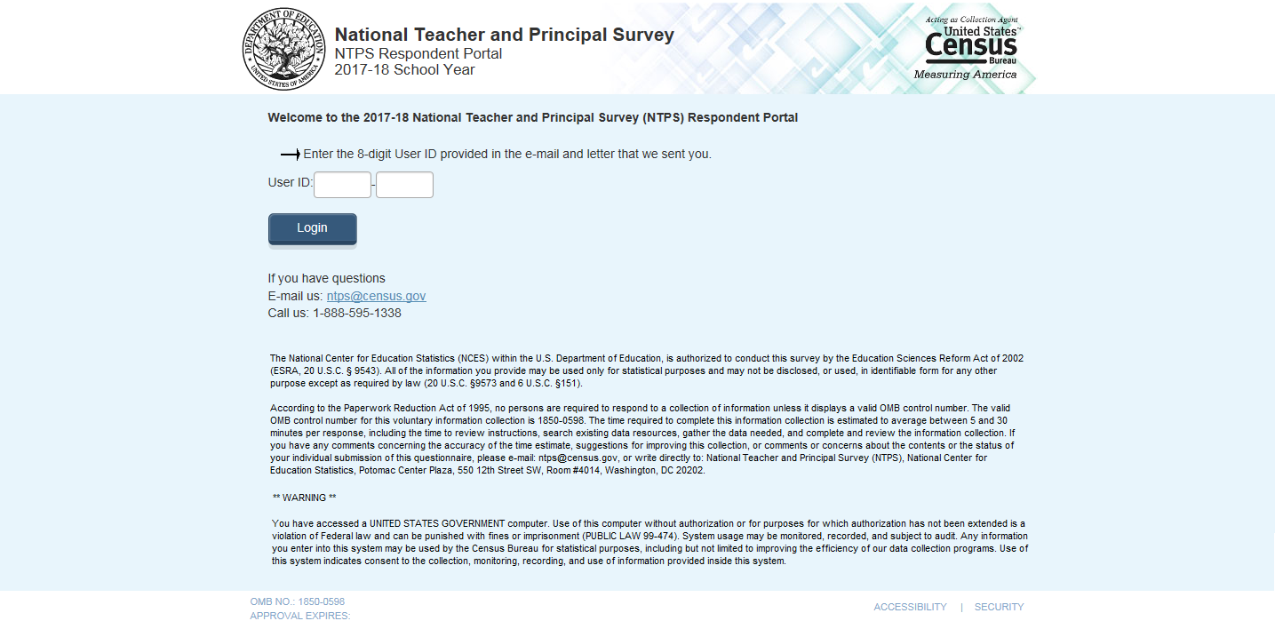
Welcome to the 2017-18 School Survey on Crime and Safety Questionnaire

Enter the User ID found on the letter we mailed to you.
User ID:
<Login> button
Email us: addp.education.survey@census.gov
Call us: 1-888-595-1338

The National Center for Education Statistics (NCES) within the U.S. Department of Education, is authorized to conduct this survey by the Education Sciences Reform Act of 2002 (ESRA 2002, 20 U.S.C. §9543). All of the information you provide may be used only for statistical purposes and may not be disclosed, or used, in identifiable form for any other purpose except as required by law (20 U.S.C. §9573 and 6 U.S.C. §151).
According to the Paperwork Reduction Act of 1995, no persons are required to respond to a collection of information unless it displays a valid OMB control number. The valid OMB control number for this voluntary information collection is 1850-0761. The time required to complete this information collection is estimated to average 53 minutes per response, including the time to review instructions, search existing data resources, gather the data needed, and complete and review the information collection. If you have any comments concerning the accuracy of the time estimate, suggestions for improving this collection, or comments or concerns about the contents or the status of your individual submission of this questionnaire, please e-mail: ssocs@census.gov, or write directly to: School Survey on Crime and Safety (SSOCS), National Center for Education Statistics (NCES), Potomac Center Plaza, 550 12th Street SW, #4012, Washington, DC 20202.

Warning: You have accessed a UNITED STATES GOVERNMENT computer. Use of this computer without authorization or for purposes for which authorization has not been extended is a violation of Federal law and can be punished with fines or imprisonment (PUBLIC LAW 99-474). System usage may be monitored, recorded, and subject to audit. Any information you enter into this system may be used by the Census Bureau for statistical purposes, including but not limited to improving the efficiency of our data collection programs. Use of this system indicates consent to the collection, monitoring, recording, and use of information provided inside this system.

OMB NO: 1850-0761
APPROVAL EXPIRES:

*Note: entering log in information takes respondent to the first question on the SSOCS:18 survey. Questionnaire content on the web instrument is the same as the paper instrument (Appendix B).

Item: Pin:
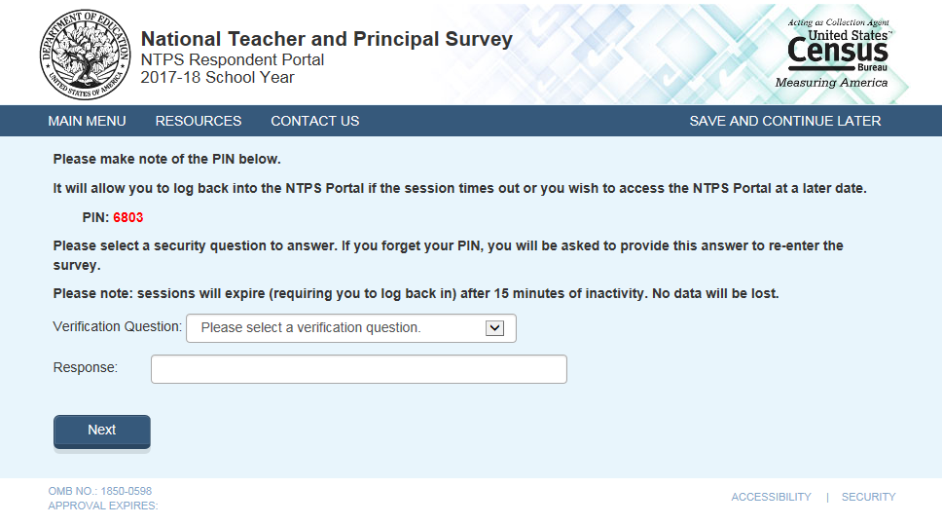
Please make note of the PIN below.
It will allow you to log back into the survey if the session times out or you need to stop and come back later. This survey will take approximately 53 minutes to complete.
PIN:
For your security, we will not be able to reset the PIN if lost or forgotten.
Please note: sessions will expire (requiring you to log back in) after 15 minutes of inactivity. No data will be lost.
Next button
*NOTE: For SSOCS, there will be an additional Definitions tab that will display the list of terms with definitions. This will be identical to the Definitions page on the paper version of the questionnaire (Appendix B).

Item: Recovery
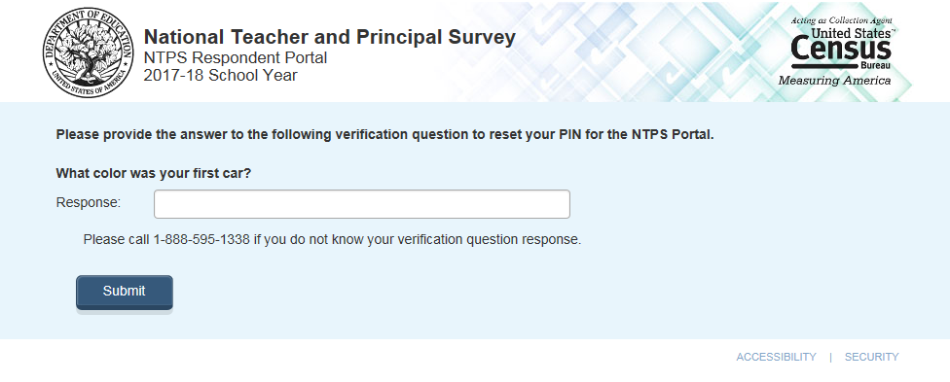
Please provide the answer to the following verification question to reset your PIN for the NTPS Portal.
What color was your first car?
Response:
Submit button
Please call XXX-XXX-XXXX if you do not know your verification question response.

Item: New PIN

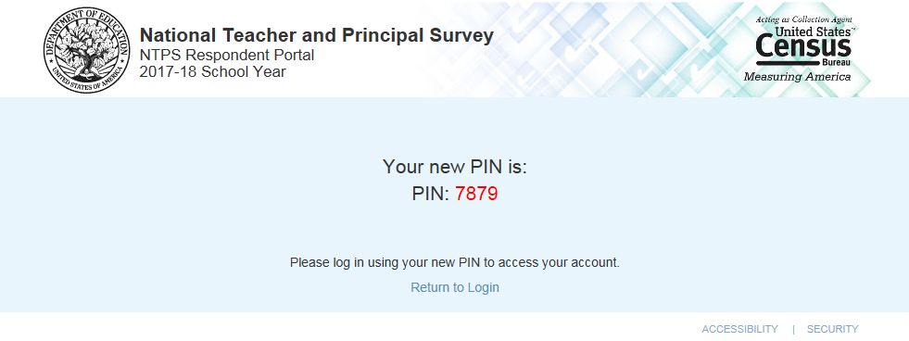
Your new PIN is:
PIN:
Please log in using your new PIN to access your account.

Item: Submit Page
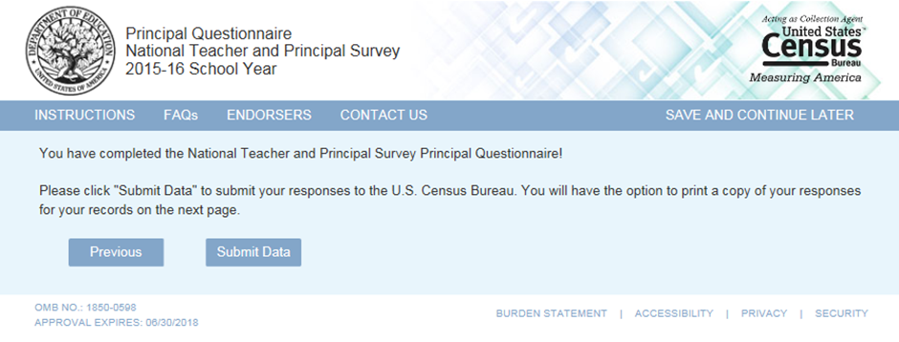
“You have completed the School Survey on Crime and Safety!
Please click “Submit Data” to submit your responses to the U.S. Census Bureau. You will have the option to print a copy of your responses for your records on the next page.”
Previous (button) Submit Data (Button)
Skips:
- Submit Data button should skip to Thank You Page.
  - Previous button should skip to the last question of the survey.

Item: Thank You Page
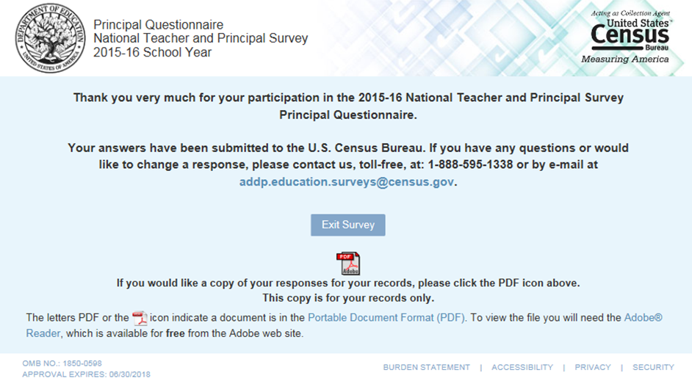
“Thank you very much for your participation in the 2017-18 School Survey on Crime and Safety.
Your answers have been submitted to the U.S. Census Bureau. If you have any questions or would like to change a response, please contact us, toll-free, at 1-888-595-1338 or by e-mail at addp.education.surveys@census.gov.”
Exit Survey button
PDF icon
“If you would like a copy of your responses for your records, please click the PDF icon above.
This copy is for your records only.
The letters PDF or the {PDF icon} icon indicate a document is in the Portable Document Format (PDF). To view the file you will need the Adobe® Reader, which is available for free from the Adobe web site.”
Skips:
- Clicking the Exit Survey button skips to the log in page (login).
- Clicking the PDF icon should open the fillable pdf of the Principal Questionnaire with the respondent’s data filled in.
- Portable Document Format (PDF) should be a hyperlink to http://www.adobe.com/products/acrobat/adobepdf.html?promoid=ISMSP
- Adobe® Reader should be a hyperlink to http://get.adobe.com/reader/

Item: Instructions Tab (instructions)
Return to Survey (button)

Text reads as below:

- Please use the ‘Previous’ and ‘Next’ buttons at the bottom of each page to navigate through the survey, rather than your browser’s back button.
- The survey will take approximately 53 minutes to complete.
- Please complete and submit the survey within two weeks.
- Each time you complete a page, your answers are saved.
- If you do not have the time to dedicate to the entire survey now, you may complete what you are able to and log out. Your responses will be saved, and when you re-enter the survey, you will be taken to the question where you left off.
- Answers to frequently asked questions and a list of survey endorsers are available on the green menu bar.
Thank you for participation in the SSOCS!

Item: Endorsers Tab (endorsers)
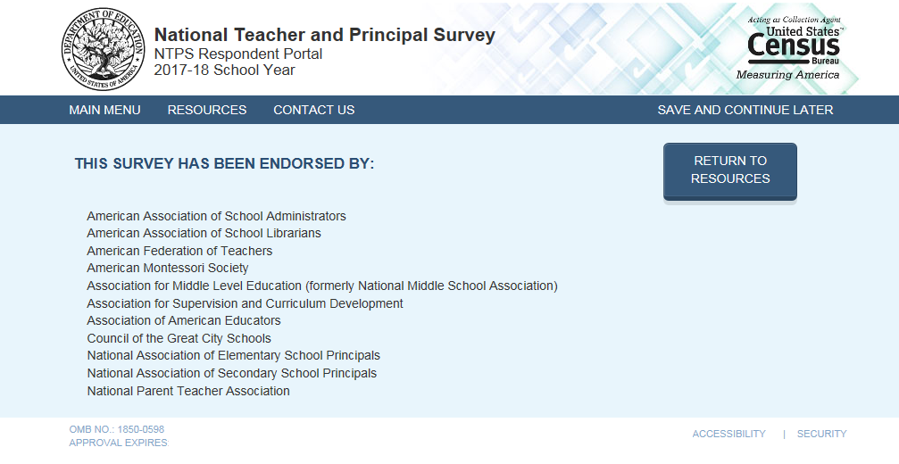
Text Reads as below:

This Survey Has Been Endorsed By:

American Association of School Administrators
American Federation of Teachers
American School Counselors Association
Association for Middle Level Education
Association of American Educators
Council of Chief State School Officers
Education Northwest
National Association of State Boards of Education
National Association of Elementary School Principals
National Association of School Resource Officers
National Association of Secondary School Principals
National Parent Teacher Association (PTA)
National School Safety Center
School Safety Advocacy Council
University of California, Los Angeles (UCLA) Center for Mental Health in Schools
National Association of School Psychologists
School Social Work Association of America

Item: FAQs Tab (faqs)

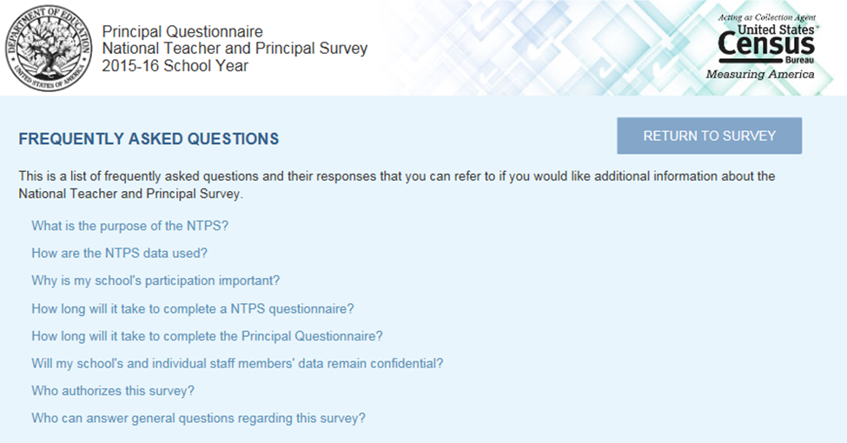
Each question is listed as a link. Move the screen down to the appropriate answer text when the user clicks on a question.
Return to Survey (button)
List the following questions as links. When clicked, display the appropriate answer text.
Why did our school get selected?
From all the public schools in the United States, we selected a random stratified sample of about 4,800 schools that represent the nation for the 2018 School Survey on Crime and Safety. Your school happened to be one of those selected. Your responses will represent schools with similar demographics that were not selected for the survey.
What kinds of questions does the School Survey on Crime & Safety ask?
- Frequency and types of crimes at schools, including homicide, rape, sexual assault, attacks with or without weapons, robbery, theft, and vandalism;
- Frequency and types of disciplinary actions such as removals, transfers, and suspensions for selected offenses;
- Perceptions of other disciplinary problems such as bullying, verbal abuse, and disorder in the classroom;
- Description of school policies and programs concerning crime and safety;
- Description of the pervasiveness of student and teacher involvement in efforts that are intended to prevent or reduce school violence;
- Mental health services available to students at school; and
- General school characteristics.
What is the purpose of this survey?
SSOCS is the primary source of school-level data on crime and safety for the U.S. Department of Education. This study collects information on school crime and safety from school principals in primary, middle, high, and combined schools across the United States. As an ongoing survey, the SSOCS measures changes over time on key issues.
Gathering this information will help schools compare their policies and programs to schools nationwide. It will also help researchers and policymakers identify trends in crime and safety across time and identify emerging problems or issues.
Why should I participate in this survey?
Although this is a voluntary survey, your cooperation is essential to make the results of this survey comprehensive, accurate, and timely. Policymakers and education leaders rely on data from this survey to inform their decisions concerning school programs and policies to reduce crime. Since it is a sample survey, your responses represent the responses of many schools that serve similar student populations. Higher response rates give us confidence that the findings are accurate.
Who is conducting this survey?
SSOCS is conducted by the National Center for Education Statistics (NCES), part of the Institute of Education Sciences (IES), within the United States Department of Education. The U.S. Census Bureau is collecting data on behalf of NCES. NCES is authorized to conduct this survey by the Education Sciences Reform Act of 2002 (ESRA 2002, 20 U.S.C. §9543). Participation is voluntary.

As part of the Department of Education, NCES fulfills a Congressional mandate to:
- Collect, collate, analyze and report complete statistics on the condition of American education;
- Conduct and publish reports; and
- Review and report on education activities internationally.
How will my information be reported?
The information you provide will be combined with the information provided by others in statistical reports. No individual data that links to your name, address, or telephone number will be included in the statistical reports.
How will these data be used?
These data are being collected for the U.S. Department of Education, National Center for Education Statistics (NCES).
Results from the study will be used to increase knowledge of policies and programs schools use to address school crime and safety. Results will also show comparisons on crime and safety data across time from the 2000, 2004, 2006, 2008, 2010, and 2016 surveys.
Summary data from the study will be placed into a public-use dataset for researchers and policy-makers. The dataset is rigorously tested prior to release to ensure no individual schools can be identified.
Reports will be published based on the SSOCS data. You will be able to compare your school’s problems and policies with those of schools that are similar to yours.
How often is the SSOCS administered?
The SSOCS was administered in the spring of the 1999–2000, 2003–04, 2005–06, 2007–08, 2009–10, and 2015-16 school years. The SSOCS will now be administered every two years.
Where can I see the results of the SSOCS?
Downloadable reports from the 1999–2000, 2003–04, 2005–06, 2007–08, and 2009–10 collections of the SSOCS such as Crime and Safety in America’s Public Schools: Selected Findings from the School Survey on Crime and Safety are available at http://www.nces.ed.gov/surveys/ssocs. Also included on the website is a table library with hundreds of tables that provide estimates on school crime and violence by selected school and student characteristics.
How do I know this survey is legitimate?
You can verify the legitimacy of our survey or find out more information on the survey’s website at www.nces.ed.gov/surveys/ssocs. You may also contact the Census Bureau at 1-800-221-1204 or by email at addp.education.surveys@census.gov.
How long will the survey take to complete?
The length of the survey will depend on the characteristics of your school, but for most people it will take about 53 minutes to complete. That time includes time spent filling out the survey itself and referring to additional information sources for the information requested.
What is the importance of this survey!
Measuring the extent of school crime is important for many reasons. The safety of students and teachers is a primary concern, but the nature and frequency of school crime have other important implications as well. Safety and discipline are necessary for effective education. In order to learn, students need a secure environment where they can concentrate on their studies. Dealing with school crime requires school resources. Gathering this information should help researchers and policy-makers devise strategies to address these problems in our schools.
Who authorizes this survey?
The U.S. Census Bureau is administering this survey for NCES as authorized by the Education Sciences Reform Act of 2002 (ESRA 2002, 20 U.S.C. §9543). The Office of Management and Budget (OMB) approved this survey. The OMB control number is 1850-0761 and the approval expiration date is XX/XX/2020.
Who can answer general questions regarding this survey?
Please contact the U.S. Census Bureau at 1-888-595-1338 if you have any questions about the survey. Someone will be available to take your call Monday through Friday, between 8:00 a.m. and 8:00 p.m. (Eastern Time). At any other time, please leave a message and someone will return your call as soon as possible. The U.S. Census Bureau is also available to answer your questions via e-mail at addp.education.surveys@census.gov.
- A ‘Go back to FAQ list’ button is provided after the answer to each question. This button returns the user to the top of the page where all questions are displayed.

Item: Contact Us Tab (contact_us)

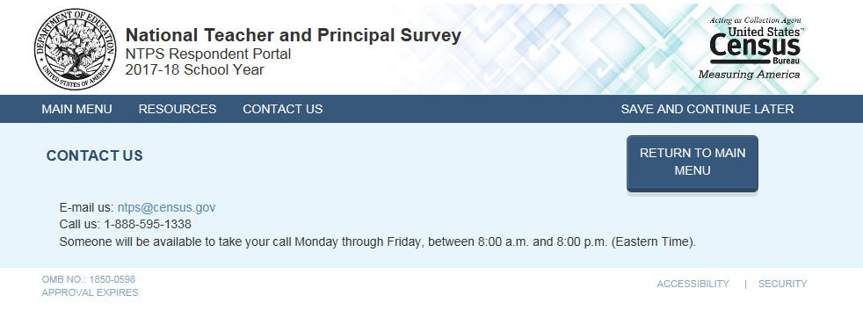

Text Reads (in black font):

“CONTACT US Return to Survey (button)
Email us: addp.education.surveys@census.gov
Call us: 1-888-595-1338
Someone will be available to take your call Monday through Friday, between 8:00 a.m. and 8:00 p.m. (Eastern Time).”

Item: Definitions Tab (definitions)
Return to Survey (button)

This will include terms and definitions that will be identical to the Definitions page on the paper version of the questionnaire (Appendix B).

Item: Accessibility Screen (accessibility)
- Return to Survey (button)
- This screen is accessible by clicking on the “Accessibility” link at the bottom of the page.
- This link will bring the user to: http://www.census.gov/about/policies/privacy/privacy-policy.html#par_textimage_1
- Note: NCES has requested for Census to put the Accessibility content (not highlighted below) on its own page to avoid participant’s confusion when seeing all of the other Census language (shaded in gray below) related to various topics including confidentiality. NCES is waiting to hear back from Census on this request.
- Text Reads As:

Online Privacy Policy
May 02, 2016
I. Online Privacy Policy
II. Our Use of Web Measurement and Customization Technologies
III. Other Information We Collect From E-Mail and Online Forms
IV. Data Retention
V. Children's Online Privacy Protection Act (COPPA)
VI. Document Accessibility
VII. Third Party Web Sites and Applications
VIII. Security & Third Party Links
IX. Contact Us

I. Online Privacy Policy
Privacy Statement
The purpose of this policy is to explain how we handle information we collect during your visit to Census Bureau web sites. This policy does not apply to third-party web sites that you are able to access from our web sites, nor does it cover other Census Bureau information collection practices that do not happen on the Internet.
We do not collect personally identifiable information (name, address, e-mail address, social security number, or other personal unique identifiers) or business identifiable information^{[1]} on our web sites unless we specifically advise you that we are doing so.

Your rights under the Privacy Act:
Information concerning the Privacy Act can be found at the Department of Justice web site.
This policy is updated when the Census Bureau makes relevant technology improvements.
______________________
¹ Business Identifiable Information is defined as (a) information that is defined in the Freedom of Information Act (FOIA) as “trade secrets and commercial or financial information obtained from a person [that is] privileged or confidential” (5 U.S.C.552(b)(4)). This information is exempt from automatic release under the (b)(4) FOIA exemption. “Commercial” is not confined to records that reveal “basic commercial operations” but includes any records [or information] in which the submitter has a “commercial interest” and can include information submitted by a nonprofit entity. Or (b) commercial or other information that, although it may not be exempt from release under FOIA, is exempt from disclosure by law (e.g., 13 U.S.C. 9).

II. Web Measurement and Customization Technologies
We use web measurement and customization technologies^{[2]}, including cookies, to optimize your experience during your visit to our web sites and to provide information about how you use our web site. Technologies commonly known as “cookies,” may include the use of session or persistent cookies. Cookies are a small amount of data generated by a website and saved by your computer to enhance your online interactions and preferences. The Census Bureau only uses session cookies. These cookies are deleted when your web browser is closed.
There are three “tiers” of these web measurement and customization technologies, as established by the Office of Management and Budget (OMB):

Tier 1 - Single Session
This technology tracks the user’s online interactions within a single session or visit to a single web site. Any information related to a particular visit to the web site is deleted from the user’s computer immediately after the session ends.

Tier 2 - Multi Session without Personally Identifiable Information
This technology notices when a user returns to a web site and “remembers” his or her online interactions and preferences across multiple sessions, typically for the purpose of statistics on web usage, but also for customizing people’s online experience. The Census Bureau does not use cookies to save your online interactions. The Census Bureau uses your login information, not cookies, to retrieve information from previous sessions.

Tier 3 - Multi Session with Personally Identifiable Information
This tier encompasses any use of multi-session web measurement and customization technologies when PII and BII is collected (including when the agency is able to identify an individual as a result of its use of such technologies). The Census Bureau does not use Tier 3 technologies.
The following sections include information describing the use of these tiers when you visit Census Bureau web sites.

Tiers Accessed When You Visit Our Web Sites

A. Data Collected Automatically
When you visit our web sites to read pages or download information, Tier 1 technology is used. We automatically collect and store the following non-personally identifying information:
- The Internet protocol (IP) address from which you access our web site. An IP address is a unique number that is automatically assigned to the computer you are using whenever you are surfing the web. This is used for our own Internet security protocols to help protect the security of the Census Bureau’s IT systems and your data.
- The type of browser, such as Safari, Internet Explorer, or Firefox and operating system, such as Windows 7, Windows Vista, Windows XP, OSX, or Linux, used to access our site, to optimize your web page experience.
- The date and time our web site is accessed, for the purpose of monitoring demand.
- The pages visited, for the purpose of improving the usefulness of our web site by providing helpful links and removing pages that are not read.
- The last web site you visit, if that web site contains a link to a Census Bureau web page, indicates how you found this web site.
The information we retain does not include personally identifying information. The above information is maintained in our system logs for analytical purposes to improve our web pages. The logs may be kept indefinitely and used at any time and in any way necessary to prevent a security breach and to ensure the integrity of the data on our servers.

B. American FactFinder
When you make use of American FactFinder, Tier 1 technology is used. Transient cookies are used to keep track of user selections so that new requests for specific data or maps can be created more efficiently. No personally identifiable information is permanently retained on either the users’ or the Census Bureau's computers. These transient cookies go away completely when you exit the browser. When you order products, we enable transient cookies to track your order through the process.

C. Electronic Census Bureau Surveys or Censuses
Under federal law, we protect the confidentiality of the data we collect. When you respond to a survey or census via the Internet, you may have to provide us personally identifiable information (PII) or business identifiable information (BII). For each survey and census, we provide an explanation to respondents about the confidentiality of the data and the laws that protect the data (e.g., Title 13, United States Code Section 9 (a)) protect against unauthorized disclosure under penalty of $250,000 and up to 5 years in prison, or both.
When you respond to surveys or censuses over the Internet that collect identifiable information, Tier 2 technology is used. Personally identifiable information or business identifiable information collected in the course of a survey or census is not used to customize your online experience.
Once you access an online survey or census, we automatically collect information about how long it took you to complete the survey or census, which questions you answered, and how many times you logged into the survey or census. In addition, we collect data on navigation of the survey or census, which includes mouse clicks and any data entered onto the survey or census, whether or not the survey or census is completed and submitted. These data are used in aggregate to assess the usability of the survey or census, or for other authorized statistical purposes. They are protected under the same confidentiality procedures as response data.
All web data submissions are encrypted to strengthen further the protection of the information we collect online. Per the Federal Cybersecurity Enhancement Act of 2015, your data are protected from cybersecurity risks through screening of the systems that transmit your data.
Questions concerning this policy may be addressed to: ask.census.gov, attn: Policy Coordination Office.

D. Blocking the use of Cookies (Opt Out)
The technologies we describe in this policy are the default settings. However, you can remove or block the use of web cookies by changing the setting of your browser as described at www.usa.gov/optout_instructions.shtml.
Should you choose to remove or block the use of web cookies, we will provide you with alternatives for acquiring comparable information or services.
______________________
² Web measurement and customization technologies are defined as technologies are used to remember a user’s online interactions with a website or online application in order to conduct analysis of usage or to customize the user’s experience

III. Other Information We Collect From E-Mail and Other Online Forms
When you send us personally identifiable information or business identifiable information over e-mail, we only use the information we need in order to respond. When you send us personally identifiable information or business identifiable information on online collection forms (e.g. conference registrations, contact lists, etc.), we only use the information for the stated purposes (shown either on the form or on a corresponding Privacy Act Statement). All information our web site visitors submit via e-mail or an online form is voluntary. Submitting voluntary information constitutes your consent to the use of the submitted information for the stated purpose.
We may contact you by email to invite you to participate in a survey or census, but we will not ask you to provide responses via email.

IV. Data Retention
We retain questions and comments only if required by law, or for a specific program need, as specified by the National Archives and Records Administration’s General Records Schedule (GRS) 20, Electronic Records or other approved records schedule as applicable.

V. Children's Online Privacy Protection Act (COPPA)
The Children’s Online Privacy Protection Act (COPPA), 16 CFR Part 312, requires operators of web sites directed to children under age 13, and operators that have actual knowledge of collecting or maintaining personal information from children under 13, to obtain verifiable consent from parents prior to the collection, use, or disclosure of personal information from children. We do not knowingly collect personal information from children under age 13 on our web sites.
For more information regarding COPPA please visit the Federal Trade Commission’s Privacy web site and select the Children’s Privacy link.

VI. Document Accessibility
The Census Bureau is committed to making online forms and other public documents on its Internet server accessible to all. Currently, we are reviewing our web sites and making modifications to those pages, which are not in compliance with the Americans with Disabilities Act. We use Hypertext Markup Language (HTML) to create pages that are generally accessible to persons using screen-reading devices, and we are careful in our construction of HTML documents to ensure maximum accessibility. We include alternate text describing graphics.
Many Census Bureau Internet documents are in ASCII or HTML formats. These documents are accessible to persons using screen-reading software. We also have a large number of documents in Adobe Acrobat PDF (Portable Document Format) files. Currently, many people using screen-reading devices cannot read documents in PDF format, specifically those that were created from a scanned hard copy.
Adobe Systems, Inc. is producing various products designed to make Adobe Acrobat documents accessible to persons using screen-reading software. Adobe's accessibility web pages describe their efforts.
To allow us to better serve those with visual disabilities who are having difficulty accessing PDF documents; you may contact us directly for further assistance at 301-763-INFO (4636), 800-923-8282, or by submitting a request at ask.census.gov.

VII. Third Party Web Sites and Applications
The Census Bureau has a presence on several social media/Web 2.0 platforms (Facebook, YouTube, Twitter and Flickr, and other third-party services)) and clearly contain the Census Bureau’s official logo. Each of these web sites provides the Census Bureau unique ways of sharing information. It also allows visitors with a way to communicate with the agency. Some may allow visitors to log in, create profiles and save information in those profiles. We do not collect any personally identifiable information about you through your use of these social media/Web 2.0 platforms. We may collect public information, such as user/screen name, city, state, and zip code of visitors to these web sites, and comments posted about the Census Bureau for statistical, research, and promotional purposes only. Further, the Census Bureau has no control over the third-party’s use of this information and is not liable regarding the third-party’s safeguarding your information. These web sites have their own privacy, security and accessibility policies.
The Census Bureau will also use a third-party web site or application (hosted service) to conduct customer satisfaction surveys and/or feedback forms. These surveys and/or feedback forms may collect your name and email address for processing purposes. The results from these surveys or forms are used to conduct primary research into the quality of the Census Bureau programs and products. The results collected will be used strictly for internal program management purposes to assess staff work, material design and development and to enhance planning efforts for current and future surveys and censuses. In addition, other third-party web sites or applications may be used to host Census Bureau data products to be used by the public. These web sites do not require the use of personally identifiably information or business identifiable information.

VIII. Security & Third Party Links

A. Security, Intrusion, and Detection
To ensure that computer service remains available to all users, this government IT system employs software programs to monitor network traffic to identify unauthorized attempts to upload or change information, or otherwise cause damage to our computer system. Web sites identified as representing an actual or potential security threat to Census Bureau information and/or information resources are blocked. Further, web sites that are known to violate Census Bureau, Department of Commerce, and/or Federal guidelines regarding access to certain types of web sites and/or content are blocked, for example:
- Web sites hosting malware/spam
- Web sites involved in the compromise of other government agencies
- Adult content web sites
- On-line storage and file sharing web sites
- Freeware/Shareware web sites
- Web sites attacking Census Bureau systems (attempting to identify and exploit vulnerabilities in Internet facing systems)
- Web sites scanning Census Bureau systems (attempting to identify Internet facing systems)

B. Links to Other Web Sites
Our web site contains links to other federal agencies, international agencies, and private organizations. Once you link to another web site, you are subject to the policies of the new web site.
Links to non-government websites are denoted by . Our linking to non-government web sites does not constitute an endorsement of any products, services or the information found on them.

IX. Contact Us
Need more information about the Census Bureau's privacy and confidentiality protections? Contact our Policy Coordination Office at 301-763-6440 or toll-free at 1-800-923-8282.

Data Requests
For information about data requests, please contact the Customer Services Center at (301) 763-INFO (4636) or toll-free 1-800-923-8282. You can also obtain additional information by visiting our Frequently Asked Questions page on our web site at ask.census.gov.

*Department of Justice link under “Your rights under the Privacy Act” shows the following text:

Privacy Act of 1974
The Privacy Act of 1974, 5 U.S.C. § 552a, establishes a code of fair information practices that governs the collection, maintenance, use, and dissemination of information about individuals that is maintained in systems of records by federal agencies. A system of records is a group of records under the control of an agency from which information is retrieved by the name of the individual or by some identifier assigned to the individual.
The Privacy Act requires that agencies give the public notice of their systems of records by publication in the Federal Register. Click here to see a list of DOJ systems of records and their Federal Register citations. The Privacy Act prohibits the disclosure of a record about an individual from a system of records absent the written consent of the individual, unless the disclosure is pursuant to one of twelve statutory exceptions. The Act also provides individuals with a means by which to seek access to and amendment of their records, and sets forth various agency record-keeping requirements.

Overview of the Privacy Act
The "Overview of the Privacy Act of 1974, 2015 Edition" is a comprehensive treatise of existing Privacy Act case law. Any questions regarding the Overview may be directed to the Office of Privacy and Civil Liberties staff.

*ask.Census.gov link under “Electronic Census Bureau Surveys or Censuses,” “Document Accessibility,” and “Data Requests” shows the following text:

Frequently Asked Questions
Hi. How can we help?
SEARCH ALL HELP

FEATURED FAQs
Where can I find information about the way people use their time?.

Most Popular FAQs
Do you have 2002 Economic Census data available for the Island Areas?
Do you have any information on the Traffic Analysis Zone (TAZ) boundaries?
How do I find out the actual revenue inflow and outflow of the United States (U.S.) Federal Government?
What information do you have on federal domestic spending as well as federal aid to state and local governments?
Where can I find data classified by the size of the company?
Where do I find basic information about the Single Audit process and the Federal Audit Clearinghouse?
Do you have information on the number of medical doctors?
Construction Spending: What data are used to calculate construction spending for residential improvements?
I have some questions about the Automatic Export System (AES) Compliance Conference seminars and workshops.
Nonemployer Statistics: Does Nonemployer data cover Island Areas businesses?
Does the American Housing Survey (AHS) collect data on the luxury home market (e.g., data on homes over $1 million)?
Are there measures of reliability for the one-family price indexes?
In M3 releases, why are there no unfilled orders or new orders for non-durable industries?
When are you conducting the 2015 Census Test in the Savannah media market?
Why does the Census Bureau collect information on Hispanic origin in the 2015 Census Test?

*www.usa.gov/optout_instructions.shtml under “Blocking the use of Cookies (Opt Out) shows the following text:

Web Measurement and Customization Opt-Out

Persistent Cookies
Many websites use "persistent cookie" technology. A persistent cookie is a small text file that this website places on your web browser so that it can gather anonymous summary demographic information, and remember your browser when it is used to visit our site again later—kind of like cookie crumbs! (Hence the name.) These cookies uniquely identify a browser on a computer, but never a person. In other words, if the same person uses Chrome and Internet Explorer, two unique browser cookies will be assigned, one for each browser, so that person well be counted as two different visitors because visits are based on browsers, not computers or persons. Most Internet browsers automatically accept persistent cookies. Although using persistent cookies creates a much better experience for you while using the site, most sites will also work without them. If you don't want to accept cookies, you can edit your browser's options to stop accepting persistent cookies or to prompt you before accepting a cookie from the websites you visit. Below you'll find directions to help you disable cookies in some of the most popular desktop browsers and mobile browsers.
Important: If you choose to set your browser to reject cookies from every website you visit, this may adversely affect the functionality of non-government websites you visit.

Changing Cookies Settings in Popular Desktop Browsers

Firefox Version 3.5 or Later
- In the "Tools" menu, select "Options"
- Under the "Firefox will:" dropdown, select "Use custom settings for history"
- Uncheck the "Accept Cookies from Sites" box to block all cookies Or
- Click the "Exceptions" button to enter specific websites that you wish to allow/disallow to set cookies

Internet Explorer version 6 or later
- In the "Tools" menu, select "Internet Options"
- Click the "Privacy" tab
- Move the "Settings" slider up or down to adjust your cookie acceptance settings (moving the slider all the way to the top will block all cookies) Or
- Click the "Sites" button to enter specific websites that you wish to allow/disallow to set cookies

Safari version 4 or later
- Click the geared wheel icon in the top right of your browser window.
- Select "Preferences"
- Select the "Security" tab
- Under "Accept Cookies:", click the "Never" option to block all cookies

Chrome version 4 or later
- Click the wrench icon in the top right of your browser window
- Select "Options"
- Click the "Under the Hood" tab
- Click the "Content Settings" button
- Click the option to "Block sites from setting any data" to block all cookies Or
- Click the "Exceptions" button to enter specific websites that you wish to allow/disallow to set cookies

Disabling cookies in popular mobile browsers

Mobile Safari
- From your home screen on your iPhone or iPad, click "Settings"
- Click on "Safari"
- Click on "Accept Cookies"
- Select "Never" to block all cookies

Opera Mini on a Blackberry device
- From within the Opera Mini browser, press the menu key.
- Scroll down to access the drop down menu of options
- Select "Settings"
- Select "Privacy"
- Change the "Accept cookies" option to "Off" to block all cookies

Android Browser
- From within the Android browser, hit the menu key.
- Select "More"
- Select "Settings"
- Uncheck the "Accept Cookies" option to block all cookies

Disabling Google Demographic and Interest Reports
Many sites also use Google Demographic and Interest reports to gather anonymous summary demographic information about website visitors such as gender, age range, and areas of interest for adults over the age of 18. You can prevent your data from being collected and used by Google Analytics by installing the Google Analytics opt-out browser add-on.

Disabling AddThis Targeting Cookie
Many sites use AddThis to enable easy content sharing. AddThis collects non-personally identifiable information, and uses the information to deliver targeted advertising and personalized content. You can prevent your data from being collected and used by AddThis, by opting-out of AddThis targeted advertising.

Government Cookie Policy
The Office of Management and Budget released guidance in June 2010, updating how Federal agencies can use web measurement and customization technologies (PDF, Download Adobe Reader), such as persistent cookies.
USA.gov is providing a central place to provide instructions for "opting-out" from one of the most common forms of web measurement and customization technologies, through disabling cookies on your web browser. We also provide instructions on opting out of Google Analytics.
Back to Top

Do you need help?
Ask us any question about the U.S. government for free. We'll get you the answer or tell you where to find it.
- Call USA.gov
- Chat with USA.gov
- E-mail USA.gov

What you think matters!
Was this page helpful?
Yes No
Next

Bottom of Form
Form Approved OMB#3090-0297 Exp. Date 07/31/2019
*Federal Trade Commission’s Privacy web site link under “Children’s Online Privacy Protection Act (COPPA) shows the following text:

Privacy Policy

What Does the FTC Do with Your Personal Information?

Our Privacy Policy
Federal law requires us to tell you how we collect, use, share, and protect your personal information. Federal law also limits how we can use your personal information. Protecting the privacy and security of consumers' personal information is very important to us. Please read this notice carefully to understand what we do with the personal information we collect both online and offline.
When you contact us to help you with a problem, we may collect personal information about you. We collect and use only the information necessary to respond to your concerns and conduct investigations. In most instances, we collect minimal personal information, such as name, address, telephone number, or email address. In limited cases, depending on the nature of your request or of our law enforcement investigations, we also may collect other personal information such as Social Security numbers, account numbers, or mortgage or health information. We also may collect information about your visit to our websites for security and internal operations purposes.

When do we collect personal information?

When you contact us...
- to order publications, obtain redress, or register for the National Do Not Call Registry.
- to file a complaint or seek help for possible consumer fraud or identity theft.
- to file a public comment or participate in a rulemaking, workshop, or community engagement project.

When we contact you...
- to ask if you will participate in a consumer survey.
- to provide information in response to a subpoena or other legal process.

When we contact others...
- to collect information about potential victims when we investigate possible law violations.

Where does your information go?

Within the FTC...
- we use consumer information to further our law enforcement investigations.
- our contractors use your information when they perform certain services, such as operating the National Do Not Call Registry or our Consumer Response Center, processing redress claims, or fulfilling your order for publications.

To other government agencies (federal, state, local, international)...
- we work with our partners to investigate complaints, coordinate law enforcement investigations, cooperate with oversight investigations, or follow up on ID theft reports.

To others outside government...
- we post public comments and transcripts, including names, state of residence, and other non-confidential information, on the FTC website in a rulemaking, workshop, blog, or other public FTC proceeding.
- we provide information to credit bureaus for complaints about consumer fraud, ID theft, or credit reports.
- we provide only your phone number to telemarketers to enforce the National Do Not Call Registry.
- we provide information to businesses or individuals in response to court orders, subpoenas, or Freedom of Information Act requests, or to resolve complaints.
- we use third-party services on our websites to assist in communicating or interacting with the public.

Additional FTC Privacy-Related Information
- FTC Website Policy
- FTC Use of Cookies
- FTC Use of Third-Party Services & Websites
- FTC Social Media Accounts
- FTC Privacy Impact Assessments

Privacy Act Information
The FTC’s Privacy Act rules – including our procedures, timelines, and instructions for submitting Privacy Act requests, and a list of FTC systems of records that are exempt from the Act’s requirements – are published at 16 C.F.R. 4.13.
- List of FTC Privacy Act Systems of Records
- For more information about making a Privacy Act request, visit our FOIA request page or use our online request form.

Questions or Complaints About This Privacy Policy
Write to the FTC's Chief Privacy Officer:
Katherine Race Brin
Federal Trade Commission
600 Pennsylvania Ave., NW, H-444
Washington, DC 20580
cpo@ftc.gov (link sends e-mail)

Questions About Identity Theft & Online Issues
Visit ftc.gov/idtheft to learn about the crime of identity theft, including detailed information to help you deter, detect, and defend against it.
Visit OnGuardOnline to learn how to be on guard against Internet fraud, secure your computer, and protect your personal information.

Questions About Other Issues
Visit our Contact Us page to find email, phone, and mail contact information and links to our secure online complaint forms.

Frequently Asked Questions
- Personal Information Collected by the FTC
- Children's Information
- Information Collected From FTC Websites
- Review of Your Information
- Limiting Use of Personal Information
- Protecting Personal Information
- Leaving the FTC Website
- Information Collected by Third-Party Services
Revised October 2016

*Accessibility web pages link under “Document Accessibility” shows the following text:
Adobe® Acrobat® DC and Adobe Acrobat Reader® DC software continue the tradition of providing strong accessibility support for Adobe PDF documents and forms. Acrobat DC features a number of built-in accommodations for people with disabilities, as well as support for users of assistive technologies. In addition, Acrobat DC provides authors with a complete set of tools to create and optimize accessible PDF files from almost any source.

Overview
- Meet PDF accessibility standards
- Acrobat DC accessibility features
- Acrobat DC accessibility FAQ

Video
- Preparing InDesign files for accessibility
Learn how to use Acrobat and Adobe InDesign® to prepare accessible PDF files for people with disabilities.

Related Resources
- More product information

Accessibility guidelines
- Acrobat DC accessibility guides

Voluntary Product Accessibility Templates
- Acrobat Pro DC (OSX) VPAT
- Acrobat Pro DC (OSX, perpetual license) VPAT
- Acrobat Pro DC (Windows®) VPAT
- Acrobat Pro DC (Windows, perpetual license) VPAT
- Acrobat Standard DC VPAT
- Acrobat Standard DC (perpetual license) VPAT
The Webpage also contains links to additional Census-related content:
- Data Protection
- Privacy Impact Assessments (PIA)
- System of Records Notices (SORN)
- Online Privacy Policy
- Contact Us

- Topics Population, Economy
- Geography Maps, Products
- Library Infographics, Publications
- Data Tools, Developers
- Surveys/Programs Respond, Survey Data
- Newsroom News, Blogs
- About Us Our Research

- Census.gov
- About the Bureau
- Policies and Notices
- Data Protection and Privacy
- Online Privacy Policy

- U.S. Department of Commerce
- Blogs
- Index A-Z
- Glossary
- FAQs

Item: Security Screen (security)
- Return to Survey (button).
- This screen is accessible by clicking on the “Security” link at the bottom of the page.
Text Reads As:

“Data are Encrypted at all Times
Our secure servers use Hypertext Transfer Protocol over Secure Socket Layer (HTTPS) to ensure the encrypted transmission of data between your browser and the U.S. Census Bureau. This means that instead of sending readable text over the Internet, both your browser and our servers encode (scramble) all text using a security key. That way, personal data sent to your browser and data you send back are extremely difficult to decode in the unlikely event of interception by an unauthorized party. As a result of this, your browser must be capable of using the required encryption protocol and strength in order to connect to our servers. If you cannot connect to our secure servers, please upgrade to a newer browser.
Third Party Identity Proofing
Our secure servers use a digital certificate (digital ID) issued by a trusted, third party Certificate Authority (CA) as proof of identity. The only way to be sure of a web site's authenticity is to view their digital ID. In this way, you can be assured that you are not being "spoofed" or tricked by an imposter. The digital ID will contain information such as the name of the organization that owns the web site, the site's registered internet name/address, and the name of the Certification Authority under which the digital ID was issued. The method for viewing a web site's Digital Certificate/ID varies depending on the web browser. Please see your browser's "Help" information for instructions on how to verify a web site's identity. “

SSOCS Webpage Text
http://www.nces.ed.gov/surveys/ssocs

Header
<SSOCS logo> <School Survey on Crime and Safety (SSOCS)>
<Publications & Products> <SSOCS & SCS Table Library> <Staff>

Left panel
<Overview>
<Survey Topics>
<Data Products>
<Questionnaires>
<Join NewsFlash>

<Overview>
The School Survey on Crime and Safety (SSOCS) is the primary source of school-level data on crime and safety for the U.S. Department of Education, National Center for Education Statistics (NCES). The SSOCS is a nationally representative cross-sectional survey of public elementary and secondary schools. To find out more information about SSOCS, please click on the questions below.

- What is SSOCS?
- The School Survey on Crime and Safety (SSOCS) is the National Center for Education Statistics' sample survey of the nation's public schools designed to provide estimates of school crime, discipline, disorder, programs and policies. SSOCS is administered to public primary, middle, high, and combined school principals in the spring of even-numbered school years.

- Who participates in SSOCS?
- SSOCS is administered during the spring of the school year to allow principals to report the most complete information possible. SSOCS was first administered to principals in the spring of the 1999–2000 school year. It has since been administered in the springs of the 2003–04, 2005–06, 2007–08, 2009–10, and 2015-16 school years. It will be administered again in the spring of the 2017–18 school year. Sampling details for each SSOCS administration can be found in its data products.

- When is SSOCS administered?
Over 3,000 public school principals are selected to receive the SSOCS questionnaire. The SSOCS sample is large enough to provide national estimates of all public schools, while taking into account a number of factors, including the level of instruction, student enrollment size, and urbanicity.
- What topics are covered by SSOCS?
The SSOCS questionnaire asks principals to report on a variety of topics related to crime and safety, including:
  - School Practices and Programs,
  - Parent and Community Involvement at School,
  - School Security,
  - Staff Training,
  - Limitations on Crime Prevention,
  - Frequency of Crime and Violence at School,
  - Frequency of incidents reported to police or law enforcement,
  - Frequency of hate crimes, gang-related crimes, and gang-related hate crimes,
  - Disciplinary problems and disciplinary actions, and
  - Other school characteristics related to school crime.

- Where can I learn more about SSOCS and other crime and safety data collections?
The SSOCS Publications and Products page contains SSOCS data products, reports, and other publications. The Crime and Safety Surveys page has information on SSOCS and other surveys.

<Survey Topics>
Sections of the SSOCS questionnaire are composed of items about specific topics. Click on the section name to read more about these topics.
- School Practices and Programs
The first section of SSOCS, entitled "School Practices and Programs," addresses current school practices and programs relating to crime and discipline. Numerous practices and programs are included in this section to inform procedures by which schools attempt to prevent and reduce crime, disorder, and violence, as well as procedures to ensure the most effective response to a myriad of potential crisis situations. Although the data are not intended to be used to evaluate the state of national school practices, the variables detailed in this section arguably present a foundation from which policymakers and researchers can begin to understand environments in which crime occurs and may be used as a catalyst for influencing safer schools
- Parent and Community Involvement at School
The second section of SSOCS, "Parent and Community Involvement at School," seeks to collect information about efforts on behalf of schools to involve parents in maintaining school discipline and in responding to student problem behaviors. It also addresses the level of parent or guardian participation in school-related activities. This section additionally seeks to inform the extent to which community groups and related organizations and agencies are involved in schools’ efforts to promote safe schools, including juvenile justice agencies, social service agencies, and religious organizations.
- School Security
This third section of SSOCS, "School Security," asks respondents about the presence of security guards, security personnel, and sworn law enforcement officers at their school. These questions seek to collect data that will illustrate the coexistence of the presence of these personnel and reports of school crime. This section also asks the respondent questions about the presence of school security during various times throughout the school day and after school hours, the number of full- and part-time security employees, whether they were armed, as well as their participation in particular school activities such as training teachers and staff in school safety or crime prevention and mentoring students.
- Staff Training
The fourth section of SSOCS, entitled "Staff Training," asks respondents about training provided by the school or school district for classroom teachers or aides. Topics addressed include classroom management, school-wide discipline policies and practices related to violence, safety procedures, and the identification of potentially violent students and those that are using illegal substances. This section also inquires about training for positive behavioral intervention strategies. A school’s use of such profiles may affect school-wide levels of discipline, yet also serve to achieve prevention through student-specific targeted interventions.
- Limitations on Crime Prevention
The fifth section of SSOCS, entitled "Limitations on Crime Prevention," asks respondents whether their efforts to reduce or prevent crime have been constrained by any factors related to teachers, parents, students, or administrative policies. Such limitations include inadequate teacher training or lack of teacher support for school policies, likelihood of complaints from parents, fear of student retaliation, and federal, state, or district policies on discipline and safety. The data from this section can be used to determine whether these limitations are indeed correlated with school crime.
- Frequency of Crime and Violence at School
The sixth section of SSOCS, entitled "Frequency of Crime and Violence at School," focuses on the incidence of homicides and shootings that occur at school. Fortunately, incidents of this type are rare; therefore estimates based on these measures will not be reported.

- Number of Incidents
The seventh section of SSOCS, "Number of Incidents," asks respondents about the frequency of a range of serious criminal incidents recorded as occurring on their school campuses. It is important to note that this section refers to specific incidents, not the number of victims or offenders, and the respondent was asked to include recorded incidents committed by both students and non-students. In addition to the total number of recorded incidents, respondents were asked to report how many of the recorded incidents were reported to the police. The criminal incidents this section discusses include rape, robbery, physical attack, theft, possession of a weapon, alcohol or illegal drugs, and vandalism. It also asks for the number of hate crimes, gang-related crimes, and gang-related hate crimes, as well as the number of disruptions such as death or bomb threats, and chemical, biological, or radiological threats.
- Disciplinary Problems and Actions
The eighth section of SSOCS, entitled "Disciplinary Problems and Actions," asks about the degree to which schools face a variety of disciplinary problems and their response. School administrators were asked about the availability and use of a number of disciplinary actions, as well as the use of disciplinary actions including removals from school, transfers, and out-of-school suspensions for specified offenses. The data provided by this section will be helpful in assessing the impact of schools’ control of lesser violations, as well as providing another measure of the disciplinary measures used in U.S. schools.
- School Characteristics
The ninth section of SSOCS, entitled "School Characteristics," asks respondents about the structural characteristics of the school campus and features of the student body. Variables include total enrollment, English proficiency, percentage of students eligible for free or reduced-price lunch, percentage male enrollment, typical number of classroom changes, level of crime where the school is located and in the areas where students live, and the number of student transfers in and out of their particular school. Correlating these characteristics with incidence of crime and safety practices will assist in developing targeted efforts to address the specific needs of schools.

<Data Products>

Public-use data files from past iterations of SSOCS can be downloaded in various software formats by clicking on the links below. Survey documentation can be viewed, downloaded, and printed as PDF files. ASCII files are below and can be used with the setup files provided to read in data to formats that are not provided on this page. To request access to restricted-use SSOCS data, please visit the restricted-use data licenses page.

School Survey on Crime and Safety (SSOCS)
2009-10 SSOCS Data Products (link goes to section below)
2007-08 SSOCS Data Products (link goes to section below)
2005-06 SSOCS Data Products (link goes to section below)
2003–04 SSOCS Data Products (link goes to section below)
1999–2000 SSOCS Data Products (link goes to section below)

2009–10 SSOCS Data Products
Data Files
Top

2007–08 SSOCS Data Products
Data Files
SAS Files
SPSS File
STATA File
ASCII (Text) Files
Data Documentation
Top

2005–06 SSOCS Data Products
Data Files
SAS Files
SPSS File
STATA File
ASCII (Text) Files
Data Documentation
Top

2003–04 SSOCS Data Products
Data Files
SAS Files
SPSS File
ASCII (Text) Files
Data Documentation
Top

1999–2000 SSOCS Data Products
Data Files
SSOCS Public-Use Data CD-ROM
SAS Files
SPSS Files
STATA File
ASCII (Text) Files
Data Documentation

<Questionnaires>

The questionnaires below can be viewed, downloaded, and printed as PDF files.

Downloadable Questionnaires

<list of questionnaires>

Visit the help section for help on viewing, downloading, and printing PDF files.

<Join NewsFlash> (link goes to NCES NewsFlash homepage for viewers to sign up)

Header: <Publications and Products>
<Data Products>
List of SSOCS-related products
<Reports>
List of products including SSOCS data (Condition of Education, Indicators of School Crime)
<Shorter Publications>
List of brochures

Header: <SSOCS & SCS Table Library>

(each bullet links to a drop-down menu of a list of tables related to that topic)
- Bullying and Cyber-bullying  - Disciplinary Problems and Actions  - Disruptions and Threats  - Drugs, Alcohol, and Illegal Substances  - Fear and Avoidance  - Firearms, Explosives & Other Weapons | - Gangs and Hate Crimes  - Parent and Community Involvement  - Physical Fights, Assaults & Sexual Harassment  - Prevention Programs and Training  - Security Practices & Rules  - Violent Crimes and Theft  - Student Experiences
SSOCS is a nationally representative sample of regular public elementary, middle, secondary and combined schools. Completed by school principals, the survey asks about school safety practices, school violence prevention programs, and the frequency of school crime and violence.
SCS is a national survey of students ages 12 through 18 in U.S. public and private elementary, middle, and high schools. Created as a supplement to the NCVS, SCS collects information about characteristics of school-related crime, victimization, and safety.
- View complete list of SSOCS and SCS data tables. (this link goes to a page with a complete listing of all crime-related tables)
Clicking on a plus sign (+) will display the contents of a publication. Clicking on "Show All" will open all sections and sub-sections, including all tables. Click on the minus sign (-) or "Hide All" to close sections.
indicates a recently added or modified table.
Header: <Staff>

Survey Area: Crime and Safety Surveys - CSS

Staff: Hansen, Rachel

