**ATTACHMENT**

(Sample Area Segment)

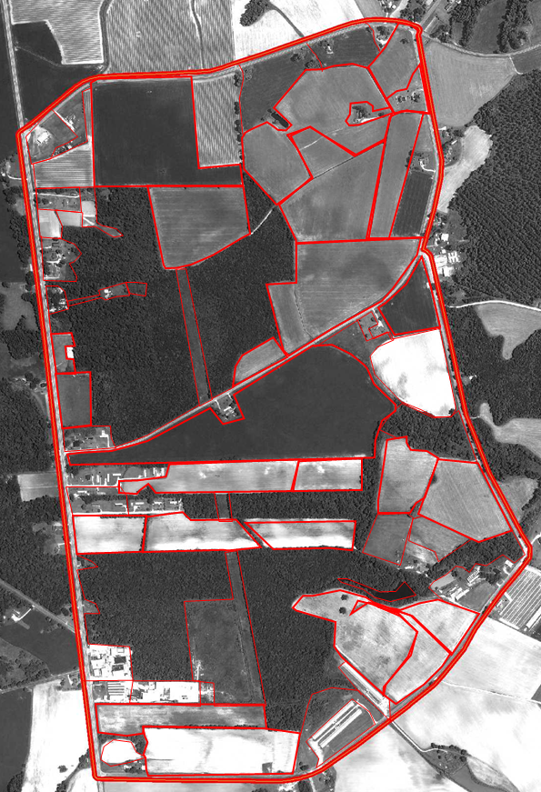

## A-1

Indiana

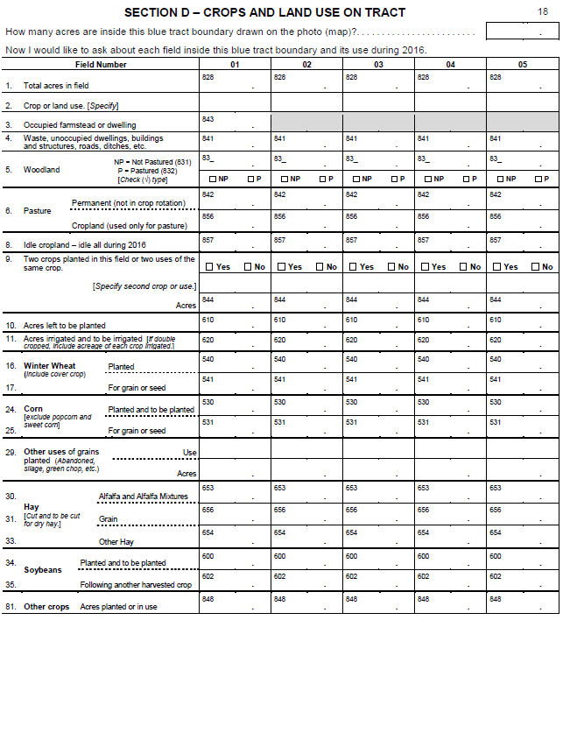

## A-2

North Carolina

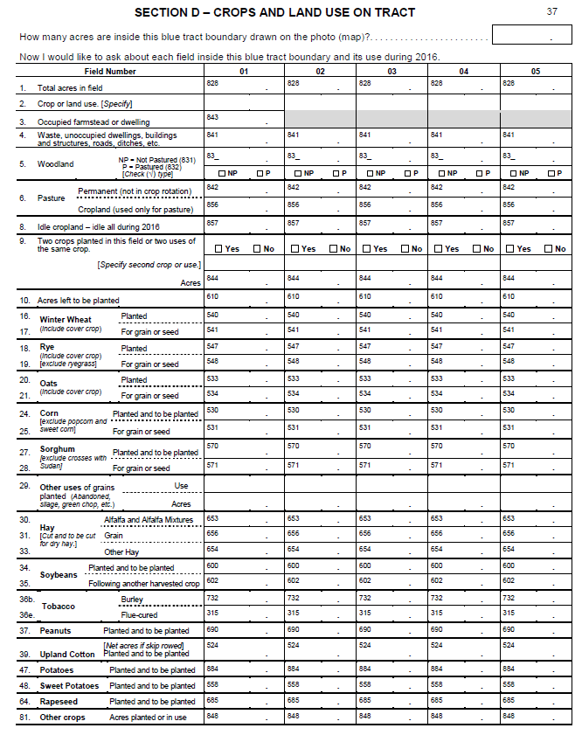A-3