OMB No. 0915-0337
Form Approved
Exp. Date XX/XX/XXXX

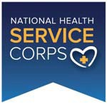
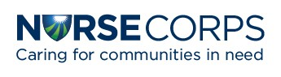
Interest Capture Form

Name: Email Address(es): Clinical Discipline: Title: Organization: City and State:

For Students
Univ/College:

Graduation Year:
1. Which NHSC and/or NURSE Corps Programs would you like to receive emails about?
- NHSC Loan Repayment Program
- NHSC Scholarship Program
- Ambassador Program
- Becoming an NHSC‐Approved Clinical Site
- NURSE Corps Loan Repayment Program
- NURSE Corps Scholarship Program
- Other (please specify)
2. What questions do you have about the NHSC and/or NURSE Corps?
3. When and how did you first hear about the NHSC and/or NURSE Corps?

Public Burden Statement: An agency may not conduct or sponsor, and a person is not required to respond to, a collection of information unless it displays a currently valid OMB control number. The OMB control number for this project is 0915-0337. Public reporting burden for this collection of information is estimated to average 90 seconds per response, including the time for reviewing instructions, searching existing data sources, and completing and reviewing the collection of information. Send comments regarding this burden estimate or any other aspect of this collection of information, including suggestions for reducing this burden, to HRSA Reports Clearance Officer, 5600 Fishers Lane, Room 14N39, Rockville, Maryland, 20857.

