BHW Management Information System Solution (BMISS)

NURSE Corps Loan Repayment Program
Online Application User Guide

November 2016
Table of Contents
Introduction: NCLRP Online Application User Guide 3
Section 1: Create Account 4
Section 2: Loggin In 7
Section 3: Forgot Your Password 8
Section 4: Home Page (Application Status = “Not Started” or “In Progress”) 10
Section 5: Eligibility 13
Section 6: General Information 15
Section 7: Employment 18
Section 8: Employment Verification 25
Section 9: Qualifying Education 28
Section 10: Loan Information 32
Section 11: Loan Details 35
Section 12: Supporting Documents 38
Section 13: Self-Certification 40
Section 14: Review & Submit 41
Section 15: Submitted Page 42
Section 16: Application Withdraw 44
Section 17: Edit Application 46
Section 18: Account Settings 48
Section 19: Resolving Issues 49
Section 20: Resolving Issue Flow Chart 51

Introduction: NCLRP Online Application User Guide
Goal: The NCLRP online application user guide serves as the main tool for the Call Center to answer applicant inquiries. In addition to this user guide, the call center analysts must be familiar with the NCLRP Application Program & Guidance, as some of the questions will be program based and are not discussed in this document. The primary intent for this user guide is to focus on the functionality developed for the NCLRP online application.

Roles: There are no roles associated with the NCLRP online application, as any external user can apply.

Section 1: Create Account
The banner will be available on all pages of review and on the Application Profile.
The first step an applicant takes in order to begin the NCLRP Online Application is to create an account.

Steps:

- Applicant navigates to the online application via the web link:
https://programportal.hrsa.gov/extranet/application/NCLRP/login.seam

- Applicant selects the “Create a NURSE Corps LRP Application Account” link in the bottom left hand section of the page.

- Please note that applicant can access login page from NCLRP website

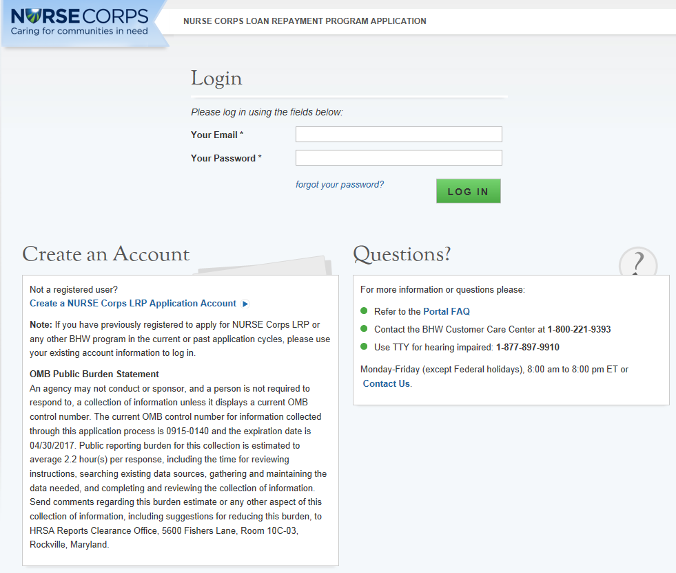

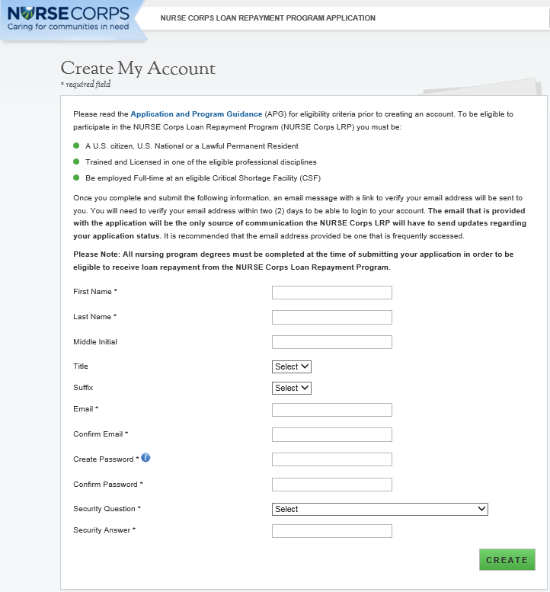
The applicant will be prompted to fill in a series of fields in order to create an account. Once the applicant selects “Create,” the system will send an activation email to the email address provided when creating an account.

Steps:

- Applicant answers each of the required fields.

- Applicant selects to register for an account with the NURSE Corps Loan Repayment Program (NCLRP).

- System re-directs the applicant to the NCLRP application “Log in” and prompts the user at the top of his/her screen that “We have successfully created your account. Please check your email for instructions how to enable your account.” (See Figure 1)

- Applicant goes to the email account used to create his/her NCLRP application and opens the message.

- Applicant selects the activation link in the body of the email.

- System re-directs the applicant to the NCLRP application “Log In” page notifying them that his/her account is enabled.

Business Rules:

- The email address provided by the applicant will serve as his/her NCLRP online application username.

- System cannot create account if applicant email already exists in a previously created account for any program in any application cycle
  - The applicant will receive an error message if he/she tries to create a new account with an existing email address
  - Error message will prompt applicant to log in with his/her existing email

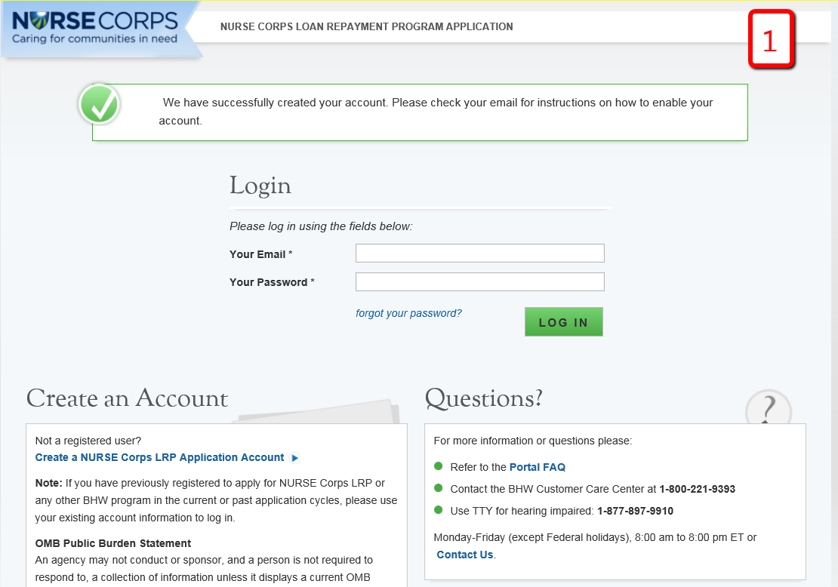
Business Rules Cont:

- The following information will be auto-populated on the General Information page based on the information entered on the Create Account page:
  - First & Last Name
  - Middle Initial
  - Title
  - Suffix

- Applicants can roll over the tool tip next to the “Password” field for details on password criteria.

- Passwords must have a minimum length of eight characters; shall not contain slang, jargon, or personal information; shall not contain all or part of your username; and must contain: at least one English upper-case character (A-Z), at least one English lower-case character (a-z), at least one numerical digit (0-9), and at least one special character (e.g. @, !, $, %). A character may not be repeated more than once in succession.

- System shall disable ability to create an account after application deadline.

Section 2: Loggin In
After an applicant activates his/her account, he/she will be able to log in. The applicant will enter his/her email address (username) and password he/she used when creating his/her account in order to log in. If the applicant forgets his/her password, he/she can reset the password by selecting the “forgot your password?” link. This will be later described in Section 3 (next page).
Steps:

- Applicant enters his/her email address and password.

- Applicant selects

- At first log in applicant is re-directed to the “Not Started” home page (screen shot displayed in section 4).

Business Rules:

- After selecting the activation link in the email, the system notifies the applicant that his/her account is activated (this only happens on the initial log in).

- At first log in, the applicant is directed to the “Not Started” home page which details the NCLRP application. Once an applicant begins his/her application he/she will not be directed to the NCLRP Not Started home page on the next log in.

- After the applicant’s second failed log in attempt, the applicant will be warned that his/her account will be locked if the next log in attempt is incorrect.

- The applicant’s account will be locked after the third failed log in attempt and he/she will be required to go through the “Forgot your Password” process or contact the Call Center to unlock his/her account.

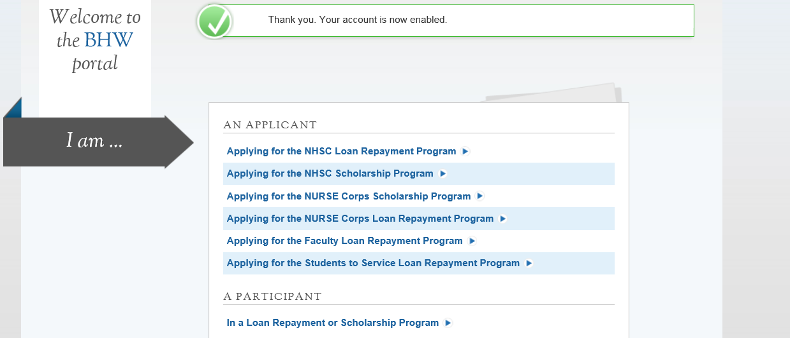

Section 3: Forgot Your Password
3
If the applicant forgets his/her password, he/she will have to select the link and follow these steps in order to reset the password.
Steps:

- Applicant selects on the log in page.

- Applicant enters his/her email address and selects (see Figure 2).

- Applicant answers his/her security question and selects (see Figure 3).

- System displays confirmation and sends an email to applicant (see Figure 4).
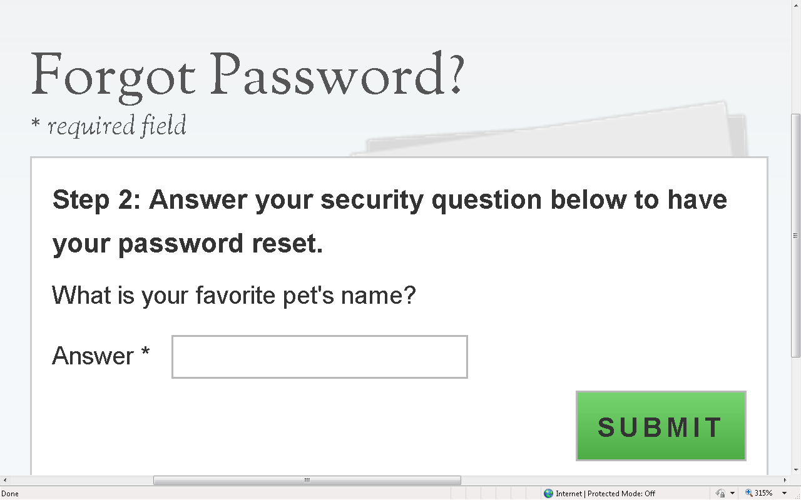
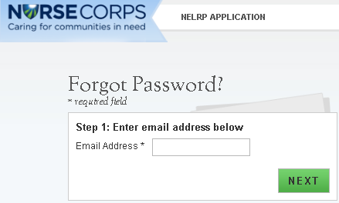
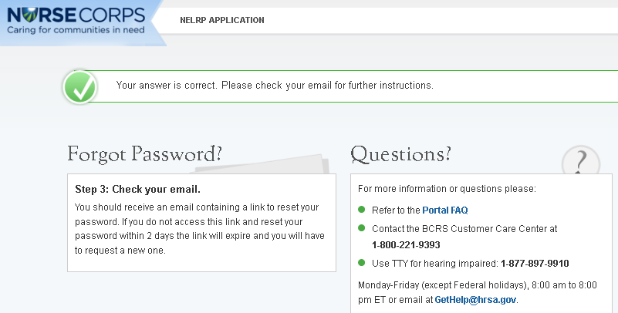
2
4
3

Steps Cont:

- Applicant goes to his/her inbox to access the email sent to unlock his/her account.

- Applicant selects Reset Password Link from email.

- Applicant enters new password and selects (see Figure 5).

- System updates new password.

- Applicant is directed to the BHW portal home page.

- Applicant selects “Applying for the NURSE Corps Loan Repayment Program.”

- Applicant enters in email address and new password.

Note:
Passwords must have a minimum length of eight characters; shall not contain slang, jargon, or personal information; shall not contain all or part of your username; and must contain: at least one English upper-case character (A-Z), at least one English lower-case character (a-z), at least one numerical digit (0-9), and at least one special character (e.g. @, !, $, %). A character may not be repeated more than once in succession.

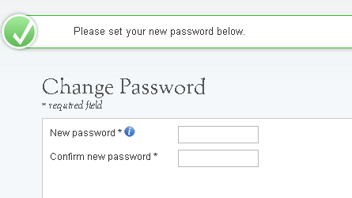
5

Section 4: Home Page (Application Status = “Not Started” or “In Progress”)
The Not Started Home Page is the first page the applicant sees on his/her initial log in. Once an applicant begins his/her application he/she will no longer be directed to the Not Started Home Page but will be re-directed to the NCLRP In Progress Home Page when logging in.

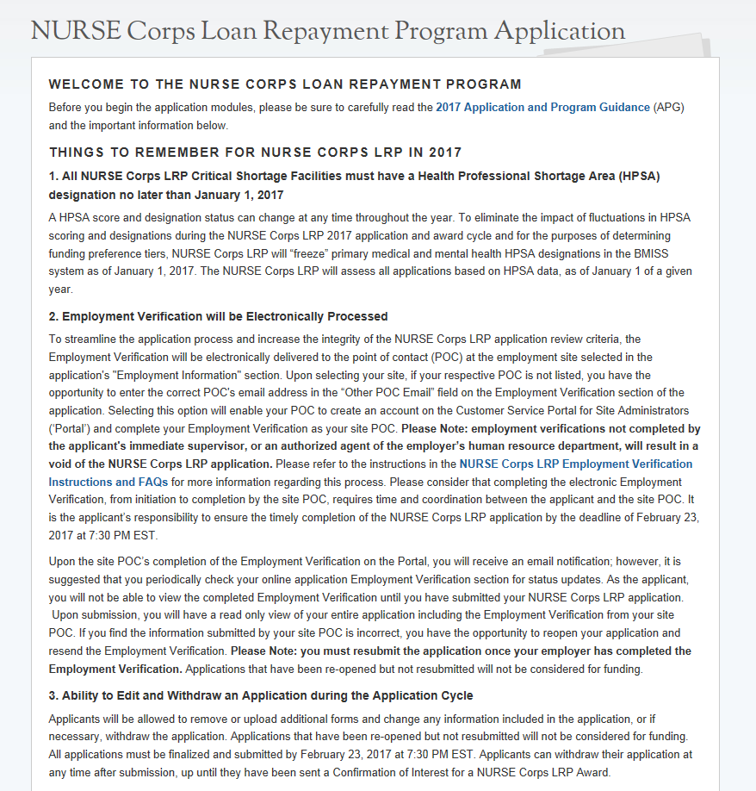
Steps:

- Applicant reads through the information displayed on the Not Started Home Page.
- Applicant selects.

Business Rules
- The APG, EVF FAQ and Funding Preference definition links will open in a new window when an applicant clicks on the link

- Once an applicant clicks he/she will no longer be directed to this page when he/she log in

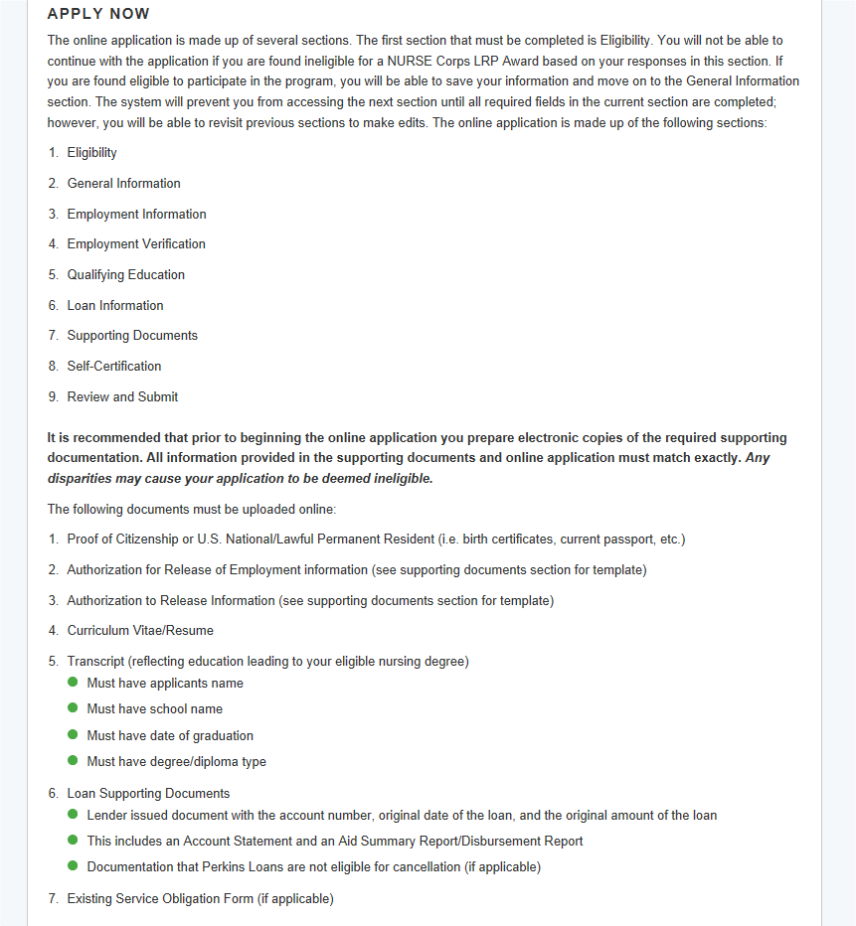

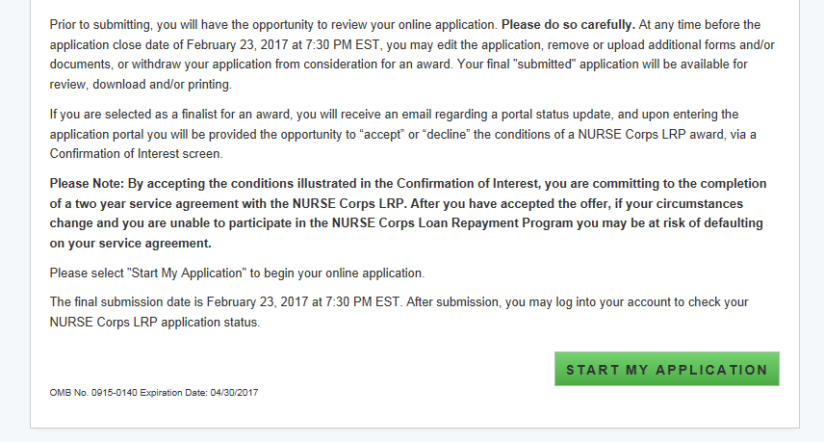

If the applicant has already started his/her NCLRP online application and logged off, upon logging back in, he/she will be directed to the In Progress Home Page. The In Progress Home Page will display the “In Progress” status, and the applicant will be able to select “Continue” or the desired section by selecting the page name in the table.
Business Rules, cont.:

- The Credit Report will be available to upload in the Review Supporting Documents table after an applicant submits his/her application, even if review for that applicant has not started.
- The Credit Report will then display on the review pages if uploaded from the Application Profile.

- Analyst can enter comments in the New Comments text box and by selecting Add Comment.

- Analyst can view all existing comments under Existing Comments.

- Existing Comments will display the analyst, date, and time of the comment.

Steps:

      - Applicant reads information on status page.

- Applicant navigates to a specific section by selecting the link to the desired page name in the table.

- The page must already been completed or is in progress to select a specific section; or

- If the applicant selects the system will direct the applicant to the first incomplete page

Business Rules:

- The system shall only link to pages that are in a “Complete” or “In Progress” status. The applicant will not be able to jump to a page that is “Not Started.”

- If the applicant selects “Continue,” the system shall direct them to the first incomplete page. For example, if Eligibility is “Complete”, system shall direct applicant to General Information once he/she log back into the application if he/she select ”Continue”.
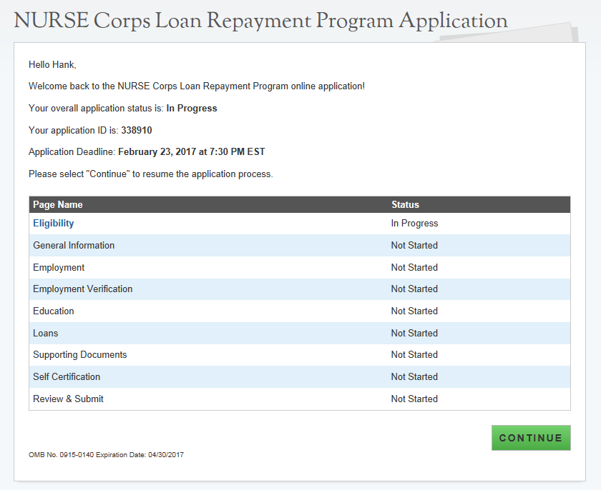

Section 5: Eligibility
The Eligibility page is used to ensure the applicant meets the qualification requirements to apply for an NCLRP application. If the applicant is deemed eligible, he/she will be able to continue with the application. If an individual does not pass the initial screening portion of the online application, he/she will not be able to continue.
Steps:

- Applicant answers all required questions.

- Applicant selects once he/she has answered all the eligibility questions.
- Applicant will be directed to General Information page if he/she is eligible.

Business Rules:

- System shall require applicant to respond to all questions before he/she can continue

- If the applicant answers “Yes” to question 3, the system will display two sub-questions, each is required.
  - If applicant indicates “Yes” for “Do you have an existing service obligation?” he/she will be required to provide supporting documentation on the supporting documents page.

- System shall direct user to ineligible landing page if one or more answer(s) is:
  - Licensed Registered Nurse = No
  - Applicant Citizen or National = No.
  - Existing Service Obligation= Yes
  - Completed before submission = No
  - Uniformed service member = No
  - Applicant Judgment Lien = Yes
  - Applicant Defaulted Federal Debt = Yes
  - Applicant CSF type/School Accreditation = No
  - Minimum working hours/Working full-time = No
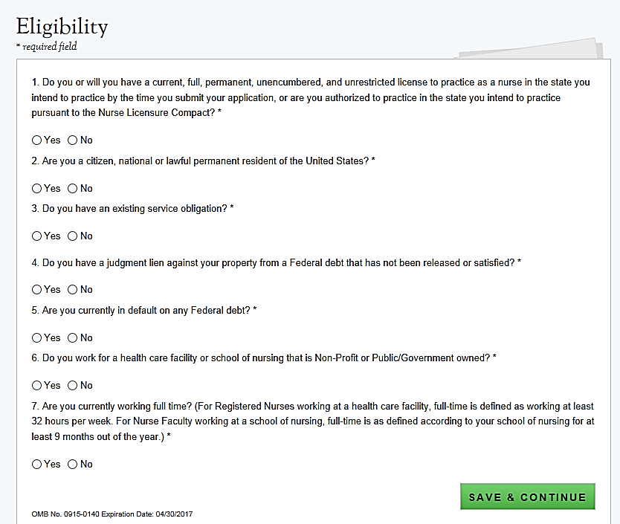
Business Rules Cont:

NOTE: The ineligible landing page will not give the specific reason that the applicant was deemed ineligible, only several possible reasons for ineligibility from the Eligibility section will be displayed

- If an applicant is logged in with an existing participant username and says no to having an existing service obligation he/she will get an error message and will not be able to continue with the application until he/she change his/her response to “Yes” to having an existing service obligation.

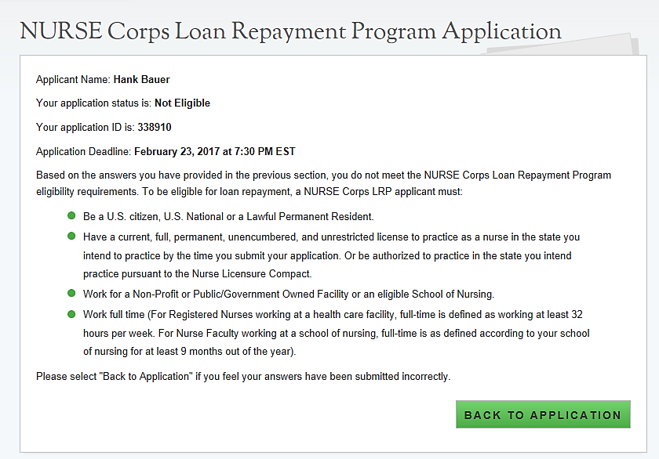

Section 6: General Information
The General Information page consists of questions about the applicant’s contact information. The information under Full Name (such as First and Last Name, etc.) is pre-populated from the answers the applicant supplied when creating his/her account. These fields are editable.
Steps:

- Applicant answers required fields.
  - Required fields denoted with an asterisk (*)

- Applicant selects once he/she have answered all the required fields.

- Applicant will be directed to Employment page if all required fields are entered.
  - If Nurse Faculty is selected applicant will be directed to the Employment School Search
  - If any other application type is selected applicant will be directed to the Critical Shortage Facility Search

Business Rules:

- The following fields are populated from answers during the create account process:
  - First Name
  - Last Name
  - Middle Initial
  - Title
  - Suffix

- Applicant will select Application Type
  - If Registered Nurse, Nurse Practitioner, Clinical Nurse Specialist, Nurse Mid Wife or Registered Nurse Anesthetist is selected system will display functional role question which will be required
  - If Nurse Practitioner is selected system will also display main specialty question which will be required
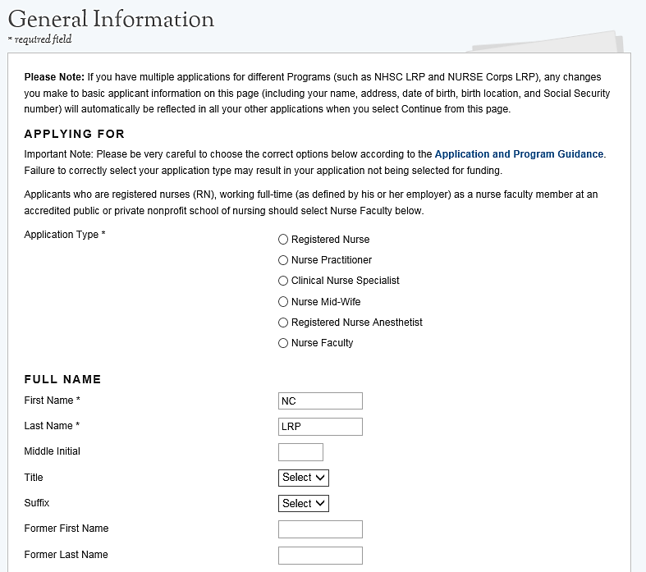

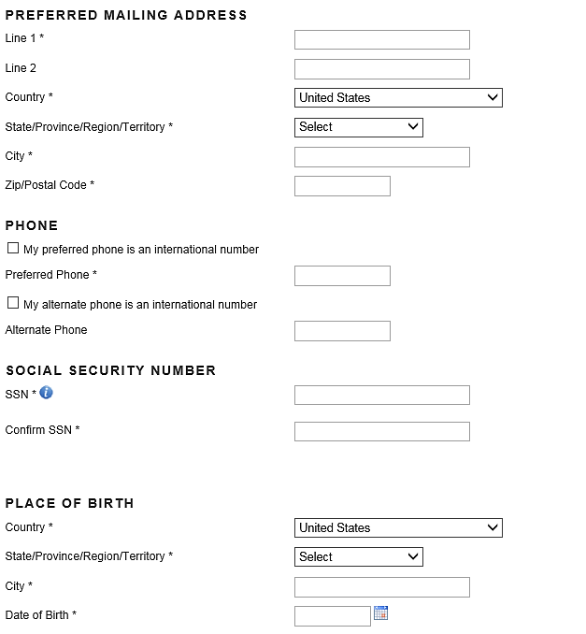
Business Rules, cont:

- If Nurse Faculty is selected, system will display tenured question which will be required

- If applicant is not tenured system will prompt applicant to input Nurse Faculty appointment dates

- The faculty appointment must be at least 9 months for applicant to be eligible and continue with the application

- If the applicant selects a Country other than the United States, the State/Province/Region field transforms from a dropdown to a required text field and the Zip/Postal will be optional.

- Based on the SSN entered, the applicant may receive an error message with an error code
  - The code can be used to determine the issue with the SSN

- System shall mask the SSN and require the user to enter it twice
  - Error message will request the user re-enter his/her SSN if he/she do not match

- Only the last 4 numbers of the applicant’s SSN will be displayed after saving the page (xxx-xxx-1245).

- The applicant will not be able to move forward if the SSN he/she entered exists in another NCLRP application account from any application cycle

- If applicant selects that one of his/her phone numbers is non-U.S. number, the field transforms from a U.S. phone format to a text field.

- The applicant Birth Date must be prior to application cycle start date.

- If applicant selects ‘Other’ for how did you hear about NURSE Corps Loan Repayment Program, system will display text box for applicant to enter information.
Business Rules, cont:

- System requires applicant to answer the question, “Do you have an individual NPI number?”

- System does not require the NPI number to be provided. The application can be submitted without an NPI number

- System shall display the NPI number if applicant provided it in a prior application. The NPI number can be updated by the applicant

- The system will store ONLY the most recent NPI number and record whether it is a full, partial, or non-match, defined as:
  - Full match: NPI number found + the first and last name match
  - Partial match: NPI number found + the first and/or last name do not match
  - Non-match: NPI number not found

- System shall display an error message if the NPI number is a partial-match: “We were unable to successfully validate the NPI number entered based on the first and last name provided. Below please find the name associated with this NPI number. Note: This validation does not affect the eligibility of or ability to submit your application. If you would like to make a change click ‘Go Back’.
[Last name, First Name,]

- System shall display an error message if the NPI number is a non-match: “We were unable to validate the NPI number entered. Note: This validation does not affect the eligibility of or ability to submit your application. If you would like to make a change click ‘Go Back’.

- System shall display an error message if the NPI number is associated with an organizational NPI, instead of an individual person: “We are unable to validate the organization NPI number entered. Please enter your individual NPI number. Note: This validation does not affect the eligibility of or ability to submit your application. If you would like to make a change click ‘Go Back’. (See screenshot to left)
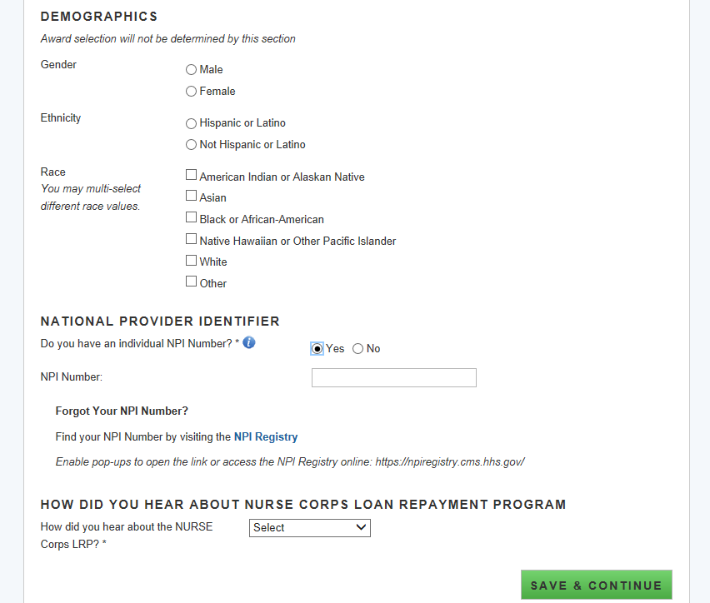
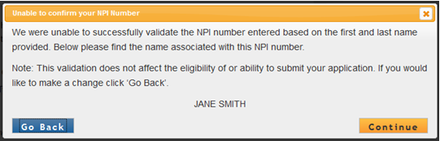

Business Rules, cont:

- Once the applicant proceeds from the General Info page, the account settings will update with the appropriate information
  - Applicant home Preferred Mailing Address
  - Applicant Primary Phone Number & Extension
  - Applicant Alternate Phone Number & Extension

- Demographic information is optional

- If applicant is logged in with an existing application account, any basic information that is changed on this page (such as SSN, name, address, etc.) will automatically be updated on all existing accounts
  - Note: this is only for existing application accounts (such as an applicant that has applied to both NCLRP and NHSC LRP). This will not update any information on the participant record.

- If an applicant wishes to change his/her application type after completing the Employment Verification section, he/she must first cancel his/her Employment Verification if his/her Employment Verification has been initiated.

- System shall not allow applicant to change Date of Birht on the General Information page if electronic loans are present.

Section 7: Employment
The Employment Information page captures the applicant’s current employment information. Depending on the applicant type, a Critical Shortage Facility will be required for NCLRP applicants or a school site will be required for NCLRP-NF applicants.
Steps NCLRP-NF:

- Applicant selects state in the drop down

- Applicant chooses a school from the drop down

- Applicant selects once he/she have answered all the required fields.

- Applicant will be moved to Employment Verification section

Steps NCLRP-NF: School Not Found:

- If the applicant cannot find his/her school he/she will select “School not Found” in school drop down (see screen shot 6)

- Applicant enters school information and selects

- A popup will display, giving the applicant a choice of sending the request to Program or restarting the search (see screenshot 7)

- If the applicant sends the request to program, he/she will be returned to Employment School Search Page and language will be displayed indicating that he/she has sent his/her school information to Program (see screen shot 8)

- Applicant will click continue and be directed to Qualifying Education page

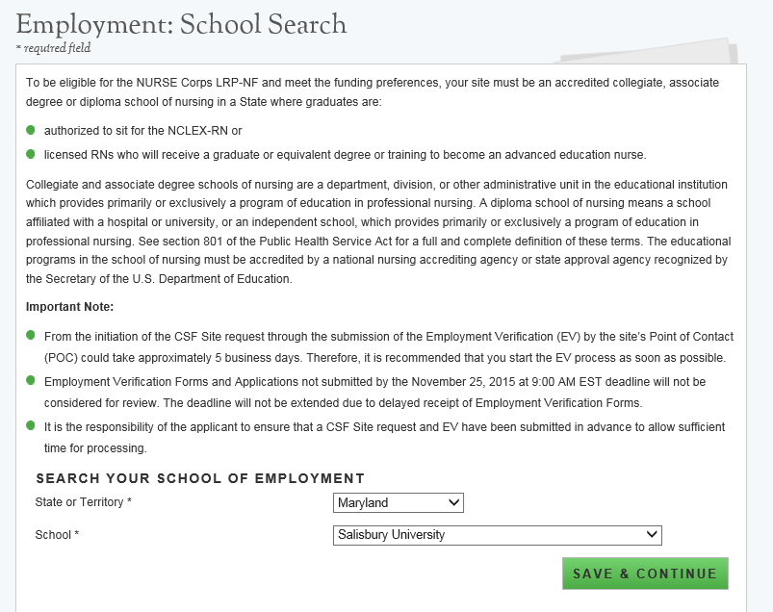

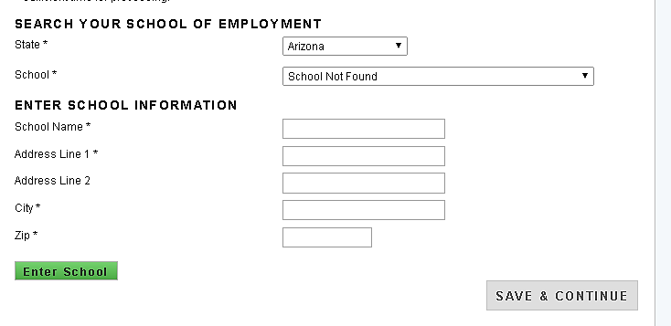
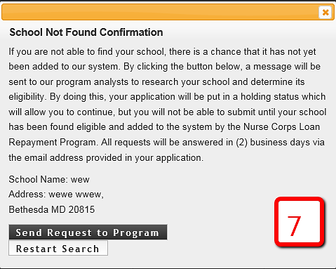
6
Business Rules:

- System shall limit school name field based on state selected
- System shall only provide schools in the school dropdown that:
- Exist in BMISS
- Are Accredited
- Have a status of non-profit/active
- System shall enable option “School Not Found” during entire application cycle which can be selected for any state
- System shall populate the following fields and require user to complete them in order to continue if applicant selects “School not Found”
- School Name
- School Address
- System shall require applicant to confirm or cancel program communication upon selecting “Enter School” if applicant does not see his/her school

- If applicant selects “Restart Search” from the School Not Found Confirmation Pop Up, he/she will be taken back to the employment search screen

- System shall send communication to Program with the following information if applicant confirms to send communication to Program
- Applicant first and last name
- Applicant email/username
- Applicant school name and address entered by applicant

- System shall put applicant in “In Progress-Employment Not Found” status if applicant sends school information to Program from the School Not Found pop up

- System shall enable Qualified Education page if user is in the “In Progress- Employment Not Found” status
  - The Employment Verification page will not be enabled in this situation

Business Rules cont:

- An analyst has the ability to make an applicant site “Eligible” or “Ineligible” from the Manage Application Documents screen when an applicant is in the “In Progress- Employment Not Found” status

- If an applicant site is made ineligible by an analyst his/her status will be “Ineligible” and he/she will be directed to the ineligible landing page after he/she refresh his/her screen or logs back in

- If an applicant is made eligible by an analyst the applicant will receive an email and his/her school will be added to BMISS
  - The applicant must repeat the steps outlined above to add his/her school of employment

Steps NCLRP:
      - Applicant fills out the name and address of his/her Critical Shortage Facility
      - Applicant selects
      - Verified address appears at the bottom of the page (see figure 9)
      - If address entered is a match applicant selects
- System will display a list of search results within a ½ mile radius of the Google address if user selects “Yes” to Google address match (see figure 10)
      - If address entered is not a match applicant selects
- System will display a list of search results within a 10 mile radius of the Google address if user selects “No” to Google address match (see figure 11)

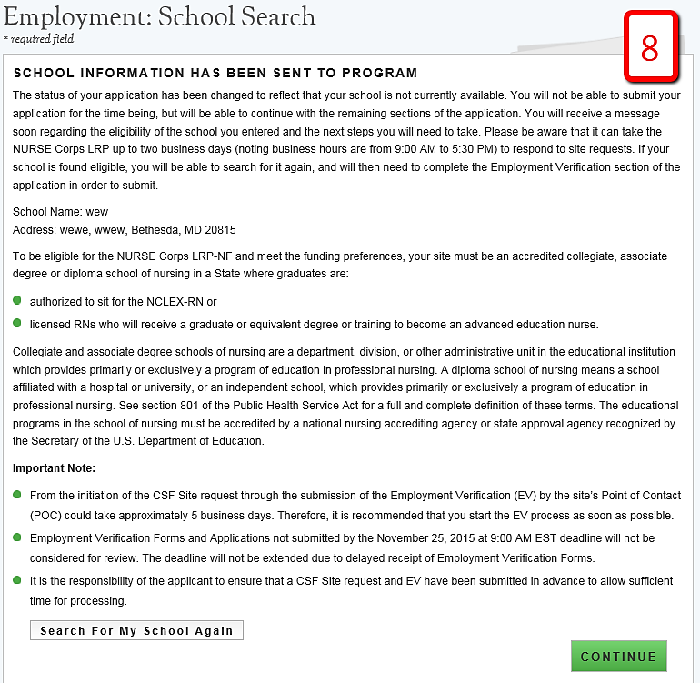
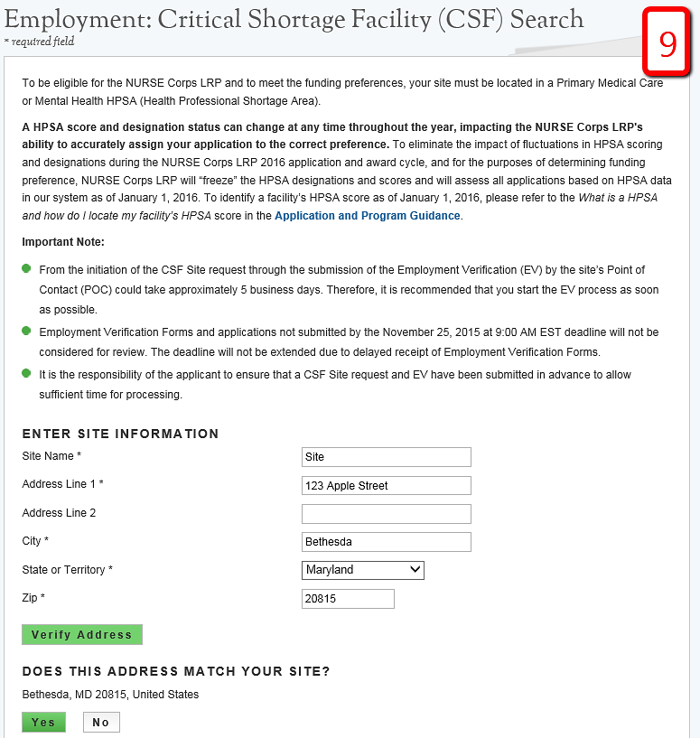
      - If applicant does not see his/her site he/she can expand the search radius.
      - Applicant selects site he/she currently work at by clicking “This is my site”.
      - Applicant clicks
      - Applicant is taken to Employment Verification Page.

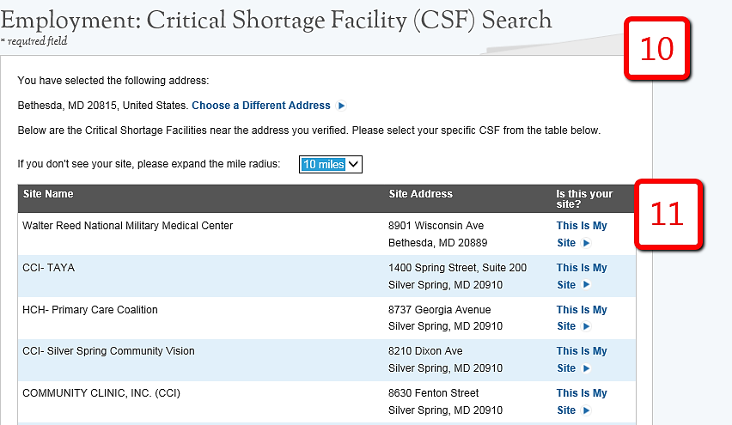
Steps NCLRP: Site Not Found:
- If applicant does not see his/her site he/she will click at the bottom of the search results
- A popup will display, giving the applicant the choice of sending the request to program or restarting the search (see figure 12)
- If the applicant sends the request to program he/she will be returned to Employment Site Search Page and language will be displayed indicating that he/she have sent his/her site information to Program (see figure 13).
- Applicant will click Save and Continue and be directed to Qualifying Education page.

Business Rules:

- System shall enable Verify Address only when applicant enters all required fields for CSF address

- System shall provide address match from Google to the address entered by user (if possible)

- System shall inform applicant if there is no Google address match for address entered by applicant if address cannot be geocoded to a Google address

- System shall direct applicant to retype address and clear address fields if there is no Google address match for address entered by applicant on the first search attempt

- System shall display Site Not Found pop-up to send site information to Program if there is no Google address match for address entered by applicant on the second or more search attempts

- System shall display a list of search results within a ½ mile radius of the Google address if user selects “Yes” to Google address match

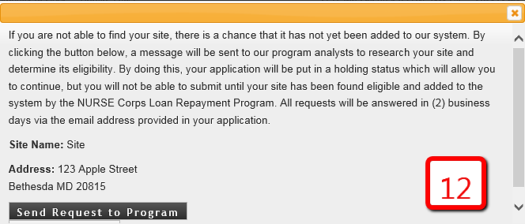
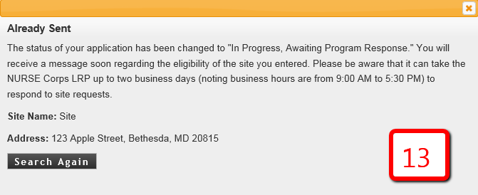
Business Rules Cont:

- System shall allow applicant to change the radius of the search results

- System shall display a list of search results within a 10 mile radius of the address the applicant entered if user selects “No” to the Google address match

- System shall only provide sites in search results that:
  - Exist in BMISS
  - Have a Mental or Primary Care HPSA score as of the Jan 1 HPSA Lock
  - Have a status of non-profit/active

- System shall direct user to Employment Verification request page if user selects a site from the search results and selects Continue

- System shall enable Continue button only when user selects an option from the search results

- System shall require applicant to confirm or cancel program communication upon selecting “I do not see my site listed” from the search results

- If applicant selects “Restart Search” from the Site Not Found Confirmation Pop Up, he/she will be taken back to the employment search screen

- System shall send communication to Program with the following information if applicant confirms to send communication to Program
  - Applicant first and last name
  - Applicant email/username
  - Applicant site name and address entered by applicant

Business Rules Cont:

- System shall put applicant in “In Progress-Employment Not Found” status if applicant sends site information to Program from the Site Not Found pop up

- System shall enable Qualified Education page if user is in the “In Progress- Employment Not Found” status
  - The Employment Verification page will not be enabled in this situation

- An analyst has the ability to make an applicant site “Eligible” or “Ineligible” from the Manage Application Documents screen

- If the applicant’s site is made ineligible by an analyst, his/her application status will update to “Ineligible,” and he/she will be directed to the ineligible landing page after he/she refreshes his/her screen or logs back in

- If an applicant is made eligible by an analyst the applicant will receive an email and his/her site will be added to BMISS
  - The applicant must repeat the steps outlined above to add his/her site

Steps to remove a Site or School:
- Applicant navigates to the employment page by clicking the Employment link at the top of the page
- Applicant clicks “Remove School” or “Remove Site”
- Once previous site is removed applicant will have to repeat steps to add another site

Business Rule:

- If the applicant has an initiated or completed Employment Verification, he/she must cancel the Employment Verification before he/she can remove his/her site

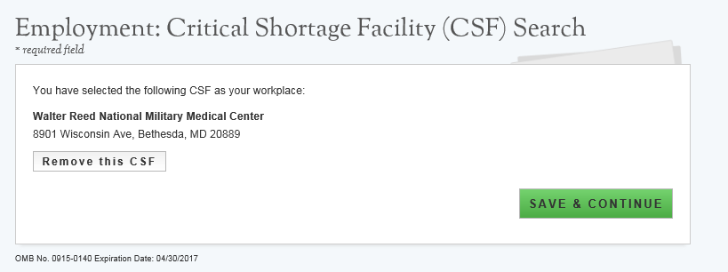

Section 8: Employment Verification
Within the Employment Verification section of the online application, employment sites are required to answer questions regarding the applicant’s current employment information. Applicants will be able to view the information submitted by the site’s Point of Contact upon submission of his/her application. Based on the answers provided by the Employment Site, an applicant can be made ineligible upon submission. If this occurs and the applicant believes it is incorrect, an applicant will be able to edit his/her application, cancel the existing EV, and re-initiate a new one.
Steps:

- System will populate EV request for site added on Employment page

- Applicant can click site name to verify that the appropriate address, phone number and point of contact are listed

- Applicant can enter “Other POC Email” if the applicant does not see his/her correct POC in the site information or if the site does not have a POC associated with it

- Applicant clicks
- Applicant clicks

- Applicant is taken to the Education section

Business Rules:

- System shall populate an EV request for the site added on the Employment page

- System shall display EV status as Not Started before applicant initiates a EV Request

- System shall enable Cancel button if EV status is “In Progress,” “Complete”, or “Returned-Unverified”

- System shall allow applicant to resend EV if EV status is “Returned-Unverified”

- System shall allow applicant to continue to next section, Qualifying Education, if individual EV Request is in any status.

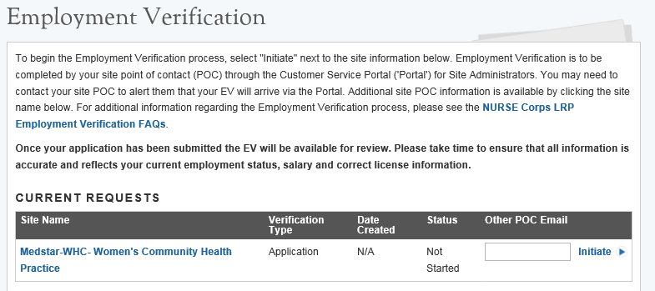
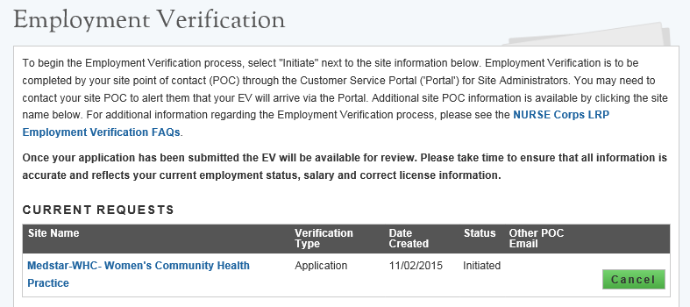
Business Rules Cont:

- System shall send an email to “Other” POC entered by applicant with instructions on how to register a portal account

- If an applicant wishes to change his/her application type (which can be done by navigating to the General Information page), he/she must first cancel his/her Employment Verification if the Employment Verification has been initiated

- If an applicant wishes to remove his/her site (which can be done by navigating to the Employment page), he/she must first cancel his/her Employment Verification if the Employment Verification has been imitated

Steps to cancel EV

      - Applicant navigates to Employment Verification page using the navigation links at the top of the screen

      - EV status will be displayed and can either be Initiated, Complete or Returned Unverified

      - Applicant selects if he/she wish to cancel the EV

      - Applicant can re-initiate EV by clicking the button

Business Rules:

- If the applicant wants to change Employment Site/School Site he/she must navigate to the Employment page and remove Employment Site/School after cancelling the EV

- If the applicant would like to change his/her application type he/she must navigate to the Employment page and remove Employment Site/School Site, then navigate to the General Information Page to change his/her application type after cancelling the EV

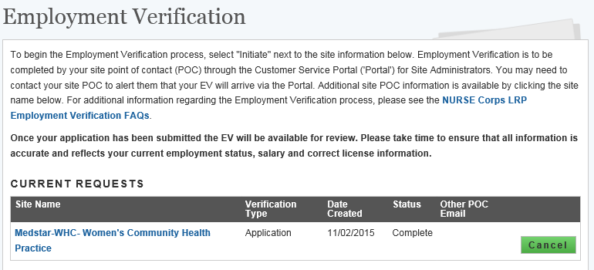
Business Rules Cont:

- If an applicant changed his/her Employment Site/ School Site or his/her application type the applicant must repeat the steps to add an Employment Site/School Site & initiate an EV

- An applicant may cancel an EV and complete the rest of the application but will not be able to submit his/her application until the Employment Verification has a status of “Complete”.

- System will display at the bottom of the page a table of all EVs that have been cancelled called the “Historical Requests” table.

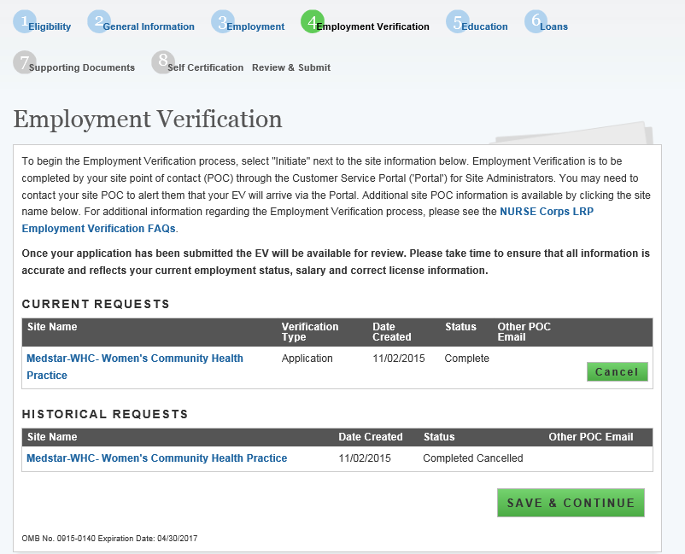

Section 9: Qualifying Education
The Qualified Education page is used to collect information about the applicant’s nursing education information.
Steps:

- Applicant selects

- Applicant is directed to the School Details page (see figure 14)

- Applicant selects the state where the school is located

- Applicant will select school based on list populated when state was selected

- Applicant will select whether he/she received a degree from selected school, transferred from selected school or attended selected school for nursing prerequisites

- Applicant will enter the date he/she began and ended his/her education at selected school
- Date format is mm/yyyy

- If applicant indicated that he/she received a degree from the schools, the applicant will select type of nursing degree(s) received and date(s) received from the school
- Date format is mm/yyyy
- Applicant selects

- Applicant is taken to the “School Documents” page (see figure 15)

- Applicant has to upload an Official/Unofficial transcript to continue to the next section

- Applicant has the option to upload unlimited Additional Supporting Documents

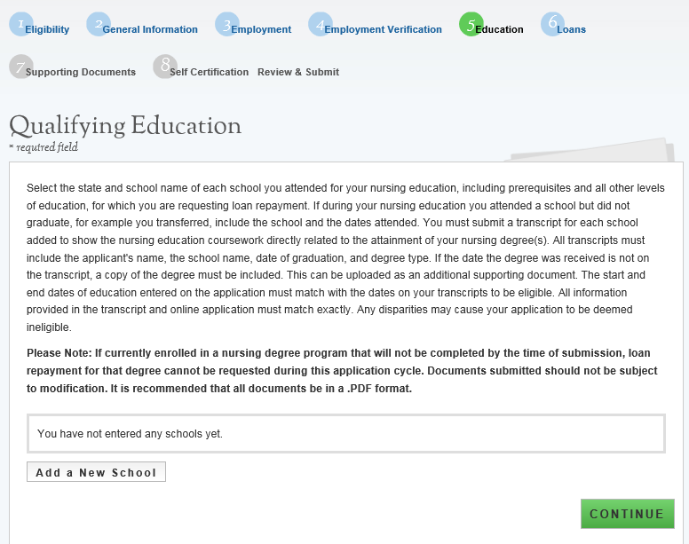
Steps Cont:

- After applicant uploads his/her documents he/she will select and be directed back to the Qualifying Education landing page (see figure 16) where he/she will see the school(s) added.

- Applicant can add an additional school or edit existing school information

- Applicant will select after adding all schools and be directed to the Loan section

Business Rules:

- System shall require user to answer required fields to be able to continue

- System shall limit school name drop down based on state selected

- System shall require user to enter in “Other School” information if “Other” is selected for NCLRP School Name

- System shall require user to check at least one:
- I received a nursing degree from this school
- I transferred from this school
- I attended this school for nursing prerequisites

- System shall not allow user to select both:
- I received a nursing degree from this school
- I attended this school for nursing prerequisites

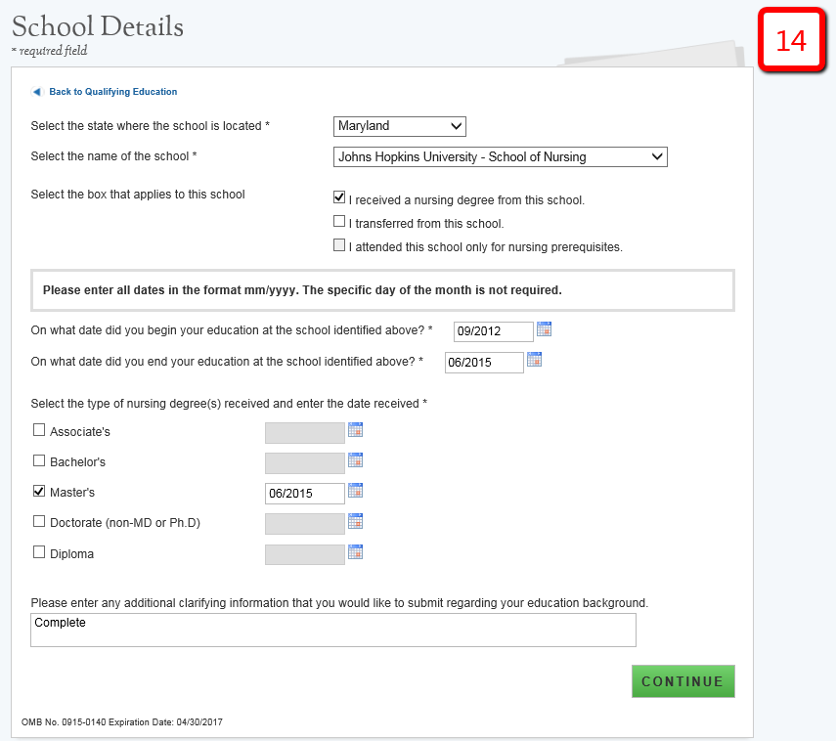
Business Rules Cont:

- System shall require user to add at least one school with a nursing degree selected to be able to continue to the loan section.

- System shall require user to answer “Date Received Degree” and if “I received a nursing degree from this school” is selected.

- System shall require that “School Start Date” is after Birth Date.

- System shall require that School Start Date is prio to current date.

- System shall require that “School Start Date” is before “School End Date”.

- System shall require that “School End Date” is on or before “Date Received Degree”.

- System shall require that “School End Date” and “Date Received Degree” is on or before the application submission date.
  - This check will occur upon submission of the application.

- System shall allow user to edit school added by clicking “Edit” in the table and the education details will populate with information entered.

- System shall require a transcript for each school added.

- System shall allow unlimited “Additional Education Supporting Document” to be uploaded for each school added.

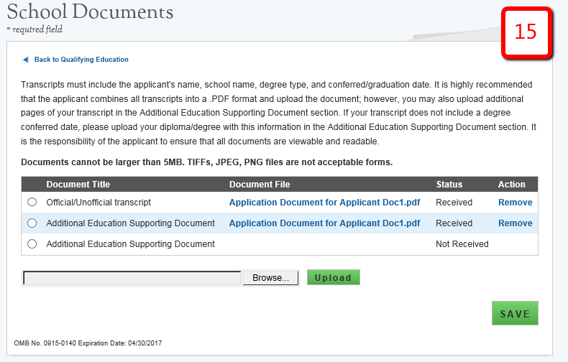
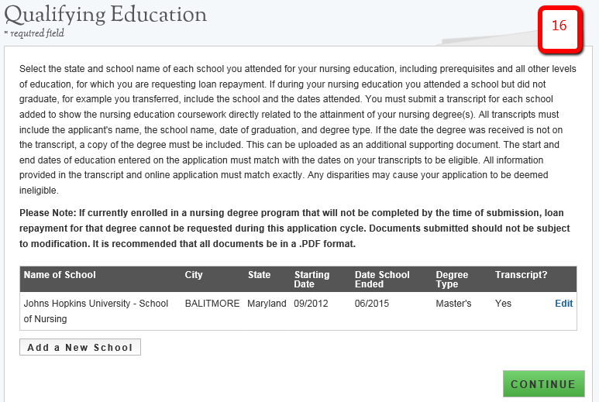
Business Rules Cont:

- System shall not allow the earliest school start date to be greater than three (3) months later than the latest loan date or the latest school end date to be greater than three (3) months prior to the earliest loan date if applicant adds or edits a school after at least one loan is added.
  - This is only if applicant navigates to education page after adding at least one loan (or chooses to edit application after submission).

- If an applicant inputs his/her dates as MM/DD/YYYY the system will default dates to MM/YYYY format.

- Education start date and degree received date is defaulted to the first day of the month in the BMISS system
  - For example, if an applicant indicated his/her education start date is 10/14/2015 and degree received date as 11/11/2019 the BMISS system will interpret it as 10/01/2015 & 11/01/2019 respectively.

- Education end date is defaulted to the last day of the month in the BMISS system
  - For example, if an applicant indicates his/her education end date as 10/14/2019 BMISS system will interpret it as 10/31/2019.

- Applicant can enter comments for each school added.

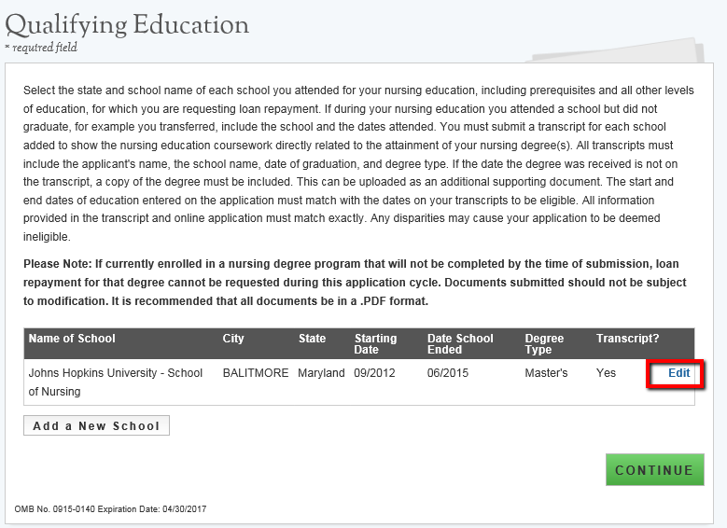

Section 10: Loan Information
The Loan Information page captures the loan data that an applicant will submit with his/her NCLRP application. If an applicant has a National Student Loan Data System (NSLDS) account, and wishes to submit federal loans as part of his/her NCLRP application, he/she will have the option to retrieve and submit his/her federal loans electronically. Applicants also have the option to manually add non-federal loans to the NCLRP application, or to enter federal loan data manually as well. The steps to add loans using an NSLDS login and/or to add loans manually are listed below.
Steps to Electronically Retrieve Loans:

      - Applicants navigate to LOG INTO YOUR NATIONAL STUDENT LOAN DATA SYSTEM ACCOUNT and clicks

      - Applicant is direct to the Department of Education's Federal Student Aid login page and logs in using their FSA ID.

      - Applicant will be automatically redirected to his/her S2S LRP application after authentication.

- If NSLDS authentication and retrieval is successful, the applicant’s loan(s) will display in the “Electronically Imported From Your NSLDS Account” table (See figure A)
  - Applicant can view a read only version of his/her loan details by clicking the “View” button next to each loan electronically retrieved.
  - The date and time of the last successful transaction with the NSLDS will be displayed for reference
  - Note: The social security number and date of birth entered in the General Information section of the application must match the social security number and date of birth on file with the Department of Education.

- Applicant will answer “Yes” or “No” to “Do you have additional Loans that need to be added?”
  - applicant answers “No,” the  button will become available and the applicant will be directed to Supporting Documents section of the application.
  - If applicant answers “Yes” applicant will be directed to Loan Details page

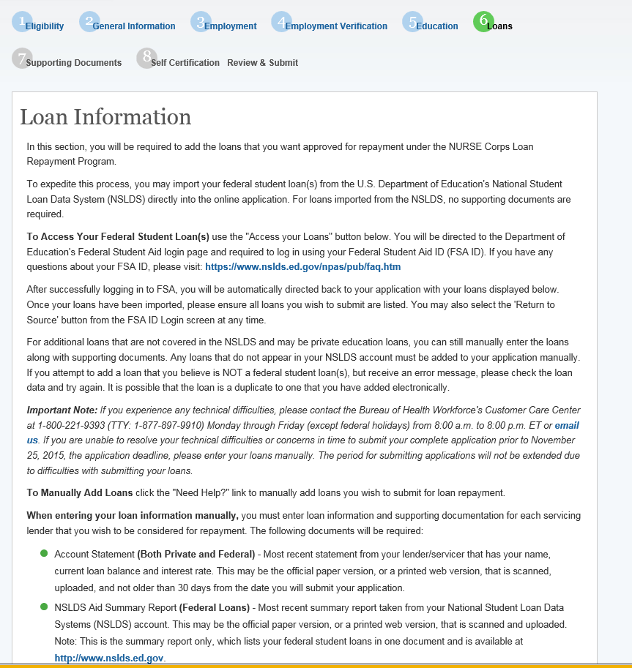
Steps Cont:

- Applicants may update loans previously retrieved from NSLDS by clicking the (Update Loans) button
  - Applicant will be required to re-authenticate with the Departments of Education using his/her FSA ID.

- Applicants can remove electronically retrieved loans by clicking the (Remove All Loans) button and confirming selection on pop-window.
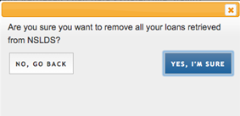
- Applicants will be able to view a comprehensive report of all NSLDS federal loan data retrieved and submitted with his/her application upon submission of his/her application.

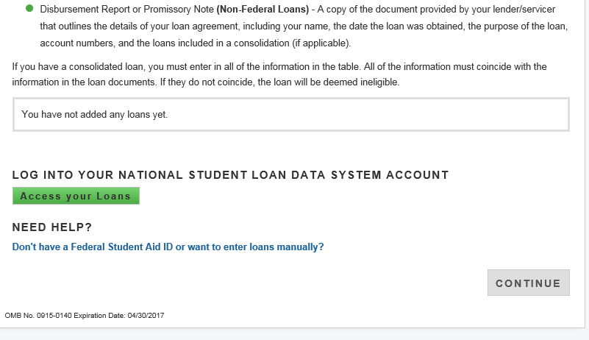
Steps to Manually Add Loans:

- Applicant clicks on the “Don’t have a Federal Student Aid ID or want to enter loans Manually?” link under the “Need Help?” heading.

- Applicants will view a popup message with a link to Add Loans Manually.

- Applicant will be directed to the Loan Details page when clicking the Add Loans Manually button.

Business Rules:

- System shall require at least one loan (Electronic or Manual) to be added to continue.

- System shall not require applicant to retrieve loans electronically.

- System shall check to see if applicant has already manually added federal loans and de-active “Access your Loans” button.

- System will deactivate the “Access your Loans” button and display a notice if the applicant is using Internet Explorer version 9 or lower.

- System shall redirect applicant to his/her application and prompt data exchange between HHS and DoED when user successfully authenticates.

- If the data exchange was not successful due to incomplete NSLDS data, the system shall display the following message “Certain loan information needed to successfully transmit from the NSLDS to your online application was incomplete. Please reach out to the NSLDS and try again - OR - add your loans manually.”

- System shall display federal loans retrieved via web service under a table tiled “Electronically Imported From Your NSLDS Account”

Section 11: Loan Details
The Loan Details page captures additional loan data that the applicant will submit for each manual loan he/she will submit with the application.

Please note: If an applicant submits all loans using the NSLDS retrieval, and does not manually add any loans to his/her application, he/she will not have access to the loan details page.
Steps to Manually Add Loans:

- Appplicant fills in all required fields to continue:
- Name of current servicing lender
- Loan account number
- Original date of the loan
- Original amount of the loan
- Current balance (Principal & Interest)
- Interest rate (Optional)
- Type of loan
- Is this loan in default
- Is this loan under Federal court judgment
- Is this a consolidated loan

- After the applicant enters all required fields, he/she will click (Continue to Documents) and will be taken to Loan Supporting Documents Page (See Figure B).

- Applicant will upload necessary documents and click (Save).
- Applicant can choose to add another loan. To add another loan, the applicant will click the Add New Loan button and repeat the steps above.

- If the applicant wants to edit or remove his/her loan, the applicant can click the check box to Remove loan at the bottom of the Loan Details page.

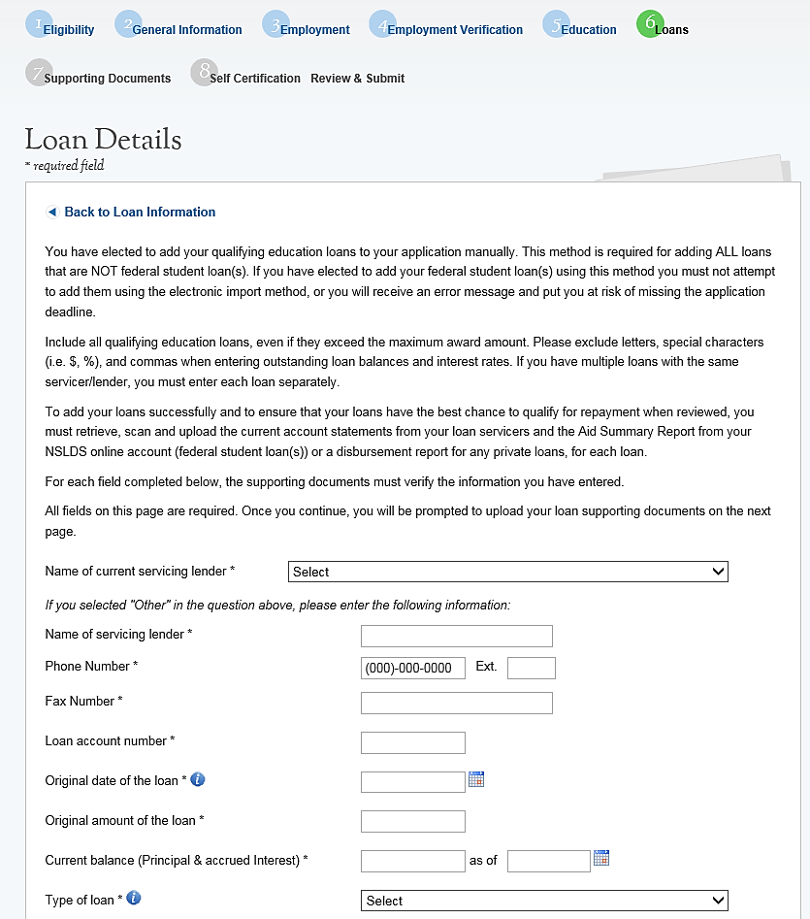
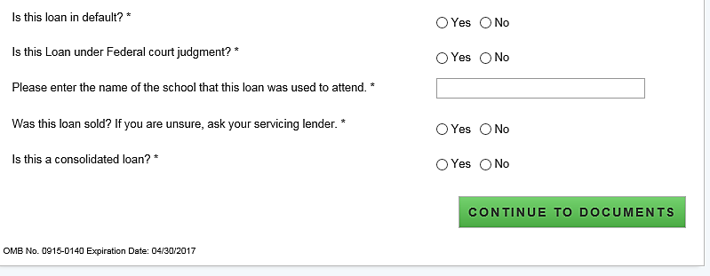
Steps Cont:

- If the applicant does not add another loan or edit his/her loan, he/she will click (Continue).

Business Rules:

- System shall allow account number to be alpha –numeric and allow special characters.

- System shall not allow “Current Balance As of Date” to be prior to “Original Date of Loan”.

- System shall not allow user to enter a “Current Balance As of Date” more than 30 days prior to current date.

- System shall not allow user to enter a “Current Balance As of Date” after the present date.

- If loan is not consolidated, System shall require that “Original Date of Loan” be:
- No more than 3 months prior to earliest education start date.
- No more than 3 months after latest education end date.

- System shall require “Consolidated Loan Dates” to be :
- No more than 3 months prior to earliest education start date.
- No more than 3 months after latest education end date.

- If loan is consolidated, “Original Date of Loan” must be prior to all “Original Date of Loan” for all consolidated loans.

- If loan is in default/under court judgment “Original Date of Loan” must be prior to Date of Court Judgment/Date of Default.

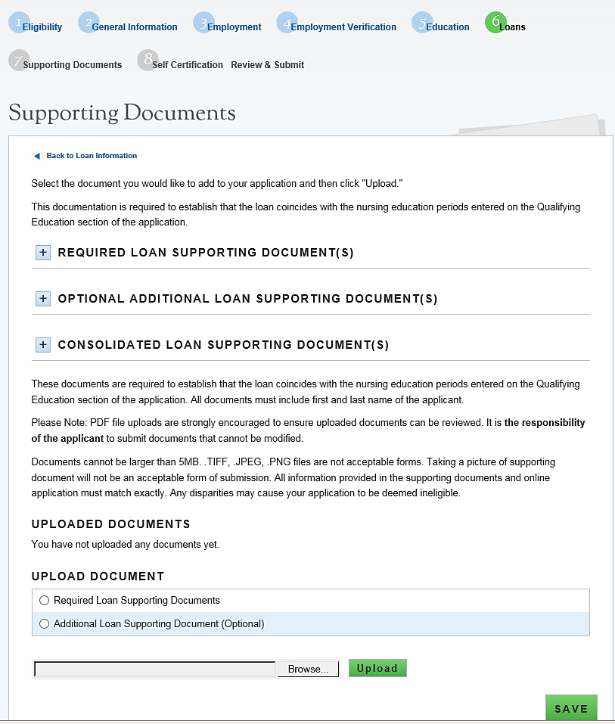
Business Rules Cont:

- System shall require user to submit a Consolidated Loan Document, if “Yes” to Consolidated Loan.

- System shall require user to submit an “Account Statment” for each loan.

- System shall require user to submit a Disbursement Report for non-Federal loans only.

- System shall require user to submit an Aid Summary Report for Federal loans only.

- System shall allow user to continue to next section without uploading all or any required loan documents. Loan page status will be “In Progress” until all required documents have been uploaded for each loan. The applicant will not be able to submit his/her application until all required loan documentation has been uploaded.

- System should not allow applicant to manually enter a federal loan if loans have been electronically retrieved via NSLDS.

Section 12: Supporting Documents
The Supporting Documents page consists of all documents that an applicant must submit with his/her NCLRP application. The documentation consists of required documents for NCLRP and NCLRP-NF applications.
Steps:

- Applicant selects the type of required document he/she will upload.

- Applicant selects “Browse” to find the document he/she wishes to upload.

- Applicant selects “Upload” when he/she selecs the appropriate document.

- Applicant repeats these steps for all of the required documents.

- Applicant clicks on “Authorization to Release Information” to download the respective form.

- Applicant will fill out and upload forms to his/her application.

- Applicant clicks “Save & Continnue” to proceed.

Business Rules:

- System shall display the required supporting documents to submit application for each applicant

- Each uploaded document will be linked for the applicant to view

- System shall allow applicant to upload different types of documents – PDF, jpeg, text, doc

- System shall allow applicant to upload document size up to 5 MB
- System shall display a required transcript for each school submitted on Qualified Education Information page

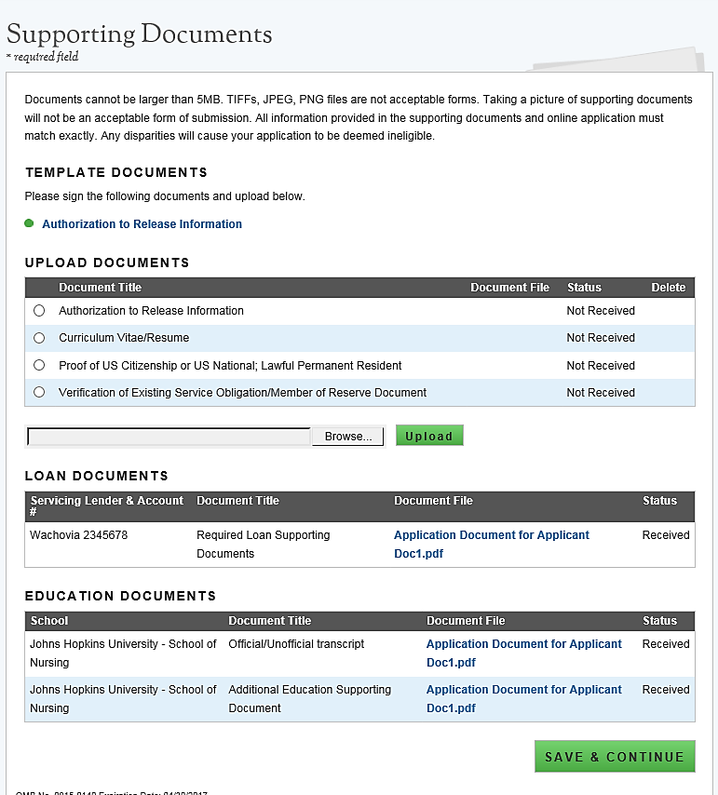
Business Rules Cont:

- System shall display all loan documents uploaded for each manually added loan

- System shall require the “Existing Service Obligation” document to be upload if the applicant answered “Yes” to having an existing service in the Eligibility section

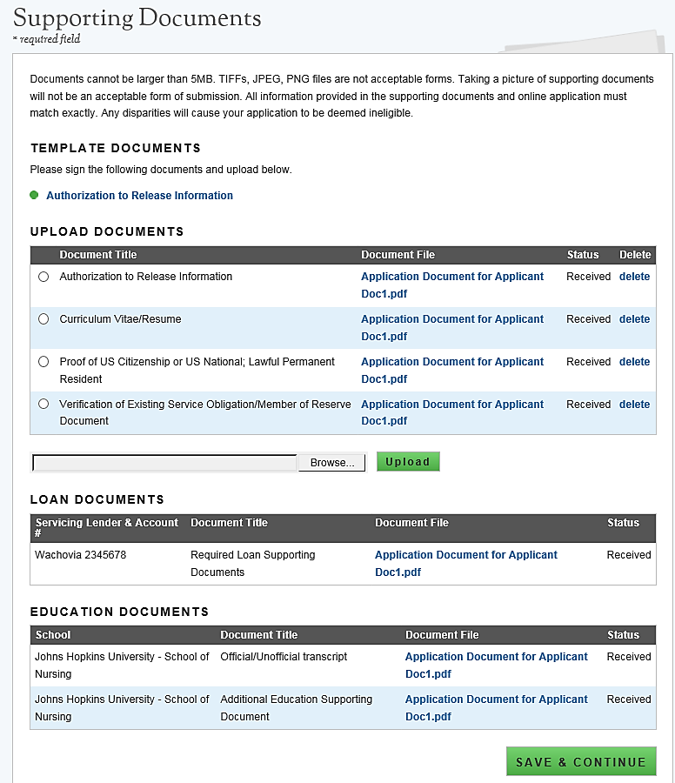

Section 13: Self-Certification
The purpose of the Certification page is for the applicant to confirm the statements regarding debarment, suspension, disqualification and related matters. The applicant also gives authorization to disclose financial information. The applicant will also agree to reading the Application Program Guidance and that all information in the application is true. The applicant must agree to all certifications in order to submit his/her.
Steps:

- Applicant reads each certification statement.

- Applicant checks the box that certifies each statement.

- Applicant selects.

Business Rules:

- System shall require the applicant to respond to each certification question to proceed.

- System will clear Self Certification page if the applicant proceeds to the Review and Submit page but then navigates to another section on the application to make any edits
  - The applicant must complete the Self-Certification each time after editing.

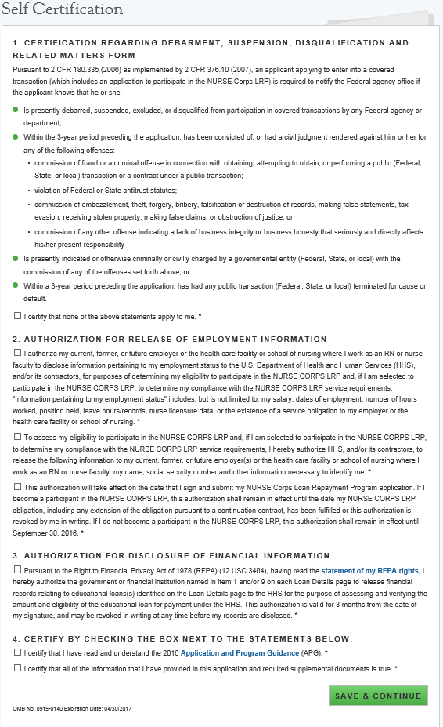

Section 14: Review & Submit
The Review & Submit page is the last page of the application. The Review & Submit page displays a table with each section and the corresponding section status. All sections must be in the “Complete” status for the applicant to submit the application. The applicant can select the top navigation menu or a particular section’s link in the table to view that page.
Steps:

- Applicant reviews the application and makes any necessary edits

- Applicant enters password

- Applicant selects.

Business Rules:

- Applicant can view and edit any page of the application by clicking on the page name before submitting.
  - Applicant will then be required to complete the Self-Certification section again

- Applicant must enter in his/her correct password in order to submit his/her application.

- All page statuses except for review and submit must be complete for applicant to submit his/her application.

- System shall not allow application to be submitted after the application deadline.

- System shall update application status to a submitted status upon submission.

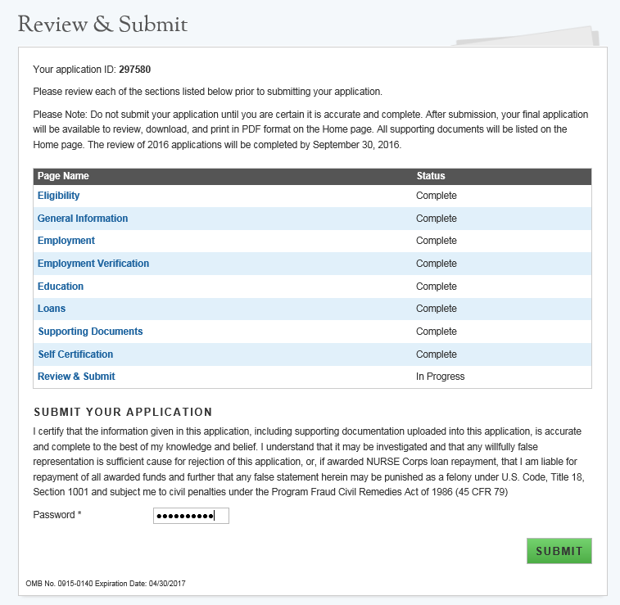

Section 15: Submitted Page
After the applicant submits his/her NCLRP application, he/she will be directed to the Submitted landing page and the overall application status will change to either “Submitted” or “Submitted – Ineligible.” If any of the responses on the online application deem an applicant ineligible, the status upon submission will be “Submitted – Ineligible.” If the responses submitted deem the applicant eligible the application status will be “Submitted.” On the Submitted landing page, the applicant will have the ability to edit or withdraw his/her application. The applicant will have the ability to edit his/her application until the application deadline. The applicant may withdraw his/her application up until the applicant receives a Confirmation of Interest (COI), if applicable.
Business Rules:

- System shall update the application status to “Submitted-Ineligible” upon submission if:
- Received degree date from education page is in the future
- Applicant has an existing BHW service that has an obligation end date in the future (validated by SSN check)
- The Employment Verification (EV) submitted by the site Point of Contact (POC) indicated that the applicant does not meet the required work hours per week to be eligible for an award
- The EV submitted by the site's POC indicated that the applicant does not have a current, full, unrestricted, and unencumbered license
- The EV submitted by the site's POC indicated that the applicants employment start date is after his/her submission date
- System shall disable the button if/when applicant is sent Confirmation of Interest (COI)

- System shall update applicant status to “In Progress” upon selecting Edit

- System shall disable Edit when application cycle closes

- System shall save most recent application status upon cycle close
(Example: If the applicant edits and never re-submits by the application close date, his/her final status will be “In Progress”)

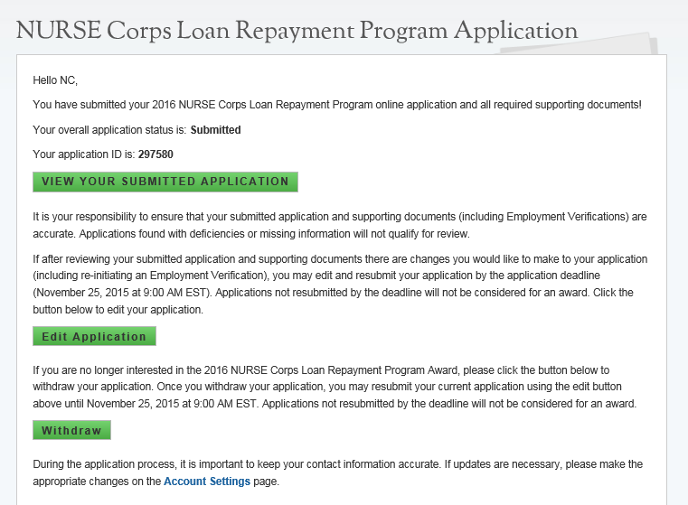
Business Rules Cont:

- System shall allow applicant to select Undo Withdrawal after he/she has Withdrawn the application if he/she wish to resubmit.

- System shall link a copy of submitted application in PDF after application has been submitted. The applicant will able to view the site POC’s EV responses within this document.

- System shall display “Submitted-Ineligible” Landing Page content if applicant is deemed ineligible upon submission (Edit and Withdraw functionalities will still be enabled until the application deadline).

- All documents uploaded by the applicant will be linked on the Submitted Landing Page.

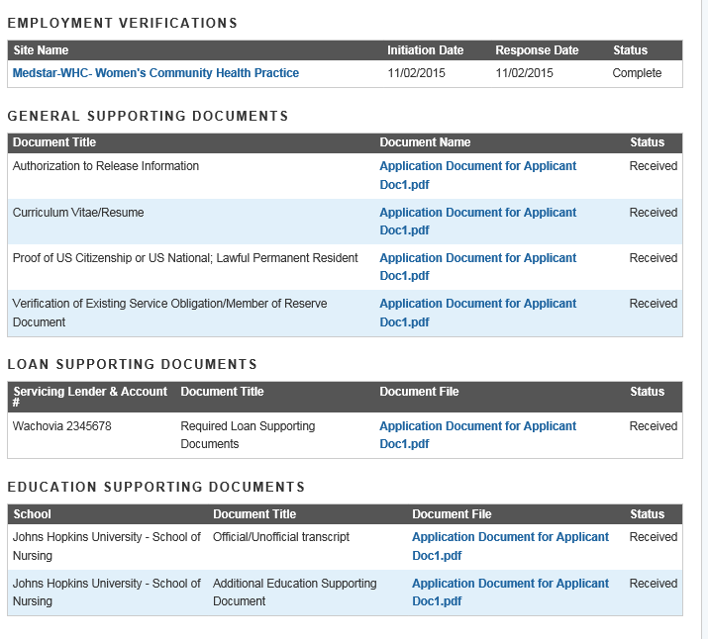

Section 16: Application Withdraw
An applicant has the option to withdraw his/her application after submission. The applicant may withdraw his/her application up until the applicant receives a COI, if that is an applicable. The applicant may resubmit the current application by using the Undo Withdrawal button. However, the applicant must resubmit his/her application by the application deadline to be considered for an award.
Steps:
      - From the Submitted Home Page an applicant will click the button

      - The applicant will be directed to the “Withdraw Application” confirmation screen

      - The applicant clicks and is directed to the Submitted Home page (see Figure 20)
- Note: The applicant will now have a status of “Withdrawn”

      - On the Submitted Home page the applicant can undo the withdraw by clicking

      - If the applicant clicks he/she will be directed to the In Progress Landing Page

      - The applicant will click from In Progress application and will be directed to the Self Certification Page

      - Applicant will follow steps to complete and submit application.

      - The applicant will read each certification

      - Applicant indicates that he/she agrees by selecting the checkbox.

      - Applicant selects.

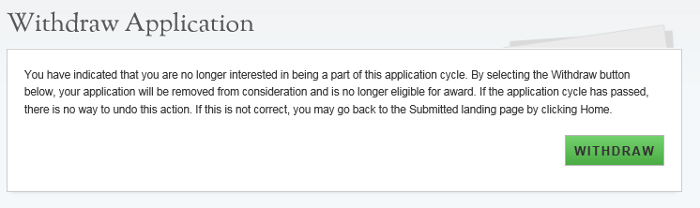
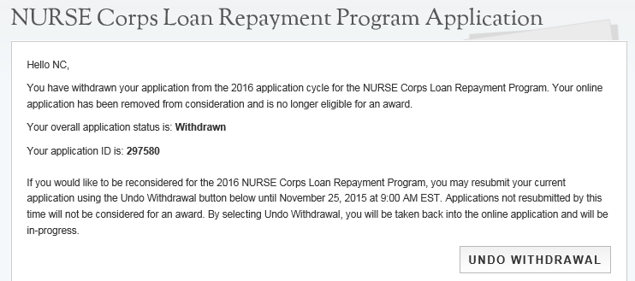

Steps Cont:

      - Applicant is directed to the Review and Submit Page

      - Applicant reviews the application.

      - The Applicant enters his/her password

      - Applicant selects and is directed to the Submitted Home Page.

Business Rules:
- The ability to withdraw an application will be disabled when the applicant is sent to COI.

- If an applicant wishes to re-submit his/her application he/she must resubmit by the application deadline.

- The system will save the most recent status once the application closes if applicant selects withdraw.

- An applicant may withdraw his/her application if his/her status is “Submitted” or “Submitted-Ineligible”.

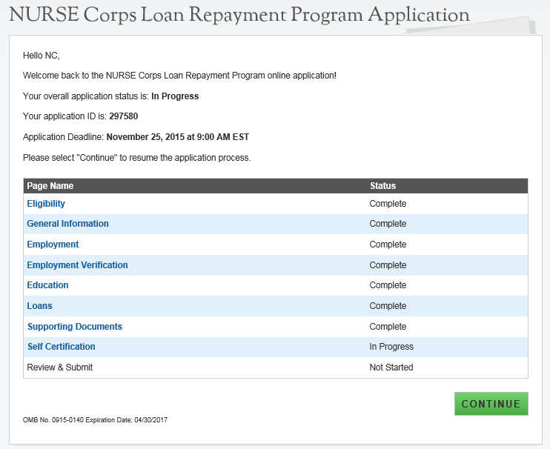

Section 17: Edit Application
If an applicant would like to edit his/her application after submission, he/she may do so prior to the application deadline. If an applicant edits his/her application, the applicant must re-submit his/her application by the application deadline. If the applicant does not resubmit his/her application, the applicant will not be considered for an NCLRP award.
Steps:

- The applicant clicks Edit Application.

- The applicant clicks or pop-up (below)

- The applicant will be directed to the In Progress Landing Page (see figure 21)

- The applicant navigates to any section to make the necessary edits

- The applicant clicks Save & Continue at the bottom of the page where edits were made in order to save the edits

- Once all edits are made and saved the applicant will navigate to the Self- Certification page

- Applicant will follow steps to complete and resubmit application

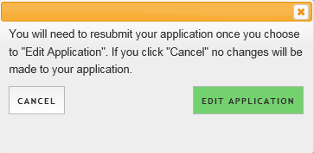
Business Rules:

- The applicant will not be able to Edit his/her application after the application deadline.

- An applicant must resubmit his/her application by the application deadline if he/she want to be considered for an award.

- The applicant will be directed to the In Progress landing page when selecting Edit.

- The applicant’s status will be changed to “In-Progress” upon selecting Edit.

- All business rules apply on each page if the applicant selects Edit.

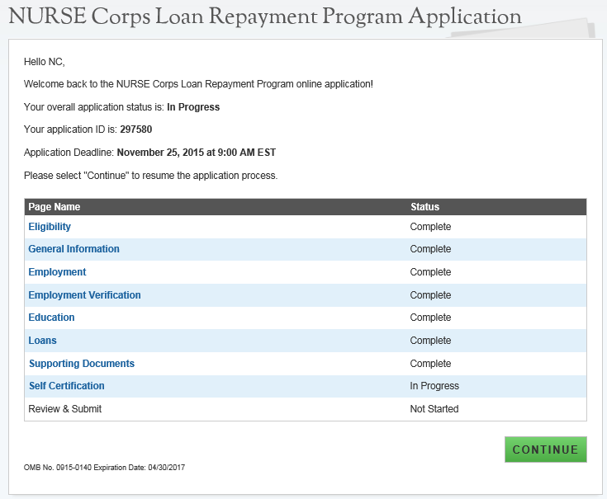

Section 18: Account Settings
The applicant can change his/her password, email and security question on the Account Setting page. In addition, the applicant will be able to see his/her application ID.
Steps to change password or email:
- Applicant enters new password or email

- Applicant confirms new password or email

- Applicant enters current password

- Applicant clicks to Change Password or Change Email

- System displays confirmation that password or email has been successfully updated

Steps to change security information:
- Applicant selects Security Question from the dropdown

- Applicant enters new Security answer

- Applicant enters current password in the “Current Password” box

- Applicant clicks Change Security Information

- System displays confirmation that security information has been successfully updated.

Business Rules:
- System shall inform user that password/email/security information is now changed upon selecting Save.

- System shall inform user that he/she must log out and log back in upon updating password/email/security information.

- System will not create account if email exists in a previously created account.

- System will send confirmation to new email if email was updated.

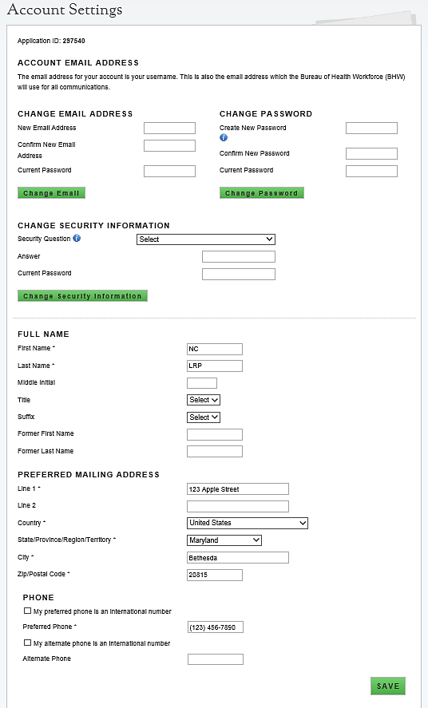

Section 19: Resolving Issues
Please follow the instructions to resolve any inquiries a NCLRP applicant might have:

- For Technical Issues:
- When a technical issue is encountered, e.g. Applicant cannot upload supporting documents, the Call Center should log this issue in JIRA with the applicant’s contact information and a description of the problem. At this point, the BMISS HyperCare Support Team would define and resolve the issue as well as notify the Call Center analyst of the resolution.

Logging Issues: When logging issues in JIRA
  - Log issues as “CC>NCLRP Online App > Eligibility Page”
    - CC refers to call center
    - Whichever page the issue is found on please indicate it after NCLRP Online App
      - If the issue occurs on the General Information page please log the issue as “CC>NCLRP Online App> General Info Page”
  - Attach a screenshot to the issue (if applicable)
    - Please do not include a screen shot of the whoops error message
    - Have the applicant take a screen shot of the page the problem was found on and attach that to the bug
  - Include the following details in the Description section:
    - Applicant information: Full name, last four of SSN, username, phone number, applicant id, application id
    - The exact Online Application screen the applicant was on when the issue occurred
    - The Web Browser the applicant was using
    - The frequency of the issue
    - Detailed description on how to reproduce the issue
    - The time and date this issue occurred
  - Include the priority and severity of the issue

- For Program Related Issues:
- If an applicant has a program question, the Call Center will try to answer the problem by referring to the Application and Program Guidance. If the Call Center is unable to answer the question then he/she must triage the question to the NURSE Corps Loan Repayment Program.

Online Application Program Related Issues Contact: To escalate questions about the NCLRP application, please submit inquires to the following email: nursecorpslrpsupport@hrsa.gov.

Capturing Applicant Information:The following applicant information should be captured and as much detail of the issue as possible:
  - First and Last Name
  - Email Address used to log into the application
  - Last four digits of SSN
  - Section of online application the user was on when he/she encountered the problem
  - Detailed summary of the problem
  - Supporting Document (If applicable)

Section 20: Resolving Issue Flow Chart

