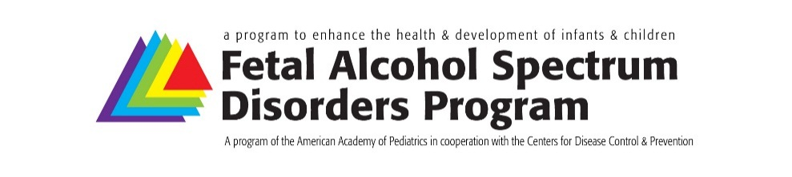
Form Approved
OMB No. 0902-XXXX
Exp.: XX/XX/20XX
Fetal Alcohol Spectrum Disorders
Regional Education and Awareness Liaisons
Improving health outcomes for infants and children diagnosed with one of the FASDs
by addressing stigma and bias and increasing early identification.

Name: ______________________________________________________________________ Date: ________________
Region: ____________________________________________

As the FASD champion for Region ____ of the American Academy of Pediatrics (AAP), I will take part in the following activities to support issues related to FASD during 2016:
FASD Champion Metric: FASD Champions will submit a work plan including specific aims and measures for achieving progress. At the end of the year, FASD Champions will provide a written summary/update on progress made towards work plan activities.
2016 Work Plan Submission Date:

FASD Champion Metric: FASD Champions will participate on Regional Network trainings/conference calls/webinars 1 times per year.
Dates:

1. _______________________________ Attended Yes ⎕ No ⎕
Details on method, mode and frequency of contact and planned collaborative efforts:

Other Person(s) Involved:

FASD Champion Metric: FASD Champions will educate pediatric clinicians in their respective regions regarding FASD.
Activity 1:
Date:
Audience:
Person(s) Involved:
Activity Details:

Activity 2:
Date:
Audience:
Person(s) Involved:
Activity Details:

*More activities can be listed on the back of this page as necessary

Other FASD Champion Activities.
Activity:
Date:
Person(s) Involved:
Activity Details:

Activity:
Date:
Person(s) Involved:
Activity Details:

Activity:
Date:
Person(s) Involved:
Activity Details:

