EVALUATION OF COVERAGE TO CARE

Appendix B

Consumer Survey: Informed Consent and Survey

(CMS-10632; 0938-New)

NOTE: This interview protocol is annotated to show (1) the standard demographics and insurance information that RAND will purchase from the survey panel (i.e. thus this information will be collected but absent on the survey); (2) section headers to denote survey topic areas; (3) project research questions associated with each topic area; (4) more detailed “domains” and “subdomains” within topic areas; (5) skip logic notes in brackets to indicate how skip logic will minimize participant burden; and (6) an appendix with sample visuals to include with question 19.

PRA Disclosure Statement
According to the Paperwork Reduction Act of 1995, no persons are required to respond to a collection of information unless it displays a valid OMB control number. The valid OMB control number for this information collection is 0938-XXXX. The time required to complete this information collection is estimated to average [Insert Time (hours or minutes)] (Expiration Date) per response, including the time to review instructions, search existing data resources, gather the data needed, and complete and review the information collection. If you have comments concerning the accuracy of the time estimate(s) or suggestions for improving this form, please write to: CMS, 7500 Security Boulevard, Attn: PRA Reports Clearance Officer, Mail Stop C4-26-05, Baltimore, Maryland 21244-1850. *****CMS Disclaimer*****Please do not send applications, claims, payments, medical records or any documents containing sensitive information to the PRA Reports Clearance Office. Please note that any correspondence not pertaining to the information collection burden approved under the associated OMB control number listed on this form will not be reviewed, forwarded, or retained.

OMB No.: 0938-XXXX

Expiration Date: MM/DD/YYYY

Evaluation of Health Insurance and Health Care Use

INFORMED CONSENT FOR CONSUMERS
Thank you for agreeing to participate in this survey. The RAND Corporation is conducting a study for the Centers for Medicare & Medicaid Services’ on From Coverage to Care, or C2C. As you may know, From Coverage to Care aims to help people with new health care coverage understand their benefits and connect to primary care. It is also designed to help community organizations and providers support consumers as they connect to care.
Purpose of the Study

This is a research project being conducted by the RAND Corporation. This study is funded by the Centers for Medicare & Medicaid Services (CMS) Office of Minority Health. This survey will ask you about healthcare, health insurance, and if you have seen or received informative health insurance materials. Your responses are important for understanding and improving healthcare utilization in the United States.

Procedures

Completing this survey should take approximately 20 minutes and can be completed at your convenience. We will not collect personally identifiable information, and your answers cannot be linked back to you. Question types include multiple choice and fill in the blank questions. You may skip any questions you do not feel comfortable answering.

Potential Risks and Discomforts

There are no identifiable risks associated with this survey. All information will be kept confidential. Your name will not be collected or linked to the data you provide at any time.

Potential Benefits

This research is not designed to help you personally, but the results may help improve healthcare utilization in the United States. We hope that, in the future, other people might benefit from this study through improved understanding of this phenomenon.

Confidentiality

We will not collect any identifiable information, thus confidentiality will be maintained, except as required by law. Should you choose not to participate in the study, information on your refusal to participate will not be released to CMS. The data collected through this survey will be summarized in aggregate form, grouped with data others provide for reporting and presentation.

Survey responses will be securely stored on the investigators’ password protected computers and password protected shared drive. Any hard copies of the data will remain in the possession of the principal investigator at her locked office. All data will be destroyed (i.e., shredded or erased) within five years after the conclusion of the study.

Compensation

You will receive your standard panel compensation for completing this survey.

Right to Withdraw and Questions

Your participation in this research is completely voluntary. You may choose not to take part at all. If you decide to participate in this research, you may stop participating at any time.

If you have questions or concerns about this study please contact the Principal Investigator of the study, Tom Concannon at 617-338-2059 x8615 or by emailing tconcann@rand.org

Participant Rights

If you decide to stop taking part in the study, if you have questions, concerns, or complaints, or if you need to report an injury related to the research, please contact the RAND Corporation’s Human Subjects Protection Committee (HSPC) toll free at (866)-697-5620 or by emailing hspcinfo@rand.org.

This research has been reviewed according to the RAND Corporation HSPC procedures for research involving human subjects.

C2C Consumer Survey

Standard Demographics
Note: Standard demographics will be provided to us by Knowledge Networks and do not appear on the survey
- Age & age categories
- Education categories
- Race/ethnicity
- Gender
- Household head
- Housing type
- Household size
- Household income
- Marital status
- Metropolitan Statistical Area status
- Internet access
- Ownership status of living quarters
- Region of U.S.
- State of residence
- Total number and age of household members
- Current employment status
- Start/end/duration time of survey

Insurance Status
Note: Questions below are collected by Knowledge Networks annually and do not appear on the survey
- Type of health insurance
- Has supplemental insurance
- Type of health insurance plan
- Enrolled in Medicare Part D plan
- Enrolled in a Medicare Advantage plan
- Ever covered by health insurance purchased through a state or federal exchange
- Year in which first purchased health insurance through an exchange
- Insured through own employer, spouse or domestic partner’s employer, parent or guardian’s employer or someone else’s employer
- Health plan has a deductible
- Annual deductible for in-network and out-of-network charges

[Begin survey]

Introduction

Welcome! Thank you for agreeing to complete this survey. This survey will ask you about healthcare, health insurance, and if you have seen or received informative health insurance materials. Your responses are important for understanding and improving healthcare use in the United States.

Completing this survey should take about 20 minutes. The survey should be completed in one session. All responses will remain anonymous, as we will not collect any personally identifiable information. All information provided on this survey will remain confidential.

Thank you in advance for your time.

Survey Description

This survey contains multiple choice and fill in the blank questions. Once you begin the survey please try to complete the survey in one sitting, as you will not be able to save or return to the survey. This survey does not require the assistance of outside resources. Completing the questions to the best of your ability, or based on minimal information searching, is acceptable for this survey. If you have any questions about this survey or require assistance, please contact the Panel Member Support Center at the toll free 1-(800)-782-6899 number if you have any difficulties.

Section 1: Usual Source of Care
  - Research questions answered:
- Did the fraction of the population with an identified primary care provider change?

- Is there a place that you usually go to when you are sick or need advice about your health?
- Yes
- No

[IF YES SHOW QUESTIONS 2 AND 3]

- What kind of place [is it/do you go to most often] -- a clinic, a doctor’s office, an emergency room, or some other place?
- Clinic (e.g. urgent care)
- Doctor’s office (e.g. primary care physician)
- Emergency room
- Some other place: ___________

3. When you attend ________(fill in from question 2), do you usually see the same care provider?
- Yes
- No

Section 2: Health Insurance Literacy
  - Research questions answered:
- Did C2C contribute to a change in consumer knowledge and understanding of health insurance coverage and how it works (e.g. health insurance literacy)?
- Did C2C contribute to a change in consumer knowledge or understanding of how to access care as a result of C2C messages or materials?

Domain: Choosing insurance
Subdomain: Confidence choosing

- How confident would you feel that you…
- Know where to go for help if you have trouble affording health insurance outside of an employer?
- Know how to estimate what you would have to pay for your health care needs in the next year, not including emergencies?
- Know if a service is covered by insurance?
- Know what questions to ask so that you can choose the best health plan for you?
- Know where to find the information you need to choose a health plan if you were not offered insurance through an employer?
- Understand health insurance terms?
- Would choose the health plan that is best for you?
  - Not at all confident
  - Slightly confident
  - Moderately confident
  - Very confident

Subdomain: Comparing plans

- When comparing health plans how likely are you to…
- Find out if the plans cover unexpected costs such as hospital stays?
- Understand what you would have to pay for emergency department visits?
- Understand what you would have to pay for specialist visits?
- Understand what you would have to pay for prescriptions drugs?
- Find out if you have to meet a deductible for health care services?
- Look to see which doctors and hospitals are covered in each plan?
  - Not at all likely
  - Somewhat likely
  - Moderately likely
  - Very likely

Subdomain: Using insurance

- How confident are you that…
- You know how to figure out your share of the costs for care, after the health plan pays their share?
- You know what to do if your health plan refuses to pay for a service you think should be covered?
- You know what questions to ask your health plan if you have a coverage problem?
- You know most of the things you need to know about using health insurance?
- You know how to find out what is and is not covered before you receive a health care service?
  - Not at all confident
  - Slightly confident
  - Moderately confident
  - Very confident

Subdomain: Being proactive

- When using your health insurance plan, how likely are you to…
- Look to member services to tell you what medical services your health plan covers?
- Look into what your health plan will and will not cover before you get health care services?
- Review the statements you get from your health plan showing what you owe and what they paid for a service?
- Find out if a doctor is in-network before you see him/ her?
  - Not at all likely
  - Somewhat likely
  - Moderately likely
  - Very likely

Section 3: Knowledge of Health Insurance
  - Research questions answered:
- Did C2C contribute to a change in consumer knowledge and understanding of health insurance coverage and how it works (e.g. health insurance literacy)?

Domain: Confidence in understanding health insurance terms

8. How confident are you that you know what the following terms mean?…
- Provider
- Network
- Deductible
- Co-insurance
- Co-payment
- Premium
- Out-of-pocket maximum
- Prescription drug list (or formulary)
- Explanation of benefits
  - Not at all confident
  - Slightly confident
  - Moderately confident
  - Very confident

Section 4: Preventive Health Care Utilization
  - Research questions answered:
- Did the use of preventive services change (e.g., primary care, vaccination)?

9. About how long has it been since you had a routine check-up by a doctor or other health professional?
- Within past 12 months
- Within past 1-2 years
- Within past 3-4 years
- Within past 5-6 years
- More than 7 years
- Never
- Don’t know

10. About how long has it been since you had your blood pressure checked by a doctor, nurse or other health professional?
- Within past 12 months
- Within past 1-2 years
- Within past 3-4 years
- Within past 5-6 years
- More than 7 years
- Never
- Don’t know

11. About how long has it been since you had a flu vaccination (shot or nasal spray)?
- Within past 12 months
- Within past 1-2 years
- Within past 3-4 years
- Within past 5-6 years
- More than 7 years
- Never
- Don’t know

Section 5: Care Utilization
  - Research questions answered:
- Did use of ED services change?
- Did use of behavioral health care change?

Domain: Primary care use

12. During the past 12 months, how many times have you seen your doctor or other health care professional about your own health (this could be for a well visit or when you were sick)?
- None
- 1
- 2-3
- 4-5
- 6-7
- 8-9
- 10-12
- 13-15
- 16 or more
- Don't know

Domain: ER use

13. During the past 12 months, how many times have you gone to a hospital emergency room about your own health (This includes emergency room visits that resulted in a hospital admission)?
- None
- 1
- 2-3
- 4-5
- 6-7
- 8-9
- 10-12
- 13-15
- 16 or more
- Don't know

[IF PARTICIPANT REPORTS ER USE SHOW QUESTIONS 14 AND 15]

14. Did your last emergency room visit result in a hospital admission?
- Yes
- No

15. Tell me which of these apply to your last emergency room visit? Check all that apply.
- It was a life-threatening illness or injury
- You didn't have another place to go
- Your doctor’s office or clinic was not open
- It was a night or weekend
- Your health provider advised you to go
- The problem was too serious for the doctor’s office or clinic
- The emergency room is your closest provider
- You get most of your care at the emergency room
- You arrived by ambulance or other emergency vehicle

Domain: Urgent care use

16. During the past 12 months, how many times have you gone to an urgent care clinic about your own health?
- None
- 1
- 2-3
- 4-5
- 6-7
- 8-9
- 10-12
- 13-15
- 16 or more
- Don't know

[IF PARTICIPANT REPORTS URGENT CARE USE SHOW QUESTION 17]

17. Tell me which of these apply to your last urgent care visit? Check all that apply.
- You didn't have another place to go
- Your doctor’s office or clinic was not open
- It was a night or weekend
- Your health provider advised you to go
- The problem was too serious for the doctor’s office or clinic
- Only a urgent care clinic could help you
- The urgent care clinic is your closest provider
- You get most of your care at the urgent care clinic
- You arrived by ambulance or other emergency vehicle

Domain: Behavioral health use

18. During the past 12 months, have you seen or talked to a behavioral or mental health professional such as a psychiatrist, psychologist, psychiatric nurse, or clinical social worker?
- Yes
- No

19. During the past 12 months, have you needed or wanted to see a behavioral or mental health professional such as a psychiatrist, psychologist, psychiatric nurse, or clinical social worker but didn’t?
- Yes
- No

Section 6: Consumer Exposure to C2C
  - Research questions answered:
- Which of the materials/messages did consumers find helpful?
- Did C2C contribute to a change in consumer knowledge and understanding of health insurance coverage and how it works (e.g. health insurance literacy)?
- Did C2C contribute to a change in consumer knowledge or understanding of how to access care as a result of C2C messages or materials?

Domain: Unaided ad recall

20. During the past 12 months, how many times have you seen or received health insurance materials that help you understand your health insurance coverage or insurance terms?
- Not at all
- Once
- 2 to 4 times
- 5 to 10 times
- More than 10 times

[IF SEEN/RECEIVED MATERIALS SHOW 21]

21. How did you see or receive these resources that helped you understand your health insurance coverage or insurance terms? Check all that apply.
- From an assister or navigator while enrolling in health insurance coverage
- At your provider’s office or other health care setting
- Event (i.e., a community event, health promotion fair, etc.)
- From an informational table or bulletin board (e.g., at a community organization or library)
- Online (e.g., by visiting a Website)
- Social media (Facebook, Twitter, etc.)
- Print (Newspaper, magazine, poster, etc.)
- Mail
- Radio
- Television
- Other: _________________

Domain: Aided ad recall

22. Have you seen, heard about, or received any From Coverage to Care materials? For example, have you seen a booklet called “A Roadmap to Better Care and a Healthier You?” or “5 Ways to Make the Most of Your Health Coverage”?
- Yes
- No

[Sample visuals to be shown included in survey Appendix]

[IF YES SHOW QUESTIONS 23-30]

23. During the past 12 months, how many times have you seen or heard about From Coverage to Care or its materials?
- Not at all
- Once
- 2 to 4 times
- 5 to 10 times
- More than 10 times

[IF NOT AT ALL, END SURVEY]

24. How did you see or hear about From Coverage to Care? Check all that apply.
- From an assister or navigator while enrolling in health insurance coverage
- At your provider’s office or other health care setting
- Event (i.e., a community event, health promotion fair, etc.)
- From an informational table or bulletin board (e.g., at a community organization or library)
- Online (e.g. by visiting a Website)
- Social media (Facebook, Twitter, etc.)
- Print (Newspaper, magazine, poster, etc.)
- Mail
- Radio
- Television
- Other

Domain: C2C targeted knowledge

25. Please rate the following statements to indicate how your understanding of the following topics have changed as a result of seeing Coverage to Care’s (C2C): “A Roadmap to Better Care and a Healthier You”?
- Why I should see a doctor on a regular basis, even if I don’t feel sick
- Health insurance terminology
- How to find out about my plan benefits and what my insurance covers
- Where to go for care if I don’t feel well
- How to find a regular healthcare provider that fits my needs
- What to bring with me to my healthcare appointment
- What to ask my provider when I am there
- That I can change my provider if I don’t like the one I have
- Where I can go if I have questions
- Other: ___________________
- None
  - My understanding is the same as it was before I saw C2C materials
  - I have a slightly better understanding
  - I have a better understanding
  - I have a much better understanding

Domain: C2C-related conversation

26. Do you recall talking about C2C or the Roadmap with anyone?
- Yes
- No

[IF YES SHOW QUESTION 27]

27. Who have you talked to about C2C? Check all that apply.

- Insurance enrollment assister/ Navigator
- Healthcare professional
- Family member
- Friend
- Co-worker
- Community organization
- Other

[IF YES TO ANY OPTIONS IN 27, SHOW 28]:

28. How many times have you talked to the following about C2C?
- Not at all
- Once
- 2 to 4 times
- 5 to 10 times
- More than 10 times

29. Have you shared information about C2C with someone else?
- Yes
- No

[IF YES SHOW QUESTION 30]

30. Who have you shared information with about C2C? Check all that apply.
- Healthcare professional
- Family member
- Friend
- Co-worker
- Community organization
- Other

Conclusion

You have completed the survey. Thank you for your time!

Appendix

Visual 1: Coverage to Care’s (C2C): “Roadmap to Better Care and a Healthier You” Cover Page

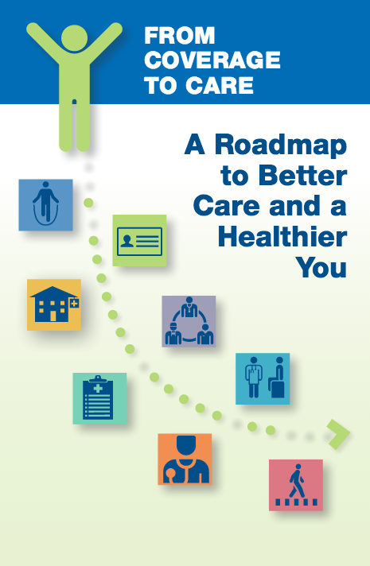

Visual 2: Coverage to Care’s (C2C): “Roadmap to Better Care and a Healthier You” Map

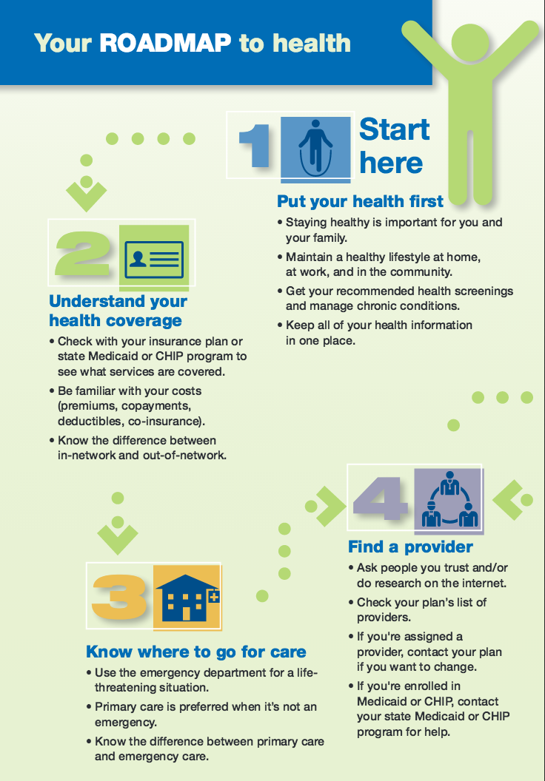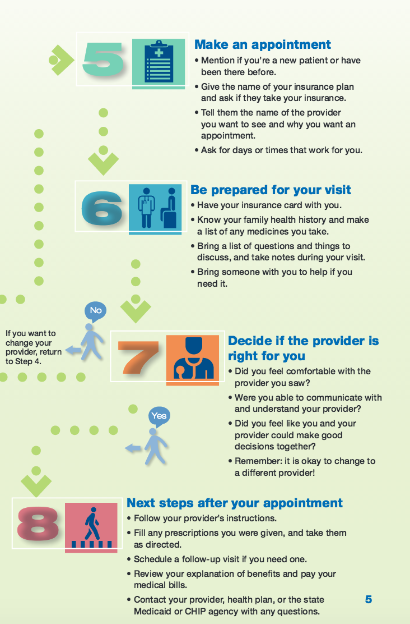

Visual 3: Coverage to Care’s (C2C): “5 Ways to Make the Most of Your Health Coverage”?

