ATTACHMENT d

CONSENT LETTERS AND FORMS, YOUTH ASSENT FORM (BASELINE survey)

Form Approved

OMB Number: XXXX-XXXX

INSERT LOGO HERE

Expiration Date: XX/XX/XXXX

Dear Parent or Guardian:

The Office of Adolescent Health (OAH) in the U.S. Department of Health and Human Services (DHHS) is doing a study of ways to delay sexual initiation, increase contraception use, and reduce sexually transmitted infections (STIs) and pregnancies for middle and high school students. The Attitudes, Behaviors, and Choices (or ABC) Studywill provide information about effective strategies to achieve these goals. OAH has hired Mathematica Policy Research, an independent policy research firm, to conduct this study.

Your child’s school is taking part in this study, and students in middle school and high school, including your child, are being asked to participate. We are asking your permission for your child to participate in the study. Research staff from Mathematica will ask youth to complete up to three surveys over the next two years. The surveys will ask about families, friends, communities, and education. They also include questions about attitudes, contraceptive knowledge, activities, including sexual activity, and drug and alcohol use. The survey will take about 30 minutes to complete. If you give permission for your child to participate in the study, he/she will complete the first survey in school over the next few weeks. The next two surveys will be conducted about 9 and 15 months later. Mathematica will again administer the survey in the schools, and will only follow-up over the telephone or email if your child is no longer enrolled in a school participating in the study. The study team will also gather information about your child’s attendance in any classes at school that he or she participates in that provide information on pregnancy and contraception.Your child might also be asked to participate in a focus group discussion later. If your child is selected for a focus group, you will be asked to provide permission for his/her participation at that time.

All information collected for the study will be kept private to the extent allowed by law. If you let your child participate, information from your child will be combined with information from other middle and high school students from your school district. Your child’s name will not be attached to the answers he/she gives, and no one outside the study team will see his/her answers. We have a Certificate of Confidentiality from the National Institutes of Health. The Certificate helps us protect your child’s privacy. This means no one can force the study team to give out information that identifies you or your child, even in court. However, we may need to share your information if it shows a serious threat to your child or to others.

Participation in the study is voluntary. If you agree that your child can participate, you or your child can choose to stop participation at any time with no consequences. The only risk to your child connected with the study is that he/she may be uncomfortable answering some questions in the surveys. If that happens, your child can refuse to answer those questions.

You may let us know whether you will allow your child to be in the study in one of two ways. The first way is by completing and signing the attached pink form. Please ask your child to return the signed form to their health class within one week. The second way is by going online to [URL] and completing the form there. Whether your answer is “yes” or “no,” your **child will receive a small gift if you complete and submit the form within one week.** Please keep the blue form for your records. If you have questions about the ABC Study or about your child’s participation, please call Laura Kalb, Mathematica’s Survey Director, toll-free, at 1-8XX-XXX-XXXX between 9 a.m. and 5 p.m. Eastern Time, Monday-Friday.

Sincerely,

Susan Zief, PhD

Project Director

Mathematica Policy Research

**Attitudes, Behaviors, and Choices Study**

Parent or Guardian Permission Form

*Sponsored by the United States Department of Health and Human Services*

I have read the information sheet describing the study. By signing this form, I am saying:

 **YES, I** **give permission**   **NO, I do not give permission**

for my child, _____________________________________, to participate in the study.

**Print Child’s Name**

In giving permission for my child to participate, I understand that Mathematica staff will administer three surveys to my child over the next two years. I futher understand that additional information will be collected through class attendance records. By giving permission for my child to be in the study, I agree that this information can be collected, and that my child may receive an email or text message to the numbers provided to arrange for participation in the follow-up surveys. I understand that participation is voluntary and may be withdrawn at any time for any reason without penalty. I further understand that all information on my child will be kept private and used only for the purposes of the study. If I have questions about my child’s rights as a research volunteer, I can call the New England Independentl Review Board, toll-free at 1-800-232-9570.

**Child’s Date of Birth:** _____ / ______ / _____  **Child’s Gender (circle one):** M / F Month Day Year

**Parent/Guardian Signature:** ___________________________ **Date: _______________**

**If you said YES above, please fill in the following information.** We will use your contact information only if we need your help in contacting your child to schedule a follow-up study survey. We also ask you to provide contact information for someone who would know how to reach you in the event you move and we cannot contact you. If we contact this person, we will not reveal any information about your child or the study, other than to say we need to locate your child to complete a survey. Thank you.

**Parent or Guardian Name:** ______________________________________________________________________

**Street Address:** _______________________________________________________________ **Apt:** ___________

**City:** _____________________________________________________ **Zip Code:** __________________________

**Telephone:** (______)_____ - ___________ Home **Email:** _________________________________

(_____) _____ - ____________ Work

(_____) _____ - ____________ Cell

**Alternate Contact Name:** _______________________________________________________________________

**Street Address:** _______________________________________________________________ **Apt.** ___________

**City:** _____________________________________________________ **Zip Code:** ________________________

**Telephone:** (_____) ____ - ___________ Home **Email:** _________________________________

(_____) ____ - ___________ Work

(_____) ____ - ___________ Cell

Parents please be aware that under the Protection of Pupil Rights Act. 20 U.S.C. Section 1232(c)(1)(A), you have the right to review a copy of the questions asked of your child. If you would like to do so, you should contact Laura Kalb toll-free at 1-8XX-XXX-XXXX to obtain a copy of the questions.

***WE NEED YOUR ANSWER, WHETHER IT IS YES OR NO. PLEASE SIGN [THIS FORM/AND RETURN THE PINK COPY TO YOUR CHILD’S HEALTH CLASS] WITHIN ONE WEEK. KEEP THE BLUE COPY FOR YOUR RECORDS. THANK YOU!***

Student Name

Teacher Last Name_Subject_Class Period_S1

School Name/Location

[](http://www.google.com/url?sa=i&source=images&cd=&cad=rja&docid=-iz53YlEl9IcZM&tbnid=F72bHkfm6gYgQM:&ved=0CAgQjRwwAA&url=http://www.sagedata.com/products/bar_code_labels.html&ei=NdQDUpuyMIuc8wSljYGADg&psig=AFQjCNHn-oZszPw4Di_AifVfOemwCsNNpg&ust=1376069045862583)

INSERT LOGO HERE

Form approved

OMB Number: XXXX-XXXX

Expiration Date: XX/XX/XXXX

**STATEMENT OF ASSENT**

**SURVEY – for youth under 18**

**attitudes, behaviors, and choices study**

Sponsored by the United States Department of Health and Human Services

An adult from Mathematica Policy Research has described the study to me, and any questions I had were answered. I was told that I have been selected to be a part of the study and that my parent or guardian has agreed to my participation. I understand I will be asked to complete up to three surveys and that each survey will take about 30 minutes to complete. I may receive an email or text message about the follow up surveys. All my information will be kept private to the extent allowed by law and will not be given to people outside of the study or shown to my parents or guardians. I also understand that I do not have to answer any questions that make me feel uncomfortable. However, if I say that I am going to hurt myself or someone else, or that someone is hurting me, someone on the study team will take steps to make sure that I am safe.

If I have questions about my rights as a research volunteer or questions about the study, I can call:

* The New England Independent Review Board, toll-free at 1-800-XXX-XXXX.
* Laura Kalb, Survey Director at Mathematica Policy Research, toll-free at 1-800-XXX-XXXX.

I understand that participation is voluntary, and I agree to participate in the study. I understand that I am allowed to stop participating in the study at any time, without punishment.

______________________________ ____________________________________ _______________

Name Signature Date

Email: __________________________________________

Cell phone: ( ) _________ - ______________

Area code

------------------------------------------------------------------------------------------------------------------------------------------

I certify that the staff members assigned to explain the study to participants were trained to do so in terms participants would understand.

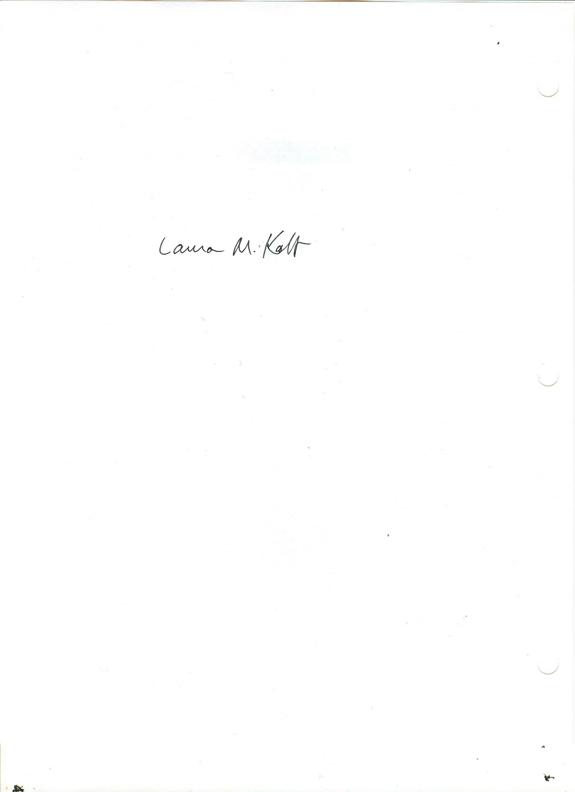

______________________________________

Laura Kalb

Survey Director

Signature Date: 08/16/13

Student Name

Teacher Last Name_Subject_Class Period_S1

School Name/Location

