


COPS Office Application Attachment to SF-424

  - Department of Justice
Office of Community Oriented Policing Services 145 N Street NE
Washington, DC 20530

Visit the COPS Office online: www.cops.usdoj.gov

May 2016

This page is intentionally blank.

This page is intentionally blank.

Contents

Section 1. COPS Office Program Request 4
Section 2. Agency Eligibility Information 3
2A. CHP eligibility questions 5
Part I. Law enforcement agency operations 5
Part II. Contracting to receive law enforcement services 5
Part III. Law enforcement agency authority 6
2B. SOS eligibility questions 7
2C. CAMP eligibility questions 8
2D. CAGI eligibility questions 8
2E. AHTF eligibility questions 8
Section 3. General Agency Information 9
Section 4. Executive Information 13
Section 5A. COPS Hiring Program Officer Request 17
Part 1 17
Part 2 21
Part 3 22
Part 4 22
Section 5B. Child Sexual Predator Program (CSPP) Officer Request 23
Section 6A. Law Enforcement & Community Policing Strategy 25
Community policing definition framework 25
Proposed community policing strategy 26
Community partnerships 27
Problem solving 30
Organizational transformation 32
Technology 33
Community policing strategy narrative 35
Section 6B. Law Enforcement & Community Policing Strategy 37
Community policing strategy 37
Community policing definition framework 38
I. Current organizational commitment to community policing 39
OMB Control Number 1103-0098 Expiration Date: 04/30/2017
II(a). Proposed community policing strategy: Problem solving and partnerships 41
Child and youth safety focus 42
Drug-related problems 43
Homeland security problems 44
Nonviolent crime problems 44
Building Trust 45
Traffic/pedestrian safety problems 46
Violent crime problems 47
II(b). Proposed community policing strategy: Organizational transformation 53
III. General community support and engagement 55
Section 7. Need for Federal Assistance 57
- Explanation of need for federal assistance 57
- Service population 57
- Fiscal health 58
- Property/Violent crime 61
Section 8. Continuation of Project After Federal Funding Ends 62
- Continuation of project after federal funding ends (for COPS Office grants with a retention plan requirement) 63
- Continuation of project after federal funding ends (for COPS Office grants with no retention plan requirement) 64
Section 9. School Safety Assessment 65
Section 10. Executive Summary 68
Section 11. Project Description (Narrative) 70
Section 12. Official Partner(s) Contact Information 73
Section 13. Application Attachments 74
Section 14. Budget Detail Worksheets 77
- Sworn officer positions 78
Part 1. Instructions 78
Part 2. Sworn officer salary information 79
Part 3. Federal/Local share costs (for hiring grants) 82
- Base salary and fringe benefits for civilian/nonsworn personnel 83
Part 1. Instructions 83
Page | ii
OMB Control Number 1103-0098
Expiration Date: 04/30/2017 Contents
- Equipment/Technology 86
- Supplies 87
- Travel/Training 87
- Contracts/Consultants 88
- Other costs 91
- Indirect costs 92
- Budget summary 93
Waiver of local match 95
Contact information for budget questions 95
Section 15A. Assurances 96
Section 15B. Certifications 100
Section 16. Disclosure of Lobbying Activities 106
Section 17. Reviews and Certifications 111
Section 18. Application Data Verification 113
Paperwork Reduction Act Notice 114
About the COPS Office 116

Page | iii

This page is intentionally blank.

Section 1. COPS Office Program Request

Federal assistance is being requested under the following COPS Office program:

Verify the COPS Office grant program for which you are requesting federal assistance. A separate application must be completed for each COPS Office program for which you are applying. Please ensure that you read, understand, and agree to comply with the applicable grant terms and conditions as outlined in the COPS Office Application Guide before finalizing your selection.

ONLY ONE PROGRAM OPTION MAY BE CHECKED.

 

 

 COPS Anti-Gang Initiative

 COPS Hiring Program

 COPS Anti-Methamphetamine Program

 COPS Anti-Heroin Task Force

 Community Policing Development

Please select a CPD topic area from the menu below: [Placeholders - subject to change]

  - Microgrants Initiative for Law Enforcement
  - Critical Response Technical Assistance
  - Community Policing Emerging Issues Forums
  - President’s Task Force on 21st Century Policing Field Initiated Projects
  - Collaborative Reform Initiative Program Evaluation
  - Invitational Initiative

Invitational Initiative

A1. Have you been provided an invitational code by the COPS Office? A2. If so, please enter your invitation code here:

Research & Development (R&D) Designation

B1. Could any portion of your project be considered research and development (R&D) as defined by 2 C.F.R. §200.87? (See definition below.)
“R&D means all research activities, both basic and applied, and all development activities that are performed by non-Federal entities. The term research also includes activities involving the training of individuals in research techniques where such activities utilize the same facilities as other research and

OMB Control Number 1103-0098 Expiration Date: 04/30/2017

development activities and where such activities are not included in the instruction function. ‘Research’ is defined as a systematic study directed toward fuller scientific knowledge or understanding of the subject studied. ‘Development’ is the systematic use of knowledge and understanding gained from research directed toward the production of useful materials, devices, systems, or methods, including design and development of prototypes and processes.”

Page | 2

Section 2. Agency Eligibility Information (all programs)
Type of Agency (select one)

 Law Enforcement  Non-Law Enforcement

From the list below, please select the type of agency which best describes the applicant. Law Enforcement Entities
Select One …

Note to applicant: Choices in this drop-down menu are as follows.

Attorney/Court Consortium Constable Corrections County Police
Emergency Response/Management (non-police) Federally Recognized Tribal - Other
Federally Recognized Tribal Council Federally Recognized Tribal Courts Federally Recognized Tribal Fish & Wildlife Government
Marshall MultiJuris
Multijurisdictional Task Force Municipal
Municipal Government National Law Enforcement
Natural Resources Police (e.g. Fish and Wildlife, Park Police) New Start-Up (please specify)
Non-profit Park Police
Private University/College Police Profit Organization
Public Housing Public Univ./College
Public University/College Police Regional Police Department Schools

OMB Control Number 1103-0098 Expiration Date: 04/30/2017

Sheriff State
State Associations Chiefs of Police (SACOP) State Associations of Sheriffs
Transit Tribal/Native Village Value-based

Non-Law Enforcement Entities
Select One …

Note to applicant: Choices in this drop-down menu are as follows.

Attorney/Court
Consortium/Partnerships(Other than police/public safety) Corrections
County Government
Emergency Response/Management (non-police) Federally Recognized Tribal - Other
Federally Recognized Tribal Council Federally Recognized Tribal Courts Government
MultiJuris
Multijurisdictional Task Force Municipal
Municipal Government National Law Enforcement Non-profit
Private University/College (Other than police/public safety) Profit Organization
Public Housing
Public University/College (Other than police/public safety) Public University/College Police
Schools State
State Associations Chiefs of Police (SACOP) State Associations of Sheriffs
State Government Transit
Tribal /Native Village Value-based

Page | 4

2A. CHP eligibility questions
In this section, we will ask you several questions about your law enforcement agency operations and authority to determine your eligibility to apply for a COPS Hiring Program (CHP) grant. Please note that CHP applicants must have a police department which is operational as of the xx/xx/2016 date of this application or receive services through a new or existing contract for law enforcement services.
Applicants must also maintain primary law enforcement authority for the population to be served.

Additionally, if funds under this program are to be used as part of a written contracting arrangement for law enforcement services (e.g., a town which contracts with a neighboring sheriff’s department to receive services), the government agency wishing to receive law enforcement services must be the legal applicant in this application (although we will ask you to supply some information about the contract service provider later).

Part I. Law enforcement agency operations
A law enforcement agency is established and operational if the jurisdiction has passed authorizing legislation and it has a current operating budget.

Q1) Is your agency established and currently operational?
Select One …
Q2) Which of the following best describes your agency (check one)?

 We are planning to establish or begin operations as a newly authorized law enforcement agency If selected, proceed to Q3a and Q3b
 We are planning to re-establish and resume operations for a previously operational law enforcement agency
If selected, proceed to Q3b

Q3a) Has your jurisdiction passed legislation which authorizes the creation of a new law enforcement agency? | Select One …
Q3b) Will your law enforcement agency be operational as of xx/xx/2016  (application close date)? | Select One …

Part II. Contracting to receive law enforcement services

Q1) If awarded, does your agency plan to use funds awarded under this grant to establish or supplement a written contract for law enforcement services (e.g., a town contracting for services with a nearby sheriff's department)?

Select One …
Note to applicant: If you answer yes to Q1, the text below plus Q2 will display.

Page | 5

An agency may apply for funds under this program to be used as part of a written contracting arrangement for law enforcement services (e.g., a town which contracts with a neighboring sheriff's department to receive services). However, the agency wishing to receive law enforcement services must be the legal applicant in this application (although we will ask you to supply some information about the contract service provider later).
Before proceeding with this application, we ask that you please log onto the COPS Office Agency Portal to update the agency providing law enforcement services as your Law Enforcement Executive/Agency Executive Information. This information will be pre-populated from the COPS Office Agency Portal in Section 4 of this application, so please ensure its accuracy.
Important Note: Two entities involved in a contracting relationship may not separately apply for funding to support the same officer position(s). For more information about contracting arrangements, please refer to the CHP application guide.

Q2) Is the legal applicant listed in this COPS Hiring Program (CHP) application and on the SF-424 the entity that will be receiving law enforcement services?

Select One …
Q3) What is the legal name of the law enforcement agency that will be providing law enforcement services to your jurisdiction?

[Proceed to next section.]

Part III. Law enforcement agency authority
An agency with primary law enforcement authority is defined as the first responder to calls for service for all types of criminal incidents within its jurisdiction. Agencies are not considered to have primary law enforcement authority if they only: respond to or investigate specific type(s) of crime(s); respond to or investigate crimes within a correctional institution; serve warrants; provide courthouse security; transport prisoners; and/or have cases referred to them for investigation or investigational support.

Q1) Based on the definition above, does your agency have primary law enforcement authority? [Or, if contracting to receive services, does the agency that will be providing law enforcement services have primary law enforcement authority for the population to be served?]

Select One …
Note to applicant: The following questions apply to a subset of applicants [Sheriff, County Police, State Police, Regional PD, Public University, Private University, Natural Resources Police, Transit Police, Public Housing Police, Attorney/Court, Multijurisdictional Task Force, Consortium, Constable, Marshals, Corrections].

Is your agency the first responder to all types of criminal incidents within your jurisdiction?

Select One …

Page | 6

Agencies with jurisdiction limited only to correctional institutes and/or courthouse settings are not eligible under this program. Is your agency the first responder to citizen-initiated calls for service outside of a correctional institute and/or courthouse setting?

Select One …

2C. CAMP eligibility questions
1. Is your agency a State Law Enforcement Agency authorized by law or by a state agency to engage in or to supervise anti-methamphetamine investigative activities, such as locating and investigating illicit activities, precursor diversion, laboratories and/or methamphetamine traffickers? (See Application Guide for more information on anti-methamphetamine investigation authority.)

Select One …

2D. CAGI eligibility questions

1. Is your agency the lead agency for this multi- jurisdictional anti-gang task force? | Select One …
2. Does your task force have all three components (state, local, and federal) represented on the task force? | Select One …

2E. AHTF eligibility questions
1. Is your agency a State Law Enforcement Agency authorized by law or by a State agency to engage in or supervise anti-heroin and/or other opioids investigative activities, such as locating and investigating illicit activities related to the unlawful distribution of heroin or unlawful distribution of prescriptive opioids, or unlawful diversion and distribution of prescriptive opioids?

Select One …

Page | 8

Section 3. General Agency Information

Applicant ORI number:
The ORI number is assigned by the FBI and is your agency's unique identifier. The COPS Office uses the first seven characters of this number. The first two letters are your state abbreviation, the next three numbers are your county's code, and the next two numbers identify your jurisdiction within your county. If you do not currently have an ORI number, the COPS Office will assign one to your agency for the purpose of tracking your grant. ORI numbers assigned to agencies by the COPS Office may end in “ZZ.”

Applicant Data Universal Numbering System (DUNS) number:
A Data Universal Numbering System (DUNS) number is required prior to submitting this application. A DUNS number is a unique nine or thirteen digit sequence recognized as the universal standard for identifying and keeping track of entities receiving federal funds. For more information about how to obtain a DUNS number, please refer to the "How to Apply" section of the COPS Application Guide.

System for Award Management (SAM)

The System for Award Management (SAM) replaces the Central Contractor Registration (CCR) database as the repository for standard information about federal financial assistance applicants, recipients, and sub-recipients. DOJ requires that all applicants (other than individuals) for federal assistance maintain current registrations in the SAM database. Please note that applicants must update or renew their SAM registration at least once a year to maintain an active status.

Applicants that were previously registered in the CCR database must, at a minimum:

- Create a SAM account
- Log into SAM and migrate permissions to the SAM account (all the entity registrations and records should already have been migrated).
Applicants that were not previously registered in the CCR database must register in SAM prior to registering in Grants.gov. Information about SAM Registration procedures can be accessed at www.sam.gov.

For more information about how to register with SAM, please refer to the “How to Apply” section of the COPS Application Guide.

Your SAM Registration is set to expire on
Please enter date in MM/DD/YYYY format.

Note: If your SAM registration is set to expire prior to September 30, 2016, please renew your SAM Registration prior to completing this application. Contact the SAM Service Desk at 866-606-8220 or view/update your registration information at www.sam.gov.

OMB Control Number 1103-0098 Expiration Date: 04/30/2017

Geographic Names Information System (GNIS) ID:
Please enter your Geographic Names Information System (GNIS) Identification Number. This is a unique ID assigned to all geographic entities by the U.S. Geological Survey. To look up your GNIS Feature ID, please go to the website: geonames.usgs.gov/domestic/index.html. For more information about how to obtain a GNIS number, please refer to the “How to Apply” section of the COPS Application Guide.

Cognizant Federal Agency:
Select One …

Note to applicant: Choices in this drop-down menu are as follows.

Bureau of Indian Affairs Department of Agriculture Department of Commerce Department of Defense Department of Education Department of Energy
Department of Health and Human Services Department of Homeland Security
Department of Housing and Urban Development Department of Justice
Department of Labor Department of State Department of the Interior Department of Transportation Department of the Treasury Department of Veterans Affairs
Environmental Protection Agency Executive Office of the President Panama Canal Commission

Select the legal applicant’s Cognizant Federal Agency. A Cognizant Federal Agency, generally, is the federal agency from which your jurisdiction receives the most federal funding. Your Cognizant Federal Agency also may have been previously designated by the Office of Management and Budget. Applicants that have never received federal funding should select the “Department of Justice” as the Cognizant Federal Agency.

Fiscal Year: to
Please enter date in MM/DD/YYYY format.

Page | 10

OMB Control Number 1103-0098
Expiration Date: 04/30/2017 Section 3. General Agency Information

Law Enforcement Agency Sworn Force Information

  - Enter the Fiscal Year Budgeted Sworn Force Strength for the current fiscal year below. The budgeted number of sworn officer positions is the number of sworn positions funded in your agency’s budget, including funded but frozen positions, as well as state, Bureau of Indian Affairs, and/or locally funded vacancies. Do not include unfunded vacancies or unpaid/reserve officers.

    - Number of officers funded in agency’s current fiscal year budget:

Full time Part time

Civilian Staffing

  - Enter the number of civilian positions funded in agency's current fiscal year budget:

    - Number of civilian positions funded in agency’s current fiscal year budget:

Full time Part time
Civilians/(Civilians + Officers) %

U.S. Department of Justice and Other Federal Funding

Applicants are required to disclose whether they have pending applications for federally funded assistance or active federal grants that support the same or similar activities or services for which grant funding is being requested under this application.
Be advised that as a general rule COPS grant funding may not be used for the same item or service funded through another funding source. However, leveraging multiple funding sources in a complementary manner to implement comprehensive programs or projects is encouraged and is not seen as inappropriate. To aid the COPS Office in the prevention of awarding potentially duplicative funding, please indicate whether your agency has a pending application and/or an active grant with any other federal funding source (e.g. direct federal funding or indirect federal funding through State sub- awarded federal funds) which supports the same or similar activities or services as being proposed in this COPS application (check all that apply):

 | Pending Application | Active Grant
Bureau of Justice Assistance (BJA) |  | 
Office of Justice Programs (OJP) |  | 
Office of Juvenile Justice and Delinquency Prevention (OJJDP) |  | 
Office on Violence Against Women (OVW) |  | 
National Institute of Justice (NIJ) |  | 
Office for Victims of Crime (OVC) |  | 

Page | 11

Other U.S. Department of Justice funding |  | 
Other federal or state subawarded funding |  | 
No federal or state subawarded funding |  | 
Please specify the other federal or state subawarded funding source(s).

Page | 12

Section 4. Executive Information
Note: Listing individuals without ultimate programmatic and financial authority for the grant could delay the review of your application or remove your application from consideration.

Law Enforcement Executive/Agency Executive Information

For Law Enforcement Agencies: This is the highest ranking law enforcement official within your jurisdiction (e.g., Chief of Police, Sheriff, or equivalent). The section below has been pre-populated from the information listed in your COPS Office Agency Portal Account. If this information is no longer correct, please log in to your COPS Office Agency Portal account and make the necessary corrections before proceeding with this application. For assistance, please call the COPS Office Response Center at 800-421- 6770.
For Non-Law Enforcement Agencies: This is the highest ranking individual in the applicant agency (e.g., CEO, President, Chairperson, or Director, etc.) who has the authority to apply for this grant on behalf of the applicant agency. If the grant is awarded, this position would ultimately be responsible for the programmatic implementation of the award. The section below has been pre-populated from the information listed in your COPS Office Agency Portal Account. If this information is no longer correct, please log in to your COPS Office Agency Portal account and make the necessary corrections before proceeding with this application. For assistance, please call the COPS Office Response Center at 800-421- 6770.

Note to applicant: The following text is displayed if you are contracting law enforcement services.

Your agency previously indicated that if awarded, this grant would be used in a written contracting arrangement to receive law enforcement services (e.g., a town which is contracting with a neighboring sheriff’s department to receive services). Therefore, question 4A, should display the executive information for the agency which will be providing the law enforcement services under this grant (e.g., Sheriff). Question 4B, should display the executive information for the government agency which will be receiving the law enforcement services under this grant (i.e., Mayor, City Manager, etc.). Before proceeding with this application, we ask that you please log onto the COPS Office Agency Portal to update the agency providing law enforcement services as your Law Enforcement Executive/Agency Executive Information. That information will be used to populate Section 4 of this application, so please ensure its accuracy.

OMB Control Number 1103-009 Expiration Date: 04/30/2017

Note to applicant: The tables below are prepopulated and are for reference only. You will not be asked to fill out these tables at this point in your application.

Title: Interim/Acting: 

First Name: MI Last Name: Suffix:
Select One …

Note to applicant: Choices in the “Suffix” drop-down menu are as follows.

Jr.
Sr. M.D.
Ph.D.

Agency Name: Street Address 1:
Street Address 2:

City: State: ZIP Code:

Telephone: Fax: E-mail:

Government Executive/Financial Official Information:

For Government Agencies: This is the highest ranking government official within your jurisdiction (e.g., Mayor, City Administrator, or equivalent). The section below has been pre-populated from the information listed in your COPS Office Agency Portal Account. If this information is no longer correct, please log in to your COPS Office Agency Portal account and make the necessary corrections before proceeding with this application. For assistance, please call the COPS Office Response Center at 800-421- 6770.
For Non-Government Agencies: This is the financial official who has the authority to apply for this grant on behalf of the applicant agency (e.g., CFO or Treasurer, etc.). If the grant is awarded, this position would ultimately be responsible for the financial management of the award. Please note that information for non-executive positions (e.g., clerks, trustees, etc.) is not acceptable. The section below has been pre-populated from the information listed in your COPS Office Agency Portal Account. If this information is no longer correct, please log in to your COPS Office Agency Portal account and make the necessary corrections before proceeding with this application. For assistance, please call the COPS Office Response Center at 800-421-6770.

Page | 14

OMB Control Number 1103-0098
Expiration Date: 04/30/2017 Section 4. Executive Information

Note to applicant: The tables below are prepopulated and are for reference only. You will not be asked to fill out these tables at this point in your application.

Title: Interim/Acting: 

First Name: MI Last Name: Suffix:
Select One …

Note to applicant: Choices in the “Suffix” drop-down menu are as follows.

Jr.
Sr. M.D.
Ph.D.

Agency Name: Street Address 1:
Street Address 2:

City: State: ZIP Code:

Telephone: Fax: E-mail:

Page | 15

Application Contact Information:

Application Contact: Enter the application contact's name and contact information. First Name: MI Last Name: Suffix:
Select One …
Note to applicant: Choices in the “Suffix” drop-down menu are as follows.

Jr.
Sr. M.D.
Ph.D.

Agency Name: Street Address 1:
Street Address 2:

City: State: ZIP Code:

Telephone: Fax: E-mail:

Page | 16

Note to applicant: Section 5A below applies only if CHP is the selected program.

Section 5A. COPS Hiring Program Officer Request

Part 1.
Enter the Fiscal Year Actual Sworn Force Strength as of the date of this application. The actual number of sworn officer positions is the actual number of sworn positions employed by your agency as of the date of this application. Do not include funded but currently vacant positions or unpaid positions.

  - Number of officers employed by your agency as of the date of this application:

Full time Part time
Note to applicant: If you are contracting law enforcement services, only the question below is displayed.

    - Enter the Fiscal Year Actual Sworn Force Strength for officers your agency currently has under contract for law enforcement services as of the date of this application. The actual number of sworn officer positions is the actual number of sworn officers under all current contracts as of the date of this application. Do not include funded but currently vacant positions or unpaid positions.

      - Number of officers deployed by your agency as of the date of this application:

Full time Part time
What is the actual population your department serves as the primary law enforcement entity?

This may or may not be the same as your census population. For example, a service population may be the census population minus incorporated towns and cities that have their own police departments within your geographic boundaries or estimates of ridership (e.g., transit police) or visitors (e.g., park police). An agency with primary law enforcement authority is defined as having first responder responsibility to calls for service for all types of criminal incidents within its jurisdiction.
For FY 2016, COPS Hiring Program (CHP) applicants are eligible to apply for the number of officers equal to 5 percent of their actual sworn force strength up to a maximum of 25 officers. Agencies with a sworn force of twenty or fewer officers may apply for one (1) officer position. Agencies with a service population of 1 million or above may apply for up to 25 officer positions; however, agencies with a service population less than 1 million may apply for up to 15 officer positions.
FY 2016 CHP grant funds cover 75 percent of the approved entry-level salary and fringe benefits of each newly-hired and/or rehired, full-time sworn career law enforcement officer for three years (36 months) up to $125,000 per officer position. CHP grant funding will be based on your agency's current entry level salaries and fringe benefits for full-time sworn officers.

OMB Control Number 1103-0098 Expiration Date: 04/30/2017

If your agency requests officers to be deployed as School Resource Officers (SRO), all of the officer positions requested below must be used to deploy full-time School Resource Officers. Applicants in this focus area are encouraged to refer to Recommendation 4.6 in the Final Report of the President’s Task Force on 21st Century Policing for suggested actions to incorporate into your proposed community policing strategy. [http://www.cops.usdoj.gov/pdf/taskforce/TaskForce_FinalReport.pdf]Do not request more officer positions than your agency can expect to deploy in this capacity. A School Resource Officer is a career law enforcement officer, with sworn authority, who is engaged in community policing activities and is assigned by the employing agency to work in collaboration with schools. If awarded a grant for SRO position(s), please note that the COPS Office requires that the officer(s) deployed into the SRO position(s) spend a minimum of 75 percent of their time in and around primary and secondary schools working on school and youth-related activities.
The placement of law enforcement officers in school carries a risk of contributing to a “school-to-prison pipeline” process where students are arrested or cited for minor, nonviolent behavioral violations and then diverted to the juvenile court system. This pipeline wastes community resources and can lead to academic failure and greater recidivism rates for these students. If awarded, the grantee will agree that any officers deployed while implementing School-based Policing under the COPS Hiring Program (CHP) grant cannot be involved in the administrative discipline of the students.
There must be an increase in the level of community policing activities performed in and around primary or secondary schools in the agency’s jurisdiction as a result of the grant. The time commitment of the funded officers must be above and beyond the amount of time that the agency devoted to the schools before receiving the grant.
Grantees using CHP funding to hire and/or deploy School Resource Officers into schools agree that a signed Memorandum of Understanding (MOU) between the law enforcement agency and the school partner(s) must be submitted to the COPS Office before obligating or drawing down funds under this award. An MOU is not required at time of application; however, if the law enforcement agency already has an MOU in place that is applicable to the partnership, the MOU can be submitted as an attachment in Section 13 of the grant application. The MOU must contain the following; the purpose of the MOU, clearly defined roles and responsibilities of the school district and the law enforcement agency; focusing officers’ roles on safety, information sharing, supervision responsibility and chain of command for the SRO and signatures. If awarded, grantee will agree that the MOU must be submitted and accepted by the COPS Office 90 days from the award start date which is located on the Award Document. The implementation of the COPS Hiring Program (CHP) grant without submission and acceptance of the required MOU within the 90 day timeframe may result in expenditures not being reimbursed by the COPS Office.
In addition, in section 6B you must select “School Based Policing through School Resource Officers” under “Child and Youth Safety Focus” as your focus area.

Page | 18

Is your agency requesting that all of these officer positions be deployed as School Resource Officers (SROs)?
 Yes  No

Based on the information provided in this application:

Your agency is eligible to apply for up to the number of officer position(s) shown below.

How many entry level, full-time officer positions is your agency requesting in this application?

IMPORTANT: If you later return to this section of the application and change the above number of officers you are requesting, you must then go to Section 14A, Part 1 to allow the application to recalculate your budget figures. You will also need to adjust your projection of your Federal/Local share costs in the chart located in Section 14A, Part3. Failure to do this will cause a conflict in your budget submission.
Next, your agency must allocate the number of positions requested under each of the three hiring categories described below based on your agency's current needs at the time of this application. Please be mindful of the initial three-year grant period and your agency's ability to fill and retain the officer positions awarded while following your agency's established hiring policies and procedures. CHP grant awards will be made for officer positions requested in each of the three hiring categories, and grantees are required to use awarded funds for the specific categories awarded.
It is imperative that your agency understand that the COPS Office statutory nonsupplanting requirement mandates that grant funds may only be used to supplement (increase) a grantee's law enforcement budget for sworn officer positions and may not supplant (replace) state, local, or tribal funds that a grantee otherwise would have spent on officer positions if it had not received a grant award. This means that if your agency plans to:
        - (a) Hire new officer positions (including filling existing vacancies that are no longer funded in your agency's budget): It must hire these new additional positions on or after the official grant award start date, above its current budgeted (funded) level of sworn officer positions, and otherwise comply with the nonsupplanting requirement as described in detail in the Grant Owner’s Manual.
        - (b) Rehire officers who have been laid off by any jurisdiction as a result of state, local, or tribal budget cuts: It must rehire the officers on or after the official grant award start date, maintain documentation showing the date(s) that the positions were laid off and rehired, and otherwise comply with the nonsupplanting requirement as described in detail in the Grant Owner’s Manual.

Page | 19

- (c) Rehire officers who are (at the time of application) currently scheduled to be laid off (by your jurisdiction) on a specific future date as a result of state, local, or tribal budget cuts: It must continue to fund the officers with its own funds from the grant award start date until the date of the scheduled layoff (for example, if the CHP award start date is September 1 and the layoffs are scheduled for November 1, then the CHP funds may not be used to fund the officers until November 1, the date of the scheduled layoff); identify the number and date(s) of the scheduled layoff(s) in this application(see below); maintain documentation showing the date(s) and reason(s) for the layoff; and otherwise comply with the nonsupplanting requirement as described in detail in the Grant Owner’s Manual. [Please note that as long as your agency can document the date that the layoff(s) would occur if CHP funds were not available, it may transfer the officers to the CHP funding on or immediately after the date of the layoff without formally completing the administrative steps associated with a layoff for each individual officer.]
Documentation that may be used to prove that scheduled layoffs are occurring for local economic reasons that are unrelated to the availability of CHP grant funds may include (but are not limited to) council or departmental meeting minutes, memoranda, notices, or orders discussing the lay-offs; notices provided to the individual officers regarding the date(s) of the lay-offs; and/or budget documents ordering departmental and/or jurisdiction-wide budget cuts. These records must be maintained with your agency’s CHP grant records during the grant period and for three years following the official closeout of the CHP grant in the event of an audit, monitoring, or other evaluation of your grant compliance.

If your agency's request is funded, your agency will have the opportunity after the award announcement to request a grant modification to move awarded funding into the category or categories that meet your agency's law enforcement needs at that time (including updating the dates of future scheduled layoffs).
If you need additional information regarding requesting a modification, please contact the COPS Office Response Center at 800-421-6770.

Page | 20

Category A: New, additional officer positions (including filling existing vacancies no longer funded in your agency’s budget).

Category A Request: <<insert>>
Category B: Rehire officers laid off (from any jurisdiction) as a result of state or local budget reductions.

Category B Request: <<insert>>
Category C: Rehire officers scheduled to be laid off (at the time of the application) on a specific future date as a result of state or local budget reductions.

Category C Request: <<insert>> (total)
We also need some information about when the layoff of officers in this category is scheduled to occur. In the space below, please indicate when the officer(s) specified in this category are scheduled to be laid off.

Number of officers:
Date these officers are scheduled to be laid off:
Number of officers:
Date these officers are scheduled to be laid off:
Number of officers:
Date these officers are scheduled to be laid off:

Part 2.
Note to applicant: This section is hidden unless category C in the previous section is not null.

Since your agency plans to use CHP funds to rehire officers who are currently scheduled to be laid off on a future date (under Category C above), please certify (by checking the appropriate boxes) to the following:

Certification:

 My agency has and will maintain documentation showing the date(s) of the scheduled layoff(s) and demonstrating that the scheduled layoff(s) is/are occurring for fiscal reasons that are unrelated to the availability or receipt of CHP grant funds.
 My agency will use its own funds to continue funding these officers until the scheduled date(s) of the layoff(s) and will use CHP funds to rehire these officers only on or after the scheduled date of the layoff(s).

Page | 21

 My agency recognizes that the CHP program provides funding based on our entry-level salary and benefits package and that any additional costs for rehired officers beyond entry-level are our responsibility to pay with other sources of funding.
If an applicant receives an award and needs to change the hiring categories after receiving the award, it must request a post-award grant modification to change the categories of hiring and receive prior approval before spending CHP funding by calling the COPS Office Response Center at 800-421-6770.

Part 3.
As noted previously, the number of officers an applicant can request under the COPS Hiring Program in 2016 is capped. However, the COPS Office is interested in learning more about the overall need for officer positions within your department. Therefore, if no officer caps were in place, what is the total number of officers that your agency would be requesting in this application?

Hire

Re-hires

Lay off

Part 4.
Under the 2016 COPS Hiring Program, applicants are not required to hire post-September 11, 2001 military veterans as new hires. However, the COPS Office supports the attorney general’s commitment to hiring military veterans whenever possible. Please note that if your agency checks “yes” to the question below, your agency will be required to maintain documentation that it made every effort possible (consistent with your internal procedures and policies) to hire at least one military veteran.
Does your agency commit to hire and/or rehire at least one post-September 11, 2001 military veteran (as defined in the Application Guide) for the officer position(s) you have requested?
 Yes  No

If yes, how many officer position(s) from your total 2016 CHP request does your agency anticipate filling with post-September 11, 2001 military veterans?

Page | 22

Part 5.
Note to applicant: This section is hidden unless applicant has selected “School-Based Policing through School Resource Officers” under “Child and Youth Safety Focus” as your problem/focus area.

The following questions will help Congress and the Department of Justice identify potential gaps in training. This information will not be used in the scoring/evaluation of your application.

Does your agency administer a police training academy? Y/N
If yes, please answer question 1 and 2
If no, please skip question 1 and only answer question 2.

- How many total hours of basic/recruit ACADEMY training are required for each of your agency’s officer/deputy recruits in the following categories (if none, please indicate 0 hours):

- Use of force _____hours
- De-escalation of conflict _____hours
- Racial and ethnic bias that includes _____hours
elements of implicit/unconscious bias
- Gender bias in response to domestic _____hours
violence and sexual assault
- Bias towards lesbian, gay, bisexual, and _____hours
transgender (LGBT) individuals
- Community engagement (e.g. community _____hours
policing and problem solving)

- On average how many hours of IN-SERVICE (non-recruit) training (e.g. FTO, continuing professional education, roll call, standard) are required annually for each of your agency’s officers/deputies in the following categories (if none, please indicate 0 hours):

- Use of force _____hours
- De-escalation of conflict _____hours
- Racial and ethnic bias that includes _____hours
elements of implicit/unconscious bias
- Gender bias in responses to domestic _____hours
violence and sexual assault
- Bias towards lesbian, gay, bisexual, and _____hours
transgender (LGBT) individuals
- Community engagement (e.g. community _____hours
policing and problem solving)

This page is intentionally blank.

Note to applicant: Section 6A is for non-hiring applicants only.

Section 6A. Law Enforcement & Community Policing Strategy
COPS Office grants must be used to reorient the mission and activities of law enforcement agencies through initiating community policing or enhancing their involvement in community policing. If awarded funds, your responses to this section will constitute your agency’s community policing strategy under this grant. Your organization may be audited or monitored to ensure that it is initiating or enhancing community policing in accordance with this strategy. The COPS Office may also use this information to understand the needs of the field and potentially provide for training, technical assistance, problem solving, and community policing implementation tools.
We understand that your community policing needs may change during the life of your grant (if awarded), and minor changes to this strategy may be made without prior approval from the COPS Office. We also recognize that this strategy may incorporate a broad range of possible community policing strategies and activities and that your agency may implement particular community policing approaches from the strategy on an as-needed basis throughout the life of the grant. If your agency’s community policing strategy changes significantly, however, you must submit those changes in writing to the COPS Office for approval. Changes are significant if they deviate from the range of possible community policing activities identified and approved in this original community policing strategy submitted with your application.

Community policing definition framework
The following is the COPS Office definition of community policing, which emphasizes the primary components of community partnerships, organizational transformation, and problem solving.
Community policing is a philosophy that promotes organizational strategies that support the systematic use of partnerships and problem-solving techniques to proactively address the immediate conditions that give rise to public safety issues such as crime, social disorder, and fear of crime.
The COPS Office has completed the development of a comprehensive community policing self- assessment tool for use by law enforcement agencies. Based on this work, we have developed the following list of primary subelements of community policing. Please refer to the COPS Office website (www.cops.usdoj.gov) for further information regarding these subelements.

OMB Control Number 1103-0098 Expiration Date: 04/30/2017

Community Partnerships: Collaborative partnerships between the law enforcement agency and the individuals and organizations they serve to both develop solutions to problems and increase trust in police | Organizational Transformation: The alignment of organizational management, structure, personnel, and information systems to support community partnerships and proactive problem-solving efforts | Problem Solving:  The process of engaging in the proactive and systematic examination of identified problems to develop effective responses that are rigorously evaluated
Agency Management
Other government agencies  Community members/groups Nonprofits/service providers Private businesses  Media | Climate and culture  Leadership Labor relations Decision making  Strategic planning Policies  Organizational evaluations Transparency | Scanning: Identifying and  prioritizing  Analysis: Analyzing problems Response: Responding to problems  Assessment: Assessing problem- solving initiatives  Using the crime triangle to focus on immediate conditions (victim/offender/location)
Organizational Structure
Geographic assignment of
officers Despecialization Resources and finances
Personnel
Recruitment, hiring, and
selection Personnel
supervision/evaluations Training
Information Systems (Technology)
Communication/access to data
Quality and accuracy of data

Proposed community policing strategy
COPS grants must be used to initiate or enhance community policing activities, either directly by your law enforcement agency, or (for non-law enforcement applicants) in collaboration with law enforcement. Please complete the following questions to describe the types of community policing activities that you are currently engaged in and that will result from COPS funding. For each question, answer on behalf of the applicant law enforcement agency, or for non-law enforcement applicants, the law enforcement agency with whom you will collaborate.
You may find more detailed information about community policing at the COPS Office website: www.cops.usdoj.gov/Default.asp?Item=36.

Page | 26

Community partnerships
Community partnerships are ongoing collaborative relationships between law enforcement and the individuals and organizations they serve to both develop solutions to problems and increase trust in the police.

My agency:

P1) Regularly distributes relevant crime and disorder information to community members.

-  YES

If yes, do you plan to use grant funding to enhance or expand this activity?

 YES

 NO

-  NO

If no, do you plan to use grant funding to initiate or implement this activity?

 YES

 NO

P2) Routinely seeks input from the community to identify and prioritize neighborhood problems (through regularly scheduled community meetings, annual community surveys, etc.).
-  YES

If yes, do you plan to use grant funding to enhance or expand this activity?

 YES

 NO

-  NO

If no, do you plan to use grant funding to initiate or implement this activity?

 YES

 NO

Page | 27

P3) Regularly collaborates with local government agencies that deliver public services.

-  YES

If yes, do you plan to use grant funding to enhance or expand this activity?

 YES

 NO

-  NO

If no, do you plan to use grant funding to initiate or implement this activity?

 YES

 NO

P4) Regularly collaborates with nonprofit organizations and/or community groups.

-  YES

If yes, do you plan to use grant funding to enhance or expand this activity?

 YES

 NO

-  NO

If no, do you plan to use grant funding to initiate or implement this activity?

 YES

 NO

P5) Regularly collaborates with local businesses.

-  YES

If yes, do you plan to use grant funding to enhance or expand this activity?

 YES

 NO

Page | 28

-  NO

If no, do you plan to use grant funding to initiate or implement this activity?

 YES

 NO

P6) Regularly collaborates with informal neighborhood groups and resident associations.

-  YES

If yes, do you plan to use grant funding to enhance or expand this activity?

 YES

 NO

-  NO

If no, do you plan to use grant funding to initiate or implement this activity?

 YES

 NO

P7) Regularly collaborates with federal government agencies through formal partnerships (task forces, working groups, etc.).
-  YES

If yes, do you plan to use grant funding to enhance or expand this activity?

 YES

 NO

-  NO

If no, do you plan to use grant funding to initiate or implement this activity?

 YES

 NO

Page | 29

Problem solving
Problem solving is an analytical process for systematically (1) identifying and prioritizing problems, (2) analyzing problems, (3) responding to problems, and (4) evaluating problem-solving initiatives. Problem solving involves an agency-wide commitment to go beyond traditional police responses to crime to proactively address a multitude of problems that adversely affect quality of life.

My agency:

PS1) Routinely incorporates problem-solving principles into patrol work.

-  YES

If yes, do you plan to use grant funding to enhance or expand this activity?

 YES

 NO

-  NO

If no, do you plan to use grant funding to initiate or implement this activity?

 YES

 NO

PS2) Identifies and prioritizes crime and disorder problems through the routine examination of patterns and trends involving repeat victims, offenders, and locations.
-  YES

If yes, do you plan to use grant funding to enhance or expand this activity?

 YES

 NO

-  NO

If no, do you plan to use grant funding to initiate or implement this activity?

 YES

 NO

PS3) Routinely explores the underlying factors and conditions that contribute to crime and disorder problems.
-  YES

Page | 30

If yes, do you plan to use grant funding to enhance or expand this activity?

 YES

 NO

-  NO

If no, do you plan to use grant funding to initiate or implement this activity?

 YES

 NO

PS4) Systematically tailors responses to crime and disorder problems to address their underlying conditions.
-  YES

If yes, do you plan to use grant funding to enhance or expand this activity?

 YES

 NO

-  NO

If no, do you plan to use grant funding to initiate or implement this activity?

 YES

 NO

PS5) Regularly conducts assessments to determine the effectiveness of responses to crime and disorder problems.
-  YES

If yes, do you plan to use grant funding to enhance or expand this activity?

 YES

 NO

Page | 31

-  NO

If no, do you plan to use grant funding to initiate or implement this activity?

 YES

 NO

Organizational transformation
Organizational transformation is the alignment of organizational management, structure, personnel, and information systems to support community partnerships and proactive problem-solving efforts.

My agency:

OT1) Incorporates community policing principles into the agency’s mission statement and strategic plan.

-  YES

If yes, do you plan to use grant funding to enhance or expand this activity?

 YES

 NO

-  NO

If no, do you plan to use grant funding to initiate or implement this activity?

 YES

 NO

OT2) Practices community policing as an agency-wide effort involving all staff (i.e., not solely housed in a specialized unit).
-  YES

If yes, do you plan to use grant funding to enhance or expand this activity?

 YES

 NO

Page | 32

-  NO

If no, do you plan to use grant funding to initiate or implement this activity?

 YES

 NO

OT3) Incorporates problem-solving and partnership activities into personnel performance evaluations.

-  YES

If yes, do you plan to use grant funding to enhance or expand this activity?

 YES

 NO

-  NO

If no, do you plan to use grant funding to initiate or implement this activity?

 YES

 NO

Technology
Technology provides agencies with the tools to communicate more effectively externally with the public and internally with their own staff and the ability to understand and analyze community problems.

My agency:

TEC01) Ensures that agency staff have appropriate access to relevant data (calls for service, incident and arrest data, etc.).

-  YES

If yes, do you plan to use grant funding to enhance or expand this activity?

 YES

 NO

Page | 33

-  NO

If no, do you plan to use grant funding to initiate or implement this activity?

 YES

 NO

TEC02) Uses technology (e.g., crime mapping or statistical software) to analyze and understand problems in the community.
-  YES

If yes, do you plan to use grant funding to enhance or expand this activity?

 YES

 NO

-  NO

If no, do you plan to use grant funding to initiate or implement this activity?

 YES

 NO

TEC03) Uses technology (e.g., GIS/GPS for deployment or laptops for field reporting) to improve the agency’s overall efficiency and effectiveness.
-  YES

If yes, do you plan to use grant funding to enhance or expand this activity?

 YES

 NO

-  NO

If no, do you plan to use grant funding to initiate or implement this activity?

 YES

 NO

TEC04) Provides officers with necessary equipment to better prevent and/or respond to crime and disorder problems.

-  YES

Page | 34

If yes, do you plan to use grant funding to enhance or expand this activity?

 YES

 NO

-  NO

If no, do you plan to use grant funding to initiate or implement this activity?

 YES

 NO

Community policing strategy narrative
Please describe your agency’s implementation strategy for this program (if awarded), with specific reference to each of the following elements of community policing: (a) community partnerships and support, including consultation with community groups, private agencies, and/or other public agencies;
(b) related governmental and community initiatives that complement your agency’s proposed use of COPS funding; and (c) organizational transformation—how your agency will use these funds, if awarded, to reorient its mission to community policing or enhance its involvement in and commitment to community policing.
In the space provided, please address your agency’s implementation strategy for this program with specific reference to each of the following elements of community policing:

Community partnerships and support, including consultation with community groups, private agencies, and/or other public agencies.
[Responses are limited to a maximum of 5,000 characters.]

) Related governmental and community initiatives that complement your agency’s proposed use of COPS funding.

[Responses are limited to a maximum of 5,000 characters.]

Page | 35

Organizational transformation—how your agency will use these funds, if awarded, to reorient its mission to community policing or enhance its involvement in and commitment to community policing.
[Responses are limited to a maximum of 5,000 characters.]

CP1) To what extent is there community support in your jurisdiction for implementing the proposed grant activities?
  - a) High level of support

  - b) Moderate support

  - c) Minimal support

CP2) If awarded, to what extent will the grant activities impact the other components of the criminal justice system in your jurisdiction?

  - a) Potentially decreased burden

  - b) No change in burden

  - c) Potentially increased burden

Page | 36

Note to applicant: Section 6B is for CHP applicants only.

Section 6B. Law Enforcement & Community Policing Strategy

Community policing strategy
COPS Office grants must be used to reorient the mission and activities of law enforcement agencies through initiating community policing or enhancing their involvement in community policing with the officers hired under this grant program, or an equal number of veteran officers who have been redeployed to implement this plan after hiring the entry-level COPS-funded officers. If awarded funds, your responses to sections II(a) and II(b) that follow will constitute your agency’s community policing strategy under this grant. Your organization may be audited or monitored to ensure that it is initiating or enhancing community policing in accordance with this strategy. The COPS Office may also use this information to understand the needs of the field, and potentially provide for training, technical assistance, problem solving and community policing implementation tools. Please note that the COPS Office recognizes that your COPS-funded officer(s) (or an equal number of veteran officers who are redeployed after hiring the entry-level COPS-funded officers) will engage in a variety of community policing activities and strategies, including participating in some or all aspects of your identified community policing strategy. Your community policing strategy may be influenced and impacted by others within and outside of your organization; this is considered beneficial to your community policing efforts.
At any time during your grant, you should be prepared to demonstrate (1) the community policing activities engaged in prior to the grant award that are detailed in section I of this application and (2) how the grant funds and grant-funded officers (or an equal number of redeployed veteran officers) were specifically used to enhance (increase) or initiate community policing activities according to your community policing strategy contained in sections II(a) and II(b) of this application.

Finally, we also understand that your community policing needs may change during the life of your grant. Minor changes to this strategy may be made without prior approval of the COPS Office; however, grantees will be required to report on progress and/or changes to the community policing strategy (if any) through required progress reports. If your agency’s community policing strategy changes significantly, you must submit those changes to the COPS Office for approval. Changes are “significant” if they deviate from the specific crime problems(s) originally identified and approved in the community policing strategy submitted with the application. In some cases, changes to the approved community policing approaches may also be deemed significant and may require approval of a modified community policing strategy by the COPS Office, depending on the scope and nature of those changes as identified in the quarterly progress reports.

OMB Control Number 1103-0098 Expiration Date: 04/30/2017

Community policing definition framework
The following is the COPS Office definition of community policing that emphasizes the primary components of community partnerships, organizational transformation, and problem solving. Please refer to the COPS Office website (www.cops.usdoj.gov) for further information regarding this definition.

Community policing is a philosophy that promotes organizational strategies that support the systematic use of partnerships and problem-solving techniques to proactively address the immediate conditions that give rise to public safety issues such as crime, social disorder, and fear of crime.
The COPS Office has completed the development of a comprehensive community policing self- assessment tool for use by law enforcement agencies. Based on this work, we have developed the following list of primary sub-elements of community policing. Please refer to the COPS Office website (www.cops.usdoj.gov) for further information regarding these subelements.

Community Partnerships: Collaborative partnerships between the law enforcement agency and the individuals and organizations they serve to both develop solutions to problems and increase trust in police | Organizational Transformation: The alignment of organizational management, structure, personnel, and information systems to support community partnerships and proactive problem-solving efforts | Problem Solving:  The process of engaging in the proactive and systematic examination of identified problems to develop effective responses that are rigorously evaluated
Agency Management
Other government agencies  Community members/groups Nonprofits/service providers Private businesses  Media | Climate and culture  Leadership Labor relations Decision making  Strategic planning Policies  Organizational evaluations Transparency | Scanning: Identifying and  prioritizing  Analysis: Analyzing problems Response: Responding to problems  Assessment: Assessing problem- solving initiatives  Using the crime triangle to focus on immediate conditions (victim/offender/location)
Organizational Structure
Geographic assignment of
officers Despecialization Resources and finances
Personnel
Recruitment, hiring, and
selection Personnel
supervision/evaluations Training
Information Systems (Technology)
Communication/access to data
Quality and accuracy of data

Page | 38

I. Current organizational commitment to community policing
- For each of the following statements, please answer in terms of existing agency policies and practices as they relate to collaborative partnerships and problem solving activities. (Please check all that apply.)

Activity | Community Partnerships | Problem Solving
Q1a. The agency mission statement, vision, and/or goals includes references to: |  | 
Q1b. The agency strategic plan includes specific goals and/or objectives relating to: |  | 
Q1c. The agency recruitment, selection, and hiring processes include elements relating to: |  | 
Q1d. Annual line officers’ evaluations assess performance in: |  | 
Q1e. Line officers receive regular (at least once every two years) training in: |  | 
- Which of the following internal management practices does your agency currently employ? (Please check all that apply.)
 Assignment of officers to specific neighborhoods or areas for longer periods of time to enhance customer service and facilitate more contact between police and citizens
 Assignment of officers to geographic hot spots that are defined statistically by creating incident maps to identify geographic clustering of crime or disorder
 In-service training for officers on basic and advanced community policing principles

 Early Intervention Systems that help identify officers who may be showing signs of stress, personal problem, and questionable work conduct

 Alternatives to formal disciplinary practices that encourage ethical behavior

 None of the above

- Which of the following do you count or measure to annually assess your agency’s overall performance? (Please check all that apply.)
 Response times

 Reported crimes

 Reported incidents

Page | 39

 Arrests and citations

 Problem solving outcomes

 Department employee satisfaction

 Clearance rates

 Complaints of officer behavior

 Reduction of crime in identified hot spots

 Repeat calls for service

 Social disorder/nuisance problems (graffiti, panhandling, loitering, etc.)

 Satisfaction with police services

 Fear of crime

 Victimization (i.e., nonreported crime)

 Community meetings held or attended

 Use of force incidents

 Meeting the priorities as identified in your agency strategic plan

 My agency does not conduct annual assessments of overall performance

- Through which of the following does your agency routinely share information with community members? (Please check all that apply.)
 Neighborhood, beat, and/or school meetings

 Local media outlets

 Agency newsletter

 Neighborhood newsletters

 Agency website

 Social networking (blogs, Twitter feeds, Facebook pages, etc.)

 Citizen alert system (telephone, e-mail, text, etc.)

 Citizen alert system that is geographically targeted, based on updated hot spots

 Public access television/radio

Page | 40

 Community organization board membership

 Public forums with chief/sheriff/command staff

 Posters, billboards, flyers

 None of the above

- In which of the following ways does your agency formally involve community members in influencing agency practices and operations? (Please check all that apply.)
 Citizen police academies

 Volunteer activities

 Auxiliary police programs

 Civilian review boards (e.g., disciplinary review boards)

 Citizen advisory groups (i.e., informal advisory function)

 Involvement in hiring decisions (interview panels, selection boards, etc.)

 Involvement in contributing to annual line officer performance reviews

 Representation on promotional boards

 Participation in accountability and performance reporting and tracking meetings

 Participation in complaint resolution process (formal mediation, disciplinary boards, etc.)

 None of the above

II(a). Proposed community policing strategy: Problem solving and partnerships
COPS grants must be used to initiate or enhance community policing activities with either the newly- hired officers funded by this grant program, or an equivalent number of veteran officers who are redeployed to implement this community policing strategy after hiring the additional entry-level officers with COPS grant funds. In this section you will be asked to identify the crime and disorder problem/focus area and the partners to be engaged through your requested COPS funding. Identifying the specific problem/focus area and partnerships that your agency plans to focus on is important to ensure that you satisfy the requirements for COPS funding under this program and to ensure that ultimately the additional grant-funded officers (or equivalent number of redeployed veteran officers) will initiate or enhance your agency’s capacity to implement community policing strategies and approaches.

Page | 41

- Using the following list, select a problem/focus area that will be addressed by the officers requested in this application. Please choose the option that best fits your problem. You may select one problem/focus area to address through this grant funding.
When identifying a problem, it is important to think about the nature of similar incidents that taken together comprise the problem, and accordingly describe it in precise, specific terms (e.g. “burglary of retail establishments”, rather than just “burglary”). In doing this, it can be helpful to consider all aspects of the problem, including the likely offenders, the suitable targets/victims, and how these come together in time and space.

Child and youth safety focus

Child sexual predators and internet safety

Please specify your child sexual predator focus; for example, noncompliant sexual offenders, trafficking in children, child sexual abuse offenses, cyber-related crimes, etc.

School-based policing through School Resource Officers

By selecting this focus area your agency is committing that, if awarded, all officer positions requested in this application (or the equivalent number of redeployed veteran officers) will be used to deploy School Resource Officers and address problems in and around primary and secondary schools.

Please specify the areas the School Resource Officer(s) would address (check all that apply):

 address crime problems, gangs, and drug activities affecting or occurring in or around an elementary or secondary school;

 develop or expand crime prevention efforts for students;

 educate youth in crime prevention and safety;

 develop or expand community justice initiatives for students;

 train students in conflict resolution, restorative justice, and crime awareness;

 assist in the identification of physical changes in the environment that may reduce crime in or around the school;
 assist in developing school policy that addresses crime and to recommend procedural changes to enhance school safety.

Page | 42

Children exposed to violence

Please specify your children exposed to violence focus; for example, children’s reactions to domestic violence; witnessing community violence; exposure to catastrophic events; etc.

Youth crime and delinquency

Please specify your youth crime and delinquency focus; for example, teen gang activity, bullying, truancy, loitering in public places, etc.

Other child and youth safety focus

Please specify.

Drug-related problems

Drug manufacturing/trafficking

Please specify your drug manufacturing/trafficking problem; for example, clandestine methamphetamine labs, drug trafficking across international borders, marijuana growing operations, etc.

Drug dealing

Please specify your drug dealing problem; for example, drug dealing in open air markets, drug dealing in apartment complexes, gang related drug dealing, etc.

Drug abuse

Please specify your drug abuse problem; for example, underage drinking, prescription drug abuse, drug abuse by prostitutes, etc.

Other drug-related problem

Please specify.

Page | 43

Homeland security problems

Protecting critical infrastructure problems

Please specify your critical infrastructure problem; for example, addressing threats against facilities, developing and testing incident response plans, etc.

Information or intelligence problems

Please specify your information and/or intelligence problem; for example, the need for criminal intelligence capacity, engaging in information sharing, expanding utilization of fusion centers, etc.

Other homeland security problem

Please specify.

Nonviolent crime problems

Burglary

Please specify your burglary problem; for example, burglary of single family houses, burglary of retail establishments, burglary of construction sites, etc.

Fraud

Please specify your fraud problem; for example, check fraud, identity theft, credit card fraud, fraud of the elderly, etc.

Larceny/Theft (non-motor vehicle)

Please specify your larceny/theft problem; for example, shoplifting, pickpocketing, etc.

Motor vehicle theft/theft from motor vehicle

Please specify your motor vehicle theft problem/theft from motor vehicle; for example, organized motor vehicle theft, joy riding, theft of motor vehicles from parking garages, theft from motor vehicles in targeted area, etc.

Page | 44

Vandalism

Please specify your vandalism problem; for example, graffiti, vandalism of public parks, tagging, etc.

Social disorder

Please specify your disorder problem; for example, disorder in public places, disorder at day laborer sites, disorder on school grounds, etc.

Quality-of-life problem

Please specify your quality-of-life problem; for example, abandoned vehicles, panhandling, fear of crime, vacant properties, etc.

Prostitution

Please specify your prostitution problem; for example, street prostitution, organized prostitution, etc.

Other nonviolent crime problem

Please specify.

Building Trust
Applicants selecting any of the following Building Trust focus areas are encouraged to refer to the Interim Report of the President’s Task Force on 21st Century Policing for suggested actions to incorporate into your proposed community policing strategy. [cops.usdoj.gov/pdf/taskforce/Interim_TF_Report.pdf]

Impartial policing

Please specify your impartial policing focus; for example, an emphasis on areas including racial profiling, disparate contact, biased enforcement, perceptions of biased enforcement, or racial reconciliation.

Page | 45

Transparency

Please specify your transparency focus; for example, educating the community on police operations, ensuring civilian oversight, and ensuring the availability of public information.

Fairness and respect

Please specify your focus on fairness and respect; for example, sensitivity to immigrant communities, persons with mental illness, LGBTQ persons, or victims of crime.

Community engagement

Please specify engagement focus; for example, community outreach mechanisms (e.g., website, social media, reverse 311), regular or effective community meetings, and interaction with or knowledge about community stakeholders.

Diversifying police departments

Please specify your police diversity focus; for example, ensuring effective recruitment of adequate candidates that are representative of the community, ensuring sufficient candidate pools, and cultural sensitivity within the department.

Other building trust focus

Please specify.

Traffic/pedestrian safety problems

Traffic congestion

Please specify your traffic congestion problem; for example, traffic congestion around schools, traffic congestion due to special events, traffic congestion during peak hours, etc.

Page | 46

Pedestrian safety

Please specify your pedestrian safety problem; for example, pedestrian safety during nighttime hours, pedestrian safety around schools, pedestrian safety at crosswalks, pedestrian traffic on roadways, etc.

Driver safety

Please specify your driver safety problem; for example, driving under the influence, speeding in residential areas, street racing, distracted driving, etc.

Traffic accidents

Please specify your traffic accident problem; for example, traffic accidents by commercial drivers, traffic accidents in residential areas, traffic accidents by young drivers, etc.

Other traffic/pedestrian safety problem

Please specify.

Violent crime problems

Assault

Please specify your assault problem; for example, assaults in and around bars, gang violence, etc.

Homicide

Please specify your homicide problem; for example, gun homicide by serious previous offenders, gang related homicide, domestic homicides, etc.

Rape

Please specify your rape problem; for example, acquaintance rape, rape in college dorm rooms, child or domestic rape, etc.

Page | 47

Robbery

Please specify your robbery problem; for example, robbery of convenience stores, robbery of taxi drivers, bank robbery, etc.

Domestic/family violence

Please specify your domestic/family violence problem; for example, domestic violence, stalking, child abuse, elder abuse, etc.

Gun violence

Please specify your gun violence problem; for example, gun violence by juvenile gang members, drug related gun violence, etc.

Please also include the number of aggravated assaults with a firearm in your jurisdiction during the last calendar year:

Other violent crime problem

Please specify.
6a) Briefly describe the problem/focus area that you will address with these grant funds and your approach to the problem. [4,000 characters or less]

6b) Will the problem/focus area described above be addressed with an explicit place-based strategy (e.g., hot-spot policing) that targets specific addresses or locations with a disproportionate share of crime or disorder?

 Yes  No

Page | 48

6c) Which of the following activities will your agency and officers hired under this grant (or an equivalent number of redeployed veteran officers) engage in as it pertains to your identified crime hot spot? (Please check all that apply.)

 Enhance enforcement efforts (sweeps or increased patrol)

 Targeted community alerts

 Prevention efforts directed at high-risk victims

 Prevention efforts directed at high-risk offenders

 Ongoing identification of crime concentrations by qualified analysts

 Formal evaluations of the effectiveness of interventions (e.g., using pre/post-test and/or comparison groups)
 None of the above

- Which of the following information sources did you use to prioritize this problem/focus area as a problem/focus area to address through this grant program? (Please check all that apply.)
 Police department data (e.g., police reports, calls for service, crime data, citizen complaints)

 Agency personnel (e.g., officer feedback, command staff priorities)

 Other local non law enforcement government agency data

 Community based organizations (e.g., faith-based, nonprofits, social service providers)

 Local businesses

 Individual community members/community meetings

 Community survey

 Local government officials

 The media

 None of the above

- If awarded funds, my agency will improve our understanding of this problem/focus area by examining the following.(Please check all that apply.)
 Routinely collected law enforcement data/information related to the problem (e.g., arrests, incident reports, calls for service)

 The location and/or time aspects of the problem/focus area (i.e., mapping)

Page | 49

 The conditions and environmental factors related to the problem/focus area

 The strengths and limitations of current responses to the problem/focus area

 Non-law enforcement data/information related to the problem/focus area (e.g., insurance crash data, other government agency data, census data, survey data)
 Existing research and best practices related to the problem/focus area

 Data/information from the community related to the problem/focus area (e.g., resident associations, business groups, nonprofit community service organizations)
 Information about offenders contributing to the problem/focus area (e.g., offender interviews, arrest records)
 Information about victims affected by the problem/focus area (e.g., crime reports, victim interviews)

 Strengths and weaknesses of previous responses to the problem/focus area

 None of the above

- If awarded funds, my agency will use the following information sources to assess our response to this problem/focus area to determine whether the response was implemented and achieved the desired outcomes. (Please check all that apply.)
 Routinely collected law enforcement data/information related to the problem/focus area (e.g., arrests, incident reports, calls for service)

 Data/information regarding whether the response was implemented as planned

 Police data collected for this specific problem/focus area (problem-specific surveys, field interview contact cards, etc.)
 Non-police data/information related to the problem/focus area (e.g., insurance crash data, other government agency data, census data, survey data)
 Data/information from the community related to the problem/focus area (e.g., resident associations, business groups, nonprofit community service organizations)
 Information about offenders contributing to the problem/focus area (e.g., offender interviews, arrest records, probation/parole data)
 Information about victims and/or stakeholders affected by the problem/focus area (e.g., crime reports, victim interviews)
 None of the above

Page | 50

- To the best of your ability at this time, please select from the list below what your primary goals are in responding to your selected problem/focus area. (Please select up to 3.)
 Eliminating the problem/focus area

 Reducing the number of incidents

 Increasing public trust in your agency

 Reducing the seriousness of the incidents or the amount of harm

 Reducing the number of victims and/or repeat victims

 Reducing the number of offenders and/or repeat offenders

 Moving the problem/focus area to another area

 Getting other agencies and/or stakeholders to assume responsibility for the problem/focus area

 Improving the response to the problem/focus area (i.e., more comprehensive and coordinated way of dealing with the problem/focus area, providing better services to victims, or greater efficiency in dealing with the problem/focus area)

 Improving citizen perceptions of the problem/focus area

 Increasing the number of arrests/citations

 Reducing the number of calls for service

 None of the above

- An important part of a comprehensive community policing strategy is the formation of partnerships, such as working with other public agencies, private organizations, or participation in regional law enforcement partnerships. If awarded funds, will your agency and the grant-funded officers (or an equivalent number of redeployed veteran officers) initiate or enhance a partnership with an external group/organization to develop responses to this problem/focus area?

 Yes  No

Note to applicant: If Yes, go to 11a; If No, go to 12.

11a) If awarded funds, how many external groups/organizations will your agency initiate or enhance a partnership with to develop responses to this problem/focus area?

Page | 51

11b) Name the most important external groups/organizations that your agency will initiate or enhance a partnership with to develop responses to this problem/focus area (maximum of 3 partners). Note: you may attach optional letters of this support from any or all of these prospective partners in section 13 of the application. You will be limited to listing no more than 3 partners per public safety problem/focus area.

Partner 1

Partner 2

Partner 3
Note to applicant: Answer the following for each partner identified.

11c) For this partner, please indicate the statement that best characterizes this partner:

 Local government agencies (non-law enforcement, e.g., probation/parole, parks and recreation, code enforcement)
 Community based organizations (e.g., faith-based, community redevelopment groups, social service providers, resident associations)
 Businesses operating in the community

 Tribal law enforcement agencies Note to applicant: If this box is selected, question 11d will be asked.

 Federal, state, or local law enforcement agencies (non-tribal) including through multijurisdictional/regional partnerships

 Local educational institutions (schools/colleges/universities)

 Individual stakeholders (persons residing, working, or with an interest in the community or problem)

11d) For your tribal law enforcement agency partner, please indicate if you have a formalized MOU/MOA signed by both partners that governs partnership activities, roles, and responsibilities:
 Yes  No

Page | 52

Note to applicant: Questions are no longer problem specific; please answer the following questions once per respondent.

II(b). Proposed community policing strategy: Organizational transformation
COPS grants must be used to initiate or enhance community policing activities. In this section you will be asked to identify the organizational change(s) that your agency plans to focus on through your requested COPS funding. Identifying the specific organizational change(s) that your agency plans to focus on is important to ensure that you satisfy the requirements for COPS funding under this program, and to ensure that ultimately the use of these funds will initiate or enhance your agency’s capacity to implement community policing approaches.
- If awarded funds, will your agency initiate or enhance any of the following internal changes to personnel management? (Select no more than 2 internal changes to personnel management that will be addressed with these grant funds.)

 Flexibility in officer shift assignments to facilitate addressing specific problems

 Assignment of officers to specific neighborhoods or areas for longer periods of time to enhance customer service and facilitate more contact between police and citizens
 Recruitment and hiring practices that reflect an orientation towards problem solving and community engagement
 In-service training for officers on basic and advanced community policing principles

 Field training officer (FTO) programs that teach and test problem solving, community engagement, and critical thinking skills
 Further define and clarify community policing roles and expectations for officers

 Personnel evaluation systems that assess officer activities, accomplishments, and performance related to problem solving and community engagement
 Early intervention systems that help identify officers who may be showing early signs of stress, personal problems, and questionable work conduct

 First-line supervisory skills to support officer problem solving and community engagement activities

 Career development and/or promotional processes that reinforce problem solving and community engagement
 None of the above

Page | 53

Note to applicant: Please provide a narrative for each internal change to personnel management identified (2,000 characters or less).

- If awarded funds, will your agency initiate or enhance any of the following internal changes to agency management? (Select up to 2 internal changes to agency management that will be addressed with these grant funds.)

 Agency mission statement, vision, and/or goals that reflect the core values of community policing

 Agency strategic plan that outlines the goals and objectives around community policing and other departmental priorities
 Organizational performance measurement systems that include community policing metrics, and conduct annual assessments of agency performance
 Technology systems that provide officers, analysts, and the community better and more timely access to data and information

 Mediation strategies to resolve citizen complaints

 Collection, analysis, and use of crime data and information in support of problem solving goals

 Formal accreditation process

 System to capture and track problem solving and partnership efforts and activities

 An organizational assessment of community policing

 Level and frequency of communication with the community on crime problems and agency activities to enhance transparency

 None of the above

Note to applicant: Please provide a narrative for each internal change to personnel management identified (2,000 characters or less).

Page | 54

III. General community support and engagement
- Did your agency consult with any of the following groups or organizations on the development of this community policing strategy? (Please check all that apply.)
 Local government agencies (non-law enforcement, e.g., probation/parole, parks and recreation, code enforcement)
 Community based organizations (e.g., faith-based, community redevelopment groups, social service providers, resident associations)
 Businesses operating in the community

 Tribal law enforcement agencies (outside your jurisdiction)

 Other federal, state, or local law enforcement agencies

 Multijurisdictional or regional task forces/partnerships

 Local educational institutions (schools/colleges/universities)

 Local government officials

 Individual stakeholders residing, working or with an interest in the community and/or problem

 None of the above

- To what extent are there related governmental and/or community initiatives that complement your agency’s proposed community policing strategy?
 a) There are a significant number of related initiatives

 b) There are a moderate number of related initiatives

 c) There are a minimal number of related initiatives

 d) There are no related initiatives

- To what extent is there community support in your jurisdiction for implementing the proposed community policing strategy?

 a) High level of support

 b) Moderate level of support

 c) Minimum level of support

Page | 55

- If awarded funds, to what extent will the community policing strategy impact the other components of the criminal justice system in your jurisdiction?
 a) Potentially decreased burden

 b) No change in burden

 c) Potentially increased burden

Page | 56

Section 7. Need for Federal Assistance

Explanation of need for federal assistance
All applicants are required to explain their inability to address the need for this award without federal assistance. Please do so in the space below.
[Please limit your responses to a maximum of 4,000 characters.]

Service population
- Enter the total population of the government entity applying for this grant using the latest census estimate available in the American Fact Finder at FactFinder2.census.gov.

- Check here if the population of the entity applying for this grant is not represented by U.S. Census figures (colleges, special agencies, school police departments, etc.).  Note to applicant: If this box is checked, complete 2a–2b.]
2a. If the population of the entity applying for this grant is not represented by U.S. Census figures, please indicate the size of the population as of the latest available estimate:

2b. Please indicate the source of this population estimate (e.g., website address):

OMB Control Number 1103-0098 Expiration Date: 04/30/2017

- What is the actual population your department serves as the primary law enforcement entity?

This may or may not be the same as the population specified above. For example, a service population may be the census population minus incorporated towns and cities that have their own police department within your geographic boundaries or estimates of ridership (e.g., transit police) or visitors (e.g., park police). An agency with primary law enforcement authority is defined as having first responder responsibility to calls for service for all types of criminal incidents within its jurisdiction.

Note to applicant: This number should be prepopulated from section 5A.

3a. If applicable, please explain why the service population differs from the census population:

Fiscal health
Note: If your application involves a contract for law enforcement services, please refer to the instructions regarding contracting arrangements found in section 7 “Fiscal Health” of the Application Guide before completing this section.
- Enter your law enforcement agency’s total operating budget for the current AND previous two fiscal years. Please note: All figures must be rounded to the nearest whole dollar.

CURRENT FISCAL YEAR (2016) | $
PREVIOUS FISCAL YEAR (2014) | $
PREVIOUS FISCAL YEAR (2013) | $
- Since January 1, 2014, what percentages of the following employees in your jurisdiction (city, county, state, tribal, university) have been reduced through layoffs? Please note: All figures must be rounded to the nearest whole percent.

Civilian Law Enforcement Agency Personnel |  | %
Sworn Law Enforcement Agency Personnel |  | %
Other Government Agency Personnel |  | %

Page | 58

- The U.S. Census Bureau American Community Survey (ACS) provides multi-year poverty rate estimates for communities. Please go to the U.S. Census Bureau’s American FactFinder (FactFinder2.census.gov) to determine the percentage of individuals in poverty in your jurisdiction. For jurisdictions not included in the census (e.g., schools, universities, transit, parks), please check the box for “Not Applicable.” Please see the program Application Guide for additional information and help in using the American FactFinder. Please note: All figures must be rounded to the nearest whole percent.

Percentage of individuals in poverty %
 Not Applicable

- The Bureau of Labor Statistics’ Local Area Unemployment Statistics (LAUS) program provides monthly estimates of unemployment for communities. Please go to the Bureau of Labor Statistics’ LAUS website (www.bls.gov/lau/data.htm) to find detailed instructions for looking up your local area’s unemployment rate. It may be necessary to select the nearest best match to your jurisdiction (for example, a city of fewer than 25,000 people may report their county level rate). Please see the program Application Guide for additional information and help in using the LAUS data. For jurisdictions not included in the census (e.g., schools, universities, transit, parks), please check the box for “Not Applicable.” Please note: All figures must be rounded to the nearest whole percent.

Percentage unemployed for 2014: %
 Not Applicable

- Indicate if your jurisdiction has experienced any of the following events since January 1, 2014: (Check all that apply.)
 A declaration of natural or other major disaster or emergency has been made pursuant to the Robert
T. Stafford Disaster Relief and Emergency Assistance Act (42 U.S.C. 5121 et seq.).

 A designation as an economically or financially distressed area by the state in which the applicant is located.

 Downgrading of the applicant’s bond rating by a major rating agency.

 Has filed for bankruptcy or been declared bankrupt by a court of law.

 Has been placed in receivership or its functional equivalent by the state or Federal Government.

 Has taken on additional law enforcement duties and responsibilities resulting from an agency merger or the disbanding of a neighboring law enforcement agency (which did not result in a new or supplemented funded contract to provide these law enforcement services).
- In addition to the data collected elsewhere in this application, the COPS Office would like to capture information from jurisdictions that may have faced an unanticipated catastrophic event that has a significant impact on the delivery of law enforcement services or experienced an unusually large

Page | 59

increase in the number of homicides in the past year. Examples of unanticipated catastrophic events include mass shootings, terrorist attacks, natural disasters, or other events leading to mass casualties that would not necessarily be reflected in the UCR crime statistics previously reported.
Please note that if your jurisdiction is faced with an unanticipated catastrophic event (e.g., mass shooting, terrorist attack, other mass casualty event) after submission of this application but before the application closing date, you should contact the COPS Office immediately at 800-421-6770 to update your application to include this information.
If your agency has experienced an unanticipated catastrophic event or an unusually large increase in the number of homicides in the time period from January 1, 2014 to present, check this box. 
Note to applicant: If this box is checked, these instructions will be provided.

You indicated that your jurisdiction has experienced an unanticipated catastrophic event. You must submit a narrative description of the catastrophic event with as much detail as possible. Please address the following:

- Description of Event (including number of casualties)

- Type of Event (natural disaster, mass shooting, bombing, unusually large increase in the number of homicides, etc.)

- Impact of the Event on Delivery of Law Enforcement Services

- Duration of the Event (how long will law enforcement services be impacted by the event until recovery)
- Law Enforcement Response and Recovery Efforts

Please attach a narrative with the above information in section 13 of this application. Attachment must be in Microsoft Word or Adobe PDF format.
- The Promise Zone Initiative is part of the President’s plan to create a better bargain for the middle class by partnering with local communities and businesses to create jobs; increase economic security; expand educational opportunities; increase access to quality, affordable housing; and improve public safety. In exchange, these designees will receive the resources and flexibility they need to achieve their goals. The designees have agreed to and must demonstrate a collaborative effort—between private business and federal, state, tribal and local officials; between faith-based and nonprofit organizations; and between children and parents—to ensure that hard work leads to a decent living for every American in every community.
To be a Promise Zone, your jurisdiction must have been designated as such by the closing date of this solicitation.
If your agency has a designated Promise Zone within its jurisdiction, check the box. 

Page | 60

D. Property/Violent crime
Please select at least one statement below:

 My agency can report crime data for all 3 years (please input in table below).

 My agency cannot report crime data for 2014.

 My agency cannot report crime data for 2013.

 My agency cannot report crime data for 2012.

1) Using UCR crime definitions, enter the actual number of incidents reported to your agency in the previous three calendar years (2012–2014) for the following crime types. Note that only those incidents for which your agency had primary response authority should be provided. Please enter 0 (zero) to indicate no incidents in a particular year/type. Leave blanks only where data is unavailable.

UCR Data * | 2014 | 2013 | 2012
Criminal Homicide
Forcible Rape
Robbery
Aggravated Assault
Burglary
Larceny (except motor vehicle theft)
Motor Vehicle Theft
Please note: Only those incidents for which your agency had primary response authority should be
provided. An agency with primary response authority is defined as the first responder to calls for service for all types of criminal incidents within its jurisdiction. Agencies are not considered to have primary response authority if they only respond to or investigate a specific type(s) of crime(s); respond to or investigate crimes within a correctional facility; serve warrants; provide courthouse security; transport prisoners; and/or have cases referred to them for investigation or investigational support.
*Note: If your agency currently reports to NIBRS or does not report crime incident totals at all, please ensure that your data is converted to UCR Summary Data style. Please see the COPS Application Guide or the FBI’s UCR Handbook (www.fbi.gov/about-us/cjis/ucr/additional-ucr- publications/ucr_handbook.pdf/at_download/file) for more information.

Page | 61

This page is intentionally blank.

Section 8. Continuation of Project After Federal Funding Ends
If you are applying for a COPS grant with a post-award retention requirement, please complete A. If you are applying for a COPS grant without a post-award retention requirement, please complete B.

Continuation of project after federal funding ends (for COPS Office grants with a retention plan requirement)
Applicants must plan to retain all sworn officer positions awarded under your COPS hiring grant for a minimum of 12 months at the conclusion of 36 months of federal funding for each position. The retained COPS funded positions should be added to your agency’s law enforcement budget with state and/or local funds at the end of grant funding, over and above the number of locally-funded sworn officer positions that would have existed in the absence of the grant. These additional position(s) must be retained using state, local, or other non-federal funding only. You may not use funds awarded by other federal grants to cover the costs of retention. At the time of grant application, applicants must affirm that they plan to retain the positions and identify the planned source(s) of retention funding. We understand that your agency’s source(s) of retention funding may change during the life of the grant.
Your agency should maintain proper documentation of any changes in the event of an audit, monitoring or other evaluation of your grant compliance. Please refer to the frequently asked questions on retention which can be found here www.cops.usdoj.gov/Default.asp?Item=2115.

- Will your agency plan to retain any additional positions awarded under this grant for a minimum of 12 months at the conclusion of federal funding for each position?
 YES  NO

Note: Agencies that do not plan to retain all the positions awarded under this grant are ineligible to receive CHP funding.
- Please identify the source(s) of funding that your agency plans to utilize to cover the costs of retention (check all that apply):

- General funds

- Raise bond/tax issue

- Private sources/donations

- Nonfederal asset forfeiture funds (subject to approval from the state or local oversight agency)

OMB Control Number 1103-0098 Expiration Date: 04/30/2017

  - Fundraising efforts

  - State, local, or other nonfederal grant funding

  - Other (Please provide a brief description of the source(s) of funding not to exceed 500 characters.)

Continuation of project after federal funding ends (for COPS Office grants with no retention plan requirement)
Please complete these questions to indicate any plans you may have to continue this program, project, or activity after the conclusion of federal funding.
- Does your agency plan to obtain necessary support and continue the program, project, or activity following the conclusion of federal support?
 YES  NO

- Please identify the source(s) of funding that your agency plans to utilize to continue the program, project, or activity following the conclusion of federal support (check all that apply):

  - General funds

  - Raise bond/tax issue

  - Private sources/donations

  - Nonfederal asset forfeiture funds (subject to approval from the state or local oversight agency)

  - Fundraising efforts

  - State, local, or other nonfederal grant funding

  - Other (Please provide a brief description of the source(s) of funding not to exceed 500 characters.)

Page | 64

Note to applicant: This section is forSOS applicants only.

Section 9. School Safety Assessment
Agencies that have conducted a school safety assessment within the last three years must answer questions about the assessment conducted. If your agency has not conducted a school safety assessment within the last three years, your agency will be asked to complete one as a requirement for grant funding. Funding may be requested through this grant application to conduct the school safety assessment. You will also be required to answer questions that will focus on the assessment that will be conducted during the grant implementation period. Please note that your agency may request other allowable items and is not limited to solely funding a school safety assessment.

Has your agency completed an assessment within the last three years?
Select One …

Note to applicant: Applicants that have conducted school safety assessments within the last three years must answer questions 1–5.

- When was the assessment completed?
- Who conducted the assessment? Identify all internal and external parties involved.

 Teachers  School Security/Safety Personnel

 Students  Consultants

 Parents  School Administrators

 Community Stakeholders

 Other
- Identify what aspects of school safety and security were assessed. Select all that apply:

 Security and Surveillance Systems  School Code of Conduct

 Building Access Control  Crisis Plans

 Classroom Security  School Incident and Discipline Data

 Student and Teacher Handbooks  Evaluation of Site Access Control Systems

OMB Control Number 1103-0098 Expiration Date: 04/30/2017

 Emergency Communications  Indoor/Outdoor Athletic Facilities located on School Grounds

 Safety and Security of School Grounds

 Other
- Did the assessment include any staff, teacher, student, or parent survey data related to school climate?

 Yes  No

If yes, please describe the survey instrument your agency used. Answers are limited to 2000 characters.

- What were the findings of the assessment? Specifically outline the school based problems identified. Please note: All budget items requested must be justified in your budget narrative as a result of these findings of the assessment. Answers are limited to 2000 characters.

Note to applicant: Applicants that have not conducted school safety assessments within the last three years must answer questions 6–11.

- When do you plan to complete the assessment?
The School Safety Assessment must be conducted within the grant implementation period.

- Will your agency request funding through this grant application to conduct a school safety assessment?
 Yes  No

If your agency answered no, please explain your response. Answers are limited to 1000 characters.

Page | 66

OMB Control Number 1103-0098
Expiration Date: 04/30/2017 Section 9. School Safety Assessment

- Who do you plan to include in your assessment? Identify all internal and external parties that may be involved. Select all that apply:
 Teachers  Law Enforcement/ Safety Personnel

 Students  Consultants

 Parents  School Administrators

 Community Stakeholders  Local Business

 Other
- Identify what aspects of preventing school violence that you intend to assess. Select all that apply:

 Security and Surveillance Systems  School Code of Conduct

 Building Access Control  Crisis Plans

 Classroom Security  School Incident and Discipline Data

 Student and Teacher Handbook  Evaluation of Site Access Control Systems

 Emergency Communications  Indoor/Outdoor Athletic Facilities located on School Grounds

 Safety and Security of School Grounds

 Other
- Does your agency plan to include any staff, teacher, student, or parent survey data related to school climate?
 Yes  No

If yes, please describe the survey instrument your agency plans to use. Answers are limited to 1000 characters.

- Specifically identify any preliminary results of the school based problems and the source of the findings. Answers are limited to 2,000 characters.

Page | 67

This page is intentionally blank.

Section 10. Executive Summary
Please provide a brief summary of how your agency will use this federal funding. Refer to the COPS Program Specific Application Guide for clarification on specific information to include in your summary, and be sure to provide a description of how you expect this grant to impact public safety and/or crime prevention in your community. The Executive Summary may be used to keep Congress or other executive branch agencies informed on law enforcement strategies to deter crime in your community.

[Responses are limited to a maximum of 4,000 characters.]

OMB Control Number 1103-0098 Expiration Date: 04/30/2017

This page is intentionally blank.

Section 11. Project Description (Narrative)
Please include in your application an in-depth narrative response detailing your proposed project. Please refer to the COPS Application Guide: "How to Apply" for information on what should be included in your response, as well as any additional formatting requirements and page length limitations. Note: Community Policing Development (CPD), COPS Anti-Methamphetamine Program (CAMP), Anti-Heroin Task Force Program (AHTF), and COPS Anti-Gang Initiative (CAGI) grant applicants must submit their entire project description as an attachment in Section 13 of this application.

- Problem Identification [Responses are limited to a maximum of 4,000 characters.]

- Project Goals/Objectives [Responses are limited to a maximum of 4,000 characters.]

- Building Relationships and Solving Problems [Responses are limited to a maximum of 4,000 characters.]

- Implementation Plan [Responses are limited to a maximum of 4,000 characters.]

OMB Control Number 1103-0098 Expiration Date: 04/30/2017

- Evaluation Plan/Effectiveness of Program [Responses are limited to a maximum of 4,000 characters.]

Project Description (Narrative) Attachment:

Community Policing Development (CPD), COPS Anti-Methamphetamine Program (CAMP), COPS Anti- Gang Initiative (CAGI), and Anti-Heroin Task Force Program (AHTF) applicants must submit their entire project description as an attachment in Section 13 of this application.
Projects that advance the recommendations of the President’s Task Force on 21st Century Policing (task force), which is available at www.cops.usdoj.gov/policingtaskforce, applicants should clearly identify the task force recommendation(s) they are proposing to address in their application narrative.

Page | 72

Section 12. Official Partner(s) Contact Information
An official "partner" under the grant may be a governmental, private, school-district, or other applicable entity that has established a legal, contractual, or other agreement with the applicant for the purpose of supporting and working together for mutual benefits of the grant. Please see the COPS Application Guide for more information on official partners that may be required.

Title:
 | MI |  | Last Name: |  | Suffix: | Select One …

First Name:

Note to applicant: The choices in the “Suffix” drop-down menu are as follows.

Jr.
Sr. M.D.
Ph.D.

Name of Partner Agency (e.g., Smithville High School) Type of Partner Agency (e.g., School District):
Street Address 1:

Street Address 2:

City: State: ZIP Code:

Telephone: Fax: E-mail:
 Click here to add additional partners.

OMB Control Number 1103-0098 Expiration Date: 04/30/2017

This page is intentionally blank.

Section 13. Application Attachments
This section should be used to attach any required or applicable attachments to your grant applications (e.g., Memorandum of Understanding).
To complete the CAMP Project and Budget Narratives, applicants must follow each link to obtain the required forms. Your Project Narrative attachment must address each element on the following form: www.cops.usdoj.gov/pdf/2016AwardDocs/camp/CAMP_Project_Narrative.pdf.

Your Budget Narrative attachment must address each element on the following form: www.cops.usdoj.gov/pdf/2016AwardDocs/camp/CAMP_Budget_Narrative.pdf.

Once completed, all CAMP applicants must attach both the Project Narrative and Budget Narrative to Section 13 using the appropriate titles in the drop down menu below. Additional information is also provided in the CAMP Application Guide.
To complete the AHTF Project and Budget Narratives, applicants must follow each link to obtain the required forms. Your Project Narrative attachment must address each element on the following form: www.cops.usdoj.gov/pdf/2016AwardDocs/ahtf/AHTF_Project_Narrative.pdf.

Your Budget Narrative attachment must address each element on the following form: www.cops.usdoj.gov/pdf/2016AwardDocs/ahtf/AHTF_Budget_Narrative.pdf.

Once completed, all AHTF applicants must attach both the Project Narrative and Budget Narrative to Section 13 using the appropriate titles in the drop down menu below. Additional information is also provided in the AHTF Application Guide.
To complete the CAGI Project and Budget Narratives, applicants must follow each link to obtain the required forms. Your Project Narrative attachment must address each element on the following form: www.cops.usdoj.gov/pdf/2016AwardDocs/cagi/CAGI_Project_Narrative.pdf.

Your Budget Narrative attachment must address each element on the following form: www.cops.usdoj.gov/pdf/2016AwardDocs/cagi/CAGI_Budget_Narrative.pdf.

Once completed, all CAGI applicants must attach both the Project Narrative and Budget Narrative to Section 13 using the appropriate titles in the drop down menu below. Additional information is also provided in the CAGI Application Guide.
Community Policing Development applicants should submit the required Project Description described in Section 11 (maximum 20 pages or 10 pages for Microgrants), up to three Resumes/Vitas, the Budget Narrative (see Community Policing Development (CPD) COPS FY2016 Application Guide), Indirect Cost Rate Agreement (if applicable), Sole Source Justification (if applicable), budget justification documentation (pay scales, travel policies, etc.), and documentation justifying consultant rates over
$550 per day if the consultant is hired through a noncompetitive bidding process (if applicable).

OMB Control Number 1103-0098 Expiration Date: 04/30/2017

Additional attachments are strongly discouraged. Applicants should attach the vitae/resumes of up to three key project staff detailing work and educational history and highlighting any experience that is relevant to their ability to successfully carry out the proposed project. Vitae and resumes of key project personnel attachments do not count toward the page limit. All CPD applicants must attach a Budget Narrative. Your agency must create and attach a document that (1) describes each item requested or group of similar items requested; and (2) links each item or group of items to the proposed project. All items will be reviewed on a case-by-case basis and in context of the allowable and unallowable costs lists. Budget narratives do not count toward the 20-page limit. See section 14 “Budget Detail Worksheets and Budget Narrative” for instructions and sample information.
If awarded, grantees using CHP funding to hire and/or deploy School Resource Officers into schools agree that a signed Memorandum of Understanding (MOU) between the law enforcement agency and the school partner(s) must be submitted to the COPS Office before obligating or drawing down funds under this award. An MOU is not required at time of application; however, if the law enforcement agency already has an MOU in place that is applicable to the partnership, the MOU can be submitted as an attachment in section 13 of the grant application. The MOU must contain the following: the purpose of the MOU; clearly defined roles and responsibilities of the school district and the law enforcement agency, focusing officers’ roles on safety; information sharing; supervision responsibility and chain of command for the SRO; and signatures. If awarded, grantee will agree that the MOU must be submitted and accepted by the COPS Office 90 days from the award start date that is located on the award document. The implementation of the COPS Hiring Program grant without submission and acceptance of the required MOU within the 90-day time frame may result in expenditures not being reimbursed by the COPS Office and/or award deobligation. Please refer to the program-specific application guide to determine if an MOU or other application attachments are required. The guide will also specify if optional attachments are permitted for submission.

ADD ATTACHMENTS

<<Upload Attachment 1 Name>> | Select One …
<<Upload Attachment 2 Name>> | Select One …
Please use appropriately descriptive file names (Program Narrative, Budget Detail Worksheet and Budget Narrative, Timelines, Memoranda of Understanding, Resumes, etc.) for all attachments.
Please do not submit executable file types as application attachments. These disallowed file types include, but are not limited to, the following extensions: .com, .bat, .exe, .vbs, .cfg, .dat, .db, .dbf, .dll,
.ini, .log, .ora, .sys, and .zip. The system may reject applications with files that use these extensions.

Page | 76

Section 14. Budget Detail Worksheets

Instructions for completing the budget detail worksheets

The following budget detail worksheets are designed to allow all COPS grant and cooperative agreement applicants to use the same budget forms to request funding. Allowable and unallowable costs vary widely and depend upon the type of COPS program. The maximum federal funds that can be requested and the federal/local share breakdown requirements also vary.
Please refer to the program-specific application guide to determine the allowable/unallowable costs, the maximum amount of federal funds that can be requested, and the federal/local share requirements for the COPS program for which your agency is applying. To assist you, sample budget detail worksheets are included in each application guide.
Please complete each section of the budget detail worksheets applicable to the program for which you are applying (see the program-specific application guide for requirements). If you are not requesting anything under a particular budget category, please check the appropriate box in that category indicating that no positions or items are requested.
All calculations will be rounded to the nearest whole dollar. Once the budget for your proposal has been completed, a budget summary page will reflect the total amounts requested in each category, the total project costs, and the total federal and local shares.

If you need assistance completing the budget detail worksheets, please call the COPS Office Response Center at 800-421-6770.
1. How many new entry level, full-time sworn officer positions not currently funded in your agency(s) local budget are your agency requesting in this application?

If your agency is not requesting funding for new entry level, full-time sworn officer positions in this application, please insert a zero (0) in the response box. Please note that you should not account for requests for officer overtime here.

OMB Control Number 1103-0098 Expiration Date: 04/30/2017

A. Sworn officer positions
No sworn officer positions requested 

Part 1. Instructions
This worksheet will assist your agency in reporting your agency’s current entry level salary and benefits and identifying the total salary and benefits request per officer position for the length of the grant term. Please list the current entry level base salary and fringe benefits rounded to the nearest whole dollar for one full-time sworn officer position within your agency. Do not include employee contributions. (Please refer to the program-specific application guide for information on the length of the grant term for the program under which you are applying.)
Special note regarding sworn officer fringe benefits: For agencies that do not include fringe benefits as part of the base salary costs and typically calculate these separately, the allowable expenditures may be included under part 1, section B. Any fringe benefits that are already included as part of the agency’s base salary (part 1, section A of the sworn officer budget worksheet) should not also be included in the separate fringe listing (part 1, section B). [There will be a pop-up certification check box for the applicant to certify that duplicate fringe benefit payments will not be incurred.]
Please refer to the program-specific application guide for information about allowable and unallowable fringe benefits for sworn officer positions requested under the program to which your agency is applying.
Below is a sample of the worksheet for sworn officer positions. Figure 1 shows a screenshot of this worksheet from the online application.

Base salary information
Year 1 salary
Enter the current first year salary for one sworn officer position.
$ x % of time on project =
$

Year 2 salary (as applicable)
Enter the second year base salary for one sworn officer position.
$ x % of time on project =
$

Year 3 salary (as applicable)
Enter the third year base salary for one sworn officer position.
$ x % of time on project =
$

Page | 78

Fringe benefit costs should be calculated for each year of the grant term.
Fringe Benefits | Year 1  Fringe Benefits | Year 2  Fringe Benefits | Year 3  Fringe Benefits
Social Security: Exempt  6.2%  Fixed rate  Cannot exceed 6.2% of total base salary | Cost: $  % of base salary: 6.2 | Cost: $  % of base salary: 6.2 | Cost: $  % of base salary: 6.2
Medicare: Exempt  1.45%  Fixed rate  Cannot exceed 1.45% of total base salary | Cost: $  % of base salary: 1.45 | Cost: $  % of base salary: 1.45 | Cost: $  % of base salary: 1.45
Health insurance: Individual  Family  Fixed rate  | Cost: $  % of base salary: | Cost: $  % of base salary: | Cost: $  % of base salary:
Life insurance: Fixed rate  | Cost: $  % of base salary: | Cost: $  % of base salary: | Cost: $  % of base salary:
Vacation:  Number of hours annually | Cost: $  % of base salary: | Cost: $  % of base salary: | Cost: $  % of base salary:
Sick leave:  Number of hours annually | Cost: $  % of base salary: | Cost: $  % of base salary: | Cost: $  % of base salary:
Retirement: Fixed rate  | Cost: $  % of base salary: | Cost: $  % of base salary: | Cost: $  % of base salary:
Worker’s Compensation: Exempt  Fixed rate  | Cost: $  % of base salary: | Cost: $  % of base salary: | Cost: $  % of base salary:
Unemployment insurance: Exempt  Fixed rate  | Cost: $  % of base salary: | Cost: $  % of base salary: | Cost: $  % of base salary:
Other: Select One … | Cost: $  % of base salary: | Cost: $  % of base salary: | Cost: $  % of base salary:
Other: Select One … | Cost: $  % of base salary: | Cost: $  % of base salary: | Cost: $  % of base salary:
Other: Select One … | Cost: $  % of base salary: | Cost: $  % of base salary: | Cost: $  % of base salary:
Benefits subtotal per year (one position) | $ | $ | $
C. Total salary + benefits per year (one position) | $ | $ | $
D. Total salary and benefits for years 1, 2, and 3  (one position) | $ | $ | $

Part 2. Sworn officer salary information
If your agency's second- and/or third-year costs for salaries and/or fringe benefits increase after the first year, check the reason(s) why in the space below:
 Cost of living adjustment (COLA)  Step raises  Change in benefit costs
 Not applicable

Page | 79

Figure 1. Sworn officer base salary and fringe benefits calculations

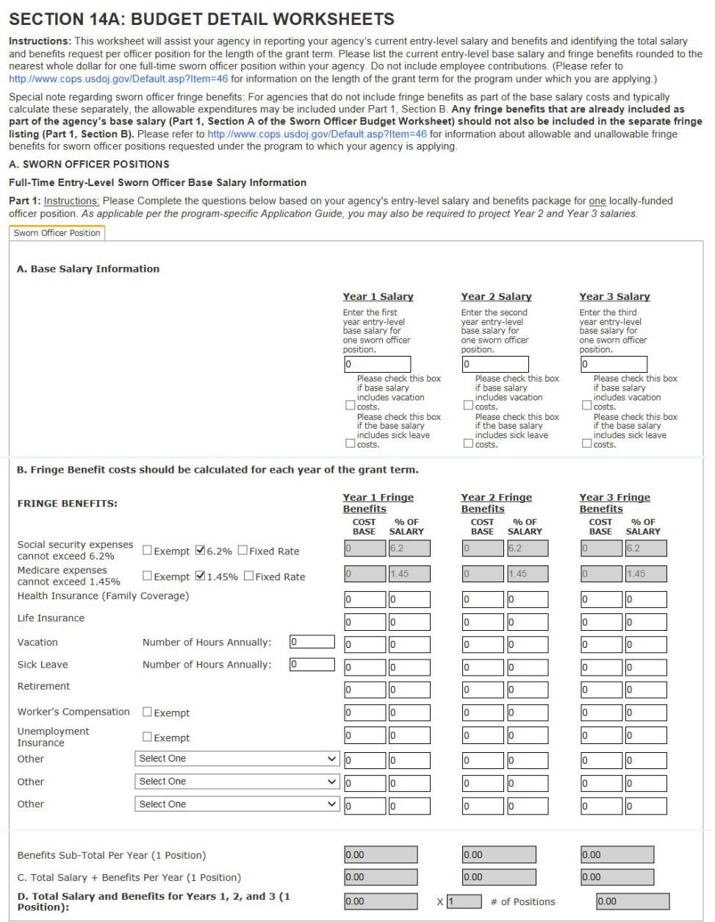

Page | 80

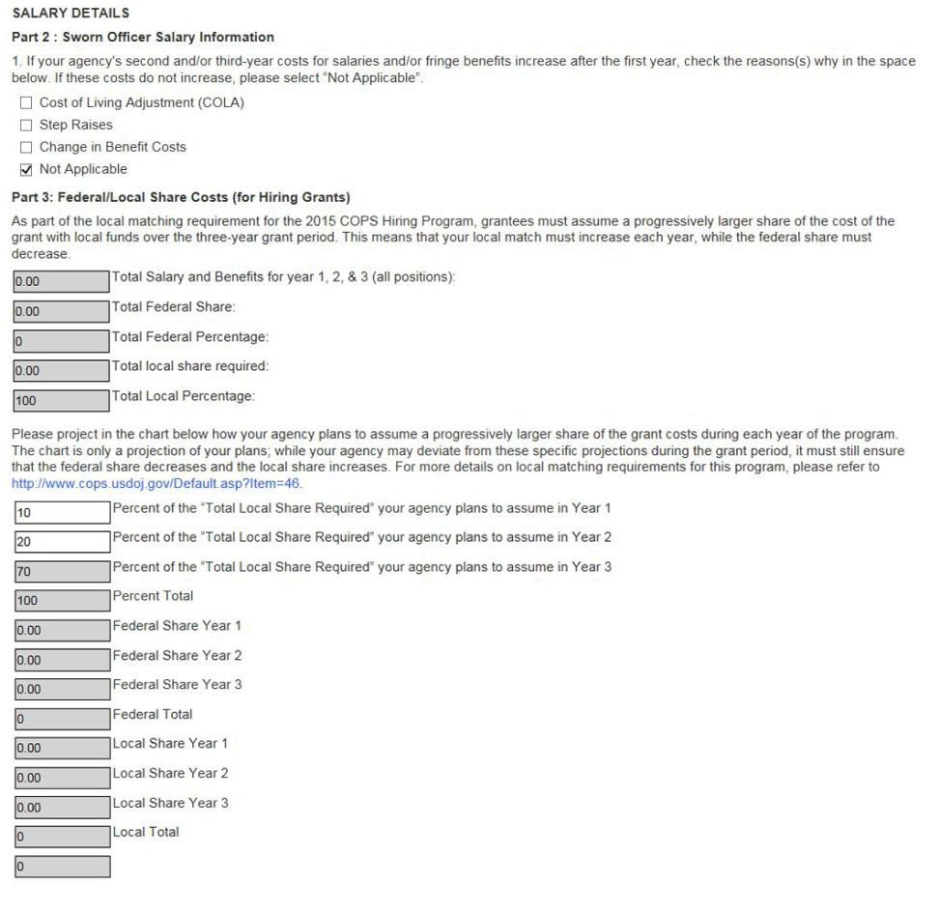

Page | 81

Part 3. Federal/Local share costs (for hiring grants)
As part of the local matching requirement for the 2016 COPS Hiring Program, grantees must assume a progressively larger share of the cost of the grant with local funds over the three‐year grant period. This means that your local match must increase each year, while the federal share must decrease.

Total salary and benefits for year 1, 2, & 3 (all positions): | Actual amount prepopulated from the budget:
Total federal share: | Actual amount prepopulated from the budget: | Percentage prepopulated from the budget:
Total local share required (sworn officer costs): | Actual amount prepopulated from the budget: | Percentage prepopulated from the budget:
Please project in the chart below how your agency plans to assume a progressively larger share of the grant costs during each year of the program. The chart is only a projection of your plans; while your agency may deviate from these specific projections during the grant period, it must still ensure that the federal share decreases and the local share increases. For more details on local matching requirements for this program, please refer to the program‐specific application guide.

Percent of the total local share required your agency plans to assume in year 1

Percent of the total local share required your agency plans to assume in year 2

Percent of the total local share required your agency plans to assume in year 3

Percent total

Local share year 1

Local share year 2

Local share year 3

Local total

Federal share year 1

Federal share year 2

Federal share year 3

Federal total

Page | 82

B. Base salary and fringe benefits for civilian/nonsworn personnel
No civilian/nonsworn officer positions requested 

Part 1. Instructions
Please complete the questions below for one nonsworn position salary and benefits package. As applicable per the program-specific application guide, you may also be required to project year 2 and year 3 salaries.
Below is a sample of the worksheet for civilian/nonsworn personnel positions. Figure 2 shows a screenshot of this worksheet from the online application.

A. Base salary information
Position title: Description:

(One position per worksheet) Year 1 salary
Enter the current first year salary for one civilian/nonsworn position.
$ x % of time on project =
$

Year 2 salary (as applicable)
Enter the second year base salary for one civilian/nonsworn position.
$ x % of time on project =
$

Page | 83

B. Fringe benefit costs should be calculated for each yea | r of the grant term.
Fringe Benefits | Year 1  Fringe Benefits | Year 2  Fringe Benefits
Social Security: Exempt  6.2%  Fixed rate   Cannot exceed 6.2% of total base salary | Cost: $  % of base salary: 6.2 | Cost: $  % of base salary: 6.2
Medicare: Exempt  1.45%  Fixed rate   Cannot exceed 1.45% of total base salary | Cost: $  % of base salary: 1.45 | Cost: $  % of base salary: 1.45
Health insurance: Individual  Family  Fixed rate  | Cost: $  % of base salary: | Cost: $  % of base salary:
Life insurance: Fixed rate  | Cost: $  % of base salary: | Cost: $  % of base salary:
Vacation:  Number of hours annually | Cost: $  % of base salary: | Cost: $  % of base salary:
Sick leave:  Number of hours annually | Cost: $  % of base salary: | Cost: $  % of base salary:
Retirement: Fixed rate  | Cost: $  % of base salary: | Cost: $  % of base salary:
Worker’s Compensation: Exempt  Fixed rate  | Cost: $  % of base salary: | Cost: $  % of base salary:
Unemployment insurance: Exempt  Fixed rate  | Cost: $  % of base salary: | Cost: $  % of base salary:
Other: Select One … | Cost: $  % of base salary: | Cost: $  % of base salary:
Other: Select One … | Cost: $  % of base salary: | Cost: $  % of base salary:
Other: Select One … | Cost: $  % of base salary: | Cost: $  % of base salary:
Benefits subtotal per year (one position) | $ | $
C. Total salary + benefits per year (one position) | $ | $
D. Total salary and benefits for years 1 and 2 (one position) | $ | $

Page | 84

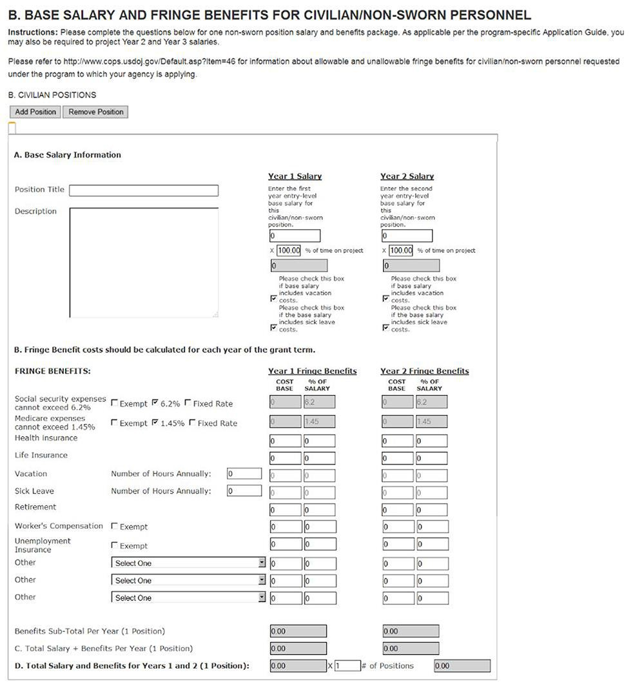
Figure 2. Civilian/nonsworn personnel base salary and fringe benefits calculations

Page | 85

Equipment/Technology
No equipment/technology requested 

Instructions. List nonexpendable items that are to be purchased. Provide a specific description for each item in the description boxes below and explain how the item supports the project goals and objectives as outlined in your application. Nonexpendable equipment is tangible property (e.g., information technology systems) having a useful life of more than one year and an acquisition cost of
$5,000 or more per unit. Expendable items should be included either in the Supplies or Other categories. Applicants should analyze the cost benefits of purchasing versus leasing equipment, especially for high- price items and those subject to rapid technical advances. Rented or leased equipment costs should be listed in the Contracts/Consultants category.
Please be advised that, to the greatest extent practical, all equipment and products purchased with these funds must be American-made.

For agencies purchasing items related to enhanced communications systems, the COPS Office expects and encourages that, wherever feasible, such voice or data communications equipment should be incorporated into an intra- or interjurisdictional strategy for communications interoperability among federal, state, and local law enforcement agencies.
See www.cops.usdoj.gov/Default.asp?item=46 for a list of allowable/unallowable costs for this program. Please limit your descriptions to 1000 characters.
Below is a sample of the worksheet for equipment/technology costs. Figure 3 shows a screenshot of this worksheet from the online application.

Name Cost Qty Sub Total Description
 | Base cost: |  | x
Total:

Figure 3. Screenshot of equipment/technology calculations

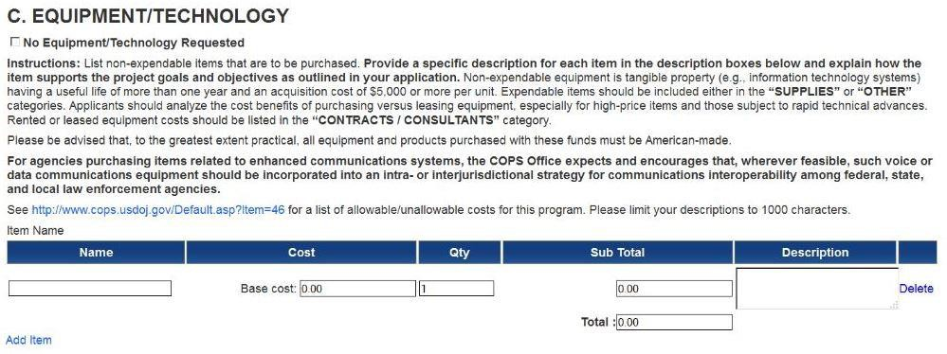

Page | 86

Supplies
No supplies requested 

Instructions. List items by type (office supplies; postage; training materials; copying paper; books; hand- held tape recorders; computing devices costing less than $5,000; etc.) Provide a specific description for each item in the description boxes below and explain how it supports the project goals and objectives outlined in your application. Generally, supplies include any materials that are expendable or consumed during the course of the project, costing less than $5,000.
See www.cops.usdoj.gov/Default.asp?item=46 for a list of allowable/unallowable costs for this program. Please limit your descriptions to 1000 characters.
Below is a sample of the worksheet for supplies costs. Figure 4 shows a screenshot of this worksheet from the online application.

Name Cost Qty Sub Total Description
 | Base cost: |  | x
Total:

Figure 4. Screenshot of supplies calculations

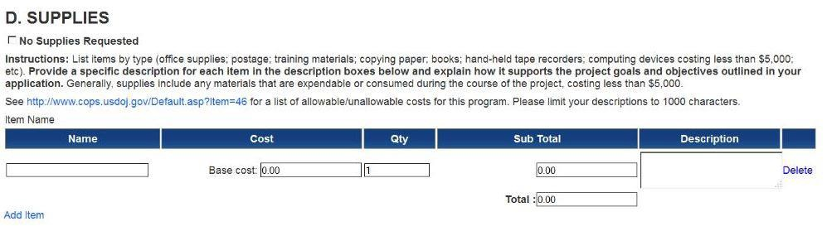

Travel/Training
No travel/training requested 

Instructions. Travel costs are the expenses for transportation, lodging, subsistence, and related items incurred by employees who are in travel status on official business of the nonfederal entity. Itemize grant-related travel expenses of grantee personnel (excluding consultants, whose expenses are listed in section F) by event (e.g., mandatory training, staff to training, field interviews, advisory group meetings). Identify the location of travel whenever possible, and show the number of staff expected to attend each event. Training fees, transportation, lodging, and per diem rates for trainees should be listed as separate travel items. Grantee travel costs specific to the grant project may be based on the grantee’s written travel policy, assuming the costs are reasonable. Grantees without a written travel policy must follow the established federal rates (found at www.gsa.gov) for lodging, meals, and per diem. For all grantees

Page | 87

(with or without a written travel policy), airfare travel costs must be one of the following: the lowest discount commercial airfare, standard coach airfare, or the Federal Government contract airfare (if authorized and available).
See www.cops.usdoj.gov/Default.asp?item=46 for a list of allowable/unallowable costs for this program. Please limit your descriptions to 1000 characters.
Below is a sample of the worksheet for travel/training costs. Figure 5 shows a screenshot of this worksheet from the online application.
Event Title and Location
Name |  | Cost | Qty | Sub Total |  | Description
Registration
 | Lodging
Per Diem Transportation
Total

Figure 5. Screenshot of travel/training calculations

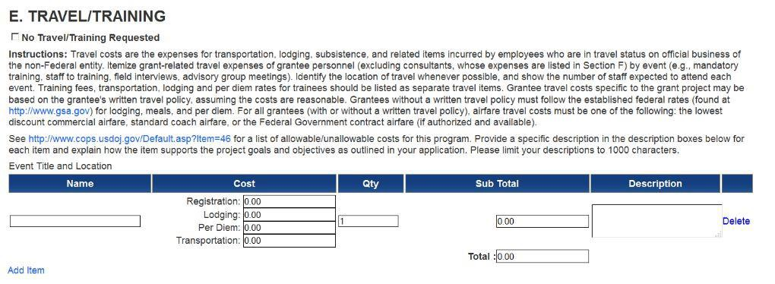

Contracts/Consultants
Below are samples of the worksheet for contract and consultant costs. Figure 6 Figure 7 show screenshots of these worksheets from the online application.
No contract costs requested 

Instructions. See www.cops.usdoj.gov/Default.asp?item=46 for a list of allowable/unallowable costs for the particular program to which you are applying. Provide a specific description in the description boxes below for each item and explain how the item supports the project goals and objectives as outlined in your application. Please limit your descriptions to 1000 characters.

Page | 88

Contracts. Provide a cost estimate for the product or service to be procured by the contract. Applicants are encouraged to promote free and open competition in awarding contracts. If awarded, requests for sole source procurements of equipment, technology, or services in excess of $150,000 must be submitted to the COPS Office for prior approval. (See www.cops.usdoj.gov/Default.asp?item=46 for more information on the required submission.)
F1. Contract costs
Name Cost Qty Sub Total Description
 | Base cost: |  | x
Total:

Figure 6. Screenshot of contracts calculations

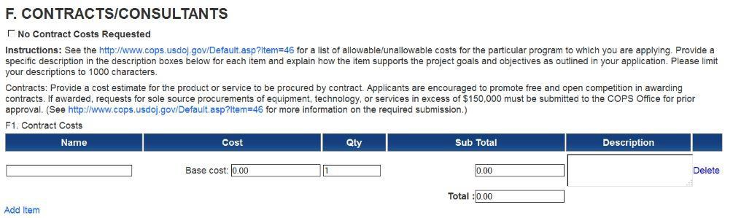

No consultant fees requested 

Instructions. See www.cops.usdoj.gov/Default.asp?item=46 for a list of allowable/unallowable costs for the particular program to which you are applying. Provide a specific description in the description boxes below for each item and explain how the item supports the project goals and objectives as outlined in your application. Please limit your descriptions to 1000 characters.
Consultant fees. For each consultant, enter the name (if known), service to be provided, hourly or daily fee (based upon an 8-hour day), and estimated length of time on the project. Unless otherwise approved by the COPS Office, approved consultant rates will be based on the salary a consultant receives from his or her primary employer. Consultant fees in excess of $550 per day require additional written justification and must be preapproved in writing by the COPS Office if the consultant is hired via a noncompetitive bidding process.
F2. Consultant Fees
Name Cost Qty Sub Total Description
 | Base cost: |  | x
Total:

Page | 89

No consultant travel requested 

Consultant travel. List all travel-related expenses to be paid from the grant to the individual consultants (e.g., transportation, meals, lodging) separate from their consultant fees.
F3. Consultant Travel
Name |  | Cost | Qty | Sub Total |  | Description
Registration
 | Lodging
Per Diem Transportation
Total

No consultant expenses requested 

Consultant expenses. List all other expenses to be paid from the grant to the individual consultants separate from their consultant fees and travel expenses (e.g., computer equipment and office supplies).
F4. Consultant Expenses
Name Cost Qty Sub Total Description
 | Base cost: |  | x
Total:

Page | 90

Figure 7. Screenshot of consultant calculations

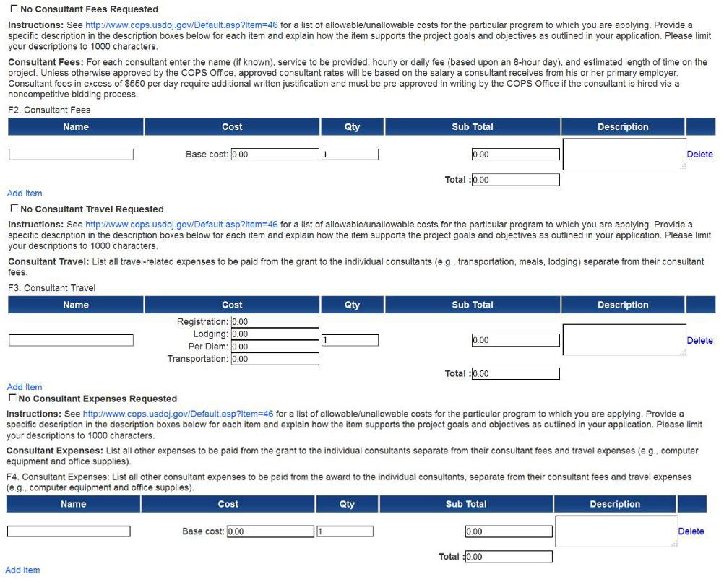

Other costs
No other costs requested 

Instructions. List other requested items that will support the project goals and objectives as outlined in your application. Provide a specific description for each item in the description boxes below and explain how the item supports the project goals and objectives as outlined in your application.
Please be advised that, to the greatest extent practical, all equipment and products purchased with these funds must be American-made.
See www.cops.usdoj.gov/Default.asp?item=46 for a list of allowable/unallowable costs for this program. Please limit your descriptions to 1000 characters.

Page | 91

Below is a sample of the worksheet for other costs. Figure 8 shows a screenshot of this worksheet from the online application.

Name Cost Qty Sub Total Description
 | Base cost: |  | x
Total:

Figure 8. Screenshot of other costs calculations

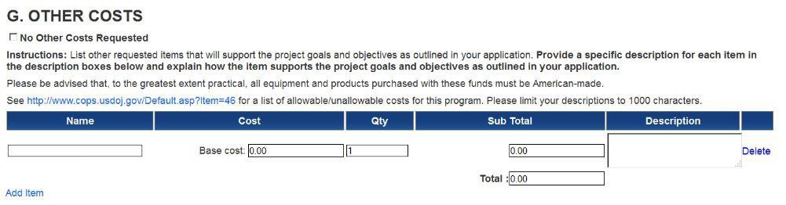

Indirect costs
No indirect costs requested 

Instructions. Indirect costs are allowed under a very limited number of specialized COPS programs. Please see www.cops.usdoj.gov/Default.asp?item=46 for a list of allowable/unallowable costs for the particular program to which you are applying.
If indirect costs are requested, a copy of the agency’s fully executed, negotiated federal rate approval agreement must be attached to this application.
If your organization is requesting indirect costs for this project, please include a copy of your current, signed federally approved indirect cost rate negotiated agreement. If the applicant does not have an approved rate, a rate can be requested by contacting the applicant’s cognizant federal agency, which will review all documentation and approve a rate for the applicant organization. Please limit your description to 1000 characters.
Below is a sample of the worksheet for indirect costs. Figure 9 shows a screenshot of this worksheet from the online application.
Indirect Cost Description
Name Cost Qty Sub Total Description
 | Base cost: |  | x
Total:

Page | 92

Figure 9. Screenshot of indirect cost calculations

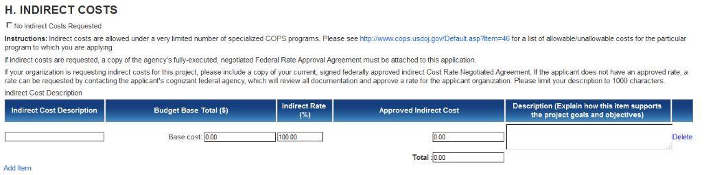

Budget summary
Instructions: Please review the category totals and the total project costs below. If the category totals and project amounts shown are correct, please continue with the submission of your application. Should you need to make revisions to a budget category, please return to the budget detail worksheet.

Below is a sample of the budget summary worksheet. Figure 10 shows a screenshot of that worksheet from the online application.

Budget Category | Category Total | Edit
A. Sworn officer positions | $
B. Civilian/nonsworn personnel | $
C. Equipment/Technology | $
D. Supplies | $
E. Travel/Training | $
F. Contracts/Consultants | $
G. Other costs | $
H. Indirect costs | $
Total project amount | $
Total federal share amount  (total project amount x federal share percentage allowable) | $ | %
Total local share amount (if applicable)  (total project amount–total federal share amount): | $ | %

Page | 93

Figure 10. Budget summary worksheet

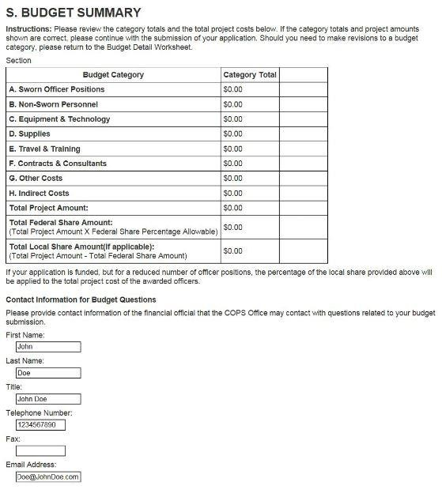
If your application is funded but for a reduced number of officer positions, the percentage of the local share provided above will be applied to the total project cost of the awarded officers.

Page | 94

Waiver of local match
The COPS Office may waive some or all of a grantee's local match requirement based on severe fiscal distress. During the application review process, your agency’s waiver request will be evaluated based on the availability of funding, a demonstration of severe fiscal distress as reflected through the fiscal health data in section 7 of this application, and a comparison of your fiscal health data with that of the overall CHP applicant pool.

Q1: Are you requesting a waiver of the local match based upon severe fiscal distress? YES/NO

If applicant answers “NO”, they would continue with the application; if “YES”, the following questions would appear:
Q1a: If awarded, please indicate the maximum local share your agency would be able to contribute to the total project cost in order to implement the grant. Please enter a value in dollars only.

Based on the waiver request above, your federal share would be and your local share would be if your application is funded.
We anticipate that waivers of the local match will be limited. The COPS Office will carefully review your request for a waiver when your application is submitted.
Q1b: If your agency does not qualify for a waiver, do you still wish to be considered for a CHP grant?

Yes, please continue to review my agency’s application even if we are not eligible for a waiver of the local match.

No, my agency could not implement this grant without a waiver of the local match, so please do not continue processing our application if we are not eligible for the waiver.

Contact information for budget questions
Please provide contact information of the financial official that the COPS Office may contact with questions related to your budget submission.

Authorized Official’s Typed Name:

Title:

Phone:

Fax:

E-mail address:

Page | 95

This page is intentionally blank.

Section 15A. Assurances
Several provisions of federal law and policy apply to all grant and cooperative agreement programs. The Office of Community Oriented Policing Services (“COPS”) needs to secure your assurance that the applicant will comply with these provisions. If you would like further information about any of these assurances, please contact your state’s COPS Grant Program Specialist at 800-421-6770.
By signing this form, the applicant assures that it will comply with all legal and administrative requirements that govern the applicant for acceptance and use of federal award funds. In particular, the applicant assures us that:
- It has been legally and officially authorized by the appropriate governing body (for example, mayor or city council) to apply for this grant or cooperative agreement and that the persons signing the application and these assurances on its behalf are authorized to do so and to act on its behalf with respect to any issues that may arise during processing of this application.
- It will comply with the provisions of federal law, which limit certain political activities of employees whose principal employment is in connection with an activity financed in whole or in part with this grant or cooperative agreement. These restrictions are set forth in 5 U.S.C. § 1501, et seq.
- It will comply with the minimum wage and maximum hours provisions of the Fair Labor Standards Act (29 U.S.C. § 201, et seq.), if applicable.
- It will establish safeguards, if it has not done so already, to prohibit employees from using their positions for a purpose that is, or gives the appearance of being, motivated by a desire for private gain for themselves or others, particularly those with whom they have family, business or other ties. In addition, it will disclose (in writing) to the COPS Office any potential conflict of interest arising during the course of performance of the grant or cooperative agreement award and also will require such written disclosures by any subrecipients.
- As required by 42 U.S.C. § 3796dd-6, it will give the Department of Justice or the Comptroller General access to and the right to examine records and documents related to the award.
- It will comply with all requirements imposed by the Department of Justice as a condition or administrative requirement of the grant or cooperative agreement, including but not limited to: the requirements of 2 C.F.R. Part 200 (Uniform Administrative Requirements, Cost Principles, and Audit Requirements for Federal Awards) as adopted by the Department of Justice in 2 C.F.R. § 2800.101 ; 48 C.F.R. Part 31 (FAR Part 31) (Contract Cost Principles and Procedures); the applicable provisions of the Omnibus Crime Control and Safe Streets Act of 1968, as amended; 28 C.F.R. Part 38 (Equal Treatment for Faith-Based Organizations); the applicable COPS Application Guide; the applicable COPS Grant Owner's Manual or Award Owner’s Manual; and with all other applicable program requirements, laws, orders, or regulations.
- As required by 42 U.S.C. § 3796dd-1(c)(11), it will, to the extent practicable and consistent with applicable law, seek, recruit and hire qualified members of racial and ethnic minority groups and qualified women in order to further effective law enforcement by increasing their ranks within the sworn positions in the agency.
- It will not (and will require any subgrantees, contractors, successors, transferees, and assignees not to), on the grounds of race, color, religion, national origin, sex, disability, or age, unlawfully exclude any person from participation in, deny the benefits of or employment to any person, or subject any person to discrimination in connection with any programs or activities funded in whole or in part with federal funds. These civil rights requirements are found in the non-discrimination provisions of Title VI of the Civil Rights Act of 1964, as amended (42 U.S.C. § 2000d); the Omnibus Crime Control and Safe Streets Act of 1968, as amended (42 U.S.C. § 3789d); Section 504 of the Rehabilitation Act of 1973, as amended (29 U.S.C. § 794); the Age Discrimination Act of 1975 (42 U.S.C. § 6101, et seq.); Title IX of the Education Amendments of 1972, as amended (20 U.S.C. § 1681, et seq.); and the corresponding DOJ regulations implementing those statutes at 28 C.F.R. Part 42 (subparts C, D, E, G, and I). It will also comply with Executive Order 13279, Equal Protection of the Laws for Faith-Based and Community Organizations; Executive Order 13559, Fundamental Principles and Policymaking Criteria for Partnerships With Faith-Based and Other Neighborhood Organizations; and the DOJ implementing regulations at 28 C.F.R. Part 38.
  - In the event that any court or administrative agency makes a finding of discrimination on grounds of race, color, religion, national origin, gender, disability or age against the applicant after a due process hearing, it agrees to forward a copy of the finding to the Office for Civil Rights, Office of Justice Programs, 810 7th Street, NW, Washington, D.C. 20531.
  - It will comply with the federal regulations pertaining to the development and implementation of an Equal Employment Opportunity Plan (28 C.F.R. Part 42 subpart E). The requirements are as follow:
If your organization has less than fifty employees or receives an award of less than $25,000 or is a nonprofit organization, a medical institution, an educational institution, or an Indian tribe, then it is exempt from the EEOP requirement. To claim the exemption, your organization must complete and submit Section A of the Certification Form, which is available online at http://www.ojp.usdoj.gov/about/ocr/pdfs/cert.pdf. If your organization is a government agency or private business and receives an award of $25,000 or more, but less than $500,000, and has fifty or more employees (counting both full- and part-time employees but excluding political appointees), then it has to prepare a Utilization Report (formerly called an EEOP Short Form), but it does not have to submit the report to the OCR for review. Instead, your organization has to maintain the Utilization Report on file and make it available for review on request. In addition, your organization has to complete Section B of the Certification Form and return it to the OCR. The Certification Form is available at http://www.ojp.usdoj.gov/about/ocr/pdfs/cert.pdf. If your organization is a government agency or private business and has received an award for $500,000 or more and has fifty or more employees (counting both full- and part-time employees but excluding political appointees), then it has to prepare a Utilization Report (formerly called an EEOP Short Form) and submit it to the OCR for review within sixty days from the date of this letter. For assistance in developing a Utilization Report, please consult the OCR's website at http://www.ojp.usdoj.gov/about/ocr/eeop.htm. In addition, your organization has to complete Section C of the Certification Form and return it to the OCR. The Certification Form is available at http://www.ojp.usdoj.gov/about/ocr/pdfs/cert.pdf. To comply with the EEOP requirements, you may request technical assistance from an EEOP specialist at the OCR by telephone at (202) 307-0690, by TTY at (202) 307-2027, or by e-mail at EEOsubmisson@usdoj.gov.
- Pursuant to Department of Justice guidelines (June 18, 2002 Federal Register (Volume 67, Number 117, pages 41455-41472)), under Title VI of the Civil Rights Act of 1964, it will ensure meaningful access to its programs and activities by persons with limited English proficiency.
- It will ensure that any facilities under its ownership, lease or supervision which shall be utilized in the accomplishment of the project are not listed on the Environmental Protection Agency’ (EPA) list of Violating Facilities and that it will notify us if advised by the EPA that a facility to be used in this grant is under consideration for such listing by the EPA..
- If the applicant’s state has established a review and comment procedure under Executive Order 12372 and has selected this program for review, it has made this application available for review by the state Single Point of Contact.
- It will submit all surveys, interview protocols, and other information collections to the COPS Office for submission to the Office of Management and Budget for clearance under the Paperwork Reduction Act of 1995 if required.
- It will comply with the Human Subjects Research Risk Protections requirements of 28 C.F.R. Part 46 if any part of the funded project contains non-exempt research or statistical activities which involve human subjects and also with 28 C.F.R. Part 22, requiring the safeguarding of individually identifiable information collected from research participants.
- Pursuant to Executive Order 13043, it will enforce on-the-job seat belt policies and programs for employees when operating agency- owned, rented or personally-owned vehicles.
- As required by 42 U.S.C. § 3796dd-3(a), it will not use COPS funds to supplant (replace) state, local, or Bureau of Indian Affairs funds that otherwise would be made available for the purposes of this grant, as applicable.
- If the awarded grant contains a retention requirement, it will retain the increased officer staffing level and/or the increased officer redeployment level, as applicable, with state or local funds for a minimum of 12 months following expiration of the grant period.
- It will not use any federal funding directly or indirectly to influence in any manner a Member of Congress, a jurisdiction, or an official of any government, to favor, adopt, or oppose, by vote or otherwise, any legislation, law ratification, policy or appropriation whether before or after the introduction of any bill, measure, or resolution proposing such legislation, law, ratification, policy or appropriation as set forth in the Anti- Lobby Act, 18 U.S.C. § 1913.
- In the event that a portion of grant reimbursements are seized to pay off delinquent federal debts through the Treasury Offset Program or other debt collection process, it agrees to increase the non-federal share (or, if the awarded grant does not contain a cost sharing requirement, contribute a non- federal share) equal to the amount seized in order to fully implement the grant project.

False statements or claims made in connection with COPS grants or cooperative agreements may result in fines, imprisonment, disbarment from participating in federal grants or contracts, and/or any other remedy available by law.

I certify that the assurances provided are true and accurate to the best of my knowledge.
Elections or other selections of new officials will not relieve the awardee of its obligations under this award.
__________________________________________ ___________________________
Signature of Law Enforcement Executive/Agency Executive Date
(For your electronic signature, please type in your name)

______________________________________________ _____________________________
Signature of Government Executive/Financial Official Date
(For your electronic signature, please type in your name)

Page | 99

This page is intentionally blank.

Section 15B. Certifications

Regarding Lobbying; Debarment, Suspension and Other Responsibility Matters; Federal Taxes and Assessments; Drug-Free Workplace Requirements; and Coordination with Affected Agencies.
Although the Department of Justice has made every effort to simplify the application process, other provisions of federal law require us to seek your agency’s certification regarding certain matters. Applicants should carefully review the statutes and regulations cited below and the instructions for certification to understand the requirements and whether they apply to a particular applicant. Signing this form complies with the certification and notice requirements under 28 C.F.R. Part 69 “New Restrictions on Lobbying”; 2 C.F.R. Part 2867 “Nonprocurement Debarment and Suspension”; 2 C.F.R. Part 200 “Uniform Administrative Requirements, Cost Principles, and Audit Requirements for Federal Awards”; the general provisions in the applicable Appropriations Act; 28 C.F.R. Part 83 “Government-Wide Requirements for Drug-Free Workplace (Grants)”; and the Public Safety Partnership and Community Policing Act of 1994.. The certifications shall be treated as a material representation of fact upon which reliance will be placed when the Department of Justice determines to award the covered grant.

1. Lobbying
As required by 31 U.S.C. § 1352, implemented at 28 C.F.R. Part 69, for persons entering into a grant or cooperative agreement over $100,000, and 2 C.F.R. § 200.450 as adopted by the Department of Justice in 2 C.F.R. § 2800.101, the applicant certifies that:

A. No federal appropriated funds have been paid or will be paid, by or on behalf of the undersigned, to any person for influencing or attempting to influence an officer or employee of any agency, a member of Congress, an officer or employee of Congress, or an employee of a member of Congress in connection with the making of any federal grant; the entering into of any cooperative agreement; and the extension, continuation, renewal, amendment or modification of any federal grant or cooperative agreement;
B. If any funds other than federal appropriated funds have been paid or will be paid to any person for influencing or attempting to influence an officer or employee of any agency, a member of Congress, an officer or employee of Congress, or an employee of a member of Congress in connection with this federal grant or cooperative agreement, the undersigned shall complete and submit Standard Form - LLL, “Disclosure of Lobbying Activities,” in accordance with its instructions;
C. If applicant is a nonprofit organization or an institution of higher education, it will comply with the additional lobbying restrictions set forth in 2 C.F.R. § 200.450(c) as adopted by the Department of Justice in 2 C.F.R. § 2800.101; and
D. The undersigned shall require that the language of this certification be included in the award documents for all subawards at all tiers (including subgrants, contracts under grants and cooperative agreements, and subcontracts) and that all sub-recipients shall certify and disclose accordingly.
2. Debarment, Suspension and Other Responsibility Matters (Direct Recipient)
Pursuant to Executive Order 12549, Debarment and Suspension, as implemented at 2 C.F.R. Part 2867, for prospective participants in primary covered transactions, as defined at 2 C.F.R. § 2867.20(a), and other requirements, the applicant certifies that it and its principals:
A. Are not presently debarred, suspended, proposed for debarment, declared ineligible, sentenced to a denial of federal benefits by a state or federal court, or voluntarily excluded from covered transactions by any federal department or agency;
B. Have not within a three-year period preceding this application been convicted of a felony criminal violation under any Federal law, or been convicted or had a civil judgment rendered against them for commission of fraud or a criminal offense in connection with obtaining, attempting to obtain, or performing a public (federal, state or local) or private agreement or transaction; violation of federal or state antitrust statutes or commission of embezzlement, theft, forgery, bribery, falsification or destruction of records, making false statements, tax evasion or receiving stolen property, making false claims, or obstruction of justice, or commission of any offense indicating a lack of business integrity or business honesty that seriously and directly affects your present responsibility;
C. Are not presently indicted for or otherwise criminally or civilly charged by a governmental entity (federal, state or local) with commission of any of the offenses enumerated in paragraph (B) of this certification; and
D. Have not within a three-year period preceding this application had one or more public transactions (federal, state or local) terminated for cause or default.
3. Mandatory Disclosure
Pursuant to the Uniform Administrative Requirements, Cost Principles, and Audit Requirements for Federal Awards, 2 C.F.R. § 200.113 as adopted by the Department of Justice in 2 C.F.R. § 2800.101, the applicant certifies that it:
- Has not violated any federal criminal law involving fraud, bribery, or gratuity that may potentially affect the federal grant or cooperative agreement.
- Shall timely disclose in writing to the federal awarding agency or pass-through entity, as applicable, any violation of federal criminal law involving fraud, bribery, or gratuity that may potentially affect the federal grant or cooperative agreement.
- Shall require that the language of this certification be included in the award documents for all subawards (including subgrants and cooperative agreements) and shall require all subrecipients certify and disclose accordingly.
4. Federal Taxes and Assessments
A. If applicable, an applicant who receives an award in excess of $5,000,000 certifies that, to the best of its knowledge and belief, the applicant has filed all Federal tax returns required during the three years preceding the certification, has not been convicted of a criminal offense under the Internal Revenue Code of 1986, and has not, more than 90 days prior to certification, been notified of any unpaid Federal tax assessment for which the liability remains unsatisfied, unless the assessment is the subject of an installment agreement or offer in compromise that has been approved by the Internal Revenue Service and is not in default, or the assessment is the subject of a non-frivolous administrative or judicial proceeding.
B. The applicant certifies that it does not have any unpaid Federal tax liability that has been assessed, for which all judicial and administrative remedies have been exhausted or have lapsed, and that is not being paid in a timely manner pursuant to an agreement with the authority responsible for collecting the tax liability.
5. Drug-Free Workplace
As required by the Drug-Free Workplace Act of 1988 (41 U.S.C. 8103), and implemented at 28 C.F.R. Part 83, for recipients (other than individuals), as defined at 28 C.F.R. § 83.660 -
A. The applicant certifies that it will, or will continue to, provide a drug- free workplace by:
(i) Publishing a statement notifying employees that the unlawful manufacture, distribution, dispensing, possession or use of a controlled substance is prohibited in the grantee’s workplace and specifying the actions that will be taken against employees for violation of such prohibition;
(ii) Establishing an on-going drug-free awareness program to inform employees about -
(a) The dangers of drug abuse in the workplace;
(b) The grantee’s policy of maintaining a drug-free workplace;
(c) Any available drug counseling, rehabilitation and employee assistance programs; and
(d) The penalties that may be imposed upon employees for drug-abuse violations occurring in the workplace;

(iii) Making it a requirement that each employee to be engaged in the performance of the grant be given a copy of the statement required by paragraph (i);
(iv)Notifying the employee in the statement required by paragraph (i) that, as a condition of employment under the grant, the employee will –

(a) Abide by the terms of the statement; and
(b) Notify the employer in writing of his or her conviction for a violation of a criminal drug statute occurring in the workplace no later than five calendar days after such conviction;
(v) Notifying the agency, in writing, within 10 calendar days after receiving notice under subparagraph (iv)(b) from an employee or otherwise receiving actual notice of such conviction. Employers of convicted employees must provide notice, including position title, to: COPS Office, 145 N Street, NE, Washington, D.C. 20530. Notice shall include the identification number(s) of each affected grant;
(vi) Taking one of the following actions, within 30 calendar days of receiving notice under subparagraph (iv)(b), with respect to any employee who is so convicted -
(a) Taking appropriate personnel action against such an employee, up to and including termination, consistent with the requirements of the Rehabilitation Act of 1973, as amended; or
(b) Requiring such employee to participate satisfactorily in a drug abuse assistance or rehabilitation program approved for such purposes by a federal, state or local health, law enforcement or other appropriate agency;
(vii) Making a good faith effort to continue to maintain a drug-free workplace through implementation of paragraphs (i), (ii), (iii), (iv), (v), and (vi).
B. The applicant further certifies that it will identify all known workplaces under each COPS Office award, keep the identification documents on file, and make them available for inspection upon request by the Department of Justice officials or their designated representatives.
6. Coordination
As required by 42 U.S.C. § 3796dd-1(c)(5) of the Public Safety Partnership and Community Policing Act of 1994, applicants must certify that there has been appropriate coordination with all agencies that may be affected by the applicant’s grant proposal if approved. Affected agencies may include, among others, the Office of the United States Attorney, state or local prosecutors, or correctional agencies. The applicant certifies that there has been appropriate coordination with all affected agencies.

Where the applicant is unable to certify to any of the statements in this Certifications form, he or she shall attach an explanation to this application regarding the particular statement that cannot be certified. Please check here  if an explanation is attached to this application. Please note that the applicant is still required to sign the Certifications form to certify to all the other applicable statements.

False statements or claims made in connection with COPS grants (including cooperative agreements) may result in fines, imprisonment, disbarment from participating in federal grants or contracts, and/or any other remedy available by law.
I certify that the assurances provided are true and accurate to the best of my knowledge.
Elections or other selections of new officials will not relieve the grantee entity of its obligations under this grant.
__________________________________________________ ___________________________
Signature of Law Enforcement Executive/Agency Executive Date
(For your electronic signature, please type in your name)
______________________________________________ ______________________________
Signature of Government Executive/Financial Official Date
(For your electronic signature, please type in your name)

Page | 105

This page is intentionally blank.

Section 16. Disclosure of Lobbying Activities
INSTRUCTIONS FOR COMPLETION OF SF-LLL, DISCLOSURE OF LOBBYING ACTIVITIES

This disclosure form shall be completed by the reporting entity, whether subawardee or prime Federal recipient, at the initiation or receipt of a covered Federal action, or a material change to a previous filing, pursuant to title 31 U.S.C. section 1352. The filing of a form is required for each payment or agreement to make payment to any lobbying entity for influencing or attempting to influence an officer or employee of any agency, a Member of Congress, an officer or employee of Congress, or an employee of a Member of Congress in connection with a covered Federal action. Complete all items that apply for both the initial filing and material change report. Refer to the implementing guidance published by the Office of Management and Budget for additional information.
- Identify the type of covered Federal action for which lobbying activity is and/or has been secured to influence the outcome of a covered Federal action.
- Identify the status of the covered Federal action.
- Identify the appropriate classification of this report. If this is a followup report caused by a material change to the information previously reported, enter the year and quarter in which the change occurred. Enter the date of the last previously submitted report by this reporting entity for this covered Federal action.
- Enter the full name, address, city, State and zip code of the reporting entity. Include Congressional District, if known. Check the appropriate classification of the reporting entity that designates if it is, or expects to be, a prime or subaward recipient. Identify the tier of the subawardee, e.g., the first subawardee of the prime is the 1st tier. Subawards include but are not limited to subcontracts, subgrants and contract awards under grants.
- If the organization filing the report in item 4 checks "Subawardee," then enter the full name, address, city, State and zip code of the prime Federal recipient. Include Congressional District, if known.
- Enter the name of the Federal agency making the award or loan commitment. Include at least one organizational level below agency name, if known. For example, Department of Transportation, United States Coast Guard.
- Enter the Federal program name or description for the covered Federal action (item 1). If known, enter the full Catalog of Federal Domestic Assistance (CFDA) number for grants, cooperative agreements, loans, and loan commitments.
- Enter the most appropriate Federal identifying number available for the Federal action identified in item 1 (e.g., Request for Proposal (RFP) number; Invitation for Bid (IFB) number; grant announcement number; the contract, grant, or loan award number; the application/proposal control number assigned by the Federal agency). Include prefixes, e.g., "RFP-DE-90-001."
- For a covered Federal action where there has been an award or loan commitment by the Federal agency, enter the Federal amount of the award/loan commitment for the prime entity identified in item 4 or 5.

OMB Control Number 1103-0098 Expiration Date: 04/30/2017

- (a) Enter the full name, address, city, State and zip code of the lobbying registrant under the Lobbying Disclosure Act of 1995 engaged by the reporting entity identified in item 4 to influence the covered Federal action.
(b) Enter the full names of the individual(s) performing services, and include full address if different from 10 (a). Enter Last Name, First Name, and Middle Initial (MI).
- The certifying official shall sign and date the form, print his/her name, title, and telephone number.

According to the Paperwork Reduction Act, as amended, no persons are required to respond to a collection of information unless it displays a valid OMB Control Number. The valid OMB control number for this information collection is OMB No. 0348-0046. Public reporting burden for this collection of information is estimated to average 10 minutes per response, including time for reviewing instructions, searching existing data sources, gathering and maintaining the data needed, and completing and reviewing the collection of information. Send comments regarding the burden estimate or any other aspect of this collection of information, including suggestions for reducing this burden, to the Office of Management and Budget, Paperwork Reduction Project (0348-0046), Washington, DC 20503.

Page | 108

OMB Control Number 1103-0098
Expiration Date: 04/30/2017 Section 16. Disclosure of Lobbying Activities

Below is a sample of the lobbying disclosure form. Figure 11 is a screenshot of the actual form including OMB approval.
Complete this form to disclose lobbying activities pursuant to 31 U.S.C. 1352. (See reverse for public burden disclosure.)

Type of Federal Action:   a. contract  - grant  - cooperative agreement  - loan  - loan guarantee  - loan insurance | Status of Federal Acti   a. bid/offer/app  - initial award  - post-award | on: 3. Report Type:  lication  a. initial filing  b. material change For Material Change only: year quarter date of last report
4. Name and Address of Reporting Entity: 5. If Reporting Entity in no. 4 is a Subawardee,
 Prime  Subawardee enter name and address of Prime: Tier _, if known:

Congressional District, if known: Congressional District, if known:
6. Federal Department/Agency: 7. Fede  CFDA n |  | ral Program Name/Description:  umber, if applicable:
8. Federal Action Number, if known: 9. Award amount, if known:
$
10. a. Name and Address of Lobbying Registrant b. Indiv (if individual: last name, first name, MI) (includi (last na |  | iduals Performing Services  ng address if different from no. 10.a.) me, first name, MI)
11.
Information requested through this form is Signature: authorized by title 31 U.S.C. section 1352. This
disclosure of lobbying activities is a material Print name: representation of fact upon which reliance was
placed by the tier above when this transaction was Title: made or entered into. This disclosure is required
pursuant to 31 U.S.C. 1352. This information will Telephone No.: Date: be available for public inspection. Any person who
fails to file the required disclosure shall be subject to a civil penalty of not less than $10,000 and not more than $100,000 for each such failure.

Page | 109

Figure 11. Lobbying disclosure form

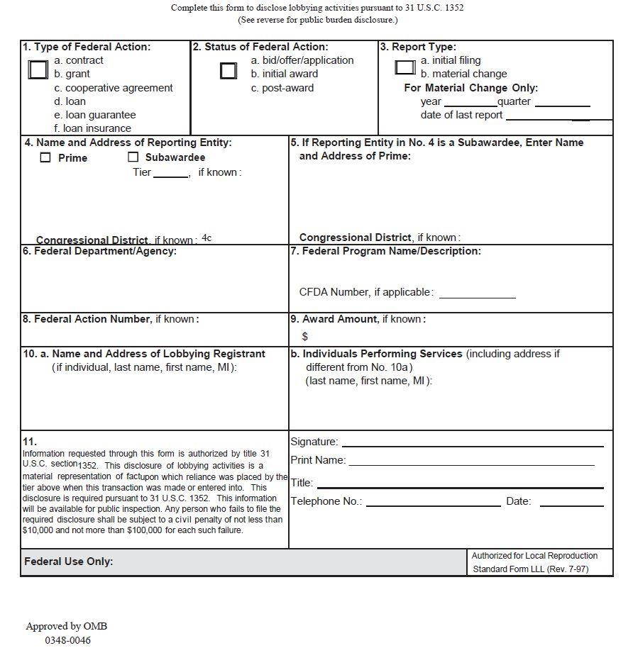

Page | 110

Section 17. Reviews and Certifications
- Federal Civil Rights and Grant Reviews:

Please be advised that an application may not be funded and, if awarded, a hold may be placed on the award if it is deemed that the applicant is not in compliance with federal civil rights laws, and/or is not cooperating with an ongoing federal civil rights investigation, and/or is not cooperating with a Department of Justice grant review or audit.

- Certification of Review of 28 C.F.R. Part 23/Criminal Intelligence Systems:

Please review the COPS Application Guide: Legal Requirements Section for additional information. Please check one of the following, as applicable to your agency’s intended use of this grant:
 No, my agency will not use these COPS grant funds (if awarded) to operate an interjurisdictional criminal intelligence system.
 Yes, my agency will use these COPS grant funds (if awarded) to operate an interjurisdictional criminal intelligence system. By signing below, we assure that our agency will comply with the requirements of 28 C.F.R. Part 23.

- Certification of Review and Representation of Compliance with Requirements:

The signatures of the Law Enforcement Executive/Agency Executive, Government Executive/Financial Official, and the Person Submitting this Application on the Reviews and Certifications represent to the COPS Office that:
  - the signatories have been legally and officially authorized by the appropriate governing body to submit this application and act on behalf of the grant applicant entity;
  - the applicant will comply with all legal, administrative, and programmatic requirements that govern the applicant for acceptance and use of federal funds as outlined in the applicable COPS Application Guide, the COPS Grant Owner’s Manual, Assurances, Certifications, and all other applicable program regulations, laws, orders, and circulars;
  - the applicant understands that false statements or claims made in connection with COPS programs may result in fines, imprisonment, debarment from participating in federal grants, cooperative agreements, or contracts, and/or any other remedy available by law to the federal government; AND
  - the information provided in this application, including any amendments, shall be treated as material representations of fact upon which reliance will be placed when the Department of Justice determines to award the covered grant.
  - the applicant understands that as a general rule COPS funding may not be used for the same item or service funded through another funding source.

OMB Control Number 1103-0098 Expiration Date: 04/30/2017

  - the applicant and any required or identified official partner(s) listed in Section 12 are partners in this grant project and mutually agreed to this partnership prior to this grant application.
The signatures of the Law Enforcement Executive/Agency Executive and the Government Executive/Financial Official on this application must be the same as those identified in Section 4 of this application. Applications with missing, incomplete, or inaccurate signatories or responses may not be considered for funding.

Signature of Law Enforcement Executive/Agency Executive Date (For your electronic signature, please type in your name)

Signature of Government Executive/Financial Official Date (For your electronic signature, please type in your name)

Signature of Person Submitting This Application Date (For your electronic signature, please type in your name)

By clicking this box,  the applicant understands that the use of typed names in this grant application and the required grant forms, including the Assurances and Certifications, constitute electronic signatures and that the electronic signatures are the legal equivalent of handwritten signatures.

Page | 112

Section 18. Application Data Verification
By signing below, I certify that I have read, understand and agree to the following:

- my agency has been requested by the COPS Office to review, confirm and/or update specific data items that were previously submitted in our COPS application and our failure to respond to the request may eliminate our application from 2016 funding consideration;
- my agency has reviewed, confirmed and/or updated the specific data items identified by the COPS Office, and certify that the information is true and accurate;
- I am authorized by the appropriate governing body to act on behalf of the grant applicant entity to make changes to our COPS application which will be considered for 2016 funding;
- the information provided in this application, including any amendments, shall be treated as material representations of fact upon which reliance will be placed when the Department of Justice determines to award the covered grant; and
- the applicant understands that false statements or claims made in connection with COPS programs may result in fines, imprisonment, debarment from participating in federal grants, cooperative agreements, or contracts, and/or any other remedy available by law to the federal government.

Signature of the Person Completing this Form Date Completed (For your electronic signature, please type in your name)
ELECTRONIC SIGNATURE: By clicking this box  , I understand that typing in my name on this form constitutes an electronic signature and that the electronic signature is the legal equivalent of a handwritten signature.
The COPS Office may request verification of your application data or any other updates to your application. In order for your agency to continue to be considered for COPS grant funding, all such application updates must be submitted through the COPS website (www.cops.usdoj.gov) by the deadline identified in the request for updates you receive from the COPS Office. For technical assistance with submitting your updates or to withdraw your agency's application from funding consideration, please call the COPS Office Response Center at 800-421-6770.

OMB Control Number 1103-0098 Expiration Date: 04/30/2017

This page is intentionally blank.

Paperwork Reduction Act Notice
The public reporting burden for this collection of information is estimated to be up to 11.3 hours per response, depending upon the COPS program being applied for, which includes time for reviewing instructions. Send comments regarding this burden estimate or any other aspects of the collection of this information, including suggestions for reducing this burden, to the Office of Community Oriented Policing Services, U.S. Department of Justice, 145 N Street, NE, Washington, DC 20530; and to the Public Use Reports Project, Office of Information and Regulatory Affairs, Office of Management and Budget, Washington, DC 20503.
You are not required to respond to this collection of information unless it displays a valid OMB control number. The OMB control number for this application is 1103-0098 and the expiration date is 04/30/2017.

OMB Control Number 1103-0098 Expiration Date: 04/30/2017

This page is intentionally blank.

About the COPS Office
The Office of Community Oriented Policing Services (COPS Office) is the component of the U.S. Department of Justice responsible for advancing the practice of community policing by the nation’s state, local, territory, and tribal law enforcement agencies through information and grant resources.
Community policing is a philosophy that promotes organizational strategies that support the systematic use of partnerships and problem-solving techniques, to proactively address the immediate conditions that give rise to public safety issues such as crime, social disorder, and fear of crime.
Rather than simply responding to crimes once they have been committed, community policing concentrates on preventing crime and eliminating the atmosphere of fear it creates. Earning the trust of the community and making those individuals stakeholders in their own safety enables law enforcement to better understand and address both the needs of the community and the factors that contribute to crime.
The COPS Office awards grants to state, local, territory, and tribal law enforcement agencies to hire and train community policing professionals, acquire and deploy cutting-edge crime fighting technologies, and develop and test innovative policing strategies. COPS Office funding also provides training and technical assistance to community members and local government leaders and all levels of law enforcement. The COPS Office has produced and compiled a broad range of information resources that can help law enforcement better address specific crime and operational issues, and help community leaders better understand how to work cooperatively with their law enforcement agency to reduce crime.

- Since 1994, the COPS Office has invested more than $14 billion to add community policing officers to the nation’s streets, enhance crime fighting technology, support crime prevention initiatives, and provide training and technical assistance to help advance community policing.
- To date, the COPS Office has funded approximately 125,000 additional officers to more than 13,000 of the nation’s 18,000 law enforcement agencies across the country in small and large jurisdictions alike.
- Nearly 700,000 law enforcement personnel, community members, and government leaders have been trained through COPS Office-funded training organizations.
- To date, the COPS Office has distributed more than 8.57 million topic-specific publications, training curricula, white papers, and resource CDs.
COPS Office resources, covering a wide breadth of community policing topics—from school and campus safety to gang violence—are available, at no cost, through its online Resource Center at www.cops.usdoj.gov. This easy-to-navigate website is also the grant application portal, providing access to online application forms.

OMB Control Number 1103-0098 Expiration Date: 04/30/2017

This page is intentionally blank.

This page is intentionally blank.

U.S. Department of Justice
Office of Community Oriented Policing Services 145 N Street NE
Washington, DC 20530

To obtain details on COPS Office programs, call the COPS Office Response Center at 800-421-6770.
Visit the COPS Office online at www.cops.usdoj.gov. May 2016

