**Introduction**

The IRS is redesigning the Tax Exempt and Government Entities part of our website. Our goal is to help people find the content they are looking for on IRS.gov. We would like you to help us by participating in a research study that helps us best organize our content.

**Instructions**

This activity should take about 10-12 minutes to complete.

Take a look at the list of items on the left. We'd like you to sort those items into groups that make sense to you.

Use the groups provided or create your own by dragging and dropping an item from the left into the space on the right. Once a group is created by dragging and dropping at least one item, you can name the group. Some groups are already provided as a starting point, but you are not required to use them. You may add as many groups as you feel are needed to sort the items.

When sorting the items into groups, it may help to ask yourself the following question: "What group would I look under to find this item?"

There is no right or wrong answer. Just do what comes naturally. When you're done click "Finished" at the top right.

***Note:*** You can click the arrow button at the upper left of each group to minimize or expand a group if you need more room on your screen.Thank you for partnering with us to improve our website.

**Pre-Survey Questions**

I am a:

* Federal, State or Local Government Employee
* Member of an Indian tribal government
* Tax professional
* Employee plan administrator
* Individual taxpayer
* Other: _______________

**This screenshot is for illustrating methodology, card contents will differ.**

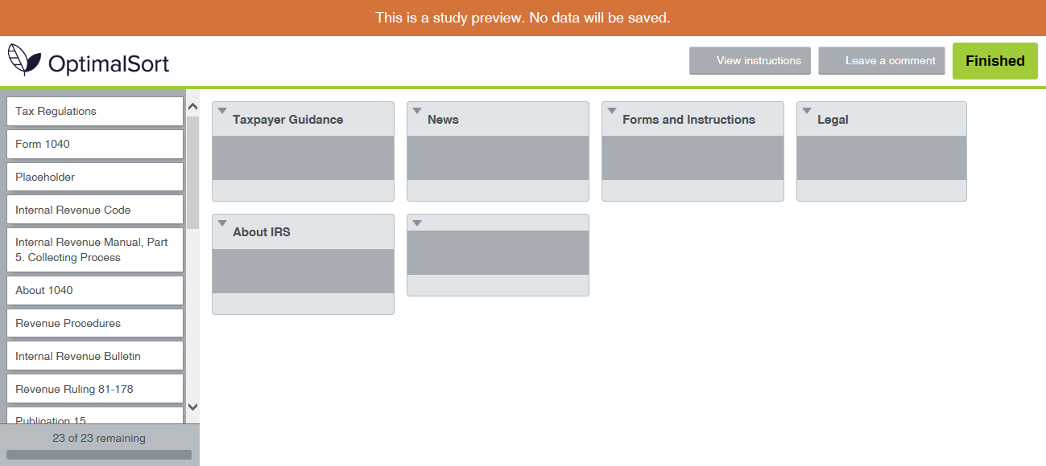

**Closing**

Thank you for participating. Your feedback will help us improve IRS.gov.