Moderator’s Guide: Nationwide Tax Forum 2019

1:1 Interviews
Tax Forum Locations
Interview duration: 30 min
Setup Needed: Laptop, internet connection, timer

- Note to researcher: This product has a low adoption rate and is underutilized, and the internal product team has a theory as to why this is true. We are using this research to support/refute this idea and don’t want to influence your interpretation by sharing this theory.

Frame Up Session - 5 mins

Thank you so much for coming in today. I wanted to give you a little information about what you will be looking at and give you time to ask any questions you might have before we get started. The purpose of today’s session is to talk to you about a secure messaging portal for Power of Attorneys. We are independent researchers and did not create this product, so please be as candid as possible when providing feedback.
But before we start, let’s go over some ground rules.
• Privacy Everything that you say here will be kept strictly private. We will use first names only and names will not be used in any report so please feel free to tell me what you think.
• Voluntary Participation Your participation today is entirely voluntary. You do not have to answer any questions that you do not wish to answer but please keep in mind, there are no wrong answers.
• Time I will be watching our time and directing our conversation. We will be here for about 30 minutes. A formal break has not been scheduled but if you need to stretch, go to the restroom, or walk around a little, feel free to do so but please come back quickly. Your comments and participation are very important to us.
- Recording I’ll be taking notes throughout our session, but I’ll also be recording to ensure we capture all of your feedback. The recording will include audio only.
• Thanks Thank you again for participating in today’s session. We appreciate your time and your feedback today.
Do you have any questions before we get started?

Demographic Questions – 3 mins

What type of tax professional are you?
- CPA
- Enrolled Agent
- Reporting Agent
- Return Preparer
- Attorney
- Software Developer
- Other:__________________________________________________

How many years have you been working in this field?
- Less than 1
- 1 – 10
- 11 – 20
- More than 20

Overview: Power of Attorney Secure Messaging - 20 mins

Now I’d like to walk you through a product where you will be acting as an Authorized Representative of your client, requesting guided help. (To researcher: Allow the participant to click through the slides.) Please follow along and share any opinions you have out loud as you walk through the experience. (To researcher: as the user walks through the click-through, encourage them by gently asking “does this make sense to you?” or “do you have any questions?” if they are not talking through their decisions to click forward aloud. Sometimes users are uncomfortable with this practice and need a bit of encouragement.)
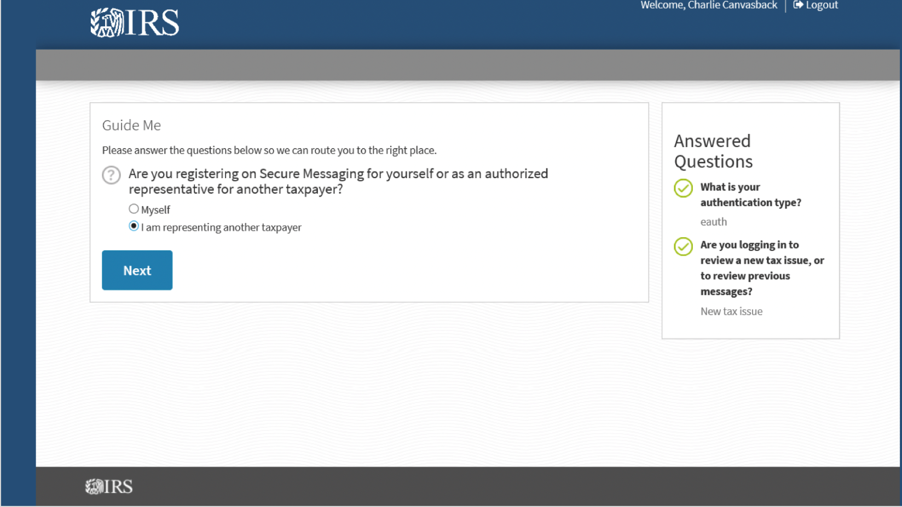

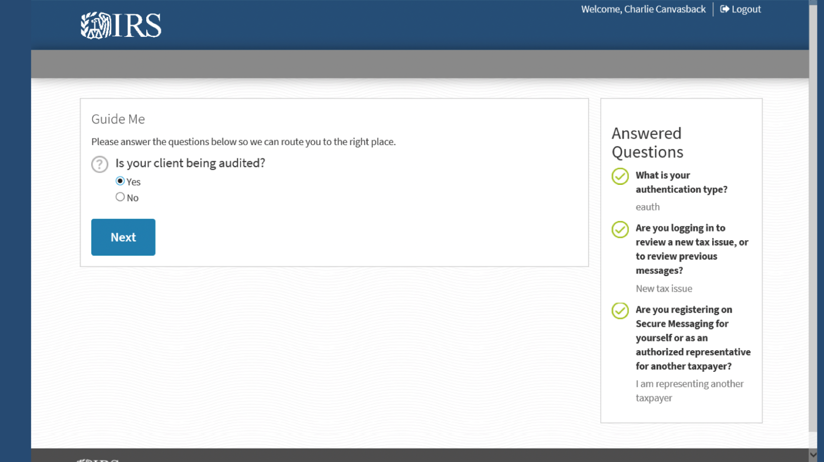
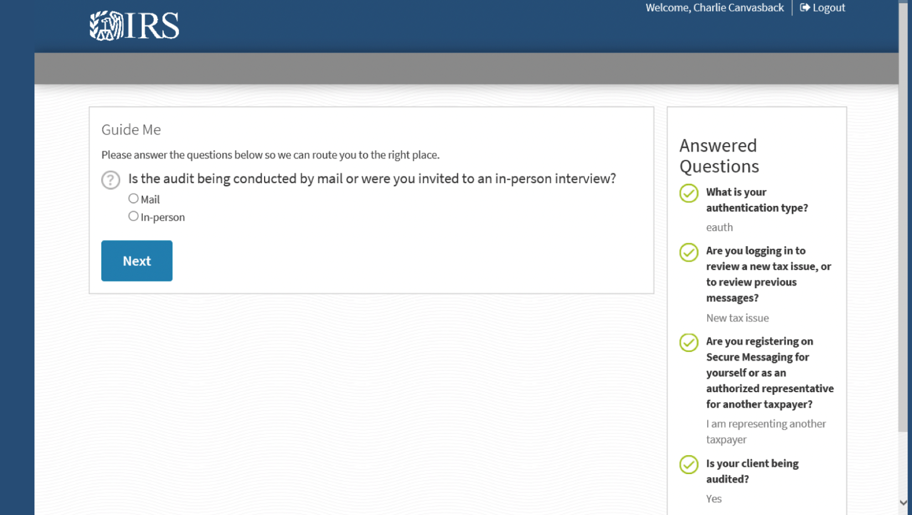

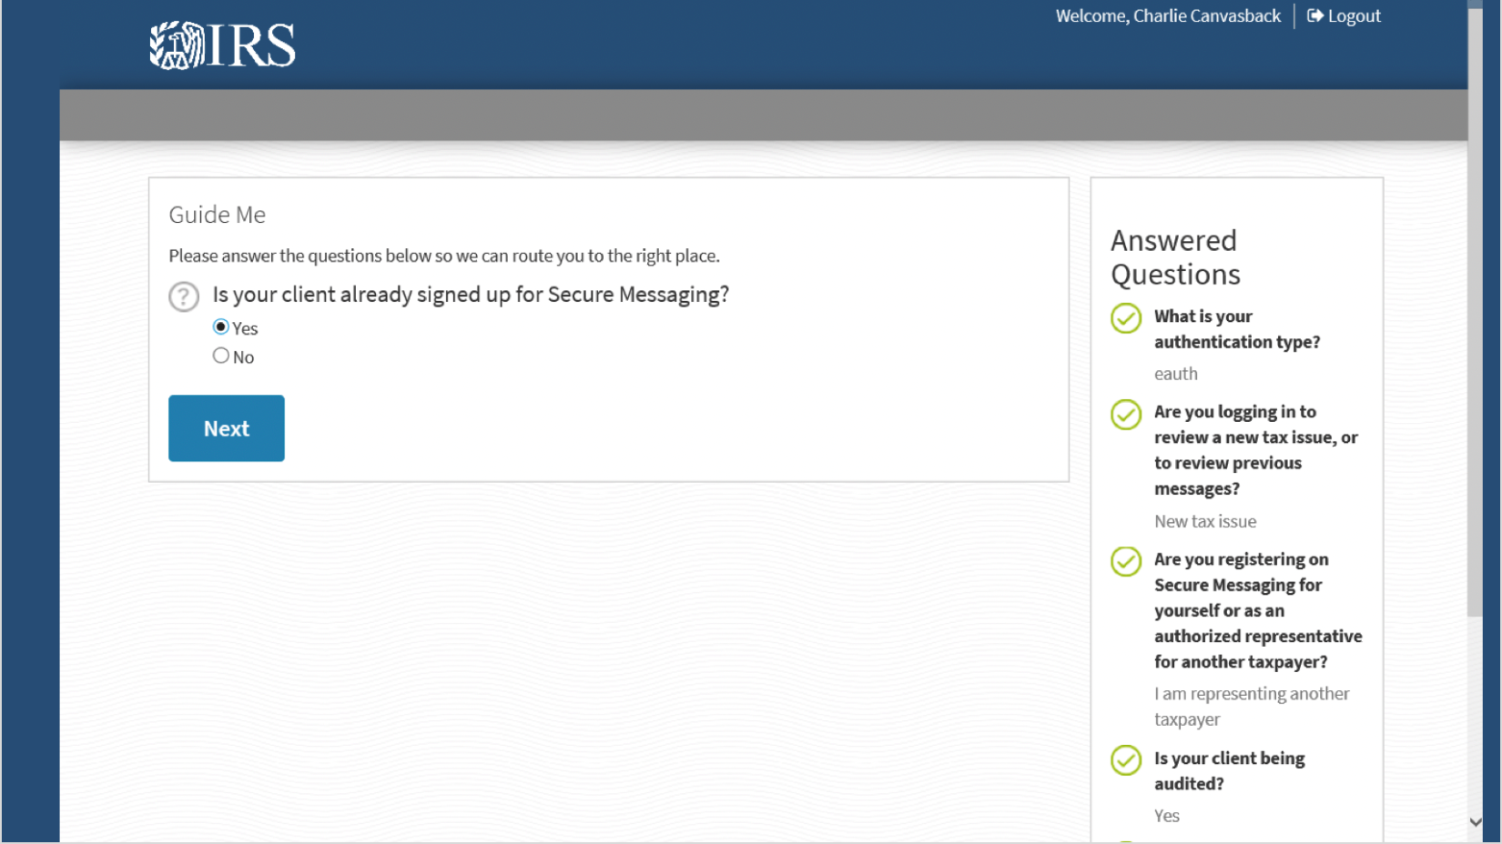
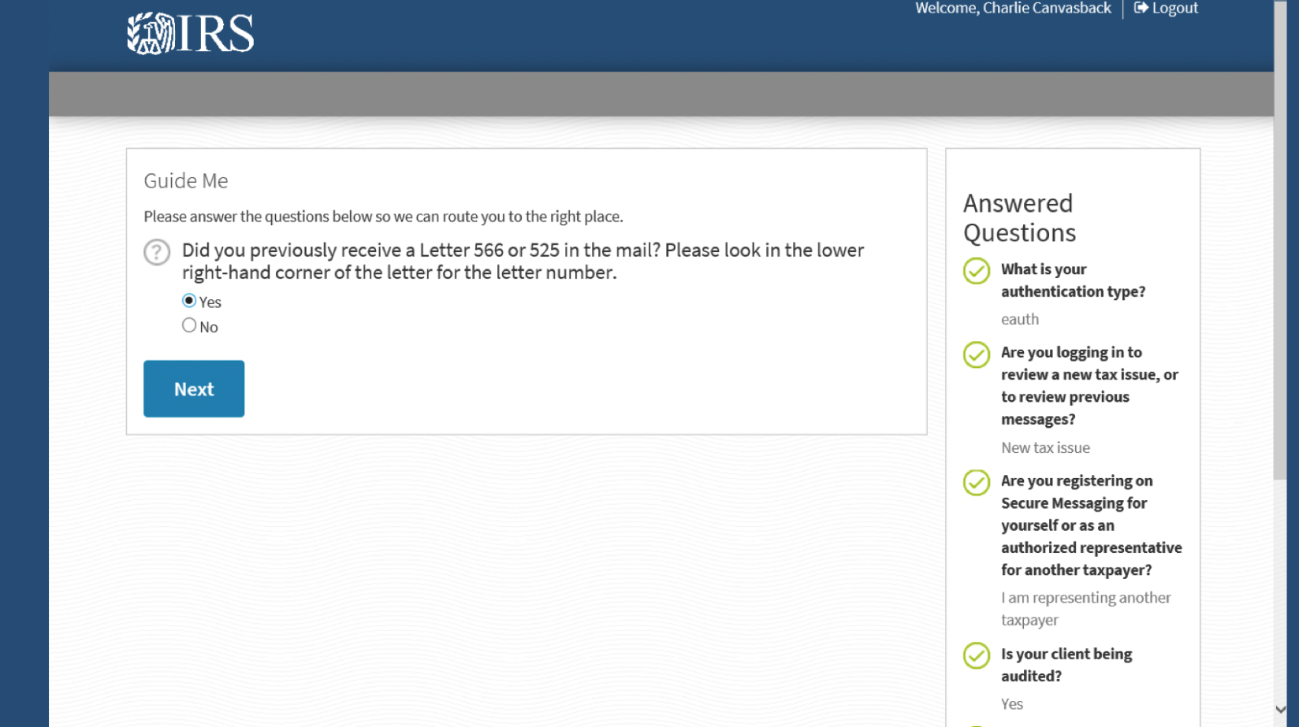
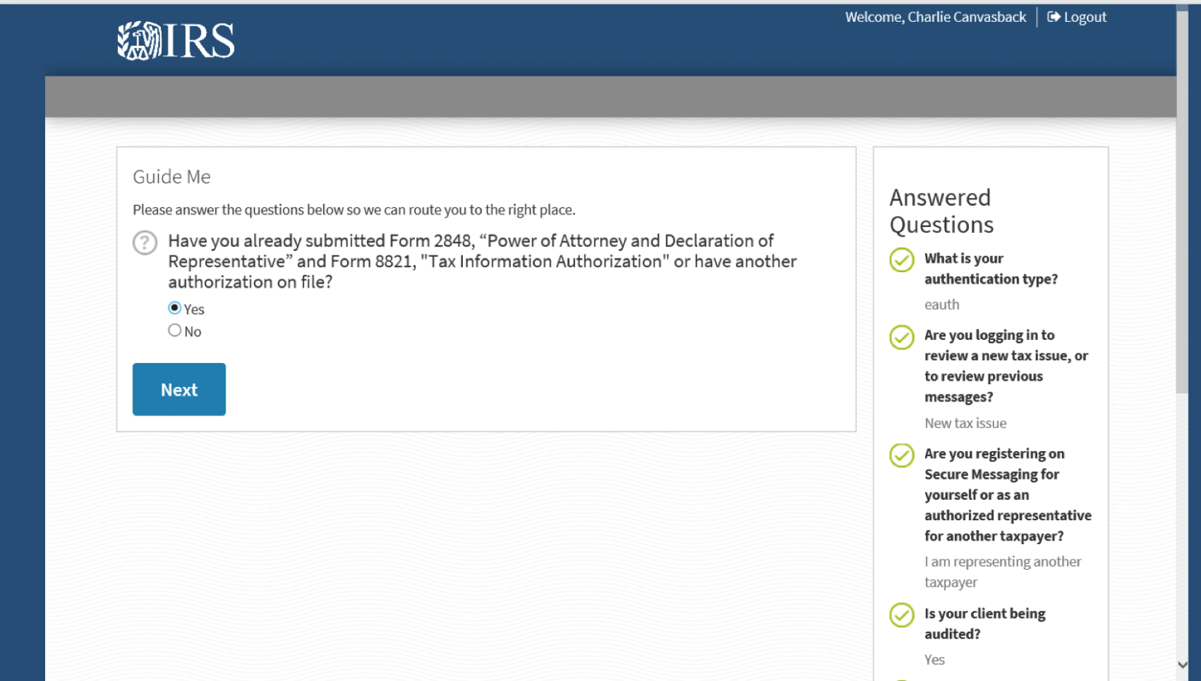
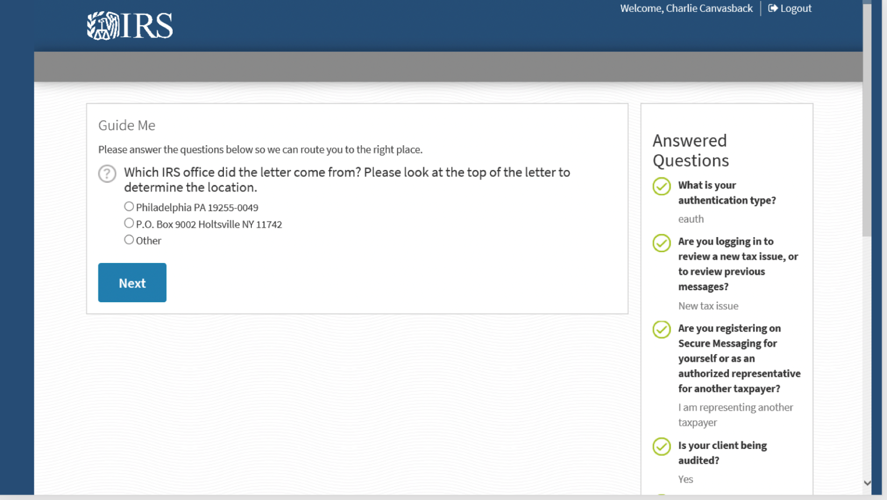

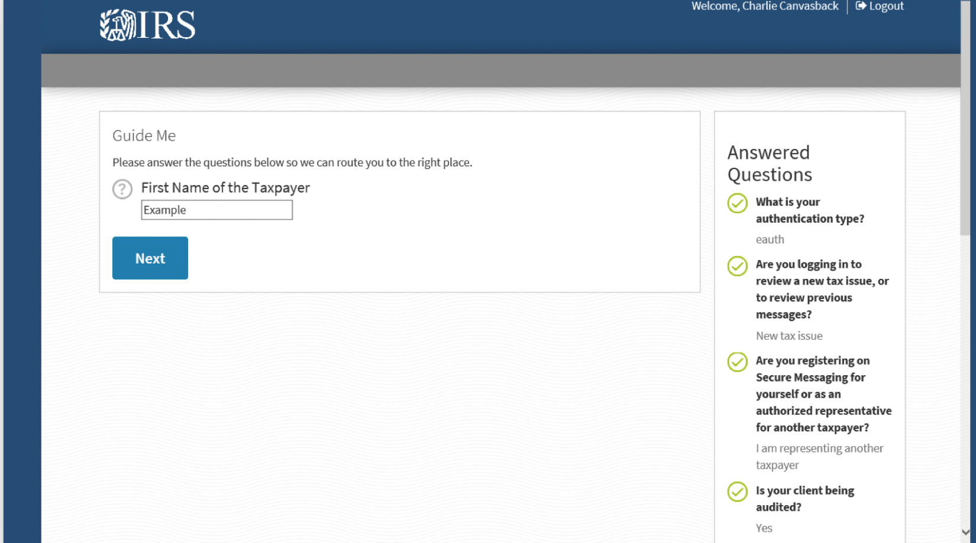
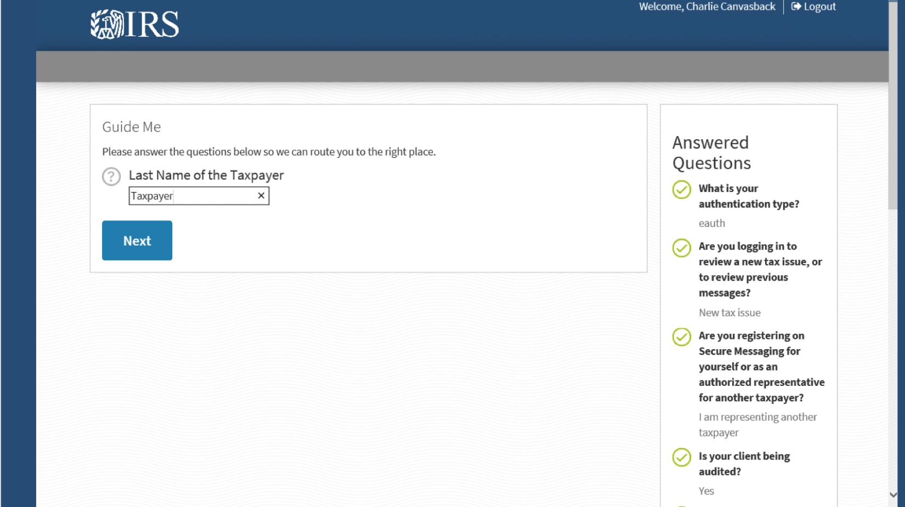

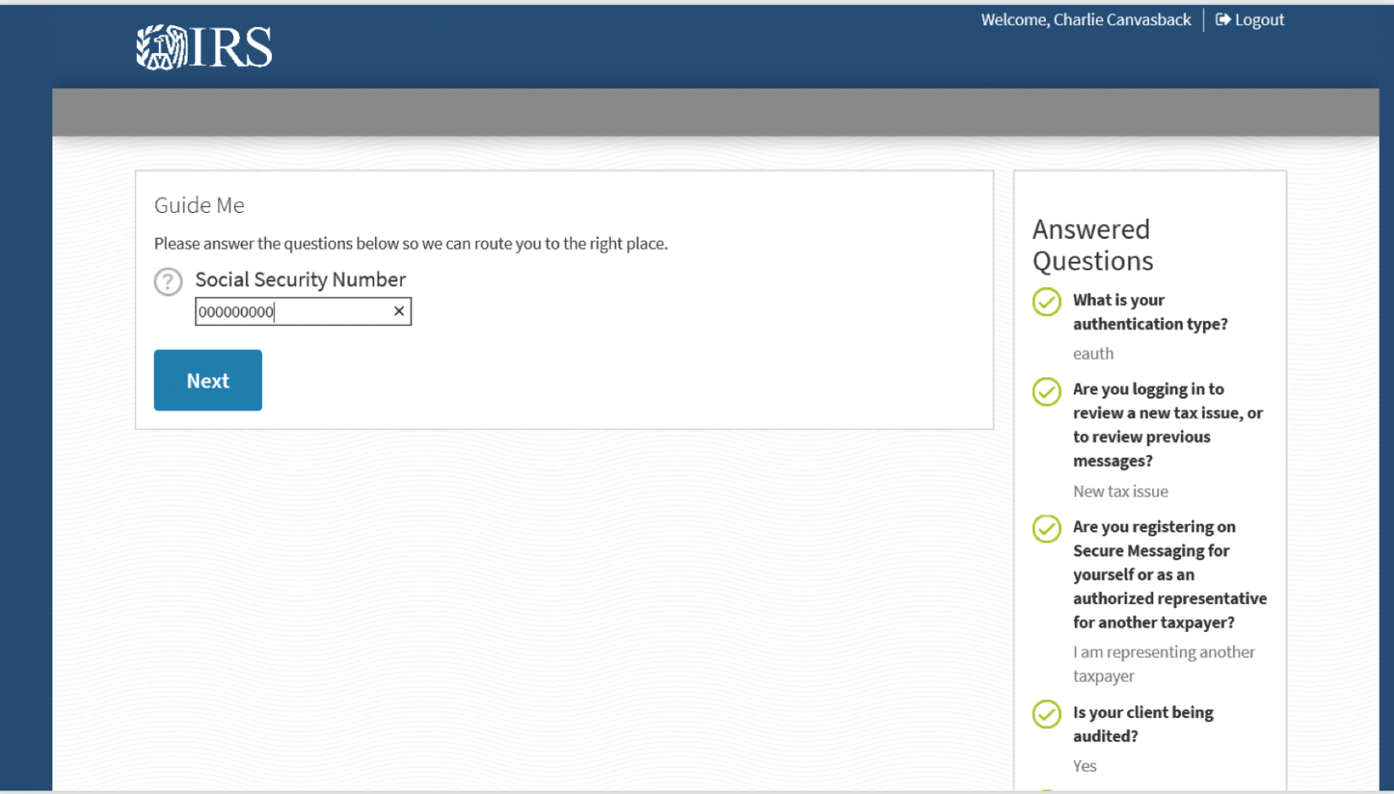

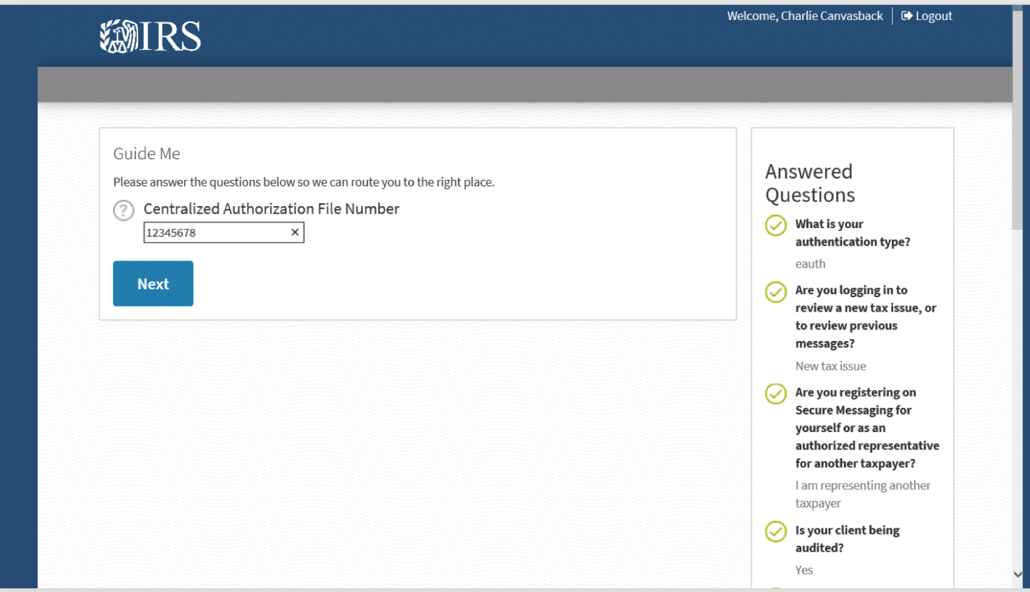
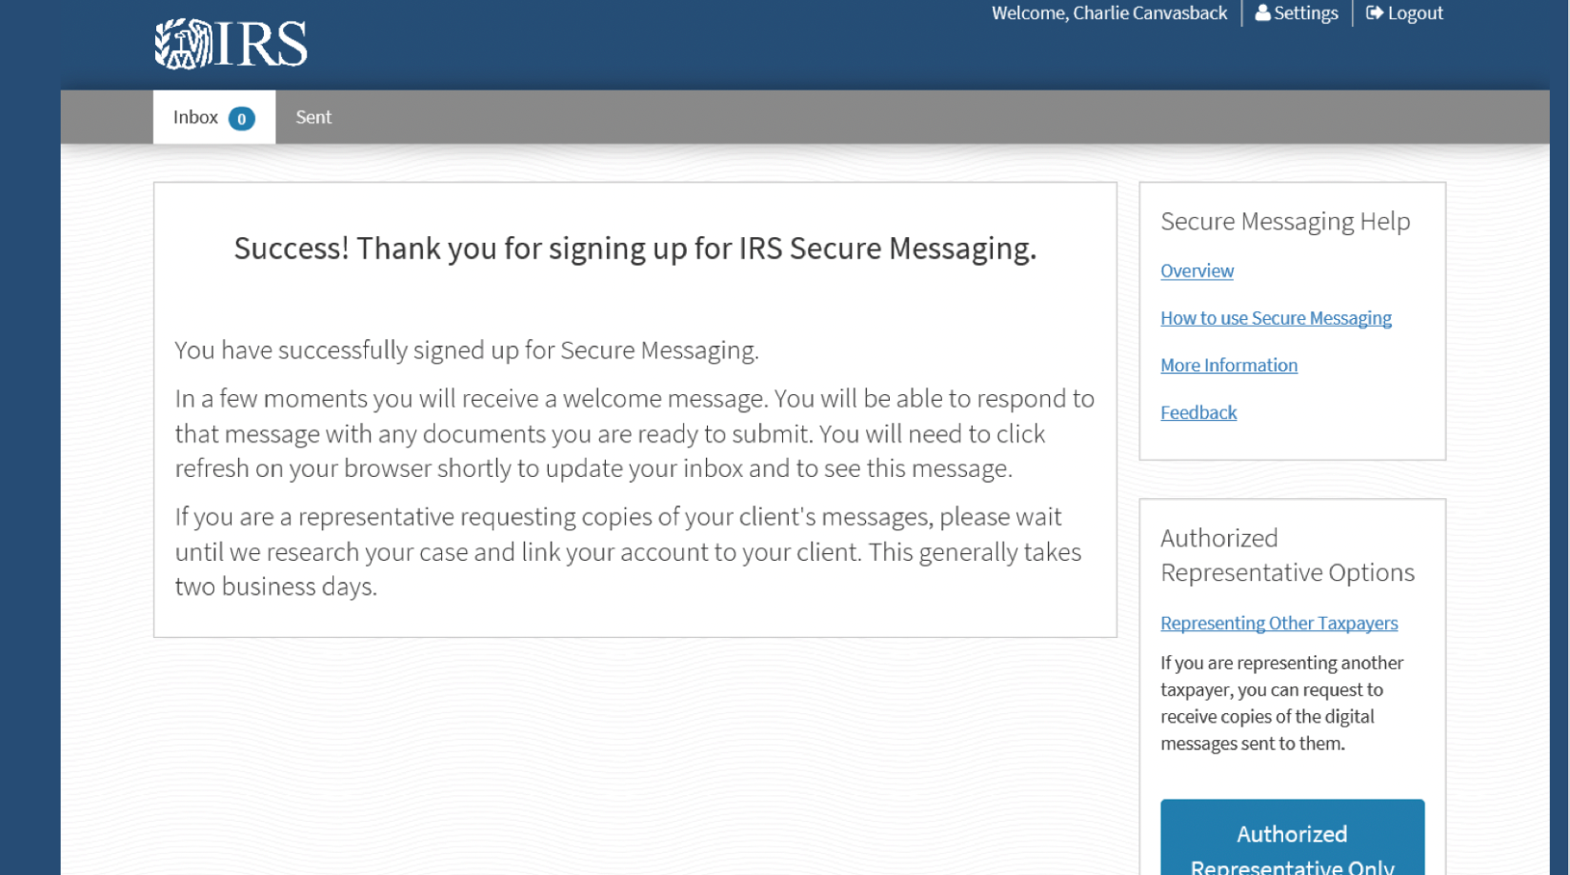

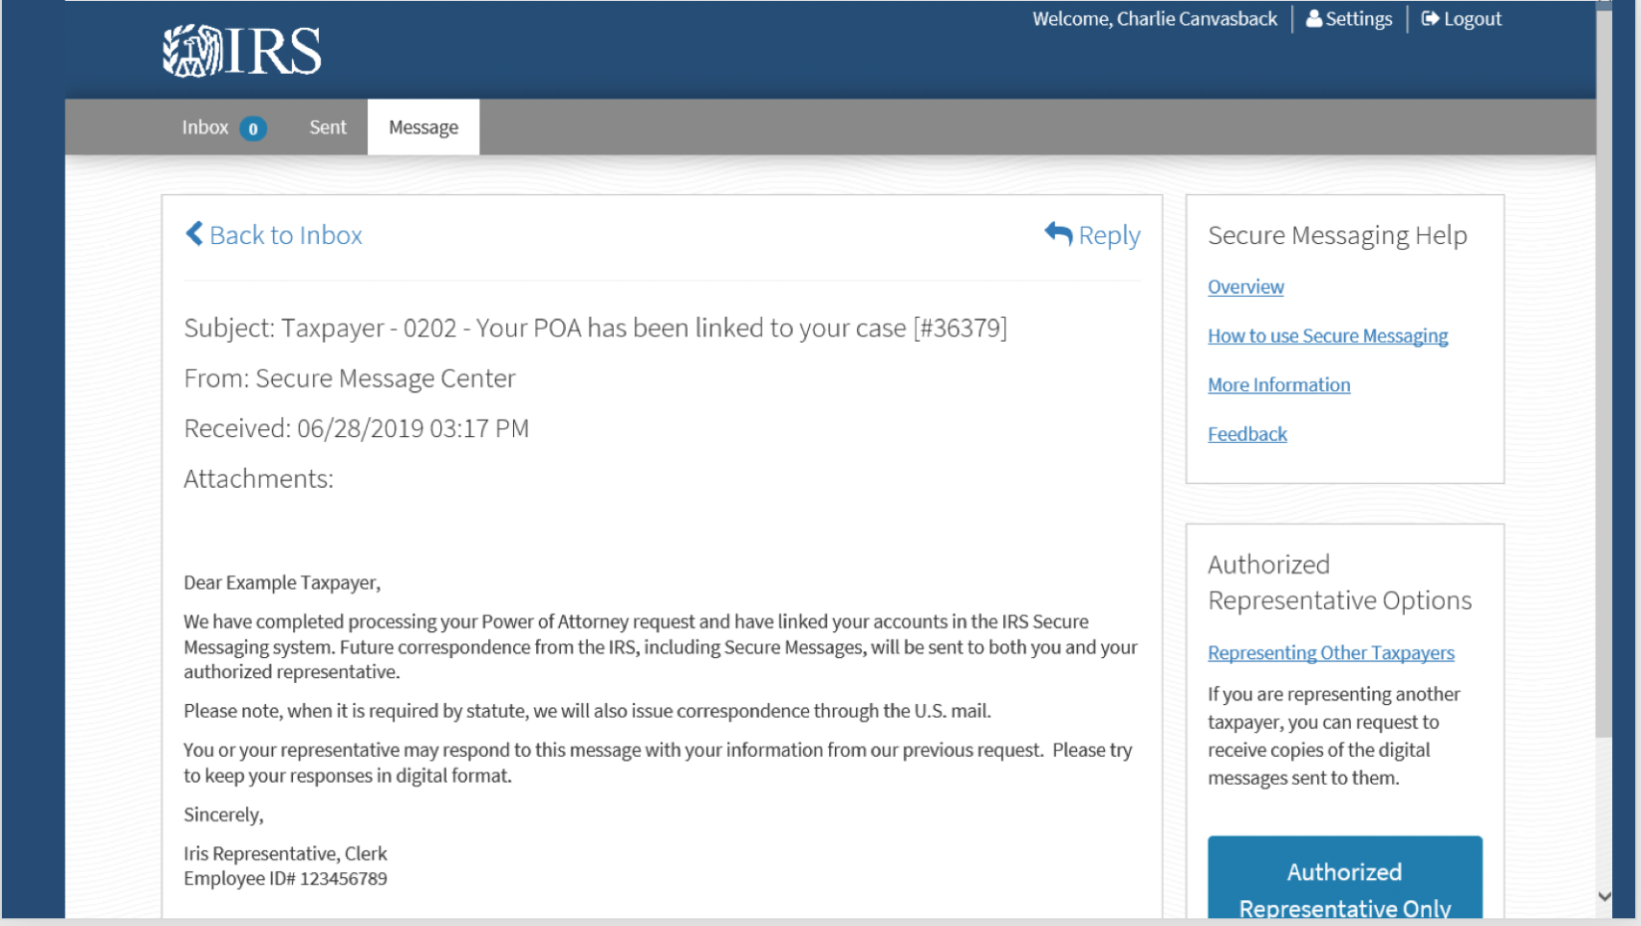
Impressions POA (Objectives & Demand)
- What are your first impressions?
- What do you like about it?
- What don’t you like about it?
- Have you previously heard of this product?
  - If yes, how did you hear about it?
- Is this a tool that you would use? Why or Why not? (Probe on low adoption rate)
  - If yes, probe on what about the tool made them want to use it.
  - If no, why haven’t you used it? (Probe to understand: is it awareness, security/trust, or legal constraint – e.g., if they had not heard about it, but discovered it, would they be interested in using it? Is it a concern about security? Is it in direct conflict of workplace rules or any statutes they follow?)
- Have your clients ever requested this service?
  - If yes / no, what did you tell them?

Magic Wand Question

- If you had the ability to create any tool or service to better serve taxpayers, what would it be?
- Any additional comments that you would like to add?

Closing (2 min)

- Thank you for your time! Do you have any feedback for me?

- Ask participant if they are willing to participate in future research studies to provide their contact info/business card. (e.g., “We are regularly speaking with people about this subject and others like it to improve the tax experience for citizens. Would you be willing to speak with us again to inform future products and services?”

