National Center for Education Statistics
National Assessment of Educational Progress

Volume II
Survey Questions

The National Assessment of Educational Progress (NAEP) Oral Reading Fluency Pilot Study 2017

OMB# 1850-0803 v.174

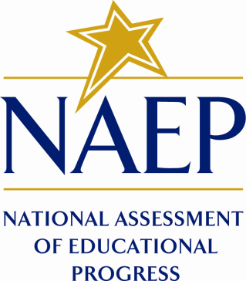

September2016

Table of Contents
Part A. Paperwork Burden Statement 1
Part B. ORF open-ended survey questions 2

Part A. Paperwork Burden Statement
The Paperwork Reduction Act and the NCES confidentiality statement are indicated below. Appropriate sections of this information are included in the consent forms and letters. The statements will be included in the materials used in the study.

Paperwork Burden Statement, OMB Information
According to the Paperwork Reduction Act of 1995, no persons are required to respond to a collection of information unless it displays a valid OMB control number. The valid OMB control number for this voluntary information collection is 1850–0803. The time required to complete this information collection is estimated to average 90 minutes, including the time to review instructions and complete and review the information collection. If you have any comments concerning the accuracy of the time estimate, suggestions for improving this collection, or any comments or concerns regarding the status of your individual submission of this form, please write to: National Assessment of Educational Progress (NAEP), National Center for Education Statistics (NCES), 550 12th St., SW, 4th floor, Washington, DC 20202.

This is a project of the National Center for Education Statistics (NCES), part of the Institute of Education Sciences, within the U.S. Department of Education.

Your participation is voluntary and your answers may be used only for research purposes and may not be disclosed, or used, in identifiable form for any other purpose except as required by law [Education Sciences Reform Act of 2002 (20 U.S.C. §9573)]. With your parent or guardian’s permission some of your responses or clips from audio recordings may be selected for use in research reports or presentations.

OMB No. 1850-0803 Approval Expires 07/31/2019

Part B. ORF open-ended survey questions

Read and on screen: In this school year, how often have you read something out loud, either in school or outside of school?

Pause for Student Oral Response

Read and on screen: Tell us about the last time you read out loud.

Pause for Student Oral Response

Read and on screen: Who did you read to?

Pause for Student Oral Response

Read and on screen: Where were you?

Pause for Student Oral Response

Read and on screen: What did you find difficult in this test?

Pause for Student Oral Response

Read and on screen: What was most interesting in this test?

Pause for Student Oral Response

Read and on screen: What would you change to make this test better?

Pause for Student Oral Response

Read and on screen: Thank you for participating in this study!

