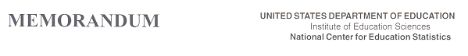
DATE: April 13, 2017
TO: Robert Sivinski & E. Ann Carson, OMB
FROM: Kashka Kubzdela, NCES
Re: NCES System Clearance for Cognitive, Pilot, and Field Test Studies Confidentiality Pledge Change Request (OMB# 1850-0803 v.194)

The request for a 3-year renewal of the generic clearance to allow the National Center for Education Statistics (NCES) to continue to develop, test, and improve its survey and assessment instruments and methodologies was approved in July 2016 (OMB# 1850-0803 v.153). The procedures utilized to this effect include but are not limited to experiments with levels of incentives for various types of survey operations, focus groups, cognitive laboratory activities, pilot testing, exploratory interviews, experiments with questionnaire design, and usability testing of electronic data collection instruments.
This request is to update the confidentiality pledge cited as part of the NCES System Clearance for Cognitive, Pilot, and Field Test Studies to account for the Cybersecurity Enhancement Act of 2015.
The confidentiality pledge has been updated in the revised Part A to reflect the addition of the Cybersecurity Enhancement Act of 2015 provision. The revised pledge informs respondents that all of the information they provide may be used only for statistical purposes and may not be disclosed, or used, in identifiable form for any other purpose except as required by law (20 U.S.C. §9573 and 6 U.S.C. §151).
This revision does not affect the estimated burden to respondents or the total cost to the federal government for IELS 2018.

