**2019 National Household Education Survey (NHES) Web Usability Testing**

**Attachment 1**

Contact, Consent, and Receipt Acknowledgment Materials

OMB# 1850-0803 v.234

**National Center for Education Statistics (NCES)**

June 2018

Table of Contents

Recruiting for English and Spanish participants 1

Email text for personal and professional contacts 1

PFI-eligible 1

ECPP-eligible 1

Text for advertisements on social media and/or craigslist 3

Recruiting Flyer 4

Broadcast Email Announcement 5

Informed Consent 6

Incentive Receipt Acknowledgement Form 7

Screener Letters to be used during usability sessions 8

# Recruiting for English and Spanish participants

English-speaking participants will be recruited with all of the materials provided in this document. Spanish-speaking participants will be recruited through contacts at community resource centers using the intercept method and using a Spanish-language flier sent to the centers (the translation of the recruiting flier for Spanish-speaking participants will be provided to OMB for approval in this document by early September 2018).

# Email text for personal and professional contacts

## PFI-eligible

Dear [contact]:

The U.S. Census Bureau is assisting with a study by the National Center for Education Statistics (NCES) of the U.S. Department of Education. In an effort to improve a web survey, we are specifically looking for parents of children either enrolled in grades K-12 or homeschooled in those equivalent grades to participate in a one-time voluntary web survey and provide feedback after taking it.

If you are eligible and participate in the study, you will receive $60 as a thank you for your participation.

**What will I be doing in a usability study?**

You will be asked to complete the web survey and do several short tasks using the web. You will also be asked questions about your experience and perceptions of the web survey.

**How long is a session?** 90 minutes

**When and where?**

The study will be held [DAYS, DATES]. You will be asked to participate [in person at our office in Suitland, MD.] OR [at a local library or community center.]

**Interested in participating?**

Please reply to this email with your contact information or call me at [ADD PHONE]. I’ll ask you some questions to help us determine if you are eligible for the study.

If someone you know is interested in participating, please contact [contact info].

Thank you for your time and help with this important study.

Sincerely,

[Recruitment Contact Info]

## ECPP-eligible

Dear [contact]:

The U.S. Census Bureau is assisting with a study by the National Center for Education Statistics (NCES) of the U.S. Department of Education. In an effort to improve a web survey, we are specifically looking for parents of children who are not yet enrolled in K-12 school (ages birth - 5) to participate in a one-time voluntary web survey and provide feedback after taking it.

If you are eligible and participate in the study, you will receive $60 as a thank you for your participation.

**What will I be doing in a usability study?**

You will be asked to complete the web survey and do several short tasks using the web. You will also be asked questions about your experience and perceptions of the web survey.

**How long is a session?** 90 minutes

**When and where?**

The study will be held [DAYS, DATES]. You will be asked to participate [in person at our office in Suitland, MD.] OR [at a local library or community center.]

**Interested in participating?**

Please reply to this email with your contact information or call me at [ADD PHONE]. I’ll ask you some questions to help us determine if you are eligible for the study.

If someone you know is interested in participating, please contact [contact info].

Thank you for your time and help with this important study.

Sincerely,

[Recruitment Contact Info]

# Text for advertisements on social media and/or craigslist

**Education Research Study –Participants Needed**

The U.S. Census Bureau is looking for participants to help evaluate a new web survey by the National Center for Education Statistics (NCES), part of the U.S. Department of Education. This survey is part of the National Household Education Survey, a study that helps educators, researchers, and policy makers better understand children’s care and schooling.

We are looking for the following groups of participants:

* Parents of children age 5 and younger who are in child care
* Parents of students in grades K-12 – public or private
* Parents of children homeschooled in grades equivalent to K-12
* Parents of children homeschooled and taking other enrolled classes – for example, at a community college or online courses, etc.

You will be asked to complete the web survey and do several short tasks on the web. You will also be asked questions about your experience and perceptions of the web survey. The session will last approximately 90 minutes. Sessions will be conducted between [DATES] and will be held in locations near public parking and public transportation.

**Eligibility to Participate:**

If interested, contact us at (301) 763-4979 and mention **Education** or by email at [csm.participate@census.gov](mailto:csm.participate@census.gov) and enter “**Education**” in the subject line of the email. We will then contact you to complete a brief telephone screening in order to determine if you are eligible. The telephone screening will take approximately 10 minutes to complete. If eligible, the U.S. Census Bureau will schedule an interview at your convenience. If you are eligible and participate in the study, you will receive $60 as a thank you for your participation.

# Recruiting Flyer

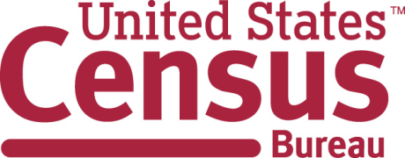

**You can participate if you are a:**

• **Parent of a child not yet in kindergarten (age 5 or younger) who is in child care**

• **Parent of a student in grades K to 12**

• **Parent of a child who is homeschooled in grades equivalent to K to 12**

**Call Kevin at: 301-763-4979 and mention “Education”**

The U.S. Census Bureau is looking for

Participants for an Education Research Study

**$60 for a 90-minute session**

Aug 2016 - Sept 2016

**csm.participate@census.gov**

**301-763-4979**

**————————-**

**csm.participate@census.gov**

**301-763-4979**

**————————-**

**csm.participate@census.gov**

**301-763-4979**

**————————-**

**csm.participate@census.gov**

**301-763-4979**

**————————-**

**csm.participate@census.gov**

**301-763-4979**

**————————-**

**csm.participate@census.gov**

**301-763-4979**

**————————-**

**csm.participate@census.gov**

**301-763-4979**

**­­————————-**

**Kevin.J. Younes@census.gov**

**301-763-4979**

**————————-**

**Kevin.J. Younes@census.gov**

**301-763-4979**

# Broadcast Email Announcement[1]

Subject: Participants with school-age children needed for questionnaire testing

From the Desk of Paul Beatty (Chief, Center for Survey Measurement)

The Center for Survey Measurement is seeking households with one or more children ages 20 or younger to test a web survey on children’s education and care arrangements. Parents of children at any level of schooling up through high school are welcome (including pre-school, day care, grades K-12, and home schooling). This research is to test the National Household Education Survey. Participants will receive $60.

We particularly need participants who meet the following criteria:

* Parent of a child who is homeschooled in grades equivalent to K to 12
* Parent of a child who is in a combination of homeschooled in grades equivalent to K to 12 and enrolled in school such as online courses, a community college, etc.
* Parent of a student in grades K to 12
* Parent of a child age 5 and younger who is not yet enrolled in school but who is in child care.

If you know anyone in the Washington, D.C. area who meets these criteria and speaks English or Spanish, we would appreciate it if you let them know of this research opportunity. Interviews will be 90 minutes and will take place at a convenient location, including at the Census Bureau in Suitland, Maryland. Study sessions will begin on [DATE] and conclude on [DATE].

While current federal employees are allowed to participate in off-duty time, they are not eligible to receive the incentive payment. Please have interested participants contact us at (301) 763-4979 and mention **Education** or by email at [csm.participate@census.gov](mailto:csm.participate@census.gov) and enter “**Education**” in the subject line of the email.

# Informed Consent [2]



**Consent Form**

**For Individual Participants**

**Usability Testing of 2019 NHES**

Each year the Census Bureau conducts many different usability evaluations. For example, the Census Bureau routinely tests the wording, layout and behavior of products, such as Web sites and online surveys and questionnaires in order to obtain the best information possible.

You have volunteered to take part in a study to improve the usability of the National Household and Education Survey (NHES). The Census Bureau is administering the NHES usability testing on behalf of the National Center of Education Statistics (NCES). NCES is authorized to conduct this study by the Education Sciences Reform Act of 2002 (ESRA 2002, 20 U.S.C., § 9543).

In order to have a complete record of your comments, your usability session will be audio and video-recorded. Only your device will be video-recorded. We plan to use the recordings to improve the design of the product. Only staff directly involved in the research project will have access to the recordings. Your participation is voluntary and all of the information you provide may be used only for statistical purposes and may not be disclosed, or used, in identifiable form for any other purpose except as required by law (20 U.S.C. §9573 and 6 U.S.C. §151). The OMB control number for this study is 1850-0803.

**I have volunteered to participate in this usability study, and I give permission for my recordings to be used for the purposes stated above.**

Participant’s Name: ______________________________________

Participant's Signature: ____________________________________ Date: ­­­­­__________

Researcher’s Name: _____________________________________

Researcher's Signature: ___________________________________ Date: __________

# Incentive Receipt Acknowledgement Form[3]

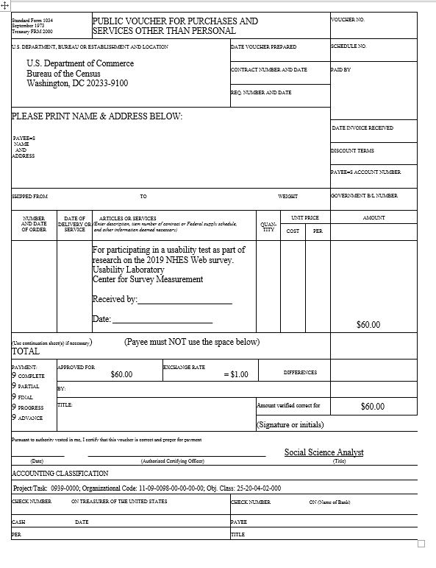

# Screener Letters to be used during usability sessions

**English version:**

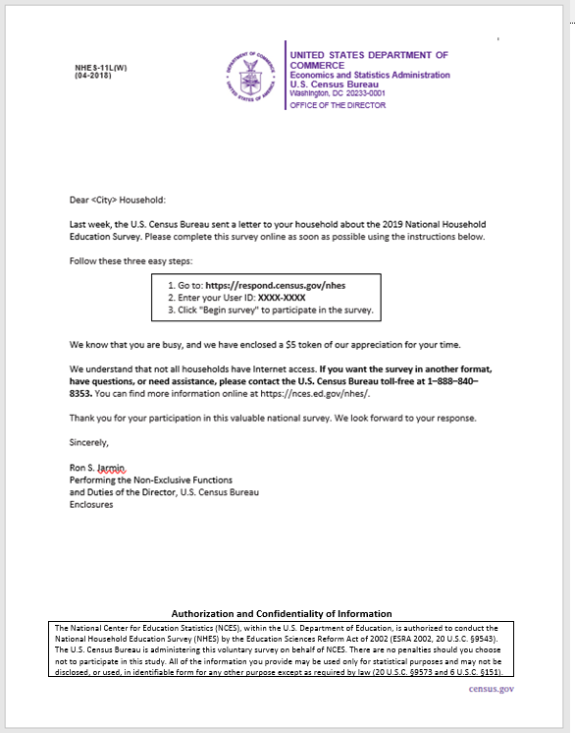

**Spanish version:**



1. This email will also go to all Census Bureau staff. We have found it useful to have staff forward research opportunities to their own contacts and neighborhood listservs.
2. This consent form will be translated into Spanish and provided to OMB by mid-September 2018.
3. This incentive consent form will be translated into Spanish and provided to OMB by mid-September 2018.