2019 National Household Education Survey (NHES) Web Usability Testing

Attachment 1

Contact, Consent, and Receipt Acknowledgment Materials

OMB# 1850-0803 v.236
(revised v.234)

National Center for Education Statistics (NCES)

June 2018
revised September 2018

Table of Contents
Recruiting for English and Spanish participants 1
Email text for personal and professional contacts 1
PFI-eligible 1
ECPP-eligible 1
Text for advertisements on social media and/or craigslist (English and Spanish) 3
Recruiting Flyer (English and Spanish) 5
Broadcast Email Announcement 6
Informed Consent (English and Spanish) 8
Incentive Receipt Acknowledgement Form (English and Spanish) 9
Screener Letters to be used during usability sessions (English and Spanish) 13

Recruiting for English and Spanish participants
English-speaking participants will be recruited with all of the materials provided in this document. Spanish-speaking participants will be recruited through contacts at community resource centers using the materials provided in this document, including using intercept method and a Spanish-language flier.

Email text for personal and professional contacts

PFI-eligible
Dear [contact]:
The U.S. Census Bureau is assisting with a study by the National Center for Education Statistics (NCES) of the U.S. Department of Education. In an effort to improve a web survey, we are specifically looking for parents of children either enrolled in grades K-12 or homeschooled in those equivalent grades to participate in a one-time voluntary web survey and provide feedback after taking it.
If you are eligible and participate in the study, you will receive $60 as a thank you for your participation.
What will I be doing in a usability study?
You will be asked to complete the web survey and do several short tasks using the web. You will also be asked questions about your experience and perceptions of the web survey.
How long is a session? 90 minutes
When and where?
The study will be held [DAYS, DATES]. You will be asked to participate [in person at our office in Suitland, MD.] OR [at a local library or community center.]
Interested in participating?
Please reply to this email with your contact information or call me at [ADD PHONE]. I’ll ask you some questions to help us determine if you are eligible for the study.
If someone you know is interested in participating, please contact [contact info].
Thank you for your time and help with this important study.
Sincerely,
[Recruitment Contact Info]

ECPP-eligible
Dear [contact]:
The U.S. Census Bureau is assisting with a study by the National Center for Education Statistics (NCES) of the U.S. Department of Education. In an effort to improve a web survey, we are specifically looking for parents of children who are not yet enrolled in K-12 school (ages birth - 5) to participate in a one-time voluntary web survey and provide feedback after taking it.
If you are eligible and participate in the study, you will receive $60 as a thank you for your participation.
What will I be doing in a usability study?
You will be asked to complete the web survey and do several short tasks using the web. You will also be asked questions about your experience and perceptions of the web survey.
How long is a session? 90 minutes
When and where?
The study will be held [DAYS, DATES]. You will be asked to participate [in person at our office in Suitland, MD.] OR [at a local library or community center.]
Interested in participating?
Please reply to this email with your contact information or call me at [ADD PHONE]. I’ll ask you some questions to help us determine if you are eligible for the study.
If someone you know is interested in participating, please contact [contact info].
Thank you for your time and help with this important study.
Sincerely,
[Recruitment Contact Info]

Text for advertisements on social media and/or craigslist

Education Research Study –Participants Needed

The U.S. Census Bureau is looking for participants to help evaluate a new web survey by the National Center for Education Statistics (NCES), part of the U.S. Department of Education. This survey is part of the National Household Education Survey, a study that helps educators, researchers, and policy makers better understand children’s care and schooling.

We are looking for the following groups of participants:
- Parents of children age 5 and younger who are in child care
- Parents of students in grades K-12 – public or private
- Parents of children homeschooled in grades equivalent to K-12
- Parents of children homeschooled and taking other enrolled classes – for example, at a community college or online courses, etc.

You will be asked to complete the web survey and do several short tasks on the web. You will also be asked questions about your experience and perceptions of the web survey. The session will last approximately 90 minutes. Sessions will be conducted between [DATES] and will be held in locations near public parking and public transportation.
Eligibility to Participate:
If interested, contact us at (301) 763-4979 and mention Education or by email at csm.participate@census.gov and enter “Education” in the subject line of the email. We will then contact you to complete a brief telephone screening in order to determine if you are eligible. The telephone screening will take approximately 10 minutes to complete. If eligible, the U.S. Census Bureau will schedule an interview at your convenience. If you are eligible and participate in the study, you will receive $60 as a thank you for your participation.
Estudio de Educación–Se Ocupa Participantes

La Oficina Del Censo de los Estados Unidos está buscando participantes para ayudar evaluar una encuesta nueva en internet del Centro Nacional de Estadísticas de Educación (NCES), parte del Departamento de Educación de los Estados Unidos. Esta encuesta es parte de la Encuesta Nacional de Hogares y Educación (NHES), un estudio que ayuda educadores, colaboradores de estudios y legisladores mejorar el entendimiento del cuidado y educación de niños.

Se busca los siguientes grupos de participantes:
- Padres de un hijo 5 años o menor y que asiste a un cuidado infantil
- Padres de un estudiante en grados K -12 asistiendo a escuelas públicas o privadas
- Padres de un hijo quien recibe enseñanza académica en el hogar perteneciendo a un grado equivalente a K-12
- Padres de un hijo quien recibe enseñanza académica en el hogar y está inscrito en otros cursos– por ejemplo, en un colegio comunitario o inscrito en cursos por internet, etc.

Le pediremos que complete la encuesta y realice una serie de tareas breves en internet. También le haremos unas preguntas sobre su experiencia con y su precepción de la encuesta en internet. La sesión durará acerca de 90 minutos. Las sesiones tomarán lugar [DATES] en sitios cercas de transporte pública y estacionamientos públicos.
Calificación para Participar:
Si le interesa participar, llámenos al (301) 763-4425 y menciona Educación o por correo electrónico a census.participa@census.gov y escriba “Educación” en la línea dedicada al asunto del correo electrónico. Después, nos comunicaremos con usted para hacerle unas preguntas breves por teléfono para determinar si usted califica. La consultación por teléfono durará aproximadamente 10 minutos. Si califica, La Oficina del Censo de los Estados Unidos le hará una cita para la entrevista a su conveniencia. Si califica para participar en el estudio, recibirá $60 como agradecimiento por su participación.

Recruiting Flyer

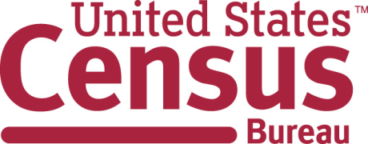
You can participate if you are a:
• Parent of a child not yet in kindergarten (age 5 or younger) who is in child care
• Parent of a student in grades K to 12
• Parent of a child who is homeschooled in grades equivalent to K to 12
Call Kevin at: 301-763-4979 and mention “Education”

The U.S. Census Bureau is looking for
Participants for an Education Research Study

$60 for a 90-minute session

Aug 2016 - Sept 2016

csm.participate@census.gov
301-763-4979
————————-
csm.participate@census.gov
301-763-4979
————————-
csm.participate@census.gov
301-763-4979
————————-
csm.participate@census.gov
301-763-4979
————————-
csm.participate@census.gov
301-763-4979
————————-
csm.participate@census.gov
301-763-4979
————————-
csm.participate@census.gov
301-763-4979
————————-
Kevin.J. Younes@census.gov
301-763-4979
————————-
Kevin.J. Younes@census.gov
301-763-4979

La Oficina del Censo de los Estados Unidos está buscando
Participantes para un Estudio de Educación

$60 para una sesión de 90-minutos

Aug 2016 - Sept 2016

Puede participar si usted es:
• Padre de un hijo que aún no empieza kínder (5 años o menor) y asiste a un cuidado infantil
• Padre de un estudiante en grados K a 12
• Padre de un hijo quien recibe enseñanza académica en el hogar pero que pertenece a un grado equivalente a K a 12

Lláme a Beverly: 301-763-4425 y menciona “Educación”

census.participa@census.gov
301-763-4425
————————-
census.participa@census.gov
301-763-4425
————————-
census.participa@census.gov
301-763-4425
————————-
census.participa@census.gov
301-763-4425
————————-
census.participa@census.gov
301-763-4425
————————-
census.participa@census.gov
301-763-4425
————————-
census.participa@census.gov
301-763-4425
————————-
Kevin.J. Younes@census.gov
301-763-4979
————————-
Kevin.J. Younes@census.gov
301-763-4979

Broadcast Email Announcement
Subject: Participants with school-age children needed for questionnaire testing
From the Desk of Paul Beatty (Chief, Center for Survey Measurement)
The Center for Survey Measurement is seeking households with one or more children ages 20 or younger to test a web survey on children’s education and care arrangements. Parents of children at any level of schooling up through high school are welcome (including pre-school, day care, grades K-12, and home schooling). This research is to test the National Household Education Survey. Participants will receive $60.
We particularly need participants who meet the following criteria:
- Parent of a child who is homeschooled in grades equivalent to K to 12
- Parent of a child who is in a combination of homeschooled in grades equivalent to K to 12 and enrolled in school such as online courses, a community college, etc.
- Parent of a student in grades K to 12
- Parent of a child age 5 and younger who is not yet enrolled in school but who is in child care.

If you know anyone in the Washington, D.C. area who meets these criteria and speaks English or Spanish, we would appreciate it if you let them know of this research opportunity. Interviews will be 90 minutes and will take place at a convenient location, including at the Census Bureau in Suitland, Maryland. Study sessions will begin on [DATE] and conclude on [DATE].
While current federal employees are allowed to participate in off-duty time, they are not eligible to receive the incentive payment. Please have interested participants contact us at (301) 763-4979 and mention Education or by email at csm.participate@census.gov and enter “Education” in the subject line of the email.

Informed Consent
Consent Form
For Individual Participants
Usability Testing of 2019 NHES

Each year the Census Bureau conducts many different usability evaluations. For example, the Census Bureau routinely tests the wording, layout and behavior of products, such as Web sites and online surveys and questionnaires in order to obtain the best information possible.
You have volunteered to take part in a study to improve the usability of the National Household and Education Survey (NHES). The Census Bureau is administering the NHES usability testing on behalf of the National Center of Education Statistics (NCES). NCES is authorized to conduct this study by the Education Sciences Reform Act of 2002 (ESRA 2002, 20 U.S.C., § 9543).
In order to have a complete record of your comments, your usability session will be audio and video-recorded. Only your device will be video-recorded. We plan to use the recordings to improve the design of the product. Only staff directly involved in the research project will have access to the recordings. Your participation is voluntary and all of the information you provide may be used only for statistical purposes and may not be disclosed, or used, in identifiable form for any other purpose except as required by law (20 U.S.C. §9573 and 6 U.S.C. §151). The OMB control number for this study is 1850-0803.
I have volunteered to participate in this usability study, and I give permission for my recordings to be used for the purposes stated above.

Participant’s Name: ______________________________________

Participant's Signature: ____________________________________ Date: __________

Researcher’s Name: _____________________________________

Researcher's Signature: ___________________________________ Date: __________

Hoja de consentimiento para participantes
Estudio de usabilidad de la Encuesta Nacional de Hogares y Educación del 2019

Cada año, la Oficina del Censo lleva a cabo distintas pruebas de usabilidad. Por ejemplo, la Oficina del Censo regularmente evalúa el texto, organización y comportamiento de ciertos productos como sitios de Internet, y encuestas y cuestionarios en línea para obtener la mejor información posible.
Usted se ha ofrecido como voluntario para participar en un estudio que tiene el objetivo de mejorar la usabilidad de la Encuesta Nacional de Hogares y Educación (NHES). La Oficina del Censo está llevando a cabo la prueba de usabilidad de NHES de parte del Centro Nacional de Estadísticas de Educación (NCES). NCES está autorizada a realizar este estudio de acuerdo con el Acto de Reforma de las Ciencias de la Educación de 2002 (ESRA 2002, 20 U.S.C., § 9543).
Para tener una anotación completa de sus comentarios, esta sesión de usabilidad será grabada por audio y video. Solamente su dispositivo será grabado por video. Pensamos usar la grabación para mejorar el diseño del producto. Sólo el personal que trabaja directamente en este estudio tendrá acceso a las grabaciones. Su participación es voluntaria, y toda la información que nos proporciona solo puede ser usada para propósitos estadísticos. No será compartida ni usada en forma identificable para ningún otro propósito excepto como requerido por ley (20 U.S.C. §9573 y 6 U.S.C. §151). El número de control de la Oficina de Administración y Presupuesto (OMB) para este estudio es 1850-0803.
Me he ofrecido como voluntario para participar en este estudio de usabilidad de la Oficina del Censo, y doy permiso para que se utilice la grabación de mi sesión con los fines previamente descritos.
Nombre del participante: ______________________________________

Firma del participante: ____________________________________ Fecha: __________

Nombre del investigador: _____________________________________

Firma del investigador: ___________________________________ Fecha: __________

Incentive Receipt Acknowledgement Form
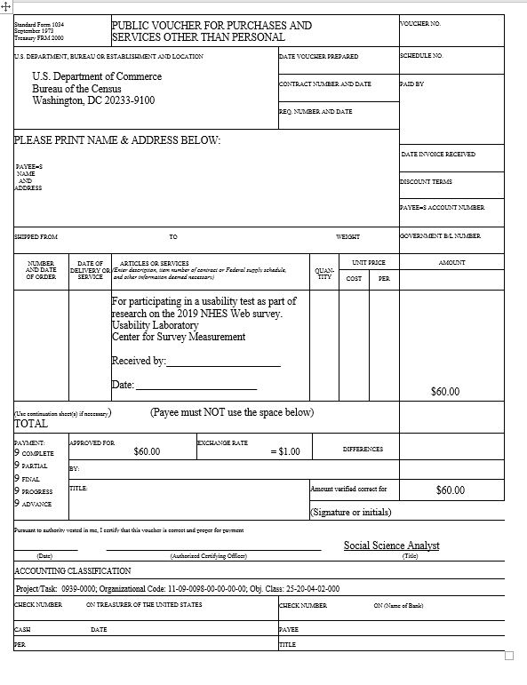

Standard Form 1034  September 1973  Treasury FRM 2000 |  | PUBLIC VOUCHER FOR PURCHASES AND  SERVICES OTHER THAN PERSONAL |  |  |  |  |  |  | VOUCHER NO.
U.S. DEPARTMENT, BUREAU OR ESTABLISHMENT AND LOCATION  U.S. Department of Commerce  Bureau of the Census  Washington, DC 20233-9100 |  |  |  | DATE VOUCHER PREPARED |  |  |  |  | SCHEDULE NO.
 |  |  |  | CONTRACT NUMBER AND DATE |  |  |  |  | PAID BY
 |  |  |  | REQ. NUMBER AND DATE
Por favor escriba nombre y dirección [PLEASE PRINT NAME & ADDRESS BELOW]:

NOMBRE Y DIRECCION DEL BENEFICIARIO[ PAYEE’S NAME AND ADDRESS]
 |  |  |  |  |  |  |  |  | DATE INVOICE RECEIVED
 |  |  |  |  |  |  |  |  | DISCOUNT TERMS
 |  |  |  |  |  |  |  |  | PAYEE=S ACCOUNT NUMBER
SHIPPED FROM TO WEIGHT |  |  |  |  |  |  |  |  | GOVERNMENT B/L NUMBER
NUMBER  AND DATE  OF ORDER | DATE OF DELIVERY OR SERVICE | ARTICLES OR SERVICES  (Enter description, item number of contract or Federal supply schedule,  and other information deemed necessary) |  |  | QUAN-TITY |  | UNIT PRICE |  | AMOUNT
 |  |  |  |  |  |  | COST | PER
 |  | Por participar en un[a] [entrevista cognitiva/grupo de enfoque/etc] como parte de una investigación sobre [nombre del proyecto]  [For participating in [cognitive interview/cognitive interview/etc] as part of research on the [ name of project]]  Center for Survey Measurement  Recibido por [Received by]:______________________  Fecha [Date]: ____________________________ |  |  |  |  |  |  | $25.00
(Use continuation sheet(s) if necessary) (Payee must NOT use the space below) TOTAL
PAYMENT:  - COMPLETE  - PARTIAL  - FINAL  - PROGRESS  - ADVANCE | APPROVED FOR  $25.00 |  | EXCHANGE RATE  = $1.00 |  |  | DIFFERENCES
 | BY:
 | TITLE: |  |  |  | Amount verified correct for |  |  |  | $25.00
 |  |  |  |  | (Signature or initials)
Pursuant to authority vested in me, I certify that this voucher is correct and proper for payment

_____________________ _______________________________________________________________________ Survey Statistician
(Date) (Authorized Certifying Officer) (Title)
ACCOUNTING CLASSIFICATION
Project/Task: 7192017-000; Organizational Code: 11-09-0098-00-00-00-00; Obj. Class: 25-20-04-02
CHECK NUMBER ON TREASURER OF THE UNITED STATES |  |  |  | CHECK NUMBER ON (Name of Bank)
CASH DATE |  |  |  | PAYEE
PER |  |  |  | TITLE

Screener Letters to be used during usability sessions
English version:
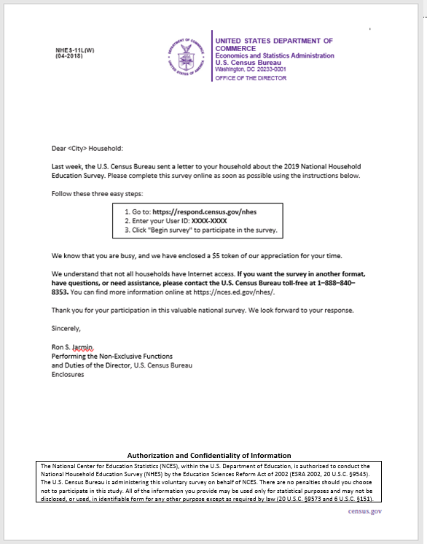

Spanish version:

This email will also go to all Census Bureau staff. We have found it useful to have staff forward research opportunities to their own contacts and neighborhood listservs.

