National Center for Education Statistics (NCES)

Attachment VIII
Student Focus Group/
Audience Assessment Materials

2019-20 National Postsecondary Student Aid Study (NPSAS:20) Pretesting

OMB# 1850-0803 v. 243

December 2018

This attachment provides the materials to be shown to participants in Section II - IV of the student focus groups to assess recruitment materials.

Contents
Materials Displayed in Section II (see Attachment VII) 3
Postcard Design 1 3
Postcard Design 2 5
Postcard Design 3 7
Postcard Design 4 9
Materials Displayed in Section III (see Attachment VII) 11
Lead Letter 1 11
Lead Letter 2 13
Lead Letter 3 15
Leaflet—NPSAS in the News 17
Materials Displayed in Section IV (see Attachment VII) 18
E-mail Subject Lines 18

Materials Displayed in Section II (see Attachment VII)

Postcard Design 1

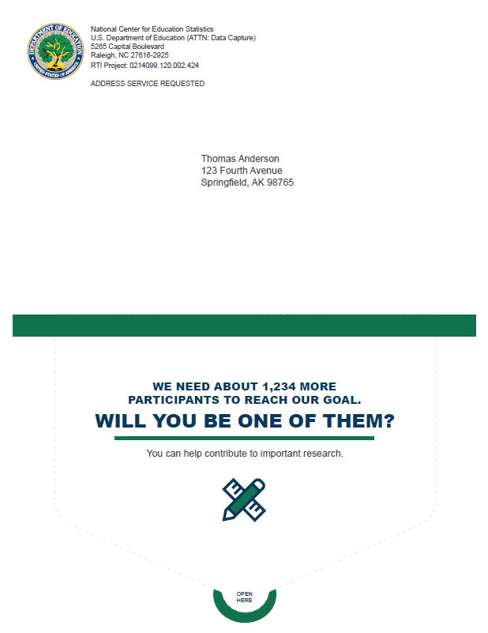

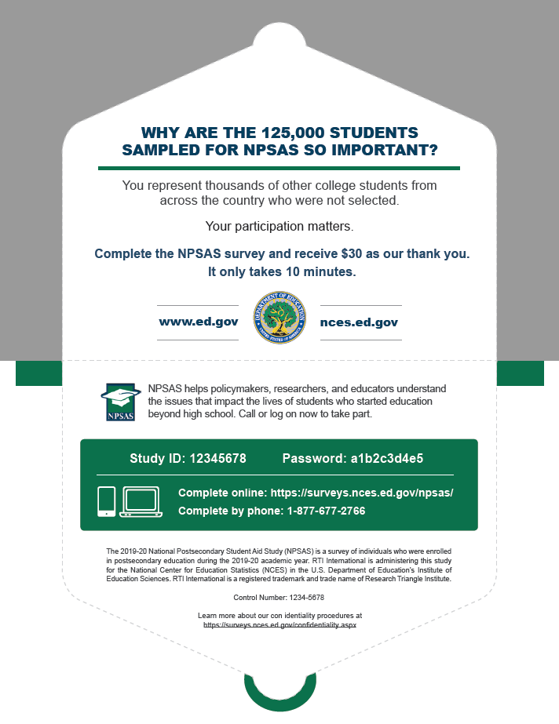

Postcard Design 2

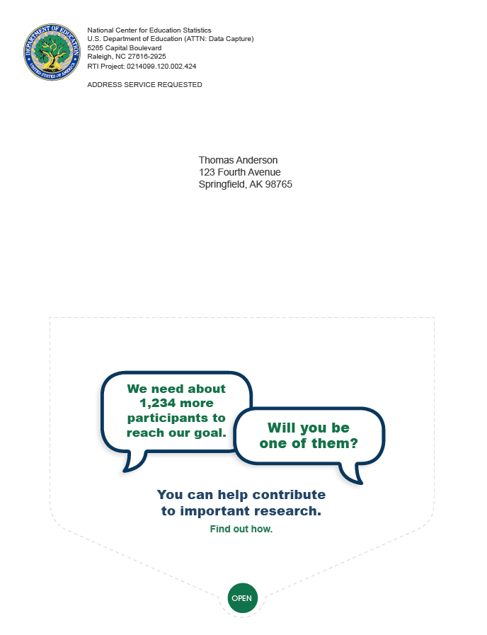

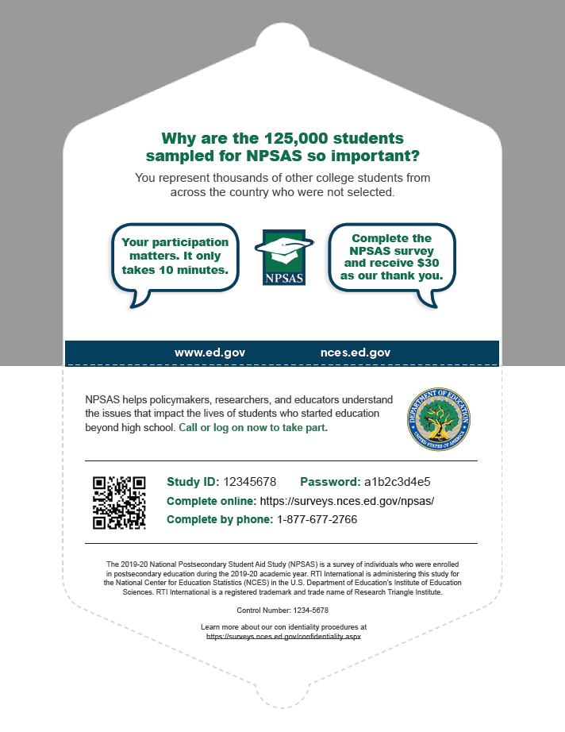

Postcard Design 3
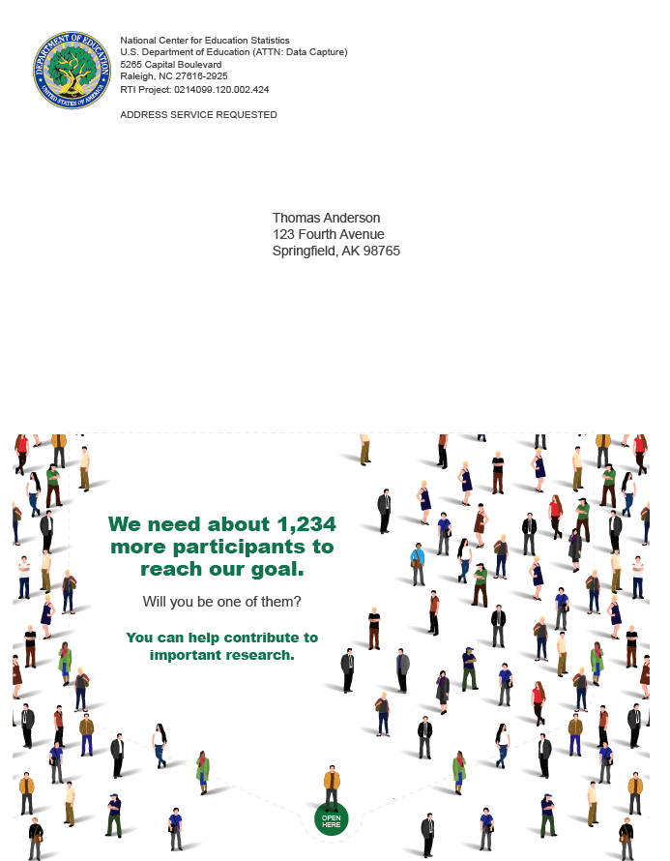
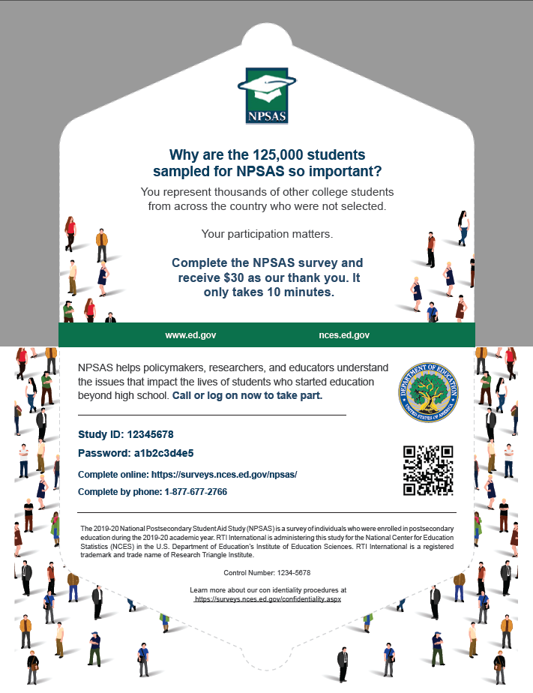

Postcard Design 4
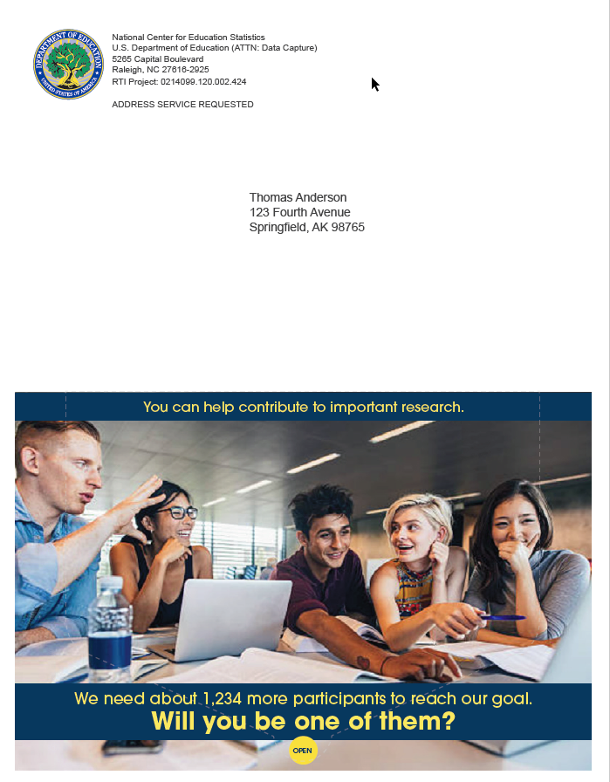
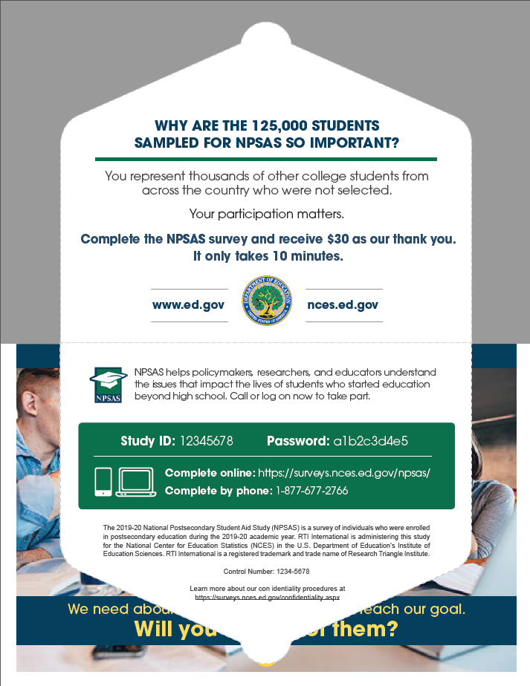

Materials Displayed in Section III (see Attachment VII)

Lead Letter 1
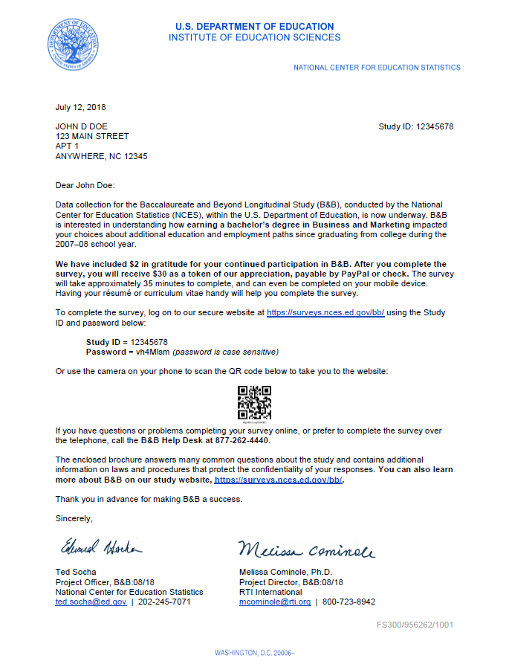
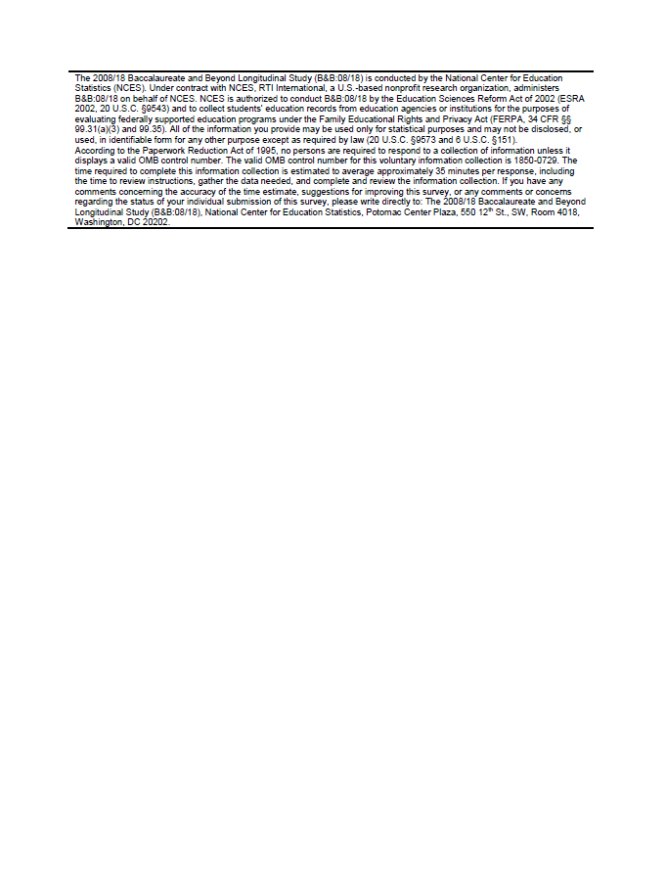

Lead Letter 2
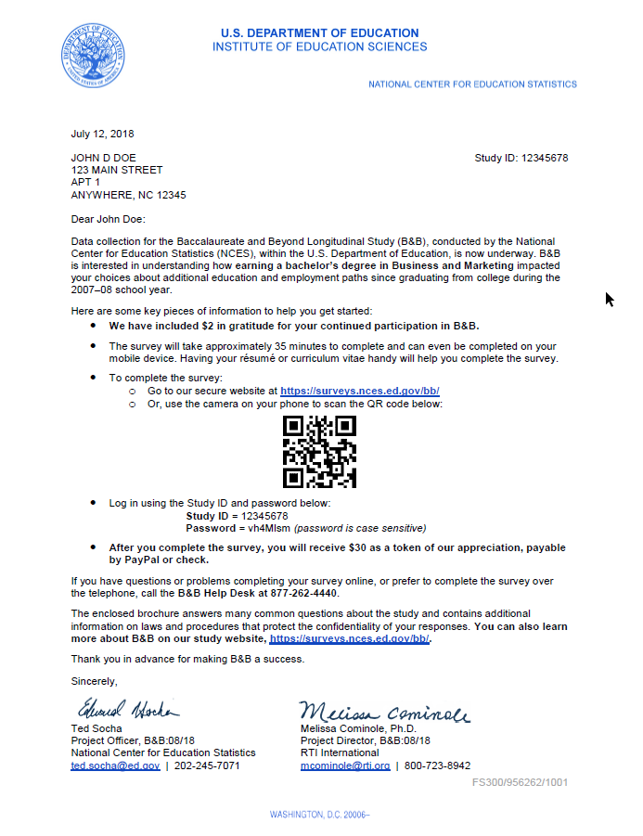
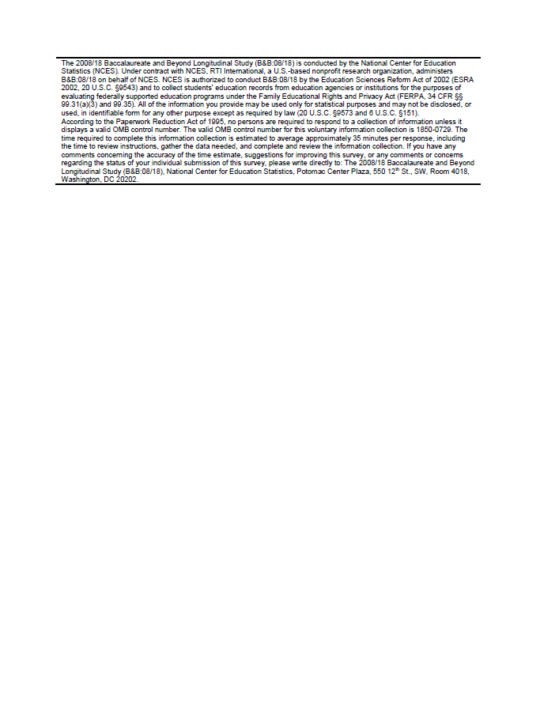

Lead Letter 3
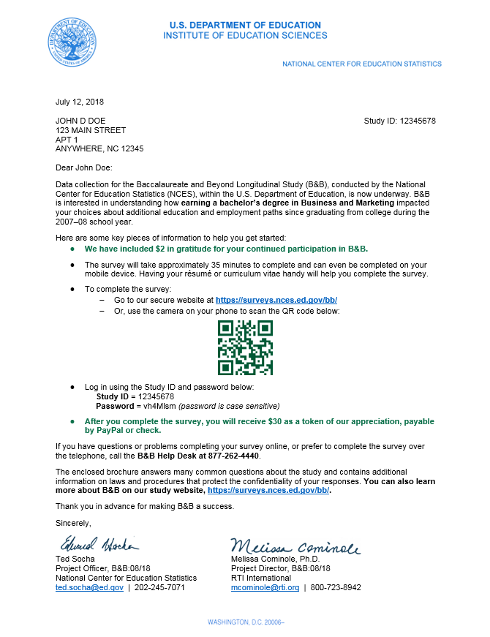
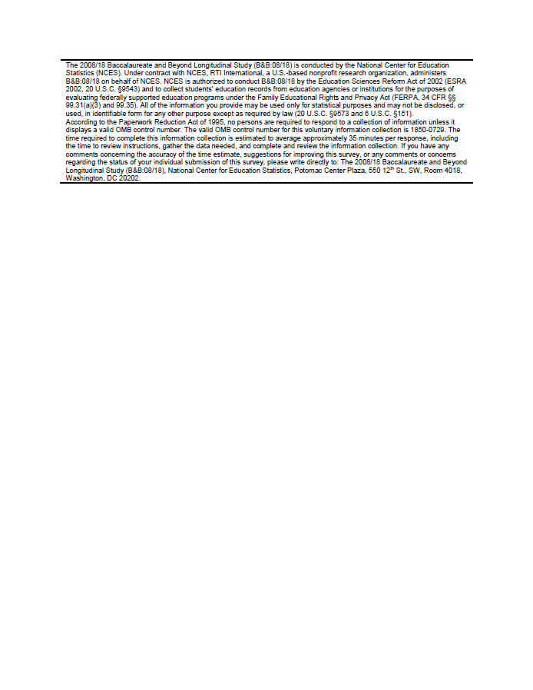

Leaflet—NPSAS in the News
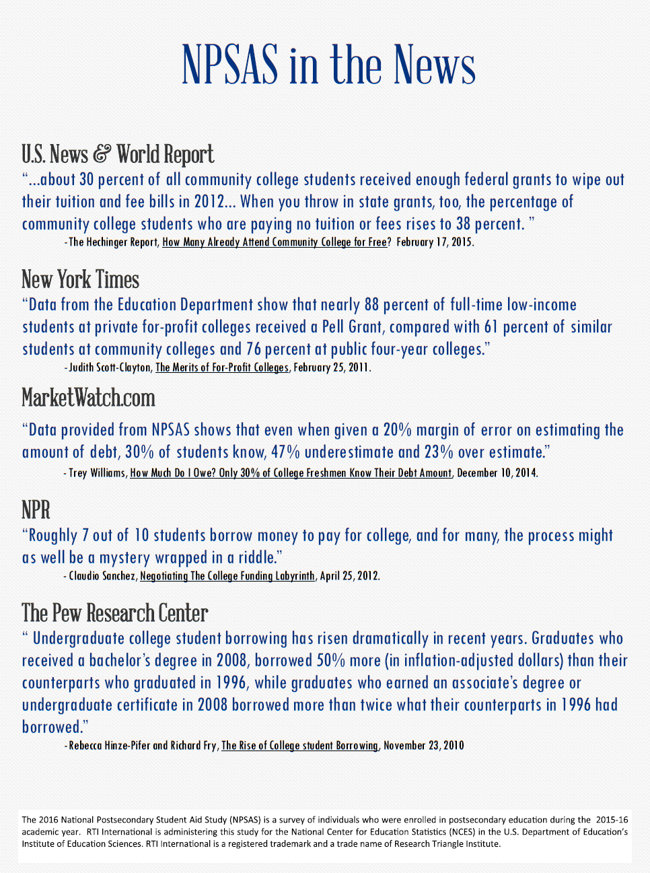

Materials Displayed in Section IV (see Attachment VII)

E-mail Subject Lines
- The National Postsecondary Student Aid Study (NPSAS)
- The NPSAS Survey Needs Your Participation
- NPSAS Data Collection Continues…
- Don’t Delay! Participate in NPSAS Today!
- NPSAS Needs You
- Only You Can Make NPSAS A Success
- <YOUR NAME>, Participate in an Important U.S. Department of Education Study
- We Have <X>% of the Participants We Need to Make NPSAS a Success – Will You Help?
- New Year's Resolution: Participate in NPSAS
- <YOUR NAME >, Can You Spare <time> Minutes for this Important Research?
- There's Not Much Time Left to Participate in NPSAS
- Participating in NPSAS is Easy and You’ll Receive $30!

