National Center for Education Statistics (NCES)

Attachments X – XIII

2019-20 National Postsecondary Student Aid Study (NPSAS:20) Pretesting

OMB# 1850-0803 v. 243

December 2018

Attachments
Attachment X – Focus Groups with Institution Staff: Recruitment Procedures and Materials
Attachment XI – Focus Groups with Institution Staff: Screening Questions and Intake Form
Attachment XII – Focus Groups with Institution Staff: Consent to Participate in Research
Attachment XIII – Focus Groups with Institution Staff: Focus Group Protocol
Contents
Attachment X. Focus Groups with Institution Staff: Recruitment Procedures & Materials 3
Recruitment Email to Potential Participants 3
Frequently Asked Questions (FAQs) 4
Confirmation E-mail 5
Thank You Email/Letter 6
Attachment XI. Focus Groups with Institution Staff: Screening Questions and Intake Form 7
Recruitment Screening Questions 7
Website Intake Form 9
Attachment XII. Focus Groups with Institution Staff: Consent to Participate in Research 11
Institution Focus Group Consent Form 11
Attachment XIII. Focus Groups with Institution Staff: Focus Group Protocol 13
Focus Group Moderator Guide 13
Exhibits
Exhibit 1. NPSAS:18-AC Enrollment list request letter 16
Exhibit 2. NPSAS:18-AC Student records request letter 16
Exhibit 3. NPSAS:18-AC Brochure 17
Exhibit 4 Student records content 18
Exhibit 5. Term collection instructions on the Institution Information Page 19
Exhibit 6. Mode selection page 19
Exhibit 7. Data collected in Enrollment section 22
Exhibit 8. Data collected in Budget section 23
Exhibit 9. Data collected in Financial Aid section 24

Attachment X. Focus Groups with Institution Staff: Recruitment Procedures & Materials

Recruitment Email to Potential Participants
IF SENT AS EMAIL–Subject: NCES needs your feedback on NPSAS:18-AC
<DATE>
Dear <NAME>,
EurekaFacts, a research company based in Rockville, MD, is administering an important study on behalf of the U.S. Department of Education’s National Center for Education Statistics (NCES) in collaboration with RTI International. The purpose of this research is to improve the 2019–20 National Postsecondary Student Aid Study (NPSAS:20), which NCES uses to collect important information about how students and parents finance postsecondary education. As a recent participant in NPSAS:18-AC, we need your help.
We are looking for staff who recently completed the NPSAS:18-AC collection to participate in focus groups to determine ways to improve the Postsecondary Data Portal (PDP) and other materials used by NCES to collect NPSAS data.
This study is crucial to the continued success of our education system as data from NPSAS:20 will be used by the federal government to inform public policy.
The focus group will be administered online and will last no more than 90 minutes. You may participate remotely from your own computer. A EurekaFacts moderator will lead the discussion on behalf of NCES and all participants should be comfortable and willing to contribute their thoughts and opinions. Because we care about your privacy, we will assign you a unique identifier (ID) and your responses will be kept separately from your name and the name of your institution.
You will receive a $50 Amazon gift card at the end of the session as a thank you for your time and effort in participating.
I have included a list of Frequently Asked Questions with additional information about the study. Please call <CONTACT PHONE> or email <CONTACT EMAIL> with any questions regarding this project.
If you are interested in participating, please fill out the following online form: <URL/LINK TO INTAKE FORM>
We look forward to speaking with you soon!
Sincerely,
<CONTACT NAME>
<JOB TITLE>
EurekaFacts, LLC <CONTACT PHONE>

ENCLOSED: Frequently Asked Questions (FAQ)

Frequently Asked Questions (FAQs)
2019–20 National Postsecondary Student Aid Study (NPSAS:20) Focus Group Sessions
- What is this study about?
On behalf of the U.S. Department of Education’s National Center for Education Statistics (NCES) and in collaboration with RTI International, EurekaFacts, a research company based in Rockville, MD, is administering focus group sessions with staff at various postsecondary educational institutions for the editing of the 2019–20 National Postsecondary Student Aid Study (NPSAS:20). The purpose of the focus group is to help NCES better understand how data is organized and collected at respective institutions, the challenges with collecting data at institutions, and how the Postsecondary Data Portal (PDP) website can be improved. Feedback from focus group discussions will be used to improve student records collection instruments for future NCES studies.
- Where will the focus group take place?
Your focus group will be virtual and take place online. You will receive a confirmation email containing the link and login information.
- What will happen during the focus group?
You are one of approximately 10 individuals in your focus group who will be asked to discuss factors related to NPSAS data collection. A EurekaFacts moderator will guide the topics of discussion but, ultimately, all participants will be asked to freely offer their opinions, feedback, and input.
All focus groups will be audio recorded to make sure we don’t leave out or misrepresent anything you say. Please see question 5 for information regarding the protection of your privacy.
- Do I need to do anything special for this online focus group?
For online focus groups, you will need to have a reliable internet connection, a webcam and a quiet private space where you can engage in the session for its duration. You will need to return your electronically signed consent form prior to the start of the session. All instructions will be provided in a confirmation email.
- Will information be confidential?
Each participant will be assigned a unique identifier (ID) so your name will not be linked to your answers. All of the information provided by participants may be used only for statistical purposes and may not be disclosed, or used, in identifiable form for any other purpose except as required by law (20 U.S.C. §9573 and 6 U.S.C. §151). Audio from the session will be recorded only for analysis. NCES is authorized to conduct this study by the Education Sciences Reform Act of 2002 (ESRA 2002, 20 U.S.C. §9543).
- How long will the focus group last and when will it take place?
The focus group will last approximately 90 minutes. Focus groups will be held in groups of up to 10 other education professionals; please see your confirmation email for the date and time of your session.
- Will the results go to the participant’s place of work?
Participants’ responses will not be disclosed to their place of work and will not be linked to any personally identifiable information.
- Is there an incentive for participating?
Yes. Upon completion of the focus group session, each participant will receive a $50 Amazon gift card. This will be sent via email. You may decline the gift card if required by your institution.
- What are the possible risks of being in the study?
There are no known risks to participating in this voluntary study.
- Who can I contact with questions or for further information?
If you have any questions about the study, you can call <NAME>, the <TITLE> at <CONTACT PHONE>. If you have questions about your rights as a study participant, you can call the EurekaFacts’ Office of Research Protection at <PHONE NUMBER> (a toll-free number).
- Can participation end early?
Participation in this study is completely voluntary. You have the right to refuse to answer particular questions. You may elect to withdraw from this study at any time and can leave the session early if you wish.

Confirmation E-mail
Subject: Confirmation for NPSAS focus groups
<DATE>
Dear <NAME>:
Thank you for agreeing to participate in an online focus group for the National Postsecondary Student Aid Study. The session will last about 90 minutes.
This is a confirmation that your focus group session has been scheduled at the following location, date, and time:
LOCATION: Your virtual focus groupwill take place online. The link for participation is <LINK.> The log in is <LOGIN>.
DATE: Day of Week, Month Day, Year
TIME: XX:XX AM/PM <TIMEZONE>
GIFT CARD: At the conclusion of the session you will be emailed a $50 Amazon gift card as a thank you for participating. You may decline the gift card if required by your institution.
According to our records, the email address and phone number where you will be participating are <EMAIL> and <PHONE>. If this information is inaccurate, please contact us using the information below.
PLEASE READ THE FOLLOWING INSTRUCTIONS:
Please use these directions below for participating in your focus group:
- Please be in a quiet private location with good quality internet service and a working webcam.
- Locate this email.
- Open the consent form, type your name and date, save it. Please reply all to this email when you attach the consent form and send it to us. You will have to return your electronically signed consent form before beginning the session.
- Please be logged into the link 15 minutes before your session is scheduled to begin.
We look forward to speaking with you. If you have any questions or concerns or if your above contact information is incorrect, please contact <CONTACT NAME> at <CONTACT INFORMATION>.
<CONTACT NAME>
EurekaFacts, LLC
<CONTACT INFORMATION >
ATTACHED: Consent Form

Thank You Email/Letter
Subject: Thank you from NCES
<DATE>
Dear <Name>,
On behalf of the U.S. Department of Education’s National Center for Education Statistics (NCES) and RTI International, EurekaFacts would like to thank you for participating in our study.
Your participation provided invaluable feedback about the forms and procedures NCES uses to collect institutional education data. The insightful input we received from you, combined with input from other professional educators, is incredibly informative and is helping us develop the best possible procedures and systems for the 2019–20 National Postsecondary Student Aid Study.
Again, thank you for your assistance.
Sincerely,
<CONTACT NAME>
<CONTACT TITLE>
EurekaFacts, LLC

Attachment XI. Focus Groups with Institution Staff: Screening Questions and Intake Form

Recruitment Screening Questions
(Script when calling potential participants from a compiled list)
Good morning/afternoon/evening. Is this <TITLE AND LAST NAME FROM CALL LIST>? Good <MORNING/AFTERNOON/EVENING> My name is <CALLER 1st AND LAST NAME>, and I am calling from EurekaFacts, a Maryland-based research company. We are administering an important national study in collaboration with RTI International on behalf of the National Center for Education Statistics (NCES), which is part of the U.S. Department of Education, and we need your help.
We are looking for staff who recently completed the NPSAS:18-AC collection to participate in focus groups to determine ways to improve the Postsecondary Data Portal (PDP) and other materials used by NCES to collect data. All participants will receive a $50 Amazon gift card as a ‘Thank you’ for their time and participation.
I’d like to tell you a little bit more about the study, but first, if now is a good time, can I ask you a few questions to see if you are eligible to participate? [YES or NO and call back later]
- Do you currently work at [institution name]?
  - Yes CONTINUE TO Q2
  - No THANK AND TERMINATE
- Were you one of the people responsible for providing data for NPSAS:18-AC?
  - Yes CONTINUE TO Q3
  - No ASK FOR THE PERSON RESPONSIBLE FOR COMPLETING NPSAS:18-AC
- Do you feel comfortable expressing and voicing your opinions in front of other postsecondary educational professionals?
  - Yes CONTINUE TO STUDY DESCRIPTION FOCUS GROUPS
  - No SWITCH TO USABILITY TESTING SCREENER
Study Description Focus Groups
Thank you. As I mentioned, the study is being administered on behalf of the U.S. Department of Education’s National Center for Education Statistics (NCES) and is a study about postsecondary educational professionals’ experiences using and interacting with the Postsecondary Data Portal (PDP). During the focus groups, participants will be asked to provide feedback about the PDP website, their own experience using the PDP’s data entry features, as well as any barriers to successfully and efficiently utilizing the PDP. This study will help improve the experiences of thousands of other postsecondary staff across the country when using the PDP each year.
The focus groups will last no more than 90 minutes and can be scheduled at your convenience and will be conducted over the internet. All of the information you provide may be used only for statistical purposes and may not be disclosed, or used, in identifiable form for any other purpose except as required by law (20 U.S.C. §9573 and 6 U.S.C. §151). NCES is authorized to conduct this study by the Education Sciences Reform Act of 2002 (ESRA 2002, 20 U.S.C. §9543). At the conclusion of your session you will receive a $50 Amazon gift card from a major credit card company via email.
- Are you interested in participating in this important study?
  - Yes CONTINUE TO Q5
  - No THANK AND TERMINATE
If YES: Great, thank you very much. To ensure that we interview a broad mix of individuals, I have a few brief screening questions to ask you. It should only take a few more minutes of your time.
- How long have you worked in postsecondary education?
  - Less than 1 year
  - 1-4 years
  - 5-10 years
  - 10-15 years
  - 15-20 years
  - 20+ years
- To participate in the interview and receive the $50 Amazon gift card we must receive a signed consent form. You must return an electronically signed consent form before the remote session can begin. Since you will be participating in an on-line focus group with other participants it is extremely important that we have your signed consent form and that you have joined the focus group 15 minutes PRIOR to the scheduled start time. Participation will be closed 5 minutes after the scheduled start time of the focus group. Do you understand that you must have a completed and signed consent form to participate?
  - Yes
  - No THANK AND TERMINATE
- Thank you for your interest. If you qualify, we will follow-up with you to schedule the interview. Could you please provide us with your contact information? (All required except “Alternate phone number”)
RECORD FIRST NAME: _____________________________________
RECORD LAST NAME: _____________________________________
RECORD EMAIL ADDRESS: _____________________________________
BEST PHONE NUMBER: _____________________________________
ALTERNATE PHONE NUMBER: _____________________________________
[Termination Language: Based on the requirements of this study, we are not able to include you in the interviews at this time. We greatly appreciate your time speaking with us. Have a good <day/evening>.

Website Intake Form
Paid Research Study Opportunity for Participants in Institutional Testing and Focus Groups
Thank you for your interest in our study!
EurekaFacts, a research company based in Rockville, MD, is administering an important national study in collaboration with RTI International on behalf of the National Center for Education Statistics (NCES), which is part of the U.S. Department of Education.
We are looking for administrators and administration staff at institutions offering postsecondary educational programs to participate in educational research to determine ways to improve the Postsecondary Data Portal (PDP) and other materials used by NCES to collect data. All participants will receive a $50 Amazon as a thank you for your time and participation.
The 8 to 10 person focus groups will last no more than 90 minutes, and can be scheduled at your convenience and will be conducted over the internet. All of the information provided by participants may be used only for statistical purposes and may not be disclosed, or used, in identifiable form for any other purpose except as required by law (20 U.S.C. §9573 and 6 U.S.C. §151). NCES is authorized to conduct this study by the Education Sciences Reform Act of 2002 (ESRA 2002, 20 U.S.C. §9543).
If you qualify and participate in the study, you will receive a $50 Amazon gift card as a thank you at the end of the session.
To ensure that we interview a broad mix of individuals, please fill out the screening questions below.
If you have any questions, please contact <NAME> at <PHONE> or <EMAIL>.
- Do you currently work at an institution that offers a postsecondary degree or certificate?
  - Yes
  - No THANK AND TERMINATE
- Were you one of the people responsible for providing data for NPSAS:18-AC?
  - Yes CONTINUE TO Q3
  - No ASK FOR THE PERSON RESPONSIBLE FOR COMPLETING NPSAS:18-AC
- Which of the following best describes your role or job title?
  - Administration
  - Institutional Research/Institutional Effectiveness
  - Registrar
  - Financial Aid
  - IT/Networking or Support Staff
  - None of the Above THANK AND TERMINATE
- Would you be interested in participating?
  - Yes
  - No THANK AND TERMINATE
- What is the name of the institution you work for and where is it located?
Name: _________________________________________
City: ______________________
State: ____________________
- How long have you worked in postsecondary education?
  - Less than 1 year
  - 1-4 years
  - 5-10 years
  - 10-15 years
  - 15-20 years
  - 20+ years

- We are conducting interview sessions between <DATE> and <DATE>. Please select three (3) days and times that would work for you to participate in the research interview.
RECORD MOST PREFERRED DATE AND TIME: _____________________________________________
RECORD 2nd ALTERNATE DATE AND TIME: ________________________________________________
RECORD 3rd ALTERNATE DATE AND TIME: ________________________________________________
- To participate in the interview and receive the $50 Amazon gift card we must receive a signed consent form. You must return an electronically signed consent form before the remote session can begin. Participation in focus groups involves other participants. It is extremely important that we have your signed consent form and that you have joined the focus group 15 minutes PRIOR to the scheduled start time. Participation will be closed 5 minutes after the scheduled start time of the focus group.
Do you understand that you must have a completed and signed consent form to participate?
  - Yes
  - No THANK AND TERMINATE
- Thank you for your interest. If qualifications are met, we will call to follow-up with you about additional questions we may have and potentially scheduling an interview. Could you please provide us with your contact information? (All required except “Alternate phone number”)
RECORD FIRST NAME: _____________________________________
RECORD LAST NAME: _____________________________________
RECORD EMAIL ADDRESS: _____________________________________
BEST PHONE NUMBER: _____________________________________
ALTERNATE PHONE NUMBER: _____________________________________
[Termination Language: Based on the requirements of this study, we are not able to include you in the interviews at this time. We greatly appreciate your time speaking with us. Have a good day.]

Attachment XII. Focus Groups with Institution Staff: Consent to Participate in Research

Institution Focus Group Consent Form
CONSENT FORM
FOR PARTICIPATION IN RESEARCH
Thank you for your interest in participating in the study described below. This consent form explains the study. Please read it carefully and feel free to ask questions about anything you do not understand. If you do not have questions now, you may ask them later as they occur to you.
- What is this study about?
On behalf of the U.S. Department of Education’s National Center for Education Statistics (NCES) and in collaboration with RTI International, EurekaFacts, a research company based in Rockville, MD, is administering focus group sessions with staff at various postsecondary educational institutions for the editing of the 2019–20 National Postsecondary Student Aid Study (NPSAS:20). The purpose of the focus group is to help NCES better understand how data is organized and collected at respective institutions, the challenges with collecting data at institutions, and how the Postsecondary Data Portal (PDP) website can be improved. Feedback from focus group discussions will be used to improve student records collection instruments for future NCES studies.
- Where will the focus group take place?
Your focus group will be virtual and take place online. You will receive a confirmation email containing the link and login information.
- What will happen during the focus group?
You are one of approximately 10 individuals in your focus group who will be asked to discuss factors related to NPSAS data collection. A EurekaFacts moderator will guide the topics of discussion but, ultimately, all participants will be asked to freely offer their opinions, feedback, and input.
All focus groups will be audio recorded to make sure we don’t leave out or misrepresent anything you say. Please see question 5 for information regarding the protection of your privacy.
- Do I need to do anything special for this online focus group?
For online focus groups, you will need to have a reliable internet connection, a webcam and a quiet private space where you can engage in the session for its duration. You will need to return your electronically signed consent form prior to the start of the session. All instructions will be provided in a confirmation email.
- Will information be kept private?
Each participant will be assigned a unique identifier (ID) so your name will not be linked to your answers. All of the information provided by participants may be used only for statistical purposes and may not be disclosed, or used, in identifiable form for any other purpose except as required by law (20 U.S.C. §9573 and 6 U.S.C. §151). Audio from the session will be recorded only for analysis. NCES is authorized to conduct this study by the Education Sciences Reform Act of 2002 (ESRA 2002, 20 U.S.C. §9543).
- How long will the focus group last and when will it take place?
The focus group will last approximately 90 minutes. Focus groups will be held in groups of up to 10 other education professionals; please see your confirmation email for the date and time of your session.
- Will the results go to the participant’s place of work?
Participants’ responses will not be disclosed to their place of work and will not be linked to any personally identifiable information.
- Is there an incentive for participating?
Yes. Upon completion of the focus group session, each participant will receive a $50 Amazon gift card. This will be sent via email. You may decline the gift card if required by your institution.
- What are the possible risks of being in the study?
There are no known risks to participating in this voluntary study.
- Who can I contact with questions or for further information?
If you have any questions about the study, you can call <NAME>, the <TITLE> at <CONTACT PHONE>. If you have questions about your rights as a study participant, you can call the EurekaFacts’ Office of Research Protection at <PHONE NUMBER> (a toll-free number).
- Can participation end early?
Participation in this study is completely voluntary. You have the right to refuse to answer particular questions. You may elect to withdraw from this study at any time and can leave the session early if you wish.
____ Yes, I agree to participate in this study
____ No, I do not want to participate in this study
-----------------------------------------------------------------------------------------------------------------------------------------------
By signing below, you agree that you, _______________________________, will participate in this study and that we may record your conversation with the researcher. You also agree that you will not use or disclose any information provided by your fellow focus group participants in identifiable form. You will receive a $50 Amazon gift card via email after your session has ended.
Your signature below will indicate that your questions have been answered satisfactorily, and that you have read and understood the information provided above.

We thank you for your voluntary participation and ask you to sign the form below.

Print Name: _____________________________________________

Signature:______________________________________________ Date:________________________
To be completed by EurekaFacts staff:
Payment Card Transaction Number: _______________________________________________________

Attachment XIII. Focus Groups with Institution Staff: Focus Group Protocol

Focus Group Moderator Guide
Moderator instructions:
This guide will be used to steer discussion to the topic areas to be covered, and the specific questions of interest within each topic area. For the purposes of qualitative research, it is not necessarily intended that these questions be asked exactly as they are worded here. Focus group discussions are more like a conversation than a set of structured questions. The discussion should be as informal as possible and participants should be encouraged to speak openly and freely. The Moderator will also need to make sure that all participants in the group have an opportunity to express their opinions. Because each group of participants may be different, a responsive and flexible approach should be used for the focus group discussion.
Issues/Information to be Discussed | Approx. Allotted Time for Discussion¹
Welcome (ALL) | 5 minutes
Topic 1: Introductions (ALL) | 5 minutes
Topic 2: Communication (ALL) | 10 minutes
Topic 3: Enrollment List Collection | 5 minutes
Topic 4: Student Records Role Assignments (ALL) | 10 minutes
Topic 5: Institution Information Page | 10 minutes
Topic 6: Student Records Modes | 20 minutes
Topic 7: Enrollment | 10 minutes
Topic 8: Budget | 15 minutes
Topic 9: Financial Aid | 15 minutes
Topic 10: Help desk & other resources (ALL) | 10 minutes
Topic 11: Giving back (ALL) | 5 minutes
Topic 12: Closing (ALL) | 5 minutes
Total time | 90 minutes available
¹ Due to time restrictions, not all topics will be discussed in all sessions. (ALL) indicates that the topic will be covered in each focus group session. The remaining topics will be divided among the focus group sessions so that each session does not exceed 90 minutes.

Welcome – [5 minutes]
Good [morning/afternoon]. My name is _______________ and I work for EurekaFacts, a research company in Rockville, Md. We are administering a comprehensive research study on behalf of the National Center for Educational Statistics and the U.S. Department of Education.
The purpose of this research is to improve the 2019–20 National Postsecondary Student Aid Study (NPSAS:20), which NCES uses to collect national information on how students and their families pay for college. During this session we will discuss your participation in NPSAS:18-AC, which was the most recent round of NPSAS data collection. This session will last about 90 minutes.
Your views and experiences are important, so we would like you to tell us what you think and feel about your experiences with the instrument. It is important that you provide us with your honest opinions and that you understand that we will not make any judgements of you for your opinions. Also, as we are talking about your personal opinions and experiences, it is not necessary for everyone to agree with each other.
DISCLOSURES
- Mention mics, audio, and videotaping.
- The session is being audio-taped so I can write an accurate report, not of “who said what,” but "what got said.” Your name will not be used in the report. All the information discussed in this session today will not be associated with your name or the name of your institution.
GUIDELINES
In order to make this session work as a research session, there are some guidelines to follow:
- Please talk in a voice at least as loud as mine.
- Please allow one person to speak at a time and allow everyone a turn to speak.
- There are no wrong answers – just different points of view.
  - So, say what you believe – be candid.
  - There is no need to change anyone’s mind.
- I may need to move on to another area of discussion sooner than you are ready, and I may have to cut a conversation short in the interest of time. If I interrupt you, it is not personal; I just want to cover everything on the agenda.
- You will receive your incentive for your time and opinions at the conclusion of the focus group session.
- Please silence your cell phones or pagers.
PERMISSIONS
- Do you have any questions before we begin?

Introductions [5 minutes]
First, I’d like to learn a little more about you. Please share with me:
- your first name
- what type of institution you represent
- your role at the institution
- your role completing NPSAS:18-AC

Communication [10 minutes]
Now we’d like to talk about the communications you received when participating in NPSAS:18-AC.
- What is your preferred mode for receiving information about and instructions for the study? Mail/email/phone/a combination?
- Mailings. I want to show you some contacting materials to get your impressions and feedback.
Imagine that your institution was selected to take part in the NPSAS:20 study conducted by the National Center of Education Statistics, or NCES. This means that you received a letter in the mail, addressed to you. [Show participants exhibits 1-3]

Exhibit 1. NPSAS:18-AC Enrollment list request letter
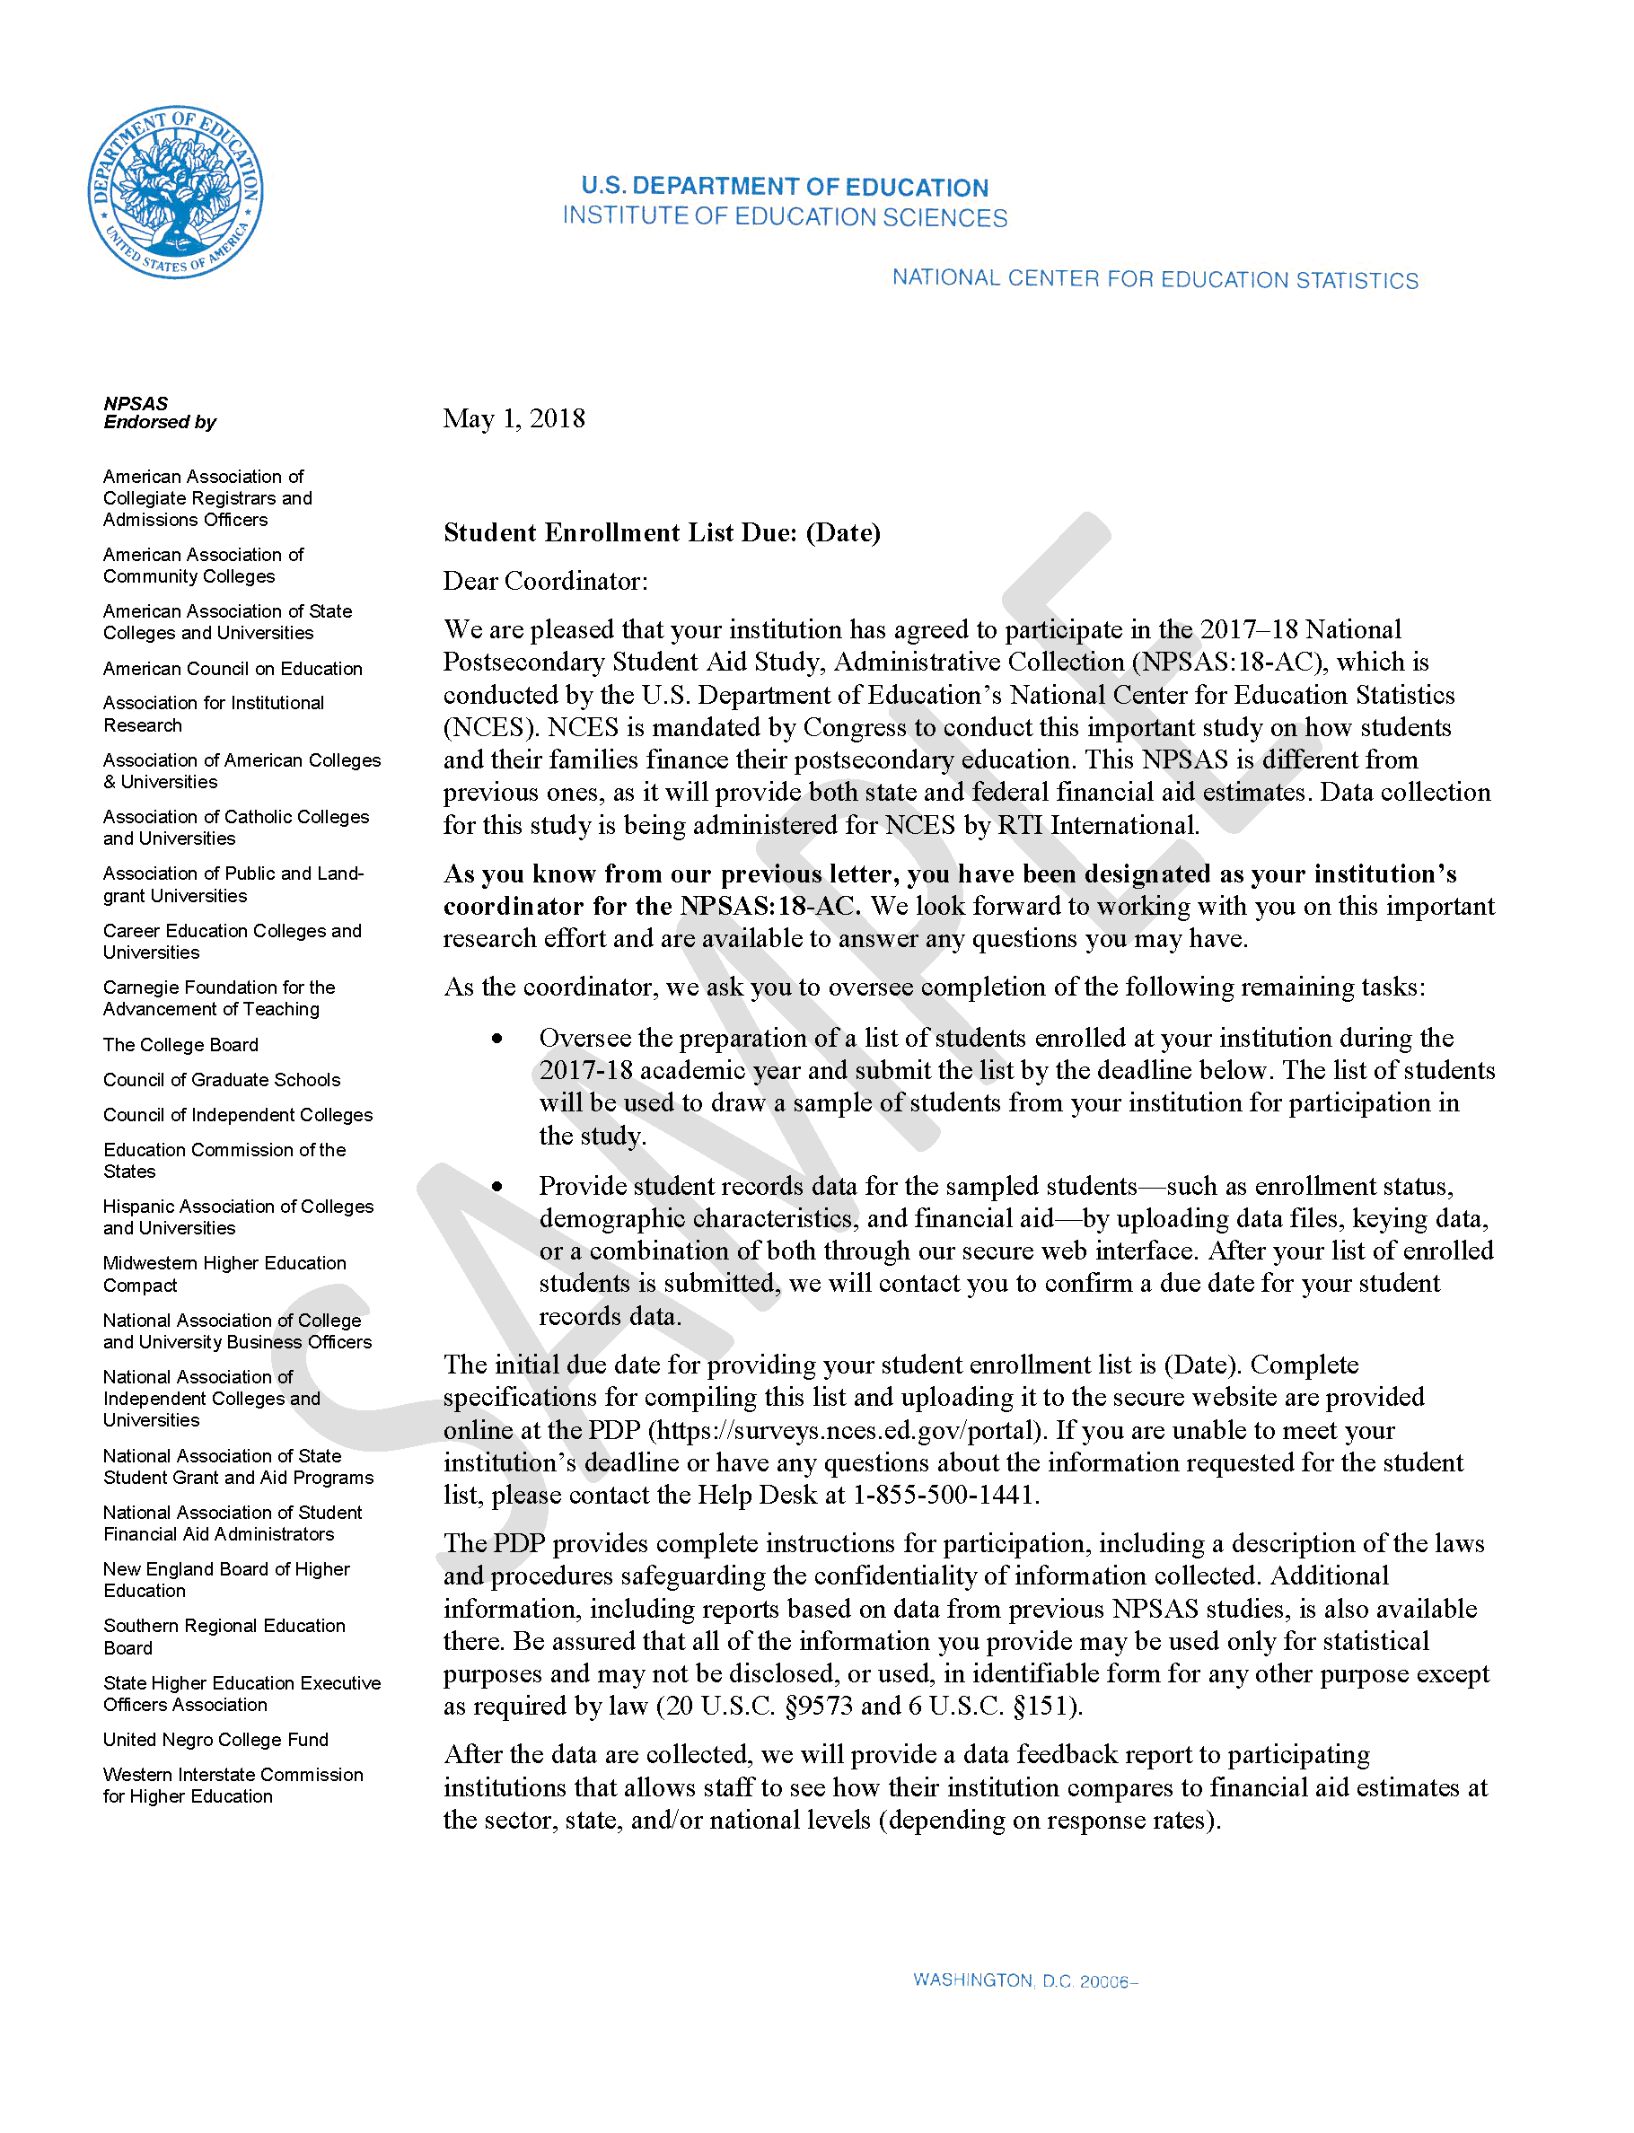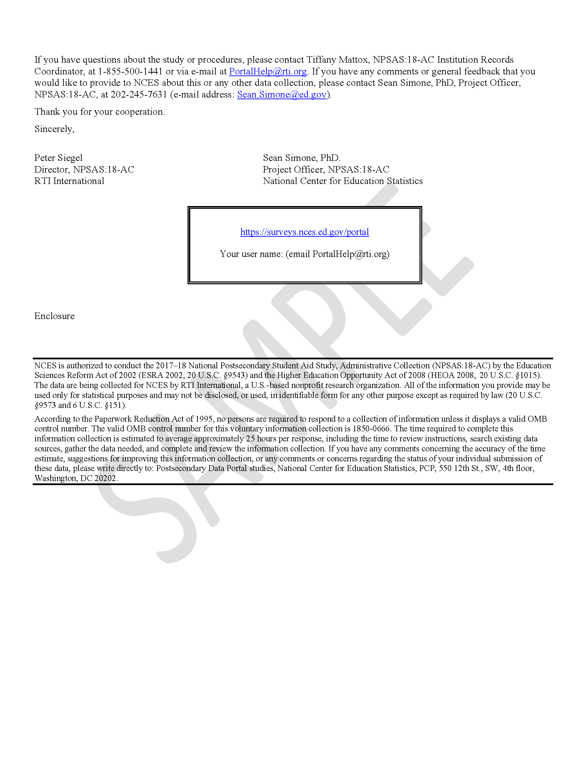

Exhibit 2. NPSAS:18-AC Student records request letter
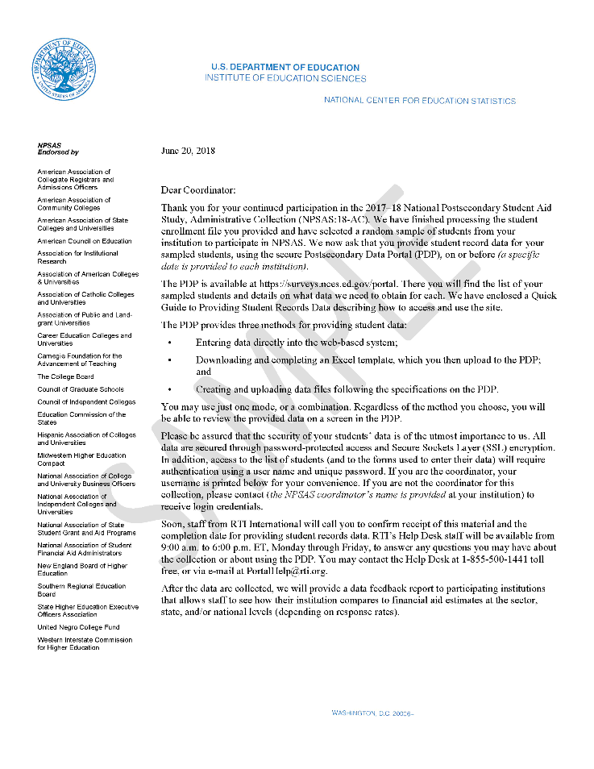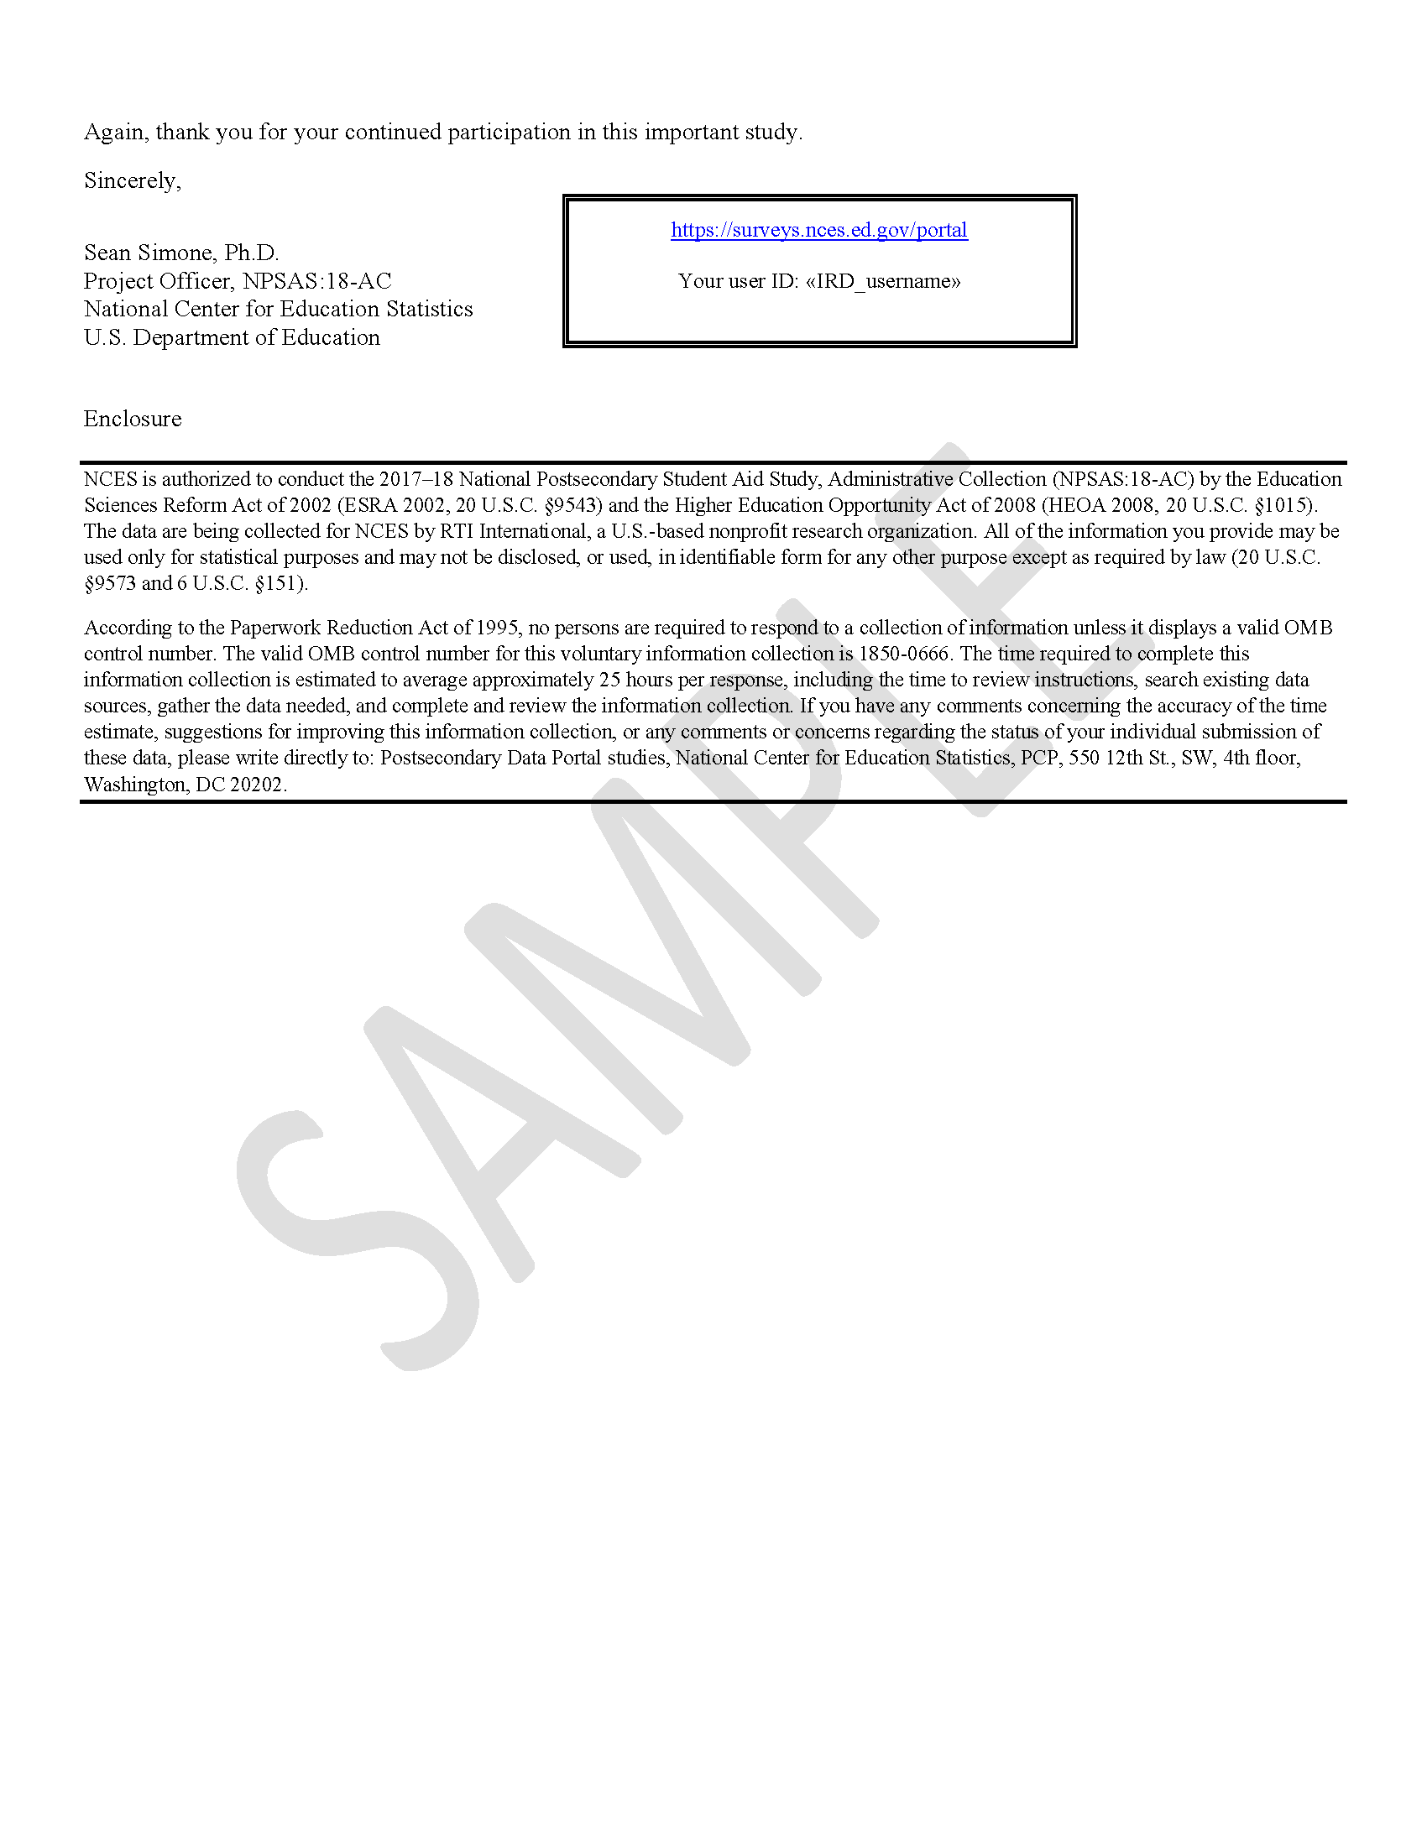

Exhibit 3. NPSAS:18-AC Brochure
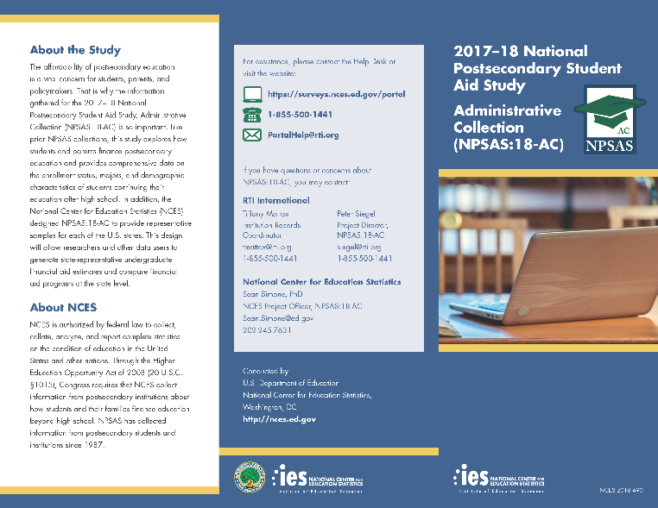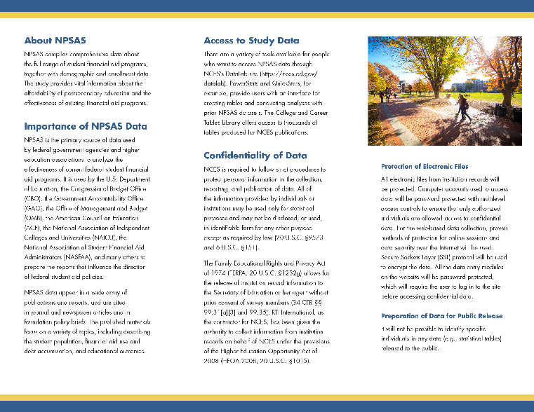
  - I’ve provided you with two of the letters that were sent out for NPSAS:18-AC, the one requesting the student enrollment list, and the one requesting student records data, and a study brochure. Do they contain an appropriate amount of information? Too much? Too little?
  - How would you revise these materials for NPSAS:20?
- If given the opportunity, would you prefer to receive additional communications about the study, such as tips for completing tasks, papers about postsecondary aid that use NPSAS data, and in-depth information about data elements?
  - If yes, what would be your preferred way to receive that information? (email listserv, newsletter, standalone website

Enrollment List Collection [5 minutes]
One of the first tasks you were asked to complete for NPSAS:18-AC was to submit a list of all eligible student enrolled at your institution between July 1, 2017 and April 30, 2018.
- Did you have any difficulty preparing and submitting the student enrollment list?
- How long did it take your institution to prepare the student enrollment list?
  - Please talk through how you estimated the amount of time involved.

Student Records Role Assignments [10 minutes]
Now we are going to dive a little deeper into the content of the student records data request, which includes 5 sections: institution information, general student, enrollment, budgeting, and financial aid information for each student. [Show exhibit 4]

Exhibit 4 Student records content
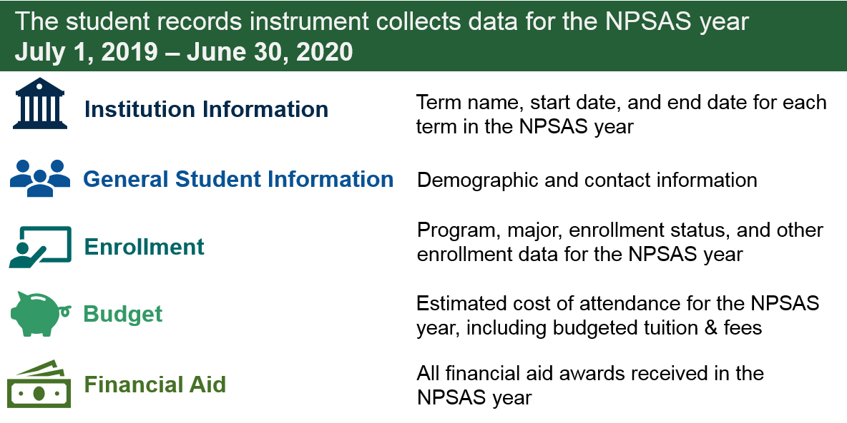
We will start with a discussion about who was responsible for completing each section.
- At your institution, did one person complete all sections, or were the sections divided up?
- If one person completed all the sections...
  - Were you able to retrieve all of the data yourself, or did you have to reach other people at your institution? How did you manage this process?
  - What challenges did you encounter retrieving the data?
- If the sections were completed by multiple people...
  - How does your school decide who is responsible for completing the different components?
  - How easy or difficult was it for you to determine who is responsible for completing each section? (E.g. entering general student info, enrollment status info, budget info, and financial aid info)
  - What was your experience when different staff complete different sections?
  - In the future, would you prefer to coordinate with and prompt the other data providers, or would you prefer Help Desk staff contact and prompt those individuals directly?
- How long did it take your institution to complete the student records request?
  - Please talk through how you estimated the amount of time involved.

Institution Information Page [10 minutes]
I’d to ask you about your experiences completing the Institution Information Page. On this page, you were asked to indicate whether you would report students’ enrollment status (e.g., full-time, half-time, etc.) by month or by term. If you selected to report by term, you were asked to provide term information for each of your terms in the NPSAS year. [Show participants exhibit 5]

Exhibit 5. Term collection instructions on the Institution Information Page
- What is your institution’s term structure?
  - Probe: Does your institution have different calendar systems depending on the program? If so, how do you decide which to report?
- Based on these instructions, what terms would you report?
  - What, if anything, is unclear about how to report your academic terms on this page?
- For future studies, NCES is considering preloading this form based on the terms that were provided in previous rounds of the study. You would be asked to review the preloaded terms and make revisions, rather than provide the information. For example, if 2017-2018 fall semester was August 2017 - December 2017, NCES would prefill a term for fall 2019 as August 2019 – December 2019.
  - How consistent are your terms from academic year to academic year? How often are there changes to your institution’s term structure?
  - Would you prefer to review preloaded terms, or would you prefer to provide the terms each round?
  - Can you think of any reason why preloading the terms would be challenging for your institution?

Student Records Modes [20 minutes]
NPSAS has three mode options for providing student records data: Excel mode, CSV mode, and web mode.
- Selecting a Mode
  - How did you determine which mode (excel, csv, web) you used to enter student records data?

Exhibit 6. Mode selection page
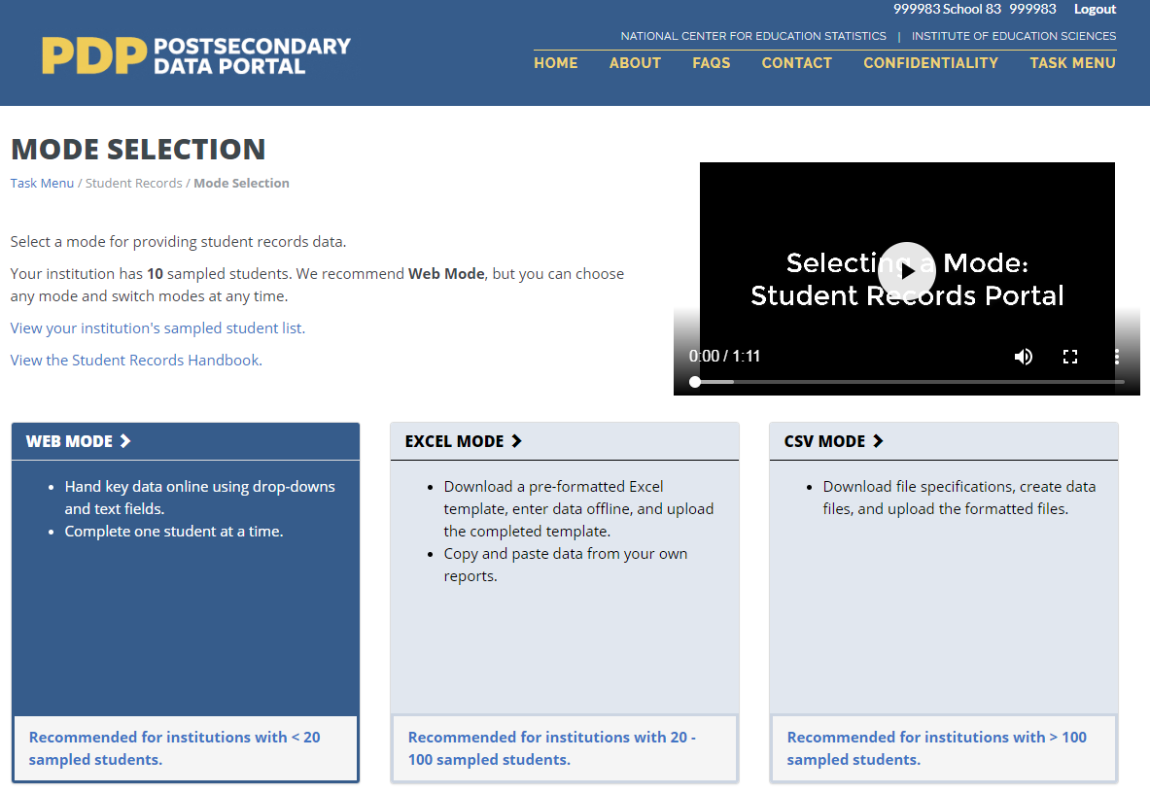
  - [Show participants Exhibit 6] Have you watched the video on this page?
  - If not, let’s take a look at the video (play video). What are your thoughts and impressions? Is it helpful to you?
  - If yes, what led you to watch the video? What were your thoughts and impressions? Did it influence your decision regarding which mode to select?
- Excel mode
  - Entering data
    - Did you hand key data, copy/paste, or select from drop-downs?
    - Did you reference the help text provided in the template? If so, was it easy or difficult to use?
    - Would you change anything about the template?
  - Uploading & finalizing data (including validation and error messages)
    - Did you encounter any problems when uploading your completed template? If so, what were they?
    - If you received error messages when uploading, were they easy or difficult to understand? Were you able to resolve the errors?
    - Did you edit the data in Web Mode or upload a revised file?
    - Would you change anything about the way that error messages are displayed?
    - Is there anything else you would change about the process?
- CSV mode
  - File specifications
    - How easy or difficult was it to understand what data was being requested in the file specifications?
    - Did you have any problems with data formats (such as decimal places or field lengths)?
    - Describe how you handled recoding data to meet the file specifications.
    - Would you change anything about the specs to make them easier to use?
  - Uploading & finalizing data (including validation and error messages)
    - Did you encounter any problems when uploading your CSV files? If so, what were they?
    - If you received error messages when uploading, were they easy or difficult to understand? Were you able to resolve the errors?
    - Did you edit the data in Web Mode or upload a revised file?
    - Would you change anything about the way that error messages are displayed?
    - Is there anything else you would change about the process?
- Other modes
  - If NCES were to accept student records data in another format, what would be the most convenient format for your institution to provide?
  - In other words, if you could provide student records data in any format, what would you choose?

Enrollment [10 minutes]
In the enrollment section, you were asked to provide both current and past information about each students’ program, major, enrollment intensity, and other items. [Show participants exhibit 7] We would like to get your feedback about some specific items in this section.
- Remedial course-taking. For each student, your institution was asked to respond Yes or No to the following question:
“Since completing high school, has the student taken any remedial/developmental courses to improve their basic skills in English, math, reading, or writing? Please answer Yes if your records indicate that the student took any remedial courses since high school, even if they were not taken at your institution.”
  - Does your institution offering co-requisite developmental courses, sometimes called “gateway courses,” in which the student is enrolled in a course that includes both developmental and post-developmental content?
    - If so, would you consider those courses to be remedial courses for the purposes of this question?
    - If NCES would like those courses to be reported as remedial courses, how could the question be improved to make it clear how they should be reported?
    - Would your institution have any difficulty determining whether a student took a co-requisite remedial course?
- Tuition charged. For each student, your institution was asked to report tuition charged:
“The amount entered should be the amount CHARGED for the period(s) in which the student was enrolled between July 1, 2019 and June 30, 2020, prior to any aid, discounts, or waivers.
Required fees include all fixed sum charges that are required of such a large proportion of all students that the student who does not pay the charges is an exception.
Include any out-of-state/out-of-district fees for applicable students.
Please enter the specific amount charged for this student (typically obtained from the business or bursar's office), not the budgeted tuition amount or the average tuition amount charged for students.
  - Did you encounter any challenges determining how much to report for this item?
  - Instead of asking for the amount changed for “period(s) in which the student was enrolled between July 1, 2019 and June 30, 2020,” would it be easier if you were asked to provide the total amount charged for specific terms?
For example:
“Report the amount charged for fall 2019, spring 2020, and summer 2020...”
“Report the amount charged for
the period(s) in which the
student was enrolled between
July 1, 2019 and June 30, 2020...”

- Are there any other items in the enrollment section that were challenging for your institution to provide?

Exhibit 7. Data collected in Enrollment section
** = most critical data elements
Initial Enrollment |  | Test Scores
First Enrolled at Institution Date |  | ACT English Score
Last Enrolled at Institution Date |  | ACT Mathematics Score
First-time Beginning Student? |  | ACT Reading Score
Accepted Transfer Credit? |  | ACT Science Score
Remedial Courses Taken? |  | ACT Composite Score
Bachelor’ Degree |  | SAT Critical Reading Score
Ever Received Bachelor’s Degree? |  | SAT Mathematics Score
Bachelor’s Degree Received Date |  | SAT Writing Score
Degree Program and Progress |  | Clock Hours
Program/Degree** |  | Total Number of Clock Hours in Program
Graduate Degree Type |  | Cumulative Clock Hours Completed
Class Level** |  | Credit Hours
Degree Completed Date |  | Total Number of Credit Hours in Program
Expected to Complete Degree Requirements by 6/30/20? |  | Cumulative Credit Hours Completed
Cumulative (Unweighted) GPA |  | Tuition Charged
Major |  | Total Tuition and Required Fees CHARGED**
First Major |  | Residency for Tuition Purposes
First Major CIP Code |  | Enrollment by Term
Second Major |  | Enrollment Status (for up to 12 terms)**
Second Major CIP Code |  | Credit Units (for up to 12 terms)
Major Undeclared?

Budget [Budget]
In the budget section, you were asked to provide costs of attendance for each student for the 2017-2018 academic year. [Show participants exhibit 8] We would like to ask you some questions about this section.
The instructions in this section requested an individualized full-time/full-year budget for each student. If the student did not have a full-time/full-year budget, you could (a) prorate the budget to full-time/full-year using Pell guidelines, or (b) provide a budget for a different budget period.
1 = Full-time, full-year
2 = Full-time, one term
3 = 3/4-time, full-year
4 = 3/4-time, one term
5 = Half-time, full-year
6 = Half-time, one term
7 = Less than half-time, full-year
8 = Less than half-time, one term
9 = Other
- How easy or difficult was it for your institution to provide data for this section?
  - Did you need to prorate any student budgets? If so, what was your experience?
  - Would you prefer that this section only request a full-time/full-year budget (which may require more proration), or would you prefer other budget period options?
- If asked for a full-time/full-year budget, would you include summer terms (i.e., a 12-month budget) or provide the rest of the academic year (i.e., a 9-month budget)?
  - If your institution prepares a budget in the fall and then the student enrolls in the following summer, what happens to the student’s budget?
- If an individualized budget is not available, how do you determine an estimated budget?
- Are there any other items in the budget section that were challenging for your institution to provide?

Exhibit 8. Data collected in Budget section
** = most critical data elements
Budget Period** |  | Transportation
Student Residence |  | Computer/Technology
Tuition/Fees** |  | Health Insurance
Room and Board |  | All Other
Books/Supplies |  | Budgeted Total Cost of Attendance**

Financial Aid [15 minutes]
In the financial aid section, you were asked to provide all financial aid received by the sample students for the July 1, 2017 to June 30, 2018 financial aid year. [Show participants exhibit 9]
We would like to ask you some questions about the instructions in this section.
“If the student had state aid for the July 1, 2019 to June 30, 2020 financial aid year, enter program name, select the type, and enter the whole dollar amount awarded for up to three state aid awards.”
- For each award in state, institution, private, and other aid, you were asked to provide the program name, program type, and program amount. How easy or difficult was it to provide this information?
- The instructions for the state aid program were as follows:
  - Based on these instructions, would you provide the amount awarded? The amount disbursed? Some other amount?
    - If awarded, would it be easier or more difficult for you to report the amount disbursed? Why or why not?
    - When is aid disbursed for summer terms? If you were asked for “aid disbursed,” when is the earliest that you could report financial aid for students enrolled in the summer term?
    - Would it be possible to report expected summer aid before it is disbursed? How far in advance could it be reported?
  - If your institution has summer terms that span the June 30/July 1 cutoff date, you were asked to report summer terms for two academic years on the Institution Information Page. How would you handle the two summers when reporting students’ financial aid? Which terms would you report aid for?
- Instead of asking for the aid awarded or disbursed “between July 1, 2019 and June 30, 2020,” would it be easier if you were asked to provide aid awarded for specific terms?
For example:
“For each state aid award, enter the total amount [awarded/disbursed] for fall 2019, spring 2020, and summer 2020.”

“If the student had state aid for the July 1, 2019 to June 30, 2020 financial aid year, enter... the whole dollar amount awarded for up to three state aid awards.”

- Are there any other portions of the financial aid section that were challenging for your institution to provide?

Exhibit 9. Data collected in Financial Aid section
** = most critical data elements * = data element is conditionally critical, depending on other responses
Satisfactory Academic Progress
Placed on Financial Aid Warning
Placed on Financial Aid Probation
Financial Aid Ineligibility
Federal Aid |  | Institution Aid (up to 3 awards)
Student had federal aid for the NPSAS year?** |  | Student had institution aid for the NPSAS year?**  Institution Program Name*
Pell Grant*
Subsidized Direct/Stafford Loan* |  | Institution Program Type*
Unsubsidized Direct/Stafford Loan* |  | Institution Program Amount*
Parent PLUS Loan* |  | Private Aid or Other Government Aid (up to 3 awards)
Graduate PLUS Loan* |  | Student had private aid or other government aid for the NPSAS year?**
Federal TEACH Grant* |  | Private Aid or Other Government Aid Name*
Perkins Loan* |  | Private Aid or Other Government Aid Type*
Federal SEOG Grant* |  | Private Aid or Other Government Aid Amount*
Federal Work Study AWARDED* |  | Other Aid (up to 3 awards)
Iraq & Afghanistan Service Grant* |  | Student had other aid for the NPSAS year?**
Veterans Benefit* |  | Other Aid Name*
State Aid (up to 3 awards) |  | Other Aid Type*
Student had state aid for the NPSAS year?** |  | Other Aid Source*
State Program Name* |  | Other Aid Amount*
State Program Type*
State Program Amount*

Help Desk & Other Resources [10 minutes]
- Help Desk
Let’s talk about the Postsecondary Data Portal Help Desk. If you call in, you are assisted by institution contactors/help desk agents Monday-Friday from 9:00-6:30 ET. If you send an email, you will be assisted by technical staff (survey researchers) who coordinate with the institution contactors to ensure your question is answered or your issue is resolved.
  - Did you interact with the institution contactors/help desk staff?
    - If you called or emailed in, do you have any feedback on your experience? Was your question answered in a timely manner? Were the staff helpful?
    - If the institution contactors reached out to you, do you have any feedback on that experience?
- Forums
  - If your institution were selected for NPSAS:20, would you be interested in participating in online forums that allow you to connect with other institutions using the same Student Information System?
  - Would you be interested in joining a webinar to learn more about NPSAS and how to provide data?
- Workspace
  - NCES is considering adding a Workspace area to the PDP that would allow you to upload any files that would help you with future data requests. These could include scripts for database queries, SAS programs, or notes about data sources. NCES would store these documents and share them with you at the time of a future data request.
    - If this feature were added, would you find it helpful?
    - What types of files would you upload?

Giving Back [10 minutes]
At the end of the study, we plan to provide a data feedback report to participating institutions that allows staff to see how their institution compares to financial aid estimates at the sector, state, and/or national levels (depending on response rates). While the report cannot provide institution to institution comparisons for several reasons (including non-representative within school student samples and confidentiality reasons), we hope that the data will be useful to institution staff.
- What are your thoughts on the data feedback report?
  - If institution staff do not think the report will be valuable to themselves or their institution, is receiving the report still perceived, as intended, to be a sincere effort to provide something back to the participants?
  - What types of information would you want included in the data feedback report?
- Is there something else we could provide to participants to say thank you, demonstrate the value of their data and contribution to the study, and give something back to them?
- How would you suggest that NCES increase awareness of NPSAS among researchers and institution staff?
- Would you want us to send a letter to the chief administrator at your institution thanking them and you for your institution’s participation and listing the names of the contact people we worked with during the study?

Closing [5 minutes]
- What was your overall experience like when completing NPSAS:18-AC?
- Did you experience any difficulties using the tools or functions in the PDP? Which ones?
- What suggestions do you have to make completing NPSAS easier to complete?
Moderator: Please excuse yourself to check with the observers to determine if there are any additional questions.
After asking any follow-up questions, thank and dismiss the participants.

All of the information provided by participants may be used only for statistical purposes and may not be disclosed, or used, in identifiable form for any other purpose except as required by law (20 U.S.C. §9573 and 6 U.S.C. §151). Though sessions are audio recorded for analysis, no personally identifying information will be recorded. NCES is authorized to conduct this study by the Education Sciences Reform Act of 2002 (ESRA 2002, 20 U.S.C. §9543).

