National Center for Education Statistics (NCES)

Attachment XVIII. Focus Groups with Institution Staff & Usability Testing: Student Records Instrument

2019-20 National Postsecondary Student Aid Study (NPSAS:20) Pretesting

OMB# 1850-0803 v. 243

December 2018

This attachment includes the items that are currently being administered for the 2017–18 National Postsecondary Student Aid Study, Administrative Collection (NPSAS:18-AC) student records collection, which was approved in January 2018 (OMB# 1850-0666 v.21). As part of the focus group and usability testing conducted to prepare for NPSAS:20, participants will be asked about their experiences using the instrument and their opinions about specific questions. The instrument will not be directly administered during the sessions; the instrument is provided in this appendix as reference material for topics that may be discussed in the testing sessions.
Table 1 lists all instrument items in this appendix and indicates any changes to the content of the instrument when compared to the instrument approved for NPSAS:18-AC, which is the student records instrument most recently in data collection. To facilitate focus group and usability testing for the NSPAS:20 student records collection, items that refer to a specific academic year have been updated to apply to the 2019-2020 academic year, which is the focus of NPSAS:20; these updates to the date references are not marked as changes. No other changes have been made from the version approved for NPSAS:18-AC; therefore, for all items, the table indicates “no change.”

Contents
PRA Statement 6
Institution Information 11
BENRTYPE 11
SUBSECTION: TERMS 11
Eligibility 12
BELIG 12
BELIGRSN 12
General Student Information 13
FNAME 13
MNAME 13
LNAME 13
SUFFIX 13
SOCIAL 13
ASTHDOB 13
ASGENDER 13
AMARITAL 14
AMAIDEN 14
SPOUSEFN 14
SPOUSEMN 14
SPOUSELN 14
ACITIZEN 14
AVETERAN 14
AHIGHSCH 14
AHIGHYR 15
SUBSCTION: RACE & ETHNICITY 15
Enrollment 19
BEERDTMY 19
BELEDTMY 19
BEFSTTM 19
BETRANSFER 19
BERECVBA 20
BEBADATE 20
BREMEVER 20
BEACTENG 20
BEACTMAT 20
BEACTRDG 20
BEACTSCI 20
BEACTCOM 20
BESATCR 21
BESATMAT 21
BESATWRT 21
BENLADEG 21
BENADTYP 21
BENLALVL 22
BEDEGDATE 23
BEEXPDEG 23
BENNFGPA 23
BECLKHRS 23
BECLKCOMP 23
BECRDHRS 23
BECRDCOMP 23
BTUITOT 24
BTUNJURI 24
BEMAJ1CIP 24
BEMAJ1 24
BEMAJ2CIP 25
BEMAJ2 25
BEUNDECL 25
BTMST[01-12] 25
BTMHR 25
Budget 26
CNPERIOD 26
CNLCLRES 26
CTUITION 27
CNESROOM 27
CNESBOOK 27
CNETRANS 27
CNESCOMP 27
CNEHLTB 27
CNEOTHER 27
CTOTLCOA 27
Financial Aid 27
CFAWARN 27
CFAPROB 28
CFAINELG 28
SUBSECTION: FEDERAL AID 28
SUBSECTION: STATE AID 29
SUBSECTION: INSTITUTION AID 31
SUBSECTION: PRIVATE AID OR OTHER GOVERNMENT AID 33
Excel Template Codebook 39
Scripts for Instructional Videos 49
Institution Information Page 49
Mode Selection 49
Web Mode 49
Excel Mode 50
CSV Mode 50
Tables
Table 1. Student records instrument for focus groups and usability testing 7

PRA Statement
The following statement will be included on the data collection website:
NCES is authorized to conduct the 2019–20 National Postsecondary Student Aid Study (NPSAS:20) by the Education Sciences Reform Act of 2002 (ESRA 2002, 20 U.S.C. §9543) and the Higher Education Opportunity Act of 2008 (HEOA 2008, 20 U.S.C. §1015). The data are being collected for NCES by RTI International, a U.S.-based nonprofit research organization. All of the information you provide may be used only for statistical purposes and may not be disclosed, or used, in identifiable form for any other purpose except as required by law (20 U.S.C. §9573 and 6 U.S.C. §151).
According to the Paperwork Reduction Act of 1995, no persons are required to respond to a collection of information unless it displays a valid OMB control number. The valid OMB control numbers for the voluntary information collections using this website are listed below. The time required to complete the information collections is estimated to average the number of minutes or hours listed below per response, including the time to review instructions, search existing data sources, gather the data needed, and complete and review the information collection.
If you have any comments concerning the accuracy of the time estimate, suggestions for improving the collections, or any comments or concerns regarding the status of your individual submission of these data, please write directly to: Postsecondary Data Portal studies, National Center for Education Statistics, PCP, 550 12th St., SW, 4th floor, Washington, DC 20202.
NPSAS:20 Student Records Collection: 22 hours
OMB Clearance Number xxxx-xxxx
Expiration Date: xx/xx/xxxx

Table 1. Student records instrument for focus groups and usability testing
Item Name | Item Description | Change  Removed (X),  Added (A), Revised (R) | Revision from NPSAS:18-AC Student Records Instrument  (OMB# 1850-0666 v.21)
Institution Information
BENRTYPE | Report Enrollment Status |  | No change
BTMNAME[01-12] | Term name [1-12] |  | No change
BTMBEG[01-12] | Term start date [1-12] |  | No change
BTMEND[01-12] | Term end date [1-12] |  | No change
CRSUNIT | Standard Academic Course Credit |  | No change
Eligibility
BELIG | Student eligible for NPSAS:18-AC? |  | No change
BELIGRSN | Ineligible reason |  | No change
General Student Information
FNAME | First name |  | No change
MNAME | Middle name |  | No change
LNAME | Last name |  | No change
SUFFIX | Suffix |  | No change
SOCIAL | Social Security Number |  | No change
ASTHDOB | Date of birth |  | No change
ASGENDER | Gender |  | No change
AMARITAL | Marital status |  | No change
AMAIDEN | Maiden name |  | No change
SPOUSEFN | Spouse first name |  | No change
SPOUSEMN | Spouse middle name |  | No change
SPOUSELN | Spouse last name |  | No change
ACITIZEN | Citizenship status |  | No change
AVETERAN | Veteran status |  | No change
AHIGHSCH | High school completion type |  | No change
ASHIGHYR | High school completion year |  | No change
ASHISPAN | Ethnicity |  | No change
ASTWHITE | Race: White |  | No change
ASTBLACK | Race: Black |  | No change
ASTASIAN | Race: Asian |  | No change
ASINDIAN | Race: American Indian or Alaska Native |  | No change
ASISLAND | Race: Native Hawaiian or Other Pacific Islander |  | No change
PERMAD1L | Permanent address line 1 |  | No change
PERMAD2L | Permanent address line 2 |  | No change
PERMCITY | Permanent city |  | No change
PERMSTAT | Permanent state |  | No change
PERMZIP | Permanent ZIP |  | No change
PRMCNTRY | Permanent country |  | No change
LOCAD1L | Local address line 1 |  | No change
LOCAD2L | Local address line 2 |  | No change
LOCCITY | Local city |  | No change
LOCSTAT | Local state |  | No change
LOCZIP | Local ZIP |  | No change
SCHSTRES | Permanent resident of [institution state] |  | No change
PHONE1 | Phone |  | No change
PHONE1TYPE | Type |  | No change
PHONE2 | Phone |  | No change
PHONE2TYPE | Type |  | No change
PRSEMAIL | E-mail address |  | No change
CAMEMAIL | Campus e-mail address |  | No change
PARFRST | Parent first name |  | No change
PARMID | Parent middle name |  | No change
PARLAST | Parent last name |  | No change
PARSUF | Parent suffix |  | No change
PARAD1L | Parent address line 1 |  | No change
PARAD2L | Parent address line 2 |  | No change
PARCITY | Parent city |  | No change
PARSTAT | Parent state |  | No change
PARZIP | Parent ZIP |  | No change
PARCNTRY | Parent country |  | No change
PAREMAIL | Parent e-mail |  | No change
PARTEL | Parent phone |  | No change
PARCELL | Parent cell phone |  | No change
PARPITL | Parent international phone |  | No change
OTHFRST | Other contact first name |  | No change
OTHMID | Other contact middle name |  | No change
OTHLAST | Other contact last name |  | No change
OTHSUF | Other contact suffix |  | No change
OTHREL | Relationship of other contact to student |  | No change
OTHAD1L | Other contact address line 1 |  | No change
OTHAD2L | Other contact address line 2 |  | No change
OTHCITY | Other contact city |  | No change
OTHSTAT | Other contact state |  | No change
OTHZIP | Other contact ZIP |  | No change
OTHCNTRY | Other contact country |  | No change
OTHEMAIL | Other contact e-mail |  | No change
OTHTEL | Other contact phone |  | No change
OTHCELL | Other contact cell phone |  | No change
Enrollment
BEERDTMY | First enrolled at this institution date |  | No change
BELEDTMY | Last enrolled at this institution date |  | No change
BEFSTTM | First-time beginning student |  | No change
BETRANSFER | Accepted transfer credit |  | No change
BREMEVER | Ever taken a remedial course |  | No change
BENLADEG | Program/Degree |  | No change
BENADTYP | Graduate Degree Type |  | No change
BENLALVL | Class level |  | No change
BEDEGDATE | Degree completion date |  | No change
BEEXPDEG | Expected to complete degree requirements by [date] |  | No change
BENNFGPA | Cumulative (unweighted) GPA |  | No change
BERECVBA | Received bachelor’s degree |  | No change
BEBADATE | Date bachelor’s degree received |  | No change
BECIPMAJ1 | CIP code for primary major |  | No change
BECREMJR1 | Primary major |  | No change
BECIPMAJ2 | CIP code for secondary major |  | No change
BECREMJR2 | Secondary major |  | No change
BEUNDECL | Major undeclared |  | No change
BEACTENG | ACT English score |  | No change
BEACTMAT | ACT Mathematics score |  | No change
BEACTRDG | ACT Reading score |  | No change
BEACTSCI | ACT Science score |  | No change
BEACTCOM | ACT Composite score |  | No change
BESATCR | SAT Critical Reading score |  | No change
BESATMAT | SAT Mathematics score |  | No change
BESATWRT | SAT Writing score |  | No change
BECRDHRS | Required credit hours in program |  | No change
BECRDCOMP | Cumulative credit hours completed |  | No change
BECLKHRS | Required clock hours in program |  | No change
BECLKCOMP | Cumulative clock hours completed |  | No change
BTTUITOT | Total tuition and required fees charged |  | No change
BTUNJURI | Residency for Tuition Purposes |  | No change
BTMST[01-12] | Enrollment status [term 1-12] |  | No change
BTMHR[01-12] | Units for credit enrolled [term 1-12] |  | No change
Budget
CNPERIOD | Budget Period |  | No change
CNLCLRES | Student residence for budget |  | No change
CTUITION | Budgeted tuition/fees |  | No change
CNESROOM | Budgeted room and board |  | No change
CNESBOOK | Budgeted books/supplies |  | No change
CNETRANS | Budgeted transportation |  | No change
CNESCOMP | Budgeted computer/technology |  | No change
CNEHLTH | Budgeted health insurance |  | No change
CNEOTHER | Budgeted all other expenses |  | No change
CTOTLCOA | Total budgeted cost of attendance |  | No change
Financial Aid
CFAWARN | Placed on financial aid warning |  | No change
CFAPROB | Placed on financial aid probation |  | No change
CFAINELG | Ineligible to receive Title IV financial aid |  | No change
CFAFEDAID | Student had federal aid |  | No change
CFADPELL | Pell Grant amount |  | No change
CFASSTAF | Subsidized Stafford/Direct Loan amount |  | No change
CFAUSTAF | Unsubsidized Stafford/Direct Loan amount |  | No change
CFADPLUS | Parent PLUS Loan amount |  | No change
CFAGPLUS | Graduate PLUS Loan amount |  | No change
CFATEACH | Federal TEACH Grant amount |  | No change
CPERKINS | Perkins Loan amount |  | No change
CFAFSEOG | Federal SEOG Grant amount |  | No change
CFATDFWS | Federal work study awarded amount |  | No change
CFAIRAQ | Iraq & Afghanistan Service Grant amount |  | No change
CFATVET | Veteran’s benefits amount |  | No change
CFASTATAID | Student had state aid |  | No change
CFSTATE[01-03] | State aid program [1-3] name |  | No change
CFSTTYP[01-03] | State aid program [1-3] type |  | No change
CSTAMT[01-03] | State aid program [1-3] amount |  | No change
CFAINSTAID | Student had institution aid |  | No change
CFAINS[01-03] | Institution aid program [1-3] name |  | No change
CFAITYP[01-03] | Institution aid program [1-3] type |  | No change
CFAIAMT[01-03] | Institution aid program [1-3] amount |  | No change
CFAOTHGOV | Student had private aid or other gov’t aid |  | No change
CFAOTHGOV[01-03] | Private aid or other gov’t aid program [1-3] name |  | No change
CFAGOVTYP[01-03] | Private aid or other gov’t aid program [1-3] type |  | No change
CFAGOVAMT[01-03] | Private aid or other gov’t aid program [1-3] amount |  | No change
CFAOTHAID | Student had other aid |  | No change
CFAOTHNAM[01-03] | Other aid program [1-3] name |  | No change
CFAOTHTYP[01-03] | Other aid program [1-3] type |  | No change
CFAOTHSRC[01-03] | Other aid program [1-3] source |  | No change
CFAOTHAMT[01-03] | Other aid program [1-3] amount |  | No change

Institution Information

BENRTYPE
Choose how you will report enrollment status
Instructions:
Later, you will be asked to report each sampled student's enrollment status (e.g., full‐time, half‐time), during each of the terms at your institution. Please indicate whether you will report the students' enrollment status by term or by month.
Provide term names and dates for each term within the academic years requested. For details about which terms should be included, review Step 4 below.
Report enrollment status for each calendar month within the academic year. Recommended for institutions that enroll continuously throughout the academic year, or for institutions with more than 12 terms in the academic year.
1 = Report Enrollment Status by Term
2 = Report Enrollment Status by Month

SUBSECTION: TERMS
Please provide your institution’s terms for the 2019-20 academic year. Later, you will be asked to indicate each sampled student’s enrollment status (e.g. full-time, half-time) during each of the terms you provide.
Enter the name, start date, and end date of each of the terms/enrollment periods occurring at [institution name] between July 1, 2019 and June 30, 2020.
Please include:
- Summer sessions.
- Short sessions longer than two weeks in duration.
- Terms for special types of students (e.g. medical students).
Terms may start prior to June 1, 2019 or end after June 30, 2020, but some portion of the term must occur between July 1 and June 30. Note that summer sessions should be included if any portion of the term falls within the period of July 1 through June 30.
If your institution has more than one term that starts and ends in the same month, you only need to report the term one time. For example, if the general college and medical school both have fall semesters that start in August and end in December, you need only provide one fall semester, even if they don’t start on the same days of the month. If the terms start or end in different months, please provide the terms separately. For additional help, click here.
[Pop-up instructions]
The following terms may be reported as a single term because they start and end in the same month:
Term name Start Date End Date
General college fall 2019 08/07/2019 12/05/2019
Medical school fall 2019 08/09/2019 12/07/2019
Law school fall 2019 08/14/2019 12/14/2019
The following terms should be reported as separate terms because they start and end in different months:
Term name Start Date End Date
General college spring 2019 01/22/2020 05/05/2020
Medical school spring 2019 01/09/2020 04/28/2020
Law school spring 2019 02/04/2020 05/14/2020

BTMNAM[01-12]
Term Name [01-12] ___________________

BTMBEG[01-12]
Term Start Date [01-12]
Month: January - December
Year: 2019-2020

BTMEND[01-12]
Term End Date [01-12]
Month: January - December
Year: 2019-2020

Eligibility

BELIG
Student is eligible for NPSAS:20?
(Note: this item defaults to Yes unless you change the selection.)
If you think that this student is ineligible for NPSAS:20, change the response to No and select a reason that the student is ineligible. If more than one reason applies, choose the reason that appears first on the list. You do not need to provide any other data for ineligible students.
The student is ineligible for NPSAS:20 if he or she meets any of the following conditions:
- Not enrolled at institution: Student was not enrolled at this institution at any time from July 1, 2019 to June 30, 2020.
- Tuition refund: Student was enrolled at one time but received a full tuition refund for all terms in study period from July 1, 2019 to June 30, 2020.
- Pays tuition to another institution: Student attends this institution under joint arrangements with another institution and pays tuition solely to the other institution.
- Length of program: Student was enrolled, but not in a program of study that required at least 3 months or 300 clock/contact hours of instruction for granting a certificate, award, or diploma.
- Non-credit program: Student was enrolled, but not in at least one course that could be applied toward fulfilling requirements for an academic degree, a certificate program, or in a term for credit that could be transferred to another school.
- Completing high school: Student was still completing high school requirements as of the last term enrolled in the July 1, 2019 - June 30, 2020 academic year.
- GED or high school completion program: Student was enrolled solely in a GED or high school completion program as of the last term enrolled in the July 1, 2019 - June 30, 2020 academic year.
- Adult basic education program: Student was enrolled solely in an adult basic education program (e.g., ESL, literacy) as of the last term enrolled in the July 1, 2019 - June 30, 2020 academic year.
1=Yes
0=No

BELIGRSN
Ineligible reason
Select the reason that the student is not eligible for NPSAS:20.
1=Student was not enrolled at this institution at any time from July 1, 2019 to June 30, 2020.
2=Student was enrolled at one time but received a full tuition refund for all terms in study period from July 1, 2019 to June 30, 2020.
3=Student attends this institution under joint arrangements with another institution and pays tuition solely to the other institution.
4=Student was enrolled, but not in a program of study that required at least 3 months or 300 clock/contact hours of instruction for granting a certificate, award, or diploma.
5=Student was enrolled, but not in at least one course that could be applied toward fulfilling requirements for an academic degree, a certificate program, or in a term for credit that could be transferred to another school.
6=Student was still completing High School requirements (for the last term enrolled).
7=Student was enrolled solely in a GED or High School completion program (for the last term enrolled).
8=Student was enrolled solely in an adult basic education program (i.e., ESL, literacy) (for the last term enrolled).
1=Not enrolled at institution
2=Tuition refund
3=Pays tuition to another institution
4=Length of program
5=Non-credit program
6=Completing high school
7=GED or high school completion program
8=Adult basic education program

General Student Information

FNAME
First Name ___________________

MNAME
Middle Name ___________________

LNAME
Last Name ___________________

SUFFIX
Suffix ___________________

SOCIAL
Social Security Number/SSN ___________________

ASTHDOB
Month: January - December
Date: 01-31
Year: 1920 - 2014

ASGENDER
Sex
0=Male
1=Female
-1=Unknown

AMARITAL
Marital Status
0=Not married (single, windowed, divorced)
1=Married
2=Separate
-1=Unknown

AMAIDEN
Maiden Name ___________________

SPOUSEFN
Spouse First Name ___________________

SPOUSEMN
Spouse Middle Name ___________________

SPOUSELN
Spouse Last Name ___________________

ACITIZEN
Citizenship Status
Please indicate the student's citizenship status using one of the response options provided. Do not provide the student's country of origin.
0 = US citizen or US national
1 = Resident alien, permanent resident, or other eligible non-citizen
2 = Foreign/International student with student visa
-1 = Unknown

AVETERAN
Veteran or Active Duty Military Status
Please indicate whether the sample member is a veteran of the U.S. Armed Forces or is serving on active duty (not whether the sample member is receiving veteran’s benefits).
0 = No
1 = Yes, veteran
2 = Yes, active duty military
-1 = Unknown

AHIGHSCH
High School Completion Type
1 = High School Diploma
2 = GED or other equivalency
3 = High school completion certificate
4 = Foreign high school
5 = Home schooled
6 = No high school degree/certificate
-1 = Unknown

AHIGHYR
High School Completion Year
Year: 1920 - 2020

SUBSCTION: RACE & ETHNICITY
Instruction: Note that these categories differ from those reported to IPEDS, but are consistent with IPEDS requirements for the collection of race and ethnicity.
For more information about IPEDS requirements for the collection and reporting of race and ethnicity, visit https://surveys.nces.ed.gov/ipeds/visfaq_re.aspx#1.

ASHISPAN
Ethnicity
0=Not Hispanic or Latino
1=Hispanic or Latino
-1=Unknown

ASTWHITE
Race: White
0 = No
1 = Yes

ASTBLACK
Race: Black or African American
0 = No
1 = Yes

ASTASIAN
Race: Asian
0 = No
1 = Yes

ASINDIAN
Race: American Indian or Alaska Native
0 = No
1 = Yes

ASISLAND
Race: Native Hawaiian or Other Pacific Islander
0 = No
1 = Yes

PERMAD1L
Permanent Address Line 1 ___________________

PERMAD2L
Permanent Address Line 2 ___________________

PERMCITY
Permanent Address City ___________________

PERMSTAT
Permanent Address State: -Select-

PERMZIP
Permanent Address ZIP ___________________

PERMCNTRY
Permanent Address Country (if not USA) ___________________

SCHSTRES
Is the student a permanent resident of [the state in which the institution is located]?
0 = No
1 = Yes
-1 = Unknown

LOCAD1L
Local Address Line 1 ___________________

LOCAD2L
Local Address Line 2 ___________________

LOCCITY
Local Address City ___________________

LOCSTAT
Local Address State: -Select-

LOCZIP
Local Address ZIP ___________________

PHONE1
Phone 1 ___________________

PHONE1TYPE
Phone 1 Type
1 = Home
2 = Mobile
3 = Other

PHONE2
Phone 1 ___________________

PHONE2TYPE
Phone 2 Type
1 = Home
2 = Mobile
3 = Other

PRSEMAIL
Personal Email ___________________

CAMEMAIL
Campus Email ___________________

PARFRST
Parent First Name ___________________

PARMID
Parent Middle Name ___________________

PARLAST
Parent Last Name ___________________

PARSUF
Parent Suffix ___________________

PARAD1L
Parent Address Line 1 ___________________

PARAD2L
Parent Address Line 2 ___________________

PARCITY
Parent Address City ___________________

PARSTAT
Parent Address State: -Select-

PARZIP
Parent Address ZIP ___________________

PARCNTRY
Parent Address Country (if not USA) ___________________

PAREMAIL
Parent Email ___________________

PARTEL
Parent Phone ___________________

PARCELL
Parent Cell Phone ___________________

PARPITL
Parent International Phone ___________________

OTHFRST
Other Contact First Name ___________________

OTHMID
Other Contact Middle Name ___________________

OTHLAST
Other Contact Last Name ___________________

OTHSUF
Other Contact Suffix ___________________

OTHREL
Relationship of Other Contact to Student
1 = Parent
2 = Guardian
3 = Sibling
4 = Aunt
5 = Uncle
6 = Grandparent
7 = Spouse
8 = Friend
9 = Colleague
10 = Other
-1 = Unknown

OTHAD1L
Other Contact Address Line 1 ___________________

OTHAD2L
Other Contact Address Line 2 ___________________

OTHCITY
Other Contact Address City ___________________

OTHSTAT
Other Contact Address State: -Select-

OTHZIP
Other Contact Address ZIP ___________________

OTHCNTRY
Other Contact Address Country (if not USA) ___________________

OTHEMAIL
Other Contact Email ___________________

OTHTEL
Other Contact Phone ___________________

OTHCELL
Other Contact Cell Phone ___________________

Enrollment

BEERDTMY
Date first enrolled at this institution
Enter the date the student enrolled at this institution for the first time. The enrollment date may have occurred prior to this academic year.
Month: January - December
Date: 01 - 31
Year: 1920-2020

BELEDTMY
Date last enrolled at this institution
If the student is no longer enrolled at this institution, enter the student’s last date of enrollment.
Month: January - December
Date: 01 - 31
Year: 1920-2020

BEFSTTM
First time Beginning Student?
A student is considered a first-time beginner (FTB) for NPSAS:20 if he or she is as an undergraduate student who enrolled in college for the first time at this institution between July 1, 2019 and June 30, 2020.
Students are NOT FTBs if they were enrolled in a postsecondary class for credit at this or any other postsecondary institution prior to July 1, 2019, unless the credit was advanced placement (AP) credit, international baccalaureate (IB) credit, or any other postsecondary credit or formal award earned while the student was still completing high school.
Please note that this is not the same as the first-time full-time designation reported to IPEDS.
0 = No
1 = Yes

BETRANSFER
Accepted transfer credit
Indicate whether your institution accepted transfer credits for this student from another postsecondary institution. Please exclude remedial or developmental courses.
0 = No
1 = Yes

BERECVBA
Received bachelor’s degree
Select Yes if the graduate student has already obtained a bachelor’s degree, even if it was not awarded by this institution.
0 = No
1 = Yes

BEBADATE
Date bachelor’s degree received
If the graduate student has obtained a bachelor’s degree, enter the date the degree was received.
Month: January - December
Date: 01 - 31
Year: 1920-2020

BREMEVER
Ever taken a remedial course
Since completing high school, has the student taken any remedial/developmental courses to improve their basic skills in English, math, reading, or writing? Please answer Yes if your records indicate that the student took any remedial courses since high school, even if they were not taken at your institution.
0 = No
1 = Yes

BEACTENG
ACT English ___________________
Enter the student’s ACT English score. If this student has multiple scores on record, enter the score that is used according to your institution’s admissions policy.

BEACTMAT
ACT Mathematics ___________________
Enter the student’s ACT Mathematics score. If this student has multiple scores on record, enter the score that is used according to your institution’s admissions policy.

BEACTRDG
ACT Reading ___________________
Enter the student’s ACT Reading score. If this student has multiple scores on record, enter the score that is used according to your institution’s admissions policy.

BEACTSCI
ACT Science ___________________
Enter the student’s ACT Science score. If this student has multiple scores on record, enter the score that is used according to your institution’s admissions policy.

BEACTCOM
ACT Composite ___________________
Enter the student’s ACT Composite score. If this student has multiple scores on record, enter the score that is used according to your institution’s admissions policy.

BESATCR
SAT Critical Reading ___________________
Enter the student’s SAT Critical Reading score. If this student has multiple scores on record, enter the score that is used according to your institution’s admissions policy.

BESATMAT
SAT Mathematics ___________________
Enter the student’s SAT Mathematics score. If this student has multiple scores on record, enter the score that is used according to your institution’s admissions policy.

BESATWRT
SAT Writing ___________________
Enter the student’s SAT Writing score. If this student has multiple scores on record, enter the score that is used according to your institution’s admissions policy.

BENLADEG
Program/Degree
In what degree program was this student enrolled on June 30, 2020? If the student was no longer enrolled on June 30, 2020, report the degree program for his or her last term enrolled between July 1, 2019 and June 30, 2020.
If the student was enrolled in more than one program, enter the highest degree program. If the student was enrolled in a dual degree program in which both degrees are the same level (such as a dual MD/PhD or dual MA/MBA), select the student’s primary degree program.
1=Enrolled in undergraduate courses, not in a degree program
2=Undergraduate certificate or diploma (occupational or technical program)
3=Associate's degree
4=Bachelor's degree
5=Enrolled in graduate courses, not in a degree program
6=Post-baccalaureate certificate program
7=Dual bachelor's/master's degree
8=Master's degree program
9=Post-master's certificate
10=Doctoral degree - research/scholarship
11=Doctoral degree - professional practice
12=Doctoral degree - other
-1=Unknown

BENADTYP
Graduate Degree Type
1 = Master of Science (MS)
2 = Master of Arts (MA)
3 = Master of Education (M.Ed) or Teaching (MAT)
4 = Master of Business Administration (MBA)
5 = Master of Public Administration (MPA)
6 = Master of Social Work (MSW)
7 = Master of Fine Arts (MFA)
8 = Master of Public Health (MPH)
9 = Master of Divinity (M.Div)
10 = Other master's degree program not listed
11 = Doctor of Philosophy (PhD)
12 = Doctor of Education (EdD)
13 = Doctor of Science or Engineering
14 = Doctor of Psychology (PsyD)
15 = Doctor of Business or Public Admin (DBA, DPA)
16 = Doctor of Fine Arts (DFA)
17 = Doctor of Theology (ThD)
18 = Law (JD, LLB)
19 = Medicine or Osteopathic Medicine (MD, DO)
20 = Dentistry (DDS, DMD)
21 = Chiropractic (DC, DCM)
22 = Pharmacy (PharmD)
23 = Optometry (OD)
24 = Podiatry (DPM, DP, PodD)
25 = Veterinary medicine (DVM)
26 = Other doctoral degree not listed
In what type of graduate degree program was this student enrolled on June 30, 2020? If the student was no longer enrolled on June 30, 2020, report the graduate degree program type for his or her last term during his or her last term enrolled between July 1, 2019 and June 30, 2020.

BENLALVL
Class Level
Enter the student's class level as of June 30, 2020. If the student was no longer enrolled on June 30, provide the student’s class level during his or her last term enrolled between July 1, 2019 and June 30, 2020.
If class level was used to determine financial aid eligibility, report that class level for this item. Otherwise, report the class level as defined by your institution.
Institutions typically define class level based on the number of earned credits. An example of a commonly used classification:
- 0-29 earned credit hours for first-year/freshman
- 30-59 earned credit hours for sophomore
- 60-89 earned credit hours for junior
- 90+ earned credit hours for senior
1 = 1st Year/Freshman
2 = Sophomore
3 = Junior
4 = Senior
5 = 5th Year or Higher Undergraduate
6 = Undergraduate (unclassified)
7 = Student with bachelor's or advanced degree taking undergraduate courses
8 = 1st year Graduate
9 = Beyond 1st year Graduate
10 = Graduate (unclassified)
-1 = Unknown

BEDEGDATE
Date Completed
If the student completed the degree program, enter the date the degree was received.
Month: January - December
Date: 01 - 31
Year: 1920-2020

BEEXPDEG
Expected to complete degree requirements by June 30, 2020?
(This item applies to programs/degrees that are not yet completed.) Is the student expected to have completed the requirements for their current degree program on or before June 30, 2020? Completion of the requirements means all required classes have been taken and passed and sufficient credit or clock hours have been earned. Some students may not yet have been awarded their degree or certificate by the institution, even though the requirements have been completed.

BENNFGPA
Cumulative (Unweighted) GPA___________________
Please provide the student’s cumulative GPA as of June 30, 2020. If your institution uses a 4.0 point scale, please enter GPA with two decimal places. If your institution uses a 100 point scale, enter the grade with one decimal place.

BECLKHRS
Total Number of Clock Hours in Program___________________
If this student is enrolled in a clock hour program, what is the total length of the program in clock/contact hours?

BECLKCOMP
Cumulative Clock Hours Completed___________________
Please provide the total cumulative clock hours earned by this student as of June 30, 2020. Include all clock hours earned, even if they do not count toward the student’s degree/program requirements.

BECRDHRS
Total Number of Credit Hours in Program___________________
If this student is enrolled in a credit hour program, what is the total length of the program in credit hours?

BECRDCOMP
Cumulative Credit Hours Completed___________________
Please provide the total cumulative credit hours earned by this student as of June 30, 2020. Include all credit hours earned, even if they do not count toward the student’s degree/program requirements.

BTUITOT
Total Tuition and Required Fees Charged ___________________
The amount entered should be the amount CHARGED for the period(s) in which the student was enrolled between July 1, 2019 and June 30, 2020, prior to any aid, discounts, or waivers.
Required fees include all fixed sum charges that are required of such a large proportion of all students that the student who does not pay the charges is an exception.
Include any out-of-state/out-of-district fees for applicable students.
Please enter the specific amount charged for this student (typically obtained from the business or bursar's office), not the budgeted tuition amount or the average tuition amount charged for students.

BTUNJURI
Residency for Tuition Purposes
Please indicate the student’s tuition classification for the 2019-2020 academic year.
An in-district student is a student who is a legal resident of the locality in which he/she attends school and thus is entitled to reduced tuition charges if offered by the institution.
An in-state student is a student who is a legal resident of the state in which he/she attends school.
A student may receive in-state or reduced tuition even if he/she is not a legal resident of the state, such as through programs that offer in-state tuition to veterans or through tuition reciprocity agreements with adjacent states. Report these students as “in-state tuition for other reason,” even if the reduced tuition is higher than in-state tuition.
An out-of-state student is a student who is not a legal resident of the state in which he/she attends school.
1 = In-district
2 = In-state tuition based on legal residence
3 = In-state tuition for other reason (e.g., veteran status)
4 = Out-of-state
5 = No differential tuition based on residency
-1 = Unknown

BEMAJ1CIP
First Major CIP Code___________________
Please provide the CIP code for this student’s first major as of June 30, 2020. If the student was no longer enrolled on June 30, provide the student’s major during his or her last term enrolled between July 1, 2019 and June 30, 2020.
CIP (Classification of Instructional Programs) codes are used by the National Center for Education Statistics (NCES) for major or field of study reporting, assessment, and tracking.
Please enter the 6 digit CIP Code of the student's first major or field of study. NOTE: This item is filled for you if a CIP code for this student was provided on your enrollment list. You may change the CIP code if what is shown is incorrect.
If you are not familiar with the codes, please leave this column blank and enter the student's current or most recent first major or field of study in the First Major item in this section. If the student has not yet declared a major, please leave this item blank and select "Yes" for the "undeclared" item in this section.

BEMAJ1
First Major ___________________

BEMAJ2CIP
Second Major CIP Code___________________
Please provide the CIP code for this student’s second major as of June 30, 2020. If the student was no longer enrolled on June 30, provide the student’s major during his or her last term enrolled between July 1, 2019 and June 30, 2020.
CIP (Classification of Instructional Programs) codes are used by the National Center for Education Statistics (NCES) for major or field of study reporting, assessment, and tracking.
Please enter the 6 digit CIP Code of the student's first major or field of study. NOTE: This item is filled for you if a CIP code for this student was provided on your enrollment list. You may change the CIP code if what is shown is incorrect.
If you are not familiar with the codes, please leave this column blank and enter the student's current or most recent first major or field of study in the First Major item in this section. If the student has not yet declared a major, please leave this item blank and select "Yes" for the "undeclared" item in this section.

BEMAJ2
Second Major ___________________

BEUNDECL
Major Undeclared
0 = No
1 = Yes

BTMST[01-12]
Enrollment Status for [Term 01-12]
Enter the student’s enrollment status in [term 1-12]. If enrollment status was used to determine financial aid eligibility, report that enrollment status for this item. Otherwise, report the enrollment status as defined by your institution.
Institutions typically define enrollment status based on the number of credit or clock hours attempted. For example, students who are enrolled as a full-time student typically carry at least
- 12 semester or quarter hours per term at the undergraduate level or 9 credit hours per term at the graduate level.
- 24 semester hours or 36 quarter hours per academic year for an educational program using credit hours for a program of less than one academic year.
- 24 clock hours per week for an education program using clock hours.
0 = Not enrolled
1 = Full-time
2 = 3/4-time
3 = Half-time
4 = Less than half-time

BTMHR
Number of Credit or Clock Hours Enrolled in [Term 01-12] ___________________

Budget
Please provide budget details for the 2019-2020 academic year (July 1, 2019 to June 30, 2020). If possible, please provide an individualized budget for this student, not an average budget or the budget for the most popular program. If an individualized budget is not available (e.g., a budget was not prepared because the student did not apply for aid), please provide a generic budget or an estimated cost of attendance.

CNPERIOD
Budget Period
Select the enrollment status that matches the budget details you will provide for this student.
If possible, please provide a full-time, full-year budget, even if the student was not enrolled full-time for the entire year. If this student’s budgeted costs were not originally calculated for full-time, full-year enrollment, you can use Pell guidelines to prorate the amount to reflect the costs for a full-time student enrolled for a full academic year in the student’s academic program. Click here for definitions and more information about prorating costs of attendance.
If a full-time, full-year budget is not available, and you cannot provide a prorated amount, you may provide budget details for other enrollment statuses. For example, for a student who had different enrollment statuses throughout the year, you could provide a "full-time, one term" budget or a "half-time, one term" budget.
Please provide budgeted costs of attendance for a full-time student enrolled for a full academic year.
Academic year: An academic year must include at least 30 weeks of instructional time for credit-hour based programs, or 26 weeks of instructional time for clock-hour based programs.
At a semester-based institution, the academic year typically includes fall and spring terms. At a trimester-based institution, the academic year typically includes fall, spring, and summer terms.
For more information about defining an academic year, visit https://ifap.ed.gov/fsahandbook/attachments/1516FSAHbkVol3Ch1.pdf
Full-time: The following minimum coursework standards are for undergraduate students enrolled full-time in the academic year:
- For credit-hour programs, at least 24 semester or trimester credit hours, or 36 quarter credit hours; or
- For clock-hour programs, at least 900 clock hours.
Adjusting budgeted costs of attendance: If your program costs are not for full-time, full-year enrollment, use the Pell guidelines to adjust your costs of attendance to report a full-time, full-year budget.
For more information about prorating costs of attendance for Pell, visit https://ifap.ed.gov/fsahandbook/attachments/1516FSAHbkVol3Ch2.pdf
1 = Full-time, full-year
2 = Full-time, one term
3 = 3/4-time, full-year
4 = 3/4-time, one term
5 = Half-time, full-year
6 = Half-time, one term
7 = Less than half-time, full-year
8 = Less than half-time, one term
9 = Other

CNLCLRES
Student Residence
For the budget period you specified for this student, enter the amount BUDGETED for tuition and fees for this student. This amount may differ from the total tuition and fees CHARGED (requested in the enrollment section), and is typically obtained from the financial aid office.
1 = On-campus or school-owned housing
2 = Off-campus without parents
3 = Off-campus with parents
-1 = Unknown

CTUITION
Tuition & Fees ___________________
For the budget period you specified for this student, enter the amount BUDGETED for tuition and fees for this student. This amount may differ from the total tuition and fees CHARGED (requested in the enrollment section), and is typically obtained from the financial aid office.

CNESROOM
Room & Board ___________________

CNESBOOK
Books & Supplies ___________________

CNETRANS
Transportation ___________________

CNESCOMP
Computer Technology ___________________
For example: a reasonable cost, as determined by your institution, for the rental or purchase of a personal computer that the student will use for study for budget period you specified for this student.

CNEHLTB
Health Insurance ___________________

CNEOTHER
All Other ___________________
For the budget period you specified for this student, enter the total estimated expense amount not included in any of the previous budget categories.

CTOTLCOA
Budgeted Total Cost of Attendance ___________________
For the budget period you specified for this student, enter the total estimated cost of attendance.

Financial Aid

CFAWARN
Financial Aid Warning
Because of your institution's Satisfactory Academic Progress policy, at any time during the July 1, 2019 to June 30, 2020 financial aid year, was the student placed on financial aid warning?
0 = No
1 = Yes

CFAPROB
Financial Aid Probation
Because of your institution's Satisfactory Academic Progress policy, at any time during the July 1, 2019 to June 30, 2020 financial aid year, was the student placed on financial aid probation?
0 = No
1 = Yes

CFAINELG
Ineligible to Receive Title IV Aid
Because of your institution's Satisfactory Academic Progress policy, at any time during the July 1, 2019 to June 30, 2020 financial aid year, was the student ineligible to receive Title IV financial aid?
0 = No
1 = Yes

SUBSECTION: FEDERAL AID
If the student had federal aid for the July 1, 2019 to June 30, 2020 financial aid year, enter the whole dollar amounts awarded to the student within each federal financial aid program. If the student was awarded a type of federal financial aid not listed here, you will have an opportunity to enter the name, type, and amount awarded in ‘Other Aid’ at the end of this section.

CFAFEDAID
Student had federal aid for the July 1, 2019 to June 30, 2020 financial aid year?
0 = No
1 = Yes

CFADPELL
Pell Grant Amount ___________________

CFASSTAF
Subsidized Direct/Stafford Loan Amount ___________________

CFAUSTAF
Unsubsidized Direct/Stafford Loan Amount ___________________

CFADPLUS
Parent PLUS Loan Amount ___________________

CFAGPLUS
Graduate PLUS Loan Amount ___________________

CFATEACH
Federal TEACH Grant Amount ___________________

CPERKINS
Perkins Loan Amount ___________________

CFAFSEOG
Federal SEOG Grant Amount ___________________

CFATDFWS
Federal Work Study AWARDED ___________________
Federal Work-Study awarded refers to the maximum amount the student could earn through the Work-Study Program over the course of the academic year. For example, if the student was awarded $1000 and actually earned $500, enter $1000 for this item.

CFAIRAQ
Iraq & Afghanistan Service Grant ___________________

CFATVET
Veterans Benefits ___________________
Veterans’ education benefits include programs administered by the U.S. Department of Veterans Affairs, including such programs as the GI Bill (for example, Post-9/11 GI Bill, Montgomery GI Bill), the Reserve Educational Assistance Program (REAP), and Dependents’ Educational Assistance program (DEA).

SUBSECTION: STATE AID
If the student had state aid for the July 1, 2019 to June 30, 2020 financial aid year, enter program name, select the type, and enter the whole dollar amount awarded for up to three state aid awards. If the student was awarded more than three state aid awards, you will have an opportunity to enter the name, type, and amount awarded in "Other Aid" at the end of this section.

CFASTATAID
Student had state aid for the July 1, 2019 to June 30, 2020 financial aid year?
0 = No
1 = Yes

CFSTATE01
State Aid Program Name 1 ___________________

CFSTTYP01
State Aid Program Type 1
Need-based grants are awarded on the basis of an applicant's financial resources. Merit-based grants are awarded on the basis of an applicant's talents, skills, demographic, geographic or other characteristics. If any part of the awarding criteria includes an applicant's financial resources, then the grant should be considered need-based.
1=Grant/scholarship, need-based
2=Grant/scholarship, merit-based
3=Grant/scholarship, both need and merit
4=Grant/scholarship, neither need nor merit
5=Grant/scholarship, unknown
6=Tuition Waiver, non-faculty/staff
7=Loan
8=Work-study
9=Athletic scholarship
10=Tuition waiver, faculty/staff
11=Teaching assistantship/stipend
12=Research assistantship/stipend
13=Other assistantship/stipend
14=Traineeship
15=ROTC/Armed Forces Grants
16=Veterans benefits
17=Resident advisor/assistant (RA) benefits
18=WIA/Job training/Vocational Rehabilitation
19=Employer aid

CFSTAMT01
State Aid Program Amount 1 ___________________

CFSTATE02
State Aid Program Name 2 ___________________

CFSTTYP02
State Aid Program Type 2
Need-based grants are awarded on the basis of an applicant's financial resources. Merit-based grants are awarded on the basis of an applicant's talents, skills, demographic, geographic or other characteristics. If any part of the awarding criteria includes an applicant's financial resources, then the grant should be considered need-based.
1=Grant/scholarship, need-based
2=Grant/scholarship, merit-based
3=Grant/scholarship, both need and merit
4=Grant/scholarship, neither need nor merit
5=Grant/scholarship, unknown
6=Tuition Waiver, non-faculty/staff
7=Loan
8=Work-study
9=Athletic scholarship
10=Tuition waiver, faculty/staff
11=Teaching assistantship/stipend
12=Research assistantship/stipend
13=Other assistantship/stipend
14=Traineeship
15=ROTC/Armed Forces Grants
16=Veterans benefits
17=Resident advisor/assistant (RA) benefits
18=WIA/Job training/Vocational Rehabilitation
19=Employer aid

CFSTAMT02
State Aid Program Amount 2 ___________________

CFSTATE03
State Aid Program Name 3 ___________________

CFSTTYP03
State Aid Program Type 3
Need-based grants are awarded on the basis of an applicant's financial resources. Merit-based grants are awarded on the basis of an applicant's talents, skills, demographic, geographic or other characteristics. If any part of the awarding criteria includes an applicant's financial resources, then the grant should be considered need-based.
1=Grant/scholarship, need-based
2=Grant/scholarship, merit-based
3=Grant/scholarship, both need and merit
4=Grant/scholarship, neither need nor merit
5=Grant/scholarship, unknown
6=Tuition Waiver, non-faculty/staff
7=Loan
8=Work-study
9=Athletic scholarship
10=Tuition waiver, faculty/staff
11=Teaching assistantship/stipend
12=Research assistantship/stipend
13=Other assistantship/stipend
14=Traineeship
15=ROTC/Armed Forces Grants
16=Veterans benefits
17=Resident advisor/assistant (RA) benefits
18=WIA/Job training/Vocational Rehabilitation
19=Employer aid

CFSTAMT03
State Aid Program Amount 3 ___________________

SUBSECTION: INSTITUTION AID
If the student had institution aid for the July 1, 2019 to June 30, 2020 financial aid year, enter the program name, select the type, and enter the whole dollar amount awarded for up to three institution awards. If the student was awarded more than three institution aid awards, you will have an opportunity to enter the name, type, and amount awarded in "Other Aid" at the end of this section.

CFAINSTAID
Student had institution aid for the July 1, 2019 to June 30, 2020 financial aid year?
0 = No
1 = Yes

CFAINS01
Institution Aid Program Name 1 ___________________

CFAITYP01
Institution Aid Program Type 1
Need-based grants are awarded on the basis of an applicant's financial resources. Merit-based grants are awarded on the basis of an applicant's talents, skills, demographic, geographic or other characteristics. If any part of the awarding criteria includes an applicant's financial resources, then the grant should be considered need-based.
1=Grant/scholarship, need-based
2=Grant/scholarship, merit-based
3=Grant/scholarship, both need and merit
4=Grant/scholarship, neither need nor merit
5=Grant/scholarship, unknown
6=Tuition Waiver, non-faculty/staff
7=Loan
8=Work-study
9=Athletic scholarship
10=Tuition waiver, faculty/staff
11=Teaching assistantship/stipend
12=Research assistantship/stipend
13=Other assistantship/stipend
14=Traineeship
15=ROTC/Armed Forces Grants
16=Veterans benefits
17=Resident advisor/assistant (RA) benefits
18=WIA/Job training/Vocational Rehabilitation
19=Employer aid

CFAIAMT01
Institution Aid Program Amount 1 ___________________

CFAINS02
Institution Aid Program Name 2 ___________________

CFAITYP02
Institution Aid Program Type 2
Need-based grants are awarded on the basis of an applicant's financial resources. Merit-based grants are awarded on the basis of an applicant's talents, skills, demographic, geographic or other characteristics. If any part of the awarding criteria includes an applicant's financial resources, then the grant should be considered need-based.
1=Grant/scholarship, need-based
2=Grant/scholarship, merit-based
3=Grant/scholarship, both need and merit
4=Grant/scholarship, neither need nor merit
5=Grant/scholarship, unknown
6=Tuition Waiver, non-faculty/staff
7=Loan
8=Work-study
9=Athletic scholarship
10=Tuition waiver, faculty/staff
11=Teaching assistantship/stipend
12=Research assistantship/stipend
13=Other assistantship/stipend
14=Traineeship
15=ROTC/Armed Forces Grants
16=Veterans benefits
17=Resident advisor/assistant (RA) benefits
18=WIA/Job training/Vocational Rehabilitation
19=Employer aid

CFAIAMT02
Institution Aid Program Amount 2 ___________________

CFAINS03
Institution Aid Program Name 3 ___________________

CFAITYP03
Institution Aid Program Type 3
Need-based grants are awarded on the basis of an applicant's financial resources. Merit-based grants are awarded on the basis of an applicant's talents, skills, demographic, geographic or other characteristics. If any part of the awarding criteria includes an applicant's financial resources, then the grant should be considered need-based.
1=Grant/scholarship, need-based
2=Grant/scholarship, merit-based
3=Grant/scholarship, both need and merit
4=Grant/scholarship, neither need nor merit
5=Grant/scholarship, unknown
6=Tuition Waiver, non-faculty/staff
7=Loan
8=Work-study
9=Athletic scholarship
10=Tuition waiver, faculty/staff
11=Teaching assistantship/stipend
12=Research assistantship/stipend
13=Other assistantship/stipend
14=Traineeship
15=ROTC/Armed Forces Grants
16=Veterans benefits
17=Resident advisor/assistant (RA) benefits
18=WIA/Job training/Vocational Rehabilitation
19=Employer aid

CFAIAMT03
Institution Aid Program Amount 3 ___________________

SUBSECTION: PRIVATE AID OR OTHER GOVERNMENT AID
If the student had private aid or other government aid for the July 1, 2019 to June 30, 2020 financial aid year, enter the program name, select the type, and enter the whole dollar amount awarded for up to three private aid or other government awards. If the student was awarded more than three private aid or other government aid awards, you will have an opportunity to enter the name, type, and amount awarded in "Other Aid" at the end of this section.

CFAOTHGOV
Student had private aid or other government aid for the July 1, 2019 to June 30, 2020 financial aid year?
0 = No
1 = Yes

CFAOTHGOV01
Private Aid or Other Government Aid Program Name 1 ___________________

CFAGOVTYP01
Private Aid or Other Government Aid Program Type 1
Need-based grants are awarded on the basis of an applicant's financial resources. Merit-based grants are awarded on the basis of an applicant's talents, skills, demographic, geographic or other characteristics. If any part of the awarding criteria includes an applicant's financial resources, then the grant should be considered need-based.
1=Grant/scholarship, need-based
2=Grant/scholarship, merit-based
3=Grant/scholarship, both need and merit
4=Grant/scholarship, neither need nor merit
5=Grant/scholarship, unknown
6=Tuition Waiver, non-faculty/staff
7=Loan
8=Work-study
9=Athletic scholarship
10=Tuition waiver, faculty/staff
11=Teaching assistantship/stipend
12=Research assistantship/stipend
13=Other assistantship/stipend
14=Traineeship
15=ROTC/Armed Forces Grants
16=Veterans benefits
17=Resident advisor/assistant (RA) benefits
18=WIA/Job training/Vocational Rehabilitation
19=Employer aid

CFAGOVAMT01
Private Aid or Other Government Aid Program Amount 1 ___________________

CFAOTHGOV02
Private Aid or Other Government Aid Program Name 2 ___________________

CFAGOVTYP02
Private Aid or Other Government Aid Program Type 2
Need-based grants are awarded on the basis of an applicant's financial resources. Merit-based grants are awarded on the basis of an applicant's talents, skills, demographic, geographic or other characteristics. If any part of the awarding criteria includes an applicant's financial resources, then the grant should be considered need-based.
1=Grant/scholarship, need-based
2=Grant/scholarship, merit-based
3=Grant/scholarship, both need and merit
4=Grant/scholarship, neither need nor merit
5=Grant/scholarship, unknown
6=Tuition Waiver, non-faculty/staff
7=Loan
8=Work-study
9=Athletic scholarship
10=Tuition waiver, faculty/staff
11=Teaching assistantship/stipend
12=Research assistantship/stipend
13=Other assistantship/stipend
14=Traineeship
15=ROTC/Armed Forces Grants
16=Veterans benefits
17=Resident advisor/assistant (RA) benefits
18=WIA/Job training/Vocational Rehabilitation
19=Employer aid

CFAGOVAMT02
Private Aid or Other Government Aid Program Amount 2 ___________________

CFAOTHGOV03
Private Aid or Other Government Aid Program Name 3 ___________________

CFAGOVTYP03
Private Aid or Other Government Aid Program Type 3
Need-based grants are awarded on the basis of an applicant's financial resources. Merit-based grants are awarded on the basis of an applicant's talents, skills, demographic, geographic or other characteristics. If any part of the awarding criteria includes an applicant's financial resources, then the grant should be considered need-based.
1=Grant/scholarship, need-based
2=Grant/scholarship, merit-based
3=Grant/scholarship, both need and merit
4=Grant/scholarship, neither need nor merit
5=Grant/scholarship, unknown
6=Tuition Waiver, non-faculty/staff
7=Loan
8=Work-study
9=Athletic scholarship
10=Tuition waiver, faculty/staff
11=Teaching assistantship/stipend
12=Research assistantship/stipend
13=Other assistantship/stipend
14=Traineeship
15=ROTC/Armed Forces Grants
16=Veterans benefits
17=Resident advisor/assistant (RA) benefits
18=WIA/Job training/Vocational Rehabilitation
19=Employer aid

CFAGOVAMT03
Private Aid or Other Government Aid Program Amount 3 ___________________

SUBSECTION: OTHER AID
If the student had any additional aid not already reported above for the July 1, 2019 to June 30, 2020 financial aid year, enter the name, type, source, and whole dollar amount awarded for up to three additional awards.

CFAOTHAID
Student had other aid for the July 1, 2019 to June 30, 2020 financial aid year?
0 = No
1 = Yes

CFAOTHNAM01
Other Aid Program Name 1 ___________________

CFAOTHTYP01
Other Aid Program Type 1
Need-based grants are awarded on the basis of an applicant's financial resources. Merit-based grants are awarded on the basis of an applicant's talents, skills, demographic, geographic or other characteristics. If any part of the awarding criteria includes an applicant's financial resources, then the grant should be considered need-based.
1=Grant/scholarship, need-based
2=Grant/scholarship, merit-based
3=Grant/scholarship, both need and merit
4=Grant/scholarship, neither need nor merit
5=Grant/scholarship, unknown
6=Tuition Waiver, non-faculty/staff
7=Loan
8=Work-study
9=Athletic scholarship
10=Tuition waiver, faculty/staff
11=Teaching assistantship/stipend
12=Research assistantship/stipend
13=Other assistantship/stipend
14=Traineeship
15=ROTC/Armed Forces Grants
16=Veterans benefits
17=Resident advisor/assistant (RA) benefits
18=WIA/Job training/Vocational Rehabilitation
19=Employer aid

CFAOTHSRC01
Other Aid Program Source 1 ___________________

CFAOTHAMT01
Other Aid Program Amount 1 ___________________

CFAOTHNAM01
Other Aid Program Name 2 ___________________

CFAOTHTYP02
Other Aid Program Type 2
Need-based grants are awarded on the basis of an applicant's financial resources. Merit-based grants are awarded on the basis of an applicant's talents, skills, demographic, geographic or other characteristics. If any part of the awarding criteria includes an applicant's financial resources, then the grant should be considered need-based.
1=Grant/scholarship, need-based
2=Grant/scholarship, merit-based
3=Grant/scholarship, both need and merit
4=Grant/scholarship, neither need nor merit
5=Grant/scholarship, unknown
6=Tuition Waiver, non-faculty/staff
7=Loan
8=Work-study
9=Athletic scholarship
10=Tuition waiver, faculty/staff
11=Teaching assistantship/stipend
12=Research assistantship/stipend
13=Other assistantship/stipend
14=Traineeship
15=ROTC/Armed Forces Grants
16=Veterans benefits
17=Resident advisor/assistant (RA) benefits
18=WIA/Job training/Vocational Rehabilitation
19=Employer aid

CFAOTHSRC02
Other Aid Program Source 2 ___________________

CFAOTHAMT02
Other Aid Program Amount 2 ___________________

CFAOTHNAM03
Other Aid Program Name 3 ___________________

CFAOTHTYP03
Other Aid Program Type 3
Need-based grants are awarded on the basis of an applicant's financial resources. Merit-based grants are awarded on the basis of an applicant's talents, skills, demographic, geographic or other characteristics. If any part of the awarding criteria includes an applicant's financial resources, then the grant should be considered need-based.
1=Grant/scholarship, need-based
2=Grant/scholarship, merit-based
3=Grant/scholarship, both need and merit
4=Grant/scholarship, neither need nor merit
5=Grant/scholarship, unknown
6=Tuition Waiver, non-faculty/staff
7=Loan
8=Work-study
9=Athletic scholarship
10=Tuition waiver, faculty/staff
11=Teaching assistantship/stipend
12=Research assistantship/stipend
13=Other assistantship/stipend
14=Traineeship
15=ROTC/Armed Forces Grants
16=Veterans benefits
17=Resident advisor/assistant (RA) benefits
18=WIA/Job training/Vocational Rehabilitation
19=Employer aid

CFAOTHSRC03
Other Aid Program Source 3 ___________________

CFAOTHAMT03
Other Aid Program Amount 3 ___________________

Excel Template Codebook
This section includes the Excel Template Codebook that was approved for NPSAS:18-AC (OMB# 1850-0666 v.21). Testing participants will be asked about their experiences using this codebook and their opinions its utility. However, the participants will not be asked to prepare data using this codebook; it is provided in this appendix as reference material for topics that may be discussed in the testing sessions.
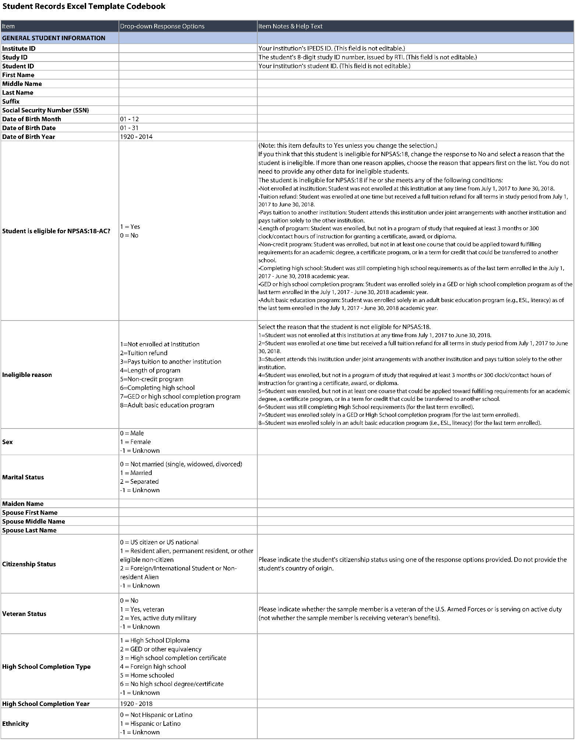
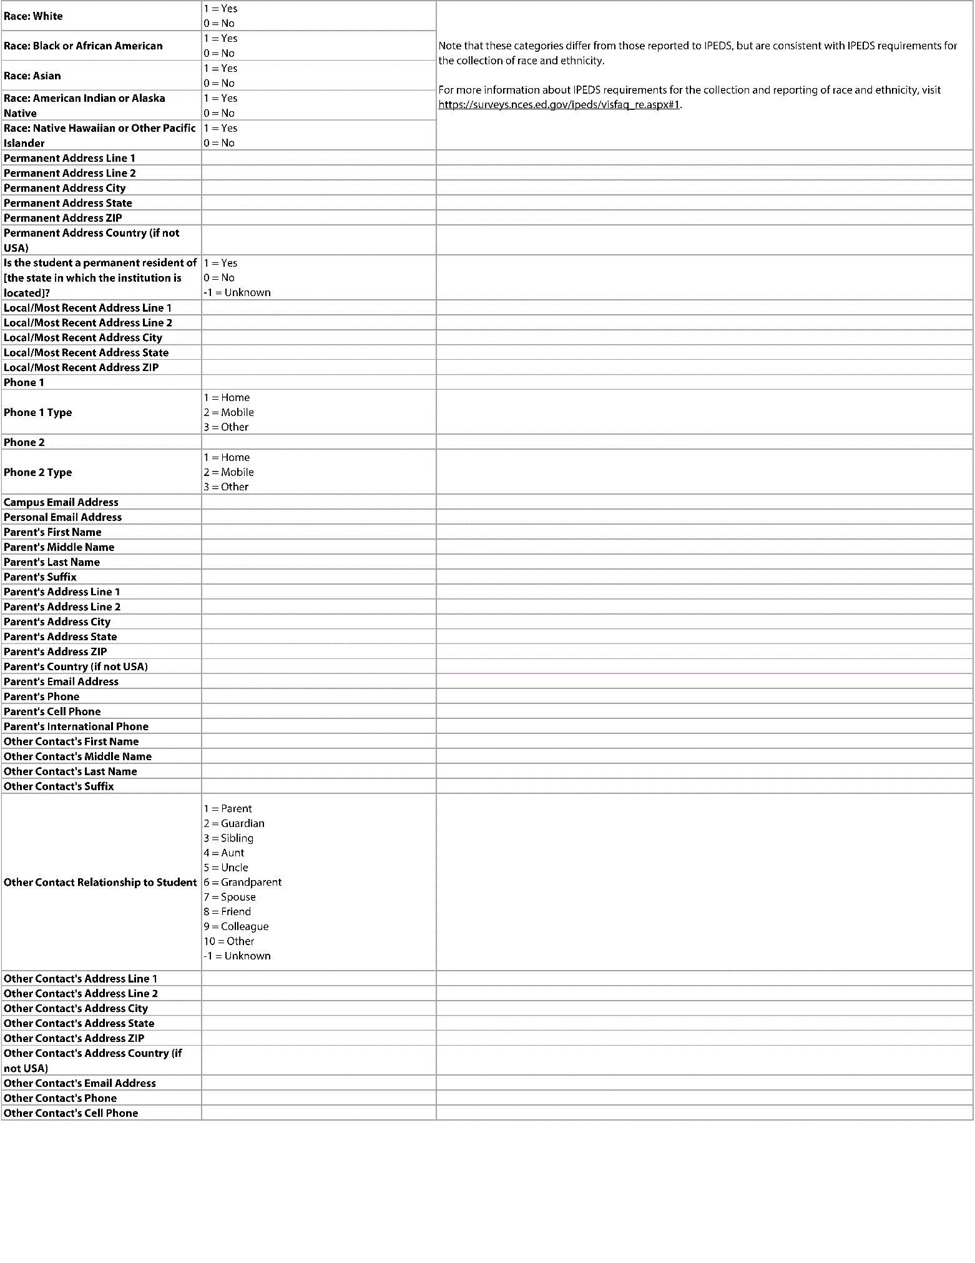

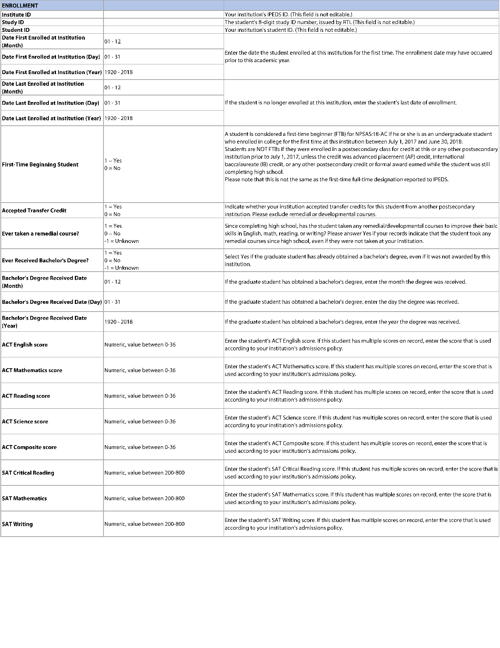

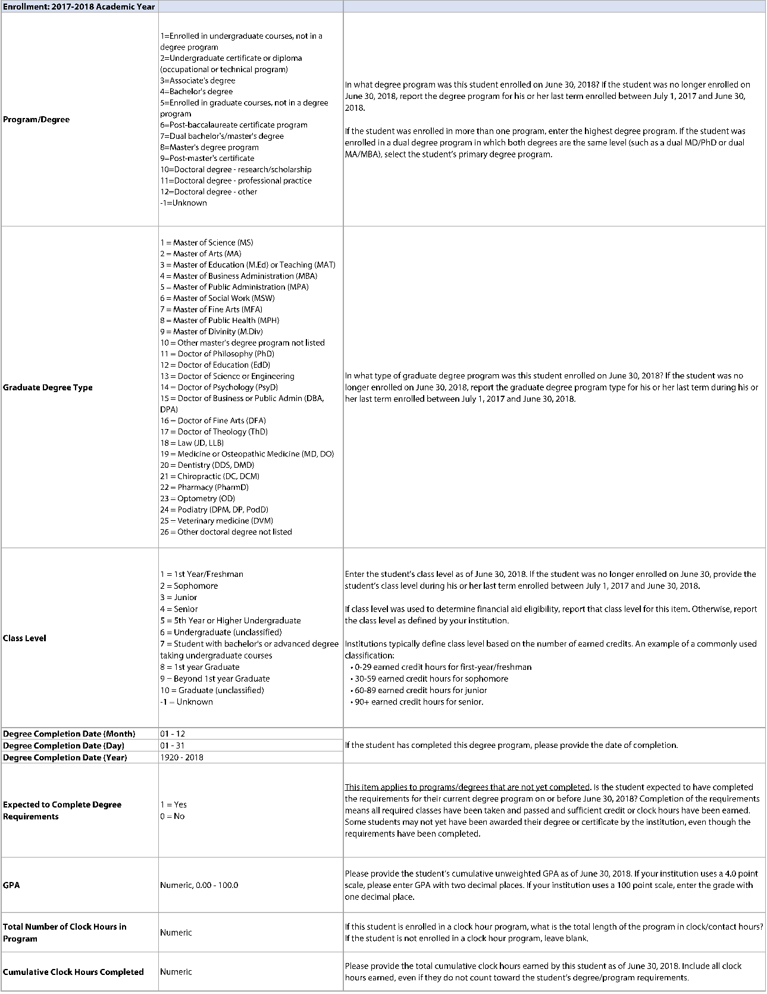

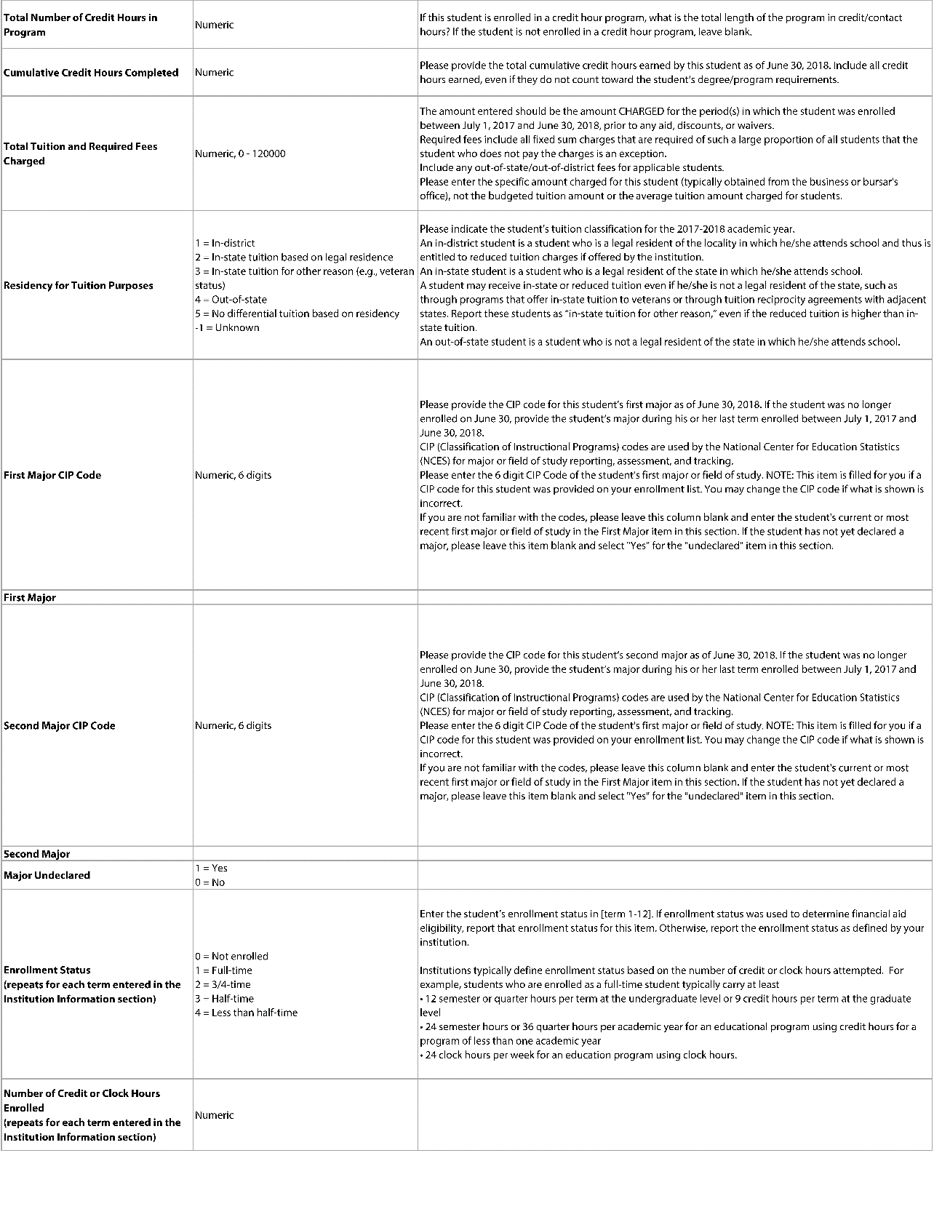

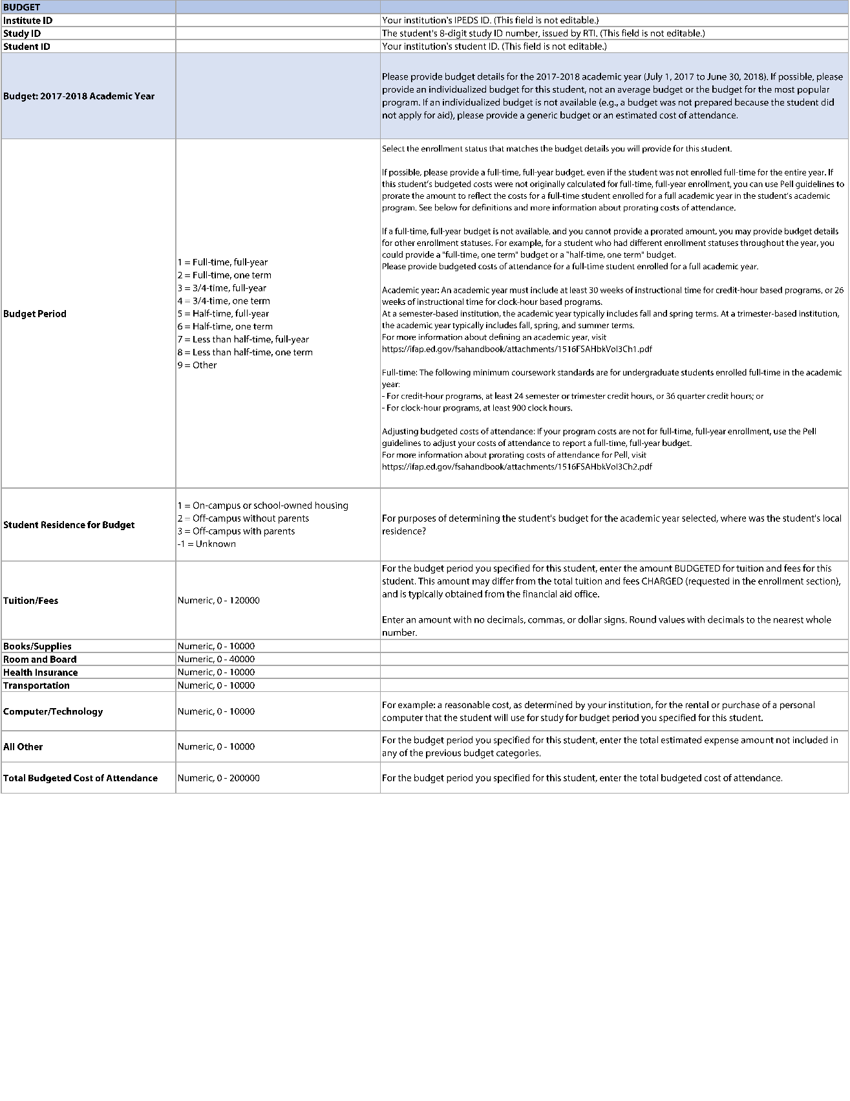

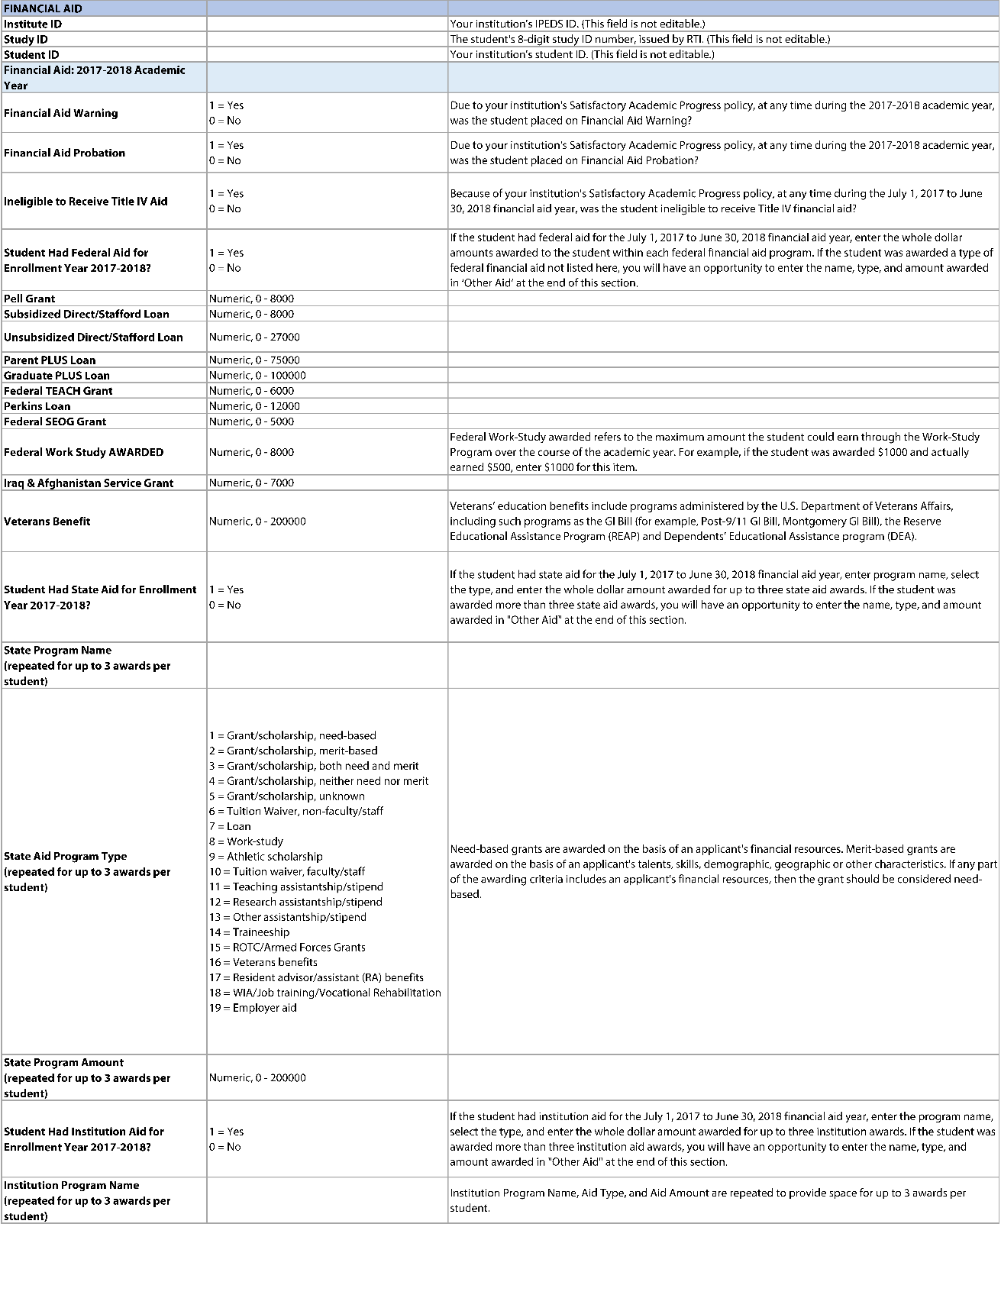

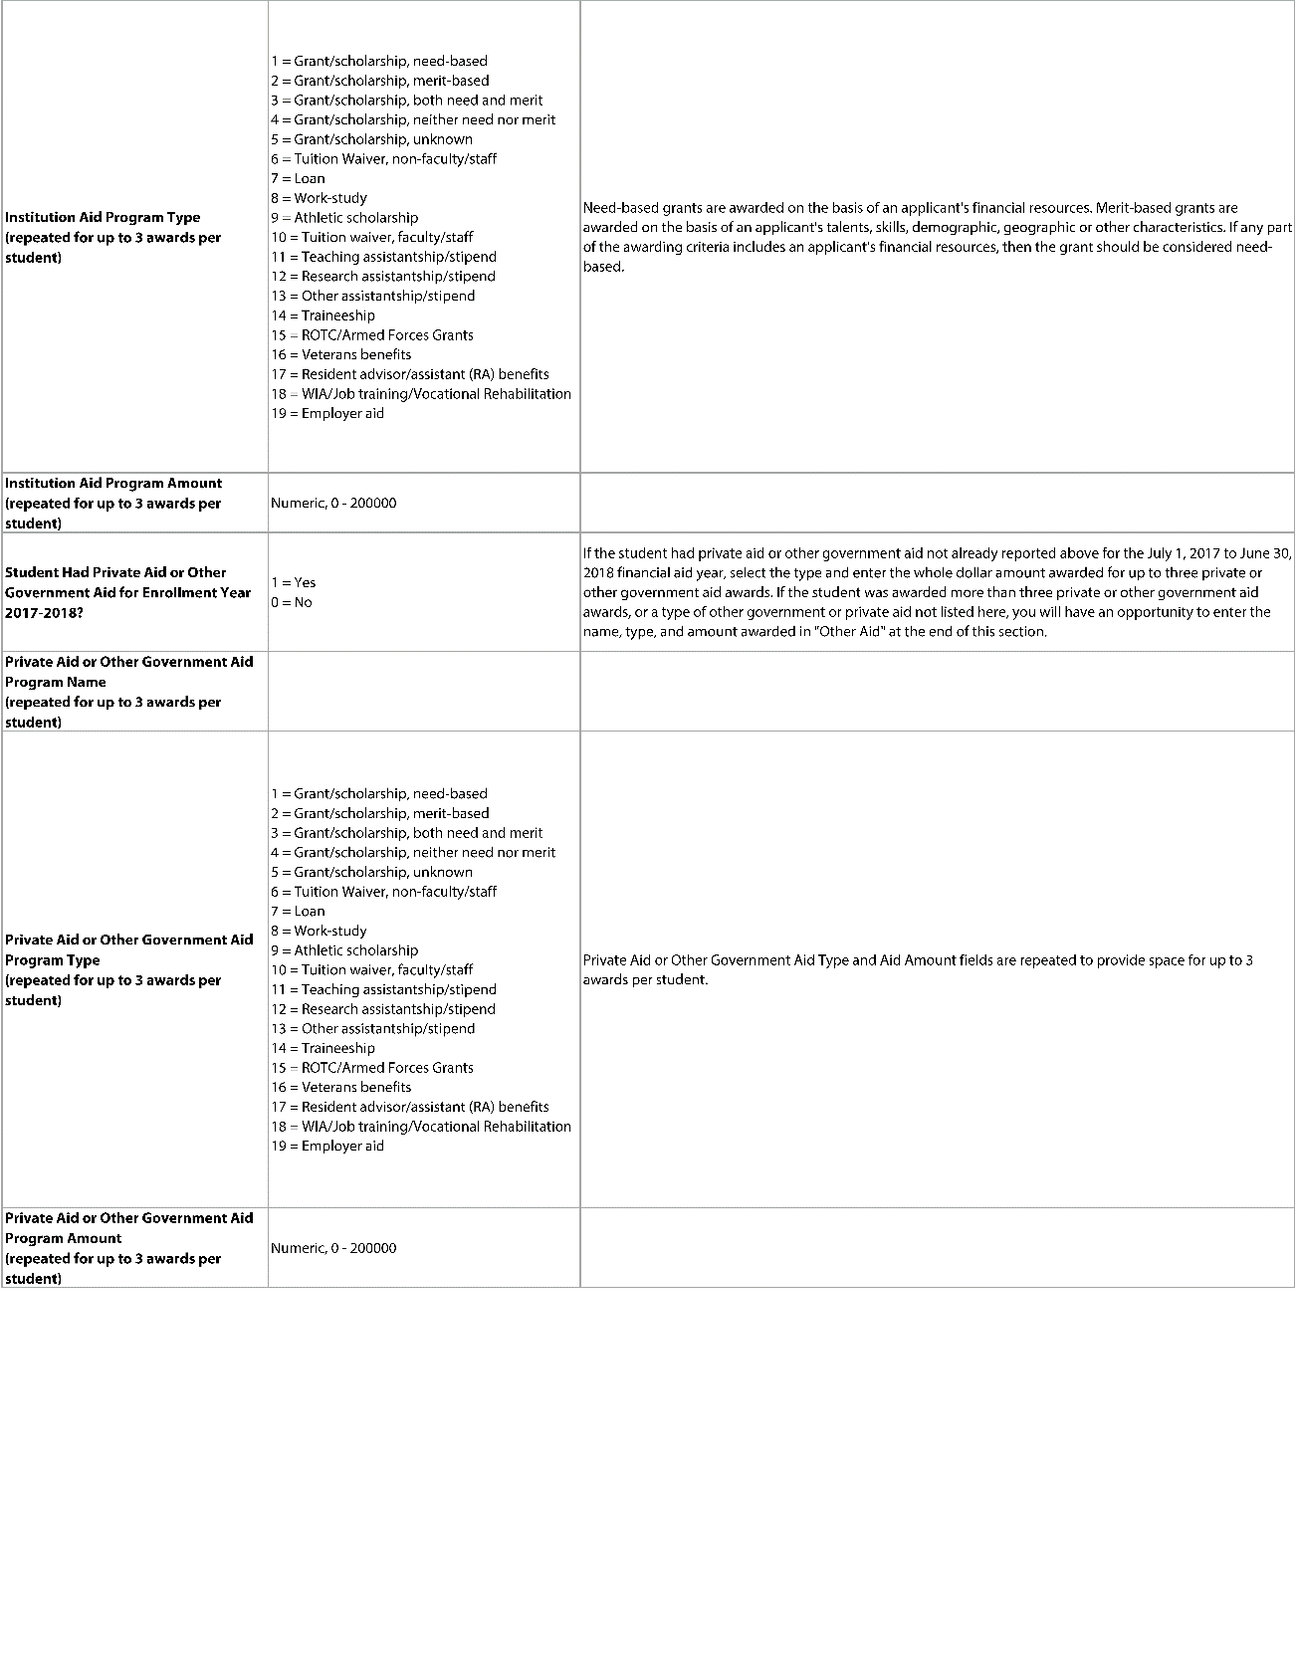

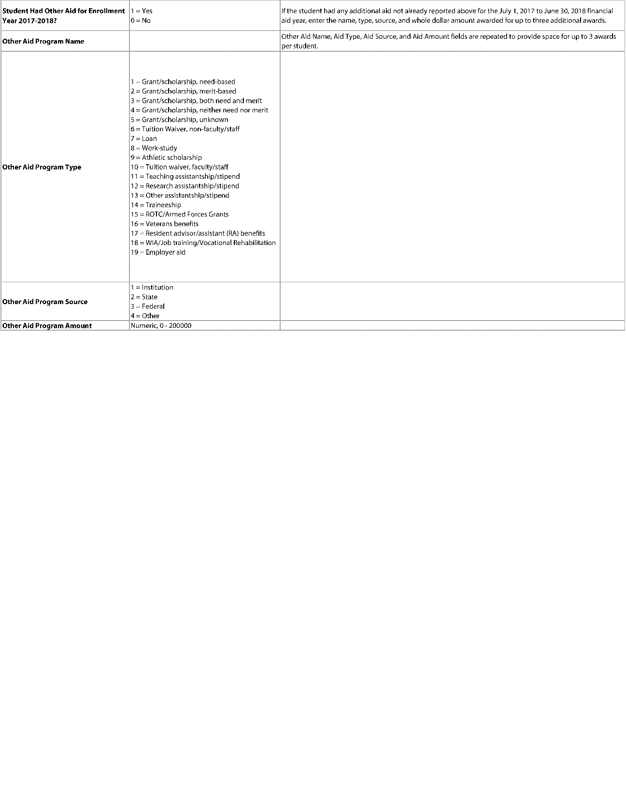

Scripts for Instructional Videos
This section includes the instructional videos that were approved for NPSAS:18-AC (OMB# 1850-0666 v.21). Testing participants will be asked about whether they viewed the videos while participating in NPSAS:18-AC and their opinions of the videos; the scripts are provided in this appendix as reference material for topics that may be discussed in the testing sessions.

Institution Information Page
Before you provide student records data for individual students, you’ll first need to complete the Institution Information Page, or IIP. The main purpose of the IIP is to collect information about your institution’s term structure. This information is important because it will be used later to collect information about students’ enrollment statuses, such as whether students were full-time or half-time, during each term in the academic year.
You can choose whether to report enrollment status by month, or by term, depending on your preference. We recommend that you select “Report Enrollment Status by Month” if you have more than 12 terms in the academic year, or if your institution enrolls continuously throughout the year.
If you choose “Report Enrollment Status by Month” option, enter term name, start date, and end date for each of your terms in the 2019-18 academic year. At least some part of the term must fall between July 1, 2019 and June 30, 2020.
Please take care when entering your terms. Once you submit, you will not be able to edit the information on this page.

Mode Selection
To get started, select a mode for providing student records data. You can choose from three mode options: web mode, Excel mode, and CSV mode.
In Web Mode, you will key student records data one student at a time. We recommend web mode for smaller institutions, such as those with fewer than 20 sampled students. You can also use web mode to edit data that you entered using Excel or CSV mode.
In Excel Mode, you will download a pre-formatted Excel template, and then enter your student data offline. When you’ve finished entering data into the Excel template, you will upload it to the Portal website. We recommend Excel mode for institutions with up to 100 sampled students.
In CSV mode, you will download your list of sampled students and a specifications document for creating Comma Separate Value, or CSV, files. You will create 4 CSV files following the specifications document and upload the completed files. We recommend CSV mode for institutions with more than 100 sampled students.
You can switch modes at any time, and any data that you previously entered will be pre-filled for you.

Web Mode
The web mode grid displays a list of your institution’s sampled students and your progress entering data for each section.
Click on a student’s name to start providing data for that student.
Once you have chosen the sampled student, provide data in each of the four sections on the page: General Student Information, Enrollment, Budget, and Financial Aid. When you change a field, it will turn green to indicate that the data have been saved.
When you have finished entering data for each section, click the Finalize button at the bottom of the section. This will check the data you provided and indicate whether there are any errors.
When you have finished entering data for all students, click the “Finalize All Student Record Data” button at the bottom of the web mode grid. Once you finalize, you will no longer be able make changes.

Excel Mode
In Excel mode, you will download a pre-formatted Excel spreadsheet file, fill out the file offline, and then upload the completed file. Prior to downloading the Excel template, check the “I agree” box that you agree to safeguard the file.
When you download the file, any data that you have previously provided will be pre-filled in the template. There are six tabs in the file. The first tab has instructions for uploading the file. The second tab has a codebook, which lists all the requested data elements and the valid response options for each item. The last four tabs correspond to each of the data sections: General Student Information, Enrollment, Budget, and Financial Aid.
Fill out each of the data tabs by typing data into the fields or selecting responses from the drop-down list. You can also copy and paste data from other files into the template.
The Excel template is locked to prevent users from changing its format. It is vital that you do not modify the template other than by entering data, and that you only use files generated by the Portal site.
When you have finished entering student data, upload your saved file to the Portal website. You can upload the file multiple times; the most recent upload will overwrite previous uploads. If your files have any errors or are missing critical items, the Portal will alert you. A list of errors and their corresponding students will appear in the Portal, and can also be downloaded as an Excel file. You will be able to review your data issues and upload fixes as needed.
When you have finished uploading data for all students, click the “Finalize All Student Record Data” button at the bottom of the page. Once you finalize, you will no longer be able make changes.

CSV Mode
In CSV mode, you will download a file specifications document, and then create comma separate value, or CSV, files according to the specs. There are four files, one for each data section: General Student Information, Enrollment, Budget, and Financial Aid. The file specifications indicate the number of fields that are required for each file, the order in which data elements should be submitted, and the valid values for each data element. Prior to downloading the files, check the “I agree” box that you agree to safeguard the data.
It is extremely important that you follow the file specifications exactly. If your CSV files don’t have the correct number of fields, the data will not be read into the Portal. If you find yourself needing to skip a data element, be sure to include a comma as a placeholder for that data element.
Once you’ve created your files, upload them on the Portal website. There are separate upload areas for each of the four file types; be sure you upload them in the correct section. You can upload the files multiple times; the most recent upload will overwrite previous uploads.
If your files have any errors or are missing critical items, the Portal will alert you. A list of errors and their corresponding students will appear in the Portal, and can also be downloaded as an Excel file. You will be able to review your data issues and upload fixes as needed.
When you have finished uploading data for all students, click the “Finalize All Student Record Data” button at the bottom of the page. Once you finalize, you will no longer be able make changes.

