The Early Childhood Longitudinal Study, Kindergarten Class of 2022-23 (ECLS-K:2023) Preschool Children's Parents Focus Groups

Attachments 2 A & B

Protocol Materials
2-A Moderator’s Guide
2-B ECLS Letter to Parents

OMB #1850-0803 v.249
(no changes from v.246)

Submitted by
National Center for Education Statistics
U.S. Department of Education

February 2019

Attachment 2-A. Moderator’s Guide
Preschool Parents Focus Group

Research Questions:

- How do members of these households interact with mail? What mail gets opened in the household? When? By whom? What mail gets thrown out? Why?
- How do members of these households decide to participate in a survey or study? The survey’s length? The incentive? The perceived importance of the study?
- Does the format and duration of the ECLS-K:2023 influence parents’ motivations to participate?
- What information do parents use when deciding whether or not to complete a survey for the ECLS-K:2023? Who or what do they consult?
- What barriers prevent or discourage participation in the ECLS-K:2023?
- What would minimize these barriers for parents?
- What factors might motivate parents to participate in a voluntary survey such as the ECLS-K:2023?
- Does the U.S. Department of Education “brand” help in motivating parents to complete the survey?
- Does the $5 bill included in the notification package and the promise of future monetary incentives motivate parents to participate?
- Would members of these households prefer to complete a survey by web or by paper? Why? What are the positive and negative aspects of each? If parents run across issues completing the online survey, would they call into a help desk? Would they want to complete the questionnaire via phone at that time or would they be willing to wait for a paper survey to be mailed?
- Are parents more receptive if the envelope, letter, and materials are coming from NCES or the Department of Education, compared to a different source? Is the invitation letter more appealing and/or credible if it is on NCES letterhead and signed by the NCES Commissioner?
- Are there specific endorsements, colors, or photos for the materials that would influence household members to decide to participate or pass them on to the appropriate member of the household? Are there any images, messages, or endorsements that would make them less likely to respond?
- What language and/or visuals will help parents understand the importance of the ECLS-K:2023 and the importance of their participation?
- What will motivate them to participate in the study?
- What is important to parents of young children about children’s early learning and development?
- What messages would be most salient to parents of young children about the unique data from the ECLS program? What value do parents perceive the ECLS-K:2023 has for our educational system?
- What current or potential ECLS-K:2023 messages or materials do parents find relevant, useful, and informative?
- What would be the most effective channels, formats, and materials to use to communicate with parents?
- What other groups (e.g., community organizations), people (e.g., teachers), or media would be effective in influencing parents on this topic, and what would be the best way to reach those influencers?

INTRODUCTION (10 MINUTES)

- My name is Christina Nicols and I work for Hager Sharp, an independent communications company conducting this focus group on behalf of the National Center for Education Statistics (NCES), which is the statistical center of the U.S. Department of Education.

Today you are participating in a focus group session. A focus group allows us to talk with people and learn more about what they think than when using other methods, such as surveys. We are looking to get your honest opinions. I will be asking questions meant to generate discussion. There are no right or wrong answers. I encourage you to express your opinion even if it might be different from other participants’. We want all viewpoints – positive, negative, and everything in between. We do not have to come to any agreement on what we talk about. Everyone’s opinion is important, so I would like to hear from each of you. We will be audio and video recording the session so that I have notes for my report. Once the report is written we will destroy the recordings.

Your feedback will be used only for the purposes of our report and will not be used for any other purpose except as required by law. No names will appear in the summary report. If at any time you decide you do not want to continue, you may choose to stop. Before we begin, do you have any questions about what I just said?

• Draft materials will be presented along with other information. I want to point out that I did not develop these materials, so you will not flatter me or insult me by anything that you say. My job is simply to ensure that we cover everything that we need to and to help keep the discussion moving. I have no stake in the outcome of the discussion.

• I’d like everyone to introduce themselves. Let me start (MODERATOR INTRO). Now, tell me about yourself. When you do, please be sure to tell me your name (first name is okay) and anything else you’d like to tell us about yourself.

REACTIONS TO MATERIALS ABOUT ECLS (60 MINUTES)

- Let’s talk about the Early Childhood Longitudinal Study or ECLS.

What, if anything, have you heard or do you know about the ECLS?

[HAND OUT PACKETS WITH NOTIFICATION LETTER, BROCHURE, SAMPLE REPORT, AND $5 BILL]. You all have an envelope of materials in front of you. Let’s not open it just yet. First, let’s look at the envelope.

- This is the information you would receive in the mail at your home address if you were selected to participate in the new ECLS. What would you most likely do with this piece of mail? (Throw it out? Open it? Give it to someone else in your household?)

For those who said they would open it – what are some reasons why?
For those who said they would not open it, or that it would get thrown away – What are some reasons why?

What changes could we make to the envelope to make it seem important enough or interesting enough for you to open it? (Probe: prominent U.S. Department of Education seal? Better indication of what’s inside?)

Now, let’s open the envelope and take a look at the materials.

- What was your overall reaction to this packet of materials? Let’s start with <Name> and have everyone give me one statement about their reaction to the materials.

- What are your thoughts on how the package is presented? Are there too many materials, or is this an appropriate amount? Would you prefer to only receive a letter and review the rest of the information online?

- Are there specific endorsements, colors, or photos for the materials that would influence you to open the materials or pass them on to the appropriate member of the household? Are there any images, messages, or endorsements that would make you less likely to respond?

- Now I’d like you to glance through it as you would if you had opened it at home. Identify the piece you would read first and look it over. Why would you read that piece first?

- [GIVE PARTICIPANTS A MOMENT TO REVIEW PACKETS, THEN GO AROUND TO EACH PARENT AND HAVE EACH ONE NAME THE PIECE THEY WOULD READ FIRST AND WHAT MADE THEM SELECT THAT PIECE.]

- At this point, what are your thoughts on the ECLS-K:2023 study?
- Is there anything that appeals to YOU about completing the survey?
- What are some potential drawbacks, issues, or concerns regarding completing the survey that you can identify?

Let me tell you a bit about the process for the ECLS-K:2023 study. First, households are invited
to complete a five-minute screening survey to make sure they are eligible to participate in the study. People are eligible if they have a child who is going to start kindergarten in the upcoming school year. Those who are eligible then continue on to answer an online survey that takes about 20-30 minutes to complete; parents can exit the online survey at any point and return to it later.

- Based on this description, would you prefer to take the brief screening survey on the web or by paper? Why? And for eligible parents, how do you feel about completing the longer questionnaire online?

- If you run across challenges in completing the surveys online, how likely would you be to call into a toll-free help desk? If you called into the help desk, how likely would you be to complete the brief screening survey by phone at that time, or would you want to wait for a paper survey to be mailed? And how likely would you be to complete the longer questionnaire by telephone?

The ECLS-K:2023 is a longitudinal study and that means we are studying the development of children over time, specifically through the fifth grade. This means that if you were selected to complete the 20-30 minute survey, you could be asked to participate in future components of the study. For the ECLS-K:2023, participating parents will be asked to complete surveys not only when their child is in preschool, but again when their child enters kindergarten in the fall, then in the springs of the kindergarten, first grade, third grade, and fifth grade years. Once their child gets to kindergarten, we will also ask parents if their child can participate in all of these later rounds, as well as asking the child’s teachers and schools to participate.

- Does this sound like something you would be willing to do? Why or why not?

- What kind of payment or incentive would you anticipate for your participation through the 6-year timeframe?

- Would you want to know about the entirety of the study when you receive this package? Would having that information make you more or less likely to complete the preschool component of the study?

- Now let’s talk specifically about the letter [hold it up to show group]: Please read along with me as I read it aloud.

- If you had received this at home, do you think you would have read the letter in full? Skimmed it? Not read it?
- Is this letter useful to you?
  - What made it useful/not useful?
- What did you like about it?
- What didn’t you like?
- Was anything confusing or hard to understand?
  - Did you understand from the letter that you could be asked to participate in the full ECLS-K:2023 study, which will last through your child’s elementary school grades?
- Was anything missing?
- How believable was this information?
- How relevant was the information to you? Did it speak to you (as opposed to someone in a different position or role)?
- What did you think about the length?
- Did the list of organizations that endorse the study encourage you to participate?
- Does the letter motivate you to read the other materials in the package?
  - If yes, what is most motivating about it?
  - If no, what would make it more motivating?
- Does the letter motivate you to participate and go online to begin the survey?
  - If yes, what is most motivating about it?
  - If no, what would make it more motivating?
  - What would you change about this letter to make it more likely that people will read it? What do you think about the tone of the letter; does it need to be more cheerful or friendly? Less formal? How would you improve the tone?
  - Would you react differently to the letter if it was on letterhead from the U.S. Department of Education or NCES? Would you react differently if the letter was signed by someone from Westat, the organization that is conducting the study, rather than someone from the U.S. Department of Education?
  - Would it be helpful to you if the letter included a QR code that you could scan to take you online directly to the survey?
  - If you participate in the ECLS-K:2023, do you think that any information that identifies you or your child (like your name or address) would be included in study reports? Do you think your child’s school would receive any information about you or your child as a result of you participating?
    - If yes, would it be helpful if we put a statement in italics at the bottom of the letter clarifying that you and your child will not be identified in any reports, and that your school will receive no information about you or your child as a part of this study? Would you read text that appears there?

Now let’s talk specifically about the brochure [hold it up to show group]. This is a brochure from an earlier ECLS study that was very similar to the ECLS-K:2023—It is intended as an example of what a brochure will be like. An actual ECLS-K:2023 brochure will be produced later for the new study.
- Please read the section titled, “About the Study.”

- Is this information useful to you?
  - What made it useful/not useful?
- What did you like about it?
- What didn’t you like?
- Was anything confusing or hard to understand?
- What questions would you have after reading this?

Let’s move on to the inside of the brochure. I will give you a moment to read it.

- Is this information useful to you?
  - What made it useful/not useful?
- What did you like about it?
- What didn’t you like?
- Was anything confusing or hard to understand?
- Was anything missing?
- How believable was this information?
- How relevant was the information to you? Did it speak to you (as opposed to someone in a different position or role)?
- What did you think about the length?
- Does the letter motivate you to participate and go online to begin the survey?
  - If yes, what is most motivating about it?
  - If no, what would make it more motivating?
  - What would you change about this brochure to make it more likely that people will read it?

- Now let’s talk specifically about the sample report [hold it up “First-Time Kindergartners in 2010-11: First Findings” report to show group]. Just take a moment to look over the type of content that is included here.
- Does this seem like it contains information that is useful to you?
  - What makes it useful/not useful?
- What do you like about it?
- What don’t you like?
- Do you have a clear understanding about why these results matter to children’s education after reading the introduction?
- How believable is this information?
- How relevant is the information to you? Does it speak to you as a parent (as opposed to someone in a different position or role)?
- What do you think about the length?
- Does the report motivate you to participate and go online to begin the survey?
  - If yes, what is most motivating about it?
  - If no, what would make it more motivating?
  - What would you change about this report to make it more likely that people will read it?

I’m going to pass out a different report which includes additional findings from the earlier ECLS study [hold up the “Primary Early Care and Education Arrangements and Achievement at Kindergarten Entry” report to show group]. Just take a moment to look over the type of content that is included here.
- Does this seem like it contains information that is useful to you?
  - What makes it useful/not useful?
- What do you like about it?
- What don’t you like?
- Do you have a clear understanding about why these results matter to children’s education after reading the introduction?
- How believable is this information?
- How relevant is the information to you? Did it speak to you as a parent (as opposed to someone in a different position or role)?
- Which findings are the most relevant or interesting to you as a parent?
- Do these results motivate you to participate and go online to begin the survey?
  - If yes, what is most motivating about it?
  - If no, what would make it more motivating?

- Now moving back to the notification package, what is your reaction to the $5 bill included in the packet and the promise of future payment for participation in the study? Does the $5 make you more or less likely to read the enclosed materials?
  - Why?
  - Did the materials tell you why the $5 bill was included? What did you think of the reason?
  - Does the $5 make you more likely to complete the brief screening survey?
  - Can you think of any alternative, non-monetary incentives that would motivate you to complete the survey? For example, we could give participants a children’s book that would be appropriate for them to read to their child, or a small set of school supplies like crayons or markers.

- Let’s talk about the package as a whole now. Based on the materials that you read and anything else that you may know about the ECLS, how would you react if you were asked to participate?

- Do these materials appeal to you as a parent of a preschool-aged child? Why or why not?
- What do you understand to be expected of you as a participant after reading these materials? In the next year as the parent of a preschool-aged child? And for the long-term study over the next several years?
- What factors would you consider? Duration of the study, time involved for you to complete it, $5 incentive...
- What questions would you have?
- Are there any concerns you would have about participating? [Probe: privacy concerns, age of the child, feelings about the government play a role].
- Is there specific information would you need or want in order to decide whether or not to participate (like confidentiality assurance, time to complete, sample procedures, how the information will be used)?
- How would you make the decision to participate or not? For example, who would be involved in the decision?
- What would be most helpful to you in deciding to participate?
- Of all the materials we have reviewed, what would motivate you the most to participate and go online to begin the survey?

BARRIERS AND BENEFITS TO PARTICIPATION (10 MINUTES)

  - Is there anything that may change your mind about participating in the ECLS-K:2023 study?
- Would something about the survey need to change? What? (PROBE FOR duration, access, time required, etc.)

  - If one thing could change about the ECLS-K:2023, what would be most important to change in order to increase the likelihood that you would participate in the study?

  - Are there any other barriers that you see to participating in the ECLS-K:2023? Are there any other concerns or negative reactions that you have?

  - Let’s talk a little more about the benefits to participating in the ECLS-K:2023. What do you think would be the benefits of having you participate in the ECLS-K:2023? (PROBE FOR benefits to parents and schools)

  - Which of these benefits is most important to you?

RECRUITMENT STRATEGIES AND SOURCES OF INFORMATION (10 MINUTES)

- Would you be more likely to complete the survey if you knew other parents in your community were completing it?

- How helpful would it be to have access to a short video that provides an overview of ECLS? How likely would you be to watch a video like this?

- Would you be likely to follow and engage with the National Center for Education Statistics on Facebook or Twitter to learn more about the study?

- Would you be more likely to participate in the study if you saw advertisements for it online? In public spaces, such as on buses?

- Would any additional resources be helpful for encouraging your participation?

- Where do you get information about what’s happening in education? About what’s happening in your school system?

- Where would you go to get additional information about the ECLS? What would be most convenient for you?

CONCLUSIONS

- Do you have any additional comments about these materials or the ECLS in general?

- Thank you.

Attachment 2-B. ECLS Letter to Parents
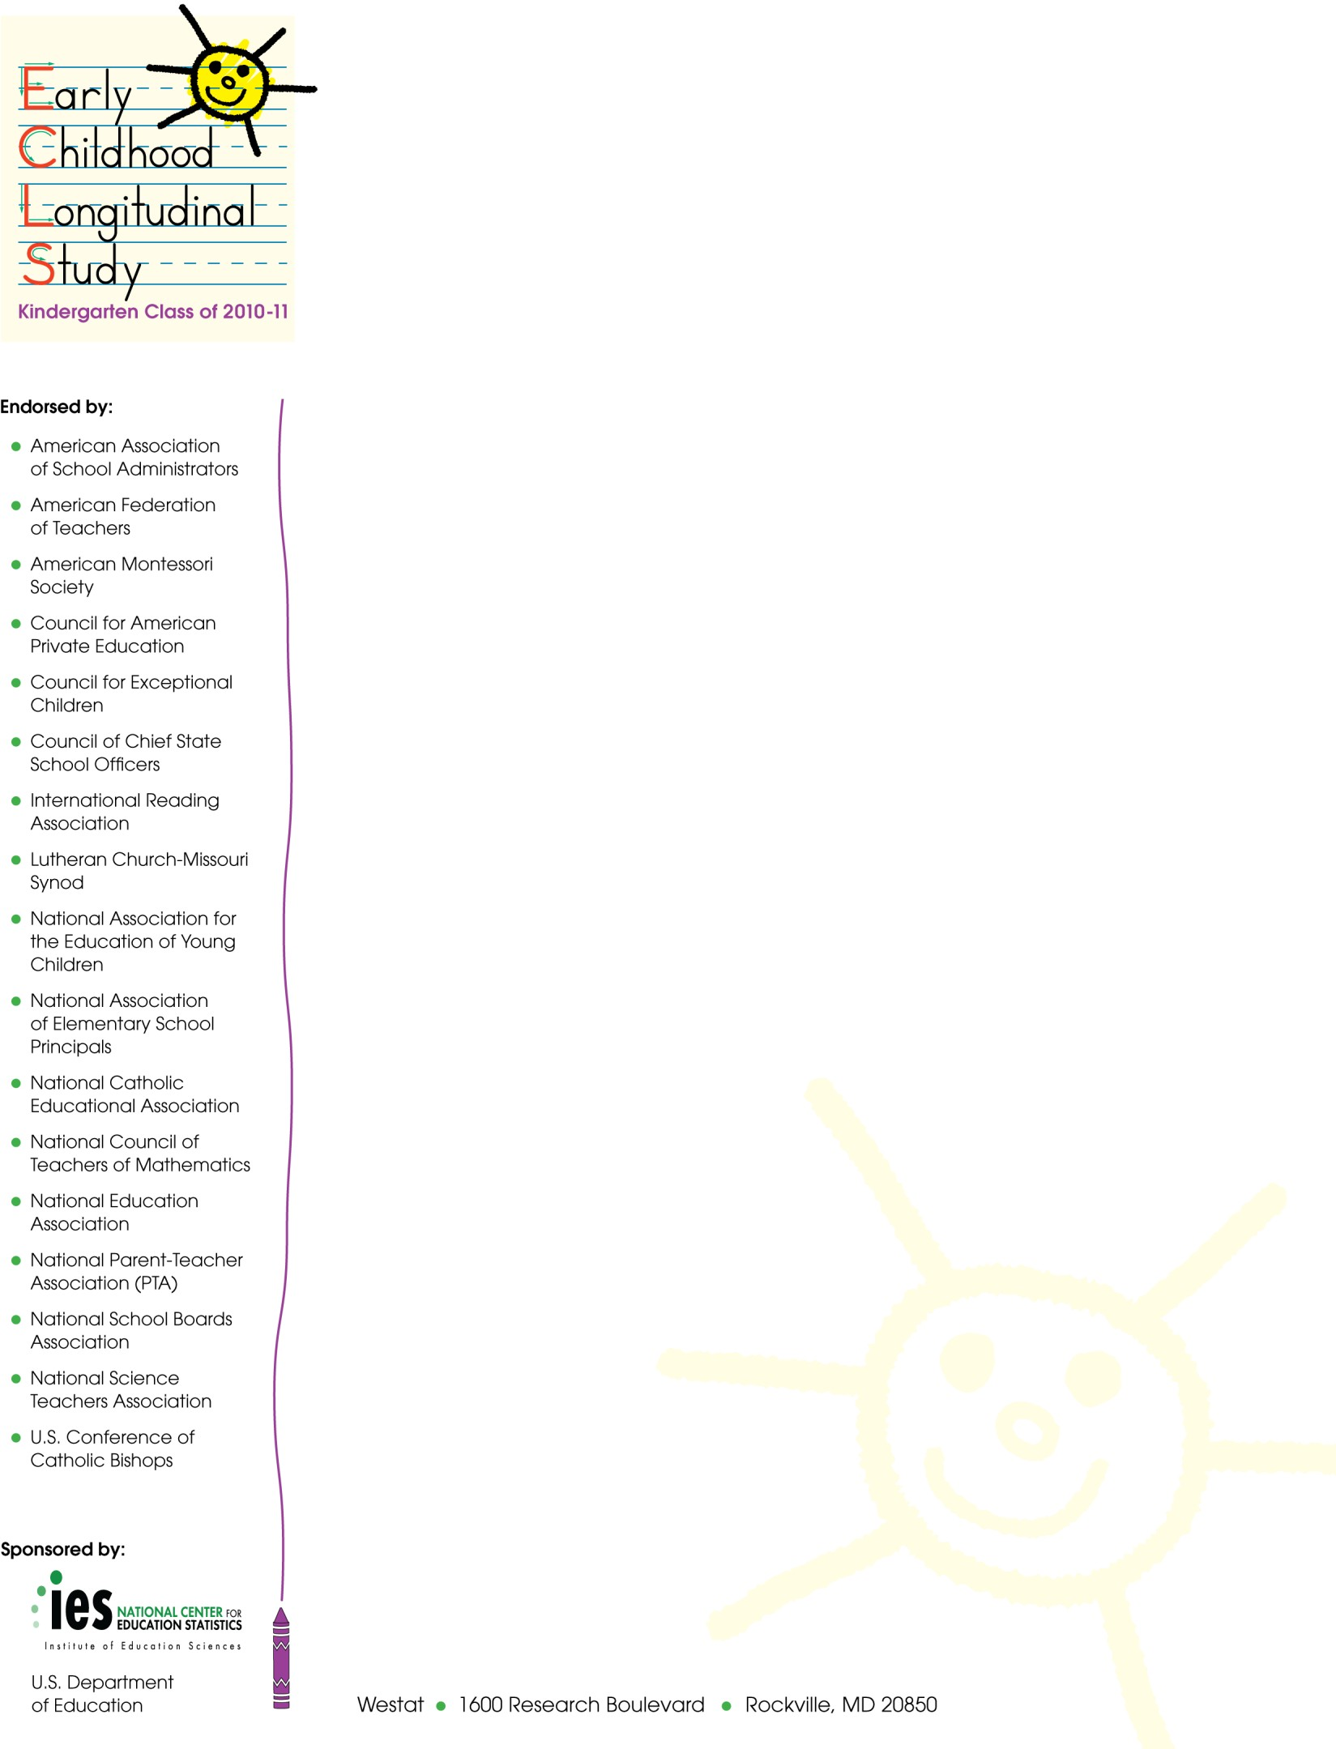
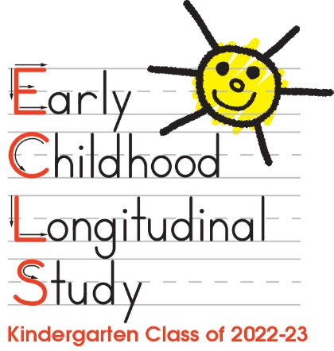
Date

Dear <Parent Name>,

I am writing to invite you to participate in an important new study about children’s educational experiences being conducted by the U.S. Department of Education’s National Center for Education Statistics (NCES). This exciting study, called the Early Childhood Longitudinal Study, Kindergarten Class of 2022-23, or the ECLS-K:2023, will collect information from children’s preschool through elementary years to update what we know about how family, school, community, and individual factors relate to children’s development and learning. Educators can use information collected through the study to improve their students’ school experiences.

I have enclosed a report from a previous ECLS kindergarten study so that you may see some of the important findings that have come from this work. I have also included a brochure on the new ECLS-K:2023 program.

Even if you have no children, it is important that you complete a short online survey so that we can better understand the households we are contacting. I have included $5 in this mailing to thank you for answering our questions.

Depending on your answers to the short online survey about your household, you may be asked to complete another web survey that takes about 30 minutes. You will receive an additional $XX when this survey is completed. I encourage you to participate if you are eligible. Your family was chosen to represent many other families across the nation. By supporting the ECLS-K:2023, you will help ensure that the experiences of all parents and preschoolers are represented, which will help improve educational outcomes for America’s children.

Please use the link and login information below to answer a few questions about your household, even if you do not have children. If we determine that you are eligible for the longer 30-minute survey, the same link will be used to begin that survey.

- Website: <Website>
- Username: <ParentID>
- Initial password: <Password>

NCES at the U.S. Department of Education is working with Westat, a research organization, to conduct this study. If you have questions, please feel free to call Westat at 1-888-204-4864 or send an email to ECLSKHELP@westat.com. You can also learn more about the ECLS-K:2023 and see examples of the questions we ask children online at https://nces.ed.gov/ecls/myECLSK2023.

Thank you for helping us with this important study!

Sincerely,

James Lynn Woodworth
Commissioner
National Center for Education Statistics, Institute of Education Sciences
The National Center for Education Statistics (NCES), within the U.S. Department of Education, is authorized to conduct ECLS-K:2023 by the Education Sciences Reform Act of 2002 (ESRA 2002, 20 U.S.C. §9543). Westat is administering this voluntary survey on behalf of NCES. There are no penalties should you choose not to participate in this study. All of the information you provide may be used only for statistical purposes and may not be disclosed, or used, in identifiable form for any other purpose except as required by law (20 U.S.C. §9573 and 6 U.S.C. §151).

