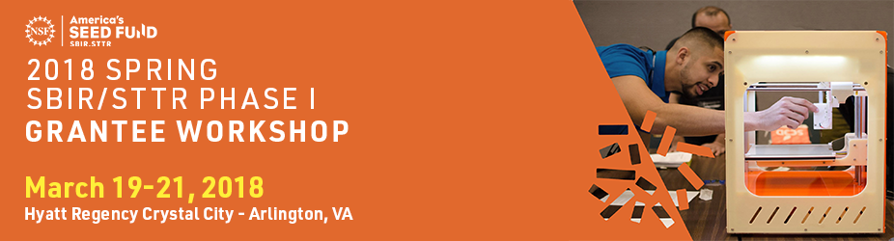

Insert Date & Location

Insert Date

Thank you for attending the SBIR/STTR Phase I Workshop and/or Beat-the-Odds Boot Camp. Your feedback is important to us and we frequently use these survey results to inform the planning for future events. Please take a few minutes to complete this survey no later than “**Insert Date**”.

**\*1. Please rate the pre-event communications, logistics, and on-site support for this event:**

|  |  |  |  |
| --- | --- | --- | --- |
| Outstanding | Good | Fair | Poor |

Please feel free to provide detailed feedback on the logistical support, website, and advance communication below:



**\*2. Did you attend the Beat-the-Odds Boot Camp?**

Yes

No

**\*3. How many customer interviews – *since you began the Boot Camp program* - did you conduct?**

Quantity Conducted:

**\*4. What did you find MOST valuable about the Beat-The-Odds Boot Camp?**



**\*5. What did you find LEAST valuable about the Beat-The-Odds Boot Camp?**



**\*6. Did you utilize the Launchpad Central platform?**

Yes

No

If "Yes", Please provide feedback on the platform. If "No", why not?

**\*7. Please evaluate the session "Welcoming Remarks and Program Director Introductions and Logistics Overview "   
by “Insert Names” on “Insert Date” from “Insert Time”**

|  |  |  |  |
| --- | --- | --- | --- |
| Outstanding | Good | Fair | Poor |

What did you like about this session? What would you do to improve this session?

**\*8. Please evaluate the session "Featured Speaker: Insert Title”   
by “Insert Names” on “Insert Date” from “Insert Time”**

|  |  |  |  |
| --- | --- | --- | --- |
| Outstanding | Good | Fair | Poor |

What did you like about this session? What would you do to improve this session?

**\*9. Please evaluate the session "Phase II Review Process: Insert Title"   
with panelists: ”Insert Names” moderated by “Insert Name” on “Insert Date” from “Insert Time”**

|  |  |  |  |
| --- | --- | --- | --- |
| Outstanding | Good | Fair | Poor |

What did you like about this session? What would you do to improve this session?

**\*10. Please evaluate the peer-to-peer networking session "Insert Title"**

**on “Insert Date” from “Insert Time”**

|  |  |  |  |
| --- | --- | --- | --- |
| Outstanding | Good | Fair | Poor |

What did you like about this session? What would you do to improve this session?

**\*11. For the peer-to-peer networking session, would you prefer?**

Have your own program director present to moderate the session

Have another portfolio program director moderate the session

No program director, just a peer moderator to kick things off

**\*12. Which did you experience this time?**

My own program director moderated

Another portfolio program director moderated

**\*13. Please evaluate the session "NSF Communications: How NSF Can Help Share Your Story and Tips & Tricks in Communications"   
by “Insert Name” on Insert Date” from “Insert Time”**

|  |  |  |  |
| --- | --- | --- | --- |
| Outstanding | Good | Fair | Poor |

What did you like about this session? What would you do to improve this session?

**\*14. Please evaluate the session "Office of Inspector General Guidance"   
by “Insert Name” on “Insert Date” from “Insert Time”**

|  |  |  |  |
| --- | --- | --- | --- |
| Outstanding | Good | Fair | Poor |

What did you like about this session? What would you do to improve this session?

**\*15. Which "Q&A Breakout Sessions by NSF Program Director" did you attend?**

Insert PD Names

 Insert PD Names

 Insert PD Names

 Insert PD Names

 Insert PD Names

Did not attend.

What did you like about this session? What would you do to improve this session?

**\*16. Did you take advantage of the Commercialization Assistance program (Dawnbreaker/Larta Inc.)?**

Yes

No

**\*17. To which Commercialization Planning Assistance organization were you assigned?**

Dawnbreaker

Larta Inc.

If you have feedback on the program please provide below.



**\*18. Did you attend the "U.S. Patent and Trademark Office Overview Presentations"?  
on** “Insert Date” **from “Insert Time”**

Yes

No

**\*19. Please rate the session "U.S. Patent and Trademark Office Overview Presentations"?  
on** Insert Date” **from “Insert Time”**

|  |  |  |  |
| --- | --- | --- | --- |
| Outstanding | Good | Fair | Poor |

What did you like about this session? What would you do to improve this session?

**\*20. Did you visit the U.S. Patent and Trademark Office Open Desks?  
on** Insert Date” **from “Insert Time”**

Yes

No

Feel free to provide feedback below.

**\*21. Did you attend the "U.S Food and Drug Administration Overview Presentations"?  
on** Insert Date” **from “Insert Time”**

Yes

No

**\*22. Please rate the session "U.S Food and Drug Administration Overview Presentations"?  
on** Insert Date” **from “Insert Time”**

|  |  |  |  |
| --- | --- | --- | --- |
| Outstanding | Good | Fair | Poor |

What did you like about this session? What would you do to improve this session?

**\*23. Did you visit the Food and Drug Administration Open Desks?  
on** Insert Date” **from “Insert Time”**

Yes

No

Feel free to provide feedback below.



**\*24. Did you attend the "Cost Analysis and Pre-Award (CAP) and Division of Grants and Agreements (DGA) Open Session"?  
on** Insert Date” **from “Insert Time”**

Yes

No

**\*25. Please rate the session "Cost Analysis and Pre-Award (CAP) and Division of Grants & Agreements (DGA) Open Session"   
on** Insert Date” **from “Insert Time”**

|  |  |  |  |
| --- | --- | --- | --- |
| Outstanding | Good | Fair | Poor |

What did you like about this session? What would you do to improve this session?

**\*25. What other aspects of the NSF SBIR/STTR Program or anything else would you like to see covered in this Workshop?**

