**December 2017 - Feedback Survey Regarding NSF SBIR/STTR Phase I Proposal Submission Process**

The National Science Foundation (NSF) Small Business Innovation Research (SBIR) or Small Business Technology Transfer (STTR) Programs help innovative entrepreneurs bring technology from the lab to the marketplace via grant funding. We are continually looking to improve the application process for these grants. Because you recently applied to the program, we would greatly appreciate your participation in this short survey to help us improve our proposal submission process and proposal preparation aids/activities.  
  
This survey is anonymous and will in no way affect the outcome of any current, pending or future NSF SBIR/STTR grant proposal.  
  
*If another individual was more closely involved with the proposal preparation and submission process, please forward this survey link to that individual!*   
  
Thank you for your time and consideration.

1. **Which of the following best describes the ethnicity or racial characteristics of your team? Select all that apply (for statistical purposes only).**

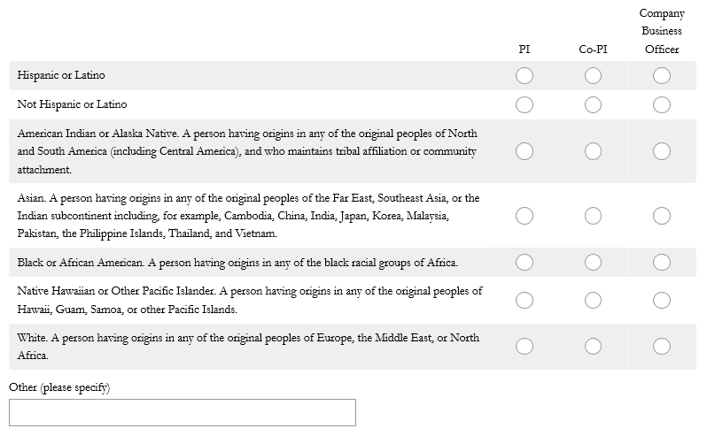

1. **Please indicate your company’s gender characteristics. Select all that apply. (For statistical purposes only).**

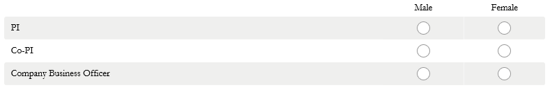

**\* 3. What is the zip code of your company’s primary address?**



**\* 4. Was your company formed in the last 3 years?**

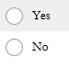

**\* 5. In the submission window that recently closed, was your firm a first-time applicant to the NSF SBIR/STTR Program?**



**\* 6. Please indicate the experience that you/your company has had with the following funding opportunities.**

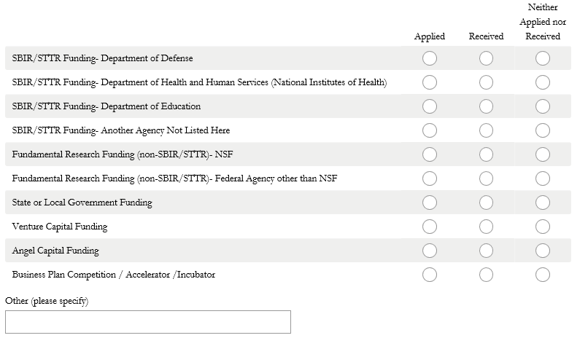

**\* 7. How did you hear about the NSF SBIR/STTR Program? Check all that apply.**

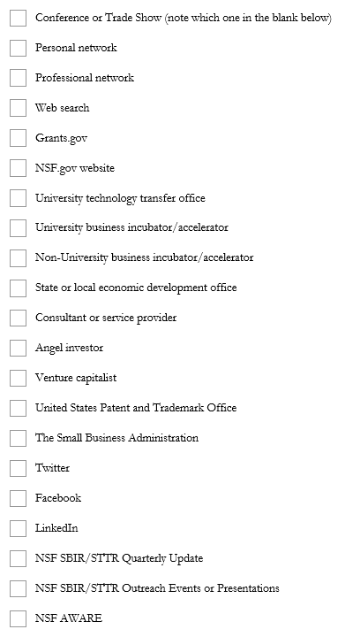

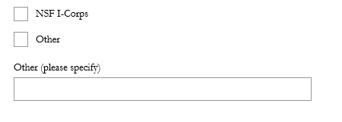

**\* 8. Please rate each aspect of the proposal submission process:**

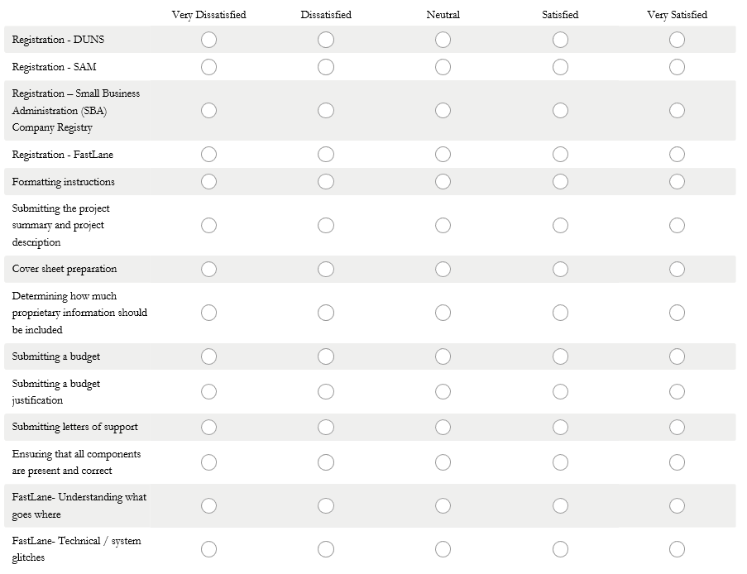

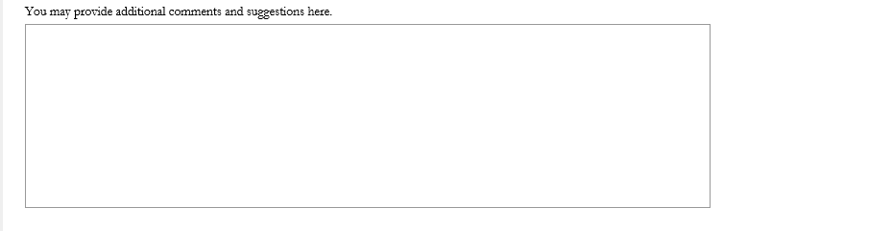

**\* 9. Please rate the following NSF SBIR/STTR proposal submission aides.**

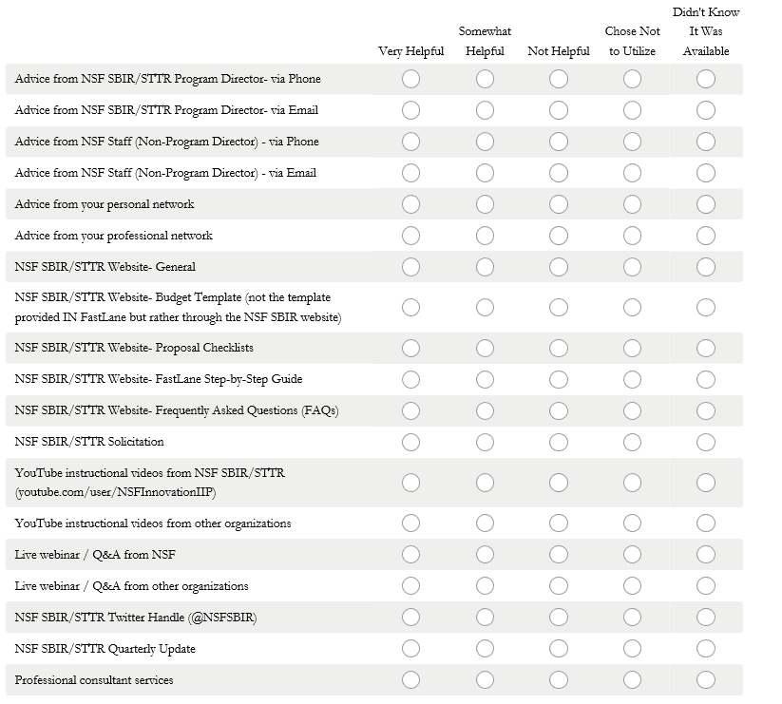



**\* 10. Outside of official webinars, visits to NSF, and direct email or phone communications related to this proposal, have you communicated with any NSF SBIR/STTR staff over the past six months?**

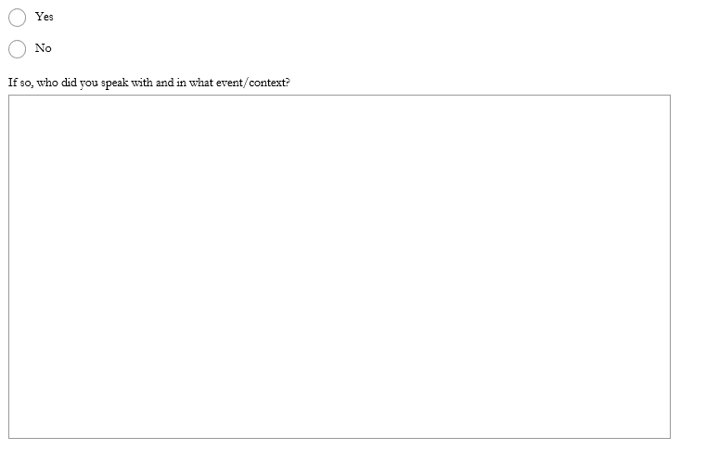

**\* 11. Did you use assistance from a party outside your company to aid in the NSF SBIR/STTR proposal preparation/submission process?**

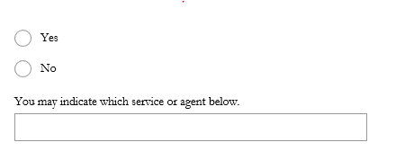

**\* 12. Do you have additional suggestions for improving the Phase I proposal submission process?**

