Attachment 3 - SNAPQCS 245 Form UAT Screenshots 9/12/2017

According to the Paperwork Reduction Act of 1995, an agency may not conduct or sponsor, and a person is not required to respond to, a collection of information unless it displays a valid OMB control number. The valid OMB control number for this information collection is 0584-0034. The time required to complete this information collection is estimated to average 2.9406 hours per response, including the time for reviewing instructions, searching existing data sources, gathering and maintaining the data needed, and completing and reviewing the collection of information. Send comments regarding this burden estimate or any other aspect of this collection of information, including suggestions for reducing this burden, to: U.S. Department of Agriculture, Food and Nutrition Services, Office of Policy Support, 3101 Park Center Drive, Room 1014, Alexandria, VA 22302, ATTN: PRA (0584-0034*). Do not return the completed form to this address
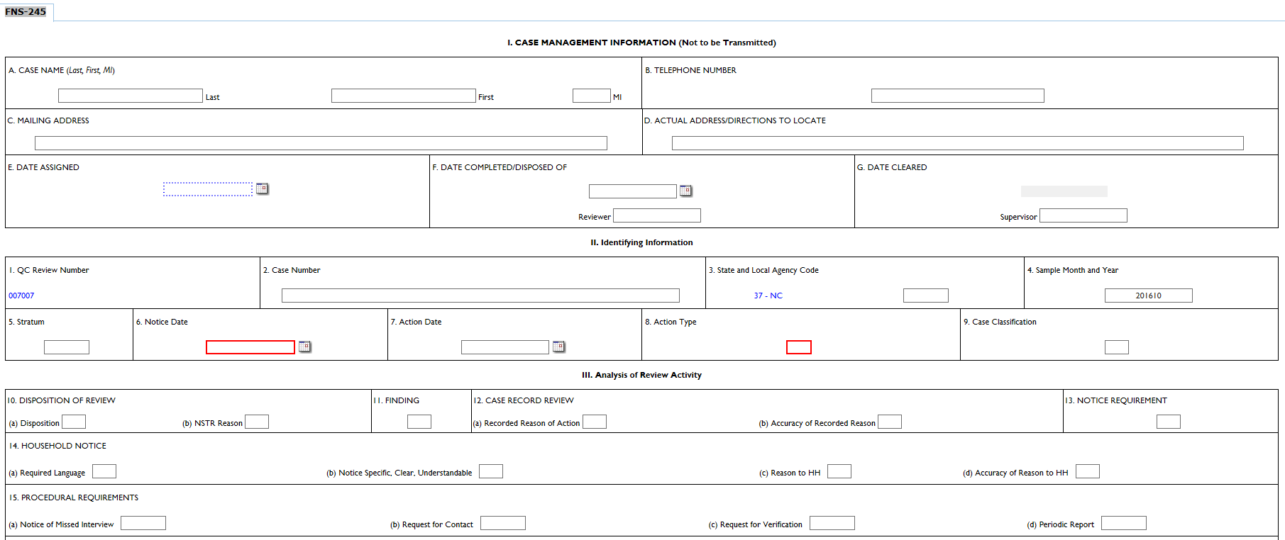

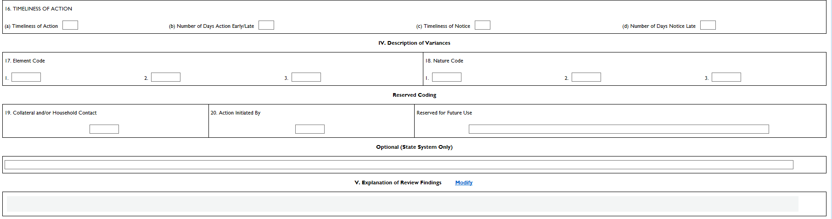

Item 8 (Action Type)
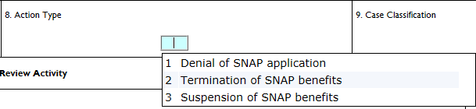

Item 9 (Case Classification)

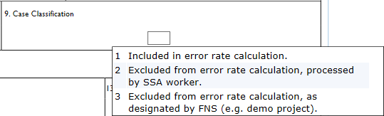

Item 10 (DISPOSITION OF REVIEW)

(a) Disposition

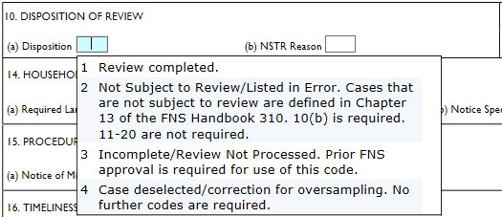

(b) NSTR Reason
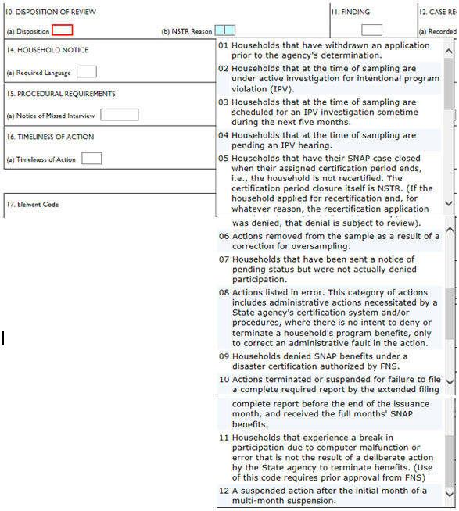

Item 11 (FINDING)
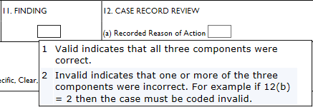

Item 12 (CASE RECORD REVIEW)

(a) Recorded Reason of Action
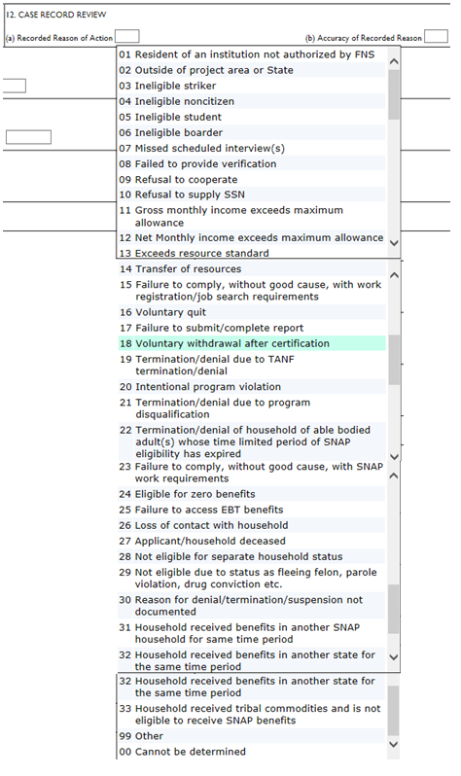

(b) Accuracy of Recorded Reason
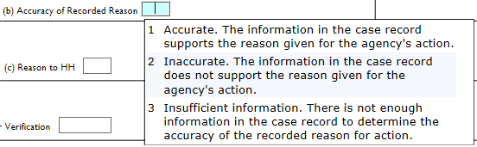

Item 13 (NOTICE REQUIREMENT)
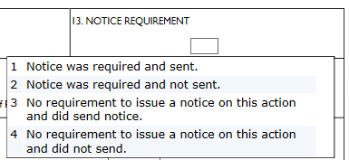

Item 14 (HOUSEHOLD NOTICE)

- Required Language
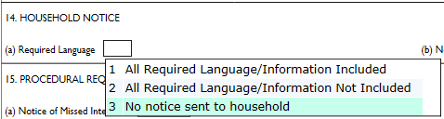

- Notice Specific, Clear, Understandable
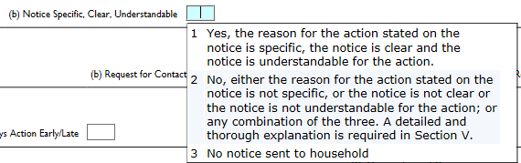

- Reason to HH
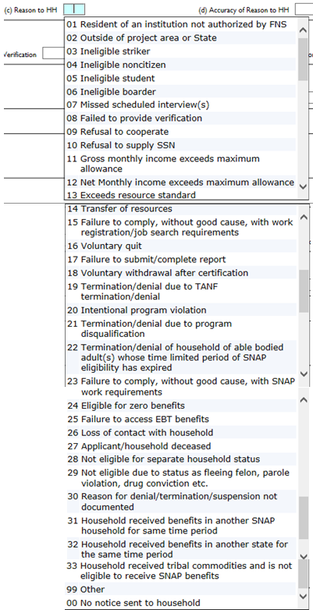

- Accuracy of Reason to HH
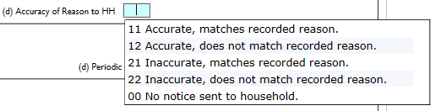

Item 15 (Procedural Requirements)

(a) Notice of Missed Interview
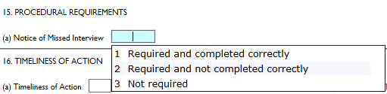

(b) Request for Contact
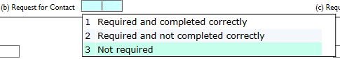

(c) Request for Verification
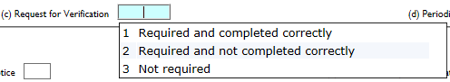

(d) Periodic Report
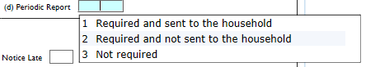

Item 16 (Timeliness of Action)

(a) Timeliness of Action
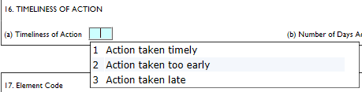
(b) Number of Days Action Early/Late

(c) Timeliness of Notice
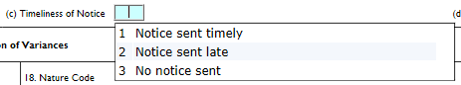

(d) Number of Days Notice Late

Item 17 (Element Code)
1.

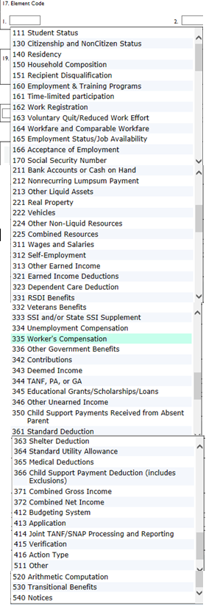

2.

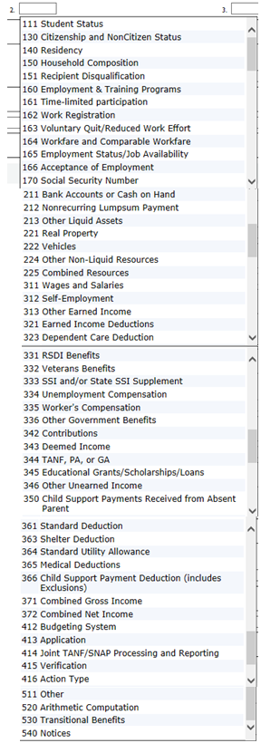

3.
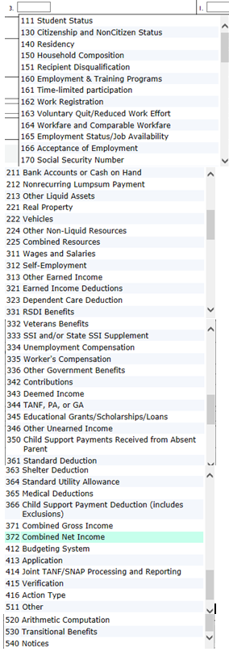

Item 18 (Nature Code)

1.

Nature Code

(Element Code = 111 Student Status)

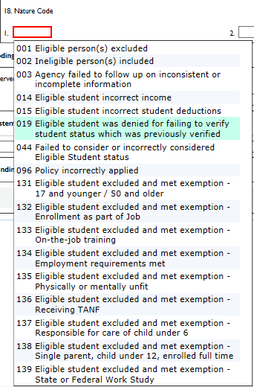

Nature Code

(Element Code = 130 Citizenship and NonCitizen Status)

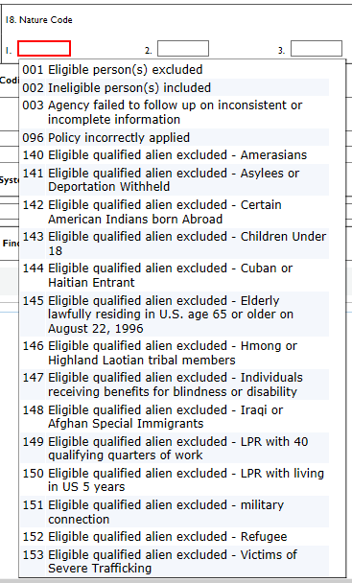

Nature Code

(Element Code = 140 Residency)

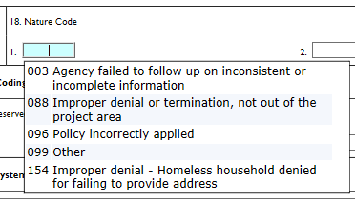

Nature Code

(Element Code =150 Household Composition)

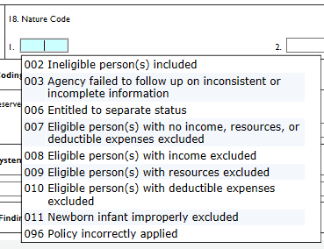

Nature Code

(Element Code = 151 Recipient Disqualification)
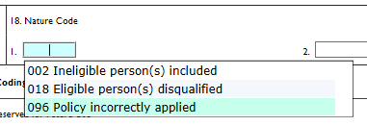

Nature Code

(Element Code = 160 Employment & Training Programs)

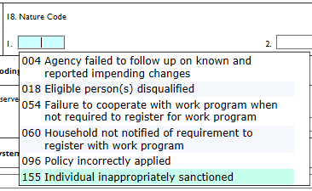
Nature Code

(Element Code = 161 Time-limited participation)

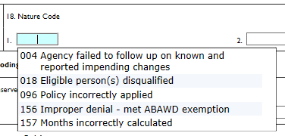
Nature Code

(Element Code = 162 Work Registration)

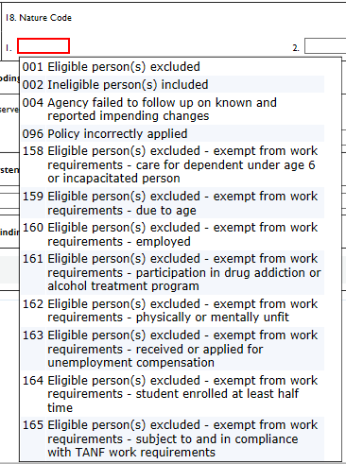

Nature Code

(Element Code = 163 Voluntary Quit/Reduced Work Effort)

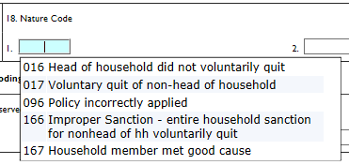
Nature Code

(Element Code = 164 Workfare and Comparable Workfare)

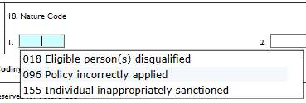

Nature Code

(Element Code = 165 Employment Status/Job Availability)

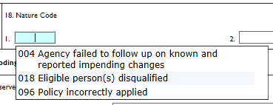

Nature Code

(Element Code = 166 Acceptance of Employment)

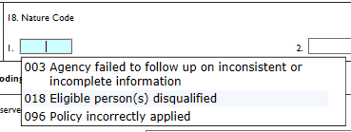
Nature Code

(Element Code = 170 Social Security Number)
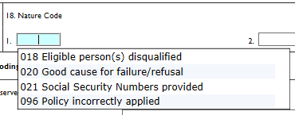

(Element Code = 211 Bank Accounts or Cash on Hand)
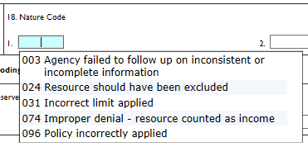

(Element Code = 212 Nonrecurring Lumpsum Payment)
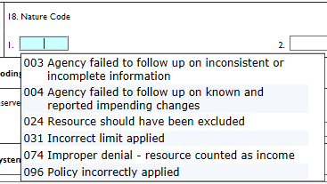

(Element Code = 213 Other Liquid Assets)
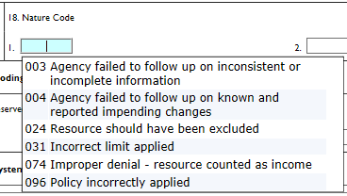

(Element Code = 221 Real Property)
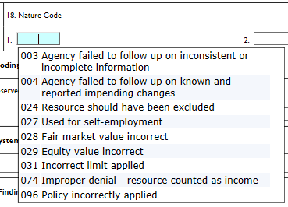

(Element Code = 222 Vehicles)
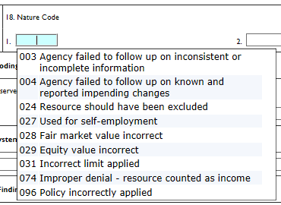

(Element Code = 224 Other Non-Liquid Resources)
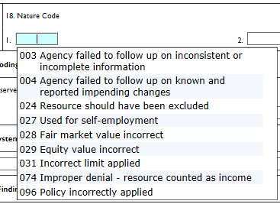

(Element Code = 225 Combined Resources)
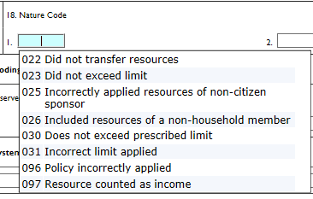

(Element Code = 311 Wages and Salaries)
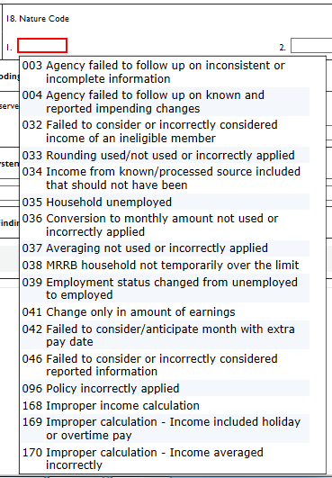

(Element Code = 312 Self-Employment)
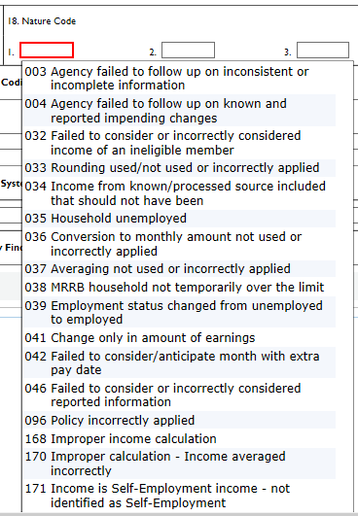

(Element Code = 313 Other Earned Income)
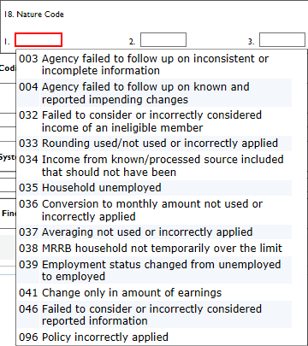

(Element Code = 321 Earned Income Deductions)
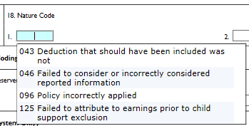

(Element Code = 323 Dependent Care Deduction)
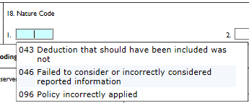

(Element Code = 331 RSDI Benefits)
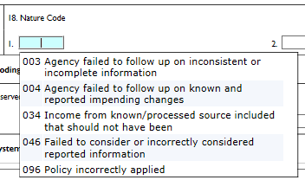

(Element Code = 332 Veterans Benefits )
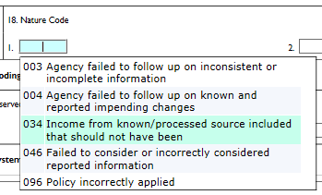

(Element Code = 333 SSI and/or State SSI Supplement)
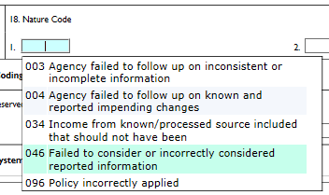

(Element Code = 334 Unemployment Compensation)
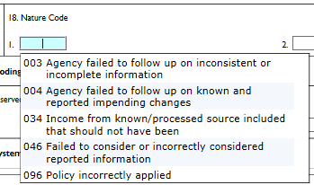

(Element Code = 335 Worker’s Compensation)
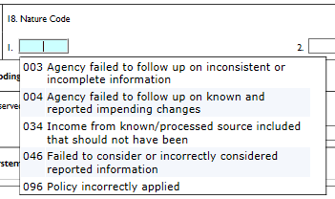

(Element Code = 336 Other Government Benefits)
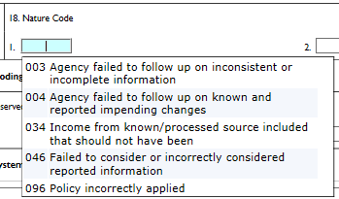

(Element Code = 342 Contributions)
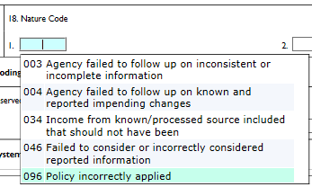

(Element Code = 343 Deemed Income)
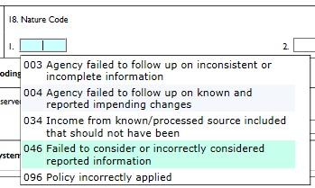

(Element Code = 344 TANF, PA, or GA)
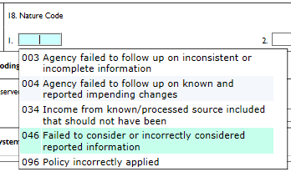

(Element Code =345 Educational Grants/Scholarships/Loans)
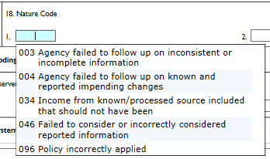

(Element Code = 346 Other Unearned Income)
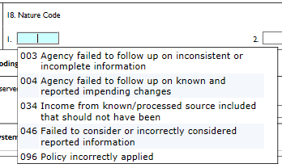

(Element Code = 350 Child Support Payments Received from Absent Parent)
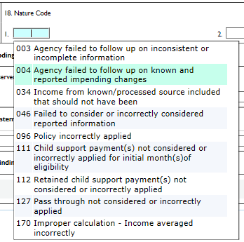

(Element Code = 361 Standard Deduction)
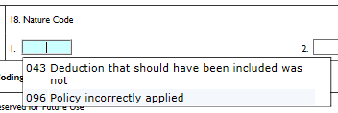

(Element Code = 363 Shelter Deduction)
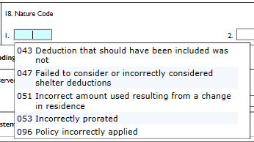

(Element Code = 364 Standard Utility Allowance)
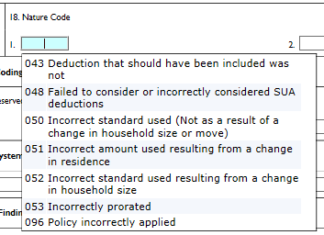

(Element Code = 365 Medical Deductions)
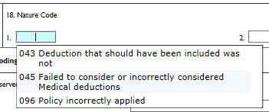

(Element Code = 366 Child Support Payment Deduction (includes Exclusions)
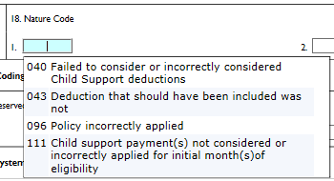

(Element Code = 371 Combined Gross Income)
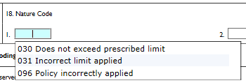

(Element Code = 372 Combined Net Income)
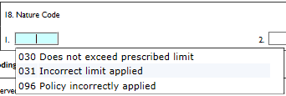

(Element Code = 412 Budgeting System)
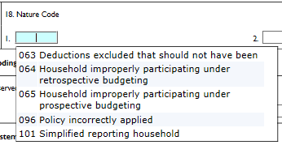

(Element Code = 413 Application)
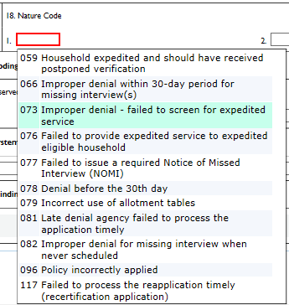

(Element Code = 414 Joint TANF/SNAP Processing and Reporting)
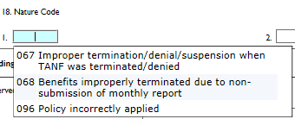

Nature Code

(Element Code = 415 Verification)
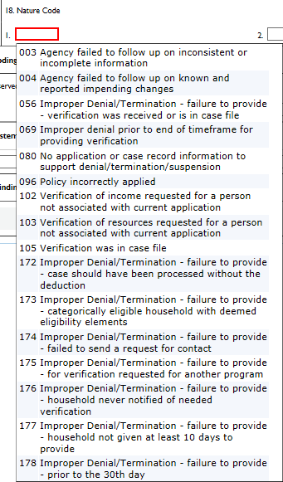

Nature Code

(Element Code = 416 Action Type)
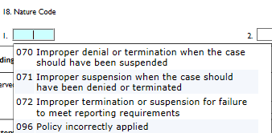

Nature Code

(Element Code = 511 other)
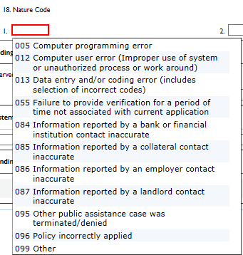

Nature Code

(Element Code = 520 Arithmetic Computation)
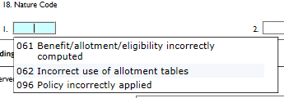

Nature Code

(Element Code = 530 Transitional Benefits)
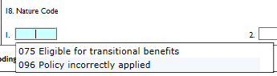

Nature Code

(Element Code = 540 Notices)
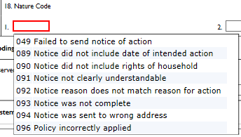

Nature Code

2. Results are the same as listed under 17 Element code 1.

Nature Code

3. Results are the same as listed under 17 Element code 1.

Item 19 (Collateral and/or Household Contact)

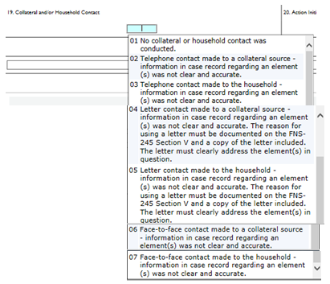

Item 20 (Action Initiated By)

