L.3 NATIONAL SCHOOL MEALS BROCHURE

Who is conducting the study?
Mathematica Policy Research and its research partners Westat, Inc. and Decision Information Resources are conducting the study for USDA. Each of these organizations has more than 25 years of experience studying school nutrition programs.

Is my household required to participate?
Your participation is entirely voluntary. You may refuse to answer any question during the interview. However, your answers are important to make your voice heard about your participation in the school meal program.

Do I have to participate?
The information you provide will help the USDA and the Congress make decisions about our National School Breakfast and Lunch Programs. They want to make sure the federal dollars supporting free and reduced-price school meals are reaching children who truly need those meals. Your participation and your opinions of the school meal program in your child’s school are vital to understanding how the program might be improved. To thank you for completing the interview, you will receive a $25 gift card.

Why are you asking about income?

Income information will help document how accurately school districts run the school meal programs. Your accuracy in responding to the questions is important to the success of this study. The answers you provide will be private and will be used for policy and planning purposes only. The information you provide will not affect the reimbursements your child’s school receives, or your household’s or child’s eligibility to receive school meals.

For further information contact:

Eric Zeidman
National School Meals Study
P.O. Box 2393
Princeton, NJ 08543-2393

Phone: 866-xxx-xxxx
Fax: 609-799-0005

Visit our websites:
www.mathematica-mpr.com
www.westat.com,
www.dir-online.com

OMB Approval No.:0584-0530
Approval Expires:

Ensuring Access to
Nutritious Meals:
National School Meals Study



USDA is an equal opportunity provider and employer

NATIONAL SCHOOL MEALS STUDY

Why is this study being done?

The U.S. Department of Agriculture (USDA) is sponsoring this study to learn about children and their households who participate in the school meal program. The USDA is sponsoring this survey to broaden its understanding of how the school meal programs get nutritious meals to those who need them.

Why did you choose my child and household?

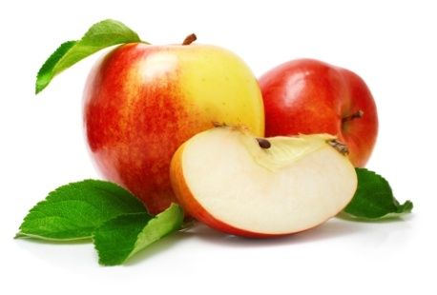
Your child was randomly selected from a list of households that applied for the school meal program or was directly approved for free meals. The survey is designed to represent all these students in your school district, regardless of whether they ever ate the school breakfast or lunch. The information you provide is essential to obtain an accurate picture of households’ participation in the school meal program.
If my child does not eat the school breakfast or lunch, should I still participate?

Yes. Even if your child has never eaten the school breakfast or lunch, we need your information in order to better understand how the school breakfast and lunch program is working in your school district. We also want to understand why parents choose not to participate in the school meal program.

Will my answers be kept private?
All information gathered for the study is private to the full extent allowed by law. The person who will interview you is prohibited from disclosing your personal information to anyone other than authorized research staff. No information on individual children will be reported. The study results will be summarized in such a way that no family can ever be identified.
According to the Paperwork Reduction Act of 1995, no persons are required to respond to a collection of information unless it displays a valid OMB control number. The valid OMB control number for this information collection is 0584-0530. The time required to complete this information collection is estimated to average 3-5 minutes per response, including the time to review instructions, search existing data resources, gather the data needed, and complete and review the information collection.
What will I be asked?

The person who interviews you may ask about:
- Participation in the school breakfast and lunch programs
- Perceptions of school meals
- Household characteristics
- Eligibility factors including household size and income sources

How long will the interview take?

The interview, which will be done in person, usually takes about 45 minutes. To thank you for participating, you will receive a $25 gift card.

For further information or to schedule an interview, please call toll-free:
Eric Zeidman 1-8xx-xxx xxxx
SchoolMealsStudy@mathematica-mpr.com

National School Meals Study

Sponsored by the U.S. Department of Agriculture
Conducted by
Mathematica Policy Research
Westat, Inc.
Decision Information Resources

