OMB Number: 0584-0530
Expiration Date: XX/XX/XXXX

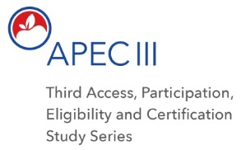

Dear <<SFA CONTACT NAME>>,

Thank you again for participating in the Access, Participation, Eligibility and Certification Study (APEC III) series.

This email serves as a friendly reminder of your upcoming APEC III data collection visit on [DAY, MONTH, DATE, YEAR at TIME].

Your data collector is [DATA COLLECTOR NAME].

If you have any questions, please feel free to contact the research team at 1-855-820-6138 or email us at schoolmealstudy@westat.com.

Thank you,

The APEC III Research Team
1-855-820-6138
schoolmealstudy@westat.com

According to the Paperwork Reduction Act of 1995, an agency may not conduct or sponsor, and a person is not required to respond to, a collection of information unless it displays a valid OMB control number. The valid OMB control number for this information collection is 0584-0530. The time required for the SFA Director to provide this information collection is estimated to average 3 minutes per response, including the time to review instructions, search existing data resources, gather and maintain the data needed, and complete and review the collection of information.

