OMB Number: 0584-0530
Expiration Date: XX/XX/XXXX
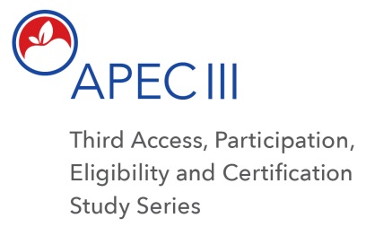

Dear <<SFA CONTACT NAME>>,

Thank you again for participating in the third Access, Participation, Eligibility and Certification Study (APEC III) series.

As we discussed, we are following up on the APEC III data collection conducted in <INSERT MONTH OF PRIOR VISIT> to see if there has there been any new meal applications submitted since our last data collection visit.

We request that you provide an update by completing a brief web-based survey. Please see the survey questions on the next page. Your response will help us prepare for the next steps, and provide any technical assistance you may need. Please complete this survey within the next 5 days. You can access the survey by clicking this link: [INSERT LINK TO WEB BASED SURVEY]

If you have any questions, please feel free to contact the research team at 1-855-820-6138 or email us at schoolmealstudy@westat.com. Thank you in advance for your help and cooperation.

Thank you again for your participation and cooperation.
Regards,
The APEC III Research Team
1-855-820-6138
schoolmealstudy@westat.com

According to the Paperwork Reduction Act of 1995, an agency may not conduct or sponsor, and a person is not required to respond to, a collection of information unless it displays a valid OMB control number. The valid OMB control number for this information collection is 0584-0530. The time required for the SFA Director to complete this information collection is estimated to average 10 minutes per response, including the time to review instructions, search existing data sources, gather and maintain the data needed, and complete and review the collection of information.

These are the questions in the web based survey:

- Have you received any new applications since the last data collection visit?

Yes (Go to Q2) No (Go to Q4)

- How many new applications have you received since the last data collection visit?

- Please provide a date and time within the next two weeks in which the data collector can conduct a brief in-person data collection visit. As a reminder, the data collector will only need access to the records for approximately 30 minutes while at the SFA. You can also call us at the study toll free number (listed below) to schedule the visit for a day that is convenient for you.

[END OF SURVEY FOR RESPONDENTS WHO ANSWERED YES TO Q1]

- Thank you for notifying us that you have not received any new applications. We will update our records. No further action is needed at this time. We will follow up with you again in a few months.

