|  |
| --- |
| OMB Number: 0584-0530  Expiration Date: XX/XX/XXXX |

**NOTE TO REVIEWER:**

This appendix provides an example of the information the data collector will enter into the sampling program and the results. This will ensure that the data collector observes a randomly selected cafeteria line (or other location) for observation.

The information entered in the sampling program would have been previously collected during the School Pre-visit Interview (Appendix C1).

The sampling program is an administrative tool and will not be used to collect new information. There is no respondent burden for this task.

According to the Paperwork Reduction Act of 1995, an agency may not conduct or sponsor, and a person is not required to respond to, a collection of information unless it displays a valid OMB control number. The valid OMB control number for this information collection is 0584-0530. The time required for the school principal and/or cafeteria manager to provide this information collection is estimated to average 20 minutes per response, including the time to review instructions, search existing data resources, gather and maintain the data needed, and complete and review the collection of information.

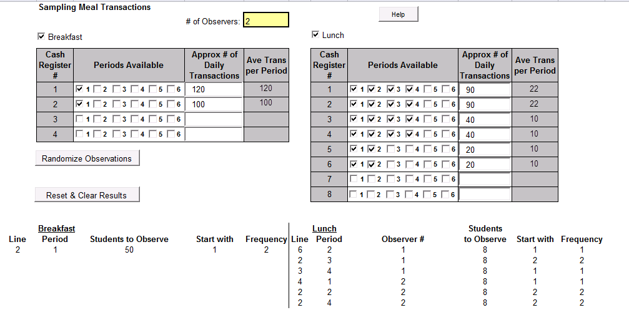

The example above shows the sampling results for breakfast (1 period, 2 cash registers and 120 daily transactions at one register and 100 daily transactions at the second register) and lunch (4 periods, 6 cash registers and the specified number of daily transactions at each register above).

For APEC III, there will typically be two data collectors conducting the meal observation. The data collectors would check the appropriate boxes to indicate the number of meal periods at each cash register and enter the approximate number of transactions for each period and cash register. Next, the data collector clicks “Randomize Observations.” The algorithm calculates and displays the results.

In this example, the data collectors would observe the following:

* Breakfast: One Data Collector would observe during Period 1, Line 2 as specified above
* Lunch: Data Collector/Observer 1 would observe during Period 2, Line 6, Period 3, Line 2 and Period 4, Line 3. Data Collector/Observer 2 would observe during Period 1, Line 4, Period 2, Line 2 and Period 4, Line 2 as specified above.