|  |
| --- |
| OMB Number: 0584-0530  Expiration Date: XX/XX/XXXX |

 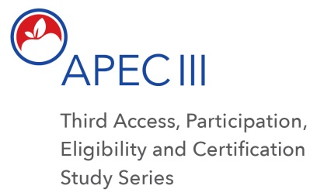

Dear <SFA PRIMARY CONTACT NAME>:

Thank you for agreeing to participate in the APEC III Study. We appreciate your help with confirming/updating information about the schools in your SFA. Your SFA’s participation will help us to maximize the efficiency of meal tracking and reporting within the program to help ensure the integrity, refinement, and continuity of both the NSLP and SBP. The Westat research team will contact you in Fall 2017 to begin data collection.

Data collection efforts at the SFA, school and household-levels will focus on school breakfast and lunch meal programs and will include the following:

1. Pre-visit interview with sampled SFAs and school personnel;
2. Review and abstraction of applications for meal benefits;
3. Observation of meal service at schools;
4. Brief interview with cafeteria managers to gather qualitative information about meal claiming procedures and process;
5. Review and abstraction of school and SFA meal counting and claiming records;
6. Household survey (in person) with a sample of parents/guardians of students that applied for meal benefits. [Note that the household survey component of APEC III is entitled National School Meals Study];
7. An in-depth phone interview with a sub-set of parents/guardians that completed the Household survey to gather qualitative information about their application process and experience;
8. SFA Director survey (web-based) with questions regarding characteristics and processes; and
9. An in-depth phone interview with a sub-set of SFA Directors to gather qualitative information on the process for eligibility determination and potential sources of error.

If you have any questions, please contact us by responding to this email or calling 1-855-820-6138.

We appreciate your time and participation in APEC III.

Sincerely,

The APEC III Research Team

According to the Paperwork Reduction Act of 1995, an agency may not conduct or sponsor, and a person is not required to respond to, a collection of information unless it displays a valid OMB control number. The valid OMB control number for this information collection is 0584-0530. The time required for the SFA Director to complete this information collection is estimated to average 5 minutes per response, including the time to review instructions, search existing data sources, gather and maintain the data needed, and complete and review the collection of information.