|  |
| --- |
| OMB Number: 0584-0530  Expiration Date: XX/XX/XXXX |

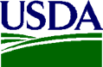 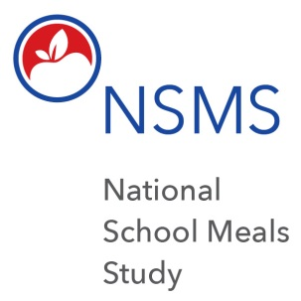

Dear Jane Doe:

I am writing to ask for your help with an important study, **the National School Meals Study (NSMS)** sponsored by the Food and Nutrition Service (FNS) of the U.S. Department of Agriculture (USDA). The USDA wants to know about people’s experiences with school lunch and breakfast meal programs. Your name was selected at random from families whose children go to school in the [SCHOOL DISTRICT NAME]. We encourage you to take part in the study even if your child does not eat a lunch or breakfast provided by the school. Your experience and opinions are still very important.

The FNS has hired Westat conduct this study. Westat is a private research company, located in Rockville, Maryland, with more than 50 years’ experience doing surveys and collecting data.

If you become part of the NSMS Study, **you will receive up to $50 as a thank you for your time in completing the survey.** The total amount depends on the tasks you do. You will get $30for completingthe survey and you can get $20 more if you provide documents to verify your income.

**About This Study**

* It is your choice to participate in the National School Meals Study, or not.
* There are no penalties if you decide not to participate.
* If you do join, we take special steps to keep everything you tell us private to the extent allowed by law.
* Your participation in the survey will not affect your eligibility for school meals, either now or in the future. The survey is for research purposes only to help FNS improve its programs.

According to the Paperwork Reduction Act of 1995, an agency may not conduct or sponsor, and a person is not required to respond to, a collection of information unless it displays a valid OMB control number. The valid OMB control number for this information collection is 0584-0530. The time required to complete this information collection is estimated to average 5 minutes per response, including the time to review instructions, search existing data sources, gather and maintain the data needed, and complete and review the collection of information.

* Your answers will only be seen by Westat researchers doing this study and our report to FNS will combine your answers with those from others to summarize what we found. Your or your child’s name or address will never be used.
* If you decide to participate, we will ask you to speak with an interviewer at your home (or another place you prefer) to answer questions from a survey.
* The survey asks about your experiences with school lunches and breakfast, your opinions about them and eligibility for meal benefits.
* The survey also asks about the people who live with you, and your family’s income. We will ask you to do an income worksheet and gather proof of income to prepare for the interview.

Again, survey questions are only for research purposes. Nothing you say is shared with FNS, the school district, or any agency that provides benefits to your household. Input from people like you is important so we can get as complete a picture as possible.

**Next Steps**

* Someone from the NSMS Study will contact you within a few days to talk about the study, answer your questions, and schedule your survey.

If you have questions before we call you, please contact us at 1-855-820-6138 or [schoolmealstudy@westat.com](mailto:schoolmealstudy@westat.com).

A study brochure is enclosed to provide more details. Thank you for thinking about the study.

Sincerely,

<SIGNATURE>

National School Meals Study

Enclosure: National School Meals Study brochure