NOTE TO REVIEWER:
This appendix includes the following:

- Template E-Letter from FNS Regional Liason to State Child Nutrition Director
  - Estimated burden to State to review the letter is 5 minutes

- Template of a spreadsheet for the State Child Nutrition Director to provide contact information
  - Estimated burden to State to complete the spreadsheet is 5 minutes

- Template SFA Sample Notification E-Letter from State Child Nutrition Director to SFA Director (attachment to letter)
  - This is a sample letter that the State Child Nutrition Director may or may not choose to use to notify SFAs
  - This was requested, but not required
  - Estimated burden to State to review/edit/send letter (if used) is 5 minutes

The Total Burden to State for Appendix O2 is 15 minutes.

The Burden to the SFA to read the notification letter (#c above) from the State (if used) is 5 minutes.

OMB Number: 0584-0530
Expiration Date: XX/XX/XXXX
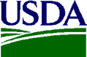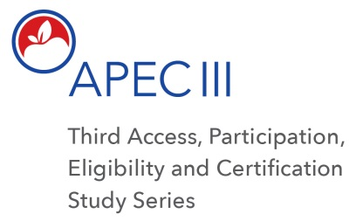

Dear <<STATE CHILD NUTRITION DIRECTOR>>:

The U.S. Department of Agriculture’s (USDA) Food and Nutrition Service (FNS) has contracted with Westat, Inc. to administer the third Access, Participation, Eligibility and Certification Study Series (APEC III). As the State Child Nutrition Director involved in the National School Lunch Program (NSLP) and the School Breakfast Program (SBP), your cooperation is expected and greatly appreciated.

The APEC studies are mandated by Congress to help ensure FNS’ compliance with the Improper Payments Elimination and Recovery Improvement Act (IPERIA) of 2010 (PL 111-204). APEC III also complies with the Healthy, Hunger-Free Kids Act of 2010.

APEC III data collection will take place during school year (SY) 2017 – 2018. The data collected will be used to:

- Generate a national estimate of the annual amount of erroneous payments;
- Provide a robust examination of the student (household), school, and School Food Authorities (SFAs) characteristics that may contribute to or mitigate error;
- Conduct a sub-study on the differences in error rates among SFAs using different implementation strategies in their school meals program, and
- Complete qualitative analyses to better understand the sources of errors and how to potentially address them.
All information collected will be used for research purposes only and kept private to the extent provided by law. The information collected will not affect meal reimbursements or meal program benefits for any participating State agency, school food authority (SFA), school and/or school cafeteria staff members, or students/households.

According to the Paperwork Reduction Act of 1995, an agency may not conduct or sponsor, and a person is not required to respond to, a collection of information unless it displays a valid OMB control number. The valid OMB control number for this information collection is 0584-0530. The time required for State Child Nutrition Director to complete this information collection is estimated to average 15 minutes per response,to review the letter, complete the spreadsheet and notify SFAs..

Using the Form FNS-742 SFA Verification Collection Report Summary data, Westat created the sample frame. The selected sample includes School Food Authorities (SFAs) in <STATE>.

We currently have two requests as part of your participation:

- First, we would like to obtain contact information for:

      - A member of your staff who will serve as a point of contact for this study and,

- Contact information of the SFA Directors of the SFAs from your State sampled for APEC III.

Using the spreadsheet template below, please record the contact information for your staff member who will serve as the point of contact for the study on the top row.

Below that is a list of SFAs in your State who have been sampled to participate in APEC III. Please provide the contact information for the SFA director for each SFA listed. Please email the completed spreadsheet back to my office within 10 days.

Spreadsheet Template:

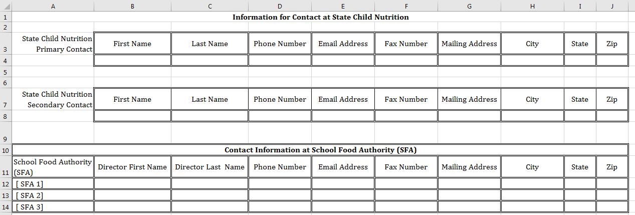

- Second, we request that you contact the SFAs identified in the spreadsheet to inform them that they have been selected into the sample, explain why their participation in the study is important, and encourage their participation. Attached you will find template letter that you can use to draft your communications to sampled SFA.

A member of the APEC III Research team will contact you within a week to follow up and answer any questions you may have regarding this request, and to solicit any suggestions you may have for working with your SFAs effectively in conducting the study.

This is a very important national and federally mandated study. Your assistance is critical to ensure a representative sample, scientifically valid findings and improvements to the NSLP and SBP.

Thank you in advance for help and cooperation.

Sincerely,

<NAME AND TITLE OF SENDER>
Attachment: Template SFA Sample Notification E-Letter From State Child Nutrition Director to
SFA Director

Attachment: Template SFA Sample Notification E-Letter From State Child Nutrition Director to SFA Director

OMB Number: 0584-0530
Expiration Date: XX/XX/XXXX

Dear <<SFA DIRECTOR>>:

The U.S. Department of Agriculture’s (USDA) Food and Nutrition Service (FNS) has contracted with Westat, Inc. to administer the third Access, Participation, Eligibility and Certification Study Series (APEC III).

Under the Improper Payments Elimination and Recovery Improvement Act (IPERIA) of 2012, all Federal agencies that administer large programs are required to report these findings to the Office of Management and Budget (OMB). The goal of the study is to provide FNS with reliable, national estimates of erroneous payments in the National School Lunch Program (NSLP) and the School Breakfast Program (SBP) in school year (SY) 2017-2018 to be compliant with applicable regulations.

APEC III will include a nationally representative sample of school districts, schools (both Community Eligibility Provision [CEP] and non-CEP) and student households within those sampled districts. It will examine participation, eligibility, and certification of the NSLP and the SBP to estimate amounts and sources of erroneous reimbursements due to certification errors (administrative errors and household reporting errors) and meal counting errors, and meal claiming errors (cashier claiming of meals as reimbursable).

Using the Form FNS-742 SFA Verification Collection Report Summary data, Westat created the sample frame. The selected sample includes School Food Authorities (SFAs) in <STATE>. The purpose of this letter is to inform you that your SFA has been selected for inclusion in this study.

Westat will contact you and provide further information about what is involved with your participation in this study. Your assistance is critical to ensure a representative sample, scientifically valid findings, and improvements to the NSLP and SBP.

Thank you in advance for your help and cooperation.

Sincerely,

<NAME AND TITLE OF SENDER>

According to the Paperwork Reduction Act of 1995, an agency may not conduct or sponsor, and a person is not required to respond to, a collection of information unless it displays a valid OMB control number. The valid OMB control number for this information collection is 0584-0530. The time required for the SFA Director to complete this information collection is estimated to average 5 minutes per response, including the time to review the letter.

