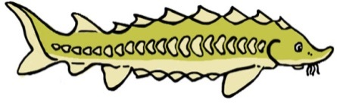

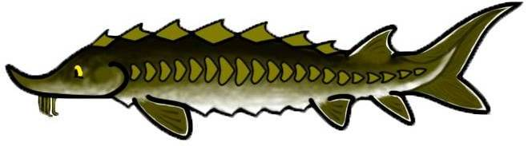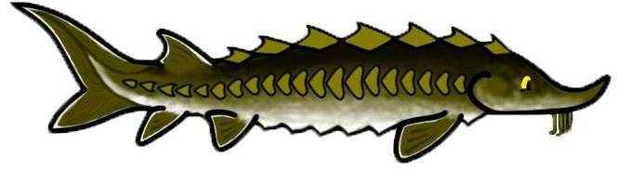SCUTES Middle - High School Educational Kit Evaluation

Dear Educator,

We hope you and your students enjoyed the lessons on Atlantic and shortnose sturgeon in the SCUTES educational kit. We would greatly appreciate your feedback about the activities and your experience with the kits. Your input will help us improve the SCUTES kit.

1. The following lessons are part of the SCUTES educational kit. Please check the box next to all the lesson plans that you used with your students/participants.

|  |  |  |  |
| --- | --- | --- | --- |
| SCUTES Logo**Science**   * Sturgeon Litter Tag * Adaptation * Food Chain Skit * Migration * Classifying Organisms * A Body of Knowledge * Adaptation to Life * Beating Extinction * Sampling Methods | * Anatomy Fish Dissection * Nets * Reproductive Strategies * Dichotomous Keys * Catch Restrictions * Sturgeon/Striped Bass Life Cycle      * Children’s Story * Stream Tables | **Math**   * Data Analysis * Swimbladder & Boyle’s Law   **History, Social Studies & Geography**   * Charting Sturgeon * Tracking Sturgeon * History of Sturgeon Fishing * Marine Migratory Species | **Language Arts**   * ABC Book * Grammar/Editing * Myths * Open Response * Spelling & Punctuation * Fishing for a Meaning * Implications & Inferences * Endangered Species Act Mock Public Hearing * Humans and Sturgeon: Great Debate |

2. Did the activities you used meet the required curriculum standards for your school/organization?

❑ Yes ❑ No ❑ Not Sure

*If no*, which activities or lessons failed to meet the standards and why?

3. Did you modify any of the lessons to fit your audience’s (i.e. students) needs?

❑ Yes ❑ No

*If yes*, how did you modify the activities or lessons?

4. In what class/grade(s) did you use SCUTES educational kit? ___________________

5. About how many students did you use the SCUTES educational kit with? _________

6. Please rate your level of agreement with the following statements based on your experience with the SCUTES educational kit.

|  |  |  |  |  |  |
| --- | --- | --- | --- | --- | --- |
| **The SCUTES educational kit activities and lesson plans:** | Strongly Disagree | Disagree | Neither | Agree | Strongly Agree |
| Had clear, easy to follow instructions. | 1 | 2 | 3 | 4 | 5 |
| Contained an adequate number of supplies I needed to complete the activities with my students. | 1 | 2 | 3 | 4 | 5 |
| Were at an appropriate reading level for students. | 1 | 2 | 3 | 4 | 5 |
| Had accurate estimated time frames (if applicable). | 1 | 2 | 3 | 4 | 5 |
| Aligned well with my curriculum. | 1 | 2 | 3 | 4 | 5 |
| Kept the students’ interest. | 1 | 2 | 3 | 4 | 5 |
| Increased my confidence in teaching students about sturgeon. | 1 | 2 | 3 | 4 | 5 |

**SCUTES Website**

7. Did you and your students visit the SCUTES website (<http://www.greateratlantic.fisheries.noaa.gov/scutes>) for information on sturgeon while participating in activities from the educational kit?

❑ Yes ❑ No

*If yes*, which web pages did you incorporate into your lessons?

* Student’s Page
* Teacher’s Page
* Activities, Games, Videos Page
* Sturgeon Information Page

8. Please share which activities or information from the web pages you think was most useful in conducting the SCUTES activities.

9. Do you have any suggestions for how to improve the SCUTES website?

**Student/Participant Outcomes**

The following questions are related to the impact of SCUTES on your students/participants:

10. To what extent did the SCUTES activities...

|  |  |  |  |
| --- | --- | --- | --- |
|  | **No Extent** | **Some Extent** | **Great Extent** |
| increase their knowledge about sturgeon? | 1 | 2 | 3 |
| increase their interest in sturgeon? | 1 | 2 | 3 |
| increase their knowledge in marine conservation? | 1 | 2 | 3 |
| increase their interest in marine conservation? | 1 | 2 | 3 |
| increase their perception of value on the importance of protecting Atlantic and shortnose sturgeon? | 1 | 2 | 3 |

11. Please describe an example of an event that supports the answer to one of the questions in question #10.

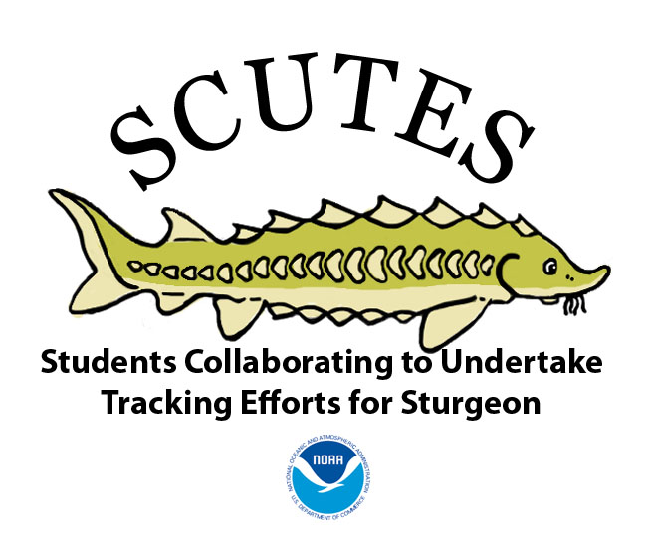

12. How did you find out about the SCUTES educational kit? *Check all that apply*

❑ Colleagues ❑ Web Site ❑ Workshop

❑ NOAA representative ❑ NMEA conference ❑ Other _____________________

13. Will you request a SCUTES educational kit in the future? ❑Yes ❑No

14. Would you recommend a SCUTES educational kit to other educators? ❑Yes ❑No

15. What were the strengths of the SCUTES educational kit?

16. How can we improve the SCUTES educational kit?

17. What other SCUTES topics would you like to see included in future educational kits?

1. ________________________________________________________________

2. ________________________________________________________________

3. ________________________________________________________________

**School/Organization**: ___________________________________________________________________

**Dates Kit Used**: ________________________________________________________________________

Please return this evaluation sheet with your kit or mail it to:

The Office of Protected Resources

NOAA Fisheries, Greater Atlantic Regional Fisheries Office

55 Great Republic Drive, Gloucester, MA 01930-2276

**Thanks for Participating in SCUTES!**