# Enclosure 1

The following documents will be cognitively tested as the proposed ACS mail materials for use in 2020.

## First Mailing to ACS Households in 2020

This mail package will contain the following items:

* ACS Initial Mailing Outgoing Envelopes – as shown below (ACS-46IMX)
* Intro Letter – as shown below (ACS-13(LX))
* Instruction Card - no changes
* Multilingual Brochure - no changes
* FAQ Brochure - no changes

### Front of Envelope for Testing, Mailing 1:

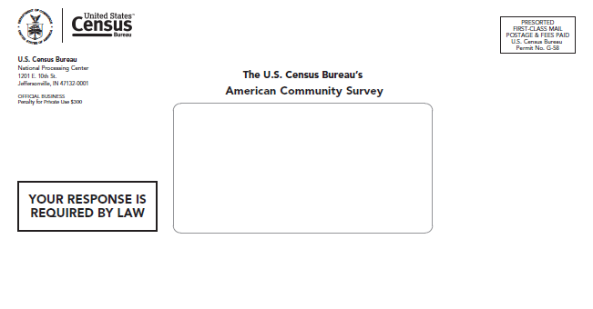

### Back of Envelope for Testing, Mailing 1:

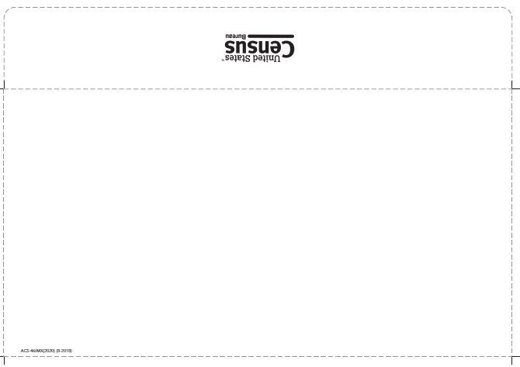

### Front of Letter for Testing, Mailing 1:

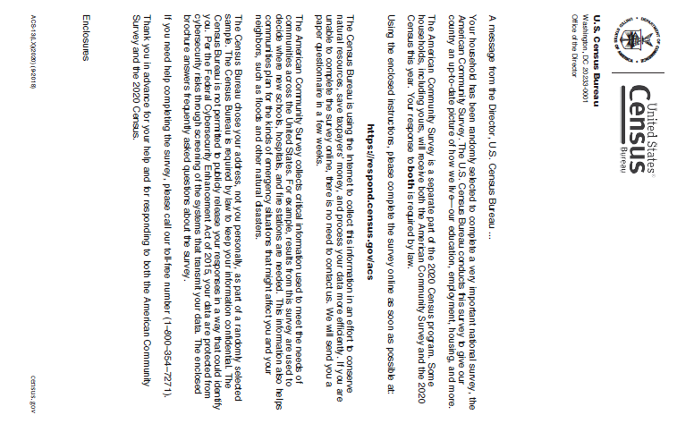

### Back of Letter for Testing, Mailing 1:

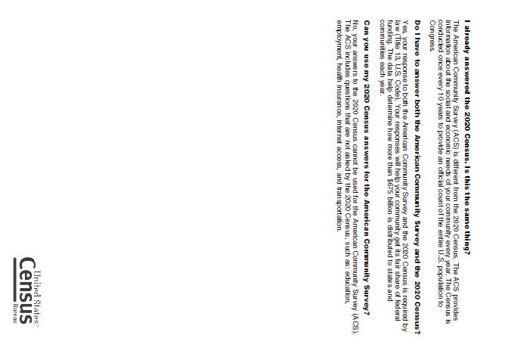

### Instruction Card, side 1

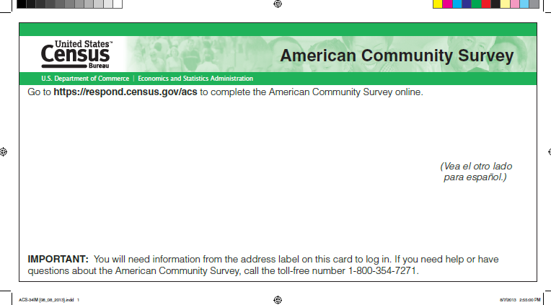

### Instruction Card, side 2

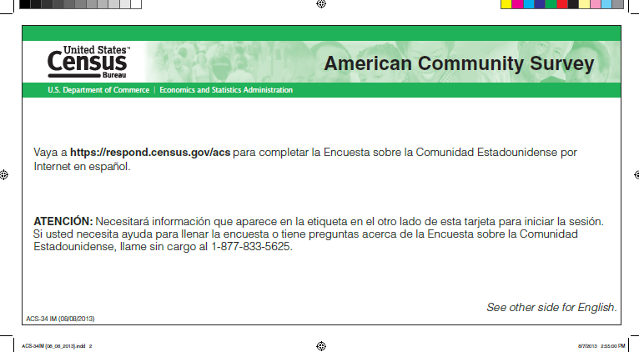

### Multilingual brochure, side 1

### Multilingual brochure, side 2

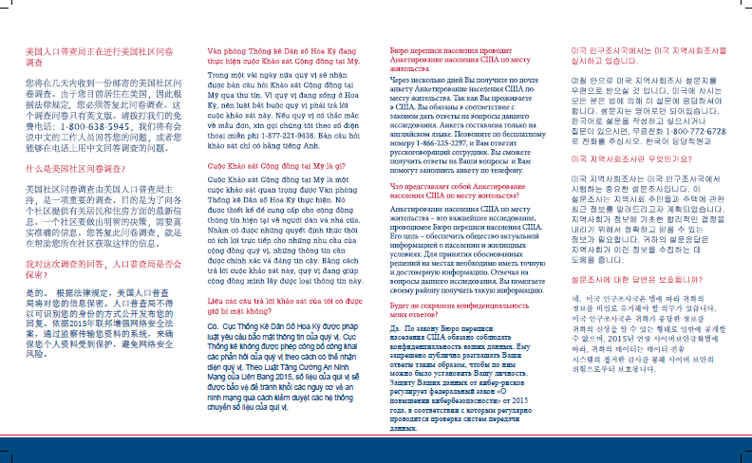

### FAQ Brochure, side 1

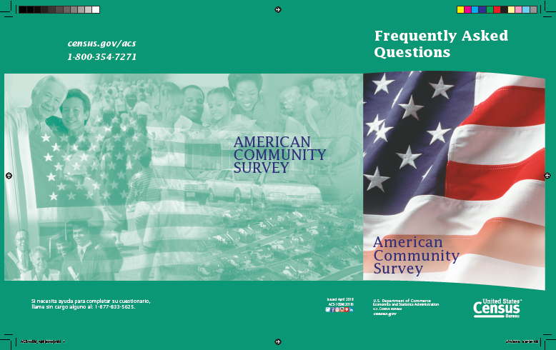

### FAQ Brochure, side 2

## Second Mailing to ACS Households in 2020

This mailing is a pressure-seal mailer with changes to both sides. The pressure seal mailer will be

ACS-20(LX)PST(2020).

### Outside of Pressure Seal Mailer for Testing, Mailing 2:

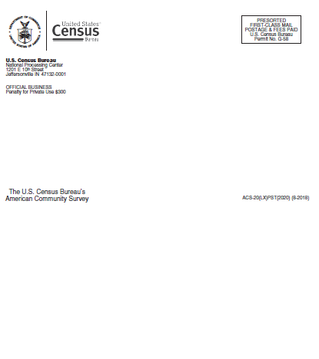

### Inside of Pressure Seal Mailer for Testing, Mailing 2:

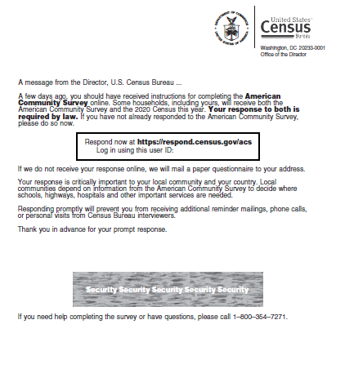

## Third Mailing to ACS Households in 2020

This mail package will contain the following items:

* ACS Outgoing Envelope – two versions to test, as shown below (ACS-46X and ACS-46XA)
* Letter – as shown below (ACS-14LX)
* Instruction Card - no changes
* FAQ brochure – no changes
* Questionnaire – no changes
* Incoming/Return envelope – no changes

### Front of Envelope for Testing, Mailing 3 v1:

### Back of Envelope for Testing, Mailing 3 v1:

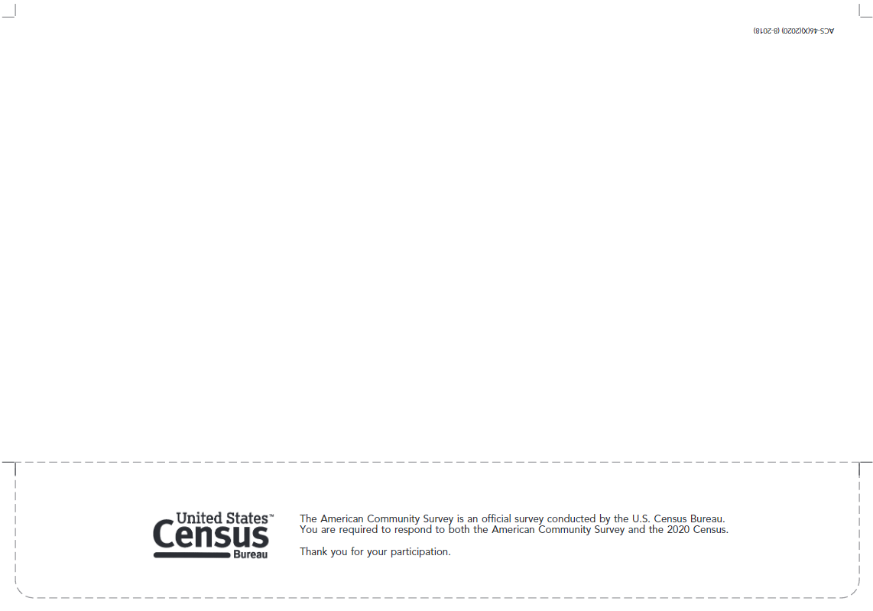

### Front of Envelope for Testing, Mailing 3, v2:

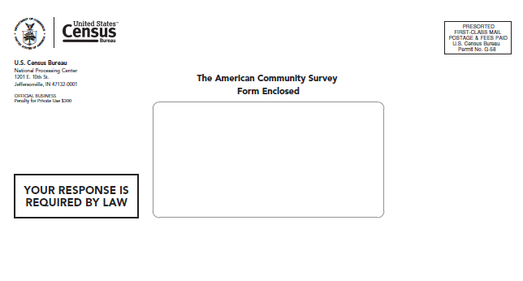

### Back of Envelope for Testing, Mailing 3, v2:

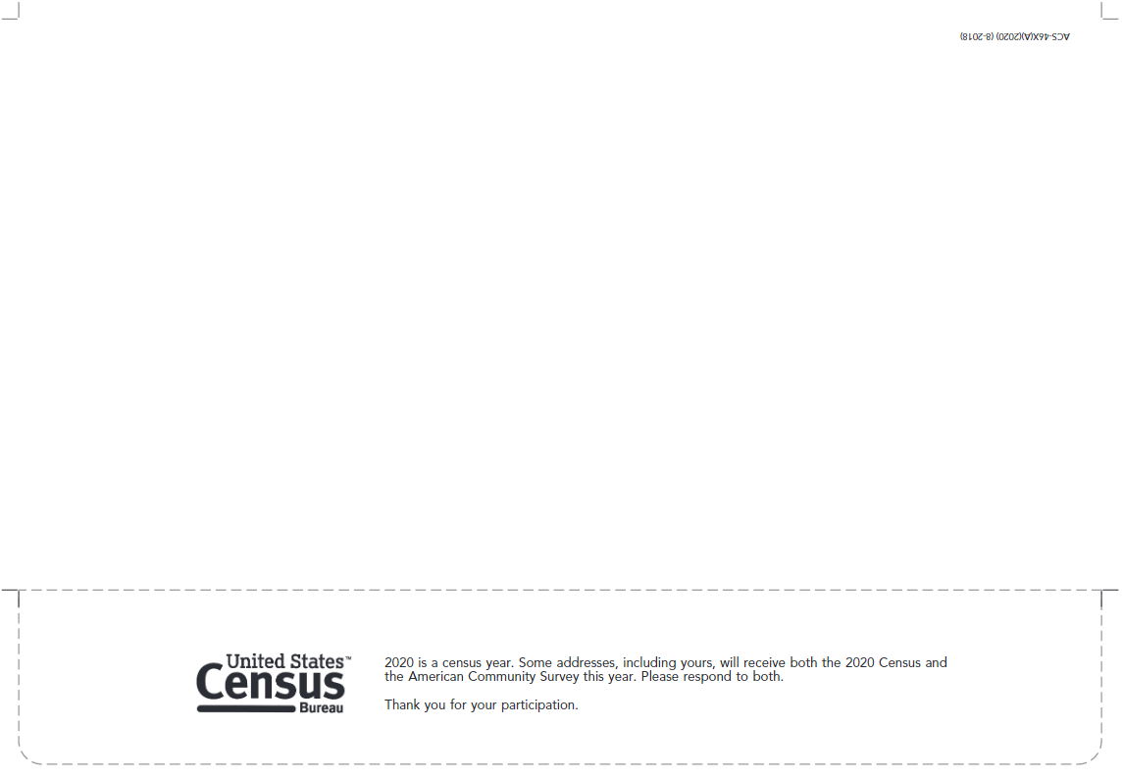

### Front of Letter for Testing, Mailing 3:

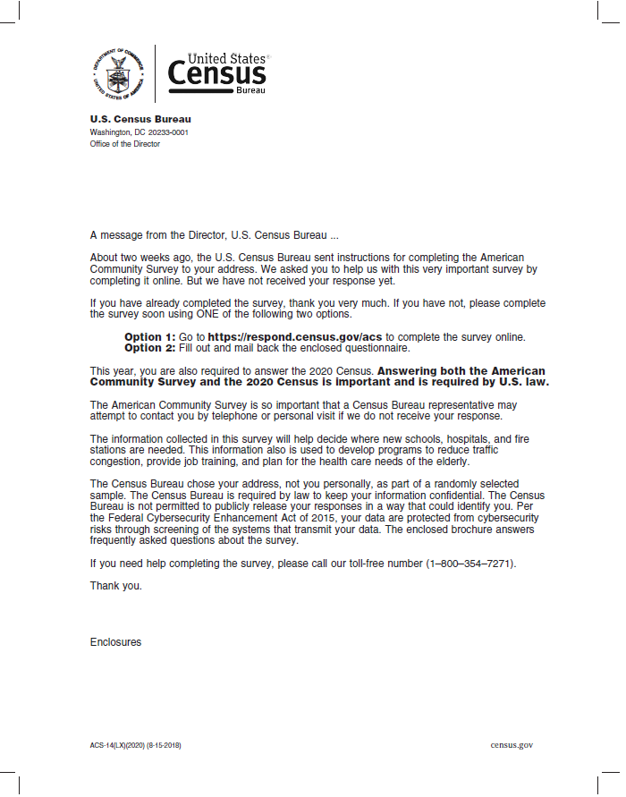

### Back of Letter for Testing, Mailing 3:

### Instruction Card, side 1



### Instruction Card, side 2



### FAQ Brochure, side 1



### FAQ Brochure, side 2

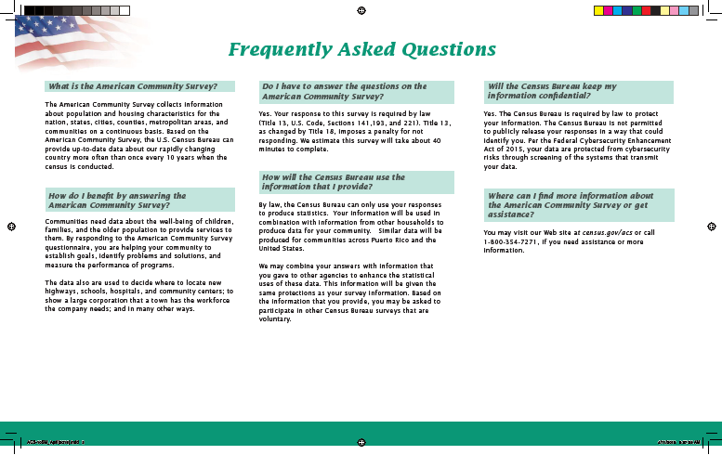

### Return Envelope

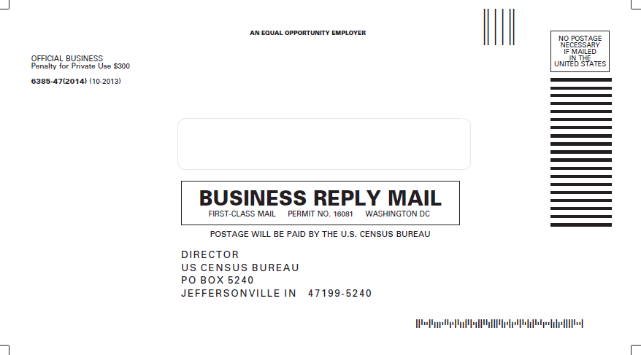

## Fourth Mailing to ACS Households in 2020

This mailing is a postcard (ACS-29LX) with changes to both sides.

### Address side of Postcard for Testing, Mailing 4:

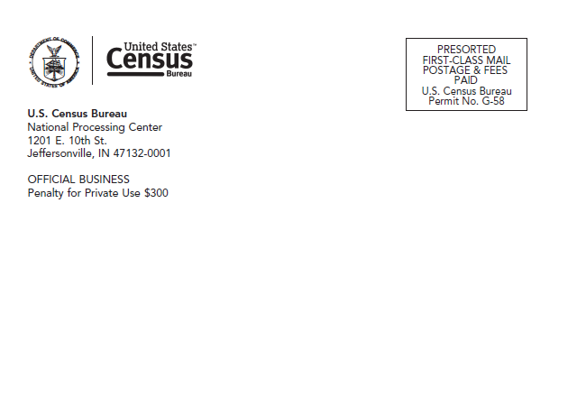

### Text side of Postcard for Testing, Mailing 4:

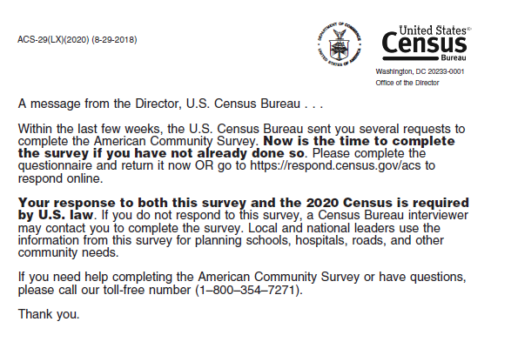

## Fifth Mailing to ACS Households in 2020

This mailing is a pressure sealed mailer (ACS-23LX) with changes to both sides.

### Outside of Pressure Seal Mailer for Testing, Mailing 5:

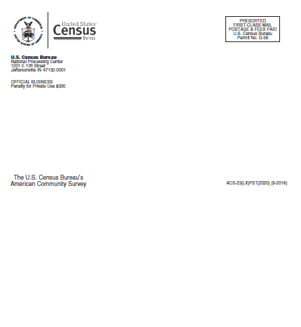

### Inside of Pressure Seal Mailer for Testing, Mailing 5:

