# Enclosure 3

The following documents will be cognitively tested as the planned **draft** 2020 Census mail materials. These materials will be used in 2020 for households in the Internet First, English Only strata.

## First Mailing to Households for the 2020 Census

This mail package will contain the following items:

* Invitation Letter
* Language Assistance Sheet
* Package Envelope

### Invitation Letter, front

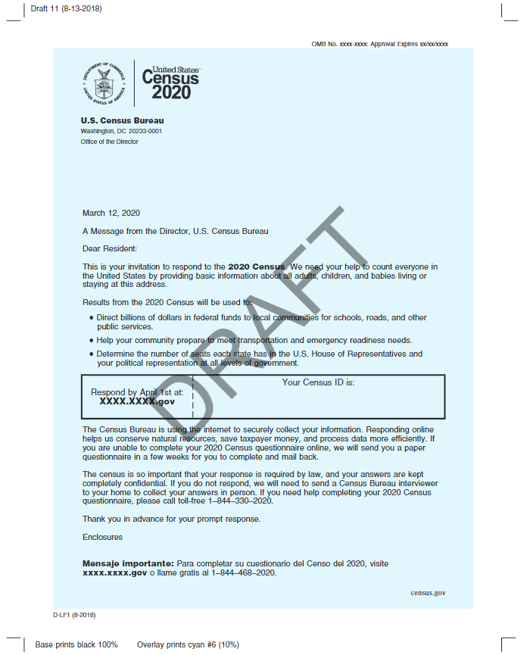

### Invitation Letter, back

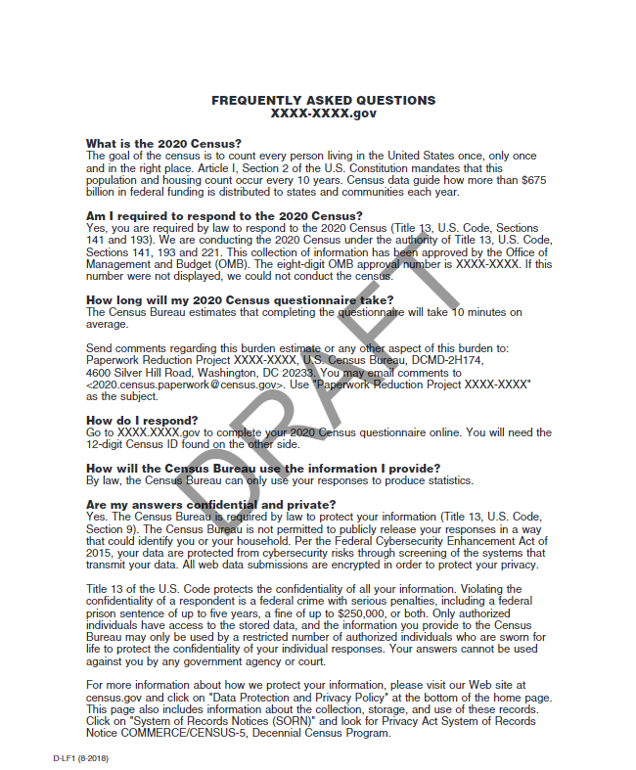

### Language Assistance Sheet, front

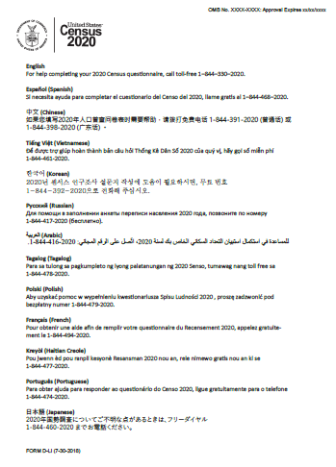

### Language Assistance Sheet, back

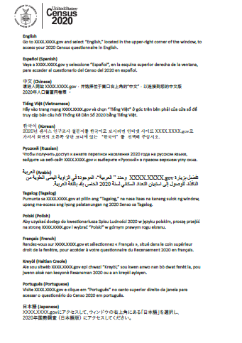

### Outbound envelope, front

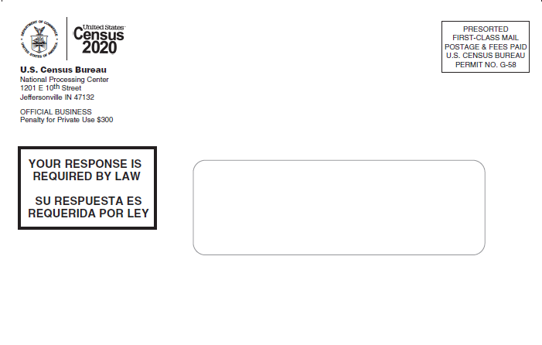

### Outbound envelope, back

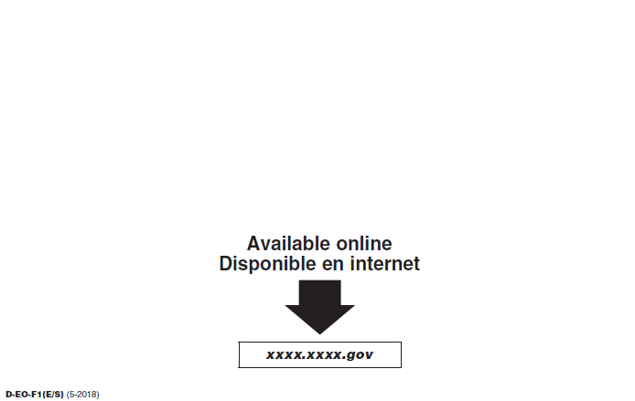

## Second Mailing to Households for the 2020 Census

This mail package will contain the following items:

* Reminder Letter
* Letter Envelope

### Reminder Letter

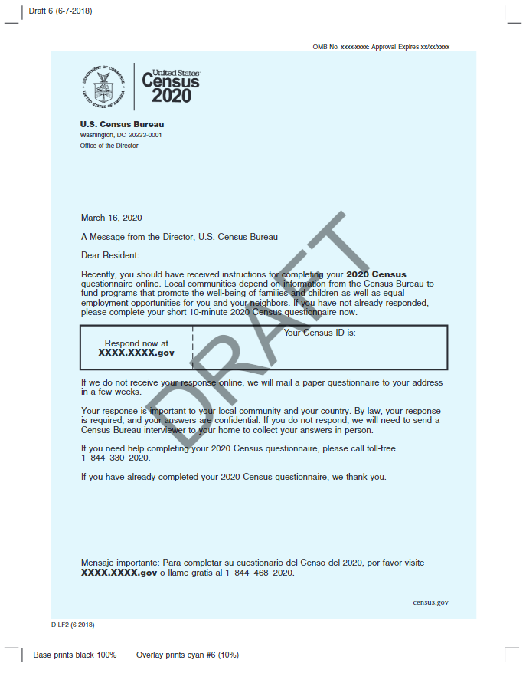

### Letter envelope, front

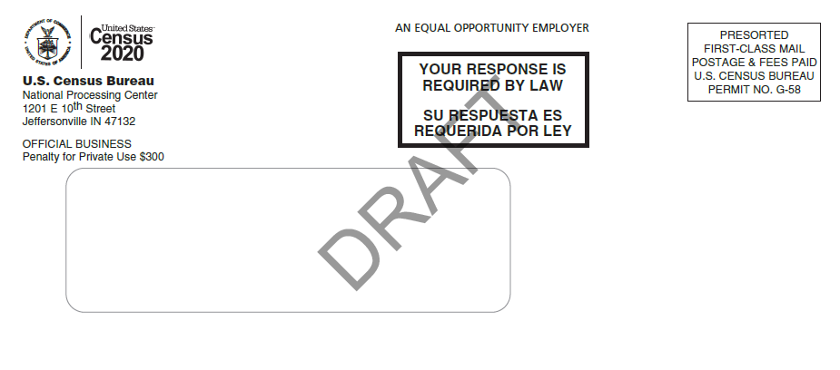

### Letter envelope, back

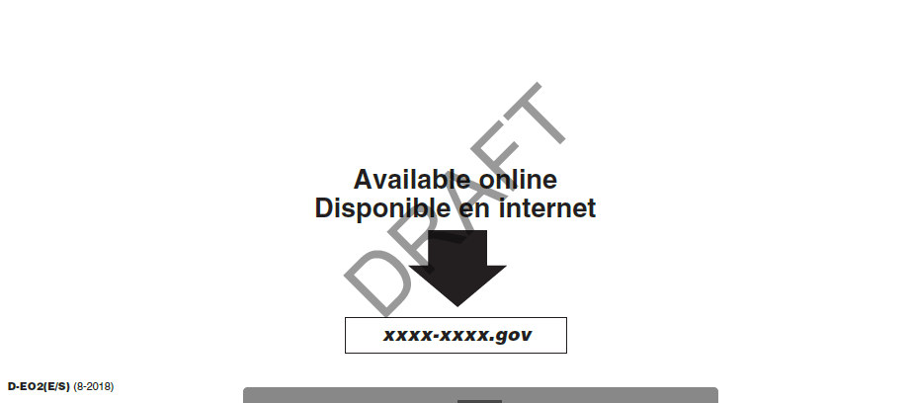

## Third Mailing to Households for the 2020 Census

This mailing will be a postcard.

### Postcard, front

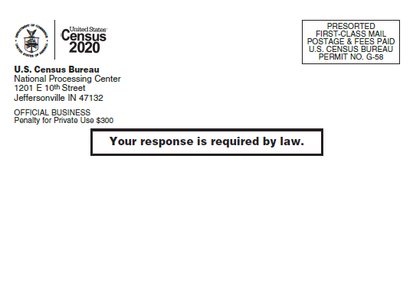

### Postcard, back

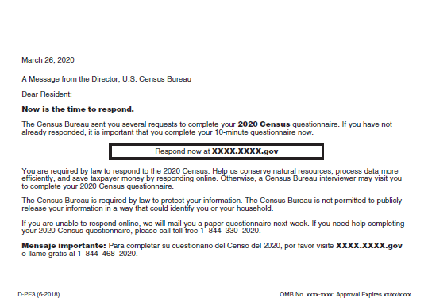

## Fourth Mailing to Households for the 2020 Census

This mail package will contain the following items:

* Package Envelope
* Reminder Letter
* Language Assistance Sheet – same document as shown in Mailing 1
* Questionnaire – in separate attachment
* Return Envelope

### Outbound package envelope, front

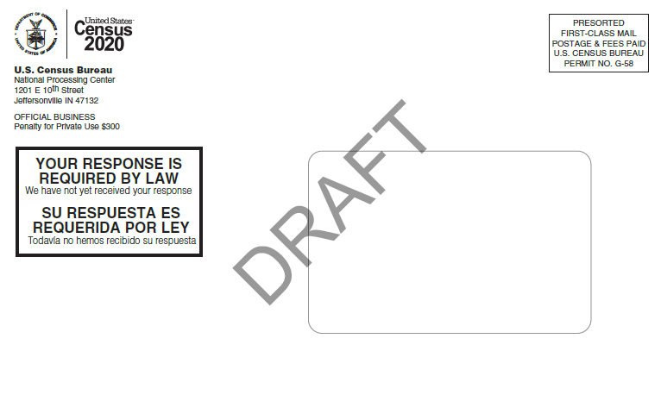

### Outbound package envelope, back

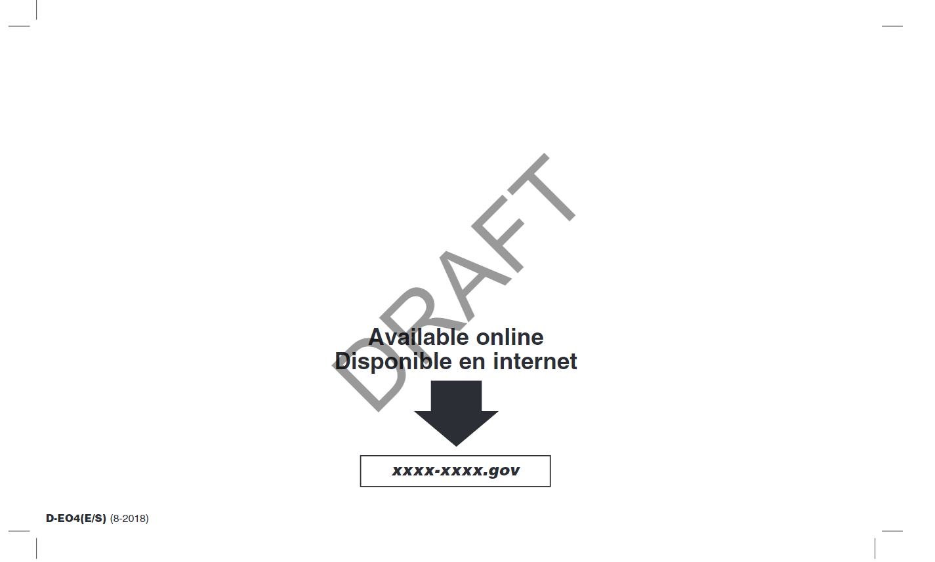

### Reminder Letter

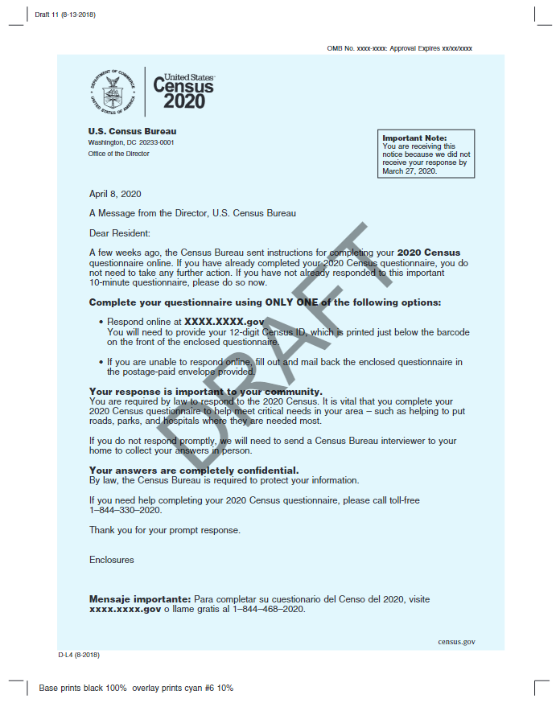

### Return envelope

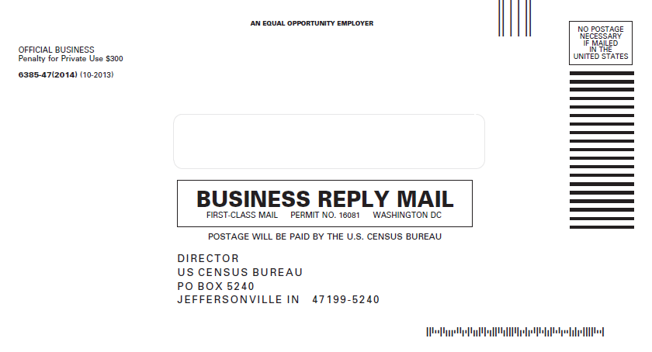

## Fifth Mailing to Households for the 2020 Census

This mailing will be a postcard.

### Postcard, front

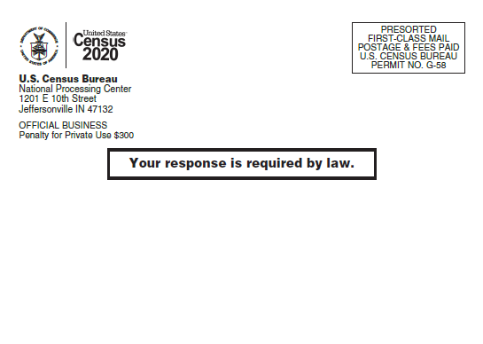

### Postcard, back

