Enclosure 1
The following documents will be cognitively tested to make sure they are easily understood by respondents as intended. The images below contain the date “January 23” but all sample materials will contain a date 7-10 days from the date of the cognitive test. This is to simulate the urgency of response for participants. The five dates will be January 23, January 30, February 6, February 13, and February 20.

Fifth Mailing to ACS 2019 Due Date Experiment Sample

Outside of pressure sealer mailer “Box only” version:
Box only version contains a due date inside the box of the letter and is otherwise unmodified form the current 5th mailing for the ACS production. The outside of the pressure sealer also has a due date.
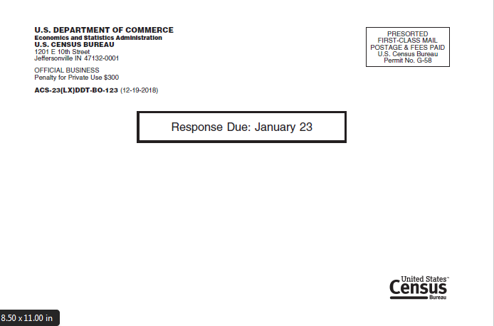

Inside of pressure seal mailer “Box only” version:
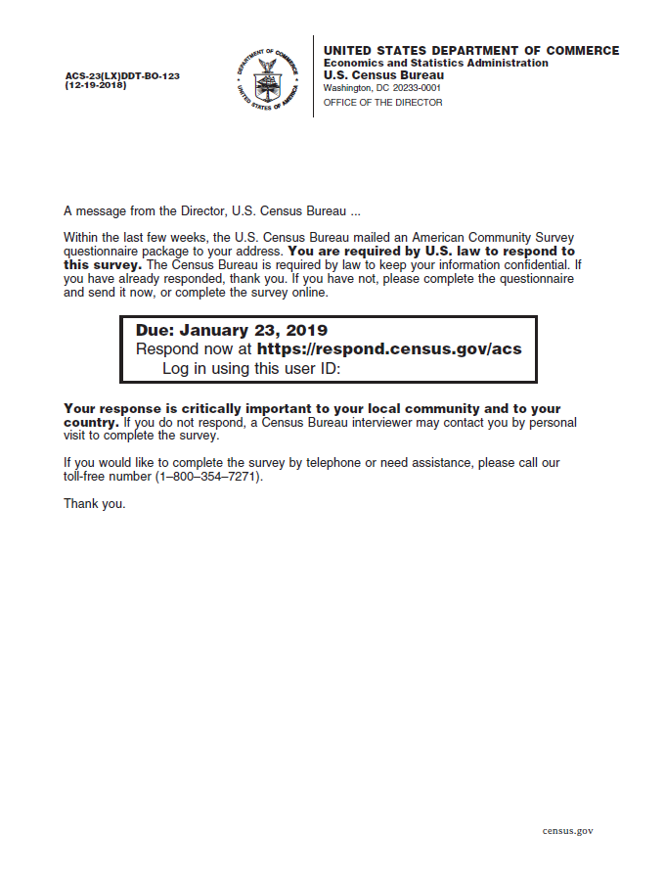

Outside of pressure sealer mailer “Add” version:
This version contains a due date in the box and text about being added to a schedule for a visit.
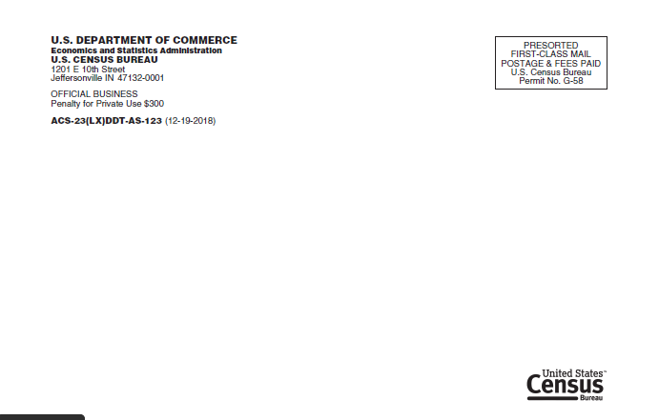

Inside of pressure seal mailer “Add” version:
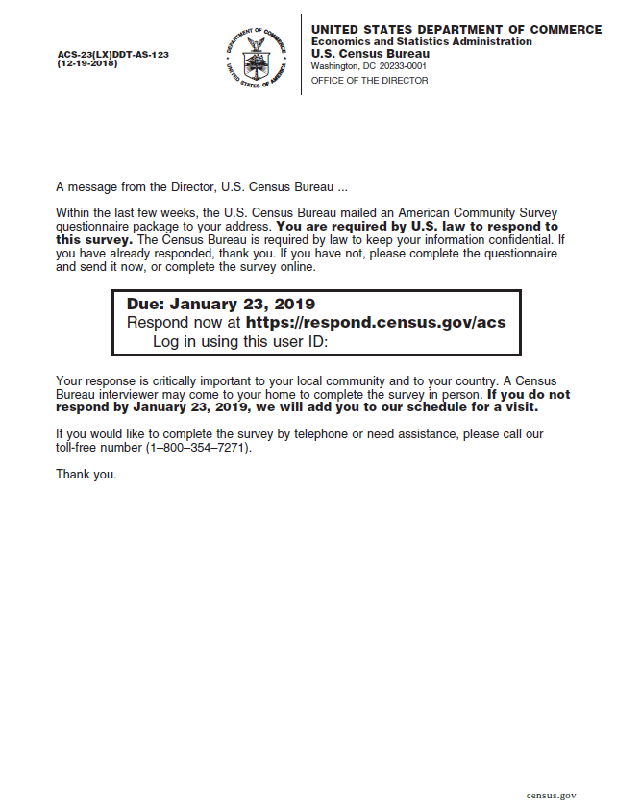

Outside of pressure sealer mailer “Neutral” version:
This version contains a due date in the box and language and emphasizes language about an interviewer coming to visit in a more neutral style than the Add or Remove versions.

Inside of pressure seal mailer “Neutral” version:
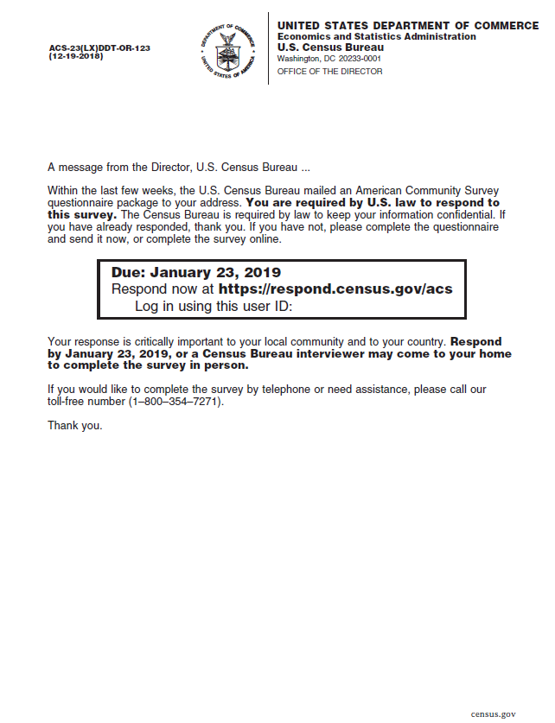

Outside of pressure seal mailer “Remove” version:
This version contains a due date in the box and text about being removed from the schedule for an interviewer visit.

Inside of pressure seal mailer “Remove” version:
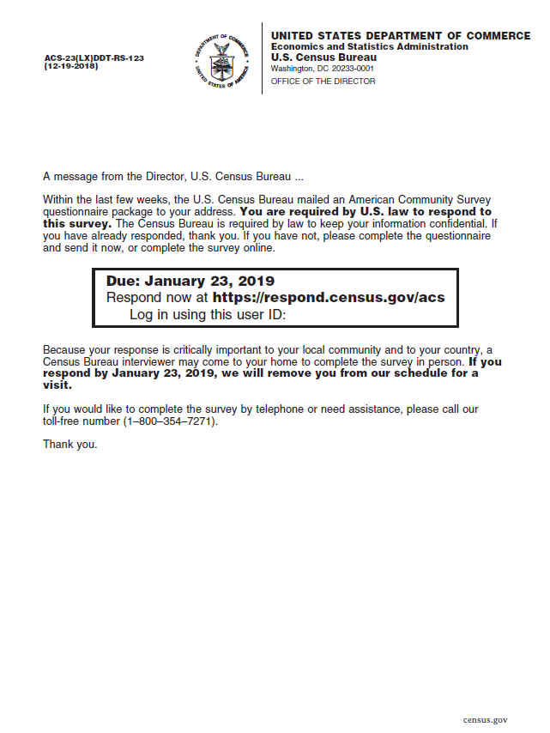

Handout to compare possible alternative version of “Remove” text:

Version 1:
Because your response is critically important to your local community and to your country, a
Census Bureau interviewer may come to your home to complete the survey in person. If you
respond by October 19, 2018, we will remove you from our schedule for a
visit.
Version 2:
Your response is critically important to your local community and to your country. If you
respond by October 19, 2018, we will remove you from our schedule for a
visit. If you do not respond, a Census Bureau interviewer may come to your home to
complete the survey in person.

