Enclosure 2
The following documents will be briefly shown to respondents before we cognitively test different versions of the fifth mailing. These mailings are unmodified from 2019 production.

First Mailing to ACS Households in 2019
This mail package will contain the following items:
- ACS Initial Mailing Outgoing Envelopes – no changes
- Intro Letter – no changes
- Instruction Card - no changes
- Multilingual Brochure - no changes
- FAQ Brochure - no changes

Front of Envelope for Testing, Mailing 1:
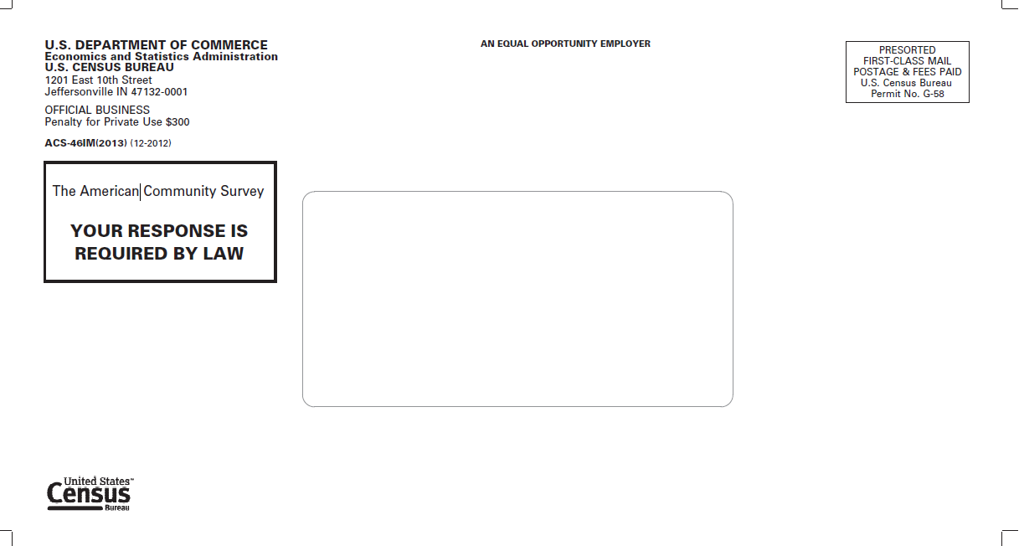

Back of Envelope for Testing, Mailing 1:

Front of Letter for Testing, Mailing 1:
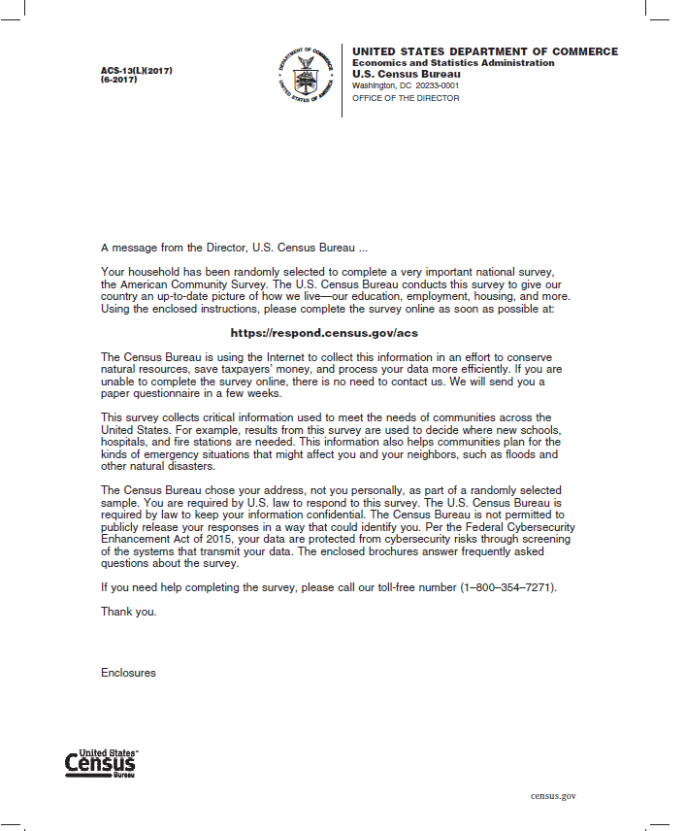

Instruction Card, side 1
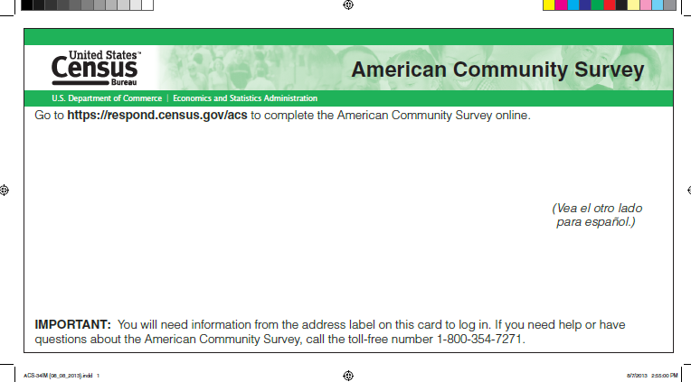

Instruction Card, side 2
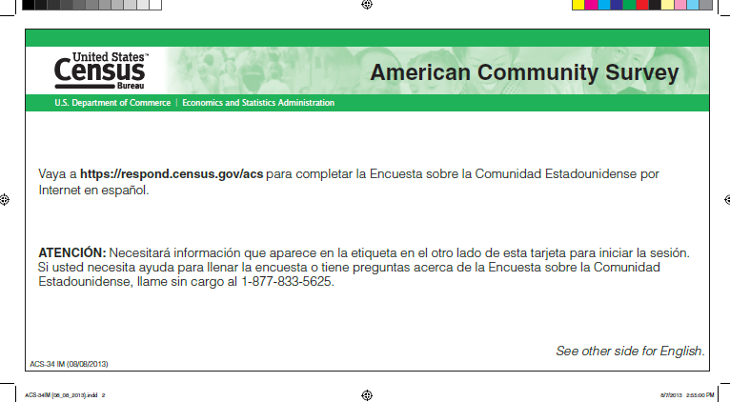

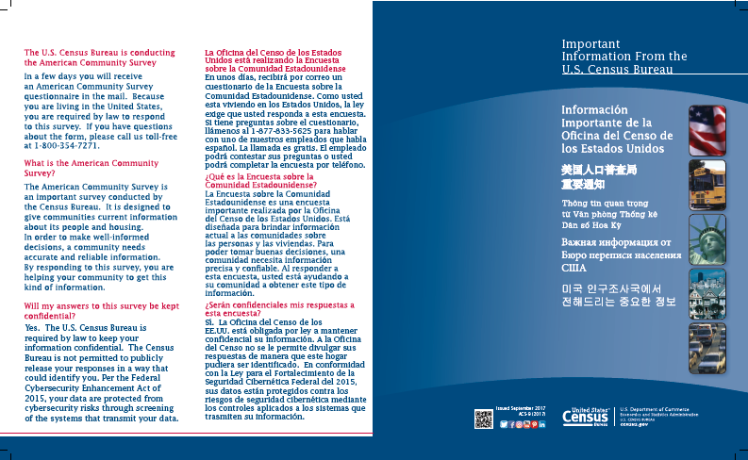
Multilingual brochure, side 1

Multilingual brochure, side 2

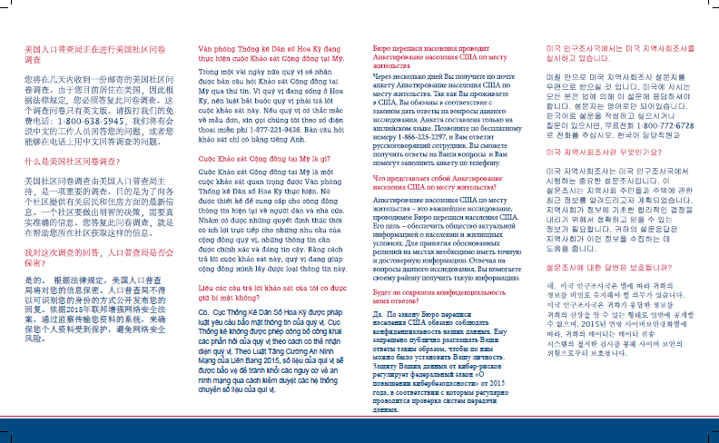

FAQ Brochure, side 1
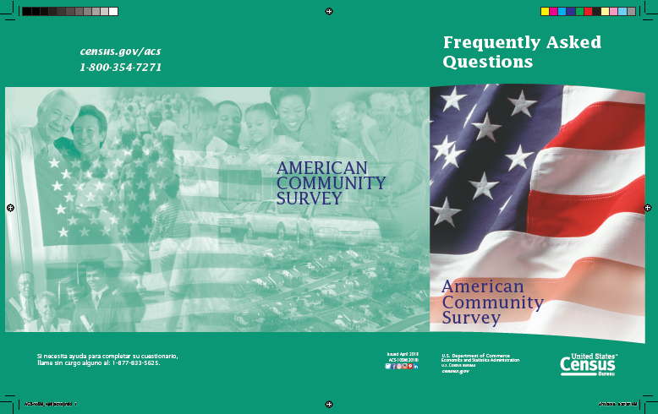

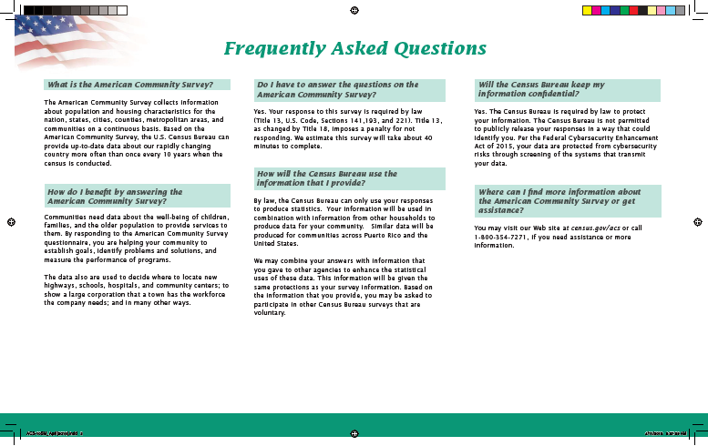
FAQ Brochure, side 2

Second Mailing to ACS Households in 2019
This mailing is a pressure-seal mailer with no changes.

Outside of Pressure Seal Mailer for Testing, Mailing 2:
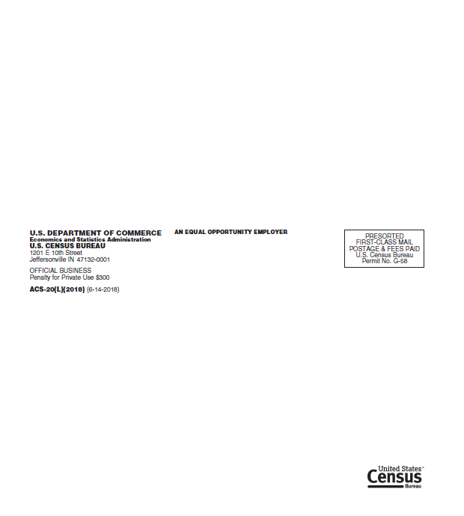

Inside of Pressure Seal Mailer for Testing, Mailing 2:
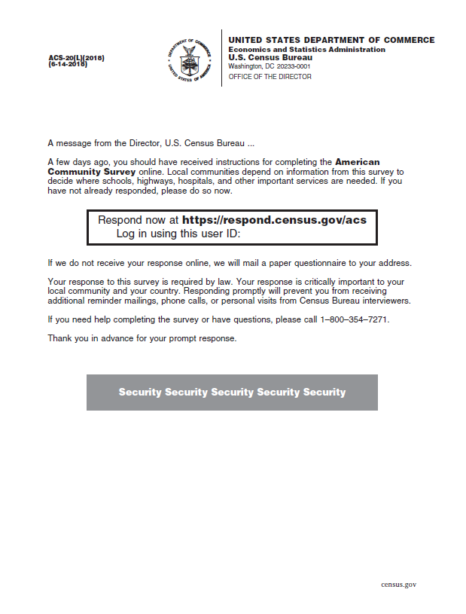

Third Mailing to ACS Households in 2019
This mail package will contain the following items:
- ACS Outgoing Envelope – no changes
- Letter – no changes
- Instruction Card - no changes
- FAQ brochure – no changes
- Questionnaire – no changes
- Incoming/Return envelope – no changes

Front of Envelope for Testing, Mailing 3:
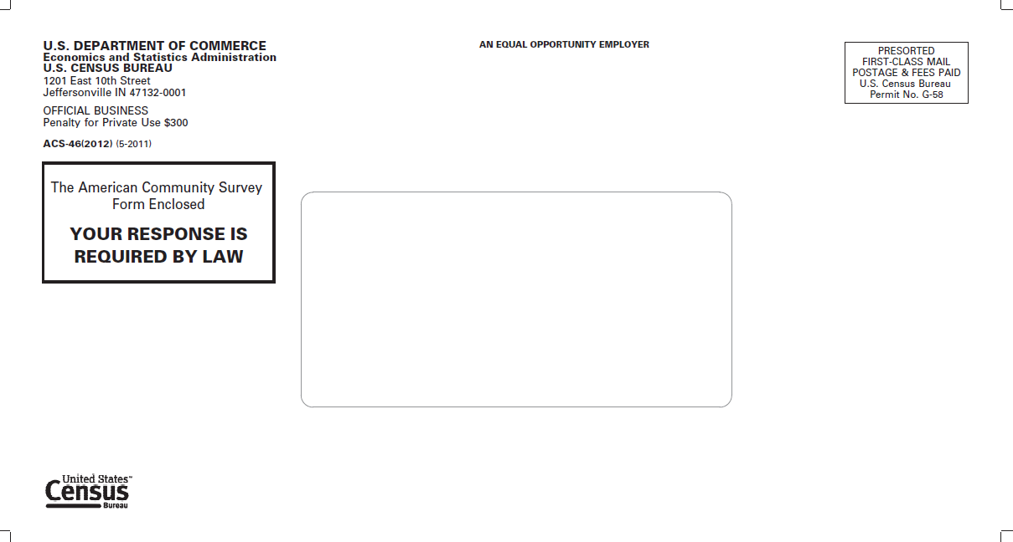

Back of Envelope for Testing, Mailing 3:
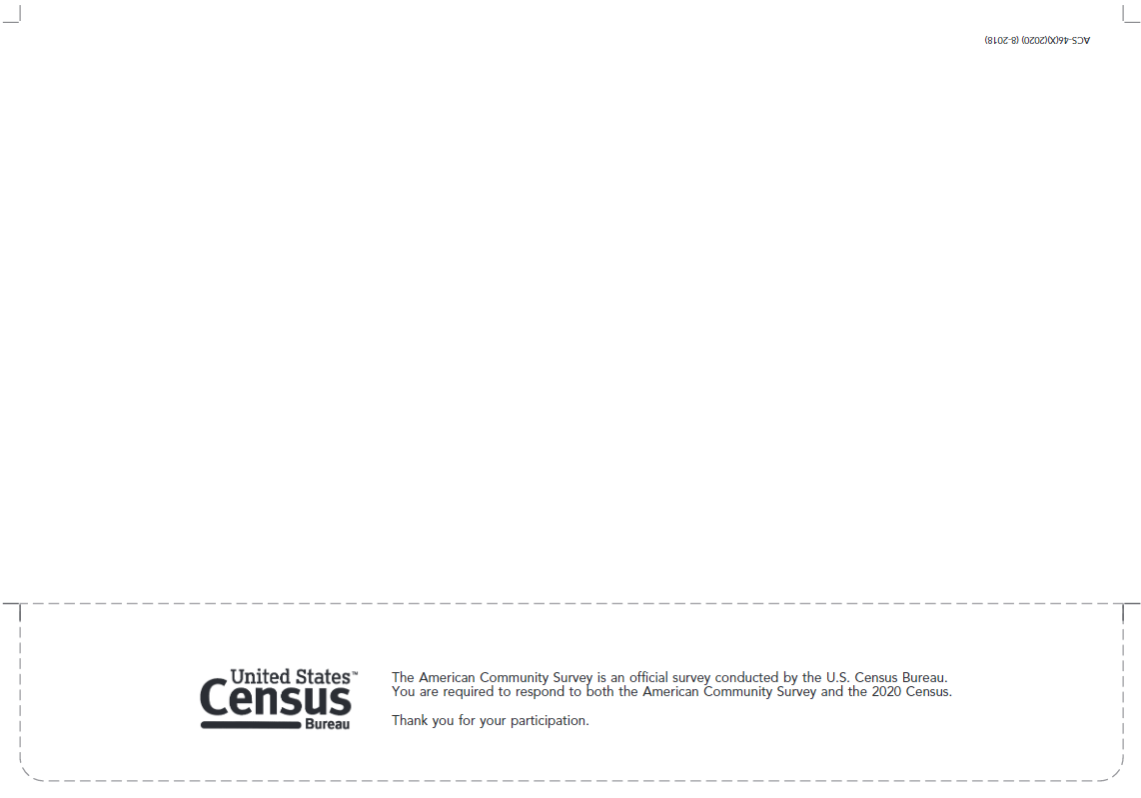

Front of Letter for Testing, Mailing 3:
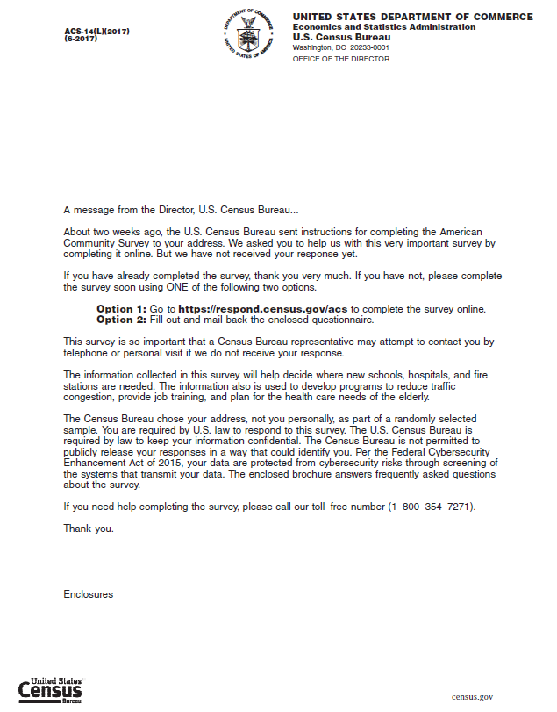

Instruction Card, side 1

Instruction Card, side 2

FAQ Brochure, side 1

FAQ Brochure, side 2

Return Envelope
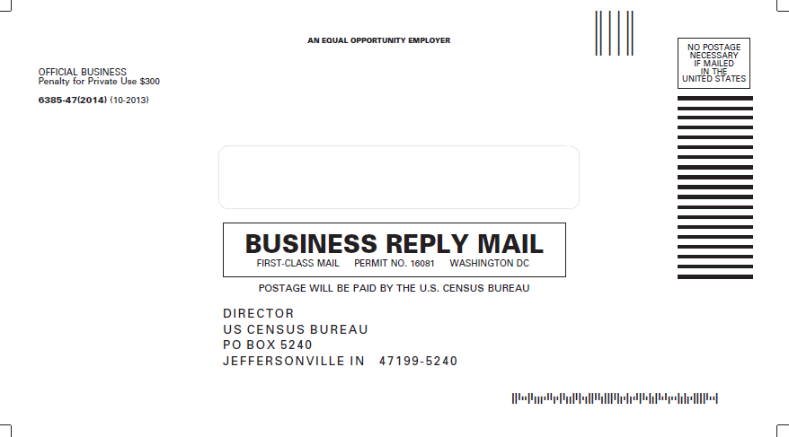

Fourth Mailing to ACS Households in 2019
This mailing is a postcard no changes.

Address side of Postcard for Testing, Mailing 4:
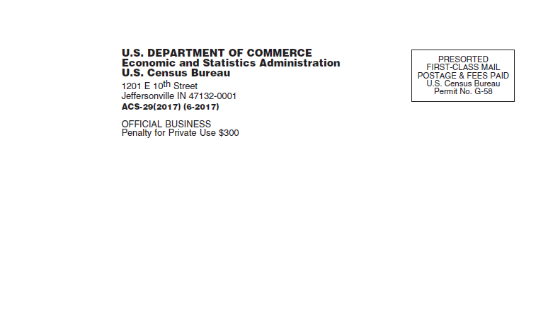

Text side of Postcard for Testing, Mailing 4:
