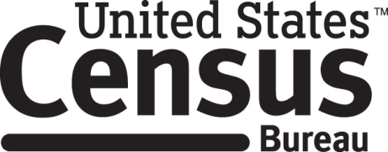

**Consent Form**

**2019 ACS Mailing Materials Cognitive Interview**

Each year the Census Bureau conducts many different surveys. The Census Bureau routinely tests the mailing materials used for these surveys in order to produce the best mailing materials possible.

______________________ [NAME] consents to take part in a study to improve the mailing materials that will be used for the American Community Survey in 2019. In order to have a complete record of all comments, the interview session will be audio recorded. The Census Bureau plans to use the tapes to improve the mailing materials. Staff directly involved in the mailing material project will have access to the recordings. Participation is voluntary and answers will remain strictly confidential.

This study is being conducted under the authority of Title 13 USC. The OMB control number for this study is 0690-0030. This valid approval number legally certifies this information collection.

I have agreed to participate in this Census Bureau ACS mailing material study, and I give permission for my tapes to be used for the purposes stated above.

____________________________ ___________________________

Participant's Signature Researcher's Signature

____________________________ __________________________

Printed Name Printed Name

___________________________ _______________________

Date Date