OHCS Customer Engagement Survey
Your email address (lynne.d.kartsakalis@noaa.gov) will be recorded when you submit this form. Not you? Switch account
* Required
Which OHCS Division provided assistance to you for this interaction? *
Choose
Please Share Your Thoughts...
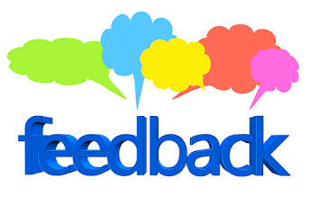
How well did OHCS meet your expectations? *
Poor Excellent
1 2 3 4 5

How would you rate OHCS's ability to effectively address your issues? *
Poor Excellent
1 2 3 4 5

How would you rate OHCS's responsiveness to your needs? *
Poor Excellent
1 2 3 4 5

What can OHCS specifically do to improve our service? *
Your answer
Do you have any other helpful comments?
Your answer
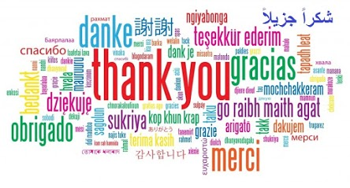
SUBMIT
Never submit passwords through Google Forms.

