Attachment 1 – Screen Shots for Modifications or Additions to the Existing FMS Application Module
OMB CONTROL NUMBER 0920-0765
FELLOWSHIP MANAGEMENT SYSTEM
NON-SUBSTANTIVE CHANGE REQUEST

PROPOSED CDC SCIENCE AMBASSADOR FELLOWSHIP (SA)
FMS APPLICATION MODULE
DATE SUBMITTED: April 28, 2017

Contents
2.1 Home Page 2
3.1a Deadline and General Instructions 2
3.1b Supporting Materials Instructions 3
3.1c Submission of Supporting Materials 3
3.1d Submission of Supporting Materials 4
4.4b Application Certification 4
4.5 Application withdrawal 4
6.1 Education Page 5
6.4a College/University Education 6
7.1a Postgraduate Training and Skills 6
7.4a Additional Training 7
8.1a Work and Volunteer Experience 7
8.2a Work Experience 8
8.3 Volunteer Experience 8
9.1a Publications, Presentations, Grants 9
9.2a Publication Section 9
9.3a Presentation section 10
10.1b Honors or Award 10
11.1a Personal Statement 11
12.1a Applicant Survey 11
12.2a Methods Heard About Fellowship 12
12.3a Interest Areas and Preferences Section 12
13.1a Letter of Recommendation 13
13.1b. Letter of Recommendation 13
16.2 Application Submission Confirmation 14
16.3 Interview Invitation for US Applicants 14
16.5 Interview Confirmation for US Applicants 14
16.7 Acceptance Letter 15

2.1 Home Page
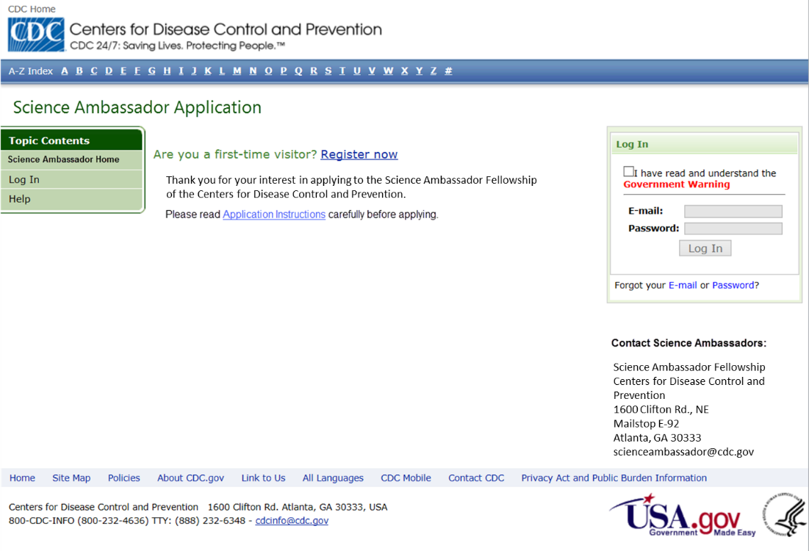
Text change
- Topic contents page is hyperlinked to: www.cdc.gov/careerpaths/scienceambassador.
- Welcome text changed to reflect fellowship name.
- Contact information text changed to reflect fellowship contact information.
2.2-2.5 No changes requested.
Please note: for sections that were removed or no changes requested, the screen shots can be found in Attachment 2 – the FMS Application Module.

3.1a Deadline and General Instructions
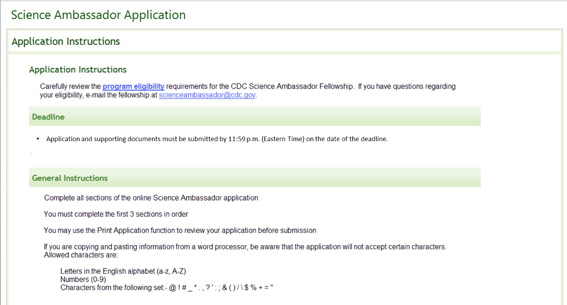
Text Change
- Deadline text changed to general deadline. The deadline is provided on the website.
- Instruction text changed to reflect the fellowship name.

3.1b Supporting Materials Instructions
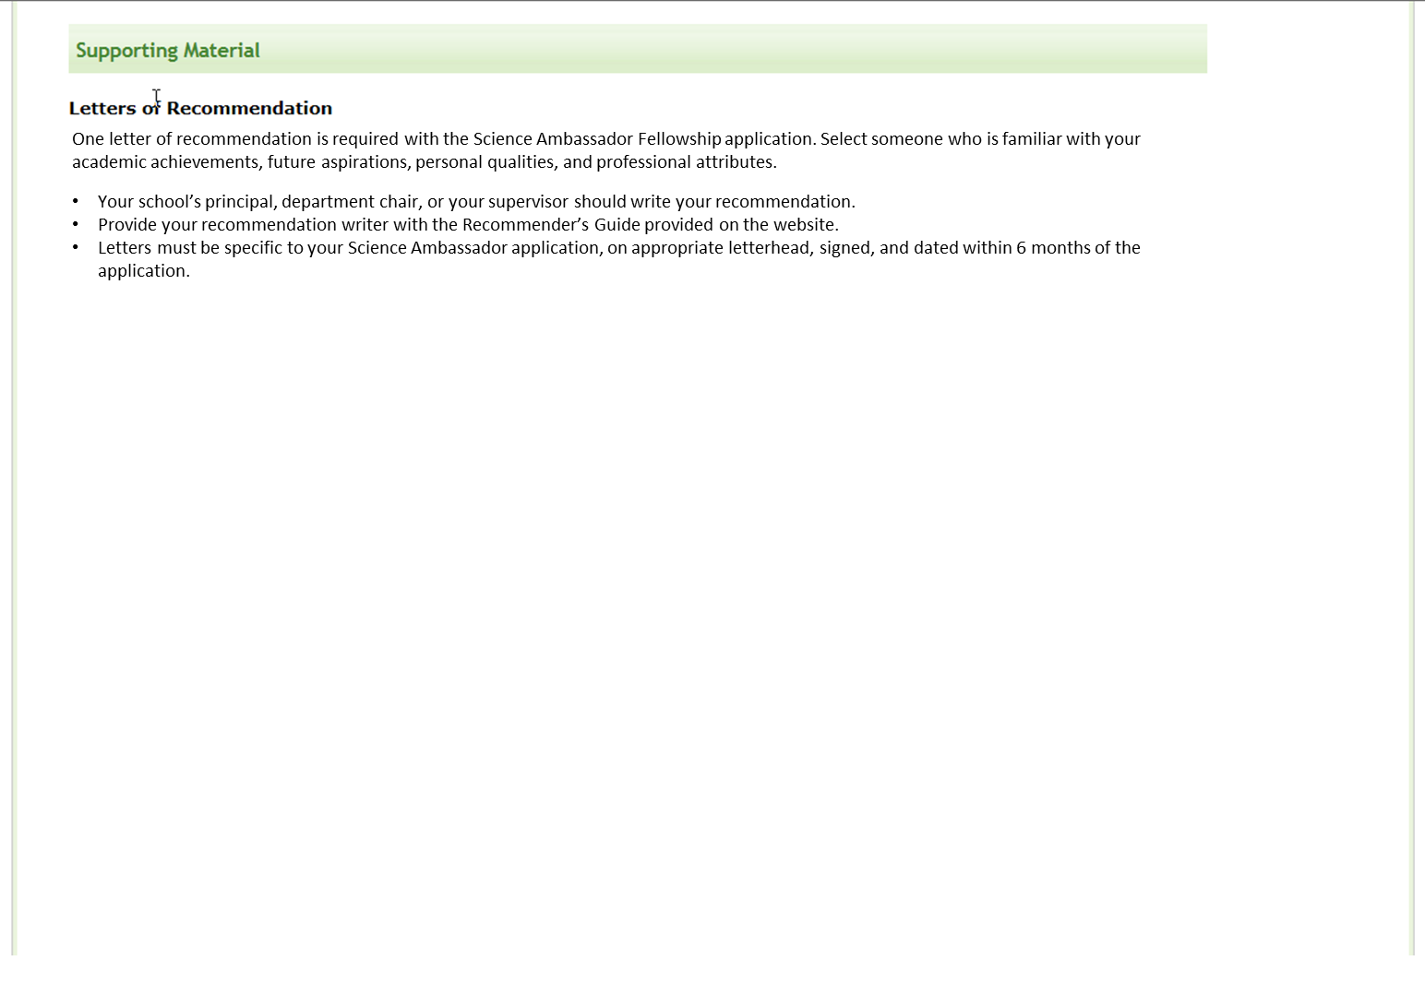
Changed text
- Letter of Recommendation directions changed to reflect the fellowship requirements. Only one letter of recommendation is required for this fellowship.

3.1c Submission of Supporting Materials
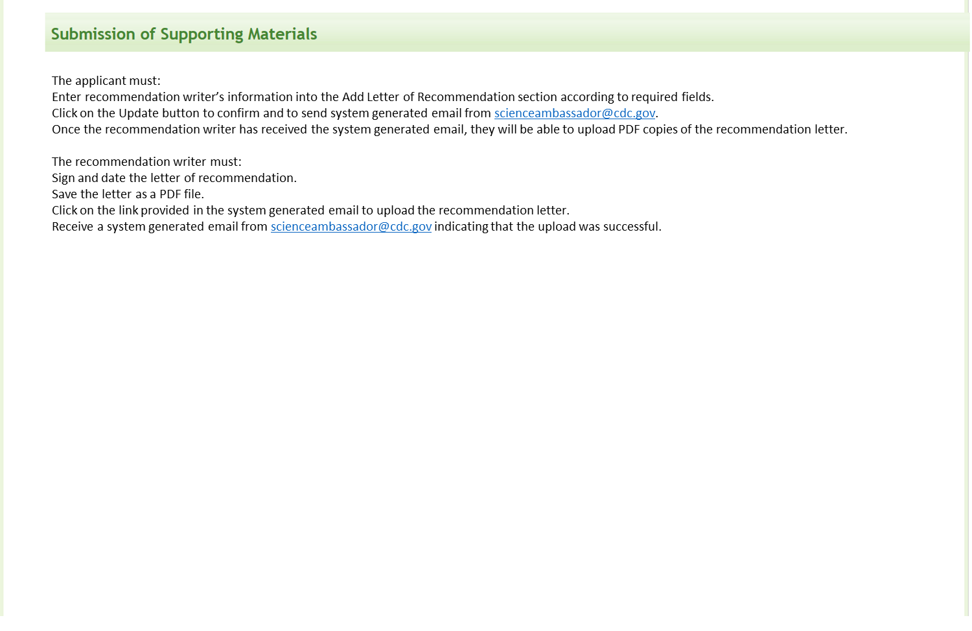
Text change
- Text changed to reflect fellowship name.
- Tailored submission of supporting materials information to fellowship.

3.1d Submission of Supporting Materials
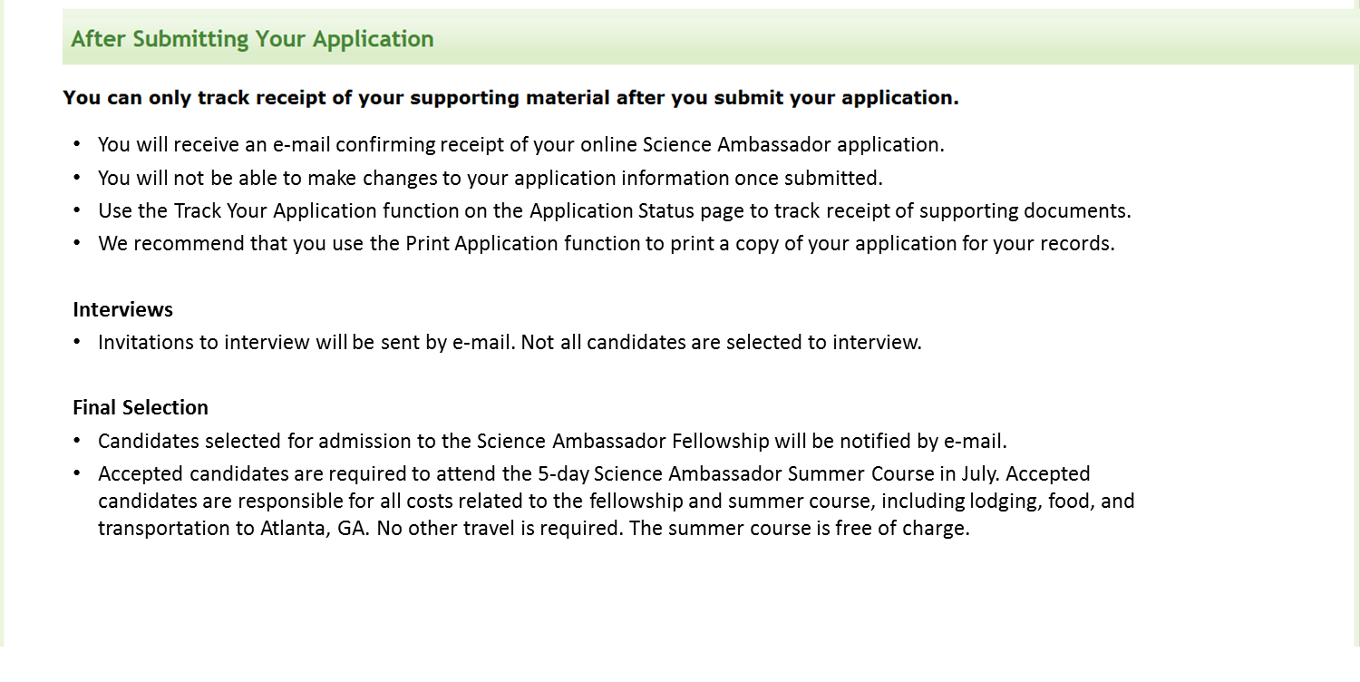
Text change
- Interview and final selection text changed to reflect fellowship procedures.

4.1- 4.2 No changes requested.
4.3 Pre-submission Validation (Removed)
4.4a No changes requested

4.4b Application Certification
Text change
- Changed “EIS application” text to “Science Ambassador application”.
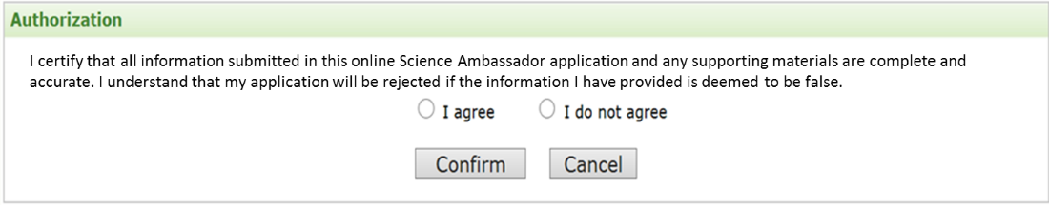

4.5 Application withdrawal
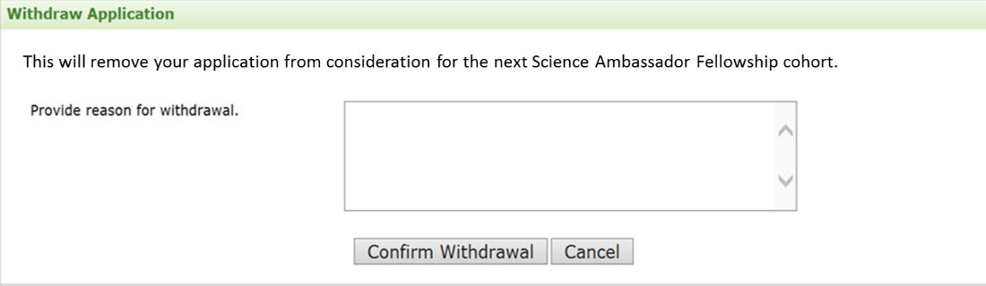
Text change
- Changed “EIS class” text to “Science Ambassador cohort”.
- Made reason for withdrawal optional.
5.1- 5.3 No changes requested.
5.4 Health Insurance (Field removed)

6.1 Education Page
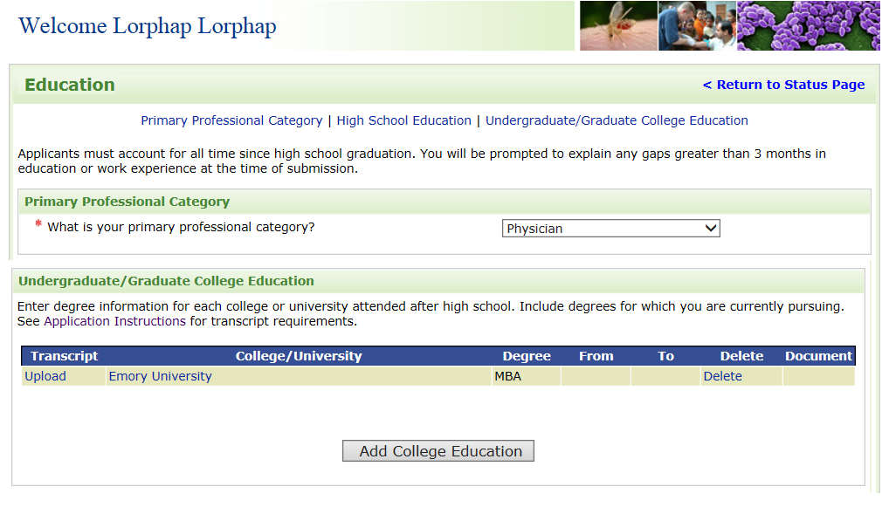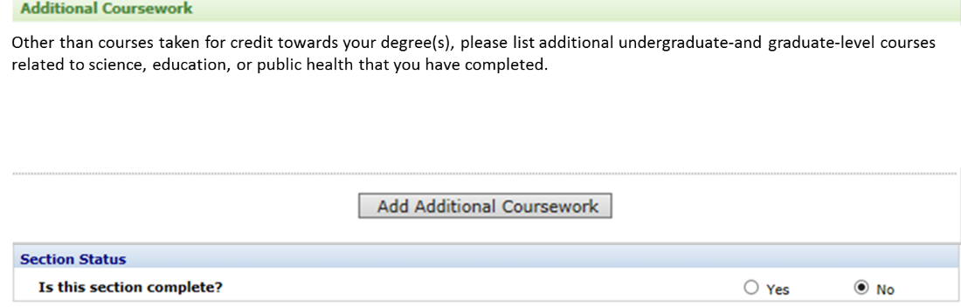
Text Change & Fields removed
- Changed professional categories to those appropriate for the fellowship, including teaching grades K-12, College, or other education-related positions.
- Removed high school education.
- Removed transcript upload.
- Changed text in additional coursework to focus on all additional coursework related to science, education, and public health.

6.2 Program eligibility (Removed)
6.3 High School Education (Removed)

6.4a College/University Education
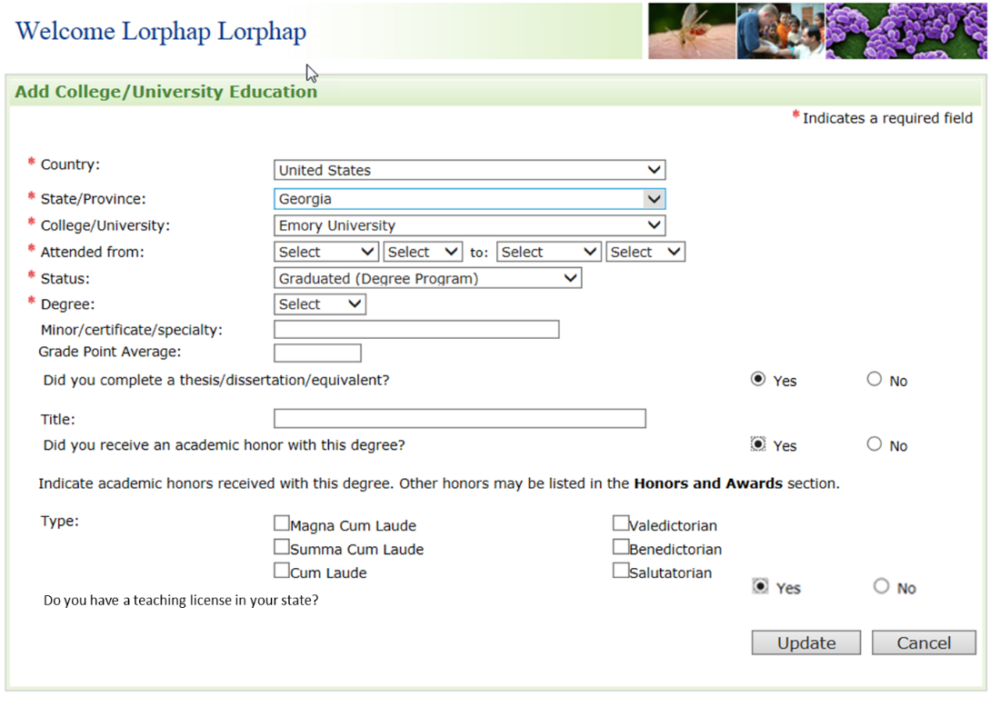
Text change
- Changed “Do you have or are you expecting an active unrestricted U.S. license to practice your specialty?” to: “Do you have a teaching license in your state? (yes, no)”.
- Removed Current License List section. Proof of license is not required.
Field change
- Made fields optional

6.4b No changes requested.
6.4c Thesis Abstract (Removed)
6.4d In School information (Removed)
6.4.1 Professional License sub-section (Removed)
Field change & text change
- Removed Clinical Training, “Do you have postgraduate clinical training?”.
- Removed US Board Certification.
- Changed field name from “Additional Training” to “Professional Development” to reflect appropriate terminology used for the fellowship.
- Changed “Additional Training” text.
- Removed Language skills.
6.5 No changes requested

7.1a Postgraduate Training and Skills
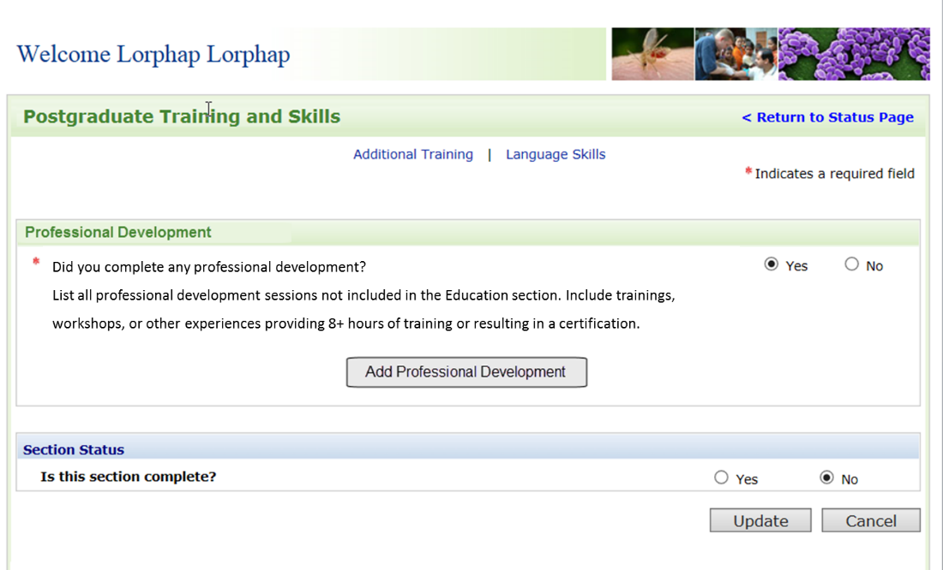
7.2 Clinical Training Section (Removed)
7.3 US Board Certification (Removed)

7.4a Additional Training
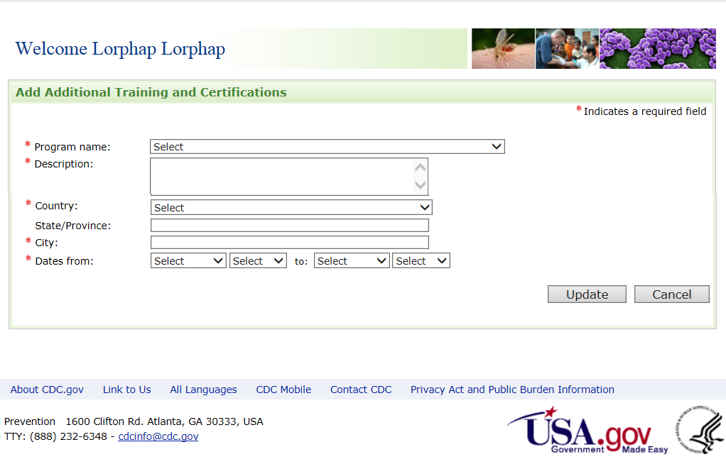
Form change & Field removed
- Removed Institution name.
- For program name, replaced drop-down menu with text box.

8.1a Work and Volunteer Experience
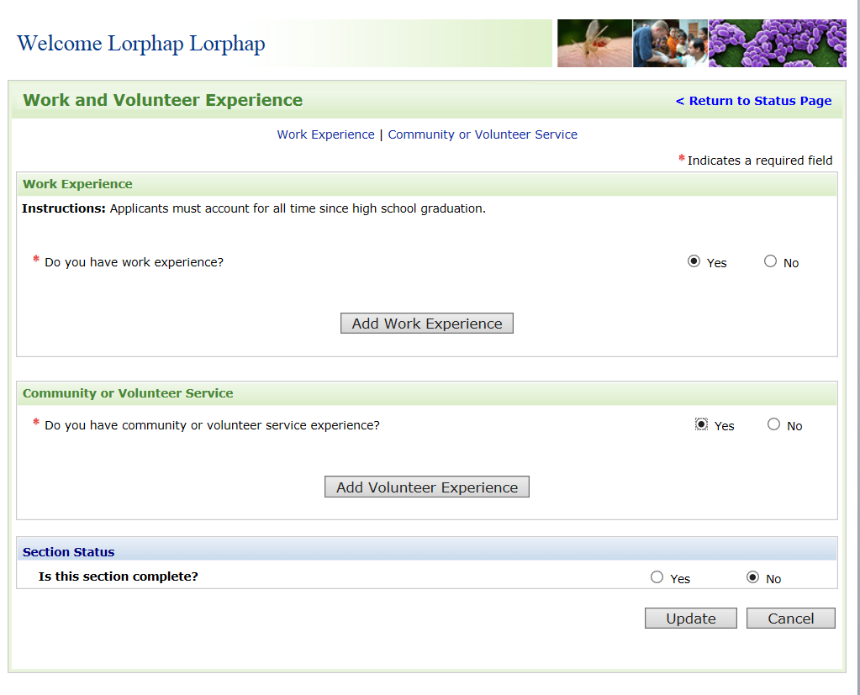
Text change & Field removed
- Changed work experience instructions. Removed sentence regarding explaining any gaps greater than 3 months in education or work experience.
- Removed Research experience, “List all research experience. Do you have research experience? (Yes/No)”.

8.2a Work Experience
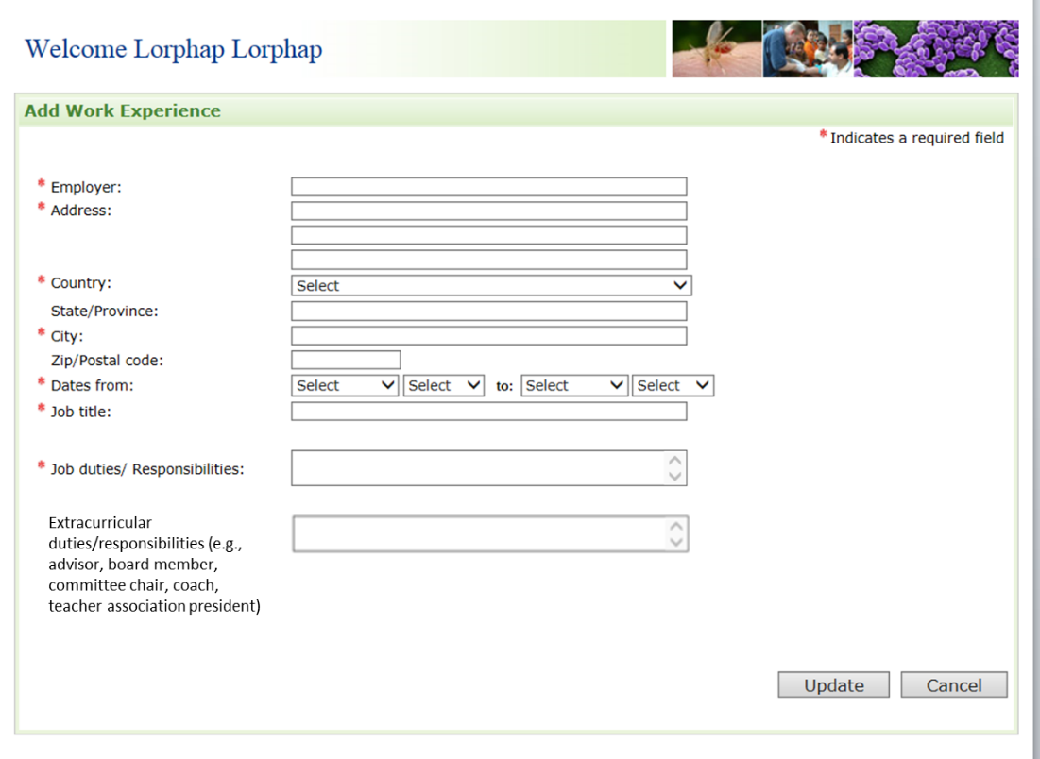
Fields removed & new field
- Removed hours/week, Reasons for leaving, and Supervisor information.
- Added new field: Extracurricular duties/responsibilities.
8.2b Reason Opt to Supervisor Contact (Removed)

8.3 Volunteer Experience
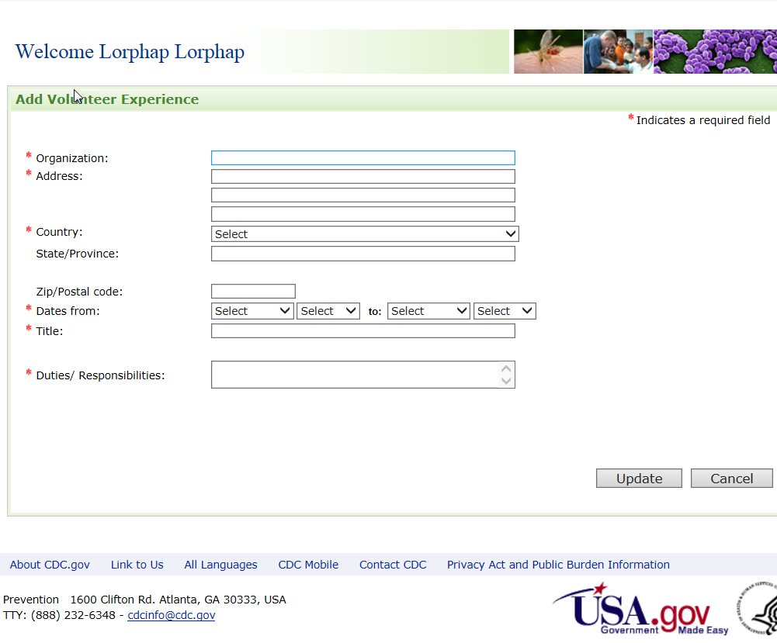
Fields removed
- Removed hours/week, reasons for leaving, and Supervisor information.
8.3b Reason Opt to Supervisor Contact (Removed)
8.4 Research experience section (Removed)

9.1a Publications, Presentations, Grants
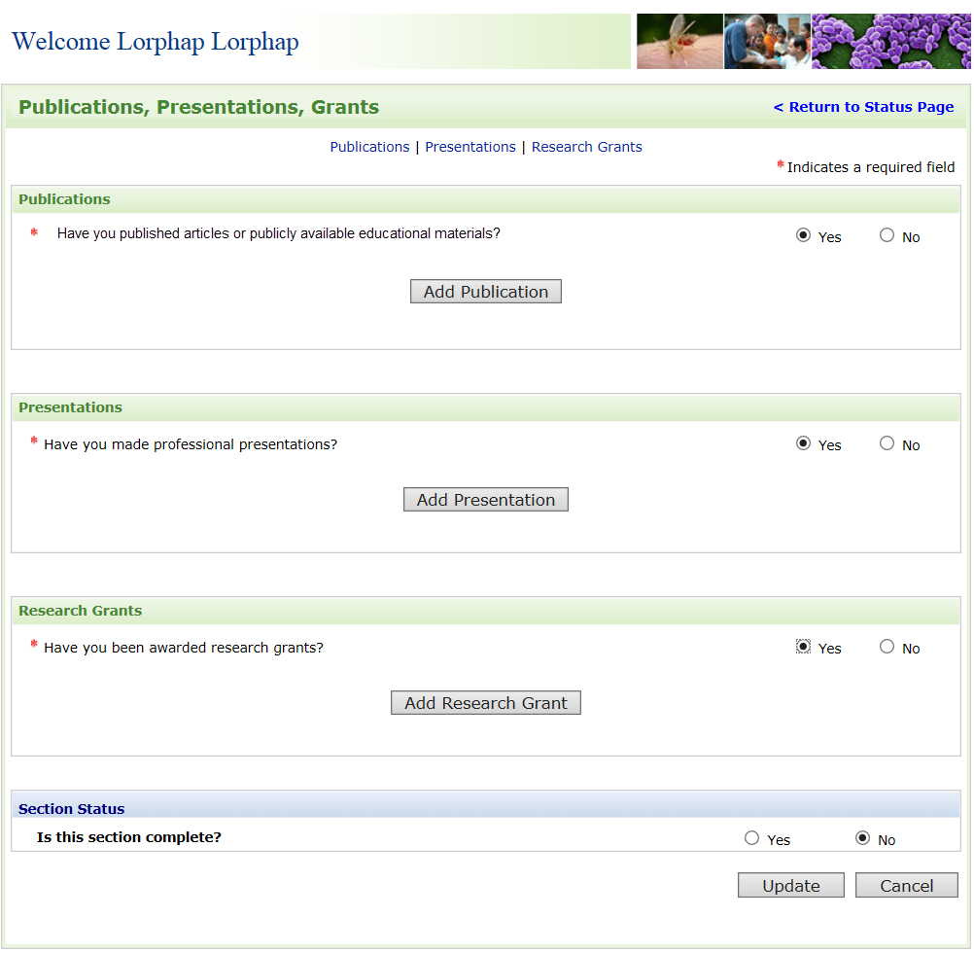
Field removed
- Removed Working papers, and Monographs and reports sections.
Text change
- Changed text from “Have you published articles?” to “Have you published articles or publically available educational materials?”
9.1b Working papers (Removed)
9.1c Monographs and reports (Removed)

9.2a Publication Section
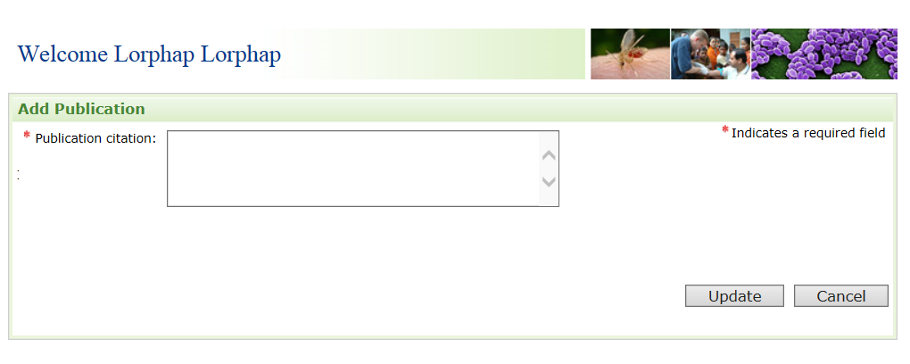
Text change
- Removed instructions for the citation. Any citation is acceptable.

9.3a Presentation section
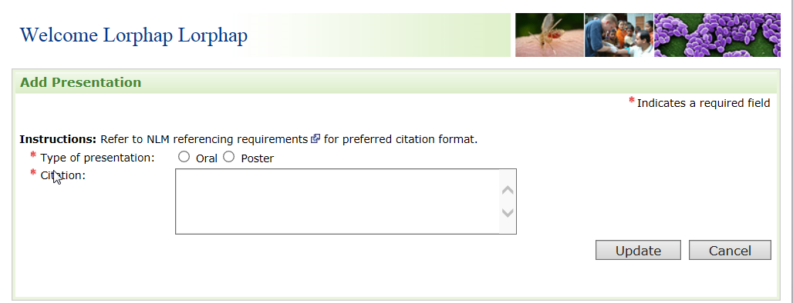
Text change
- Removed instructions for the citation. Any citation is acceptable.

9.4 No changes requested
9.5 Add Working papers (Removed)
9.6 Add Monographs and reports (Removed)
10.1a No changes requested

10.1b Honors or Award
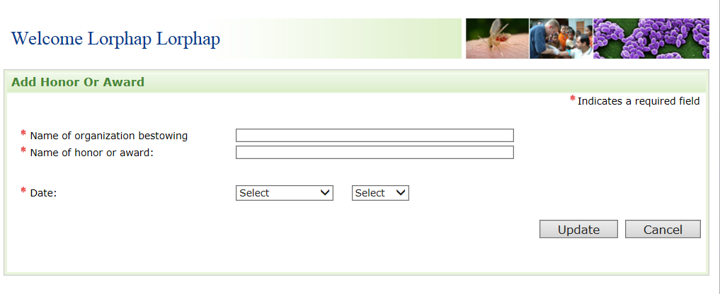
Field removed
- Removed “Type of honor and award”.

11.1a Personal Statement
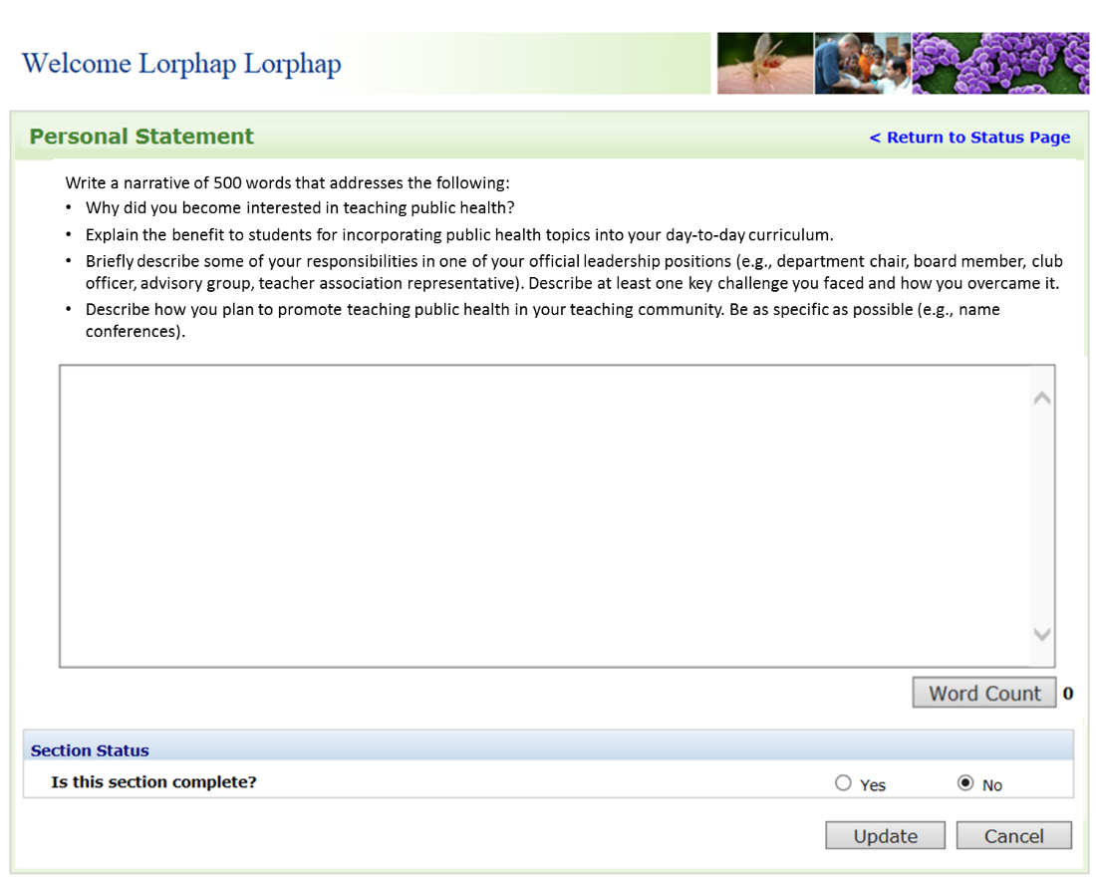
Text change
- Instructions for the personal statement were changed to reflect fellowship objectives.

12.1a Applicant Survey
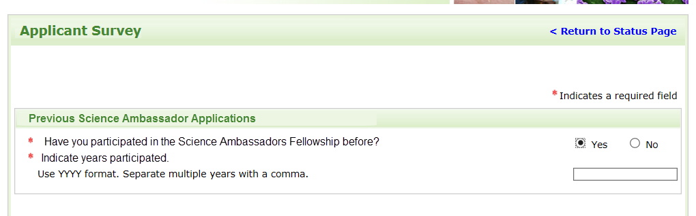
New Question
- Added a new question: “Have you participated in the Science Ambassador Fellowship before? Indicate years participated.”
12.1b Other Fellowship (Removed)
12.1c Public Health/Population-based Work Experience (Removed)

12.2a Methods Heard About Fellowship
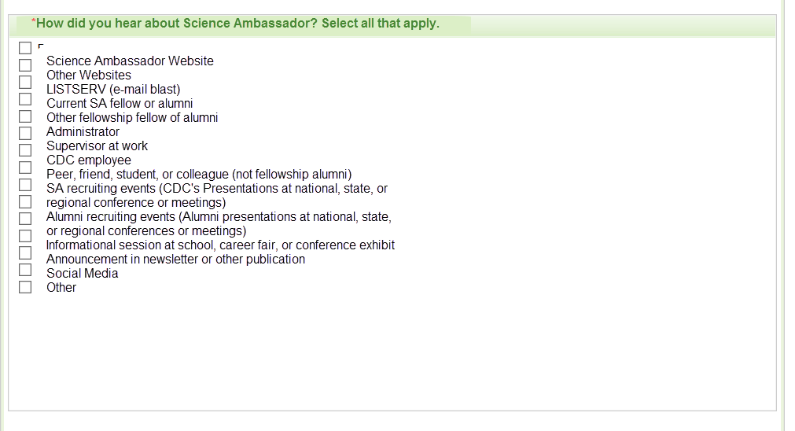
Text change
- Changed options in Science Ambassador Fellowship recruitment.

12.2b Influences to Decision to apply (Removed)

12.3a Interest Areas and Preferences Section
Text change
- Tailored options to include more specific public health areas captured by CIOs that are commonly covered during the Fellowship. More specific areas include “obesity, nutrition, and physical activity” previously captured as part of chronic disease and “foodborne diseases”, “waterborne diseases”, and “One Health (i.e., zoonotic diseases) previously captured by “infectious disease”. “Birth defects and developmental disabilities” and “genomics” were removed.
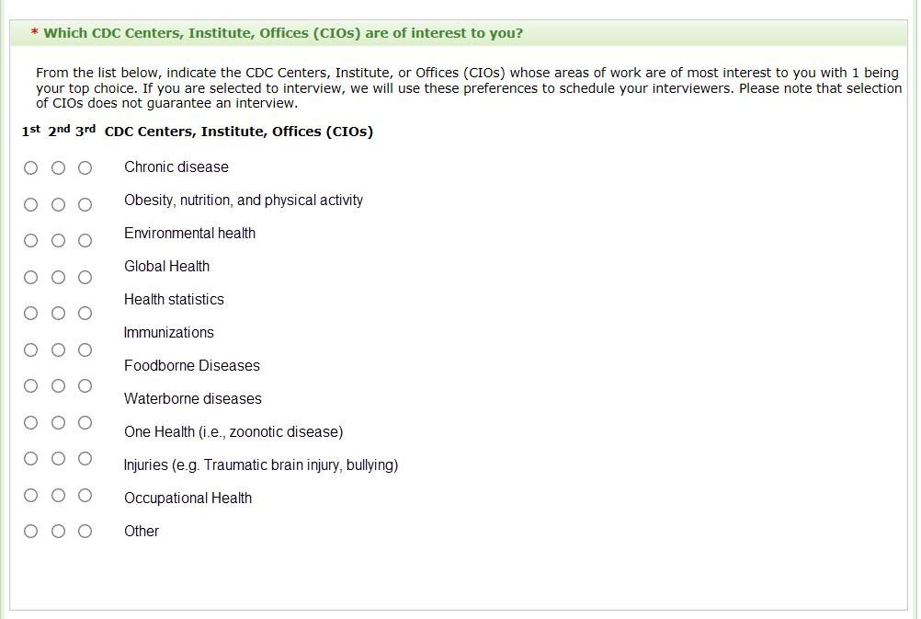
12.4a Location Preferences (Removed)
12.4b Geographic Constraints (Removed)
12.4c Regional Preferences (Removed)

13.1a Letter of Recommendation
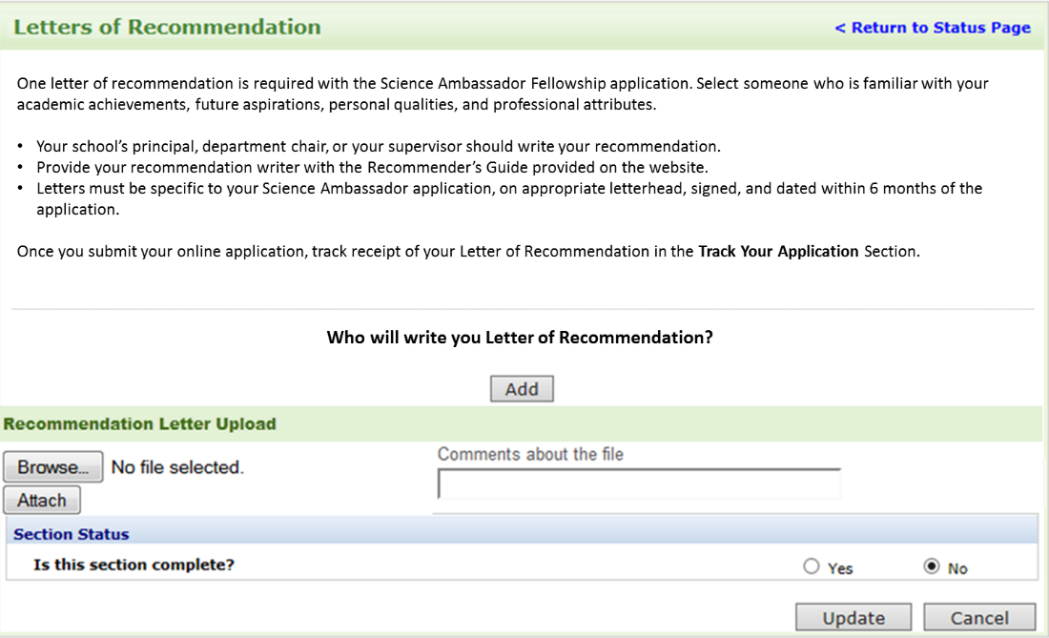
Text change
- Letter of Recommendation directions changed to reflect the fellowship requirements. Only one letter of recommendation is required for this fellowship.

13.1b. Letter of Recommendation
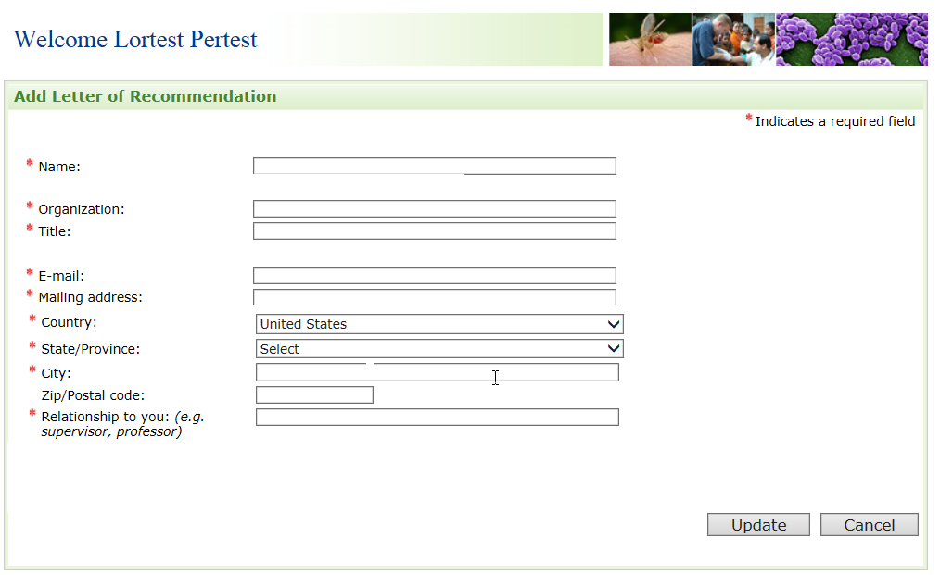
Fields removed
- Removed “Check if dean of medical school”.
- Removed “phone number”.

14.1 Special Requirements (Removed)
15 Self-Assessment of Skills (Removed)
16.10 (No change requested)
Please note that for sections 16.2, 16.3, 16.5 and 16.7, there are no screen shots provided, just text that we have included below, because the text below is what the applicant will see as they are completing the application process in FMS.
Please refer to Attachment 2 - FMS Application Module to see how these sections will appear in FMS, with the modifications indicated below.

Section 16.2: see page 68 of the FMS Application Module.
Section 16.3: see page 69 of the FMS Application Module.
Section 16.5: see page 73 of the FMS Application Module.
Section 16.7: see page 74 of the FMS Application Module.

16.2 Application Submission Confirmation
Text change
- Text changed to reflect the fellowship name and required documents.
- *Note: Only text provided. No screenshots available.
Dear strFname strLname,

We have received your online application for the Science Ambassador Fellowship. Please upload one letter of recommendation to the Science Ambassador Fellowship to the application portal. These supporting materials must be uploaded by strSubmissionDate.

It is the applicant’s responsibility ensure that all required forms are submitted prior to the deadline. Late submissions will not be considered. You may track receipt of your letter of recommendation and the status of your application online at: InternetWebAddress.

16.3 Interview Invitation for US Applicants
Text change
- Text changed to reflect the fellowship name, requirements, and interview information.
- *Note: Only text provided. No screenshots available.
Congratulations! You are invited to participate in the next step in the CDC Science Ambassador Fellowship application process.
In considering whether you wish to interview, please review the following CDC Science Ambassador Fellowship requirements:
- Completion of an introduction to epidemiology and public health online course.
- Commitment to a full-time, 1-week summer course in July.
- Collaboration with CDC remotely from July 1 – June 30.

The phone interview takes 20 minutes. The interviewers will inquire about the depth of your interest in bringing epidemiology and public health science into the K-12 classroom, and the Science Ambassador Fellowship. In addition, they will assess personal qualities such as communication and interpersonal skills, motivation, and enthusiasm.
If you are interested in interviewing, complete the Science Ambassador Fellowship Interview request form to scienceambassador@cdc.gov. Your interview date and time will be confirmed by e-mail. You are encouraged to schedule your interview as soon as possible.

16.4 Interview Invitation for International Applicants (Removed)

16.5 Interview Confirmation for US Applicants
Text change
- Text changed to reflect the fellowship name and interview directions.
- *Note: Only text provided. No screenshots available.
Your Science Ambassador Interview is scheduled for InterviewDate, InterviewTime. At your interview time, please call in to the conference call line and enter the passcode as directed.

Please do not call until the exact time of interview. Many of our interviews run back-to-back.

If you have further questions, please contact us as scienceambassador@cdc.gov.

16.6 Interview Confirmation for International Applicants (Removed)

16.7 Acceptance Letter
Text change
- Text changed to reflect the fellowship name, expectations, and acceptance instructions.
- *Note: Only text provided. No screenshots available.
Congratulations! Your application and interview exemplify the qualities needed to become a Centers for Disease Control and Prevention (CDC) Science Ambassador Fellow. It is because of these qualities that we are pleased to extend an invitation for you to participate in the 2017 CDC Science Ambassador Fellowship. Fellows are expected to attend the summer course in July at CDC Headquarters in Atlanta, Georgia and participate remotely in the program from July 1 of this year to June 30 of next year. Attached you will find your acceptance letter.

To initiate your participation, you must confirm your acceptance by sending an e-mail to scienceambassador@cdc.gov by March 15.

Please contact us at scienceambassador@cdc.gov if you have any questions or require additional information.

16.8 Invitation to Match Letter (Removed)
16.9 Travel confirmation letter (Removed)
16.10 Onboarding letter (Removed)

