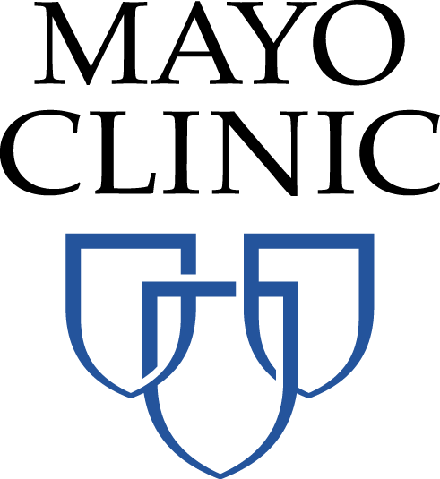

AAPCHO/Mayo Tuberculosis Project Information Sheet

WHAT: A 15-minute online survey about screening and treatment for tuberculosis as part of a project that AAPCHO and the Mayo Clinic Center for Tuberculosis are conducting to better understand tuberculosis-related practices at community health centers.

WHY: By participating, you will help identify high-priority gaps that, if filled, could enhance the care you provide and ultimately the health of your patients.

WHO: Clinic staff who screen or treat patients with tuberculosis and/or administrative staff who have knowledge regarding these practices at your clinic.

WHEN: Within the next 2 weeks.

WHERE: [survey link]

If have questions about this project, please contact:

Vivian Li
vli@aapcho.org
510-746-5079

Thank you!

