Attachment 4f. Exposure Measurement Form
Form Approved
OMB No. 0923-XXXX
Exp. Date xx/xx/201x

Study ID Number _______________________
Sample Collection Date _______________________
Collector ID _______________________

Field Air Samples
(mark collection locations on field chart)
Sample Type | Field Location A  Sample Collected | Field Location B  Sample Collected | Background Location  Sample Collected
VOC Sample | Yes No | Yes No | Yes No
SVOC Sample | Yes No | Yes No | Yes No
Particle Sample | Yes No | Yes No | Yes No

Field Wipe Samples
(mark collection locations on field chart)
Sample Type | Field Location A  Sample Collected | Field Location B  Sample Collected | Field Location C  Sample Collected
SVOC Sample A | Yes No | Yes No | Yes No
SVOC Sample B | Yes No | Yes No | Yes No
Metals Sample | Yes No | Yes No | Yes No

ATSDR estimates the average public reporting burden for this collection of information as 3 hours per response, including the time for reviewing instructions, searching existing data sources, gathering and maintaining the data needed, and completing and reviewing the collection of information. An agency may not conduct or sponsor, and a person is not required to respond to collection of information unless it displays a currently valid OMB control number. Send comments regarding this burden estimate or any other aspect of this collection of information, including suggestions for reducing this burden to CDC/ATSDR Reports Clearance Officer; 1600 Clifton Road, MS D-74, Atlanta, GA 30333, ATTN: PRA (0923-XXXX).
Field Dust Samples
(mark collection locations on field chart)
Sample Type | Field Location A  Sample Collected | Field Location B  Sample Collected | Field Location C  Sample Collected
SVOC Sample | Yes No | Yes No | Yes No
Metals Sample | Yes No | Yes No | Yes No
Particles Sample | Yes No | Yes No | Yes No

Sample Collection Locations

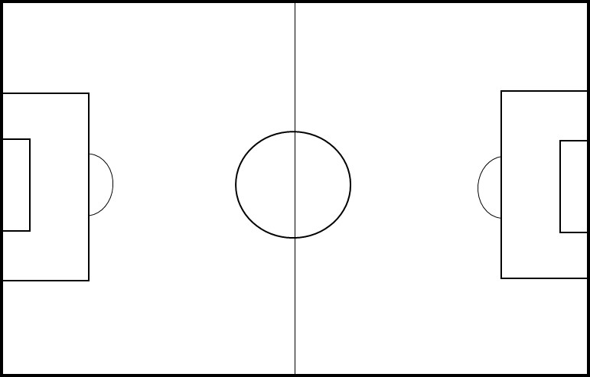
NOTE: Use one form for each participant if multiple participants are part of a sampling event
Study ID Number _______________________

Personal Air Sample – VOCs
Sample Type | Sample Collected
Personal | Yes No

Dermal Dosimeter Samples - SVOCs
Sample Type | Sample Collected
Location 1 – Hand | Yes No
Location 2 – Arm | Yes No
Location 3 - Leg | Yes No

Dermal Dosimeter Samples - Metals
Sample Type | Sample Collected
Location 1 – Hand | Yes No
Location 2 – Arm | Yes No
Location 3 - Leg | Yes No

Urine Samples
Sample Type | Sample Collected
Pre-Activity | Yes No
Post-Activity | Yes No

Blood Samples
Sample Type | Tube 1 Collected | Tube 2 Collected
Pre-Activity | Yes No | Yes No
Post-Activity | Yes No | Yes No

