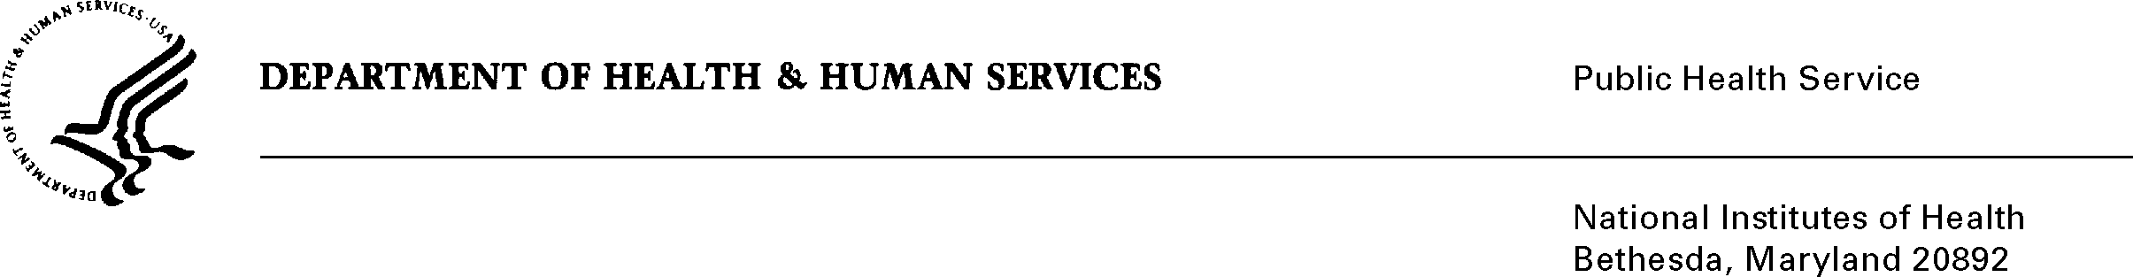
DATE: May 26, 2017

TO: Stephanie Mok
Office of Management and Budget (OMB)
Reports Clearance Officer, DHHS

FROM: Mikia P. Currie
Chief, Project Clearance Branch

SUBJECT: Change Request to a Currently Approved Form
(OMB # 0925-0001, Expiration Date 10/31/2018)

NIH is requesting a non-substantive change to the eRA Commons Personal Profile (Attachment 15) approved under 0925-0001 which does not change the approved data collection or anticipated burden hours. This data will be imported into our system minimizing any additional burden to respondents. This is a change of the ORCID ID from an optional to a required field only. In accordance with requirements in the 21st Century Cures Act, Section 7 “Shared Database of Researcher Information” the goal of this change is for NIH to develop and maintain a single online database of the expertise, employment, education and professional accomplishments of researchers who apply for Federal grants to conduct scientific research. This change will help reduce the administrative burden by providing a single source of information for researcher biosketches across Federal research funding agencies. ORCIDs are already required by many scientific journals prior to publication. Attachment B shows the text that will be used and/or how the changes will appear within the eRA Commons Personal Profile.

Attachment A: eRA Commons Profile Data Elements – Name and ID Field: “ORCID ID”

Attachment B: Personal Profile eRA Screenshot

Your full consideration is appreciated.

