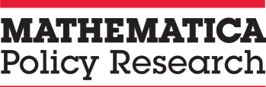 |  | OMB#: 0990-0421 Date of Expiration: 10/31/2019  Exploring Measurement of Performance Outcomes and Work Requirements in Programs Promoting Economic Independence (EMPOWERED)
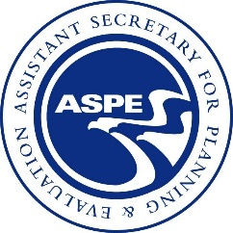
What is the focus of this study? | Low-income individuals and families frequently qualify for multiple human services programs that are funded, regulated, and administered by different Federal agencies, each with its own eligibility criteria, program requirements, and performance priorities and metrics. The purpose of this 18-month study, conducted for the Office of the Assistant Secretary for Planning and Evaluation (ASPE) at the U.S. Department of Health and Human Services (HHS), is to conduct a cross-cutting examination of the use work requirements among human services programs that include a focus on promoting self-sufficiency.  Through this examination, this study will document the use of work requirements across human services programs and identify how work requirements could be best incorporated into human services programs that currently do not have them.
What data will the study collect? | The study relies on several data collection efforts that will inform findings, including the following:  - Environmental scans of publicly available documents describing human services programs and policies related to work requirements  - Reviews of Federal program administrative data on work requirements across relevant programs  - Interviews with national and Federal stakeholders, and State and local program administrators  - Case studies and site visits to localities for in-depth information on work requirements
When will the study happen? | The study began in September 2017 and will continue until March 2019.
What will the study produce? | The study team will develop several products to share the findings from the study with key stakeholders at HHS as well as the human services and workforce development communities. These include up to five issue briefs and presentations.
To find out more | Contact the Mathematica project director: Pamela Holcomb at (202) 250-3573 or pholcomb@mathematica-mpr.com.  Contact the ASPE project officers: Erica Meade at Erica.Meade@hhs.gov and Stephanie Acker Housman at Stephanie.AckerHousman@hhs.gov.  According to the Paperwork Reduction Act of 1995, no persons are required to respond to a collection of information unless it displays a valid OMB control number. The valid OMB control number for this information collection is 0990-0421. The time required to complete this information collection is estimated to average 1.5 hours per response, including the time to review instructions, search existing data resources, gather the data needed, and complete and review the information collection. If you have comments concerning the accuracy of the time estimate(s) or suggestions for improving this form, please write to: U.S. Department of Health & Human Services, OS/OCIO/PRA, 200 Independence Ave., S.W., Suite 336-E, Washington D.C. 20201, Attention: PRA Reports Clearance Officer

