**U.S. Bureau of Labor Statistics**

**International Price Program**

Import/Export Price Survey website

**Login page**

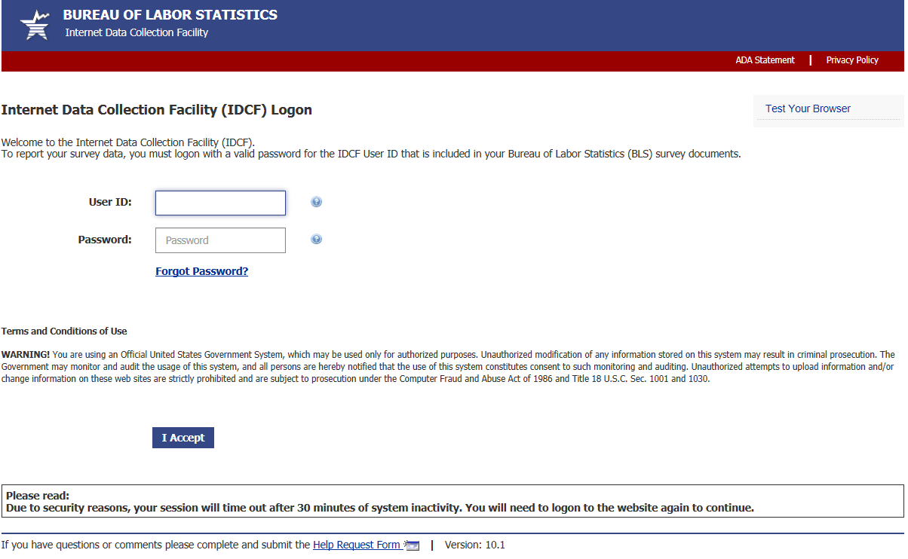

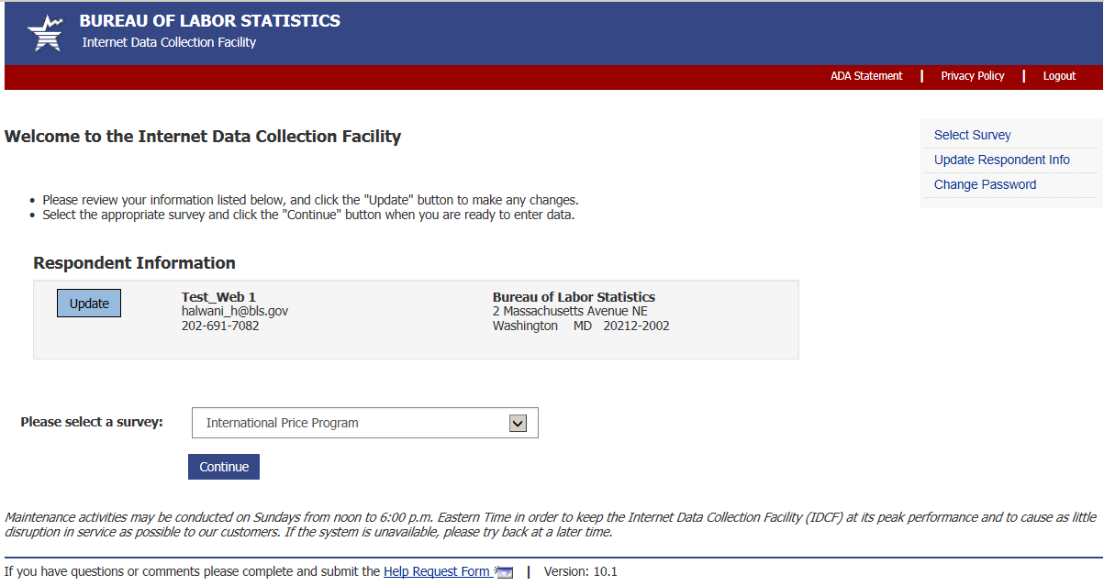

**Welcome Screen**

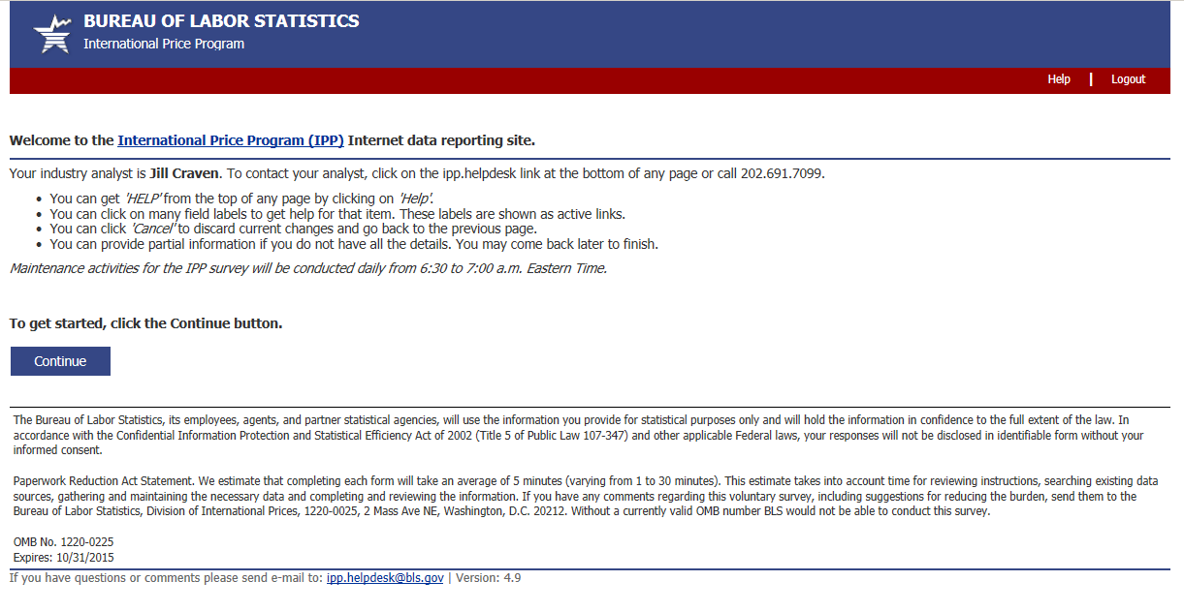 OMB No: 1220-0225

Expires: 10/31/2018



**Verify Contact Information screen (Step 1)**

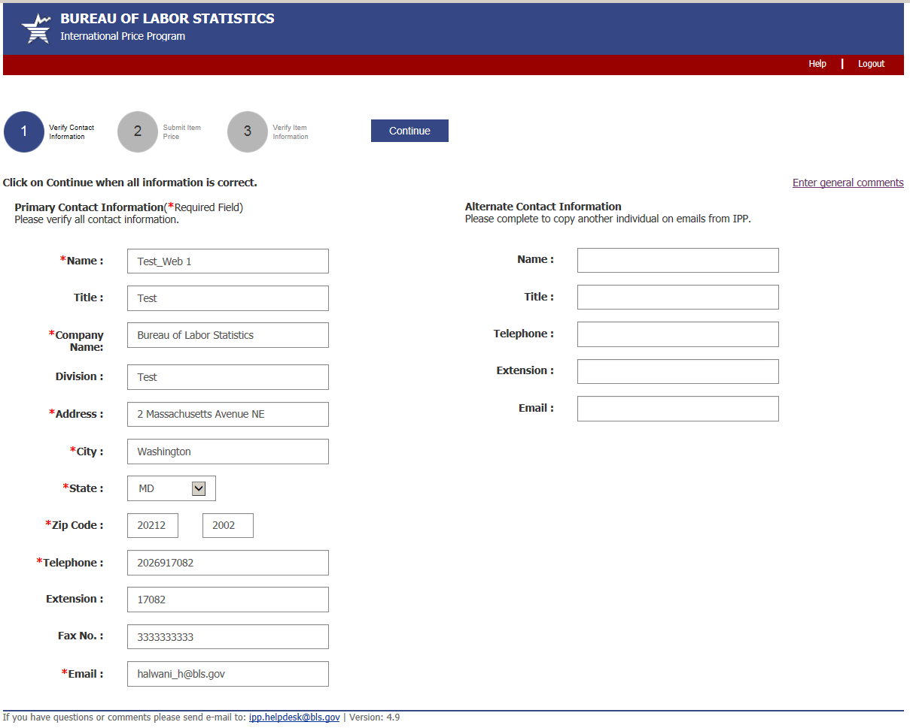

**Submit Price Information Screen (Step 2)**

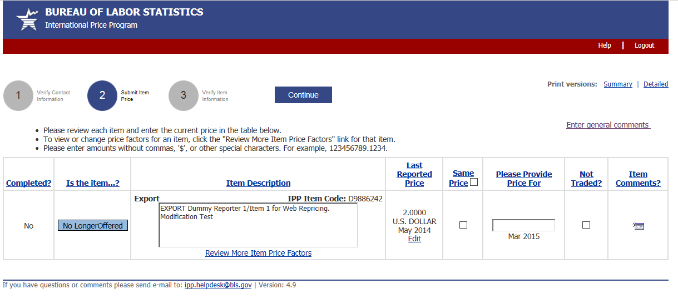

**Verify Price Information Screen (Step 3)**

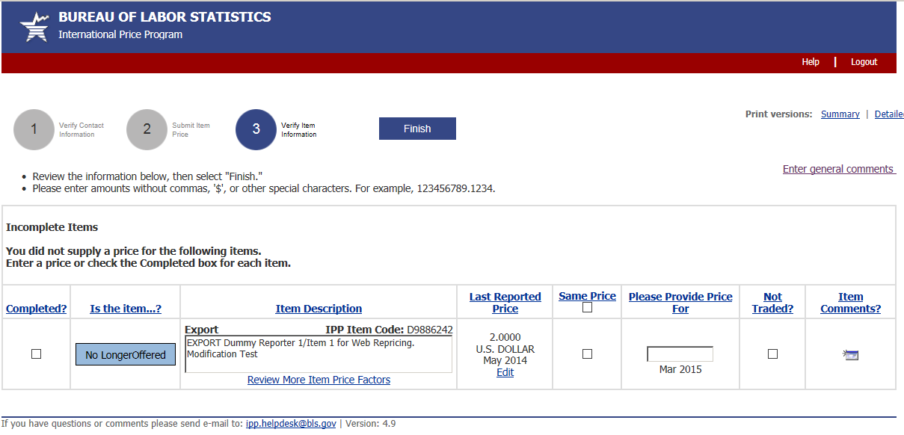

**More Item Price Factors screen**

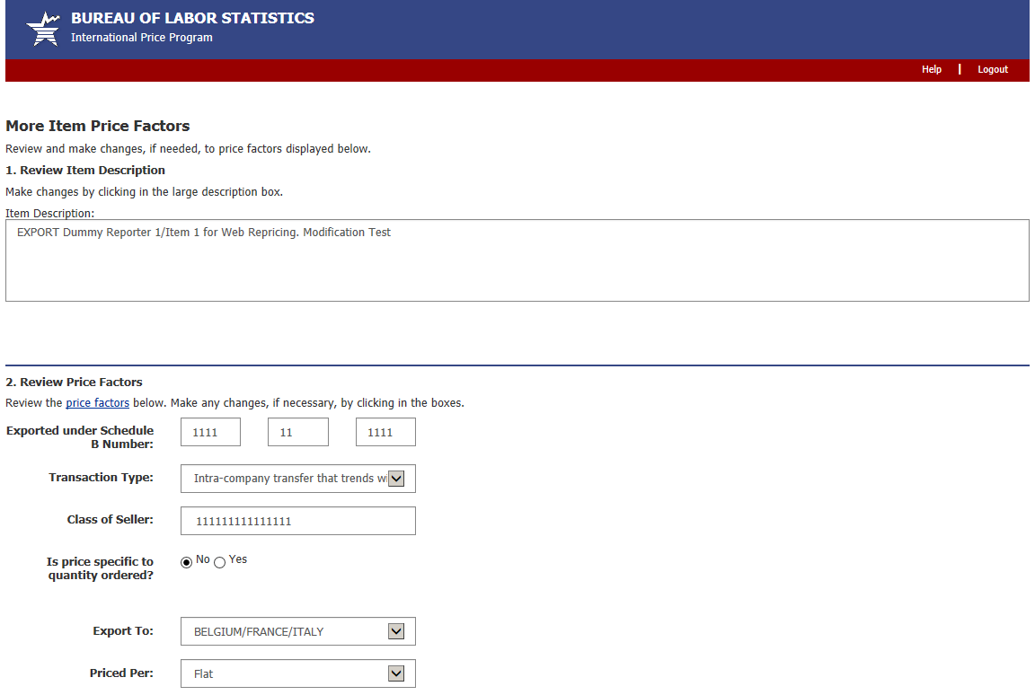

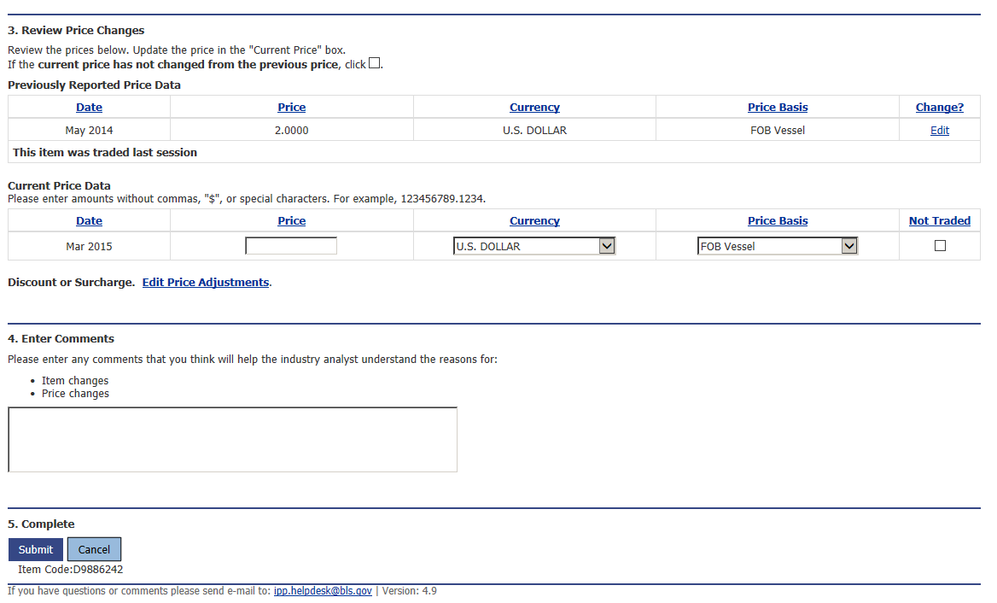

**Edit Price Adjustments screen**

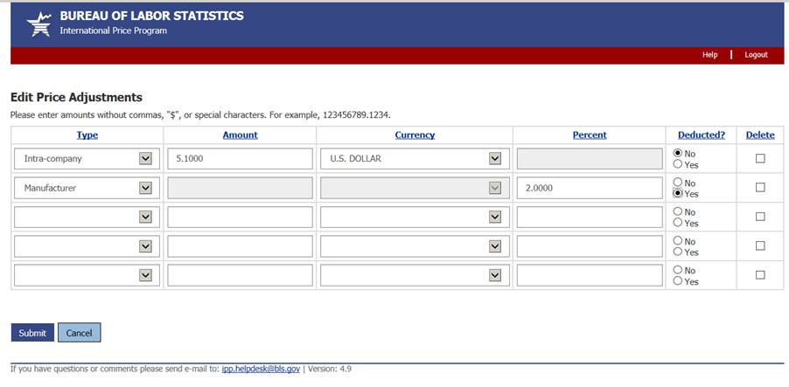

**Review/Verify Large Price change screen**

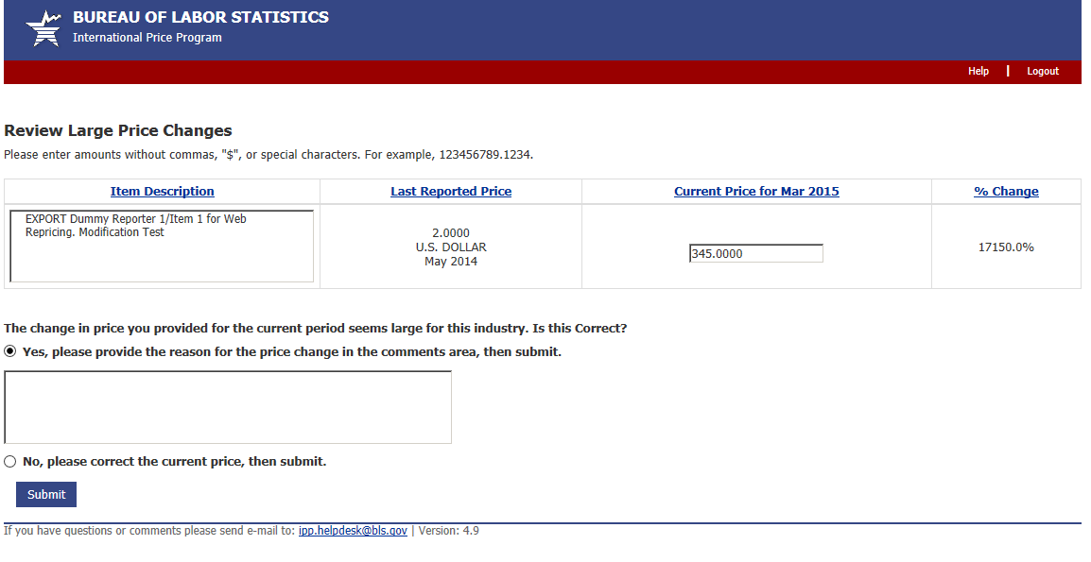

**Review/Verify Cost of Modification screen**

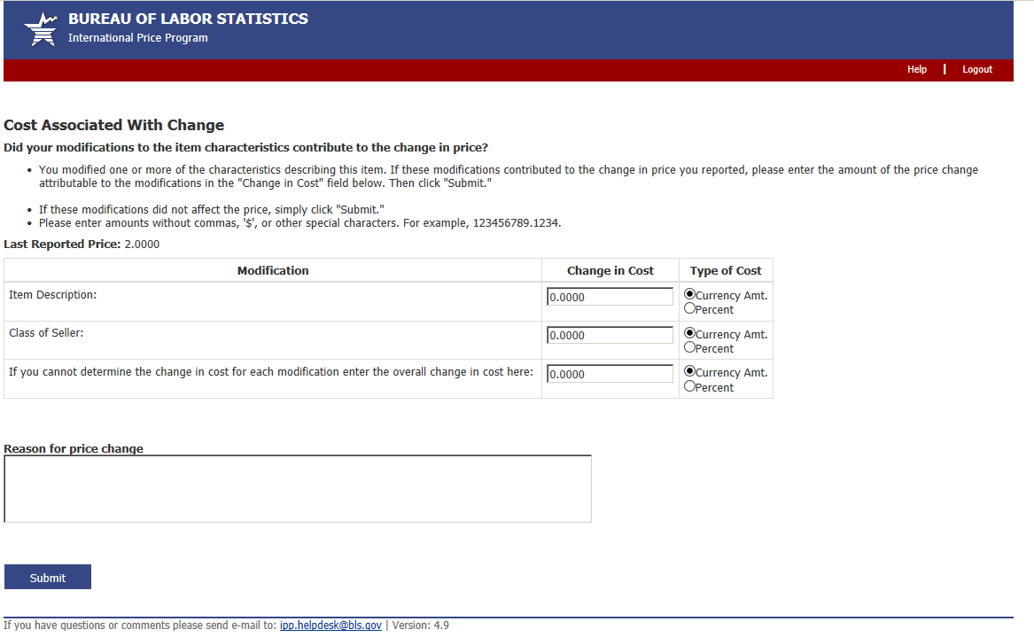

**Update Last Reported Price screen**

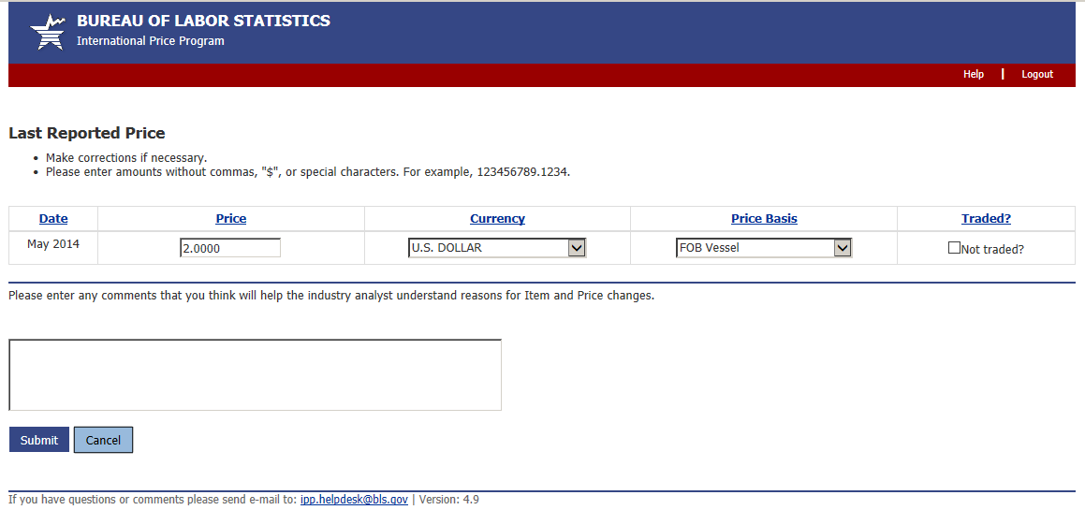

**Discontinue/Replace Item screen**

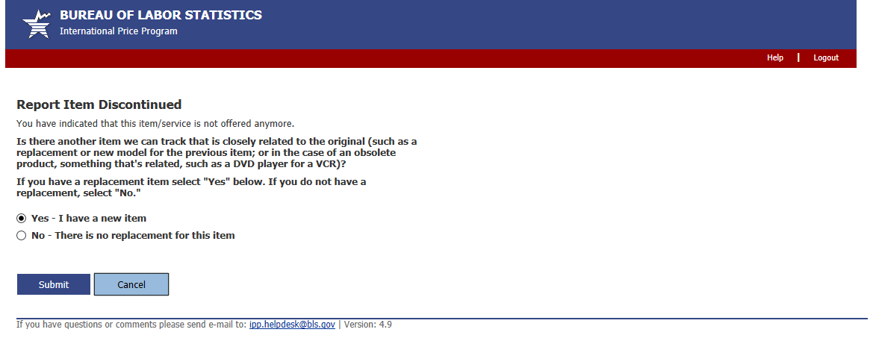

**Replaced Item Screen**

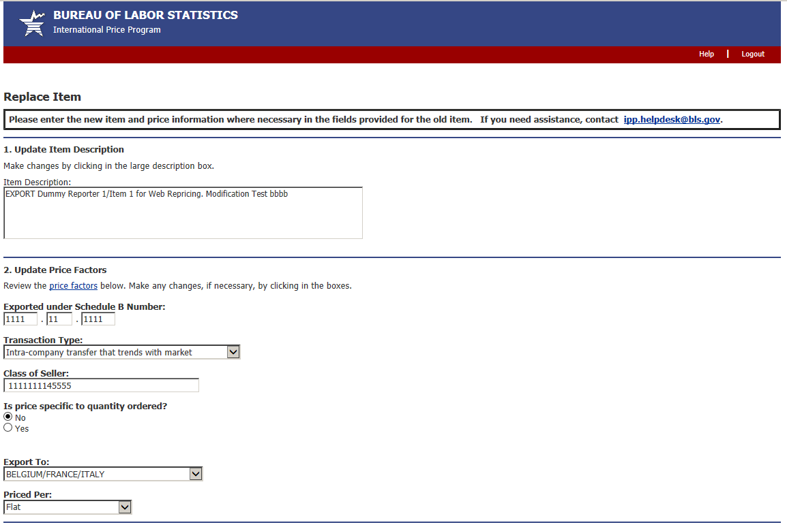

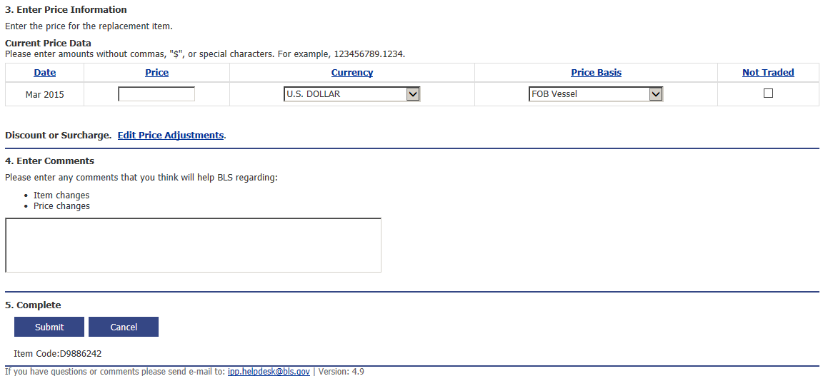

**Undo Replacement screen**

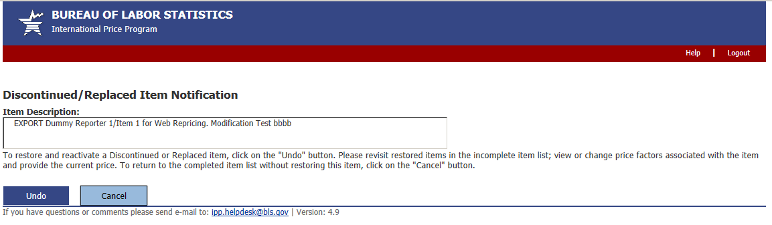

**Thank You screen**

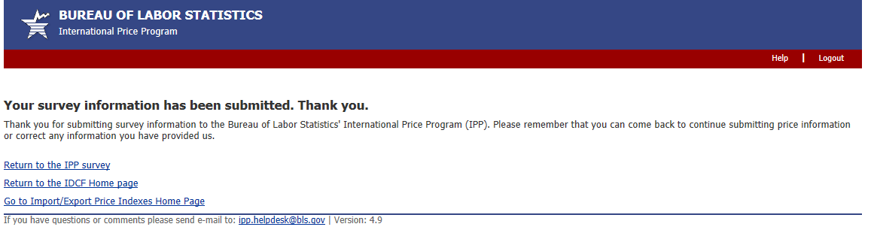

**Server Maintenance message**

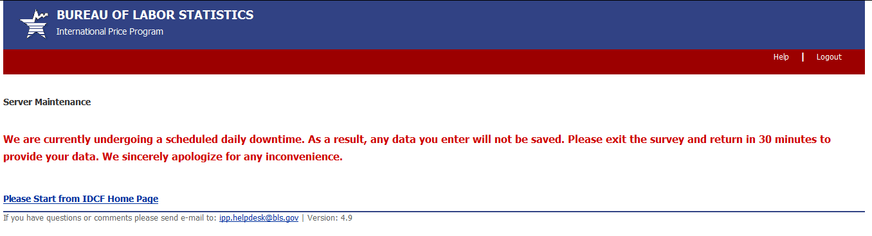

**Downtime Message**

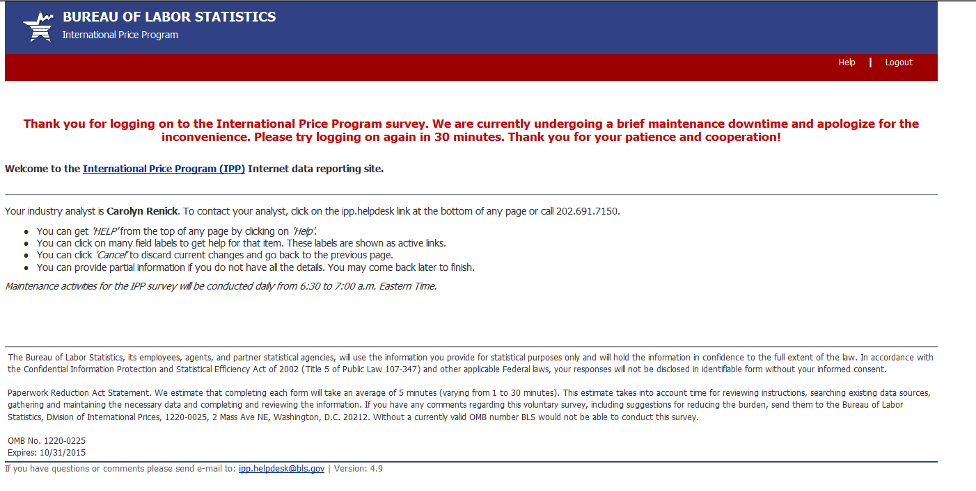

 OMB No: 1220-0225

Expires: 10/31/2018



**Privacy and Security Statement**

