US Bureau of Labor Statistics
International Price Program
Import/Export Price Survey website

Server Maintenance message
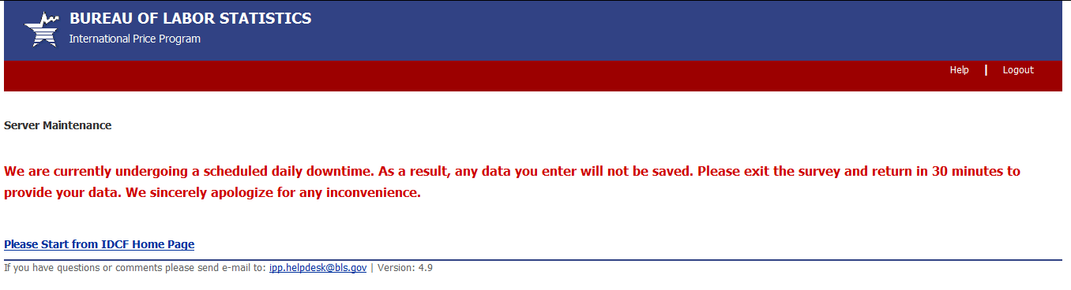

Downtime Message
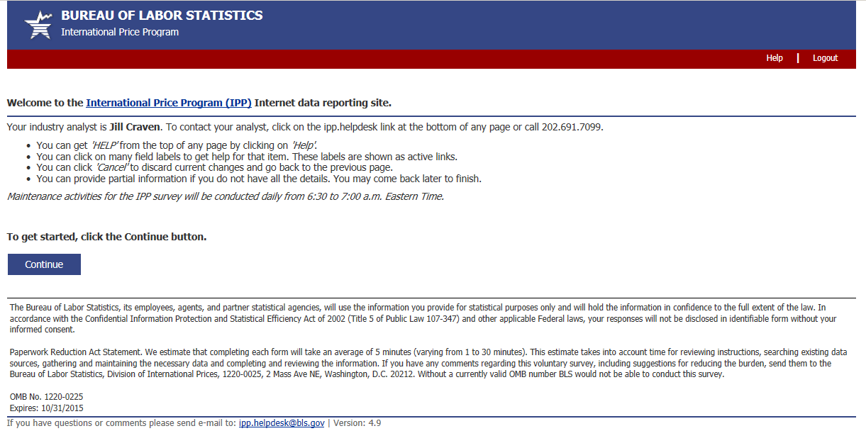 OMB No: 1220-0225
Expires: 10/31/2018

