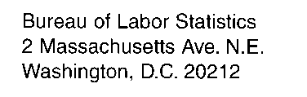

March 6, 2015

Dear Respondent,
We would like to take this opportunity to thank you for your valued participation in the International Price Program (IPP). The IPP produces indexes that measure price change in the foreign trade sector of the U.S. economy. We collect data and publish indexes on a quarterly and monthly basis.
The IPP is presently involved in an on-going process of resampling which will provide us with an updated sample of items that better reflect current trade patterns. As part of the resampling process, some or all of the items for which your company reports prices are to be discontinued from our database. We will no longer ask your company to report prices for the items listed on the attached page. If you have items that will remain in our database, we will continue to depend on your accurate and timely report of transaction prices.
As the IPP draws future samples, other items traded by your company may be selected. Should this be the case, the IPP will be in contact with you to request your cooperation in providing price data for these newly selected items.
If you have any questions, please call Blair McCarthy at (202) 691-7112
We look forward to your continued participation in our survey.
Sincerely,

International Price Program

