Justification for non-substantive change request.

1405-0142 Request for prior approval for brokering activity

# Summary

DDTC requests to amend 1405-0142, request for prior approval for brokering activity, via a non-substantive change request. 1405-0142 does not have a form associated with it. Currently, respondents are instructed by the collection’s supporting statement to submit information in accordance with 22 CFR part 129. DDTC wishes to provide industry the opportunity to respond to this collection electronically via DDTC’s new case management system. This system, which will be accessed through DDTC’s website, will allow industry to submit information securely through the internet, thus eliminating the need for third party delivery. DDTC has developed form DS-4294 to electronically capture the information required by DDTC to process requests related to this collection. If this request is approved by OMB, respondents will have the option of submitting their requests in hard copy using any written format (no change to the process) or electronically via form DS-4294.

1405-0142 was last approved in January 2016. At that time, DDTC provided notice to the public that an electronic method of submission was forthcoming:

“Currently, there is no option of electronic submission of this information. Submissions are made via hardcopy documentation. Applicants are referred to ITAR part 129 for guidance on information to submit regarding proposed brokering activity. DDTC plans to provide an electronic form that applicants may use for the purposes of obtaining prior written approval for proposed brokering activity. Eventually, the applicant will be able to access this form from the DDTC website, complete it online, and submit it via the Internet.” (Supporting Statement, Question 3)

DDTC did not receive comments in response to the possibility of electronic submission during the 60 or 30 day comment periods.

# Proposed form DS-4294

|  |  |  |
| --- | --- | --- |
| Block |  | Corresponds with ITAR Section |
| Transaction Number | 🡪 | N/A |
| Supporting Documents | 🡪 | N/A |
| 1 | 🡪 | Date is generated by the system. |
| 2 | 🡪 | 129.6(a)(1) |
| 3 | 🡪 | 129.6(a)(2) |
| 4 | 🡪 | 129.6(b)(1) |
| 5 | 🡪 | 129.6(b)(2) |
| 6 | 🡪 | 129.6(b)(3) |
| 7 | 🡪 | Calculated Automatically |
| 8 | 🡪 | 129.6(b)(3)(vii) |
| 9 | 🡪 | 129.6(b)(3)(vii) |
| 10 | 🡪 | 129.6(b)(4) |
| 11 | 🡪 | 129.6(c) and 129.6(d) |

## Blocks 1-11 *(required fields):*

The proposed form, DS-4294, does not require information beyond what is currently approved. Respondents are currently required to provide all information required by part 129 of the ITAR. ITAR § 129.6(b) and (c) (Procedures for obtaining approval) requires applicants to fully describe the brokering activities that will be undertaken, including certain enumerated requirements. This new form captures the requirements enumerated in § 129.6 and does not requires applicants to provide any additional information. The form also allows for the possibility, as described in ITAR § 129.6(d), that at the time of submission certain of the enumerated requirements in 129.6(b) may not be available and allows the applicant to nevertheless submit the form and explain the missing information in Block 11. Please refer to the matrix above for more detailed information on how DS-4294 aligns with § 129.6.

## Cover Page (*optional fields*):

DDTC has included two optional fields on the form that are not required by § 129.6—Transaction ID and Supporting Documentation. .

Providing a Transaction ID may be preferred by respondents who submit multiple requests at the same time. These IDs, which could be anything from a descriptive phrase to an internal tracking number, will make it easier for respondents to differentiate between submissions without having to open documents for viewing. The screenshot below illustrates an example of what a respondent with multiple submissions might see when tracking their submissions.

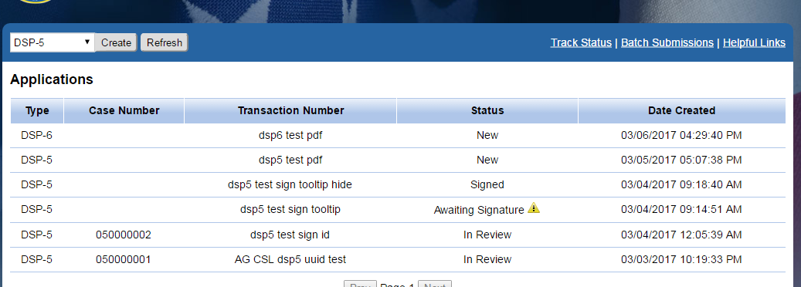

The current process does not prohibit respondents from attaching supporting documentation they feel might be helpful to include with their submission. The “documents” field on Form DS-4294 will ensure that respondents who normally submit supporting documentation are not stripped of the ability to submit electronically via form DS-4294.

DDTC recognizes that these options may be very important to respondents and might usually be included in paper submissions. This is why DDTC does not wish to prohibit industry from providing one or both of these. DDTC, however, **will not** reject a submission if a respondent chooses not to provide a transaction number and/or supporting documentation

# Benefits

Allowing electronic submission will produce the following benefits:

1. Applicants who choose to submit electronically will instantly transmit their information directly to DDTC. This eliminates the need for a third party to transport information to DDTC which, in turn, reduces the amount of time that passes between industry submission and DDTC response, as well as eliminates any costs associated with mailing submissions and responses.
2. DS-4294 assists applicants by clearly identifying required fields while providing a systematic approach to submission. Ensuring that all required information has been provided reduces the risk of requests being returned without action due to a lack of information.
3. Form DS-4294 structures the data to be more easily assessed by DDTC.

Drafted: DCanfield x33759

Approved: KWrege

Cleared:

DTCM ADearth (ok)

L/PM SRogers (ok)